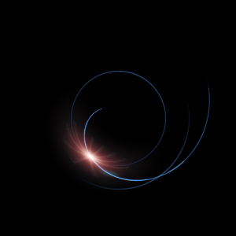
بِسْمِ ٱللَّهِ ٱلرَّحْمَٰنِ ٱلرَّحِيمِ
In the name of God, Allah,
the most Merciful qualitatively,
the most Merciful quantitatively

Quran and Primalogy
Prime Numbers are The Key

Ali Adams

www.heliwave.com

Introduction
All praise is due to God, the Sustainer of all Seen and Unseen worlds, for revealing to us new knowledge from the first chapter of the holy book of Islam, The Quran called The Opener or The Key (and not The Opening as many Muslims think).
This short and oft-repeated chapter is so central to Muslims’ prayers and Quran recitation that all such actions must begin by reciting it first. Here is the chapter in Arabic and English:
أعوذ بالله من الشيطٰن الرجيم بِسْمِ ٱللَّهِ ٱلرَّحْمَٰنِ ٱلرَّحِيمِ
- بِسْمِ ٱللَّهِ ٱلرَّحْمَٰنِ ٱلرَّحِيمِ
- ٱلْحَمْدُ لِلَّهِ رَبِّ ٱلْعَٰلَمِينَ
- ٱلرَّحْمَٰنِ ٱلرَّحِيمِ
- مَٰلِكِ يَوْمِ ٱلدِّينِ
- إِيَّاكَ نَعْبُدُ وَإِيَّاكَ نَسْتَعِينُ
- ٱهْدِنَا ٱلصِّرَٰطَ ٱلْمُسْتَقِيمَ
- صِرَٰطَ ٱلَّذِينَ أَنْعَمْتَ عَلَيْهِمْ غَيْرِ ٱلْمَغْضُوبِ عَلَيْهِمْ وَلَا ٱلضَّآلِّينَ
- In the name of Allah, the Beneficent, the Merciful.
- Praise be to Allah, Lord of the Worlds,
- The Beneficent, the Merciful.
- Master of the Day of Judgment,
- You (alone) we worship; and from You (alone) we seek help.
- Show us the straight path,
- The path of those whom You have bestowed Your favours upon;
Not (the path of) those who have earned Your anger;
nor (the path of) those who went astray.

Number Colors
The Unit U = Whole number that is indivisible.
Prime number P = Whole number that is divisible by itself only.
Additive Prime AP = Prime with a prime digit sum.
Non-additive Prime XP = Prime with a non-prime digit sum.
Composite number C = Whole number that is divisible by itself and others.
Additive Composite AC = Composite with a composite digit sum.
Non-additive Composite XC = Composite with a non-composite digit sum.
The Container Hadith
So pivotal chapter The Key is that the Prophet (peace be upon him and his family) said that the whole Quran is contained within this chapter and the whole chapter is contained within its first verse of “Bism Allah Ar-Rahmaan Ar-Raheem” and the whole verse is contained within its first letter “Baa”!
The Quran => The Key => Bism Allah ArRahmaan ArRaheem => Baa
Note that all Quran chapters start with letter "Baa" even the one without BismAllah (chapter #9 Al-Tawba). Also note the extra shadda on the BismAllah of chapters #95
(Al-Teen) and #97 (Al-Qadr) as the chapters before end with "Baa" sakina.

The Key Structure
Glory to God for making chapter The Opener or The Key (الفاتحة) to consist of 7 verses, 29 words and 139 letters which are all prime numbers. That is, numbers divisible by themselves and 1 only.
Not only these numbers are prime but their digit sums are prime too (7=7, 2+9=11, 1+3+9=13) making them a special kind of prime numbers called “Additive Prime Numbers”. What’s more, even adding these digit sums (7+11+13=31) produces a prime too.
And to confirm the deliberate use of prime numbers, God has chosen the numbers of verses, words, and letters such that joining them left-to-right (729139) or right-to-left (139297) also produces prime numbers with prime digit sums (1+3+9+2+9+7=31). Once again, additive prime numbers!
And when we learn that prime numbers are used as keys for encoding and decoding secret messages then we realize why God has named the chapter, The Key or The Opener (not The Opening).
Prime Numbers and Cryptology
Prime numbers have baffled mathematicians over 2300 years of recorded history and currently The Clay Mathematics Institute, Cambridge, Massachusetts, USA is offering a $1,000,000 prize to whoever can solve their distribution mystery amongst the natural numbers. See http://www.claymath.org/millennium/Riemann_Hypothesis.
Due to this mysterious distribution, there is no easy way to tell if a number is prime or where the next prime is. For this reason, prime numbers are used as keys in public key cryptography (the RSA) to encrypt messages into unreadable text without requiring to share a common key to lock and unlock messages. When you buy a product over the Internet, two large secret prime numbers are multiplied together to produce a huge composite number that is made public to enable your computer to wrap your credit card details with it before sending your details to the computer hosting the website you buying from, using the https protocol (Secure Hypertext Transfer Protocol). No one can see your financial details except those who know the private keys (the large primes) or can factor the huge composite public key into its large prime factors which may require many years making it impractical to hack. World governments use even larger prime numbers (1000s of digits long) to secure their communication channels which require billions of years to factor using super-computers because of the exponential factorization time.
In addition to prime numbers, the RSA algorithm uses modular arithmetic, please see www.heliwave.com/RSADemo.txt or download www.heliwave.com/RSADemo.zip.
Readable Ciphertext
God has revealed the Quran in an Arabic tongue (not Arabic emlaaei text) and challenges man and jinn to produce a book like it, or ten chapters like it, or even single chapter like it (but not a single verse like as this is possible). And what’s more, God tells the disbelievers that “They will never succeed”.
This can only be a hint that although readable on the surface, the Quran is in fact encrypted at chapter level, and then each ten chapters together, and finally all chapters together so as to produce a final encrypted text that is readable, thus the name The Quran which literally means The Readable.
God All-knowing named the first chapter The Key and based it on prime numbers and named the book The Readable despite being encrypted to show us that prime numbers hold the key to unlocking the hidden knowledge behind the readable outer text of the Quran.
Multi-layered Book
In Quran 18:109, God Almighty informs us that the Book contains more words than the 77878 words seen in its outer layer:
أعوذ بالله من الشيطٰن الرجيم بِسْمِ ٱللَّهِ ٱلرَّحْمَٰنِ ٱلرَّحِيمِ

قُل لَّوْ كَانَ ٱلْبَحْرُ مِدَادًا لِّكَلِمَـٰتِ رَبِّى لَنَفِدَ ٱلْبَحْرُ قَبْلَ أَن تَنفَدَ كَلِمَـٰتُ رَبِّى وَلَوْ جِئْنَا بِمِثْلِهِۦ مَدَدًا
Say: If the ocean were ink for the Words of my Lord, the ocean would run out, before the Words of my Lord run out, even if we double the ink supply.
This may mean, whereas chapter The Opener is to be used as a Key to unlock the first hidden layer beneath the outer layer, the newly unhidden layer may also contain its own Opener chapter to unlock the layer below it and so on until there are no more Opener chapters, and God knows all. Furthermore, God challenges us five times in the Quran to produce a Text like, and assures us we will never succeed:
Challenge 1: Produce a Saying structured like it in Quran 52:34
فَلْيَأْتُوا۟ بِحَدِيثٍۢ مِّثْلِهِۦٓ إِن كَانُوا۟ صَٰدِقِينَ
52:34 "Let them then produce a recital like unto it,- If they speak the truth!"
Challenge 2: Produce a Quran like it in Quran 17:88
قُل لَّئِنِ ٱجْتَمَعَتِ ٱلْإِنسُ وَٱلْجِنُّ عَلَىٰٓ أَن يَأْتُوا۟ بِمِثْلِ هَٰذَا ٱلْقُرْءَانِ لَا يَأْتُونَ بِمِثْلِهِۦ وَلَوْ كَانَ بَعْضُهُمْ لِبَعْضٍۢ ظَهِيرًۭا
17:88 Say: "If the whole of mankind and jinnkind were to gather together to produce the like of this Qur'an, they could not produce the like thereof, even if they backed up each other with help and support."
Challenge 3: Produce 10 Chapters like it in Quran 11:13
أَمْ يَقُولُونَ ٱفْتَرَىٰهُ ۖ قُلْ فَأْتُوا۟ بِعَشْرِ سُوَرٍۢ مِّثْلِهِۦ مُفْتَرَيَٰتٍۢ وَٱدْعُوا۟ مَنِ ٱسْتَطَعْتُم مِّن دُونِ ٱللَّهِ إِن كُنتُمْ صَٰدِقِينَ
11:13 Or they may say, "He forged it," Say, "Bring ye then ten Suras forged, like unto it, and call (to your aid) whomsoever ye can, other than Allah!- If ye speak the truth!"
Challenge 4: Produce 1 Chapter like it is also in Quran 10:38
أَمْ يَقُولُونَ ٱفْتَرَىٰهُ ۖ قُلْ فَأْتُوا۟ بِسُورَةٍۢ مِّثْلِهِۦ وَٱدْعُوا۟ مَنِ ٱسْتَطَعْتُم مِّن دُونِ ٱللَّهِ إِن كُنتُمْ صَٰدِقِينَ
10:38 Or do they say, "He forged it"? Say: "Bring then a Sura like unto it, and call (to your aid) anyone you can other than Allah,- If ye speak the truth!!"
Challenge 5: Produce 1 Chapter like it (not 1 verse) in Quran 2:23
وَإِن كُنتُمْ فِى رَيْبٍۢ مِّمَّا نَزَّلْنَا عَلَىٰ عَبْدِنَا فَأْتُوا۟ بِسُورَةٍۢ مِّن مِّثْلِهِۦ وَٱدْعُوا۟ شُهَدَآءَكُم مِّن دُونِ ٱللَّهِ إِن كُنتُمْ صَٰدِقِينَ
2:23 "And if ye are in doubt as to what We have revealed to Our servant, then produce a Sura like thereunto; and call (to your aid) your witnesses or helpers other than Allah!- If ye speak the truth!"
This may suggest that the inner Quran was first encrypted at chapter-level producing a non-readable intermediate text (or ciphertext), which is again encrypted at chapter-level (see double 1 Chapter challenges) producing yet another non-readable intermediate text, which is then encrypted each 10 Chapters together to produce yet another non-readable intermediate text, followed by a global encryption at Book-level to produce 85 readable chapters and 29 non-readable chapters, and finally using initial letters, these 29 non-readable chapters become readable so the whole Book becomes fully readable and thus is named Al-Quran (The Readable) despite being encrypted.

A clear evidence for chapter-level encryption can be seen in the spelling of the name of prophet Ibrahim (peace upon him) which is spelt without elf nor yaa in chapter #2 while spelt without elf only throughout the rest of the Book. The word "Ibrahim" is written 15 times as "Ibrhm" with superscripted elf and yaa "إِبْرَٰهِـۧمُ" throughout chapter #2 and written 54 times as "Ibrhim" with a superscript elf "إِبْرَٰهِيمَ" throughout the remaining chapters of the Quran.
See http://heliwave.com/Symmetry.pdf for evidence of Book-level encryption and http://heliwave.com/InitialLetters.html for an evidence that the initial letters may not have a meaning but a role to play in the encryption/decryption process. God know all.
Book Structure
God Almighty says in Quran 15:87:
أعوذ بالله من الشيطٰن الرجيم بِسْمِ ٱللَّهِ ٱلرَّحْمَٰنِ ٱلرَّحِيمِ
وَلَقَدْ ءَاتَيْنَـٰكَ سَبْعًا مِّنَ ٱلْمَثَانِى وَٱلْقُرْءَانَ ٱلْعَظِيمَ
And We’ve given you seven of the doubles and the Grand Quran.
The Prophet (pbuh+f) explained the seven of the doubles as the seven verses of chapter The Opener or The Key that are recited twice in each prayer. This means, that God Almighty is saying that The Book has two parts; chapter The Opener as the Key and the remaining chapters as the Message. And indeed additive prime numbers confirms this assumption too:
Book = Key + Message
114 = 1 + 113 chapters
6236 = 7 + 6229 verses
where 113 and 6229 are prime numbers with primes digit sums (1+1+3=5, 6+2+2+9=19), making them additive prime numbers.
God All-knowing even gives a Great Oath by the composite and prime numbers in Quran 89:1–5
أعوذ بالله من الشيطٰن الرجيم بِسْمِ ٱللَّهِ ٱلرَّحْمَٰنِ ٱلرَّحِيمِ
1. By the dawn. وَٱلْفَجْرِ .1
2. by the ten nights. وَلَيَالٍ عَشْرٍۢ .2
3. by the co-dependent and by the indivisible. وَٱلشَّفْعِ وَٱلْوَتْرِ .3
4. by the night as it eases away. وَٱلَّيْلِ إِذَا يَسْرِ .4
5. Isn’t this a big oath for he who thinks? هَلْ فِى ذَٰلِكَ قَسَمٌۭ لِّذِى حِجْرٍ .5
This oath is not swearing by the Even and Odd numbers as these are child-play numbers and have no valuable information rather, God swears by the co-dependent and independent numbers which are full of valuable information (RSA, https, etc.) and use in nature (energy levels of electronic shells).
https://www.scienceforums.net/topic/109798-primes-electron-configurations-please-help-part-ii/
Reality = Energy + Information
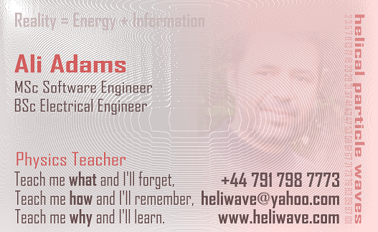
Reality is made up of Energy continuously pumped up into our Universe from God plus Information hidden deep within the composite and prime numbers at the micro-level and the 114 verses-per-chapter numbers at the macro-level.
7, 286, 200, 176, 120, 165, 206, 75, 129, 109, 123, 111, 43, 52, 99, 128, 111, 110, 98, 135, 112, 78, 118, 64, 77, 227, 93, 88, 69, 60, 34, 30, 73, 54, 45, 83, 182, 88, 75, 85, 54, 53, 89, 59, 37, 35, 38, 29, 18, 45, 60, 49, 62, 55, 78, 96, 29, 22, 24, 13, 14, 11, 11, 18, 12, 12, 30, 52, 52, 44, 28, 28, 20, 56, 40, 31, 50, 40, 46, 42, 29, 19, 36, 25, 22, 17, 19, 26, 30, 20, 15, 21, 11, 8, 8, 19, 5, 8, 8, 11, 11, 8, 3, 9, 5, 4, 7, 3, 6, 3, 5, 4, 5, 6
These Quran's 114 magical numbers and composite and prime numbers literally contain (all) required information that control how photons interact with each other to produce our physical world.
The universe is written in numbers.
At a micro-level, as light rays emerge from the centre of the big bang, they spiral either clockwise or anticlockwise depending on their time of emergence or birth. Composite light rays helicate clockwise while prime light rays helicate anticlockwise. The first light ray (the unit) circulates the big bang centre and never propagate away.
At a macro-level, the Quran's 114 numbers control the interactions among light rays to create our physical reality as matter (5%), antimatter (5%) and dark matter (19%), while non-interacting light stays as dark energy (71%) which expands space continuously.
Furthermore, I believe that all Helical Particle Waves follow the golden ratio rule:
Golden ratio (φ) = Helical wavelength ÷ Helical diameter
The higher the frequency (the shorter the wavelength), the smaller the wave helical diameter but never diminishes to zero.

Mathematical Structure Examples
1. Quran has 114 chapters
where
114th prime number = 619
114 = 6 × 19
Chapter 114 has 6 verses
Digit sum of 114 = 1+1+4 = 6
Quran 74:30 "Guarded by nineteen."

"There is no god but Allah. Muhammed is the Messenger of Allah."
لا اله الا الله محمد رسول الله Frequency_Linear value = 114
لا اله الا الله محمد رسول الله Abjad_Gematria value = 619

2. Quran 74:30 "Guarded by nineteen."
where
19 = 8th prime
19th composite = 8th non-additive composite = 30
19th additive composite = 30th composite
Chapter 67 (19th prime) has 30 (19th composite) verses.
God uses 8 fractions and 30 whole numbers in the Quran.

3. Bi-symmetrical Book
Sum of chapter numbers = 6555
Sum of verses per chapter = 6236

Count of all C+V sums = 114
Count of even C+V sums = 57
Count of odd C+V sums = 57

Sum of even C+V sums = 6236
Sum of odd C+V sums = 6555
4. Iron: The most stable chapter and chemical element
Chapter #57 The Iron has 29 verses
where
57 is half the total number of chapters 114
29 is the median or middle number between 1 to 57

57 × 29 = 1653
16th prime number = 53

There are 16 additive prime chapter numbers.
There are 53 additive composite chapter numbers.

Chapter #57 stays in position 57 after sorting the entire Quran
chapters by C×V multiplication product in ascending order.

Chapter #87 The High has 19 verses with 87 × 19 = 1653
chapter #87 keeps chapter #57 in position 57 and not more to position 58 when sorting in descending order because it has the
same C×V multiplication product as chapter #57.

The Iron chemical element has the most stable nucleus amongst all
chemical elements in nature just as chapter The Iron is the most
stable chapters in the whole Quran by C×V multiplication.

5. Quran and golden ratio
Quran C+V sums point to the golden ratio (φ) where:
d = Sum of all duplicate C+V sums = 7906
u = Sum of all unique C+V sums = 4885
d ÷ u = 7906 ÷ 4885 = 1.618(4237...)

6. Different page sizes. Not decoration!
The first two pages of the Quran are much shorter than all other
pages not for decoration purposes but to teach to treat the hamza
between letters lam and elf as a standalone countable hamza.

The first two pages of the Quran = 319 letters
(including the hamza of waBil-Aa'khira)

The first 7 verses on page 3 = 319 letters
(including the hamza of Al-Aa'khir)

Sum of chapter numbers - Sum of verses = 6555 - 6236 = 319

7. Chapter + Verses = 114
Sum of chapter numbers with (C+V = 114) = 319
-------------------
C V C+V
-------------------
15 99 114
39 75 114
70 44 114
88 26 114
107 7 114
-------------------
Sum 319 251 570
-------------------

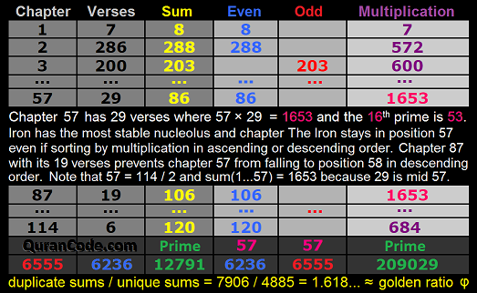

Primalogy System
In order to understand the role of prime numbers in decrypting the Message of the Quran as pointed to in chapter The Key, God Almighty has guided us to a new numerology system we called Primalogy that assigns prime values to the 28 Arabic letters plus the standalone Hamza (ء) in Alphabetical order as shown below:
 |  |  |  |  |  | 1 | ء
79 | ك | 47 | ض | 19 | د | 2 | ا
83 | ل | 53 | ط | 23 | ذ | 3 | ب
89 | م | 59 | ظ | 29 | ر | 5 | ت
97 | ن | 61 | ع | 31 | ز | 7 | ث
101 | ه | 67 | غ | 37 | س | 11 | ج
103 | و | 71 | ف | 41 | ش | 13 | ح
107 | ي | 73 | ق | 43 | ص | 17 | خ
Primalogy: The New Numerology System
This system has been validated by applying it to the most important chapters of the Quran, chapter Al-Fatiha (The Opener) and chapter Al-Ikhlaas (Oneness of God), and to the word “Allah” and consistently produced prime numbers with prime digit sums.
What's more, the most important verses in the Quran, verse 2:255 Aya Al-Kursi (The Throne), and the 31-repeated verse of chapter Ar-Rahmaan (The Merciful) also produced additive prime numbers.
The following letter simplification rules are used to reduce the 37 letters used in the Quran to the 29 basic Arabic letters based on shapes not sounds:
From | ٱ | ا | آ | أ | إ | ى | ىٰ | ىٰىٰ | ة | ؤ | ئ | ئئ | ء
To | ا | ا | ا | ا | ا | ي | ي | ي | ه | و | ي | ي | ء
Letter Simplification Rules

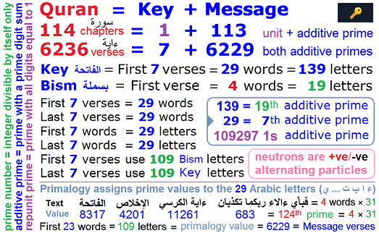
Primalogy Value of the word “Allah”
Applying the newly discovered Primalogy system to the word “Allah” in Arabic (الله):
ا ل ل ه
2+83+83+101
produced a primalogy value of 269 which is prime with a prime digit sum (2+6+9 = 17), an additive prime number.
Primalogy Value of chapter The Key
Applying the Primalogy system to the 139 letters of chapter The Key or The Opener (الفاتحة):
ب س م ا ل ل ه ا ل ر ح م ن ا ل ر ح ي م (1)
3+37+89 2+83+83+101 2+83+29+13+89+97 2+83+29+13+107+89
ا ل ح م د ل ل ه ر ب ا ل ع ل م ي ن (2)
2+83+13+89+19 83+83+101 29+3 2+83+61+83+89+107+97
ا ل ر ح م ن ا ل ر ح ي م (3)
2+83+29+13+89+97 2+83+29+13+107+89
م ل ك ي و م ا ل د ي ن (4)
89+83+79 107+103+89 2+83+19+107+97
إ ي ا ك ن ع ب د و إ ي ا ك ن س ت ع ي ن (5)
2+107+2+79 97+61+3+19 103+2+107+2+79 97+37+5+61+107+97
ا ه د ن ا ا ل ص ر ط ا ل م س ت ق ي م (6)
2+101+19+97+2 2+83+43+29+53 2+83+89+37+5+73+107+89
ص ر ط ا ل ذ ي ن أ ن ع م ت ع ل ي ه م (7)
43+29+53 2+83+23+107+97 2+97+61+89+5 61+83+107+101+89
غ ي ر ا ل م غ ض و ب ع ل ي ه م
67+107+29 2+83+89+67+47+103+3 61+83+107+101+89
و ل ا ا ل ض آ ل ي ن
103+83+2 2+83+47+2+83+107+97
produced a primalogy value of 8317 which is prime with a prime digit sum too (8+3+1+7=19), an additive prime value.
Primalogy Value of chapter Oneness of God
This new Primalogy system was further validated when applied to the letters of the next most important chapter in the Quran, #112, Oneness of God (الإخلاص), and amazingly produced two additive prime values, with and without the non-numbered verse of “Bism Allah Ar-Rahmaan Ar-Raheem” as follows:
ب س م ا ل ل ه ا ل ر ح م ن ا ل ر ح ي م
3+37+89 2+83+83+101 2+83+29+13+89+97 2+83+29+13+107+89
ق ل ه و ا ل ل ه أ ح د (1)
73+83 101+103 2+83+83+101 2+13+19
ا ل ل ه ا ل ص م د (2)
2+83+83+101 2+83+43+89+19
ل م ي ل د و ل م ي و ل د (3)
83+89 107+83+19 103+83+89 107+103+83+19
و ل م ي ك ن ل ه ك ف و ا أ ح د (4)
103+83+89 107+79+97 83+101 79+71+103+2 2+13+19
with BismAllah produced a prime primalogy value of 4201 with a prime digit sum (4+2+0+1=7), and without BismAllah produced a prime primalogy value of 3167 with a prime digit sum (3+1+6+7=17) too.
This clearly shows that the “Bism Allah Ar-Rahmaan Ar-Raheem” phrase is a prefix to this chapter and any chapter that has it unnumbered whereas this same phrase is an integral part of chapter The Key as it is numbered as verse 1 and thus has a full verse status and therefore must be recited loudly with the other six verses of the chapter, and Allah knows best.
Primalogy Value of verse The Throne
Full Letter Simplification Rules
God behold, additive prime numbers are guiding us as to how to simplify the Quran text when no clear rules exist. For example, the second most important verse in the Quran after Quran 1:1 “Bism Allah Ar-Rahmaan Ar-Raheem”, verse The Throne in Quran 2:255 shows that superscript letters (hamza ـٔ, elf ـٰ, yaa ـۧ and noon ـۨ) are to be treated as diacritics (harakaat) and be ignored all together:
أعوذ بالله من الشيطٰن الرجيم بِسْمِ ٱللَّهِ ٱلرَّحْمَٰنِ ٱلرَّحِيمِ
ٱللَّهُ لَآ إِلَٰهَ إِلَّا هُوَ ٱلْحَىُّ ٱلْقَيُّومُ ۚ لَا تَأْخُذُهُۥ سِنَةٌۭ وَلَا نَوْمٌۭ ۚ لَّهُۥ مَا فِى ٱلسَّمَٰوَٰتِ وَمَا فِى ٱلْأَرْضِ ۗ مَن ذَا ٱلَّذِى يَشْفَعُ عِندَهُۥٓ إِلَّا بِإِذْنِهِۦ ۚ يَعْلَمُ مَا بَيْنَ أَيْدِيهِمْ وَمَا خَلْفَهُمْ ۖ وَلَا يُحِيطُونَ بِشَىْءٍۢ مِّنْ عِلْمِهِۦٓ إِلَّا بِمَا شَآءَ ۚ وَسِعَ كُرْسِيُّهُ ٱلسَّمَٰوَٰتِ وَٱلْأَرْضَ ۖ وَلَا يَـُٔودُهُۥ حِفْظُهُمَا ۚ وَهُوَ ٱلْعَلِىُّ ٱلْعَظِيمُ
Ignoring the superscript hamza (ـٔ) produces a prime value of 11261 with a prime digit sum of (1+1+2+6+1=11), additive prime number!
The following letter simplification rules are used to reduce the 41 normal and superscript letters used in the Quran to the 29 basic Arabic letters:

From | ٱ | ا | آ | أ | إ | ى | ىٰ | ىٰىٰ | ة | ؤ | ئ | ئئ | ء | ـٔ | ـٰ | ـۧ | ـۨ
To | ا | ا | ا | ا | ا | ي | ي | ي | ه | و | ي | ي | ء
Full Letter Simplification Rules
Primalogy Value of verse The Merciful
Primalogy Correctness
Additive prime numbers act as validation checksums to keep us on the right path. For example, the primalogy value of the most repeated verse in the entire Quran (فباي ءالاء ربكما تكذبان) which is found in chapter The Merciful is 683. Not only 683 is an additive prime number (6+8+3=17), but as brother Aminreza Ebrahimi Saba points out, 683 is 124th prime number where 124 = 31 x 4 and the verse itself is repeated 31 times and is 4-word long. Amazing !!!
This is an undeniable proof of the correctness but not necessarily completeness of the newly discovered Primalogy system.
QuranCode Software
QuranCode is a C# open-source application that has been developed to support this research effort for finding valid methods of using primalogy to letter-process the Quranic text (letter jumping by PV values, making sound waves with primalogy values of Quran words, drawing golden ratio pictures of Quran letter Primalogy values, etc.
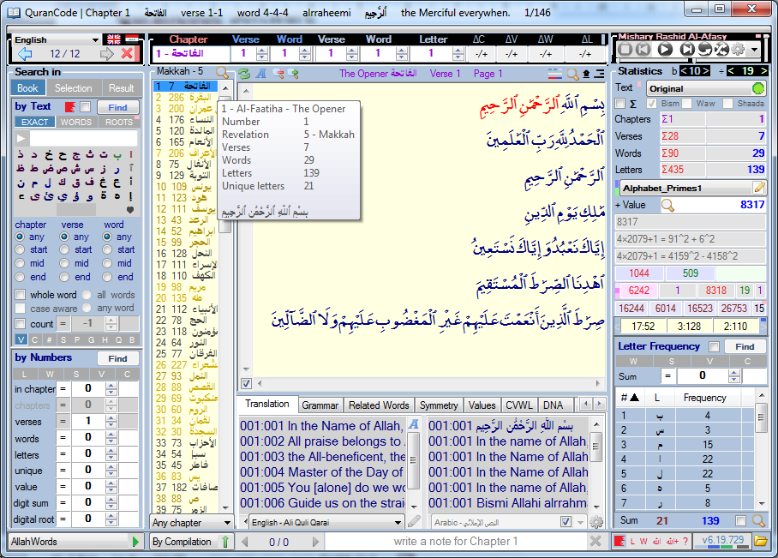
QuranCode open-source project at http://qurancode.com
Quran text taken from http://www.tanzil.net

References
The Quran: 610-632 [23 lunar years of revelations]
Recitation Method: Hafs bin Suleiman Al-Ghadhiri Al-Kufi ◄ Aasim bin abi Al-Nijood◄ Abi Abdul-Rahmaan As-Selemi ◄ Imam Ali bin abi Talib
Writing Method: Uthmani script.
| web: www.heliwave.com | email: heliwave@yahoo.com |

