IMPROVED

NGAIRA

2024-01-19

# Load Data

# VIEW DATA

# Summary

## STATION REGISTERED TURNOUT PERCENTAGE   
## Length:19 Min. : 11.0 Min. : 8.0 Min. :53.31   
## Class :character 1st Qu.: 579.0 1st Qu.: 362.5 1st Qu.:56.82   
## Mode :character Median : 783.0 Median : 452.0 Median :58.72   
## Mean : 797.1 Mean : 473.5 Mean :61.15   
## 3rd Qu.:1085.0 3rd Qu.: 618.5 3rd Qu.:63.26   
## Max. :1781.0 Max. :1074.0 Max. :79.82   
## 2D%age Rej votes ZERO CAST   
## Min. :53.31 Min. : 0.000 Min. : 3.0   
## 1st Qu.:56.83 1st Qu.: 2.500 1st Qu.:191.5   
## Median :58.72 Median : 5.000 Median :309.0   
## Mean :61.15 Mean : 5.158 Mean :323.6   
## 3rd Qu.:63.27 3rd Qu.: 8.000 3rd Qu.:457.0   
## Max. :79.82 Max. :12.000 Max. :707.0

# Count the NAs # MISSING VALUES

## STATION REGISTERED TURNOUT PERCENTAGE 2D%age Rej votes ZERO CAST   
## 0 0 0 0 0 0 0

# DATA VISUALISATION

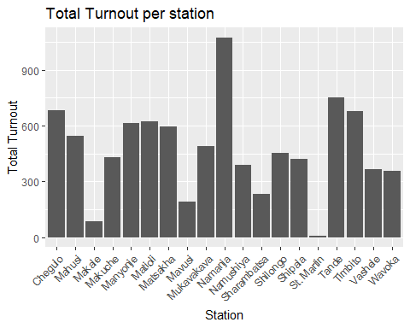

# Scatter plot of Scatter plot of Total Registered vs. Turnout

