PERSONAL CHECKS

NGAIRA

2024-01-19

# Load Data

## Rows: 1410 Columns: 11  
## ── Column specification ────────────────────────────────────────────────────────  
## Delimiter: ","  
## chr (2): period, county  
## dbl (9): Total Dewormed, Acute Malnutrition, stunted 6-23 months, stunted 0-...  
##   
## ℹ Use `spec()` to retrieve the full column specification for this data.  
## ℹ Specify the column types or set `show_col_types = FALSE` to quiet this message.

# Summary

## period county Total Dewormed Acute Malnutrition  
## Length:1410 Length:1410 Min. : 97 Min. : 1.0   
## Class :character Class :character 1st Qu.: 2454 1st Qu.: 15.0   
## Mode :character Mode :character Median : 4564 Median : 39.0   
## Mean : 11458 Mean : 125.4   
## 3rd Qu.: 8222 3rd Qu.: 143.5   
## Max. :392800 Max. :4123.0   
## NA's :355   
## stunted 6-23 months stunted 0-<6 months stunted 24-59 months diarrhoea cases  
## Min. : 1.0 Min. : 1.0 Min. : 1.0 Min. : 198   
## 1st Qu.: 69.5 1st Qu.: 36.5 1st Qu.: 22.0 1st Qu.: 1464   
## Median : 159.0 Median : 84.0 Median : 50.0 Median : 2158   
## Mean : 280.2 Mean : 139.8 Mean : 110.8 Mean : 2813   
## 3rd Qu.: 328.5 3rd Qu.: 157.0 3rd Qu.: 114.2 3rd Qu.: 3335   
## Max. :4398.0 Max. :7900.0 Max. :3169.0 Max. :15795   
## NA's :11 NA's :19 NA's :14   
## Underweight 0-<6 months Underweight 6-23 months Underweight 24-59 Months  
## Min. : 6.0 Min. : 16.0 Min. : 1.00   
## 1st Qu.: 87.0 1st Qu.: 249.0 1st Qu.: 51.25   
## Median : 162.5 Median : 456.0 Median : 120.50   
## Mean : 223.5 Mean : 652.3 Mean : 305.74   
## 3rd Qu.: 272.8 3rd Qu.: 791.8 3rd Qu.: 311.00   
## Max. :1937.0 Max. :5348.0 Max. :4680.00   
##

# Count the NAs

## period county Total Dewormed   
## 0 0 0   
## Acute Malnutrition stunted 6-23 months stunted 0-<6 months   
## 355 11 19   
## stunted 24-59 months diarrhoea cases Underweight 0-<6 months   
## 14 0 0   
## Underweight 6-23 months Underweight 24-59 Months   
## 0 0

# Data Visualization

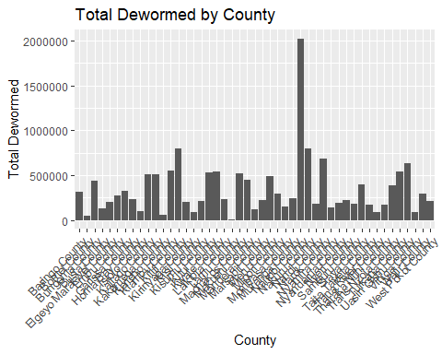

## Warning: Removed 355 rows containing missing values (`geom_point()`).

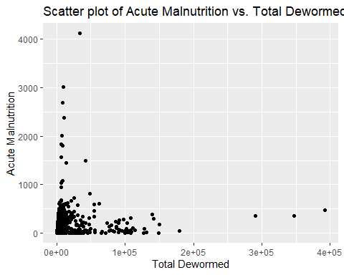

## Warning: Removed 11 rows containing non-finite values (`stat_boxplot()`).

