CTAE STANDARD 1 MASTER DOCUMENT

Computer Science Programs / Aldrin Torres 2026-2027

1.1 COURSE SYLLABI

Introduction to Software Technology / Computer Science Principles (Dual Credit)
Pathway: Computer Science Pathway
Course Description:
This yearlong course introduces students to computing, programming, and digital innovation. During Semester 1, students complete Introduction to Software Technology coursework focused on digital literacy, technology systems, web development, robotics, and programming foundations. During Semester 2, students transition into Computer Science Principles concepts through creative computing, programming, data analysis, cybersecurity, ethics, and computing impacts. Students utilize CodeHS, GitHub.dev, Micro:bit devices, and Finch robots while developing employability and technical skills necessary for future careers in technology.
System Grading Scale
- A = 90-100
- B = 80-89
- C = 70-79
- F = Below 70
Class Grading Scale
- Major Assessments = 55%
- Minor Assessments = 35%
- Practice Assignments = 10%
Career Opportunities
- Software Developer
- Web Developer
- Data Analyst
- Cybersecurity Specialist
- Computer Programmer
- Systems Analyst
- Database Administrator
- Technology Consultant
- Network Administrator
- IT Support Specialist
EOPA
- NOCTI Computer Programming Industry Certification

AP Computer Science Principles
Pathway: Computer Science Pathway
Course Description:
AP Computer Science Principles introduces students to foundational computing concepts through programming, data analysis, cybersecurity, and computational thinking. Students engage in creative problem-solving using Python, JavaScript, and project-based learning experiences. Students investigate computing innovations, analyze data, develop programs, and examine the impact of technology on society while preparing for the AP Computer Science Principles Examination.
Class Grading Scale
- Major Assessments = 55%
- Minor Assessments = 35%
- Practice Assignments = 10%
Career Opportunities
- Software Developer
- Data Scientist
- Cybersecurity Analyst
- Cloud Computing Specialist
- Artificial Intelligence Specialist
- Information Technology Specialist
- Systems Analyst
- Technology Entrepreneur
- UX/UI Designer
- Data Engineer
EOPA
- NOCTI Computer Programming Industry Certification

AP Computer Science A
Pathway: Computer Science Pathway
Course Description:
AP Computer Science A provides students with opportunities to develop object-oriented programming skills through Java programming. Students design, implement, test, and analyze software solutions while working with classes, methods, iteration, selection structures, and data collections. Students prepare for both advanced programming coursework and the AP Computer Science A Examination.
Class Grading Scale
- Major Assessments = 55%
- Minor Assessments = 35%
- Practice Assignments = 10%
Career Opportunities
- Software Engineer
- Java Developer
- Backend Developer
- Application Developer
- Computer Programmer
- Systems Analyst
- DevOps Engineer
- Database Developer
- Solutions Architect
- Software Project Manager
EOPA
- NOCTI Computer Programming Industry Certification

Game Design and Simulation
Pathway: Game Design Pathway
Course Description:
Students develop technical and creative skills through game development experiences using Unity and C#. Students design interactive media, build games, analyze gameplay systems, create user interfaces, and investigate careers within the game development industry while preparing for industry certification opportunities.
Class Grading Scale
- Major Assessments = 55%
- Minor Assessments = 35%
- Practice Assignments = 10%
Career Opportunities
- Game Developer
- Unity Developer
- Gameplay Programmer
- Game Designer
- Level Designer
- Technical Artist
- Interactive Media Designer
- XR/VR Developer
- Simulation Developer
- 3D Artist
EOPA
- Unity Certified Associate: Game Developer

1.2 COURSE PACING GUIDES

IST Semester 1
Georgia Standards
- IT-IST-1 through IT-IST-7

Unit | Timeline
Orientation & Career Exploration | Week 1
Digital Citizenship & Safety | Weeks 2-3
Technology Systems & Troubleshooting | Weeks 4-5
Programming Foundations with Micro:bit | Weeks 6-8
Web Development & UI Design | Weeks 9-10
Robotics & Automation with Finch | Weeks 11-12
Career Exploration & Capstone Project | Weeks 13-18

Major Projects
- Technology Career Research
- Micro:bit Programming Project
- Personal Website Development

FBLA Connections
- Introduction to Information Technology
- Website Coding & Development
- Coding & Programming

CSP Semester 2
Georgia Standards
- IT-CSP-1 through IT-CSP-9
Unit | Timeline
Creative Computing & Digital Artifacts | Weeks 1-2
Programming with JavaScript | Weeks 3-5
Data & Abstraction | Weeks 6-7
Internet & Cybersecurity | Weeks 8-9
Impact of Computing & Ethics | Weeks 10-11
Create Performance Task & Capstone | Weeks 12-18

Major Projects
- JavaScript Application
- Data Visualization Project
- Cybersecurity Investigation
- Computing Ethics Analysis

FBLA Connections
- Computer Problem Solving
- Coding & Programming

AP Computer Science Principles
Georgia Standards
- AP CSP Big Idea 1: Creative Development
- AP CSP Big Idea 2: Data
- AP CSP Big Idea 3: Algorithms and Programming
- AP CSP Big Idea 4: Computer Systems and Networks
- AP CSP Big Idea 5: Impact of Computing

Semester 1
Unit | Timeline
Introduction to Computing & Digital Literacy | Weeks 1–2
Programming Foundations with Python | Weeks 3–6
Algorithms & Problem Solving | Weeks 7–9
Data & Information | Weeks 10–12
Internet & Cybersecurity | Weeks 13–15
Impact of Computing & Ethics | Weeks 16–18

Semester 2
Unit | Timeline
Creative Development with Roblox & Lua | Weeks 1–5
Data Science Applications | Weeks 6–8
Advanced Programming Projects | Weeks 9–11
AP Create Performance Task Preparation | Weeks 12–14
AP Create Performance Task Submission | Weeks 15–16
AP Examination Review | Weeks 17–18

Major Projects
- Roblox Interactive Experience
- Data Science Investigation
- Computational Artifact Development
- AP Create Performance Task
- AP Exam Preparation Portfolio

FBLA Connections
- Computer Problem Solving
- Coding & Programming
- Cyber Security

AP Computer Science A
Georgia Standards
- AP Computer Science A Framework
Unit | Timeline
Using Objects and Methods | Weeks 1-7 (semester 1)
Selection and Iteration | Weeks 8-12 (semester 1)
Class Creation | Weeks 13-17 (semester 1)
Data Collections | Weeks 18-30 (semester 2)
AP Examination Review | Weeks 31-36 (semester 2)
Major Projects
- Java Fundamentals Application
- Selection and Iteration Project
- Object-Oriented Programming Project
- Data Collections Application
- AP Practice Portfolio

FBLA Connections
- Coding & Programming
- Computer Problem Solving
- Programming Concepts

Game Design and Simulation
Georgia Standards
- GDAS1 Employability Skills
- GDAS2 Introduction to the Game Industry
- GDAS3 Game Design Process
- GDAS4 Game Asset Development
- GDAS5 Programming and Game Development
- GDAS6 Testing, Debugging, and Deployment
- GDAS7 Career Development and Industry Certification

Semester 1
Unit | Timeline
Introduction to Game Design & Unity | Weeks 1-2
Programming Basics with C# | Weeks 3-5
Game Mechanics & Interactivity | Weeks 6-8
UI Design & Player Feedback | Weeks 9-10
Debugging & Optimization | Weeks 11-12
Unity Game Development Project | Weeks 13-18

Major Projects
- Unity Environment Project
- Interactive Prototype
- Gameplay Systems Project
- User Interface Design Project
- Optimization Analysis
- Original Unity Game

Semester 2

Unit | Timeline
Advanced Unity Development | Weeks 1–3
Asset Creation & Integration | Weeks 4–6
Gameplay Refinement & User Experience | Weeks 7–9
Testing, Debugging, & Optimization | Weeks 10–12
Unity Certification Preparation | Weeks 13–15
Final Game Development Project & Presentation | Weeks 16–18

Major Projects
- Digital Dopamine Game Design Document (GDD)
- Asset Library Development
- Unity Certification Practice Activities
- User Testing Report
- Final Unity Game Project
- End-of-Course Project Presentation

FBLA Connections
- Game Design
- Computer Game & Simulation Programming

1.3 FBLA STUDENT ACTIVITIES

IST/CSP

Micro:bit Smart Hall Pass System
FBLA Event: Sales Presentation
Students design and build a Micro:bit-powered hall pass system intended to streamline student movement tracking and improve school operations. Students create a prototype, prepare a product pitch, and present the solution as a technology product.
Evidence Required
- Assignment Sheet
- One Graded Student Sample
- Teacher Feedback

AP Computer Science Principles

What's the Odds? Powerball vs. Bitcoin Mining
FBLA Event: Computer Problem Solving
Students investigated and compared the probability of winning the Powerball lottery versus successfully mining Bitcoin. Students researched the problem, gathered supporting information, analyzed the mathematics required for comparison, explored probability concepts, and followed a design-thinking process to develop a proposed software solution before implementation.
Evidence Required
- One Graded Student Sample
- Teacher Feedback
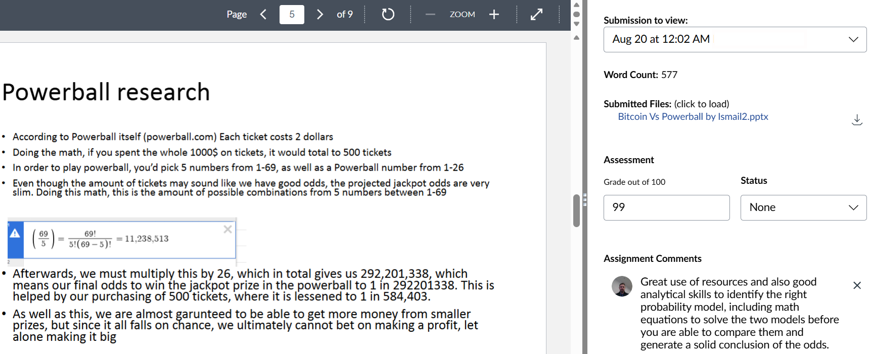

AP Computer Science A

Technology Leadership Speaking Challenge
FBLA Event: Impromptu Speaking
Students receive a technology topic, are given twenty minutes to prepare, and deliver a five-to-seven-minute speech demonstrating communication, leadership, and technical understanding.
Evidence Required
- One Graded Student Sample
- Teacher Feedback

Game Design and Simulation

Environment and Emotional Design Analysis
Students evaluate how environmental design, audio, storytelling, color theory, level design, and gameplay mechanics affect player engagement and overall user experience.
Evidence Required
- Assignment Sheet
- One Graded Student Sample
- Teacher Feedback
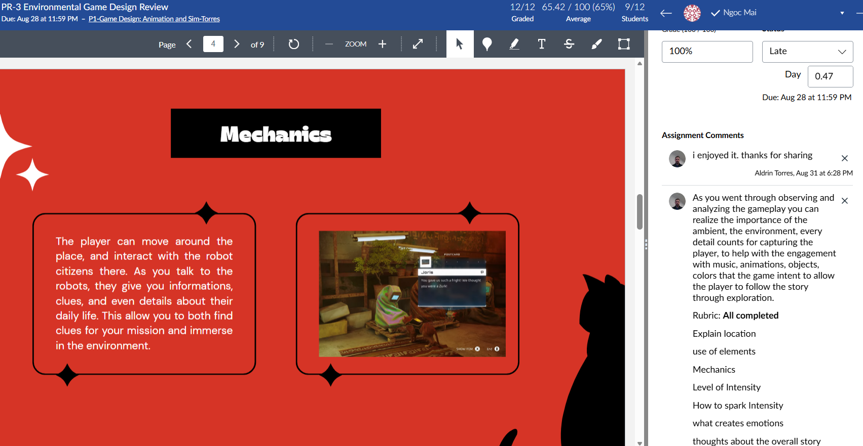

1.5 LONG-TERM PROJECTS

Program Theme

Digital Wellness, Human Behavior, and Technology

Computer Science Pathway

Digital Wellness Analytics Platform
Community Partner: Neuroscience & Psychology Club
Students develop a web-based analytics platform that investigates the relationship between technology usage habits and student wellness. Students create anonymous survey instruments, collect voluntary anonymous survey data, organize and analyze datasets, develop visualizations, and publish findings through an interactive website dashboard.

Deliverables
- Project Proposal
- Anonymous Survey Instrument
- Dataset
- Data Analysis Report
- Interactive Website Dashboard
- Final Presentation

Total Time
23 Hours

Industry Skills
- Data Collection
- Data Cleaning
- Data Visualization
- Front-End Web Development
- User Experience Design
- Software Testing
- Project Documentation

Game Design Pathway

Digital Dopamine: Understanding Technology Through Interactive Play
Community Partner: Neuroscience & Psychology Club
Students develop a lightweight 2D Unity educational game that demonstrates how technology habits influence focus, attention, reward systems, habit formation, and digital wellness. The game emphasizes simple assets, scene transitions, educational gameplay mechanics, and accessibility within school hardware constraints.

Deliverables
- Game Design Document
- Storyboard
- Asset Library
- Playable Unity Prototype
- Testing Report
- Final Presentation

Total Time
22 Hours

Industry Skills
- Game Design
- Unity Development
- C# Programming
- User Interface Design
- Debugging
- Asset Management
- Interactive Storytelling

