CHALLA SATHVIKA
2400032790

Step 1: Initialize repository

Step 2: Add and commit files
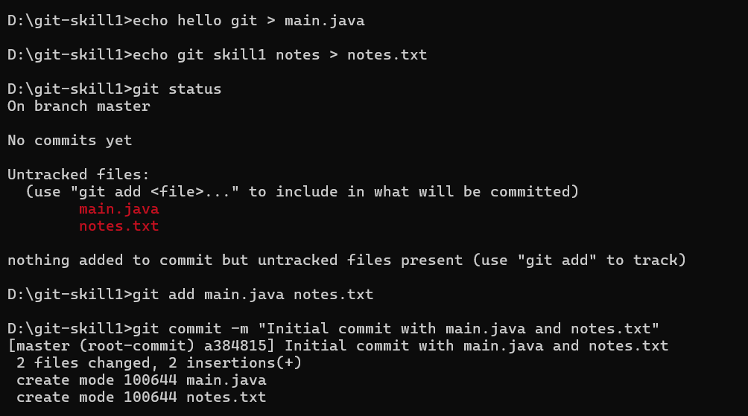
step 3: git status


step 4:pushing the files into git
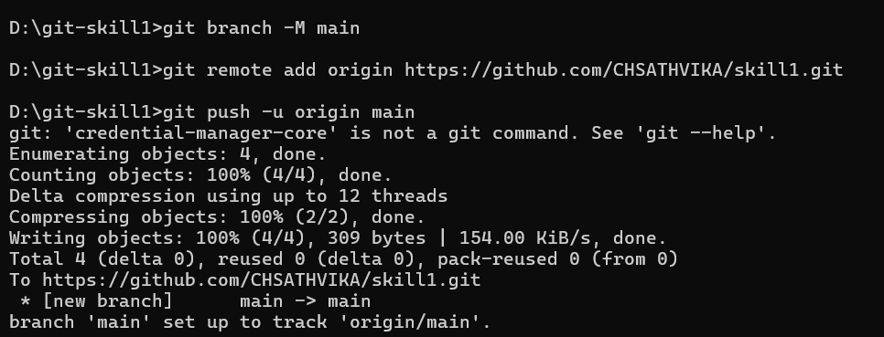

step 5: Create first branch and commit
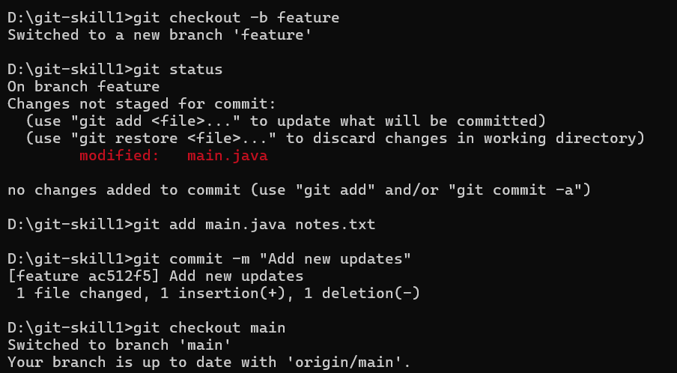

step 6: Create second branch and commit
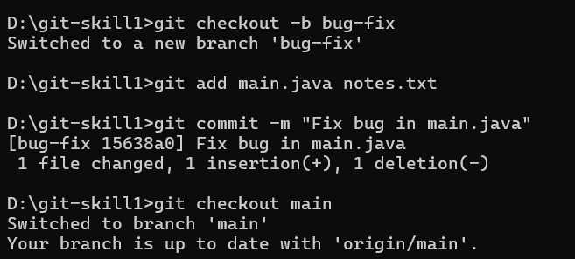

step 7:merging the branches
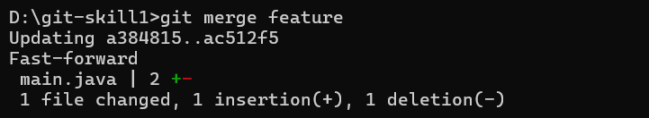
step 8: Conflict resolution
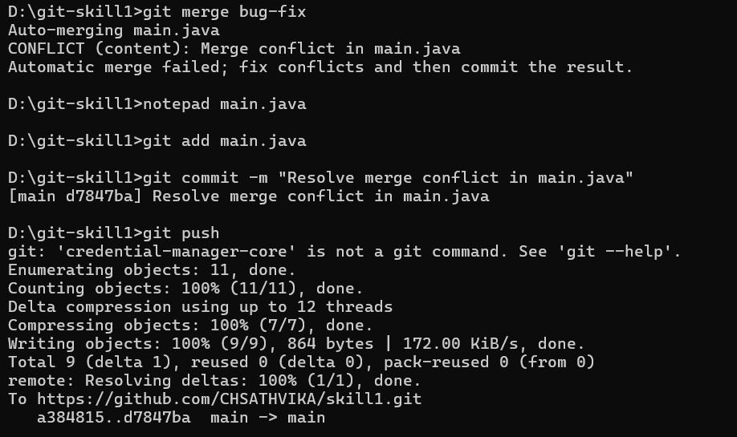
Step 9: all commits and merges
