CHALLA SATHVIKA
2400032790
SKILL-4 OUTPUT SCREENSHOTS
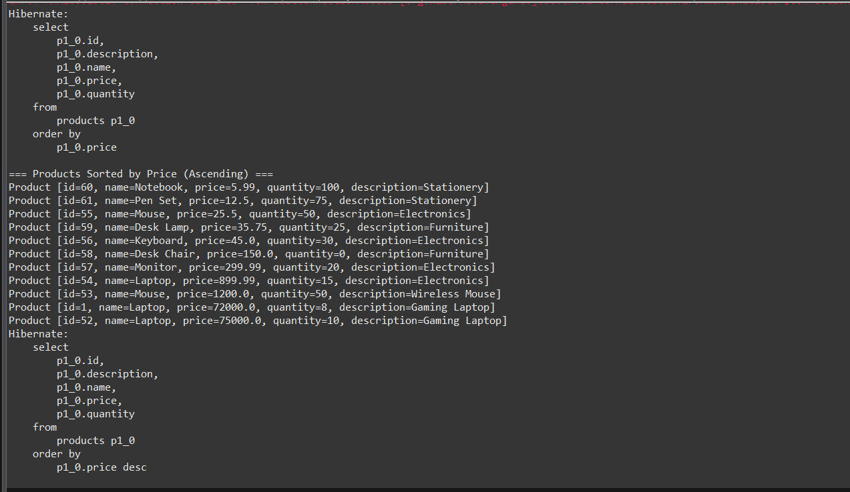

=== Products Sorted by Price (Descending) ===
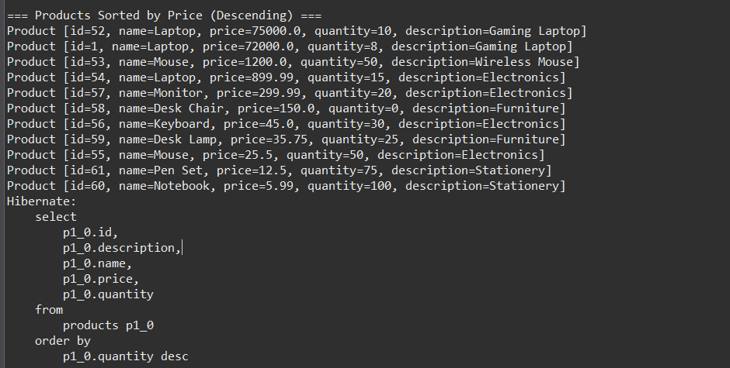

=== Products Sorted by Quantity (Highest First) ===\
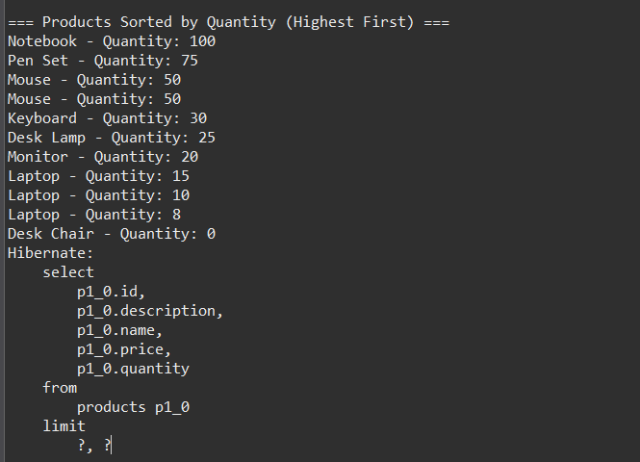
=== First 3 Products ===
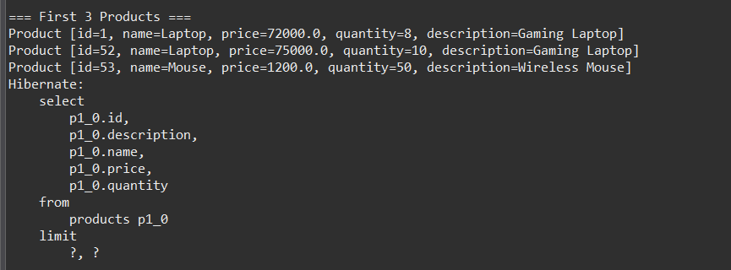

=== Next 3 Products ===
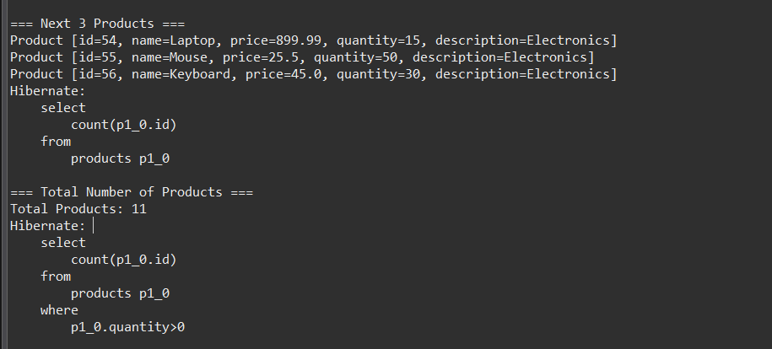

=== Total Number of Products ===
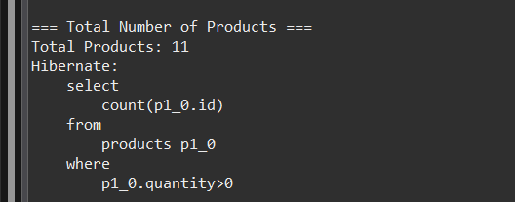

=== Products in Stock (Quantity > 0) === and === Products Grouped by Description ===
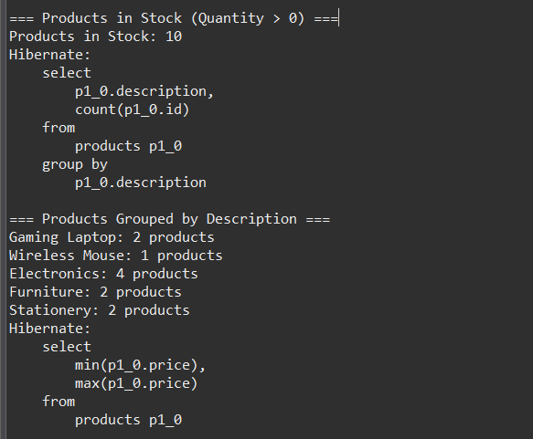

=== Price Range ===
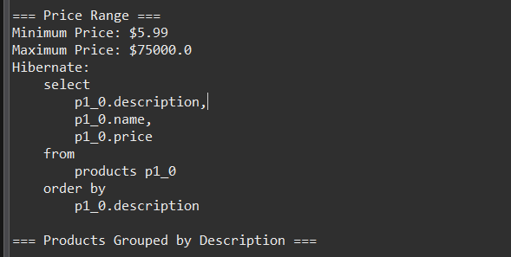

=== Products Grouped by Description ===
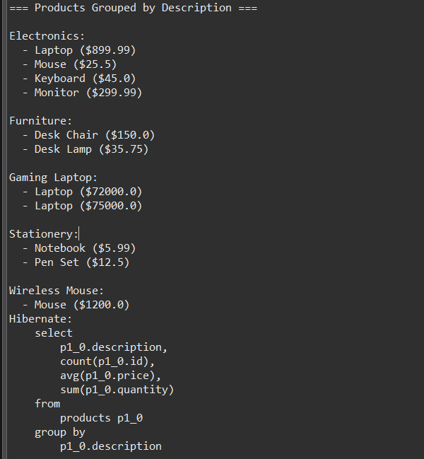

=== Product Statistics by Category ===
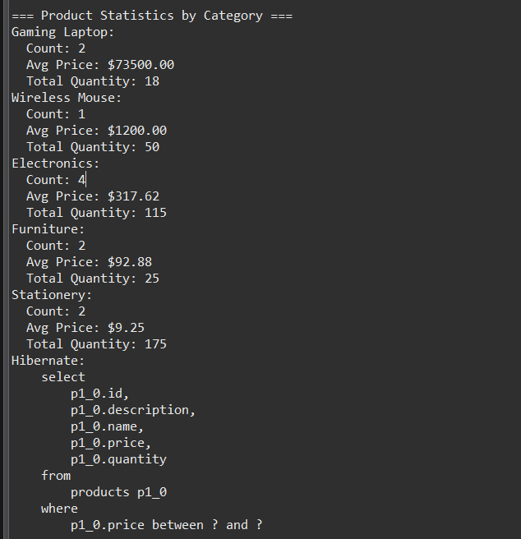

== Products Between $20.0 and $100.0 === and === Products Starting with 'D' ===
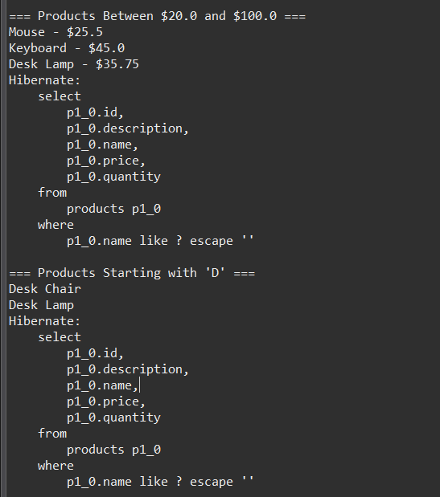

=== Products Ending with 'p' === and === Products Containing 'Desk' === and === Products with Name Length 5 ===
