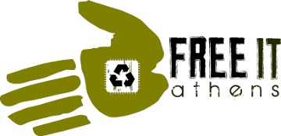Free I.T. Athens (FRITA) is a group of like-minded citizens who realize that computers are a necessary component of everyday life. We believe that everyone deserves access to low-cost computer equipment and computer-related services. Our goal is to provide access to information technology resources to Athens-Clarke County residents and organizations. We also aim to create well informed advocates in free software and open information technology.