**Final Year Project – 1 Report**

**Title**

**Roshan Kisan**

**Submitted by**

* Ali Hamza (004)
* Mutti Ullah (022)

**Supervisor**

* Dr. Salma

**Supervisor’s Designation**

DEPARTMENT OF ENGINEERING TECHNOLOGY

INFORMATION ENGINEERING TECHNOLOGY PROGRAM  
FOUNDATION UNIVERSITY SCHOOL OF SCIENCES AND TECHNOLOGY

FUSST

December 2023

**Table of Content**

Chapter # 01

Introduction

* Main Objectives

Chapter # 02

Literature Review

Chapter # 03

Methodology

* Application Development tools
* Model Approach
* ER-Diagram
* Gantt Chart

Chapter # 04

Design

* GUI
* Flowchart
* Use Case diagram

Chapter # 05

Conclusion

**Chapter No . 01**

**Introduction**

Step into the future of farming with "RoshanKisan," where technology meets the soil in a game-changing initiative. The heart of this venture? The 'Crop Doctor,' a crucial component of our project that harnesses the power of artificial intelligence (AI) and machine learning. This isn't just about farming; it's about transforming the way crops are grown, making it smarter, sustainable, and more prosperous.

In a world where technology is reshaping industries, agriculture is no exception. 'Crop Doctor' is our superhero, armed with high-tech tools, ready to revolutionize crop management. By seamlessly blending cutting-edge technology with the wisdom of traditional farming methods, we're not just farming; we're cultivating a community that thrives while significantly boosting crop output.

The challenges farmers face today are vast, from the constant threat of crop diseases to the unpredictable dance of weather patterns. "RoshanKisan" steps up to these challenges, aiming to reduce stress, enhance productivity, and foster a healthy farming community. We're on a mission to empower farmers, bridging the gap between what they know and the latest technological breakthroughs.

But it's not just about flashy gadgets; it's about creating a future for farmers that is resilient, sustainable, and lucrative. "RoshanKisan" is more than a project; it's a movement towards making agriculture easier, smarter, and more connected in this digital era.

* **Main Objectives:**

**Tech Integration:**

Infuse advanced technology through 'Crop Doctor' tools to make crop management efficient.

**Sustainable Farming:**

Promote practices that are not only good for the crops but also for the environment and farmers.

**Community Thriving:**

Build a strong farming community through shared knowledge, interaction, and support.

**Enhanced Productivity**:

Utilize smart tech to overcome challenges, leading to a significant increase in crop output.

**Knowledge Empowerment:**

Bridge the gap between traditional farming wisdom and the latest technological advancements.

**Resilient and Profitable Future:**

Shape a future for farmers that is resilient, sustainable, and economically rewarding.

**Chapter No . 02**

**Chapter No . 03**

**Chapter No . 04**

**Design**

**|**

**GUI Graphical user interface**

The GUI will be going to look like this

Launching Screen

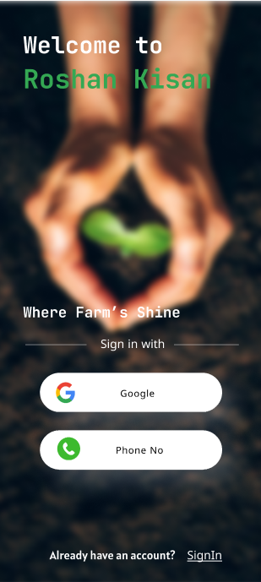

Authentication Screen

Language Selection

Home Screen

Community

Crop Doctor

**Design**

**|**

**Use Case Diagram**

**Actors:**

* Guest
* Registered User
* AI

**Use Cases:**

* User Registration & Authentication
* Crop Doctor
* Weather Alert / Weather Information
* Chatbot

**Relationships:**

**Guest**: Can view weather information and interact with the chatbot.

**Registered User**: Can register and authenticate with the app, access the crop doctor, and receive weather alerts.

**Crop Doctor**: Can diagnose crop diseases and provide solutions.

**Weather Alert / Weather Information**: Can provide weather information and alerts to registered users.

**Chatbot**: Can interact with users and provide information and assistance.

**Detailed Description of Use Cases:**

User Registration & Authentication: Users can register for an account or authenticate their existing account. Registered users have access to more features, such as the crop doctor and weather alerts.

Crop Doctor: Users can upload images of their crops to the crop doctor for diagnosis. The crop doctor will identify the disease and provide solutions.

Weather Alert / Weather Information: Registered users can receive weather alerts and view weather information for their location.

Chatbot: Users can interact with the chatbot to get information and assistance. The chatbot can answer questions about the app, provide information about agriculture, and help users with tasks such as finding crop prices and ordering supplies.

Example Use Cases:

Guest: A guest user views the weather information for Rawalpindi, Pakistan.

Registered User:

A registered user uploads an image of their crops to the crop doctor for diagnosis. The crop doctor identifies the disease as leaf blight and provides solutions.

Registered User:

A registered user receives a weather alert for a thunderstorm in Rawalpindi, Pakistan.

Registered User:

A registered user asks the chatbot how to plant tomatoes. The chatbot provides instructions on how to plant tomatoes, including information on soil preparation, spacing, and watering.

**Design**

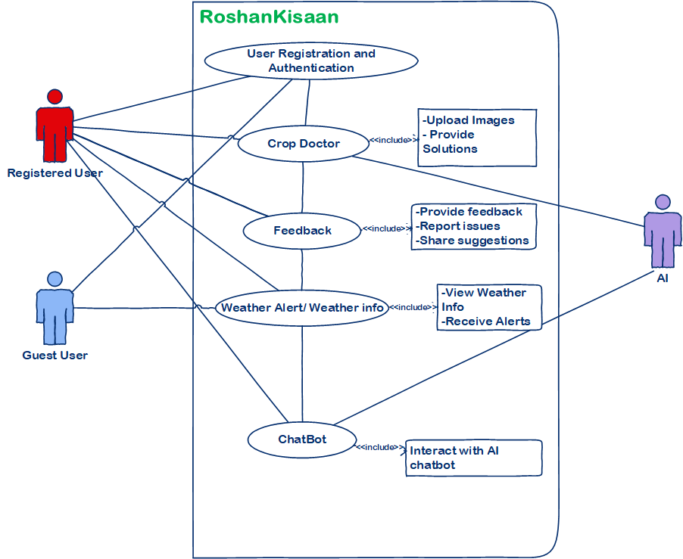

**Flowchart**