MATLAB Homework 4

學號 : B10901163 姓名 : 張顥譽

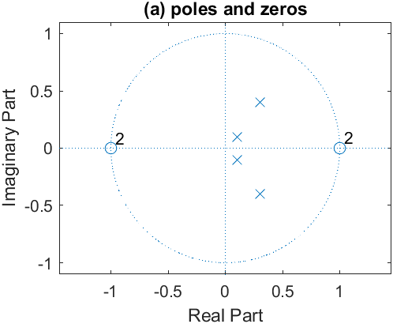

ROC : |z|>0.5

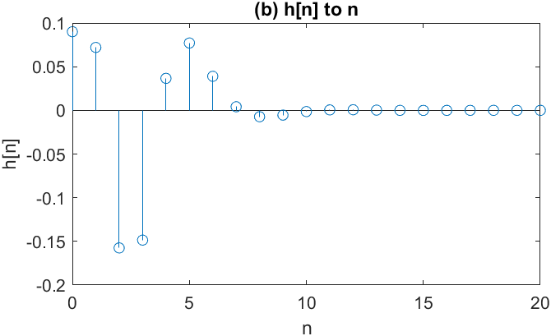

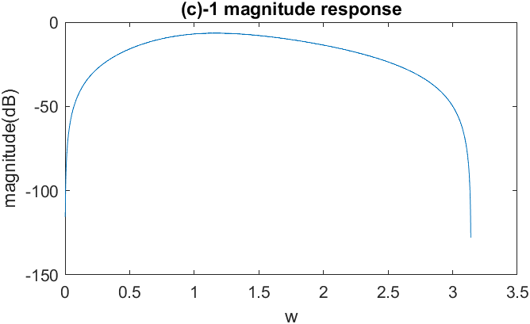

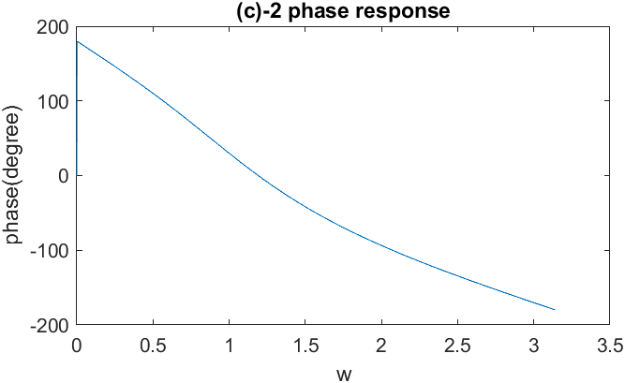

(d) $${H\left(z\right)=H}_{1}\left(z\right)H_{2}\left(z\right)$$

$$H_{1}\left(z\right)=\frac{0.09+0.18z^{-1}+0.09z^{-2}}{1-0.2z^{-1}+0.02z^{-2}}$$

$$H_{2}\left(z\right)=\frac{1-2z^{-1}+z^{-2}}{1-0.6z^{-1}+0.25z^{-2}}$$

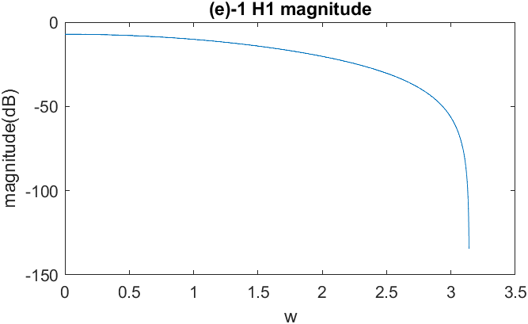

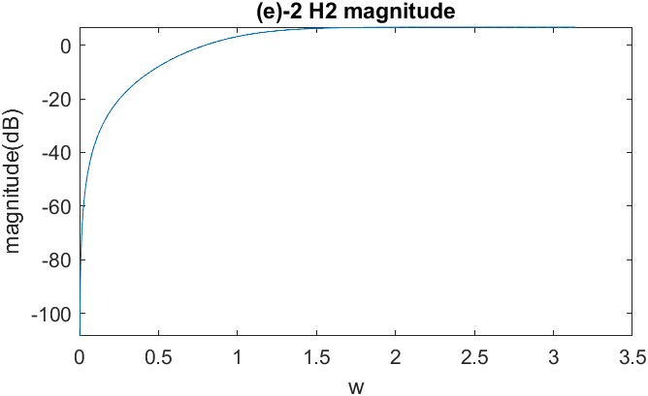

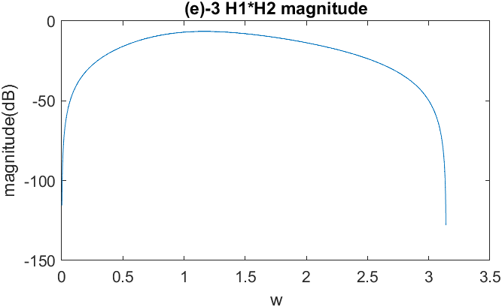

The result of |H1(z)||H2(z)| is the same as the result in (c), because

|H(z)| = |H1(z)·H2(z)| = |H1(z)||H2(z)|

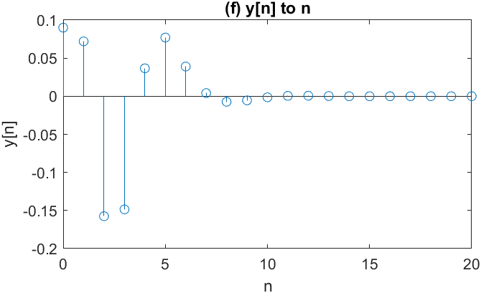

The result of y[n] is the same as the result of (b) because

y[n] = δ(n) \* h[n]

Y(z) = 1\*H[z] = H[z]

y[n] = h[n]