**Homework 1** (10%)

CSE 5120 (Section 01) – Introduction to Artificial Intelligence – Fall 2024

*Submitted to*

Department of Computer Science and Engineering  
California State University, San Bernardino, California

*by*

Cameron Hartling(007735059)

Date: September 29, 2024

Email:

* 007735059@coyote.csusb.edu

**Report**

I worked alone for this homework. In the program homework_1_search.py, I implemented four search algorithms to find a route from San Bernardino to Los Angeles. The search algorithms I used were Depth First Search, Breadth First Search, Uniform Cost Search, and A* Search.

1. **Depth First Search**

The Depth First Search algorithm uses a Last In First Out storage method. The LIFO storage method is achieved with a Stack. This allows the DFS algorithm to add all the child nodes to the storage and move through the tree by expanding the deepest nodes first.

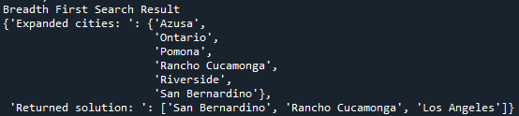

1. **Breadth First Search**

The Breadth First Search algorithm uses a First In First Out storage method. The FIFO storage method is achieved with a Queue. This allows the BFS algorithm to add all the child nodes to the storage and move through the tree by expanding the shallowest nodes first.

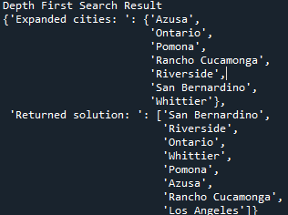

1. **Uniform Cost Search**

The Uniform Cost Search algorithm expands the node that is the cheapest. This is achieved with a PriorityQueue. The weights in the form of the g(n) function are used to determine the cheapest route. The algorithm uses The weights at line 139 to keep a tally of the total cost to get to each node. Once this value is put into the PriorityQueue, the next node to be chosen is determined by the lowest of the costs of the visited nodes.

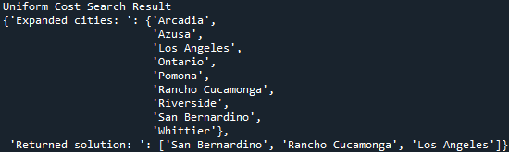

1. **A* Search**

The A* Search algorithm is similar to the Uniform Cost Search algorithm other than it uses the sum of the weight, g(n), and the heuristic, h(n) to determine the next node to expand. In line 171 and 172, the cost of the neighbor and the cost with the heuristic are calculated. It is then inserted into the PriorityQueue to be expanded when it has the lowest sum of its cost and heuristic.

