# Client – Server / *UDP*

## Registrierung am Server [Aktiv]

|  |  |
| --- | --- |
| **Server** | **Client** |
| |  |  | | --- | --- | | 🡨 ConnectClient | | | Username | **UserXY** | | SessionID | **Null** | | MessageNr | **0** | |  |
|  | |  |  | | --- | --- | | OperationStatus 🡪 | | | Username | UserXY | | SessionID | {Guid} | | MessageNr | 1 | |
| |  |  | | --- | --- | | 🡨 StartGame | | | SessionID | {Guid} | | MessageNr | 2 | |  |
|  | |  |  | | --- | --- | | Question 🡪 | | | NumberA | 50 | | NumberB | 50 | | Operator | Plus | | SessionId | {Guid} | | MessageNr | 3 | |

## Fragenablauf Client / Server [Aktiv]

|  |  |
| --- | --- |
| **Server** | **Client** |
|  | |  |  | | --- | --- | | Question 🡪 | | | NumberA | 50 | | NumberB | 50 | | Operator | Plus | | SessionId | {Guid} | | MessageNr | {3} | |
| |  |  | | --- | --- | | 🡨 Answer | | | AnswerContent | 100 | | SessionID | {Guid} | | MessageNr | 4 | |  |
| *Bei fehlender Antwort:* |  |
|  | |  |  | | --- | --- | | Question 🡪 | | | NumberA | 20 | | NumberB | 40 | | Operator | Minus | | SessionId | {Guid} | | MessageNr | 4/5 | |
| *Bei Spielende:* |  |
|  | |  |  | | --- | --- | | EndGame 🡪 | | | GameCount | 20 | | GamePlaySeconds | 40 | | Points | Minus | | Username | UserXy | | MessageNr | {6} | |

## Registrierung am Server [Passiv]

|  |  |  |
| --- | --- | --- |
| **Client** | **Server[Passiv]** | **Server[Aktiv]** |
|  | |  |  | | --- | --- | | ConnectClient 🡪 | | | Username | **UserXY** | | SessionID | **Null** | | MessageNr | **-** | | Reconnect Endpoint | **{Connection Endpoint}** | |  |
|  |  | |  |  | | --- | --- | | TunnelMessage 🡪 | | | SessionID | **{Guid]** | | MessageNr | **-** | | Content | |  |  | | --- | --- | | ConnectClient 🡪 | | | Username | **UserXY** | | SessionID | **Null** | | MessageNr | **-** | | Reconnect Endpoint | **{Connection Endpoint}** | | |
| |  |  | | --- | --- | | 🡨 ConnectClient | | | Username | **UserXY** | | SessionID | **Null** | | MessageNr | **-** | | Reconnect Endpoint | **{Connection Endpoint}** | |  |  |

# Server – Server / *TCP*

|  |  |
| --- | --- |
| **Server A [Client Connector]** | **Server B [Server Listener]** |
|  | |  |  | | --- | --- | | ConnectServer 🡪 | | | SessionID | null | | MessageNr | - | |
| |  |  | | --- | --- | | 🡨 ConnectServer | | | SessionID | {Guid} | | MessageNr | - | |  |
|  | |  |  | | --- | --- | | SyncMessage 🡪 | | | SessionID | {Guid} | | MessageNr | - | | RandomNr | {RandomNr X} | | ServerStartTime | {DateTime A} | |
| |  |  | | --- | --- | | 🡨 SyncMessage | | | SessionID | {Guid} | | MessageNr | - | | RandomNr | {RandomNr Y} | | ServerStartTime | {DateTime B} | |  |
| **Connection Synced – Connection Keep Alive (Heartbeat)** | |
|  | |  |  | | --- | --- | | Heartbeat 🡪 | | | SessionID | null | | MessageNr | - | | CheckToken | {RandomNr} | |
| |  |  | | --- | --- | | 🡨 ConnectServer | | | SessionID | {Guid} | | MessageNr | - | | CheckToken | {RandomNr} | |  |
| *Nach Erfolgreichen Verbindungssync: (Server Aktiv an Passiv)* | |
|  | |  |  | | --- | --- | | Merge 🡪 | | | SessionID | null | | GameClientList | List<GameClient> | | HighScoreList | List<HighScoreItem> | |

# MonitorClient – Server / *TCP*

|  |  |
| --- | --- |
| **Monitor** | **Server** |
|  | |  |  | | --- | --- | | ConnectMonitor🡪 | | | SessionID | null | | MessageNr | - | |
| |  |  | | --- | --- | | 🡨 OperationStatus | | | SessionID | {Guid} | | MessageNr | - | | Status | [OK/ERROR] | | Message | {StatusMessage] | |  |
| |  |  | | --- | --- | | 🡨 LogMessage | | | SessionID | {Guid} | | MessageNr | - | | Date | {DateTime} | | Message | MessageXY | | Type | LogMessageType | |  |
| |  |  | | --- | --- | | 🡨 LogProtocolMessage | | | SessionID | {Guid} | | MessageNr | - | | IsOutgoing | True/false | | ProtocollMessage | {CalcItMessage} | |  |

# Protokoll

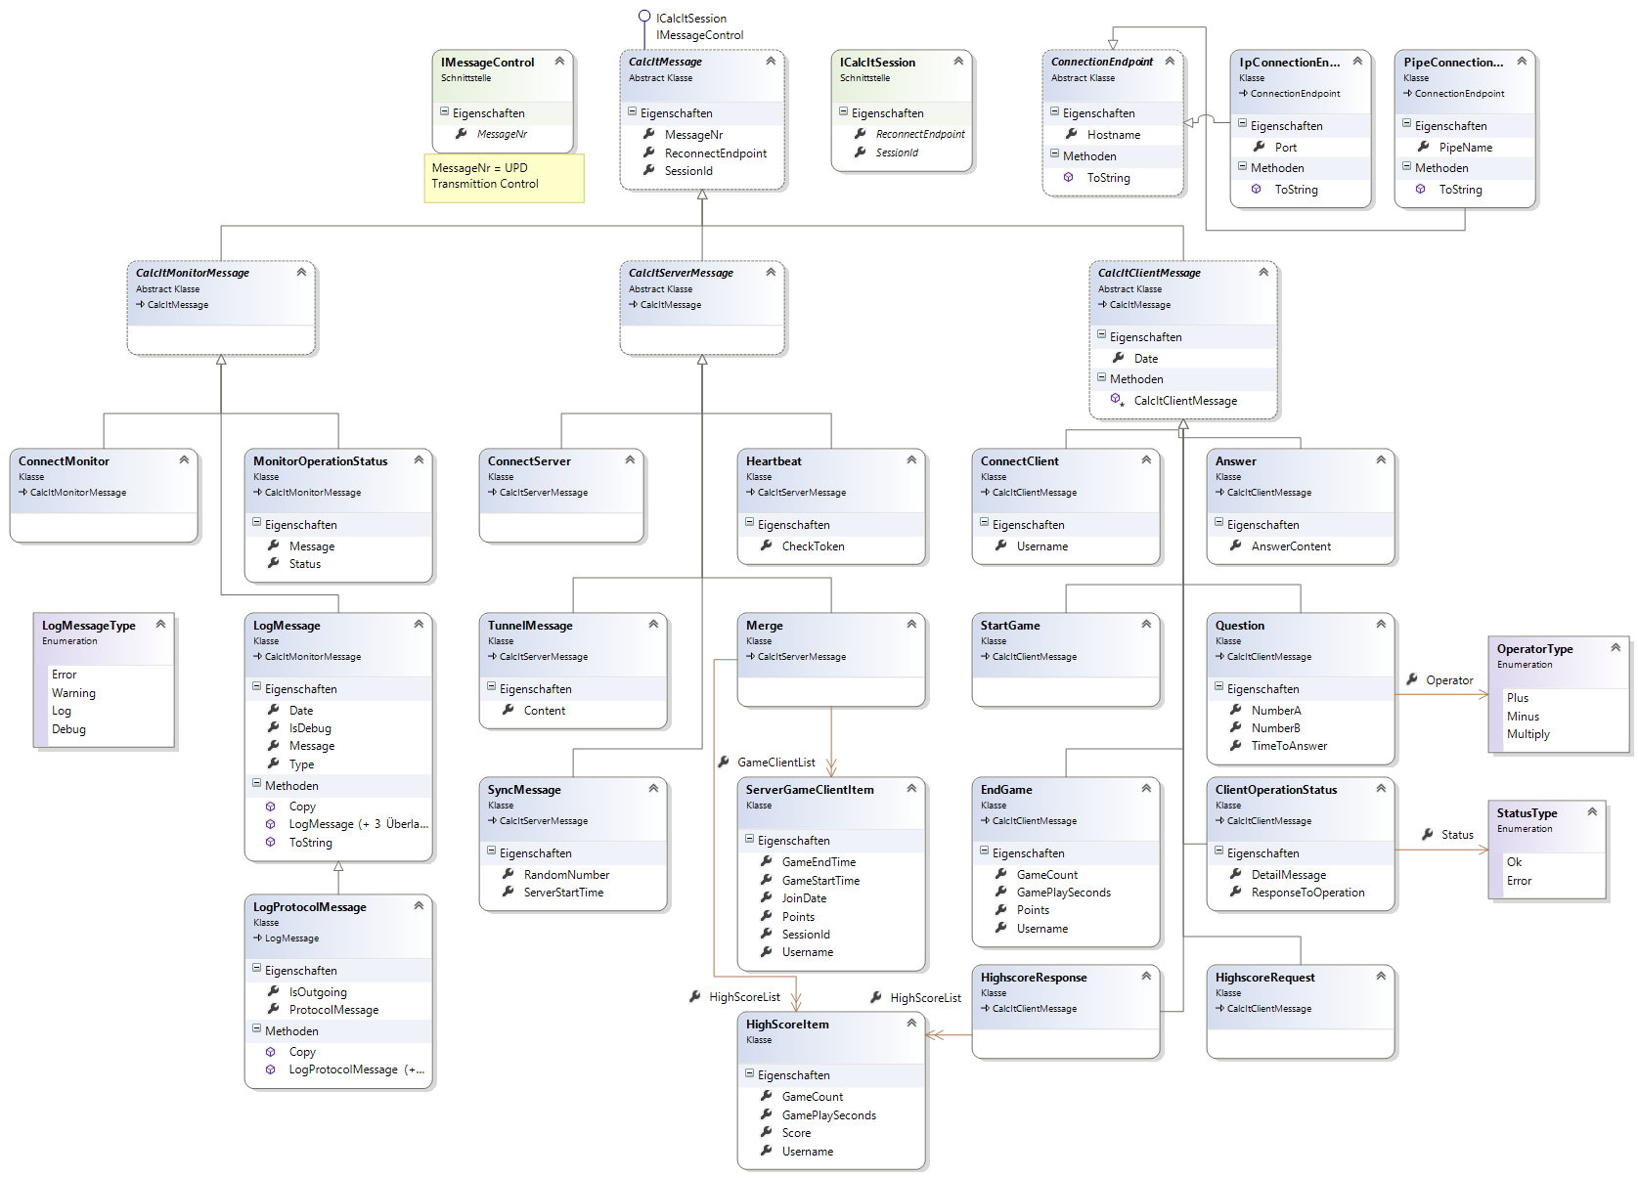

# Übertragung: DataContractSerializer/XML

## CalcIT Implementierung „Transformer“

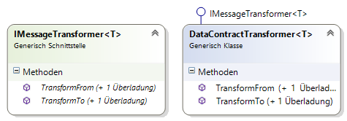

## DataContract Aufbau – Basis Message

[DataContract]

[KnownType(typeof(CalcItClientMessage))]

[KnownType(typeof(CalcItMonitorMessage))]

public abstract class CalcItMessage : ICalcItSession, IMessageControl

{

/// <summary>

/// Gets or sets the message nr.

/// </summary>

/// <value>

/// The message nr.

/// </value>

[DataMember]

public int MessageNr { get; set; }

/// <summary>

/// Gets or sets the session endpoint.

/// </summary>

/// <value>

/// The reconnect endpoint.

/// </value>

[DataMember]

public ConnectionEndpoint ReconnectEndpoint { get; set; }

/// <summary>

/// Gets or sets the session id.

/// </summary>

/// <value>

/// The session identifier.

/// </value>

[DataMember]

public Guid? SessionId { get; set; }

}