RetriFlow Tika Sample
This DOCX sample validates heading, paragraph, table, and embedded-image extraction.
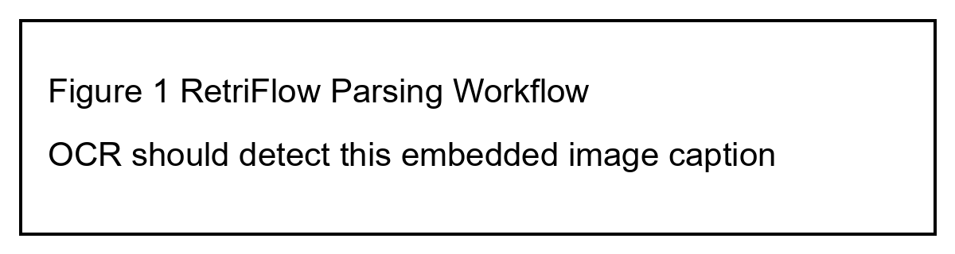
图1 RetriFlow document parsing overview
Field | Value
Owner | RetriFlow

