CprE 381, Computer Organization and

Assembly-Level Programming

Lab 2 Report

Student Name _Caleb Hemmestad__________________________

Submit a typeset pdf version of this on Canvas by the due date. Refer to the highlighted language in the lab document for the context of the following questions.

[Part 2 (a)] Draw the interface description for the MIPS register file. Which ports do you think are necessary, and how wide (in bits) do they need to be?

The data in and both the data out’s should be 32 bits wide. Rs, rt, and rd should all be five bits wide. Rst, Clk, and En should be only one bit.

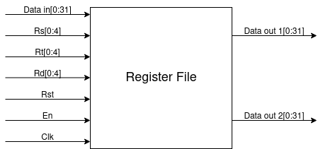
[Part 2 (b)] Create an N-bit register using this flip-flop as your basis.

Done.

[Part 2 (c)] Waveform.

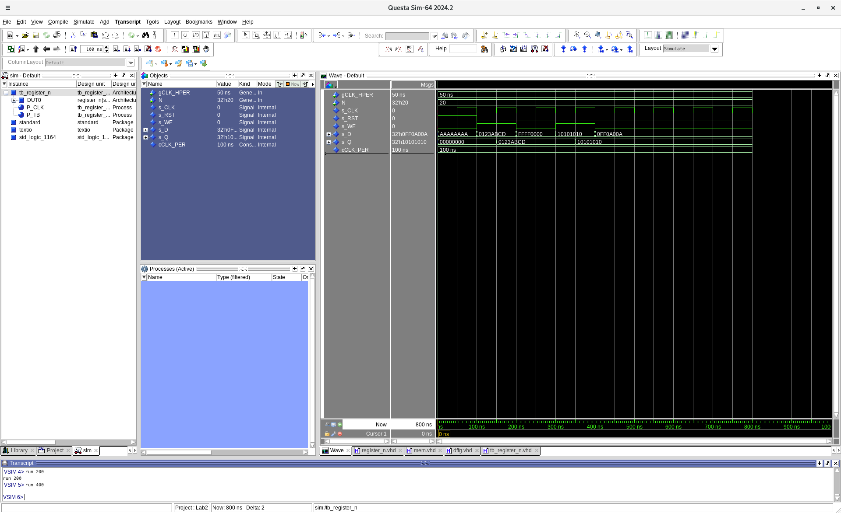
[Part 2 (d)] What type of decoder would be required by the MIPS register file and why?
It would need to be a 5:32 decoder because there will be 32 registers to select from and log2(32) = 5 which means you would need five select bits for that many options.

[Part 2 (e)] Waveform.

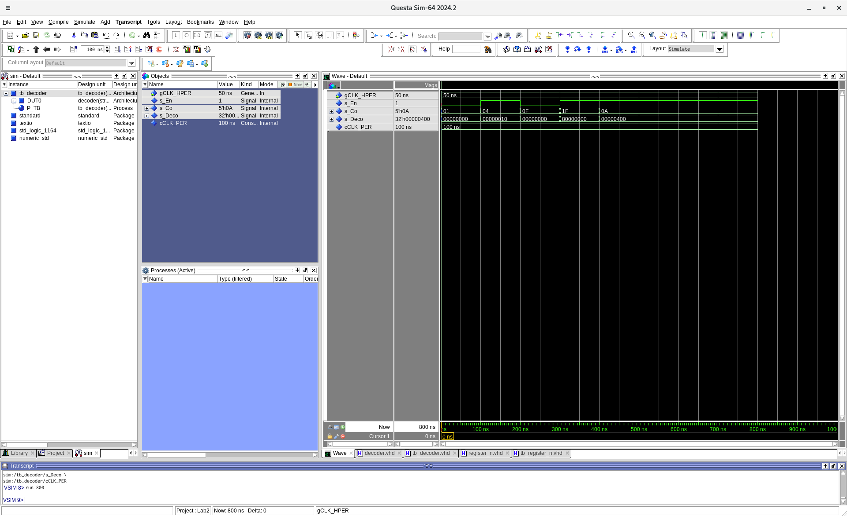
[Part 2 (f)] In your write-up, describe and defend the design you intend on implementing for the next part.

For my design I am using a dataflow approach because it will be easier and faster to implement for a multiplexer this large.

[Part 2 (g)] Waveform.

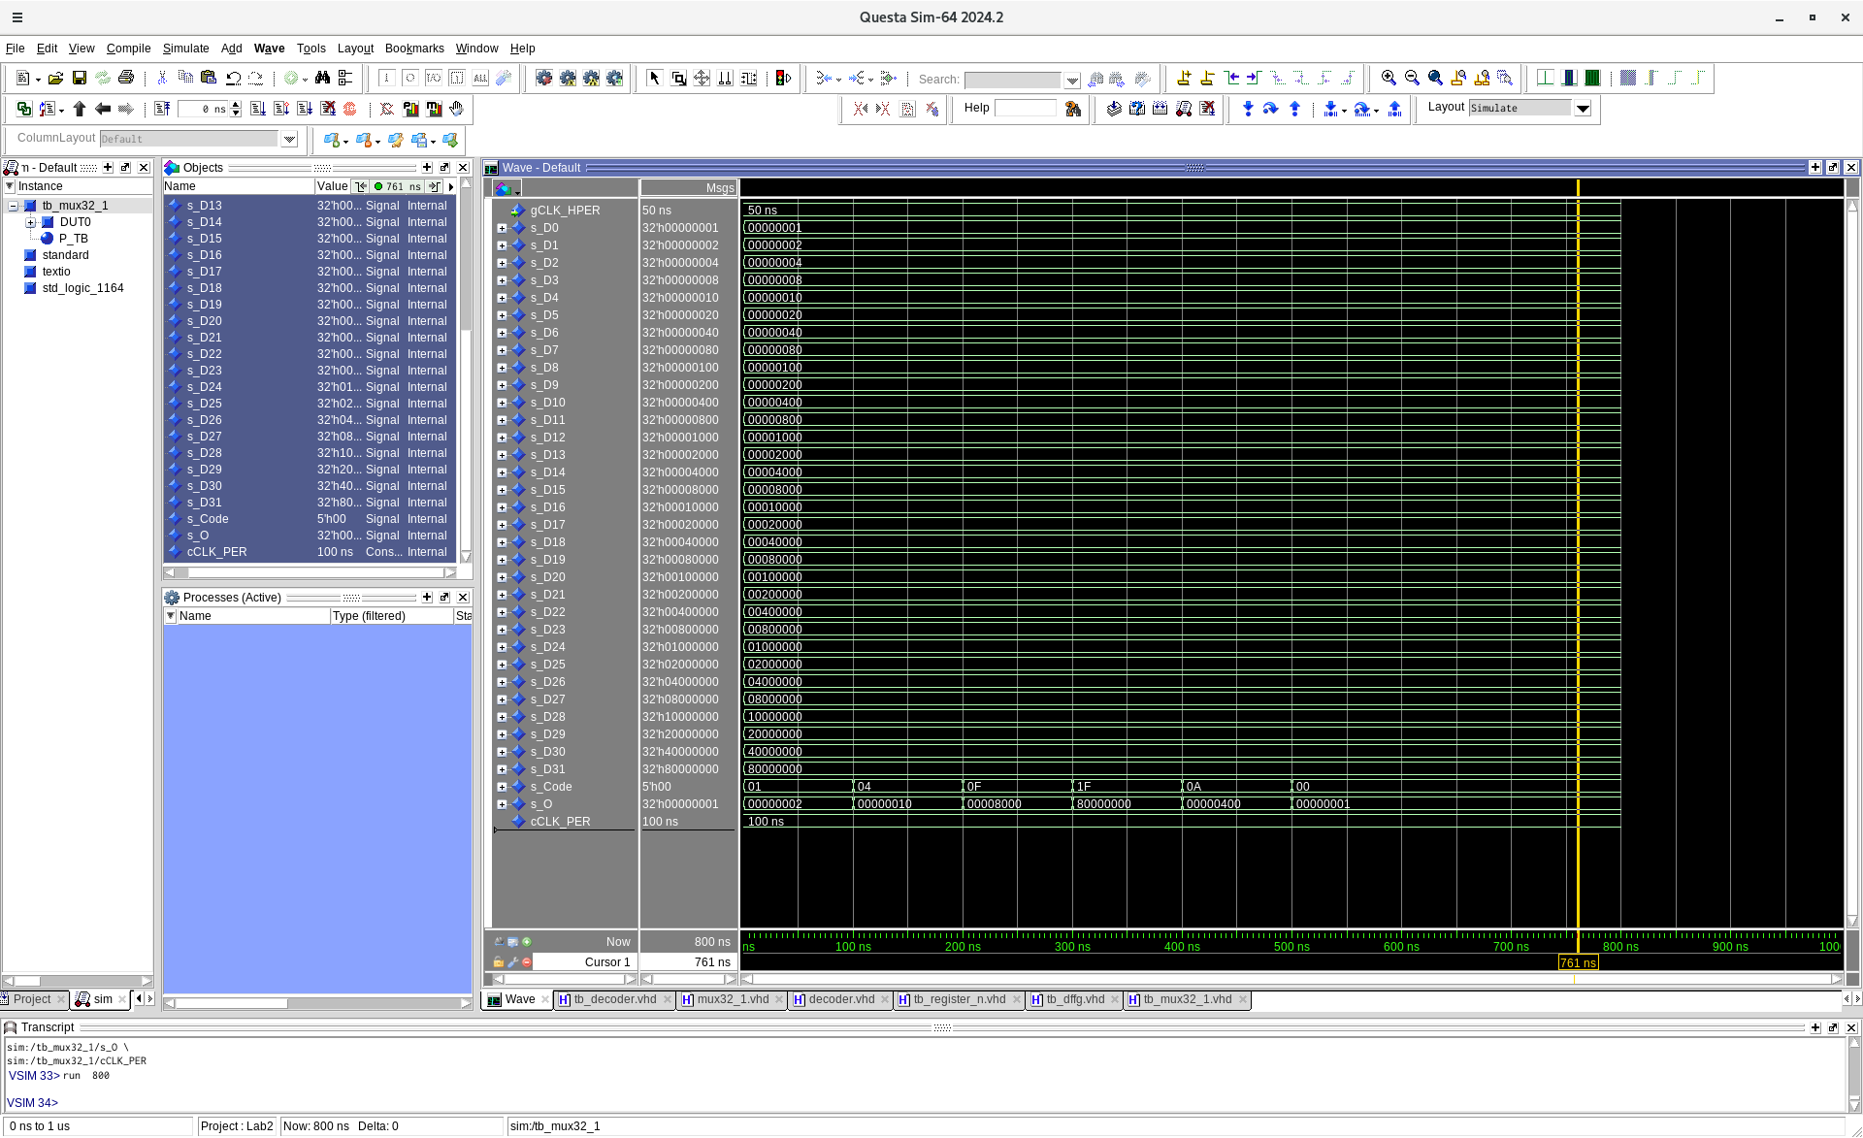
[Part 2 (h)] Draw a (simplified) schematic for the MIPS register file, using the same top-level interface ports as in your solution describe above and using only the register, decoder, and mux VHDL components you have created.
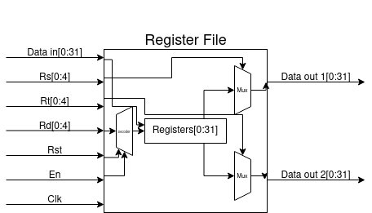

[Part 2 (i)] Waveform.
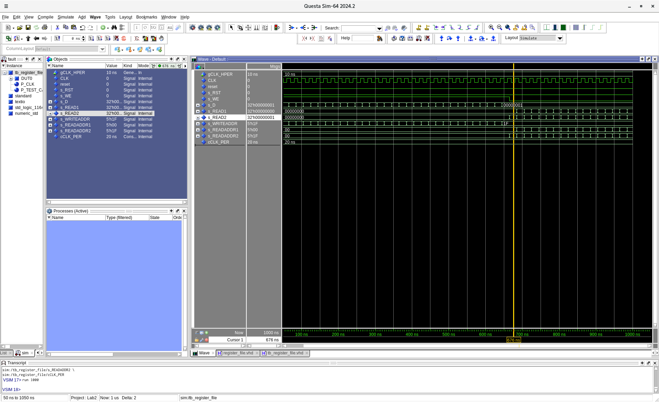
[Part 3 (b)] Draw a symbol for this MIPS-like datapath.

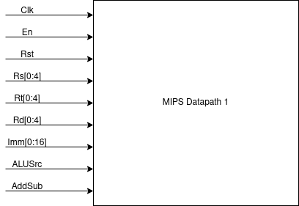

[Part 3 (c)] Draw a schematic of the simplified MIPS processor datapath consisting only of the component described in part (a) and the register file from problem (1).
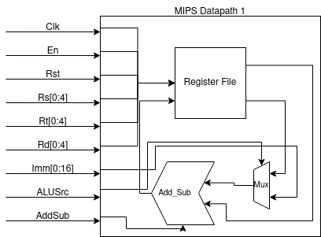

[Part 3 (d)] Include in your report waveform screenshots that demonstrate your properly functioning design. Annotate what the final register file state should be.

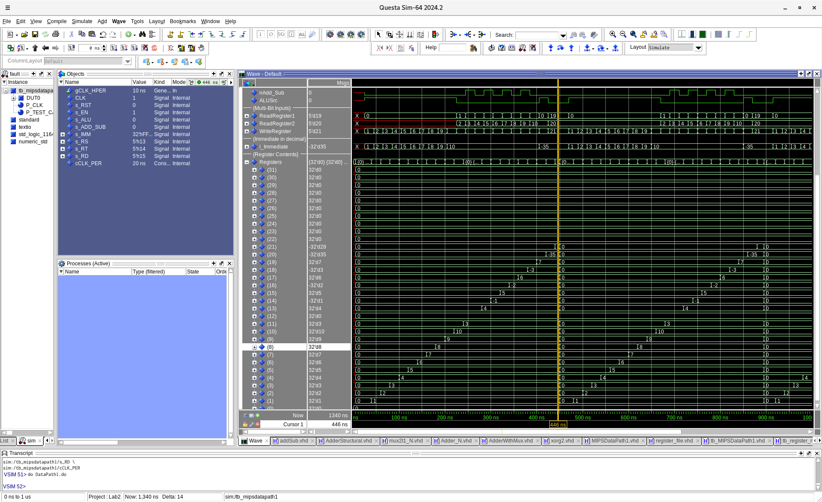
The file registers should be as follows:
$0 = 0
$1 = 1
$2 = 2
$3 = 3
$4 = 4
$5 = 5
$6 = 6
$7 = 7
$8 = 8
$9 = 9
$10 = 10
$11 = 3
$12 = 0
$13 = 4
$14 = -1
$15 = 5
$16 = -2
$17 = 6
$18 = -3
$19 = 7
$20 = -35
$21 = -28
$22 = 0
$23 = 0
$24 = 0
$25 = 0
$26 = 0
$27 = 0
$28 = 0
$29 = 0
$30 = 0
$31 = 0

[Part 4 (a)] Read through the mem.vhd file, and based on your understanding of the VHDL implementation, provide a 2-3 sentence description of each of the individual ports (both generic and regular).

Data width is for how wide the data that is being used is and then Addr width is for how wide the memory address is. Clk is for the clock to load and store data. Addr is for the address value to know where to load and read the data from. We is for enabling read or write. Q is for the output when reading the data.

[Part 4 (c)] Waveforms.
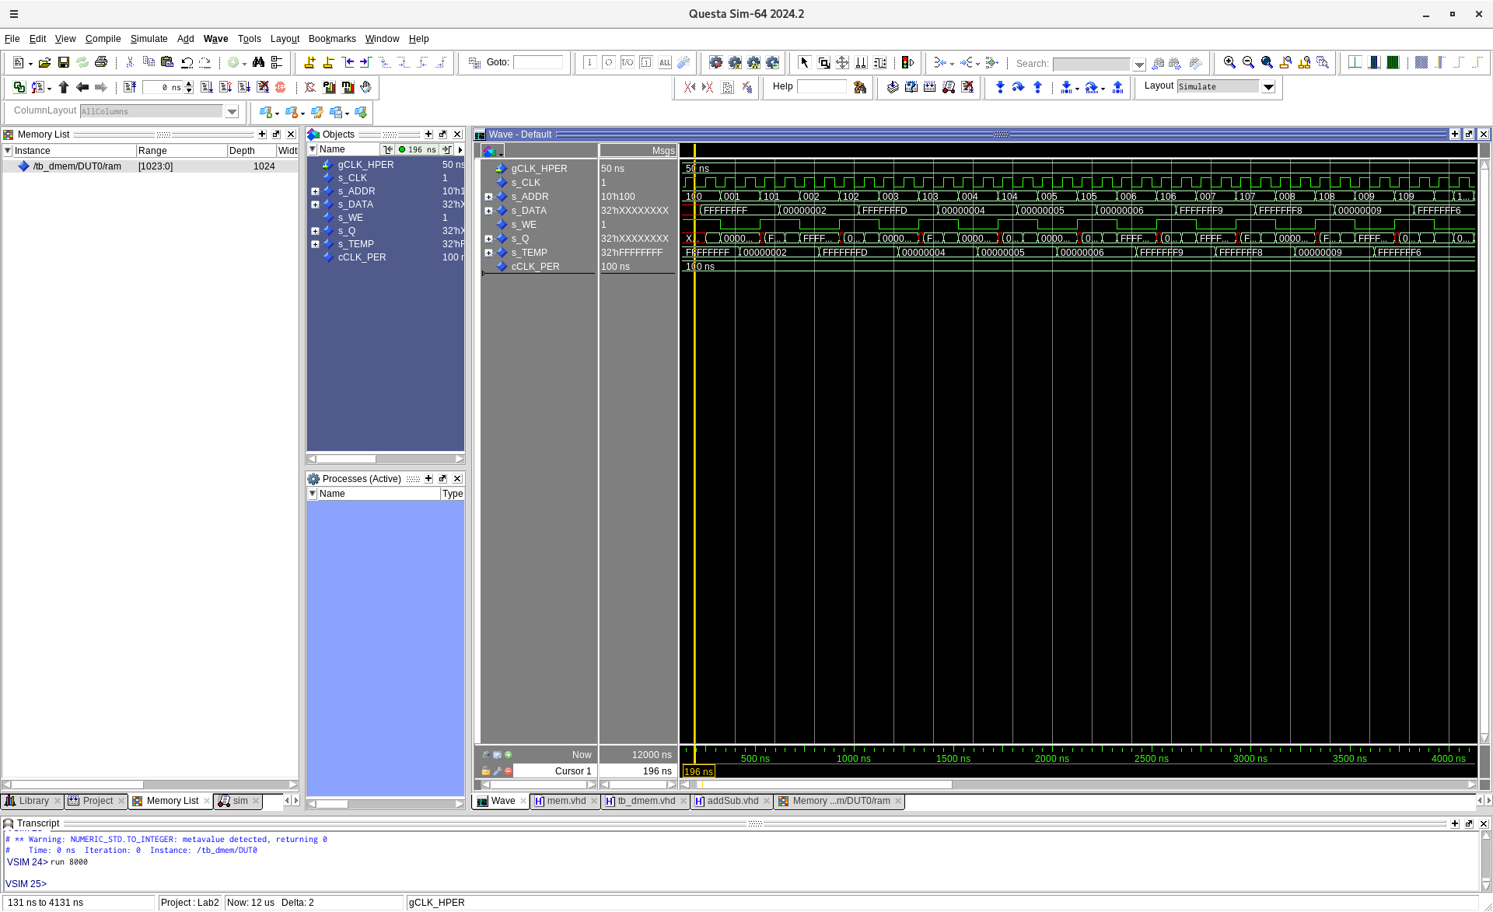
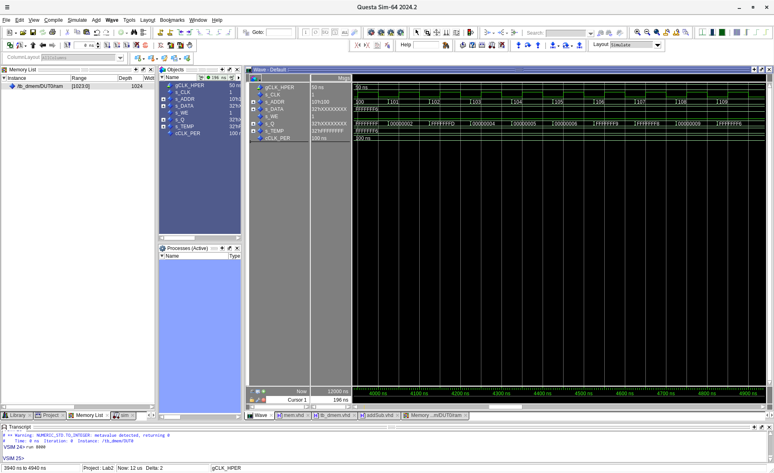
[Part 5 (a)] What are the MIPS instructions that require some value to be sign extended? What are the MIPS instructions that require some value to be zero extended?

Some instructions that require it to be extended are sltiu, stli, addiu, and addi and then some instructions that would be required to be zero extended are andi and ori.

[Part 5 (b)] what are the different 16-bit to 32-bit “extender” components that would be required by a MIPS processor implementation?

We would need one for the two add instructions and another for the less than instructions. Then you would need one for the load word instruction and another for the store word instruction.

[Part 5 (d)] Waveform.

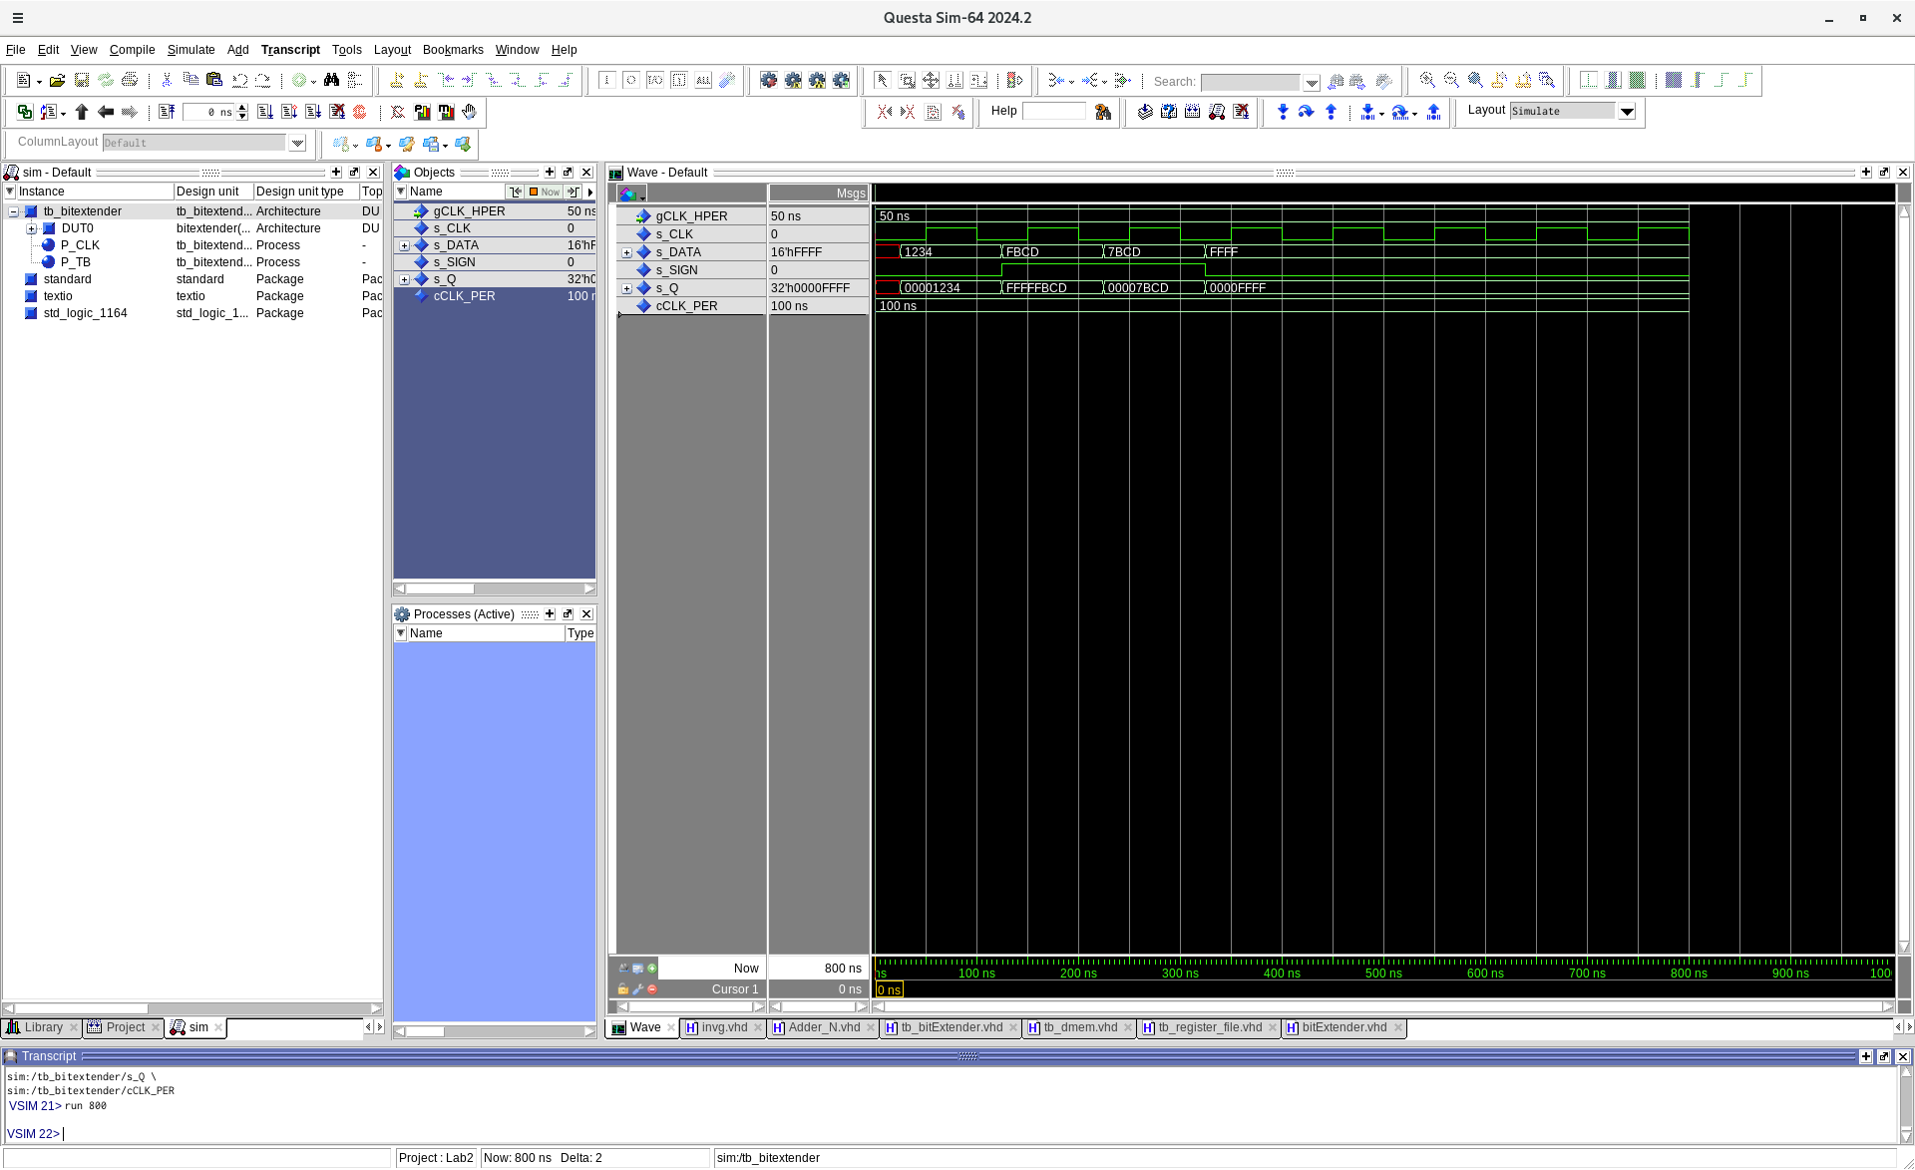

[Part 6 (a)] what control signals will need to be added to the simple processor from part 2? How do these control signals correspond to the ports on the mem.vhd component analyzed in part 3?

There will need to be an enable signal for writing to the memory and then another signal for reading from the memory.

[Part 6 (b)] Draw a schematic of a simplified MIPS processor consisting only of the base components used in part 2, the extender component described in part 4, and the data memory from part 3.

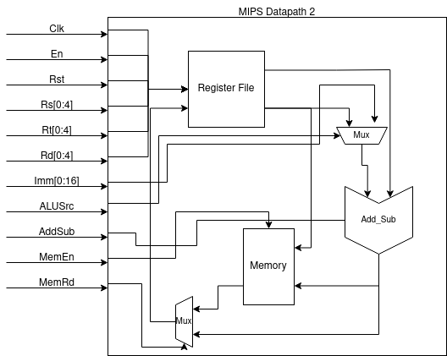
Extender

[Part 6 (c)] Waveform.

