1050 Programming Logic
Lab 3 (20 points total)

Name: Christopher Herbert

Paste your code and screenshots below.

- Compare and contrast the if single-selection statement and the while repetition statement. How are these two statements similar? How are they different? (2 Points).

While repetition statements are used to repeat something, If statements are used based something that is true, if the statement is true that it will go on to other statements to execute. The similarities are they both have data output and both follow a sequence of steps. The difference is how it is executed.

- Declare two int variables: 1) speedLimit and 2) speed. Assign values speedLimit=35 and speed=42. Write an if statement that displays “SLOW NOW” if speed is greater than speedLimit. (2 points)

int SpeedLimit = 35;
int Speed = 42;

if (Speed >= 35)
Console.WriteLine("SLOW NOW");

- if-else statement - Write a program that declares and assigns a value to a Boolean variable called isTrue. Use a condition to output “It is True!” or “It is False!” based on the assigned value. Paste your code and screenshots of your program running with both true and false values (3 points).
{
bool istrue = true;

if (istrue)
{
Console.WriteLine("it is true!");
}

}

{
bool istrue = true;

if (istrue)
{
Console.WriteLine("it is true!");
}

}
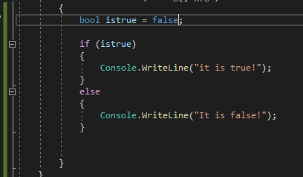
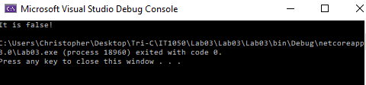
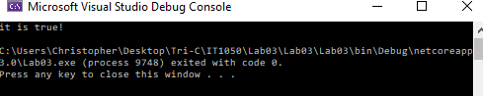

- if statement - Write a program that converts a Fahrenheit temperature to Celsius. The user should be able to input the temperature at the Command prompt and it should output the temperature. In addition, you should output “It is cold” if the Fahrenheit value is less that 40 or it should output “It is hot” if the temperature is over 90 (4 points). Code to read a value: double fahrenheit = Convert.ToDouble(Console.ReadLine()); Code to convert: celsius = (fahrenheit - 32d) * 5d / 9d;

double celsius;
Console.Write("Enter Fahrenheit temperature : ");
double fahrenheit = Convert.ToDouble(Console.ReadLine());
celsius = (fahrenheit - 32) * 5 / 9;
Console.WriteLine("The converted Celsius temperature is " + celsius);
if (fahrenheit > 90)

{ Console.WriteLine("It is hot!"); }

if (fahrenheit < 40)
{ Console.WriteLine("It is cold!"); }

Console.ReadLine();

- Write a while loop that outputs values 1-10. Increment by 1 (3 points).
int i = 1;
while (i < 11)
{
Console.WriteLine(i);
i++;

- Write a while loop that outputs values 60 to 20. Decrement by 1 (3 points)

int i = 60;
while (i > 19)
{
Console.WriteLine(i);
--i;

- Create a while that outputs values 10-20 (3 points).
int i = 10;
while (i < 21)
{
Console.WriteLine(i);
i++;

