Sarawak Tun Openg University of Technology (SOTECH)
IT PROJECT 2 REPORT
CHAPTERS 1–6
Web-Based Preorder and Freshness Management System for Home-Based Entrepreneurs
Christopher Hansen
Student ID: 2402081406
Supervisor
Ms. Nur Elana Binti Mohd Saferinor
2026

ABSTRACT
Home-based food businesses need an accessible way to coordinate preorders, dated ingredients, customer choices and handover. This project implements a single-vendor web application for Wrap & Bowl Kuch, a home-based business in Kuching, Sarawak. React provides customer and staff interfaces, Django enforces the application rules and PostgreSQL stores accepted orders, stock and evidence. Client feedback refined the system to a name/phone passkey account, morning delivery or collection, area-based delivery fees and a simpler actual-receipt workflow without required cooking-task planning.
Customers can browse a branded eight-menu catalogue, use optional explainable recommendations and a whole-basket date/quantity/budget finder, review their basket and submit QR/bank-transfer evidence or delivery cash. Placement captures accepted names, prices, recipes and packaging, then allocates eligible ingredients and packaging transactionally. Owners maintain documented shelf-life and storage evidence, review private payment proof separately from food receipt, print daily/order summaries and inspect sales, cost and contribution information. FreshCast remains separate decision support with explicitly identified local and external data boundaries.
Fresh verification at source 6edde5e ran 1,046 backend tests: 970 passed and 76 were skipped, comprising PostgreSQL-dependent and optional real-model checks. Thirty-seven local release/runtime checks and selected frontend suites, lint and build also passed. Retained browser evidence supports selected responsive, account, recovery and stock behaviours. These are developer verification results, not actual bank transactions, food-safety measurements or a completed user study. Informal client feedback informed development; editable client acceptance and student usability instruments are supplied for the formal evaluation still to be collected.

TABLE OF CONTENTS
CHAPTER 1 1
1.1 INTRODUCTION 1
1.2 PROBLEM STATEMENTS 2
1.3 OBJECTIVES 3
1.4 SCOPE 3
1.5 REVENUE MODEL 4
1.6 METHODOLOGY 5
1.7 GANTT CHART 5
1.8 SOFTWARE TOOLS 5
1.9 CONCLUSION 6
CHAPTER 2 7
2.1 INTRODUCTION 7
2.2 BACKGROUND STUDY 8
2.3 METHODOLOGY 14
2.4 TECHNOLOGY 16
2.5 IMPLEMENTATION IMPLICATIONS 17
CHAPTER 3 19
3.1 INTRODUCTION 19
3.2 ITERATIVE DEVELOPMENT AND REQUIREMENT REFINEMENT 19
3.3 USE CASE DIAGRAMS 20
3.4 USE CASE SPECIFICATIONS 22
3.5 ACTIVITY DIAGRAMS 30
3.6 SEQUENCE DIAGRAMS 34
3.7 CLASS DIAGRAM 39
3.8 ENTITY–RELATIONSHIP DIAGRAMS 39
3.9 REQUIREMENT TRACEABILITY AND DESIGN LIMITS 47
3.10 CONCLUSION 47
CHAPTER 4 48
4.1 INTRODUCTION 48
4.2 APPLICATION ARCHITECTURE AND TECHNOLOGY 48
4.3 CLIENT REQUIREMENTS AND DEVELOPMENT ITERATIONS 50
4.4 CUSTOMER INTERFACES 51
4.5 OWNER INTERFACES 62
4.6 CORE CALCULATIONS AND TRANSACTION RULES 73
4.7 FRESHCAST AND SUPPORTING DECISION TOOLS 75
4.8 REMINDERS, SECURITY AND DEPLOYMENT 76
4.9 INTERFACE AND ACCESSIBILITY DECISIONS 77
4.10 CONCLUSION 78
CHAPTER 5 79
5.1 INTRODUCTION 79
5.2 TESTING STRATEGY AND ENVIRONMENT 79
5.3 DECISION TABLES AND BOUNDARIES 81
5.4 EXECUTED FUNCTIONAL AND SECURITY CASES 83
5.5 CURRENT REGRESSION RESULTS 87
5.6 BROWSER FINDINGS, DEFECTS AND RETESTING 87
5.7 FORECAST EVALUATION AND DATA LIMITS 89
5.8 EVALUATION AGAINST THE UNCHANGED OBJECTIVES 90
5.9 CLIENT AND CUSTOMER EVALUATION PLAN 90
5.10 DISCUSSION IN RELATION TO THE LITERATURE 92
5.11 CONCLUSION 92
CHAPTER 6 94
6.1 INTRODUCTION 94
6.2 ACHIEVEMENT OF THE ORIGINAL OBJECTIVES 94
6.3 DEVELOPMENT CHALLENGES AND RESPONSES 96
6.4 STRENGTHS OF THE IMPLEMENTED SYSTEM 98
6.5 LIMITATIONS 98
6.6 PRIORITISED FUTURE WORK 99
6.7 HANDOVER AND MAINTENANCE 100
6.8 CONCLUSION 100
REFERENCES 102
APPENDIX A — SUPERVISOR CONSULTATION RECORD 106
APPENDIX B — ORIGINALITY / SIMILARITY RECORD 106
APPENDIX C — DECLARATION OF INTEGRITY 107
APPENDIX D — CURRENT APPLICATION DATA DICTIONARY 108
APPENDIX E — CLIENT FOLLOW-UP AND ACCEPTANCE FORM 125
APPENDIX F — STUDENT CUSTOMER-USABILITY QUESTIONNAIRE 128
APPENDIX G — IMPLEMENTATION AND TEST EVIDENCE MAP 131
APPENDIX H — SHORT OWNER OPERATING GUIDE 135
LIST OF FIGURES
Figure 1.1: Original IT Project 1 proposal Gantt chart (retained; not an actual completion log). 5
Figure 2.1: Original literature map retained from IT Project 1. 7
Figure 3.1: Customer use cases for the current storefront and account workflow. 21
Figure 3.2: Owner/staff use cases for stock, orders, reporting and configuration. 22
Figure 3.3: Checkout validation and atomic ingredient/packaging allocation. 31
Figure 3.4: Batch date evidence, validation and stock eligibility. 32
Figure 3.5: Packaging receipts, menu mappings and placement deductions. 33
Figure 3.6: Separate payment review and actual customer receipt. 34
Figure 3.7: Customer passkey registration. 35
Figure 3.8: Authentication using a saved customer passkey. 35
Figure 3.9: Authoritative pricing, scoped evidence and transactional placement. 36
Figure 3.10: Private evidence review and manual payment recording. 37
Figure 3.11: Daily/sales reporting and read-only order-slip preview. 38
Figure 3.12: Authenticated, bounded owner handover reminder processing. 39
Figure 3.13: Selected core domain classes and their associations. 41
Figure 3.14: Identity, customer profile and passkey records. 42
Figure 3.15: Catalogue, recipe, batch and inventory-log relationships. 43
Figure 3.16: Accepted order terms, private proof and ingredient allocation. 44
Figure 3.17: Current and accepted packaging requirements and stock movements. 45
Figure 3.18: Payment, amendment, expense and wastage evidence. 46
Figure 4.1: Current customer/staff application architecture and external boundaries. 49
Figure 4.2: Founder-story page using the client-supplied business introduction (local developer capture). 52
Figure 4.3: Client menu, category filters and food cards with illustrative images. 53
Figure 4.4: Ordinary phone-viewport menu capture with compact cards and basket access. 54
Figure 4.5: Customer name/phone and passkey account dialog (ordinary phone capture). 55
Figure 4.6: Separate kitchen staff sign-in and explicit customer-account return control. 56
Figure 4.7: Date/quantity/budget finder and its one-menu versus mixed choice. 57
Figure 4.8: Basket quantities and optional item details without duplicate delivery forms. 58
Figure 4.9: Checkout offered-day guidance, upcoming date shortcuts and minute-based time selection. 59
Figure 4.10: Checkout receipt-evidence state and enabled placement controls (synthetic local proof). 61
Figure 4.11: Customer order confirmation with separate food-receipt and payment states. 62
Figure 4.12: Inventory overview with ingredient filters, recorded status and batch actions. 63
Figure 4.13: Batch evidence form with conditional date inputs and a planning-deadline preview. 64
Figure 4.14: Aligned stock-target controls and totals across the offered menus. 65
Figure 4.15: Packaging stock balance and actions for current menu supplies. 66
Figure 4.16: Packaging-assignment dialog with per-selling-unit quantities and aligned controls. 66
Figure 4.17: Owner order queue with receipt groups, filters and deliberate per-order actions. 67
Figure 4.18: Payment-review dialog showing proof, amount and payment history. 68
Figure 4.19: Daily order/menu-unit summary for kitchen work. 69
Figure 4.20: Order-slip print preview; an A4 preview is intentionally different from a web-page viewport. 70
Figure 4.21: Sales overview with date filtering and separate food/delivery values. 71
Figure 4.22: Read-only price/bulk-offer scenario and progressively disclosed cost records. 72
Figure 4.23: Section-based kitchen settings with explicit save scope. 73
Figure 4.24: Compact public recorded-stock counts with an optional date-based average explanation. 74
Figure 4.25: Owner email configuration/status and optional execution details. 76
LIST OF TABLES
Table 2.1: Summary of findings on Malaysian online food delivery consumer behaviour. 8
Table 2.2: Research areas, focus and identified gaps retained from the proposal. 11
Table 2.3: Proposal-stage feature comparison; provider features/regions may change. 13
Table 2.4: Agile and traditional comparison, adapted from the original proposal summary (Islam & Ferworn, 2020). 14
Table 2.5: Comparison of development dimensions, adapted from the proposal’s Leau et al. (2012) summary. 15
Table 3.1: Client-led design changes and their consequences 20
Table 4.1: Technology responsibilities in the current implementation 50
Table 4.2: Representative development problems and implemented responses 51
Table 4.3: Illustrative date calculation using explicit evidence 74
Table 5.1: Verification environment and interpretation 80
Table 5.2: Account eligibility and authentication decisions 81
Table 5.3: Current handover and payment decisions 81
Table 5.4: Stock allocation and history decisions 82
Table 5.5: Date evidence and recommendation boundaries 82
Table 5.6: Executed functional cases TC-01–TC-05 83
Table 5.7: Executed functional cases TC-06–TC-10 84
Table 5.8: Executed functional cases TC-11–TC-15 84
Table 5.9: Executed functional cases TC-16–TC-20 85
Table 5.10: Executed functional cases TC-21–TC-25 86
Table 5.11: Executed functional cases TC-26–TC-26 86
Table 5.12: Fresh verification summary at source 6edde5e 87
Table 5.13: Representative defects, corrections and observed retests 88
Table 5.14: Objective evidence and remaining validation 90
Table 6.1: Limitations and their practical implications 98
LIST OF ABBREVIATIONS
Abbreviation | Meaning
API | Application programming interface
CSRF | Cross-site request forgery
DRF | Django REST Framework
ERD | Entity–relationship diagram
FEFO | First-expiry, first-out
FK / PK | Foreign key / primary key
FYP | Final-year project
MAE | Mean absolute error
MYR / RM | Malaysian ringgit
ORM | Object-relational mapper
RPC | Remote procedure call
SMTP | Simple Mail Transfer Protocol
UAT | User acceptance testing
UML | Unified Modeling Language
WAPE | Weighted absolute percentage error
WCAG | Web Content Accessibility Guidelines

CHAPTER 1
INTRODUCTION

1.1 INTRODUCTION
The home-based food industry experienced significant growth during and after the COVID-19 pandemic (Pallianysamy et al., 2025). According to Statista (2024), the online food delivery market in Malaysia is forecasted to reach USD 2.77 billion in 2024 and is projected to grow to USD 4.63 billion by 2029.
However, existing food ordering platforms may not adequately address the specific needs of home-based food entrepreneurs, particularly in supporting structured pre-order operations. Some local home-based food sellers might rely on WhatsApp for ordering — either through its structured cart feature or informal chat — or use large food delivery platforms such as GrabFood and FoodPanda. While the big platforms offer scheduled ordering, the proposal-stage comparison recorded advance booking windows of approximately 1–2 days, which may not align with the needs of home-based sellers who prepare food in batches and require confirmed orders further in advance. WhatsApp, meanwhile, has no proper mechanism for date-based preordering in either mode: in its cart feature, any date must be manually written into the product title or description, requiring the seller to read and verify each date themselves rather than having the system check availability or capacity automatically; chat-based arrangements, similarly, rely entirely on the seller manually tracking dates and capacity.
Neither WhatsApp nor large food ordering platforms such as GrabFood and FoodPanda offer any feature for monitoring ingredient freshness, leaving sellers without a structured way to track raw food expiry. This is particularly concerning given that storing large quantities of perishable goods increases the risk of microbial growth (Pallianysamy et al., 2025), a risk further worsened by Malaysia's indoor temperature range of 21°C to 37°C (Gou et al., 2018), which accelerates food spoilage. Real-life food poisoning incidents, such as the illness of 65 primary school students after consuming flat noodle soup in May 2024 ("Sixty-five Sungai Petani primary school pupils suffer food poisoning," 2024) and the deaths caused by spoiled fried noodles and eggs in Selangor, highlight the seriousness of this problem ("Food poisoning turns fatal," 2024).
In addition, GrabFood and FoodPanda place multiple competing sellers within the same marketplace environment, limiting opportunities for sellers to establish distinctive branding and direct customer relationships. WhatsApp offers either a fixed, generic Catalog template with no customizable layout, or informal product sharing via chat — neither gives sellers a distinct, independently branded storefront presence. Furthermore, the basic WhatsApp ordering workflow reviewed here does not provide the integrated analytics and menu-recommendation functions proposed for this system. Sellers who need to adopt a different platform for preordering, freshness monitoring, or a dedicated storefront would also benefit from integrated analytics and recommendation features, rather than relying on separate or absent tools. The absence of recommendation mechanisms may contribute to customer decision fatigue, which could negatively influence purchasing decisions and potentially increase the likelihood of purchase abandonment, while limited access to sales analytics restricts sellers' ability to monitor performance and make informed business decisions.
To address these issues, this proposal introduces a web-based food pre-ordering system that allows home-based food sellers to manage personalised storefronts and strengthen their branding efforts. The system also includes raw ingredient freshness monitoring based on storage duration, sales analytics to support better business decisions, and a menu recommendation system to assist customers in selecting suitable menu options and enhance the overall purchasing experience.
In conclusion, the proposed web-based system aims to assist home-based food sellers in managing pre-order operations more efficiently through a dedicated platform tailored to their business needs. The system further incorporates ingredient freshness monitoring to support food safety practices, while providing personalized storefront management, sales analytics, and menu recommendation features to enhance sellers' operational effectiveness and customer experience.

1.2 PROBLEM STATEMENTS
1. Lack of reliable advance preordering: The proposal-stage comparison recorded approximately 1–2-day advance windows for GrabFood and FoodPanda, which may not align with the needs of sellers preparing food in batches further ahead. WhatsApp's cart feature has no structured date field, requiring sellers to manually write and verify dates themselves rather than having the system check availability automatically. Chat-based ordering has no structure at all, leaving sellers to track every order manually.
2. Lack of ingredient freshness monitoring: The consumer ordering interfaces compared in this proposal do not provide the proposed kitchen-level ingredient shelf-life and storage records, limiting sellers' ability to proactively manage food safety.
3. Lack of dedicated single-vendor storefront: GrabFood and FoodPanda place competing sellers in the same multivendor environment, limiting branding opportunities. WhatsApp offers either a fixed, generic Catalog template with no customizable layout, or informal product sharing via chat — neither gives sellers a distinct, independently branded storefront presence.
4. Limited business and decision support tailored to small operators: The basic WhatsApp ordering workflow reviewed here does not provide these integrated analytics or menu-recommendation functions. Sellers who need to adopt a different platform for preordering, freshness monitoring, or a dedicated storefront would also benefit from integrated analytics and recommendation features, rather than relying on separate or absent tools.

1.3 OBJECTIVES
1. To design and develop a web application that supports flexible date-based food preordering and scheduling for home-based food entrepreneurs.
2. To implement a food stock freshness monitoring feature based on ingredient shelf life and storage duration.
3. To develop a personalised single-vendor storefront module that allows sellers to strengthen branding without direct competitor distraction.
4. To implement a sales analytics dashboard that supports data-driven business decision-making for home-based food operators.
5. To develop a menu recommendation system that reduces customer decision fatigue and improves purchase conversion rates.

1.4 SCOPE

1.4.1 Customer Scope
- Customer can view the seller's storefront and product listings with category filters
- Customer can select available preorder dates when placing orders
- Customer can view food recommendations and add items to cart

1.4.2 Food Entrepreneur Scope
- Seller can log in as admin and manage product listings
- Seller can manage preorder availability settings
- Seller can monitor ingredient freshness status based on remaining shelf life duration
- Seller can view sales analytics to support business decisions
- Seller can customise their storefront including store name, story, contact information and menu photographs

1.4.3 System Scope
- The system checks future preorder dates and kitchen availability, and distinguishes confirmed bookings from explicit owner-review requests
- The system tracks and displays ingredient freshness status based on remaining shelf life
- The system shows recommended and all product listings filterable by category
- The system displays relevant features based on user role — entrepreneur or customer

1.4.4 IMPLEMENTED SCOPE CLARIFICATION
The implemented case study is Wrap & Bowl Kuch, Kuching. Client feedback simplified ordering to a name/phone passkey account, permitted delivery or collection dates and morning handover, area-based fees, private QR/bank-transfer evidence or delivery cash, immediate ingredient/packaging allocation, and actual receipt recording. The client no longer needs cooking-task Planner confirmation in the operating workflow. Original proposal scope is retained above as historical context; Chapters 3–6 describe these refinements. The five objectives remain unchanged.

1.5 REVENUE MODEL
The proposed solution is designed to help home-based food entrepreneurs manage preordering operations through a structured and fixed-cost platform with record-based ingredient-date monitoring and personalised branding. The proposed commercial model has two revenue streams; automated seller subscription billing is outside the implemented system:
1. Upfront payment A one-time fee is charged for initial system access and setup.
2. Recurring fee Monthly maintenance and hosting fees are charged to sustain system operation.

1.6 METHODOLOGY
This project follows an Agile methodology due to its suitability for small-scale iterative development. Development is organised into iterative cycles where each cycle involves requirement gathering, design, implementation and testing of specific features. The process begins with identifying home-based food entrepreneurs' needs and customer pain points. Each feature — including product preordering, ingredient freshness monitoring, storefront management, sales analytics and menu recommendation — is then designed, implemented and tested iteratively. The system is refined based on feedback and testing outcomes throughout development.

1.7 GANTT CHART
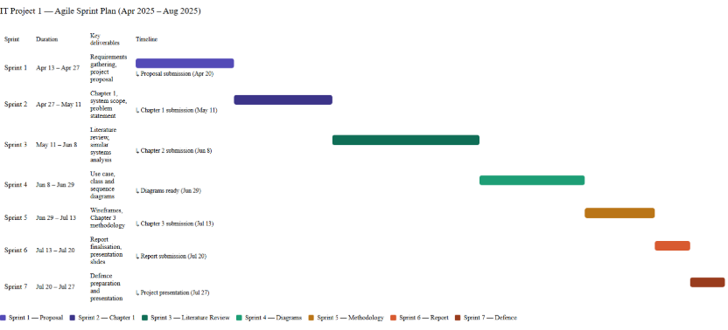
Figure 1.1: Original IT Project 1 proposal Gantt chart (retained; not an actual completion log).

1.8 SOFTWARE TOOLS
1. React — Frontend framework for building interactive user interfaces
2. Django — Backend framework supporting rapid development with built-in ORM and MVT architecture
3. PostgreSQL — Relational database suited for structured interconnected data entities
4. Visual Studio Code — Code editor with extensive Python and JavaScript extension support
5. GitHub — Version control platform for tracking code changes and managing development history

1.9 CONCLUSION
The proposed system aims to help home-based food entrepreneurs manage preorder operations more efficiently through a dedicated fixed-cost web platform tailored to their business needs.
By providing flexible date-based preordering, ingredient freshness monitoring, personalised storefront management, sales analytics and menu recommendation features, the system addresses key operational gaps faced by home-based food entrepreneurs. Operating through a dedicated platform allows sellers to maintain their own branded storefront and build direct customer relationships independent of large multivendor marketplace environments.
The project follows an Agile methodology to support iterative feature development and flexibility throughout the development process. Therefore, the proposed system supports the growth of local home-based food SMEs while contributing to food safety awareness and improved customer purchasing experience.

CHAPTER 2
LITERATURE REVIEW

2.1 INTRODUCTION
This chapter consists of three parts including background study, methodology, and technology.
The background study discusses the evolution of the food ordering industry, digital transformation in Malaysia’s food and beverage (F&B) sector, and the research interest landscape related to preorder and freshness management systems. In addition, similar existing systems and current technological trends relevant to the proposed system will also be reviewed and discussed.
The methodology section discusses the comparison between Agile and Traditional software development approaches to determine the most suitable methodology for the proposed system.
Meanwhile, the technology section describes the framework and database technologies considered for the project. A comparison between Django and Express.js will be carried out to determine the most suitable framework for the proposed system. Moreover, a comparison between Firebase and PostgreSQL will also be conducted to identify the most suitable database solution for the proposed system.
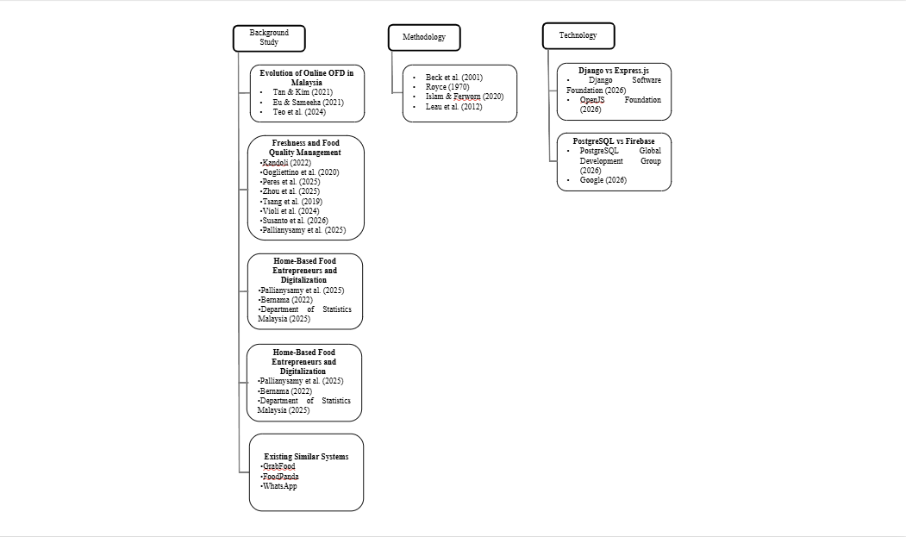
Figure 2.1: Original literature map retained from IT Project 1.

2.2 BACKGROUND STUDY

2.2.1 Evolution of Online Food Ordering Industry in Malaysia
The Online Food Ordering industry boomed in Malaysia in 2017, driven by smartphone adoption and internet accessibility (Tan & Kim, 2021). The COVID-19 pandemic further accelerated this growth as consumers shifted toward online food ordering amid the shutdown of non-essential services and dining restrictions (Eu & Sameeha, 2021). Within this growing market, research has identified food quality and health considerations as significant factors influencing Malaysian consumer behavior in OFD platforms (Teo et al., 2024).
Therefore, understanding consumer expectations regarding food quality and freshness within Malaysia's digital food ecosystem is important in identifying the relevance of the proposed web-based preorder and freshness management system. Table 2.1 presents an analysis of key findings and their implications for the Malaysian OFD landscape.
Table 2.1: Summary of findings on Malaysian online food delivery consumer behaviour.
APA citation | Key finding | Relevance
Tan & Kim (2021) | Food quality, service approach and perceived price were linked to satisfaction. | Supports attention to food quality and service.
Eu & Sameeha (2021) | 76.9% perceived limited healthy options; 85.9% expressed willingness to purchase healthy food. | Highlights a gap in perceived choice/quality.
Teo et al. (2024) | Health, quality, service and value influence continuance intention. | Supports integrating quality and service information.

Across these studies, food quality and healthy food availability consistently emerge as critical factors influencing Malaysian consumers' OFD usage and satisfaction. However, existing platforms are perceived as inadequately addressing these concerns. Given that freshness is identified as a core component of food quality (Tan & Kim, 2021), this suggests a gap for more practical freshness management features within digital food ordering systems.

2.2.2 Freshness and Food Quality Management in Digital Food Systems
Food storage is one method used to preserve food for future consumption (Kandoli, 2022). However, certain perishable food products with high nutrient content remain vulnerable to microbial contamination and pathogen growth if storage conditions are not properly managed (Gogliettino et al., 2020). The presence and growth of these microorganisms influence the freshness status and quality of raw food, thereby requiring proper freshness management before food is served to consumers.
Food quality management has become a critical aspect of the food industry, particularly in ensuring food safety and freshness throughout the supply chain. Recent studies have explored the integration of Industry 4.0 technologies such as sensor systems, blockchain, and artificial intelligence to improve food monitoring, process automation, and traceability mechanisms (Peres et al., 2025). Furthermore, TTIs and FIs were explored in food shelf-life monitoring (Zhou et al., 2025).
However, these technologies are generally implemented within large-scale food supply chains and industrial environments where structured operational processes, dedicated quality control divisions, and larger financial resources are available. Such implementations commonly emphasize end-to-end supply chain monitoring rather than operational-level freshness management for small-scale food services or home-based food businesses.
Another study explored the integration of IoT, fuzzy logic, and zero-order quality degradation models into an Internet of Things-based Shelf Life Management System (Tsang et al., 2019). Nevertheless, the implementation complexity and infrastructure requirements of such systems may reduce their suitability for home-based food microbusinesses.
Similarly, Violi et al. (2024) proposed a mathematical inventory-routing model for perishable products. The model assists warehouses in determining delivery priorities to minimize spoilage while addressing stochastic demand using historical sales data and Conditional Value-at- Risk (CVaR) risk analysis. However, the computational complexity and integration requirements of such approaches may limit their applicability in small-scale academic projects and home-based food business operations. Furthermore, these systems may require IoT infrastructure to monitor physical inventory movement, potentially increasing implementation costs.
Susanto et al. (2026) also proposed a Quality Management System framework for food SMEs consisting of Quality Planning, Quality Assurance, and Quality Control and Improvement stages. However, the implementation scope of such systems may exceed the operational requirements of small-scale home-based food businesses.
Moreover, Pallianysamy et al. (2025) highlighted the need for monitoring and inspection solutions for home-based food operations from a food safety perspective. Nevertheless, implementing advanced monitoring technologies such as cameras, sensors, or IoT devices may introduce additional infrastructure and maintenance costs that are less suitable for lightweight small-scale systems.
Therefore, a research gap exists in the development of lightweight and cost-effective freshness management approaches that can be integrated into smaller-scale digital food systems such as online preorder and home-based food ordering platforms.

2.2.3 Home-Based Food Entrepreneurs and Digitalization
Home-based food businesses in Malaysia represent a growing segment particularly following COVID-19 (Pallianysamy et al., 2025). This growth coincides with significant expansion in Malaysia's digital food market — ecommerce transactions increased by 21.8 percent from 2020 to RM1.1 trillion in 2021 (Bernama, 2022), with revenue for the first nine months of 2025 reaching RM937.5 billion (Department of Statistics Malaysia, 2025).
However, as identified in Section 2.2.5, existing platforms present several limitations for home-based food operators. GrabFood and FoodPanda were recorded in the proposal comparison as offering approximately 1–2-day advance windows, which is insufficient for sellers who prepare food in batches and require confirmed orders further ahead of time. WhatsApp's Cart feature has no structured date field, requiring sellers to manually write and verify dates themselves rather than having the system check availability automatically, while informal chat-based ordering has no structure at all, making it difficult for sellers to reliably track orders and avoid missing them amid casual conversation. None of these platforms provide ingredient freshness monitoring features.
Furthermore, existing platforms lack dedicated personalised storefronts — GrabFood and FoodPanda offer limited personalisation within competitive multivendor environments, while WhatsApp offers either a fixed, generic Catalog template with no customizable layout, or informal product sharing via chat — neither gives sellers a distinct, independently branded storefront presence. While dedicated single-vendor ordering systems exist for large established food brands such as McDonald's, these systems are developed for large-scale commercial operations and are not accessible to informal home-based food micro-entrepreneurs as ready-to-use platforms.
Home-based entrepreneurs whose operational needs — flexible preordering, freshness monitoring, or a dedicated single-vendor storefront — are not met by GrabFood, FoodPanda, or WhatsApp would therefore need to adopt a different platform altogether; once on such a platform, they would also benefit from integrated sales analytics and recommendation features rather than having to rely on separate or absent tools. While GrabFood and FoodPanda do provide sales analytics through vendor dashboards (Table 2.3), and WhatsApp offers none at all, neither pathway currently combines these analytics and recommendation capabilities with the preorder, freshness, and storefront features that the proposed system addresses together as a single integrated solution.

2.2.4 Research Interest & Academic Relevance Landscape
Tan & Kim (2021) examined consumer satisfaction in Malaysian OFD, focusing on factors such as food quality and pricing. However, this study focuses on consumer satisfaction rather than operational tools for food businesses.
In addition, research on healthy food awareness in OFD platforms indicates that Malaysian consumers value healthier food options and food quality visibility (Eu & Sameeha, 2021). However, these studies mainly focus on healthy food availability perception and food choice behavior, rather than real-time freshness monitoring or freshness-status tracking within online food ordering systems.
Moreover, recent studies exploring digital technologies in food monitoring suggest increasing adoption of Artificial Intelligence (AI), Internet of Things (IoT), and smart sensors for food tracking and waste reduction (Zhou et al., 2025). However, these solutions are often complex and costly, making them less suitable for small-scale food businesses. Therefore, there is a need for a more lightweight and cost-effective approach to freshness management, such as a system based on shelf-life tracking and inventory entry time. Table 2.2 presents an analysis of existing research areas and their identified gaps relevant to the proposed system.
Table 2.2: Research areas, focus and identified gaps retained from the proposal.
Research area | Study focus | Gap relevant to this project | Citation
Consumer satisfaction | Quality, price and service | Operational preorder/freshness tools | Tan & Kim (2021)
Healthy food availability | Perceptions of variety and price | Practical ingredient-date visibility | Eu & Sameeha (2021)
Digital food monitoring | AI/IoT and larger supply chains | Lightweight tools for small operators | Zhou et al. (2025)

Overall, the existing literature tends to focus either on consumer behavior, healthy food availability perception, or advanced technological solutions, with limited attention given to affordable, practical freshness management systems tailored for home-based food entrepreneurs. This identifies a clear research gap that the proposed web-based preorder and freshness management system aims to address.

2.2.5 Existing Similar Systems
The following platform descriptions and Table 2.3 preserve the proposal-stage comparison. Ordering windows and commercial features can vary by region, account and date; they were not revalidated as current provider promises for this implementation review. The comparison is not a universal claim that no other software supports these functions.
This section compares existing systems to identify features currently available and limitations that the proposed system aims to address.

2.2.5.1 GrabFood
GrabFood is the most popular food ordering platform among university students (Lok et al., 2024). It was founded in 2018 which provided online food delivery solutions in Southeast Asia (Grab, 2018). The platform primarily focuses on registered restaurant vendors and large-scale food businesses and was recorded in the proposal comparison as allowing advance preordering up to two days. Moreover it is a multivendor platform, therefore, they provide less freedom in personalized content. However, publicly available platform features indicate limited support for freshness-status monitoring and inventory- oriented analytics.

2.2.5.2 FoodPanda
FoodPanda was launched in 2012 before expanding across Southeast Asia (Foodpanda, 2012). It allows advance preordering up to 1 day. Same with GrabFood, the platform primarily focuses on registered restaurant vendors and large-scale food businesses. It allows limited preordering and does not provide personalized storefront. It also does not offer food freshness monitoring features, and provides limited sales analytics through its vendor dashboard. Recommendation capabilities are relatively limited and primarily focused on vendor visibility rather than personalized freshness-oriented recommendations.

2.2.5.3 WhatsApp
WhatsApp may be used as an informal preorder communication platform among small- scale food businesses and microentrepreneurs in Southeast Asia. However, the preorder process is largely unstructured and dependent on manual chat management, which may increase the risk of missed orders and communication inefficiencies. In addition, WhatsApp does not provide dedicated features such as freshness monitoring, analytics dashboards, or personalized preorder management.
This section reviews several existing platforms related to online food ordering and preorder management to identify their functionalities, limitations, and relevance to the proposed system. The comparison focuses on preorder flexibility, personalization, freshness monitoring, sales analytics, and recommendation capabilities. Through this comparison, the limitations of current systems can be identified to justify the need for the proposed system.
Table 2.3: Proposal-stage feature comparison; provider features/regions may change.
Feature | GrabFood | foodpanda | WhatsApp | McDonald’s | Proposed system
Advance ordering | Up to 2 days | Up to 1 day | Manual date in conversation | Limited scheduling | Flexible seller rules
Single-vendor storefront | Marketplace | Marketplace | Basic catalogue/chat | Brand-owned | Dedicated kitchen
Ingredient-date monitoring | Not in compared interface | Not in compared interface | Manual records | Not in compared interface | Shelf-life records
Sales analytics | Vendor analytics | Vendor analytics | Not in basic ordering flow | Not evaluated | Integrated reports
Recommendations | Platform-based | Category-based | Not in compared flow | Not evaluated | Explainable ranking

Note. McDonald's is included as a reference example of an existing single-vendor dedicated ordering system. It is not a practical alternative for home-based food entrepreneurs, as such systems are developed for large-scale commercial operations and are not accessible as ready-to-use platforms for informal micro-entrepreneurs.

2.3 METHODOLOGY
Agile methodology is an iterative software development approach where developers can always revisit earlier stages of the Software Development Life Cycle after feedback. According to Beck et al. (2001), the Agile Manifesto emphasizes four core values: individuals and interactions over processes and tools, working software over comprehensive documentation, customer collaboration over contract negotiation, and responding to change over following a plan. Individuals and interactions over processes and tools means the methodology capitalizes more on human resources rather than advanced technologies or tools. Working software over comprehensive documentation means the methodology makes use of early prototypes for testing purposes rather than planning everything from start through documentation. Customer collaboration over contract negotiation means the method prefers continuous customer feedback rather than a fixed negotiation contract at the beginning. Responding to change over following a plan means the methodology prioritises adapting to new information and feedback rather than rigidly adhering to an initial plan.
A traditional model is a software development process where each stage is rigidly planned from the beginning. According to Royce (1970) it consists of system requirements, software requirements, analysis, program design, coding, testing, operation. He, however, said that the model is so simple that it's very risky for larger and more costly software projects.
Agile methodology is an incremental software development process while traditional methodology is a more formal or plan-driven software development approach (Islam & Ferworn, 2020). The comparisons between the two are described in the table below.
Table 2.4: Agile and traditional comparison, adapted from the original proposal summary (Islam & Ferworn, 2020).
Dimension | Agile (proposal summary) | Traditional (proposal summary)
Approach | Adaptive | Predictive
Success emphasis | Business value | Conformance to plan
Typical project context | Small / evolving | Larger / stable
Management emphasis | Decentralised | Centralised
Change | Adaptability | Controlled changes
Culture | Collaboration | Formal coordination
Documentation | Selected supporting records | Extensive records
Focus | People and iteration | Process and sequence
Cycles | Numerous | Limited
Domain | Exploratory | Predictable
Team | Small / adaptable | Larger / structured
Upfront planning | Incremental | Comprehensive
Return | Incremental delivery | Later completion

This table summarises the proposal’s comparison rather than establishing universal rules about documentation, team size or engineering skill. The present project uses iterative development with written requirements, diagrams and automated tests in every relevant increment.
Agile methodology is selected for this project due to its suitability for small-scale projects, support for iterative feature development, and flexibility to accommodate requirement changes throughout the development process. These characteristics align with the nature of this academic project, where features may be refined or extended based on feedback and testing outcomes. Leau et al. (2012) provide a comparative analysis between Agile and traditional methodologies regarding rework costs, testing protocols, and project scalability, as outlined in Table 2.5.
Table 2.5: Comparison of development dimensions, adapted from the proposal’s Leau et al. (2012) summary.
Dimension | Agile | Traditional
Requirements | Iteratively refined | Defined before implementation
Rework | Earlier feedback can reduce later rework | Late changes can be expensive
Direction | Changeable within iterations | More fixed baseline
Testing | Each iteration | Historically later stages
Customer involvement | Frequent | Often concentrated at milestones
Developer skills | Interpersonal and business knowledge | Technical and coordination skills still required
Project scale in proposal | Low to medium | Larger plan-driven context

This table summarises the proposal’s comparison rather than establishing universal rules about documentation, team size or engineering skill. The present project uses iterative development with written requirements, diagrams and automated tests in every relevant increment.

2.4 TECHNOLOGY

2.4.1 Django vs Express.js
According to the Django Software Foundation (2026), Django is a high-level Python web framework designed to support the rapid development of backend code. The framework is widely adopted for its Model-View-Template (MVT) architecture, which separates the application's core data, logic, and user interface. Within this architecture, a Model is defined as a Python class object that maps directly to a database table, providing an object-relational interface to database queries (Django Software Foundation, 2026). The View serves as a function or class that accepts web requests and returns the corresponding web responses. Finally, the Django architecture incorporates Templates, which consist of HTML code enhanced with template tags to dynamically display the data retrieved from the database to the end user (Django Software Foundation, 2026).
According to the OpenJS Foundation (2026), Express.js is a minimalist web framework designed to provide a robust set of features for web and application development. The framework relies primarily on two core functionalities: routing and middleware. Routing defines how application endpoints or URIs respond to specific incoming client requests, while middleware functionality allows developers to access and manipulate the request (req) and response (res) objects during the application's cycle (OpenJS Foundation, 2026).
Django was selected over Express.js due to prior development experience with the framework, which reduces learning overhead in a time-constrained academic project. Additionally, Django's MVT architecture enforces a clear project structure that supports code maintainability and organisation throughout development.

2.4.2 PostgreSQL vs Firebase
According to PostgreSQL Global Development Group (2026), PostgreSQL is an open- source object-relational database that has been developed for more than 35 years, making it a reputable database. It has many features that help developers in application building, administrators that protect data integrity, and support datasets of varying sizes. Furthermore, many features that are supported by SQL standard are also supported by PostgreSQL making it compliant with the SQL standard.
The Google (2026) comparison concerns Cloud Firestore, Firebase’s document-oriented database, rather than every service under the Firebase platform. Meanwhile, it stores data in documents where each document contains key-value pairs. A document object is a type of JSON object that supports extra data types and has document size limits. Collection is the container that holds instances of the same data structure.
PostgreSQL is selected as its relational data model better suits structured data with interconnected entities, improving readability and maintainability compared to Firebase's document-based storage which may result in deeply nested data structures that are harder to navigate and maintain. Furthermore, Firebase's NoSQL structure is not natively supported by Django's ORM, which would require bypassing Django's built-in database management tools and increasing implementation complexity.

2.5 IMPLEMENTATION IMPLICATIONS
The literature rationale remains the same: a lightweight integrated tool is relevant to a home kitchen whose workflow is not represented by a short-notice marketplace checkout. The current React/Django implementation uses recorded date evidence, traceable ingredient and packaging allocations, a single-vendor storefront and explainable menu suggestions. Client feedback removed required cooking-task planning from the active workflow. These changes do not alter the proposal literature or the five objectives. Physical food safety, behavioural improvement and actual commercial outcomes require separate evidence, as discussed in Chapters 4–6.

CHAPTER 3
METHODOLOGY AND SYSTEM DESIGN

3.1 INTRODUCTION
This chapter retains the iterative development approach established in IT Project 1 and updates the design where the client’s operating requirements changed. The five objectives in Section 1.3 are unchanged. The implemented case study is Wrap & Bowl Kuch, Ayu Shafinaz’s home-based business in Kuching, Sarawak. Its catalogue comprises salad bowls, Wanpaku sandwiches and a Monday rice bowl. The client information used here consists of the menu poster, founder introduction and feature requests supplied by the project author. These materials are requirements evidence; they are not a transcribed interview or a completed acceptance study.
The principal refinement is a simpler operating workflow. Scheduling means choosing a permitted future delivery or collection date and time, rather than requiring the owner to define cooking tasks or confirm a preparation plan. Customer access uses a name/phone profile with a passkey. The owner retains separate staff authentication. Ingredient and packaging allocations occur when an order is accepted. Payment verification and actual food receipt remain distinct events. Earlier scheduling and payment components remain in the codebase for compatibility, but they are not the active client checkout design.

3.2 ITERATIVE DEVELOPMENT AND REQUIREMENT REFINEMENT
Development followed small requirement, implementation, verification and feedback cycles. The original problem, literature rationale and objectives provided the baseline. Client feedback subsequently prioritised name-and-phone contact, packaging stock, payment-proof upload, area fees, daily order summaries, printing and a received/not-received presentation. Additional iterations addressed phone normalisation, accepted-order snapshots, stock shortages, passkey recovery limitations and consistent interfaces.
The project used iterations rather than claiming formal team Scrum ceremonies that did not take place. A working feature was reviewed through its visible interaction and its server-side rules. Regression checks were rerun when a change could affect existing orders, stock or permissions. The author’s client meetings informed these revisions, but no attendance count, signed approval or interview answer is inferred from the code history. Chapter 4 explains the implementation decisions and Chapter 5 separates developer verification from the evaluation still to be collected.
Table 3.1: Client-led design changes and their consequences
Requirement change | Current design consequence | Preserved constraint
Reduce registration effort | Name and phone profile with native passkey registration/sign-in | A phone number is contact data, not proof of identity
No cooking Planner in daily use | Future handover date/time, offered days and cutoffs; no cooking reservation | A date must still be permitted and within the supported horizon
Track packaging as well as ingredients | Packaging quantities, menu assignments and per-order allocations | A shortage must prevent the whole placement
Upload payment evidence | Private sanitised receipt image associated with the quoted selection | An upload never means the bank payment has been verified
Morning deliveries and area fees | Editable minute-based hours and delivery-area price mapping | The server calculates the accepted fee
Simplify order handling | Received / Not received, with cancellation and audited corrections | Food receipt does not record money received

3.3 USE CASE DIAGRAMS
The customer diagram uses one Customer actor consistently. Public browsing does not require an account; checkout and private history do. The owner diagram represents authenticated staff. A bank or courier is not drawn as an automatically connected application actor because the current website does not call either provider’s operational API. The customer uses a separate banking application, and the kitchen arranges the rider externally.
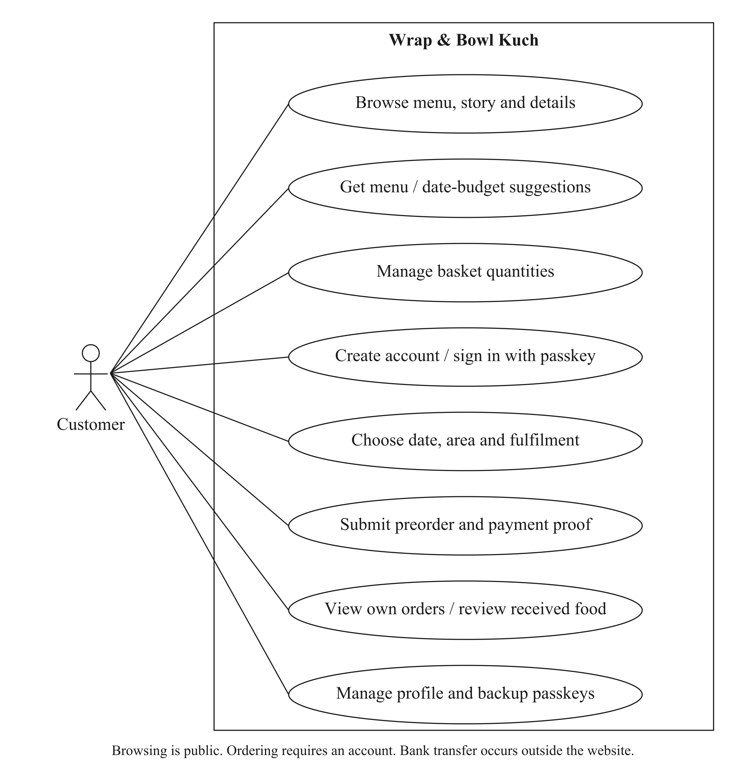
Figure 3.1: Customer use cases for the current storefront and account workflow.
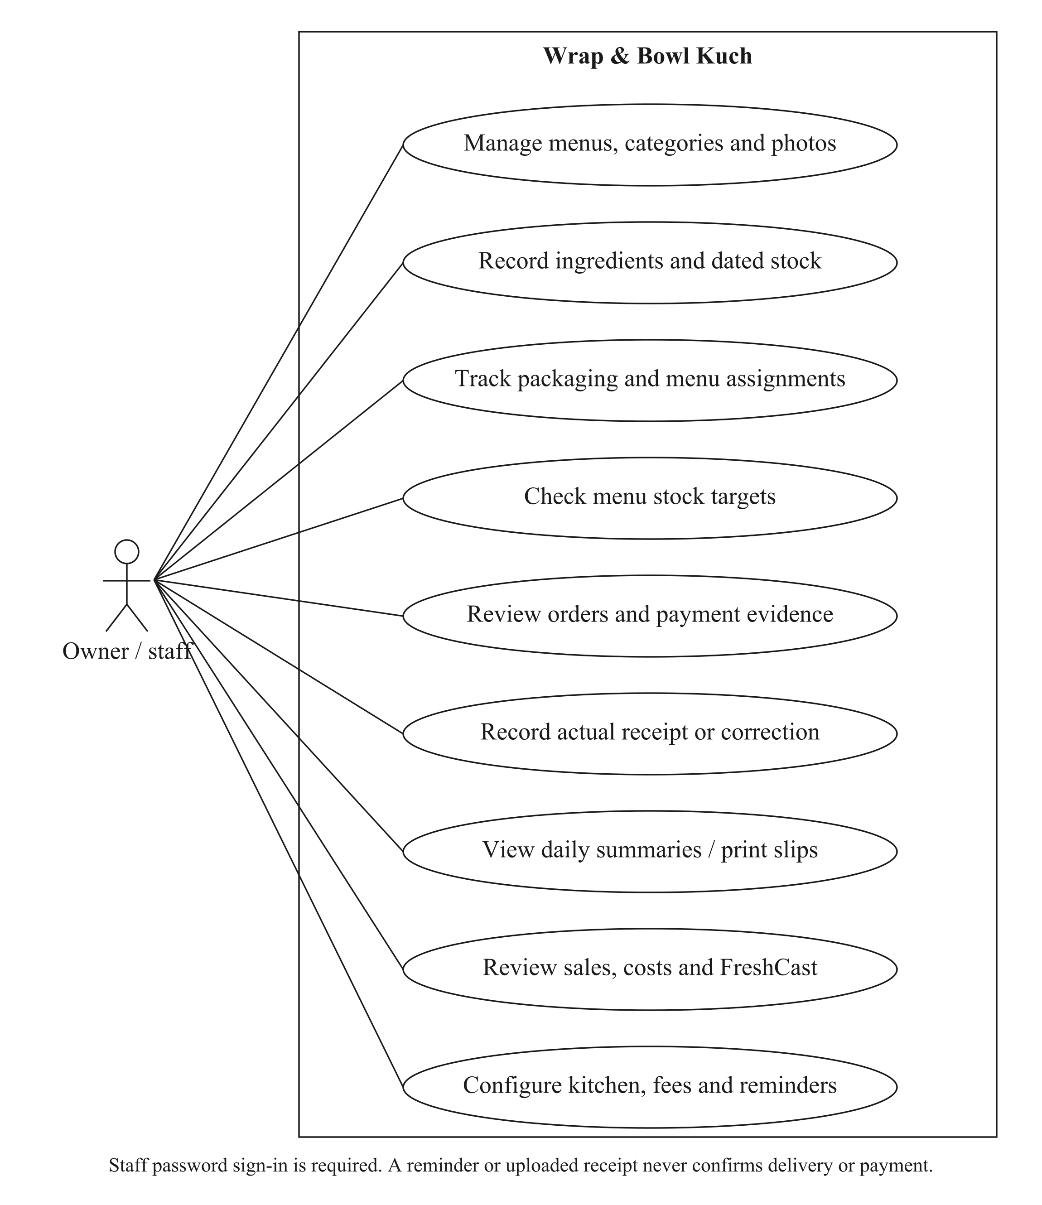
Figure 3.2: Owner/staff use cases for stock, orders, reporting and configuration.

3.4 USE CASE SPECIFICATIONS
The specifications below describe the current client workflow. Shared preconditions include a valid session, role-appropriate permissions and current saved configuration. An error must leave an order, payment or stock operation either fully recorded or unrecorded; the interface must not treat an uncertain response as a successful second submission.

3.4.1 BROWSE MENU
Use case | Current specification
ID / actor | UC-01 — Visitor/customer
Precondition | Public storefront available.
Main flow | Open the menu; search/filter categories; inspect price, contents and offered days.
Alternative / exception | Empty results or unavailable records show a recovery state.
Postcondition | No order or stock change.

3.4.2 CREATE CUSTOMER ACCOUNT
Use case | Current specification
ID / actor | UC-02 — Customer
Precondition | Browsing session; supported passkey device.
Main flow | Enter name and full phone; request registration; complete native verification.
Alternative / exception | Invalid phone, unsupported device, rejected origin/challenge or cancelled ceremony does not create false authentication.
Postcondition | Registered account preserves its existing basket; no website password/email required.

3.4.3 SIGN IN
Use case | Current specification
ID / actor | UC-03 — Customer / staff
Precondition | Registered passkey or staff credentials.
Main flow | Use the customer passkey; staff use the separate protected password form.
Alternative / exception | Wrong credential remains an error; the phone alone never opens another account.
Postcondition | Verified session and role-appropriate access.

3.4.4 MANAGE PROFILE AND PASSKEYS
Use case | Current specification
ID / actor | UC-04 — Customer
Precondition | Authenticated account.
Main flow | Review saved contact; reauthenticate for sensitive changes; add or remove a backup key.
Alternative / exception | Last-key removal and unauthorised/stale verification are rejected.
Postcondition | Profile/key change is saved without rewriting accepted order contacts.

3.4.5 GET MENU SUGGESTIONS
Use case | Current specification
ID / actor | UC-05 — Customer
Precondition | Menus configured; date finder needs a valid selection.
Main flow | Browse date-free cards or choose date, total units, mix/same and optional budget; inspect up to three alternatives.
Alternative / exception | No feasible match is explained; replacing a basket needs deliberate confirmation.
Postcondition | Proposed basket obeys relevant stock/pricing rules; no handover hour reserved.

3.4.6 MANAGE BASKET
Use case | Current specification
ID / actor | UC-06 — Customer
Precondition | Browsing or registered session.
Main flow | Add food, adjust quantity, remove a line and review subtotal.
Alternative / exception | Failures retain truthful current/error state; no duplicate successful add is invented.
Postcondition | Basket changes only; accepted stock is not yet consumed.

3.4.7 CHOOSE FULFILMENT AND DATE
Use case | Current specification
ID / actor | UC-07 — Customer
Precondition | Registered account and nonempty basket.
Main flow | Select delivery/collection, configured area if needed, common offered date and allowed time.
Alternative / exception | Invalid weekdays, cutoffs, time bounds or restricted area block a valid quote.
Postcondition | Current server-priced fulfilment selection; no accepted order yet.

3.4.8 UPLOAD PAYMENT PROOF
Use case | Current specification
ID / actor | UC-08 — Customer
Precondition | Manual payment available; confirmed quote and account.
Main flow | Pay externally if appropriate; select an eligible receipt image and upload it.
Alternative / exception | Nonimage, excessive size, wrong scope, unauthorised/private read or reused evidence is rejected.
Postcondition | Private scoped proof ID; payment is still unverified.

3.4.9 PLACE PREORDER
Use case | Current specification
ID / actor | UC-09 — Customer
Precondition | Account, valid fulfilment/contact, accepted price and required proof or delivery cash.
Main flow | Submit one request ID; server locks/rechecks current state and commits order plus allocations.
Alternative / exception | Any shortage, stale scope or later write error rolls back the entire placement; retry is idempotent.
Postcondition | Accepted snapshots, one ingredient/packaging deduction and saved order confirmation.

3.4.10 VIEW OWN ORDER AND REVIEW FOOD
Use case | Current specification
ID / actor | UC-10 — Customer
Precondition | Authenticated owner of order.
Main flow | Open My orders; inspect saved details/payment/receipt; use an eligible review or change action.
Alternative / exception | Another account cannot access private history; ineligible changes are rejected.
Postcondition | Read-only display or a separately validated audited change.

3.4.11 MANAGE CATALOGUE
Use case | Current specification
ID / actor | UC-11 — Owner/staff
Precondition | Staff session.
Main flow | Create/edit category/menu, price, unit contents, offered dates, image, recipe and selling status.
Alternative / exception | Invalid fields show form errors; protected historic relationships prevent unsafe deletion.
Postcondition | Current catalogue updates; accepted order names/prices remain unchanged.

3.4.12 RECEIVE OR ADJUST INGREDIENT BATCH
Use case | Current specification
ID / actor | UC-12 — Owner/staff
Precondition | Ingredient unit and actual received evidence available.
Main flow | Choose date basis, storage and handling; enter quantity; review deadline and save with a reason where needed.
Alternative / exception | Invalid evidence or stale edit version is rejected.
Postcondition | Dated batch and audit record; held/expired stock excluded.

3.4.13 CHECK A STOCK TARGET
Use case | Current specification
ID / actor | UC-13 — Owner/staff
Precondition | Current recipes and packaging configured.
Main flow | Choose a date and 1–100 units per offered menu; inspect totals, shortfalls and included menus.
Alternative / exception | Missing recipes/settings and no offered menus are reported distinctly.
Postcondition | Read-only target/worksheet; no receipt, reservation or deduction.

3.4.14 MANAGE PACKAGING
Use case | Current specification
ID / actor | UC-14 — Owner/staff
Precondition | Staff session.
Main flow | Create packaging, record received pieces/cost, assign per-menu pieces and review movements.
Alternative / exception | Invalid removal or missing supplies is rejected; removals require review.
Postcondition | Current pieces and menu mappings saved; old accepted allocations preserved.

3.4.15 RECORD VERIFIED PAYMENT
Use case | Current specification
ID / actor | UC-15 — Owner/staff
Precondition | Accepted order and bank/cash evidence.
Main flow | Inspect private proof; check external receipt; record full payment reference and outcome.
Alternative / exception | An upload alone is insufficient; duplicate/conflicting events are validated.
Postcondition | Payment event/state updated; food receipt unchanged.

3.4.16 CONFIRM ACTUAL FOOD RECEIPT
Use case | Current specification
ID / actor | UC-16 — Owner/staff
Precondition | Eligible current order(s); actual handover confirmed.
Main flow | Select one or more orders; review exact set and confirm food received.
Alternative / exception | Stale/ineligible selected order prevents an unreviewed partial update.
Postcondition | Actual receipt/audit state updated; no invented payment.

3.4.17 REVIEW DAILY SUMMARY AND PRINT
Use case | Current specification
ID / actor | UC-17 — Owner/staff
Precondition | Orders and a chosen handover date.
Main flow | Open daily menu totals; inspect orders; open a slip and explicitly print/save PDF.
Alternative / exception | Undated records and missing slips are handled without invented dates.
Postcondition | Read-only report/preview with accepted name/address/phone.

3.4.18 REVIEW SALES AND PRICING
Use case | Current specification
ID / actor | UC-18 — Owner/staff
Precondition | Relevant recorded orders and known costs where required.
Main flow | Select period; distinguish operational value from paid/received sales; compare a price/bulk scenario.
Alternative / exception | Unknown costs remain unavailable; CSV ranges and formula text are bounded/sanitised.
Postcondition | Read-only report/export/scenario; live prices unchanged.

3.4.19 RECORD WASTE OR EXPENSE
Use case | Current specification
ID / actor | UC-19 — Owner/staff
Precondition | Batch quantity or overhead evidence.
Main flow | Review a waste deduction with reason, or record/void an eligible operating expense.
Alternative / exception | Do not double-count cooking deductions or ingredients as overhead; invalid quantities rejected.
Postcondition | Waste adjusts stock with cost evidence; expense ledger remains separate.

3.4.20 MANAGE KITCHEN SETTINGS
Use case | Current specification
ID / actor | UC-20 — Owner/staff
Precondition | Staff session.
Main flow | Save identity/story, area fees/hours, enabled collection, receiving QR and promotion section.
Alternative / exception | Invalid configuration is rejected; one section save preserves unrelated drafts.
Postcondition | New quotes use settings; accepted terms remain snapshots.

3.4.21 PROCESS OWNER REMINDER
Use case | Current specification
ID / actor | UC-21 — Scheduler / owner
Precondition | Authenticated worker and configured SMTP.
Main flow | Check due delivery/collection events and receipts; recheck under lock; attempt bounded sends.
Alternative / exception | Unauthorised calls rejected; failed sends do not save a success receipt.
Postcondition | Run metadata/accepted-send receipt only; order/payment/stock not changed.

3.4.22 USE KITCHEN HELP AND FRESHCAST
Use case | Current specification
ID / actor | UC-22 — Customer / staff respectively
Precondition | Relevant public help or staff decision route available.
Main flow | Use supported help/contact guidance; staff select clearly labelled decision data/scenarios.
Alternative / exception | Service failure provides recovery; local, external and illustrative evidence are not mixed.
Postcondition | Assistance or hypothetical analysis; no automatic banking/courier/procurement action.

3.5 ACTIVITY DIAGRAMS

3.5.1 CUSTOMER CHECKOUT AND STOCK COMMITMENT
The customer selects delivery or available collection, an offered date and an allowed time. Delivery requires an area from the kitchen’s configured list when that list is restricted. The server quotes food, bulk discount and delivery together. Delivery can use an available QR/bank-transfer method or cash. Collection requires a receiving QR and payment evidence. Placement repeats the relevant checks inside the order transaction and creates accepted terms before allocating stock. A failure must preserve the basket without a partial order or partial deduction.
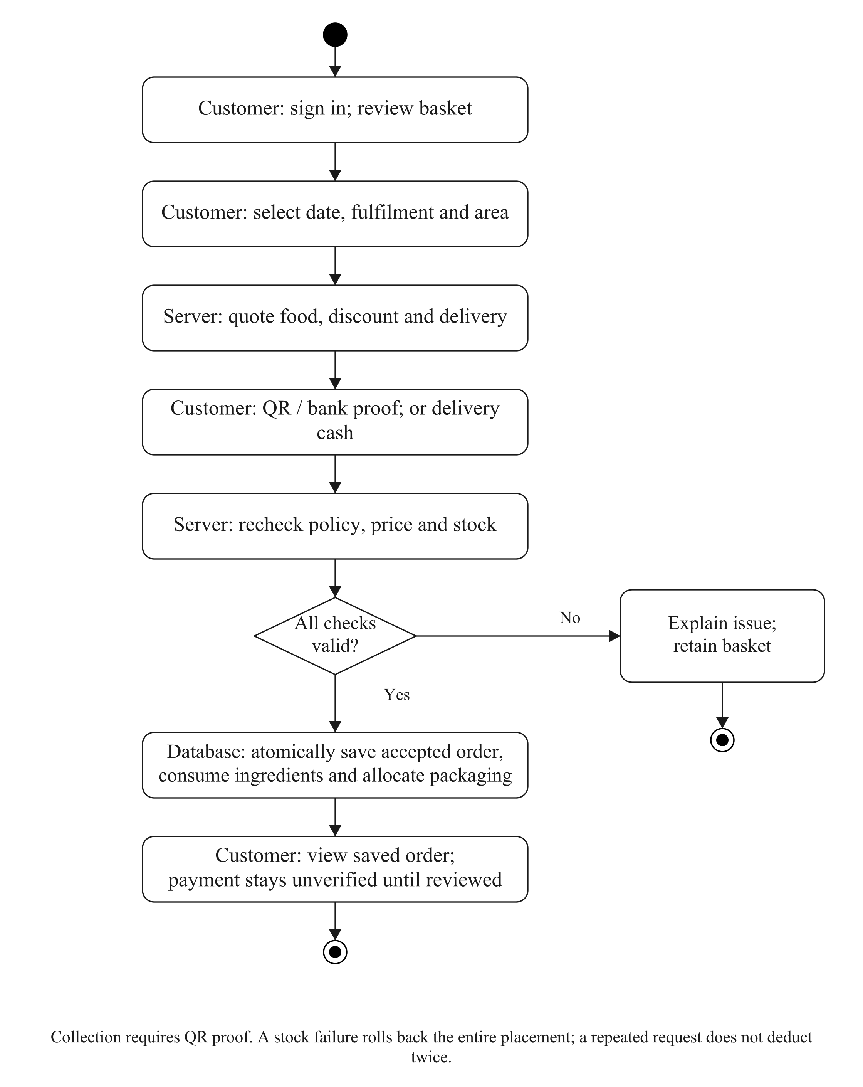
Figure 3.3: Checkout validation and atomic ingredient/packaging allocation.

3.5.2 DATED INGREDIENT BATCHES
An ingredient definition supplies its inventory unit and optional documented storage guidance. A received batch records its own quantity, dates, actual storage and handling evidence. Printed-date, manufacture-plus-life and receipt-plus-storage-life modes use different anchors. Opening and thawing limits can shorten the base deadline. Uncertain handling or a known breach holds the batch. Selecting a wet-market source does not itself prove that the product has no usable supplier label or establish a safe duration.
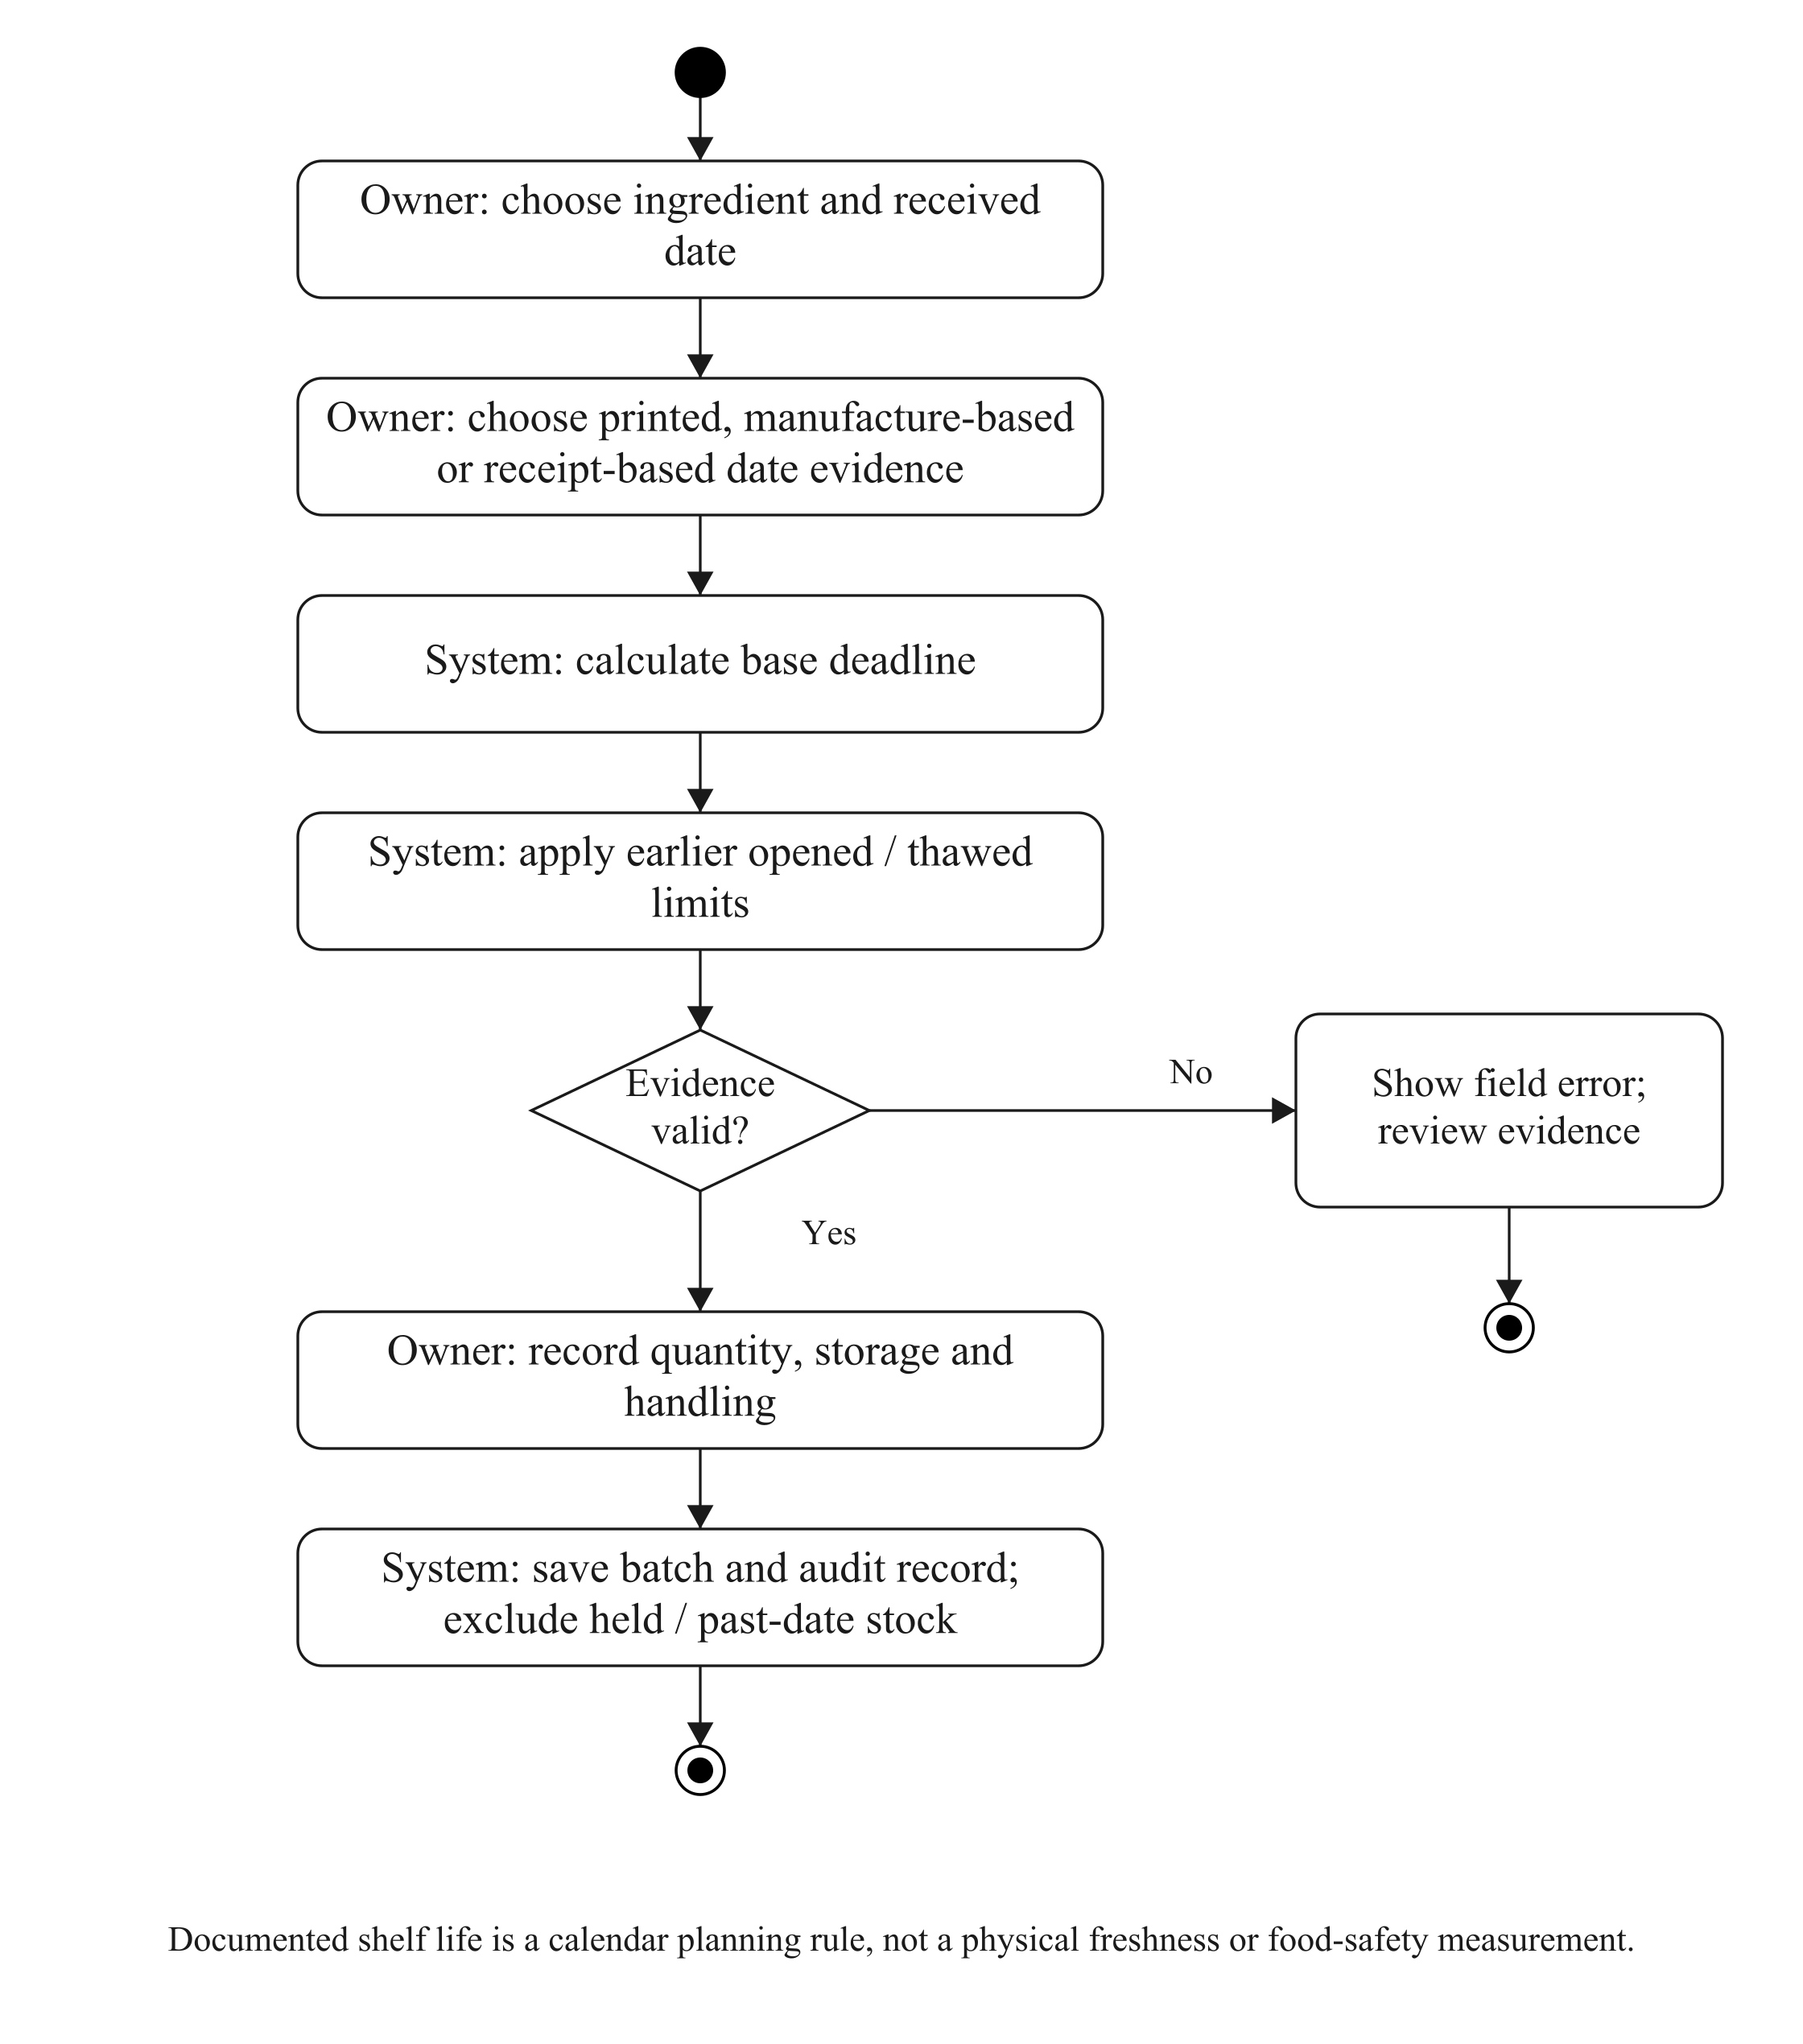
Figure 3.4: Batch date evidence, validation and stock eligibility.

3.5.3 PACKAGING STOCK
Packaging is tracked in whole pieces independently of edible ingredients. Each menu maps the pieces required for one selling unit. Placement multiplies these requirements by the ordered quantity and captures the accepted packaging names, quantities and costs. A later menu edit cannot rewrite that accepted allocation.
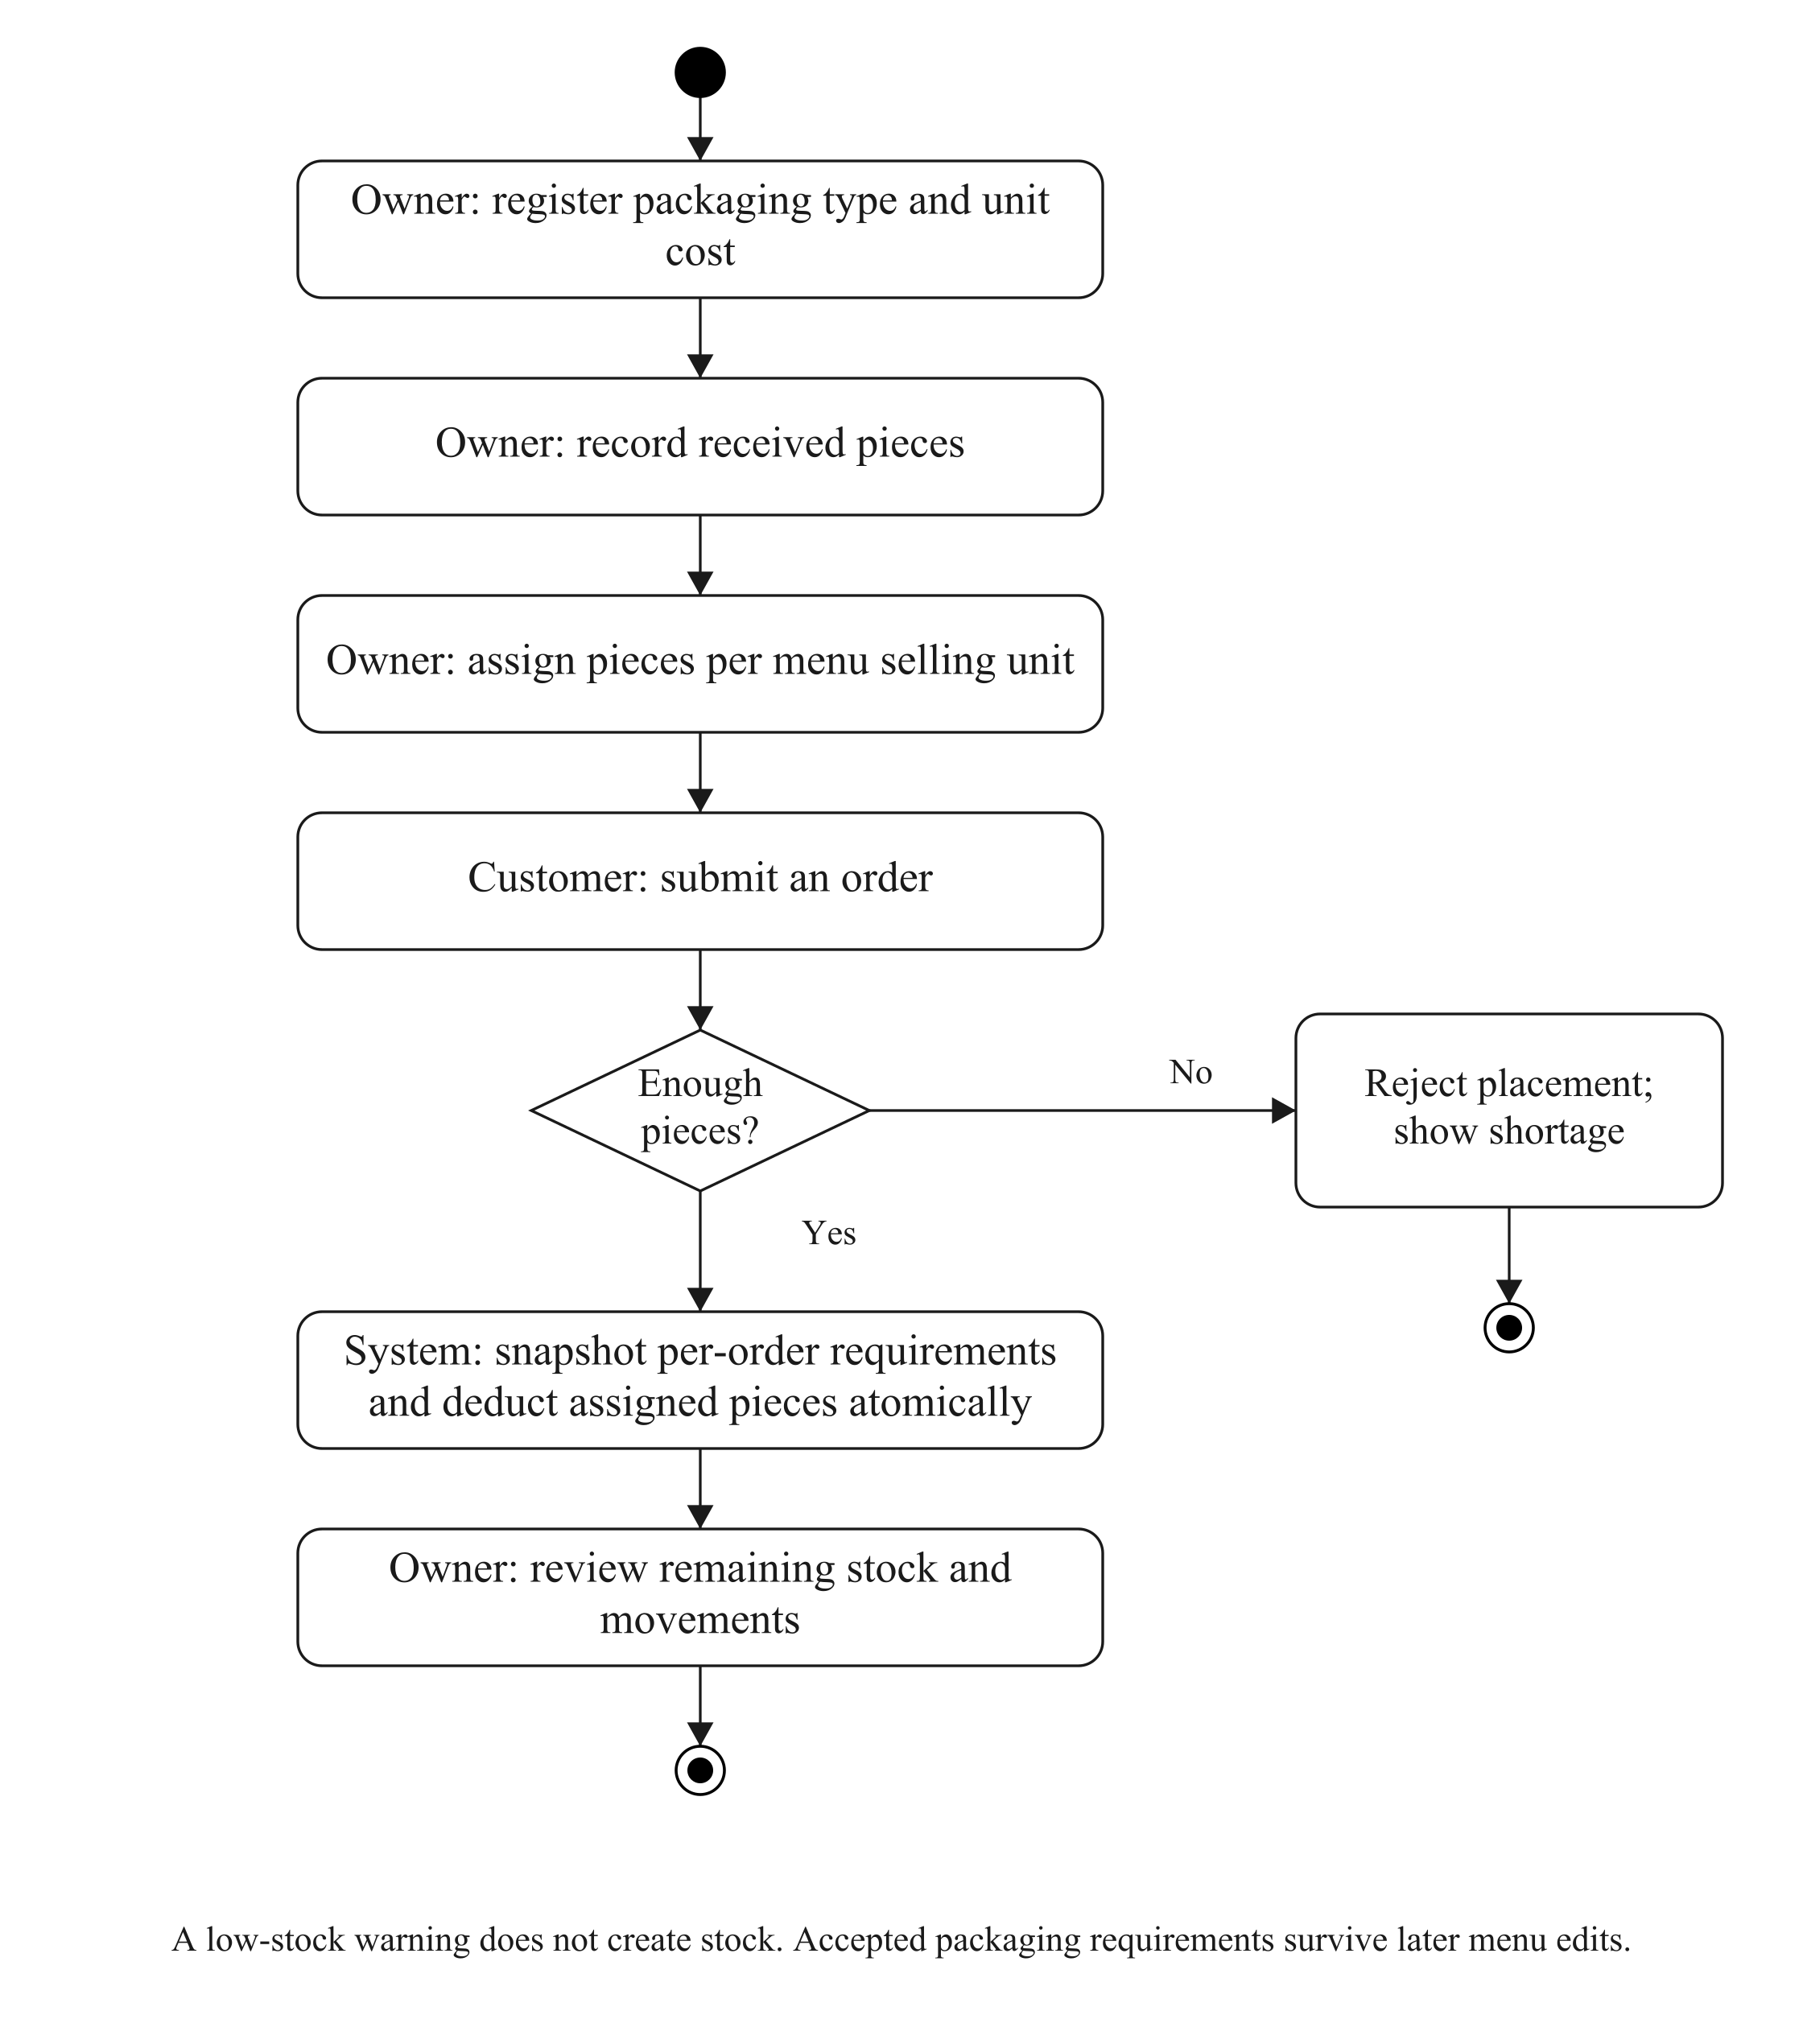
Figure 3.5: Packaging receipts, menu mappings and placement deductions.

3.5.4 ACTUAL FOOD RECEIPT
The owner confirms actual receipt only when the customer has received or collected the food. Several eligible orders can be selected together, but the selected set and current versions must be rechecked. A planned time, bank receipt, reminder or timer cannot establish that the food was received. Corrections and cancellation use their own audited operations.
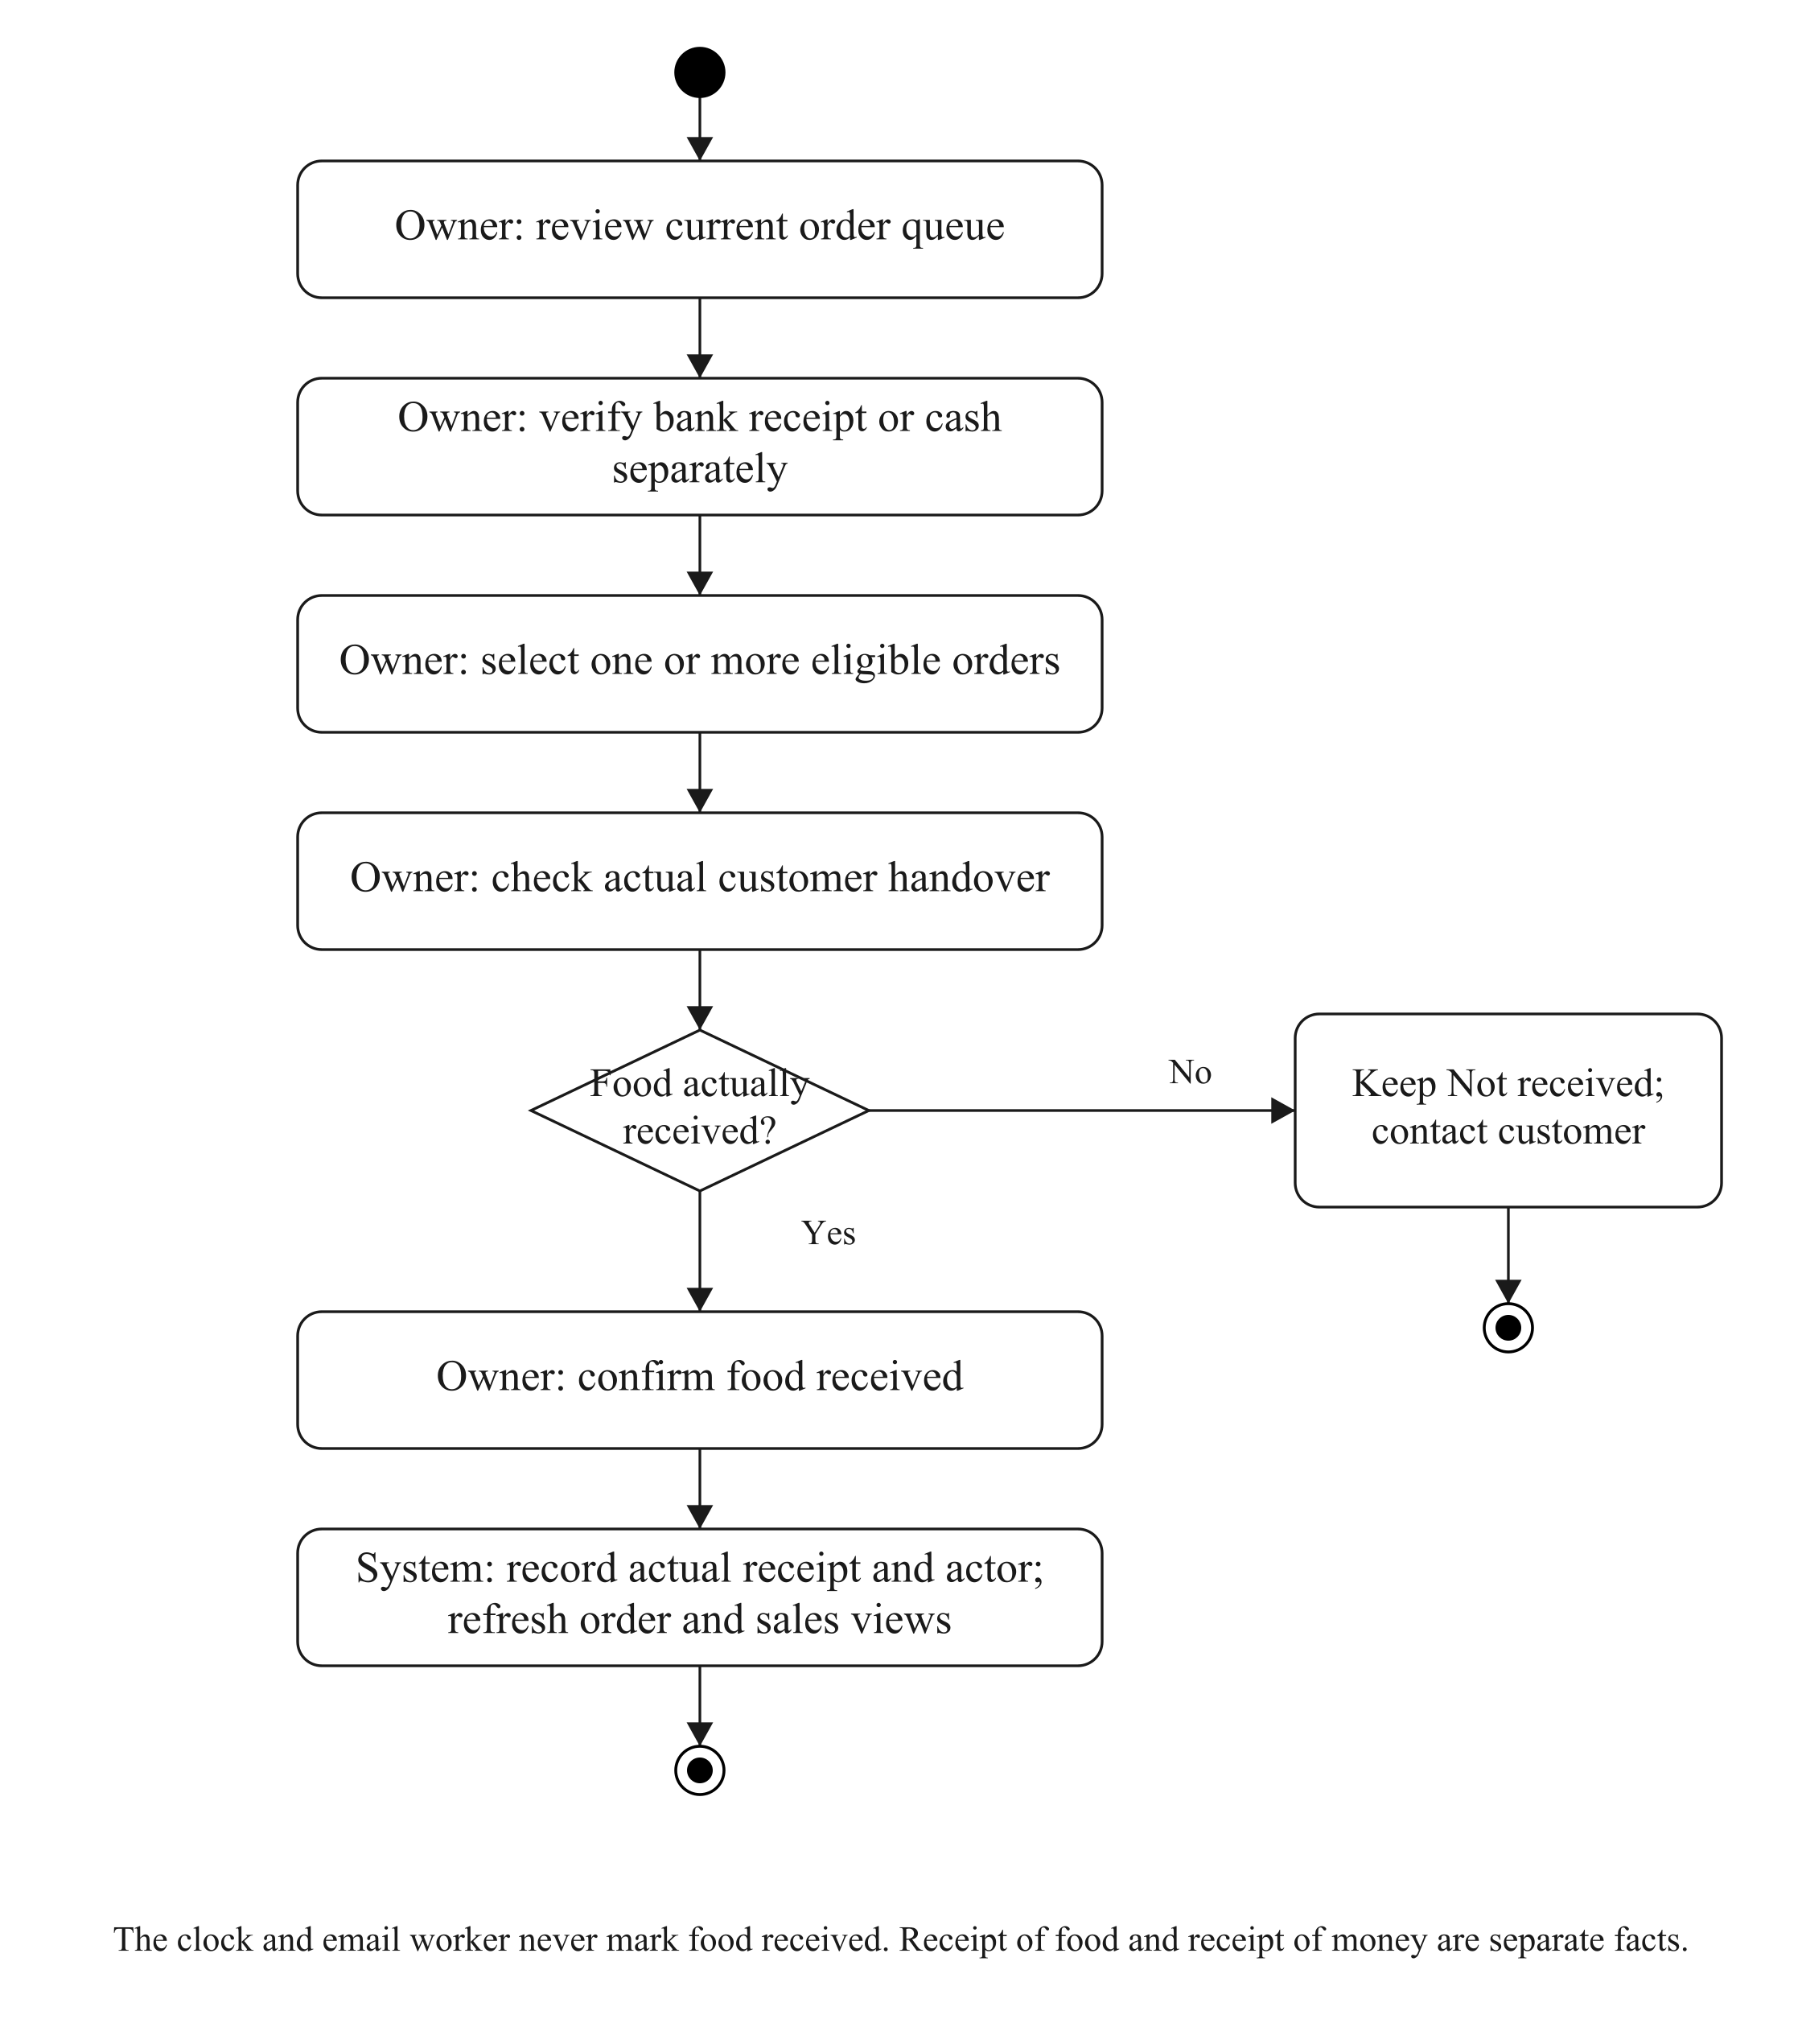
Figure 3.6: Separate payment review and actual customer receipt.

3.6 SEQUENCE DIAGRAMS

3.6.1 CUSTOMER PASSKEY ACCESS
Registration and authentication use session-bound, short-lived WebAuthn challenges. The device obtains user verification and signs a response; Django verifies the relevant challenge, origin, relying party and credential data. The server stores a public key, credential identifier and account association. It does not receive the customer’s fingerprint, face template, private key or device PIN. A matching phone number is not used to take over an existing account.
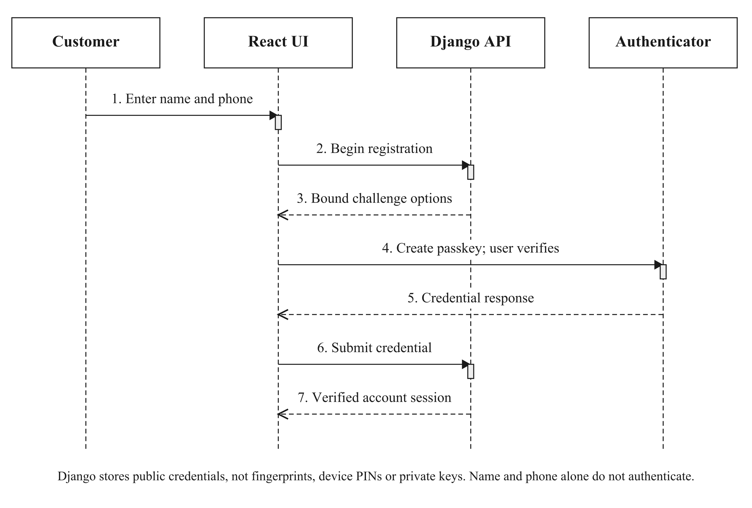
Figure 3.7: Customer passkey registration.
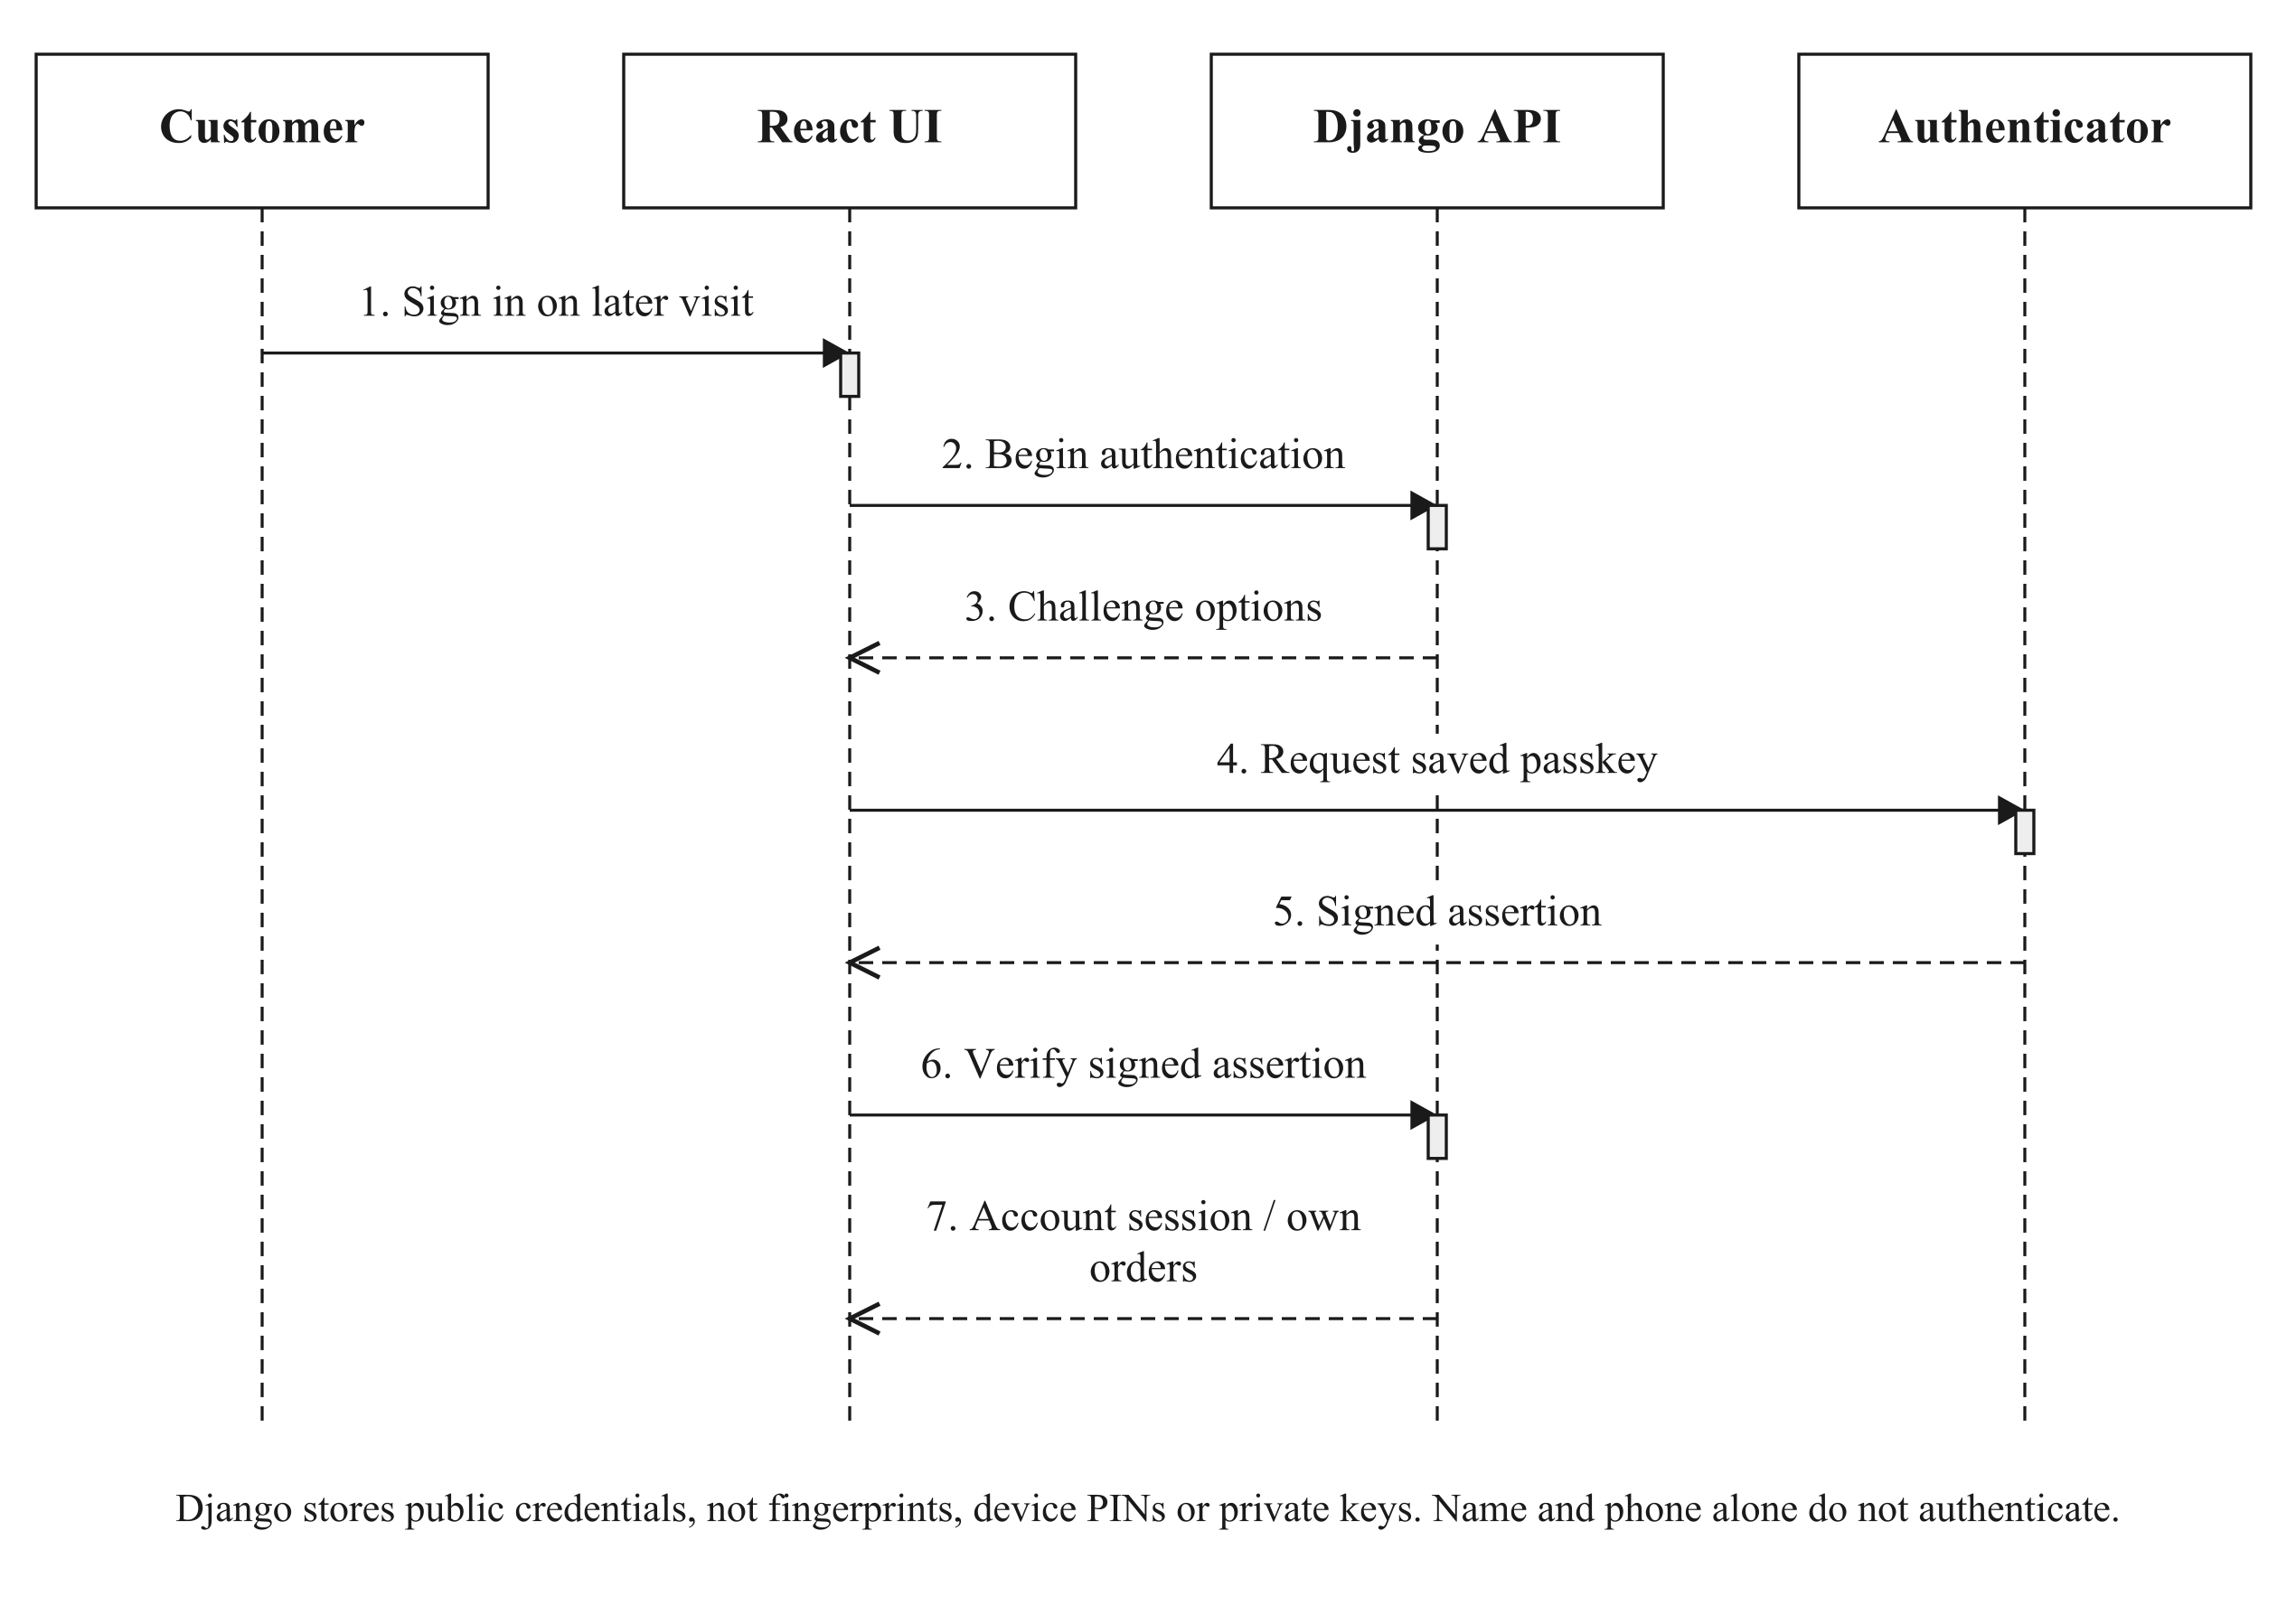
Figure 3.8: Authentication using a saved customer passkey.

3.6.2 QUOTE, PRIVATE PROOF AND ORDER PLACEMENT
The quote is advisory until placement succeeds. Its pricing uses the current basket and fulfilment selection. A receipt upload is authenticated, sanitised and bound to a price/selection scope. Changing the basket, recipient configuration or relevant fulfilment details can require the existing receipt to be reviewed or uploaded again; it must not prompt a second bank payment automatically. Placement uses a request identifier and locks current state so replay does not allocate ingredients or packaging twice.
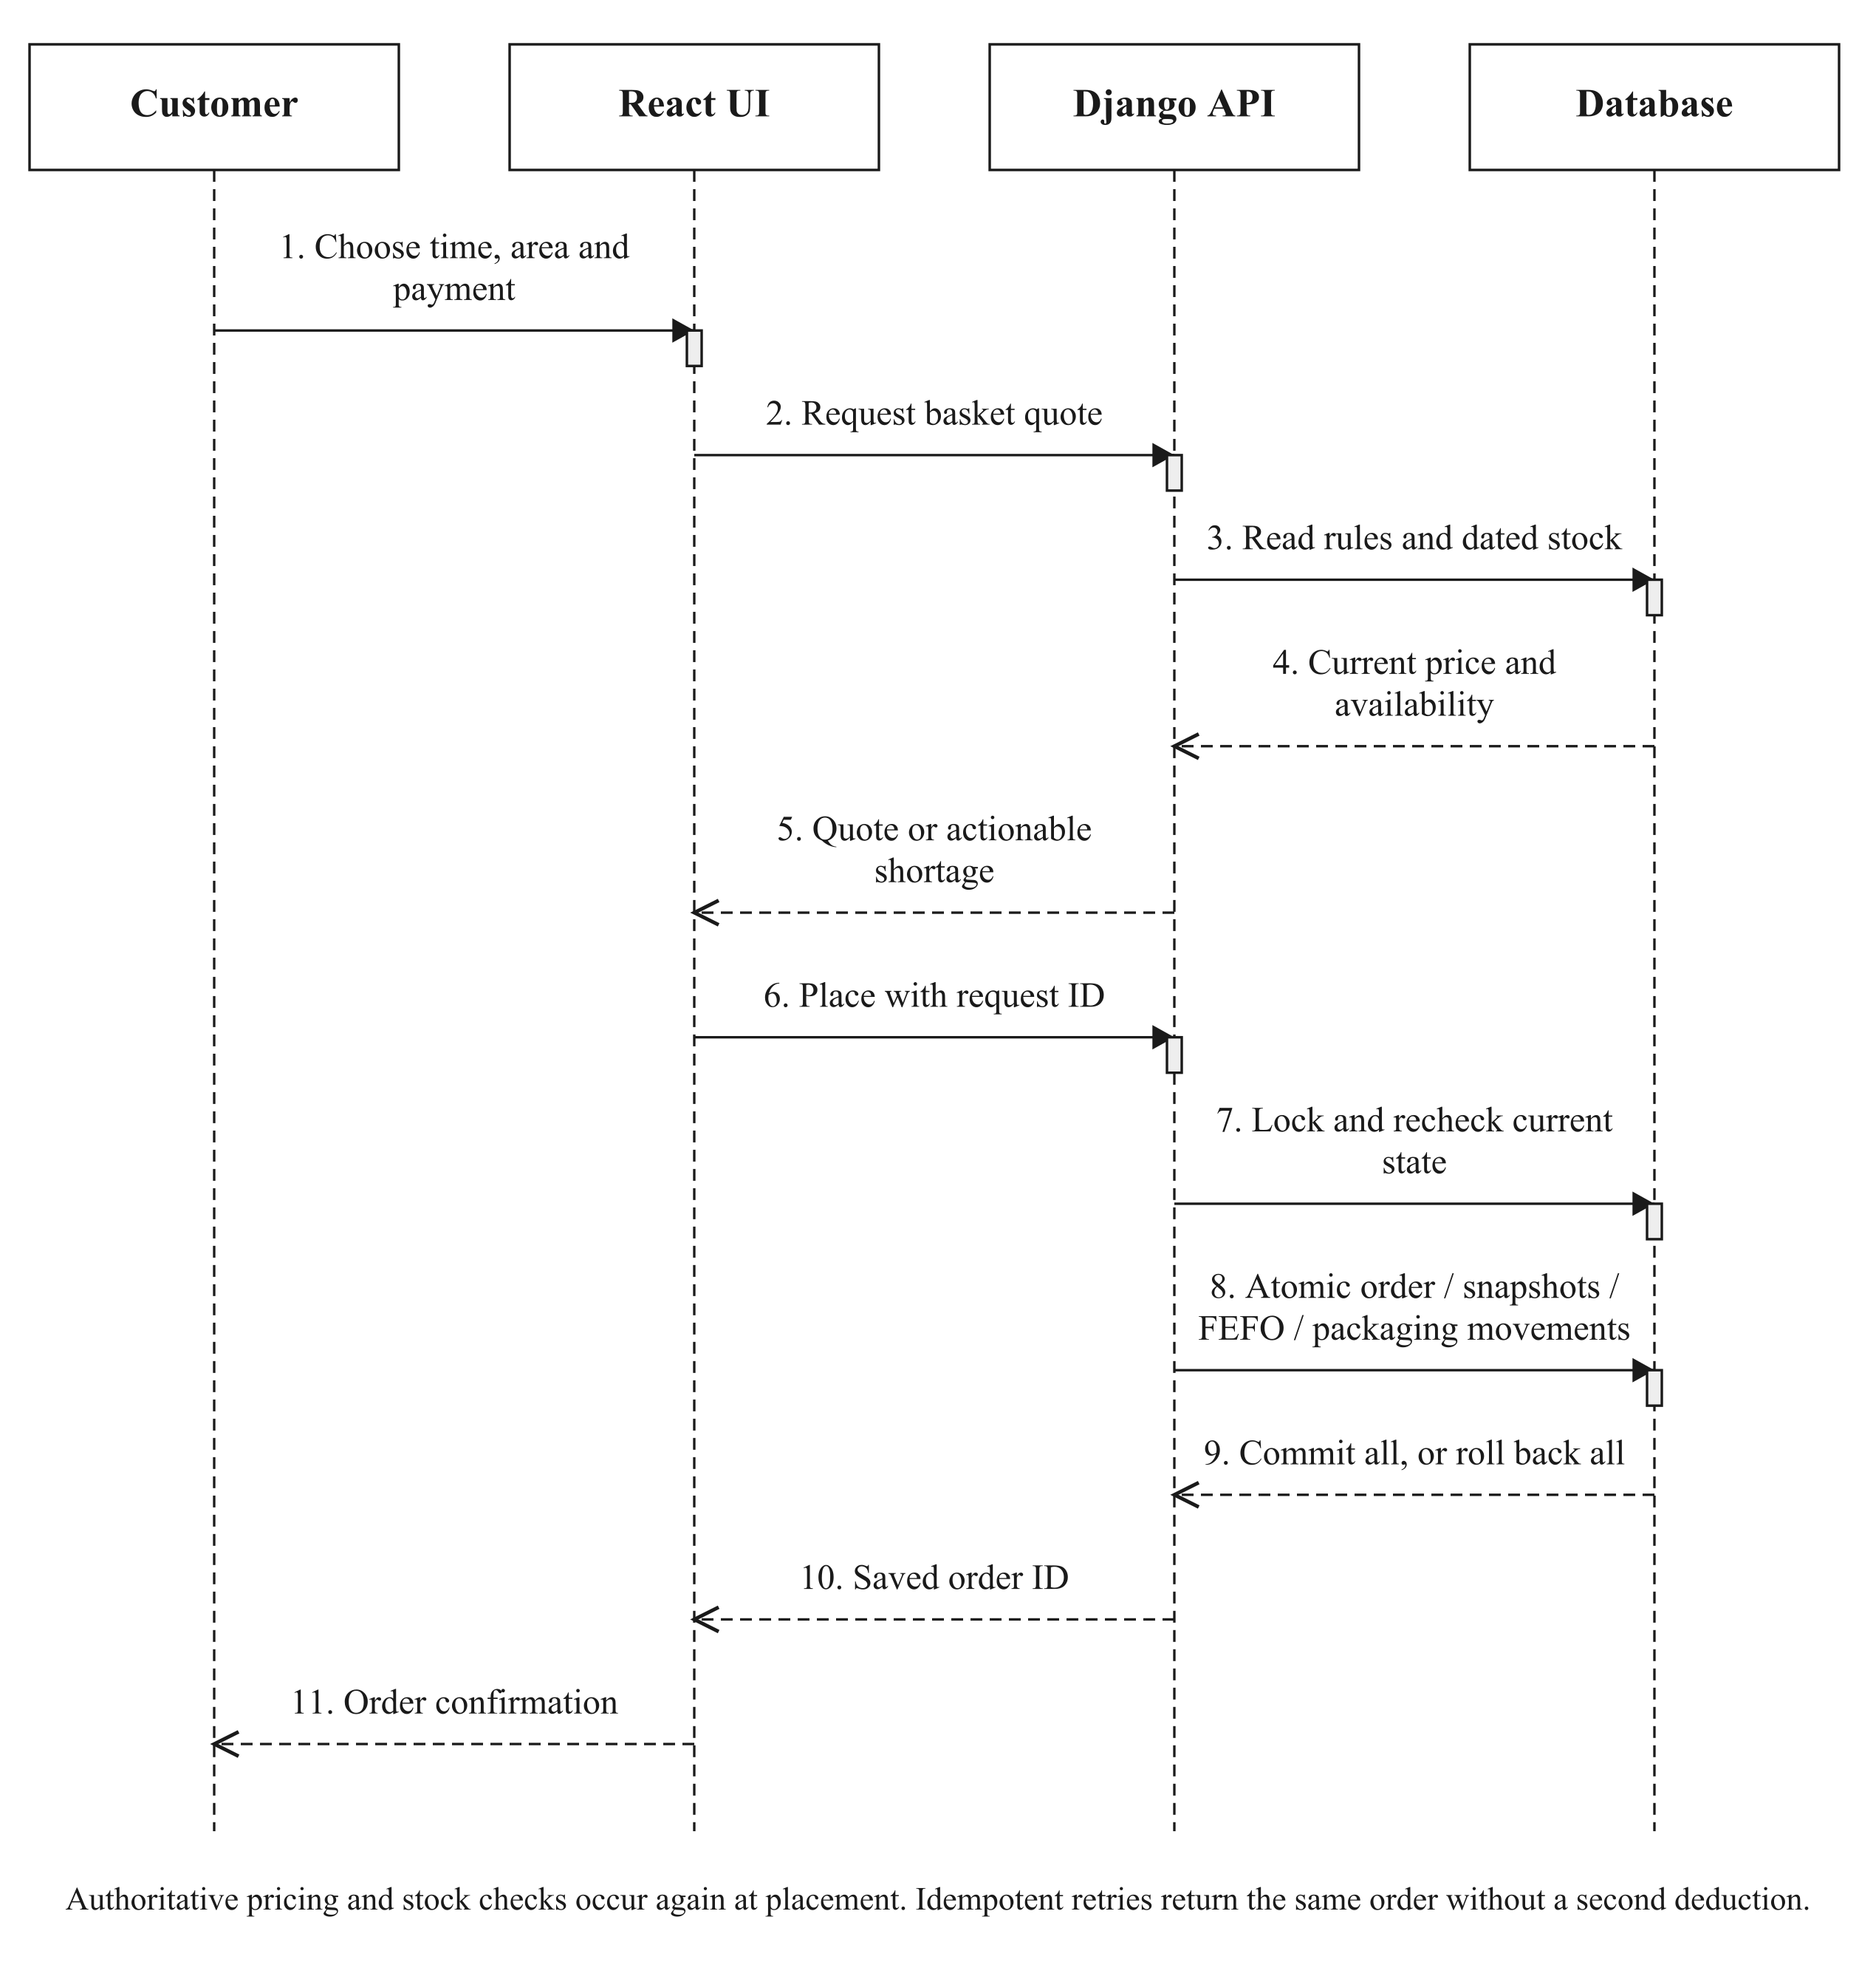
Figure 3.9: Authoritative pricing, scoped evidence and transactional placement.

3.6.3 OWNER PAYMENT VERIFICATION
The kitchen reviews the uploaded image and its bank records outside the website. Recording a completed full receipt creates a payment event and updates the payment state under server validation. A refund record describes money already returned externally; it is not a bank-transfer instruction. The payment operation does not establish physical food receipt.
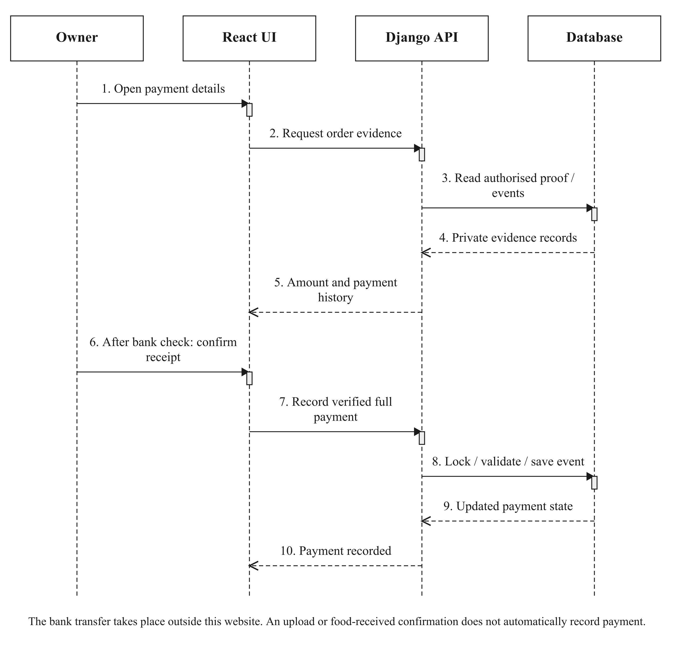
Figure 3.10: Private evidence review and manual payment recording.

3.6.4 REPORTING AND PRINT PREVIEW
Daily reports aggregate accepted line names and quantities for the selected handover date. Sales reporting applies its own paid-and-received inclusion rules. A printable slip uses the saved customer, phone, address and collection/delivery details. Opening its preview does not change the order, and printing starts only from an explicit print action.
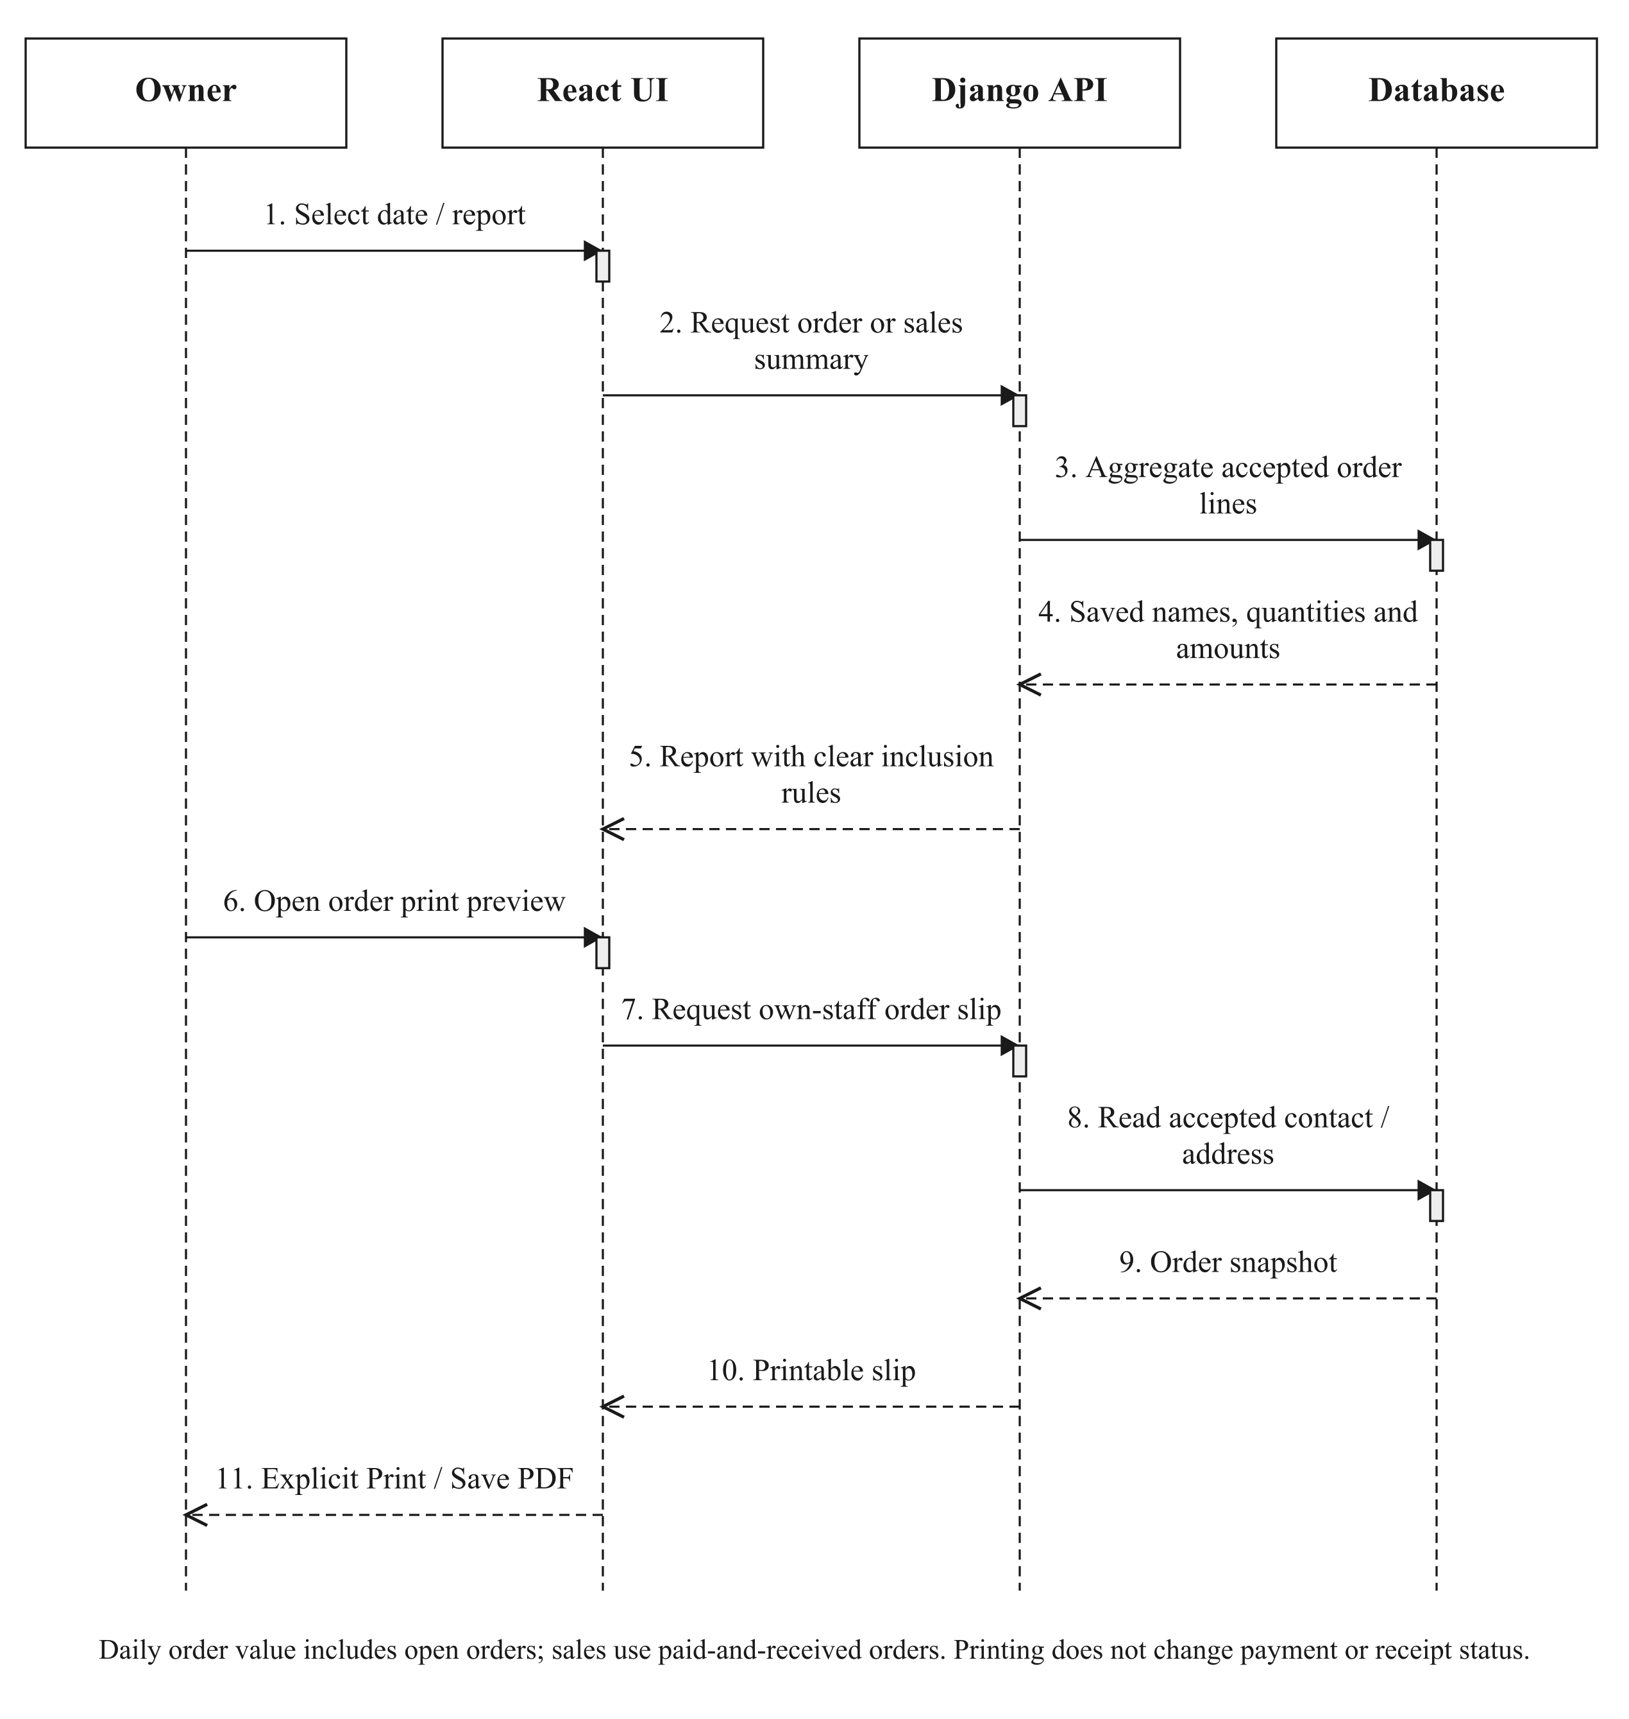
Figure 3.11: Daily/sales reporting and read-only order-slip preview.

3.6.5 OWNER HANDOVER REMINDERS
One authenticated worker checks eligible reminder events. In simple mode, the current owner queue concerns delivery/collection rather than preparation. Successful provider acceptance is followed by a saved reminder receipt; failed attempts can be retried. The worker has a bounded attempt budget. Provider acceptance is not proof of inbox receipt, and a crash between acceptance and saving the receipt can still cause a duplicate on retry.
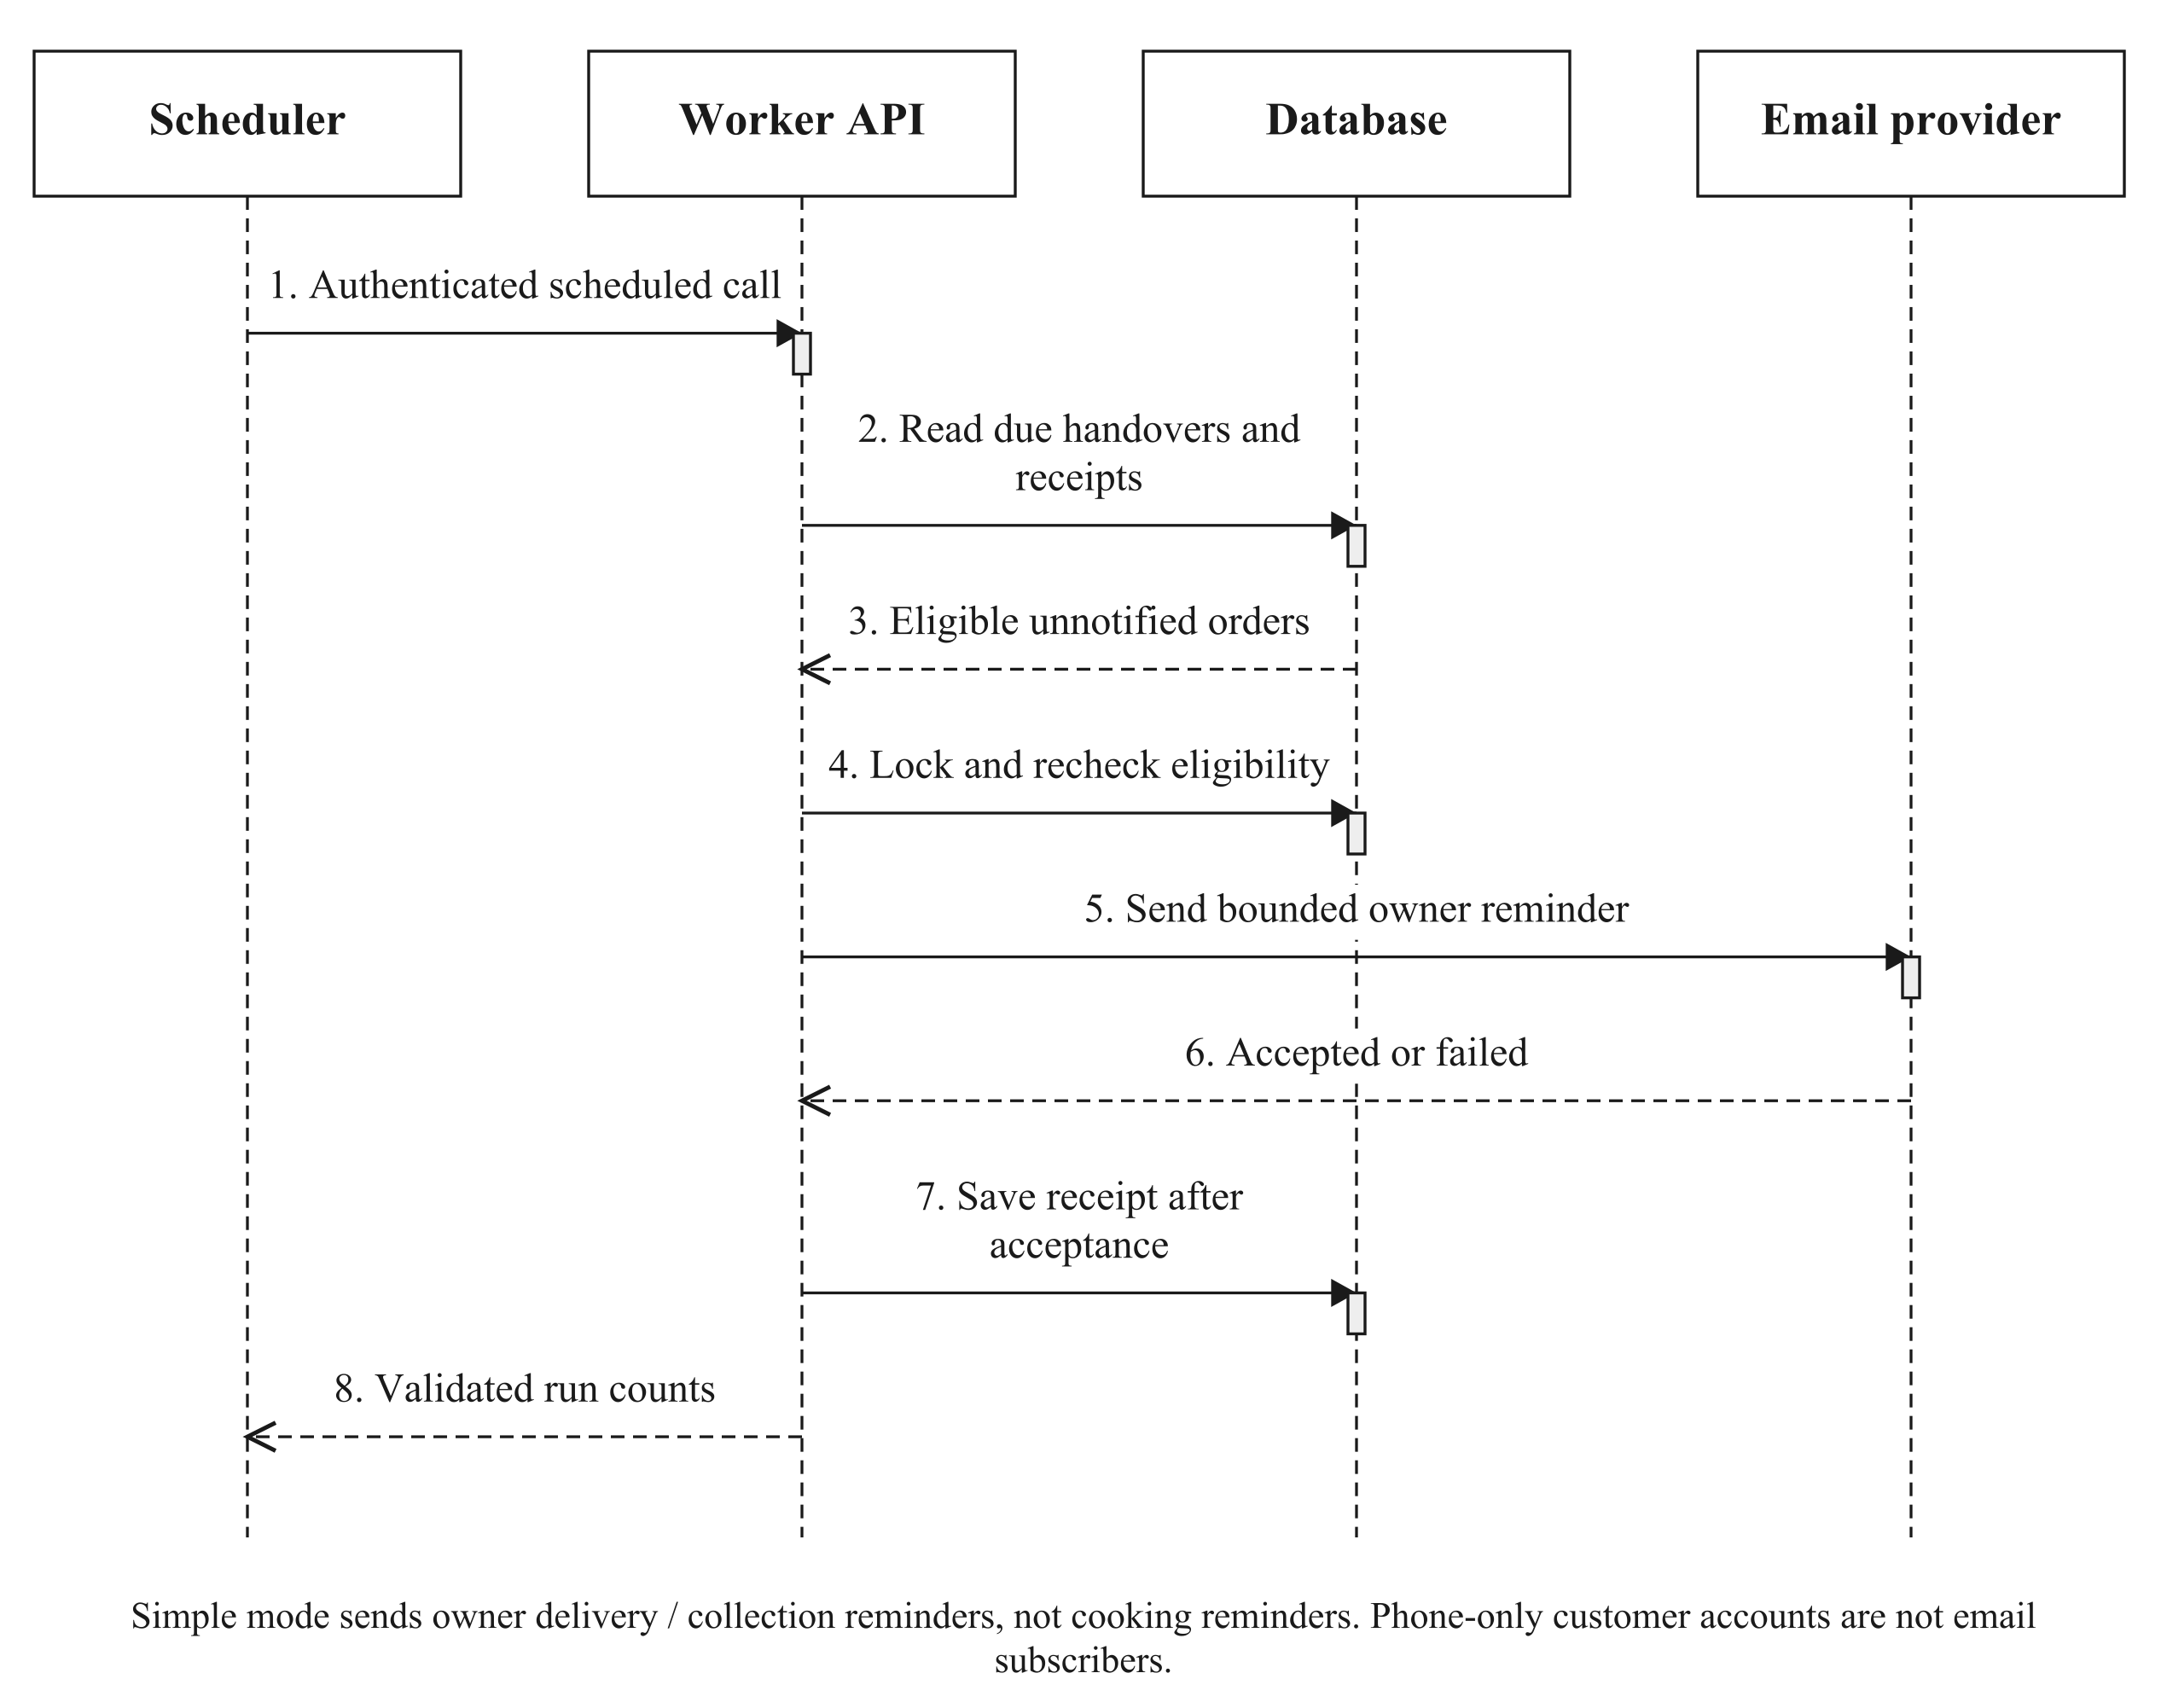
Figure 3.12: Authenticated, bounded owner handover reminder processing.

3.7 CLASS DIAGRAM
Figure 3.13 shows a selected core of the implemented Django domain, rather than inventing a separate class for every screen. Product represents the current menu, while OrderItem records accepted purchase terms. ProductIngredient connects current recipes to RawMaterial; InventoryItem records dated lots. The full application contains additional account, packaging, payment and operational models described in the ERDs and Appendix D. Methods shown correspond to the actual implementation.

3.8 ENTITY–RELATIONSHIP DIAGRAMS
The ERDs show selected attributes and actual relationship columns. Multiplicities apply at the indicated entity ends. Database fields for earlier scheduling, wallet and external-payment experiments still exist for compatibility. Their presence does not imply that those methods are available in the current client checkout. Appendix D distinguishes current and supporting/legacy models.

3.8.1 IDENTITY AND ACCOUNT ACCESS
Django’s auth_user remains the underlying identity table. A browsing session can use an opaque GuestCustomer identity with an unusable password. A registered customer has a CustomerAccount and one or more public CustomerPasskey credentials. PasskeyCeremony binds a short-lived action to its session and, where applicable, user. Staff continue to use the protected staff credential flow. Address is retained as a supporting/legacy address entity, while current orders preserve accepted contact/address snapshots.

3.8.2 CATALOGUE, RECIPES AND INVENTORY
A category contains current menus. A recipe joins a menu and ingredient with a positive quantity in that ingredient’s inventory unit. A material can have many dated batches and each batch can have many inventory log entries. Batch quantity and date eligibility are authoritative for the stock check; a displayed stock-supported menu quantity is derived, not a second manually maintained physical count.

3.8.3 ACCEPTED ORDERS AND CONSUMPTION
OrderItem has both a nullable Product foreign key and its own product_name, unit_price and quantity. History displays the saved name and price, so a menu rename does not rewrite a previous purchase. OrderIngredient preserves the accepted recipe requirement. IngredientConsumption records actual batch allocations against order items, including quantity, cost and recorded expiry evidence. CheckoutProof is private evidence belonging to its user and, after acceptance, its associated order.

3.8.4 PACKAGING RELATIONSHIPS
ProductPackaging defines the current per-menu requirement. OrderPackaging preserves the accepted per-order-line requirement, including the packaging name and cost where known. PackagingMovement records stock changes and can refer to an accepted packaging allocation. Names and quantities are deliberately snapshotted so later catalogue edits do not alter history.

3.8.5 FINANCIAL AND AUDIT RECORDS
PaymentEvent stores completed/pending/failed receipt or refund evidence. OrderAmendment stores the actor and before/after documents for relevant corrections. OperatingExpense records overhead rather than ingredient purchases. WasteRecord associates discarded quantities and estimated cost with an inventory batch. These records support an audit trail; they do not replace bank reconciliation or establish net profit.

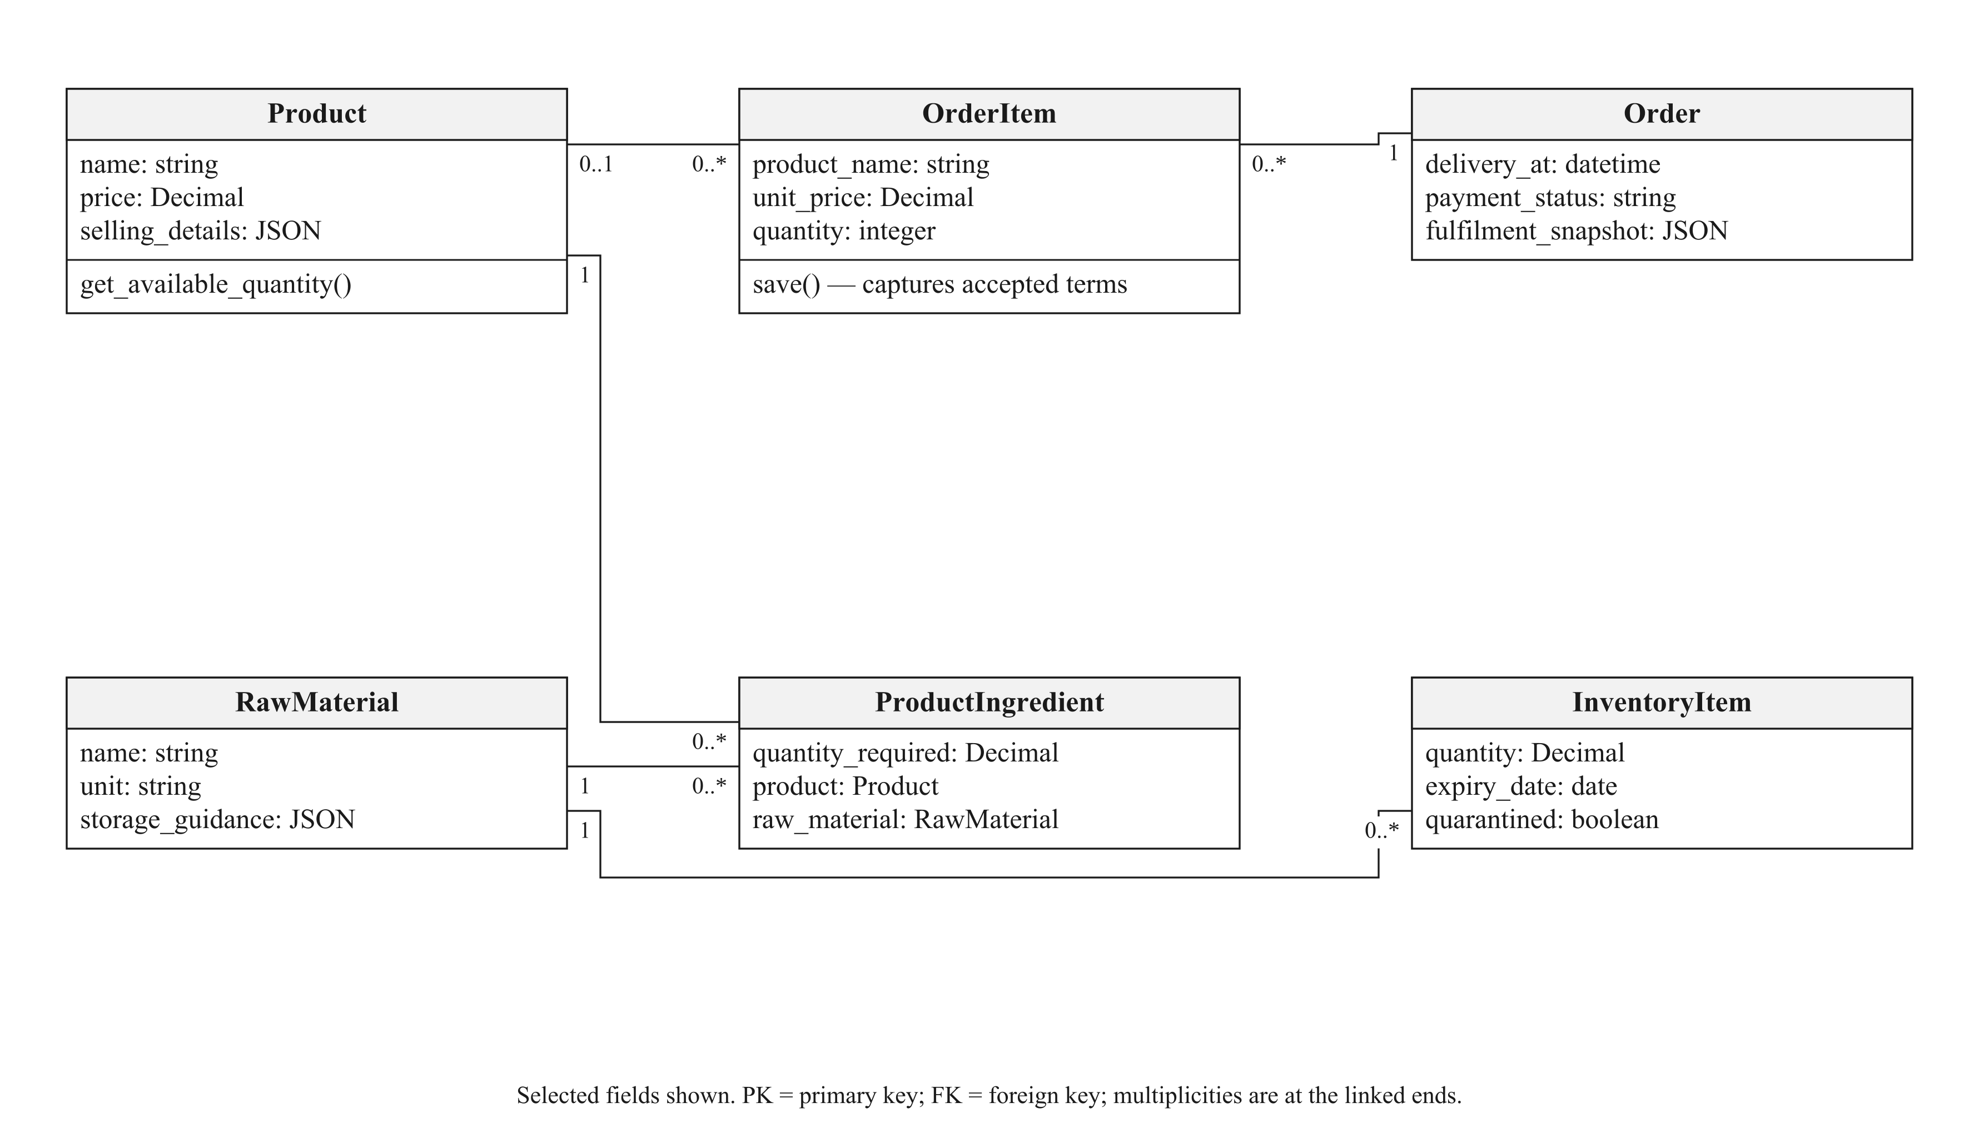
Figure 3.13: Selected core domain classes and their associations.

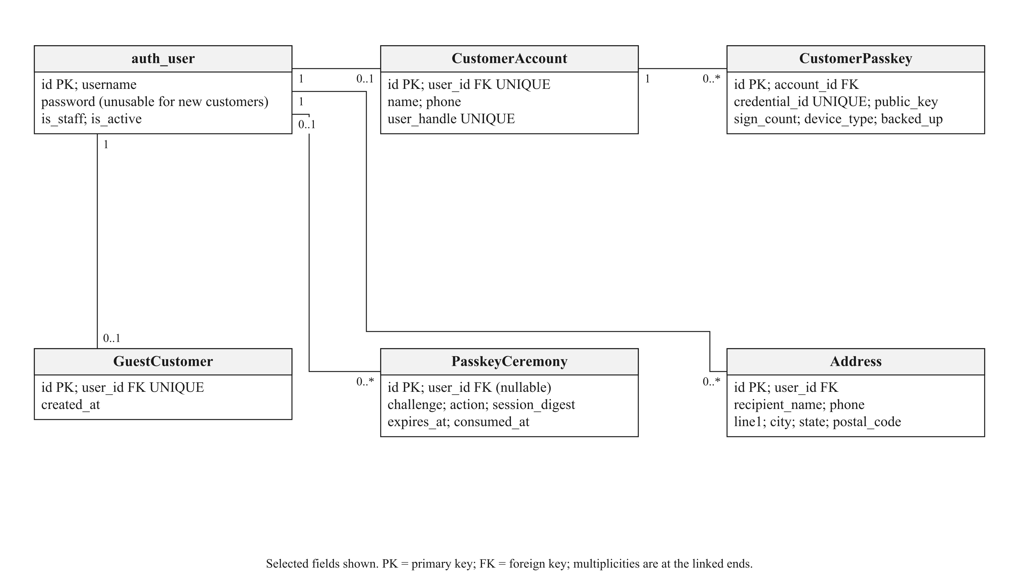
Figure 3.14: Identity, customer profile and passkey records.

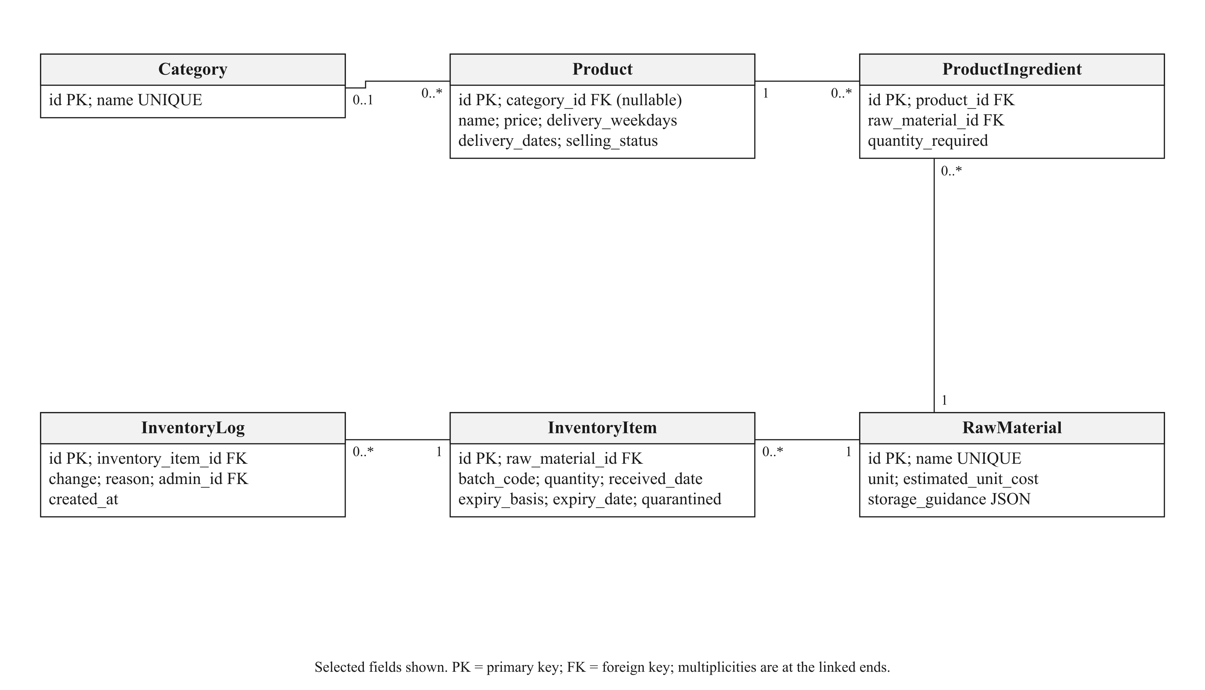
Figure 3.15: Catalogue, recipe, batch and inventory-log relationships.

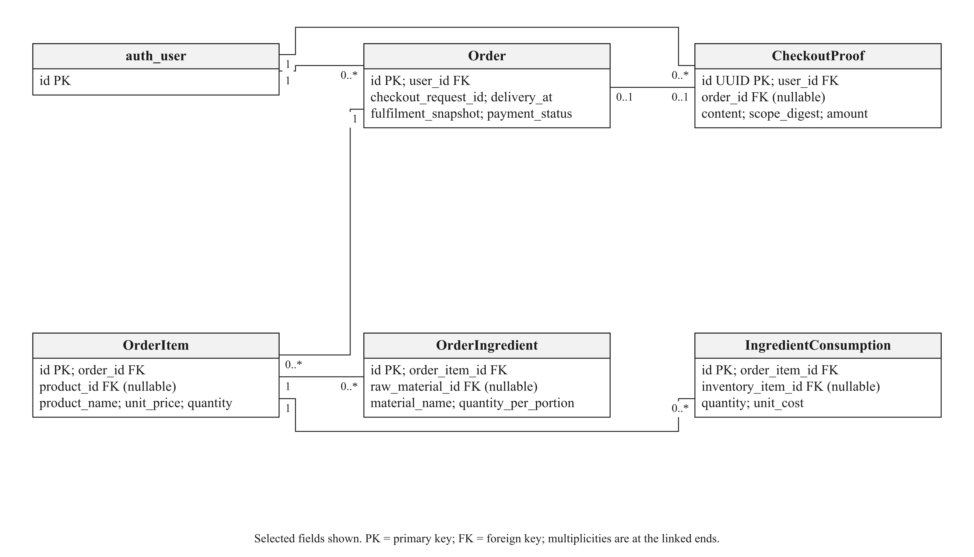
Figure 3.16: Accepted order terms, private proof and ingredient allocation.

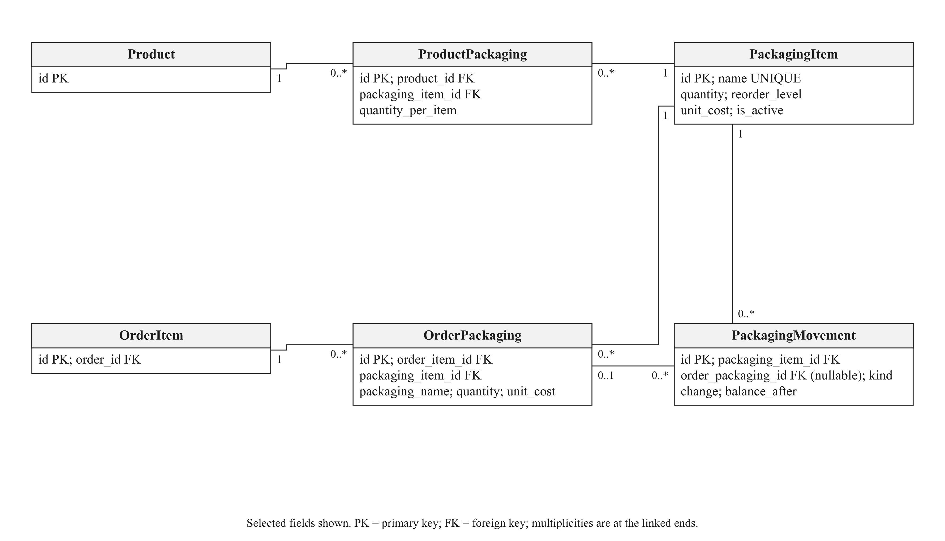
Figure 3.17: Current and accepted packaging requirements and stock movements.

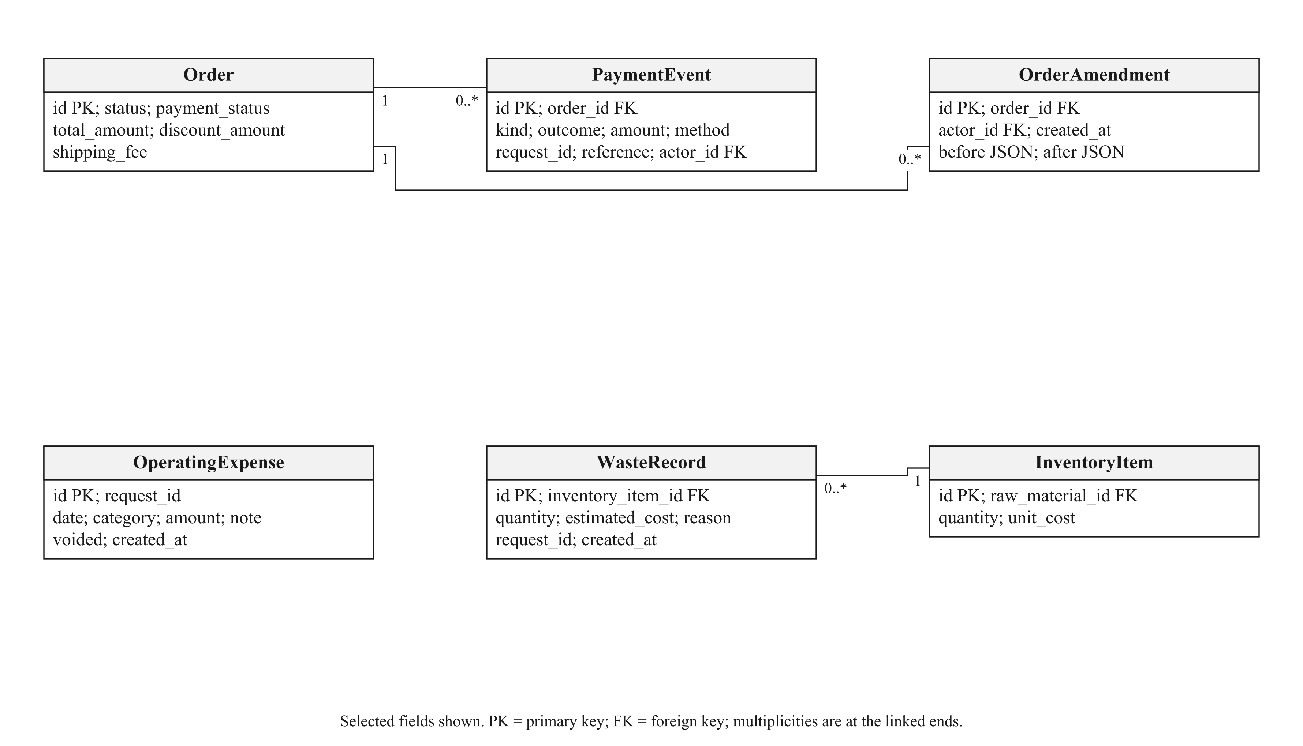
Figure 3.18: Payment, amendment, expense and wastage evidence.

3.9 REQUIREMENT TRACEABILITY AND DESIGN LIMITS
The first objective is realised through permitted future handover dates, editable delivery/collection hours and date-dependent menu checks. It does not require automatic cooking-task allocation after the client removed that workflow. The second objective is implemented through recorded shelf-life evidence and storage duration; it is not a sensor-based food-safety claim. The single-vendor storefront supports the third objective. Sales and cost evidence support the fourth, and the two recommendation surfaces implement the fifth. Whether recommendations reduce decision time or increase conversion must be evaluated with users rather than inferred from successful test requests.
The design intentionally leaves transfers, rider booking and physical handover outside automatic verification. It provides clear records and contact routes around those activities. Supported browser/device access, honest stock records, correct ingredient quantities and owner configuration remain prerequisites. Chapter 5 identifies the checks performed and the empirical claims that remain unmeasured.

3.10 CONCLUSION
The revised design reflects the client’s simpler ordering model while keeping the original project objectives. Accepted-order snapshots protect historical terms, and the placement transaction coordinates ingredient and packaging records. The next chapter explains the implemented interfaces, calculations and development decisions using this design.

CHAPTER 4
INTERFACE AND SYSTEM IMPLEMENTATION

4.1 INTRODUCTION
The implemented application combines a customer storefront and a staff workspace for Wrap & Bowl Kuch. This chapter describes the current source revision, 6edde5e, rather than the earlier Dapur Kita report baseline. The client’s public menu poster and founder story supplied the business identity, eight products, advertised prices and offered days. The project author authorised editable recipe estimates, standard packaging assignments and fictional operational records for demonstration and testing. These are implementation inputs, not measured production yields, actual sales or certified storage guidance.
The supplied senior report organises its interface chapter around customer and administrator tasks. This chapter follows that useful structure while also explaining the development decisions and problems highlighted by the briefing rubric. The screenshots are actual retained browser captures from isolated developer scenarios, not hand-drawn interface mock-ups. Desktop and phone views use ordinary viewport captures; an order-slip image is a print preview. Different captures document different development checks, so they are not presented as photographs of the client’s live database or as proof that the latest Vercel deployment was observed.

4.2 APPLICATION ARCHITECTURE AND TECHNOLOGY
React renders the storefront, account dialogs and staff pages. Django with Django REST Framework validates requests, authenticates sessions, calculates prices and enforces stock/order rules. PostgreSQL, hosted through Supabase for the deployed setup, provides persistent application records. Vercel hosts the application deployment; it is not a substitute database for the order and inventory tables. Local verification uses isolated SQLite, with PostgreSQL-specific tests identified separately. Session writes use CSRF protection and privileged operations require the appropriate staff role.

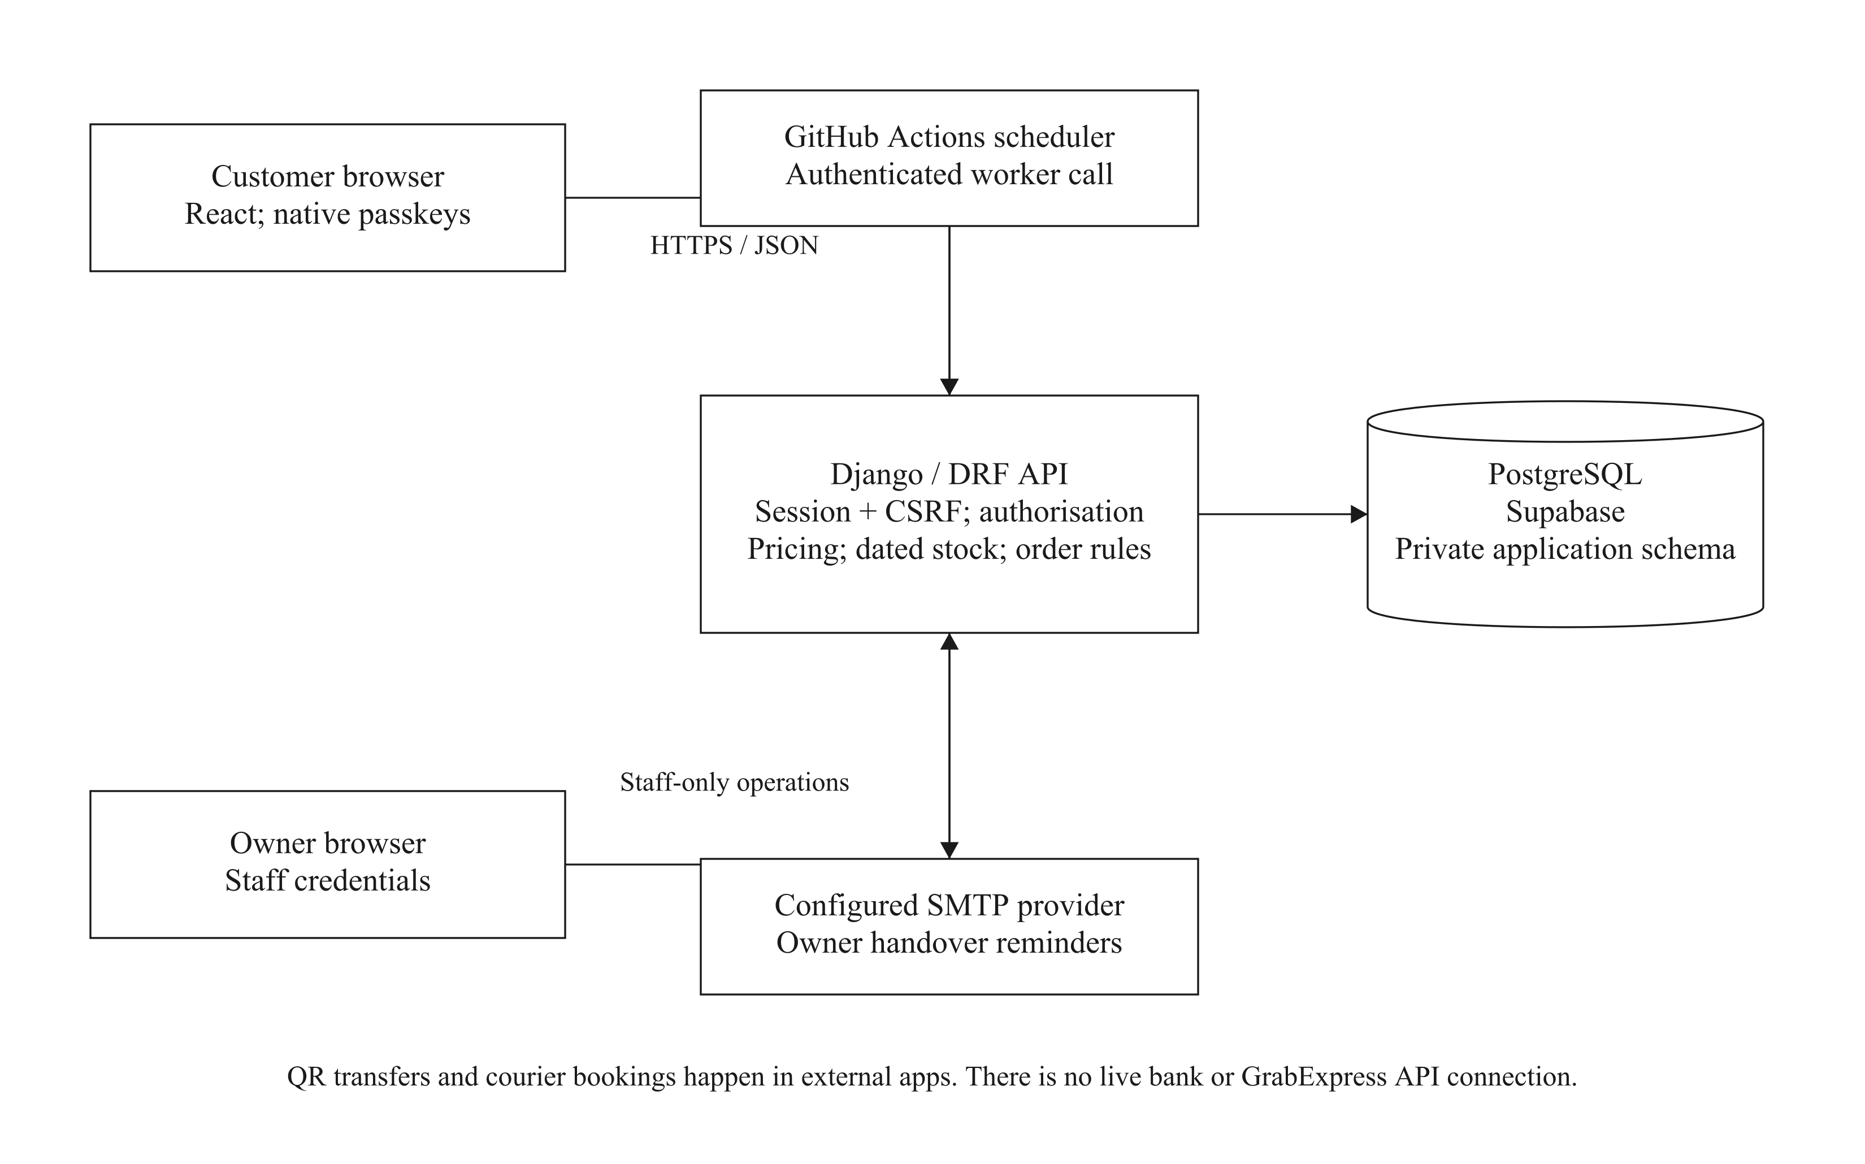
Figure 4.1: Current customer/staff application architecture and external boundaries.

The architecture keeps user-interface convenience separate from authority. A disabled button is helpful feedback, but it does not replace server validation. A client-supplied total is compared against server-calculated prices. Stock is rechecked at acceptance, receipt images are served privately, and a customer cannot read another customer’s history by changing an identifier. Request cancellation and session-current guards prevent late responses from repopulating data after an account change.
Table 4.1: Technology responsibilities in the current implementation
Component | Responsibility | Important boundary
React and React Router | Responsive pages, dialogs, form feedback and navigation | Client state does not authorise a payment or stock mutation
Django / DRF | Sessions, role checks, validation, pricing and transactions | Current rules are enforced again on submission
PostgreSQL / Supabase | Orders, accepted terms, stock, public credentials and evidence | Private application tables and binary proof are not public download folders
Native WebAuthn | Device-mediated customer registration and sign-in | The website never receives biometric templates or a device PIN
SMTP and scheduled worker | Bounded owner delivery/collection reminders | An accepted send is not an inbox or delivery guarantee
External banking/courier apps | Actual transfer and rider booking | There is no active bank reconciliation or GrabExpress API integration

4.3 CLIENT REQUIREMENTS AND DEVELOPMENT ITERATIONS
The original system explored detailed kitchen scheduling and additional payment mechanisms. The client’s requirements shifted the operating interface towards a Google-Form-like contact experience, morning preorders and simpler fulfilment handling. The implementation retained security through passkeys rather than allowing anyone who knows a phone number to open that person’s order history. It also retained the recipe records needed for ingredient calculations while removing cooking-plan confirmation from the client’s normal workflow.
The changes were delivered in reviewable increments. Packaging stock and order allocations were introduced alongside placement deduction. Reporting added daily menu-unit totals, paid/received sales and a preview-first print slip. Follow-up iterations synchronised area fees and checkout totals, corrected phone formats, preserved profile defaults, required the customer account before ordering and clarified the distinction between received food and received money. Later interface passes reduced dense settings content, moved date selection to checkout, aligned inputs/actions and repaired dialog scroll-lock cleanup.
Table 4.2: Representative development problems and implemented responses
Observed issue | Implemented response | Verification approach
Contact-only login could expose another account | Native passkey authentication; phone remains contact information | Challenge/origin/signature/session tests and virtual-device browser flows
Delivery fee looked free after an area selection | Authoritative area pricing, refresh state and stale-total rejection | Quote/proof/placement reconciliation and browser checks
Ingredient and packaging records could diverge from ordering | Shared accepted requirements and transactional placement allocation | Exact stock-deduction, rollback and replay tests
Customer could choose an unoffered day | Shared basket ordering-day guidance and upcoming date shortcuts | Weekday intersection, invalid-date and quote-clearing checks
An uploaded proof was confused with paid status | Explicit unverified evidence and separate owner payment recording | Permission, private-file and payment-event tests
Admin sign-in occasionally left scrolling disabled | Shared dialog scroll-lock ownership and final-owner cleanup | Both dialog closing orders, repeated switches and actual wheel scrolling
Stock-check form labels and action were unclear/misaligned | Date to check, Units per menu, target example and scoped grid | Measured desktop/tablet alignment and stacked phone controls

These iterations are evidence of a responsive development process. They do not establish that all usability defects have been eliminated. The client acceptance form and customer task study in Chapter 5 provide a route for checking the revised interfaces with the intended users.

4.4 CUSTOMER INTERFACES

4.4.1 BRANDED STOREFRONT AND MENU
The storefront presents one kitchen’s identity without competitor listings. Settings supply the kitchen name, introduction, founder name, story, food philosophy, signature food, service-area description and contact route. The case-study story identifies Ayu Shafinaz and describes the cooking hobby that became Wrap & Bowl Kuch. No founder photograph or nutritional certification is invented. Illustrative menu graphics can be replaced through the menu photo upload controls.
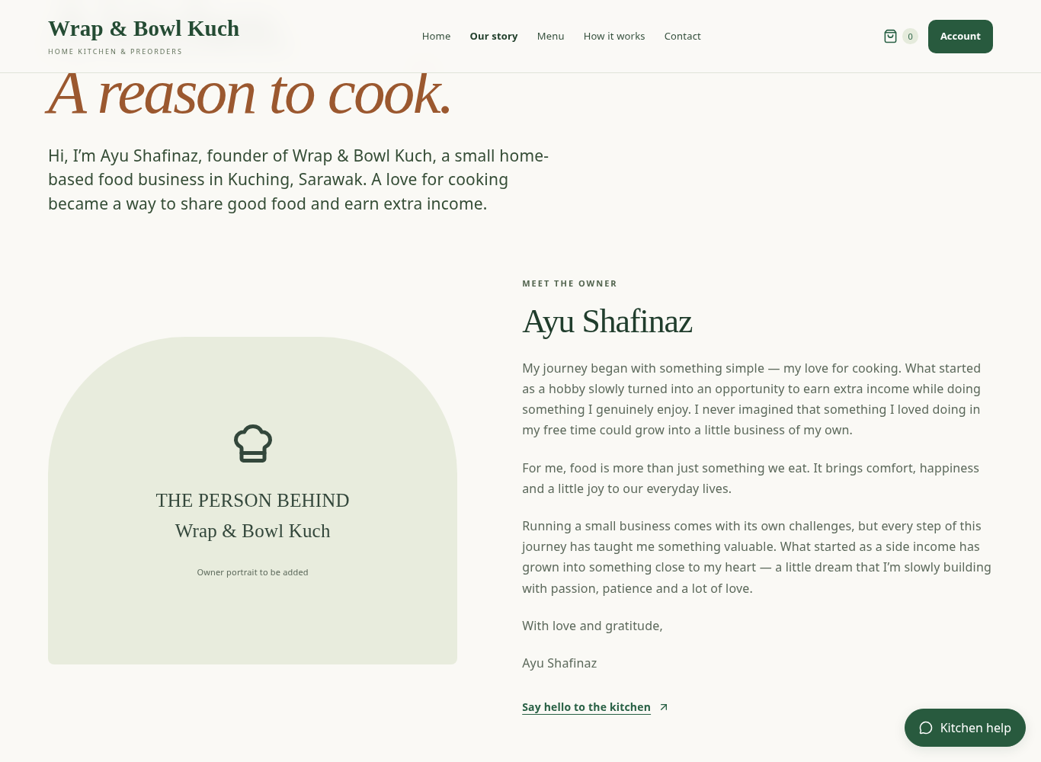
Figure 4.2: Founder-story page using the client-supplied business introduction (local developer capture).
The eight-menu catalogue contains Chicken Grilled Salad (RM13), Chicken Popcorn Salad (RM13), Eggsquisite Salad (RM12), Beef Sukiya Salad (RM18), Wanpaku Chicken Katsu (RM12), Wanpaku Chicken Grilled (RM12), Salmon Grilled Salad Bowl (RM28) and Sukiya Beef Rice Bowl (RM20). The first seven are offered Monday–Friday; the rice bowl is Monday only in the supplied menu. Categories group the catalogue into salad bowls, sandwiches and rice bowls. These settings remain editable by the owner.
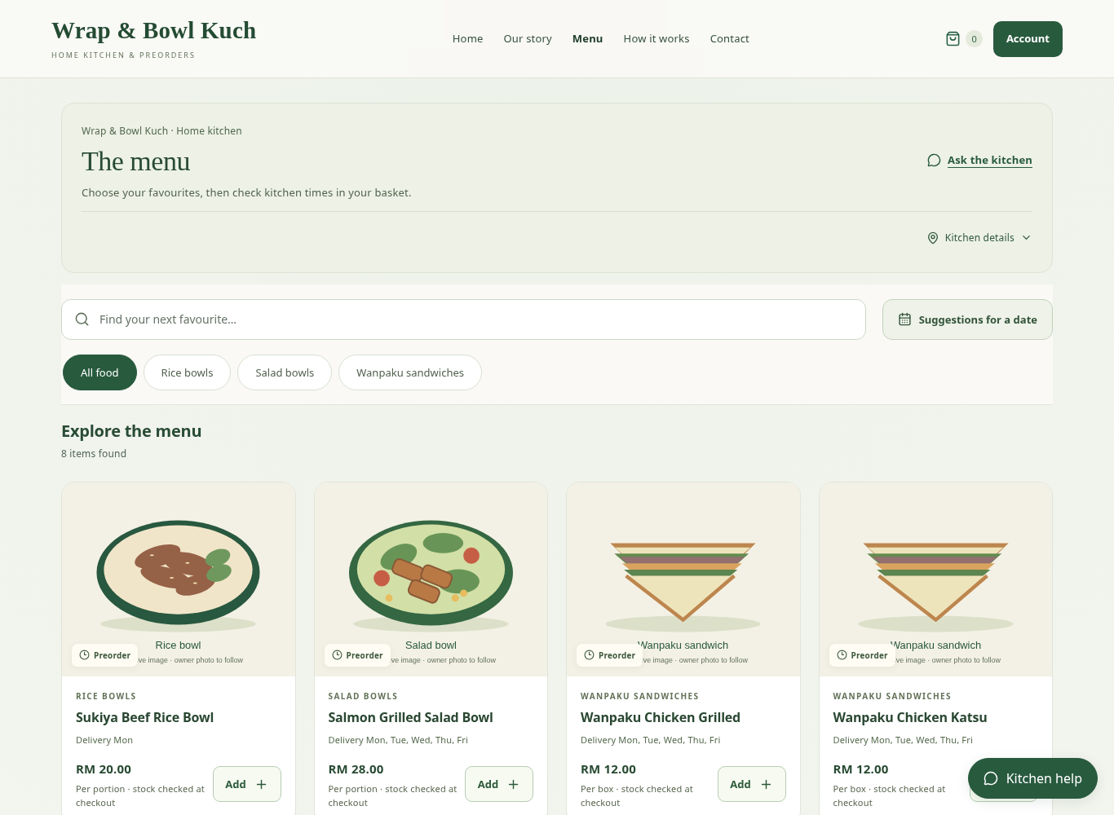
Figure 4.3: Client menu, category filters and food cards with illustrative images.
Search and category filters support direct browsing. A card presents its selling unit, price and availability information before the add action. A quantity already in the basket can be shown as a quantity control rather than another unexplained Add button. Stock-supported units are calculated from recorded ingredients and packaging and shared across menus; adding one menu can affect the supportable quantity of another. The displayed quantity is therefore an indication, while checkout checks the complete basket.
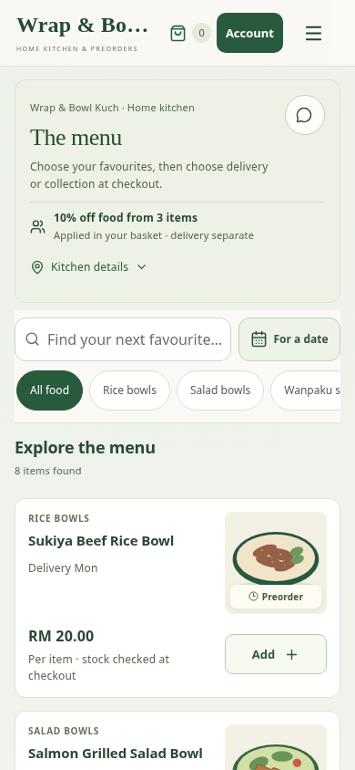
Figure 4.4: Ordinary phone-viewport menu capture with compact cards and basket access.

4.4.2 CUSTOMER ACCOUNT AND STAFF ACCESS
Public browsing can start without customer registration. Before placing an order or uploading private payment proof, the customer creates or signs into a passkey account. Registration collects a name and full phone number, then opens the browser/device passkey ceremony. Malaysian local and international spellings are normalised consistently. A prefix such as 011 alone is incomplete; a full valid number is required. The phone is stored as a contact route, not authenticated through SMS.
The device may use a fingerprint, face verification, screen-lock PIN or security key as supported by its passkey manager. The user does not need to memorise a website username and password. That convenience depends on a compatible device/browser and access to a saved or synchronised passkey. Backup passkeys and an explicit sign-in path are important because a name and phone number alone cannot securely recover an account on a different device.
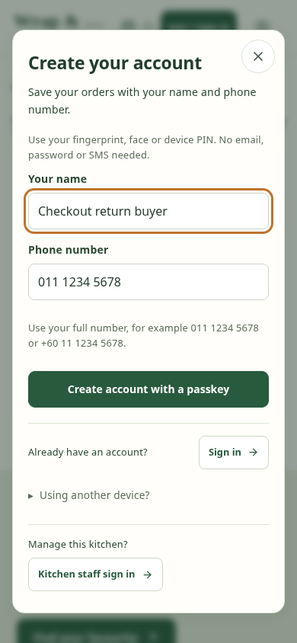
Figure 4.5: Customer name/phone and passkey account dialog (ordinary phone capture).
Staff access is intentionally separate. The kitchen signs in with its existing staff username/email and password. The dialog provides a clear return to customer account creation and blocks dismissal while an authentication write is pending. Staff password recovery depends on a configured recoverable staff email and working mail setup; it is not recovery for a phone-only customer passkey. Returning between dialogs preserves an unsent customer draft during that session, while closing the customer dialog clears it.
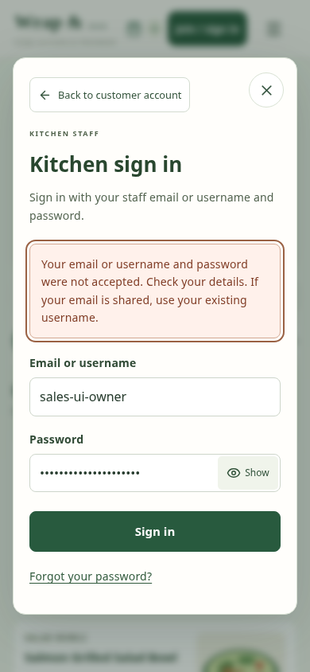
Figure 4.6: Separate kitchen staff sign-in and explicit customer-account return control.
The customer account page shows saved profile details and public passkey records. Adding a backup key or changing sensitive profile data requires recent native verification. Removing a key identifies the selected key and preserves access to the last remaining key. The application does not provide a staff shortcut that authenticates a customer merely by entering their phone number.

4.4.3 COMPLEMENTARY RECOMMENDATION SURFACES
Recommended for you provides a small, date-free discovery set using available purchase/category and popularity information. It supports browsing without forcing a form ahead of the menu. These suggestions do not constitute a promise that all items can be accepted for a future date. The optional Suggestions for a date finder adds delivery date, total item count, category and an optional whole-order budget. A meal, box or pack counts as one selling unit; the count is not a number of diners.
The finder supports Allow a mix and One menu only. A mixed result is a complete proposed basket, retaining existing items where required. A one-menu result offers alternative baskets consisting of the requested quantity of a single menu; it does not mean that only one alternative should be displayed. Replacement asks for confirmation rather than silently removing existing basket items. Up to three alternatives are shown after eligibility and budget partitioning.
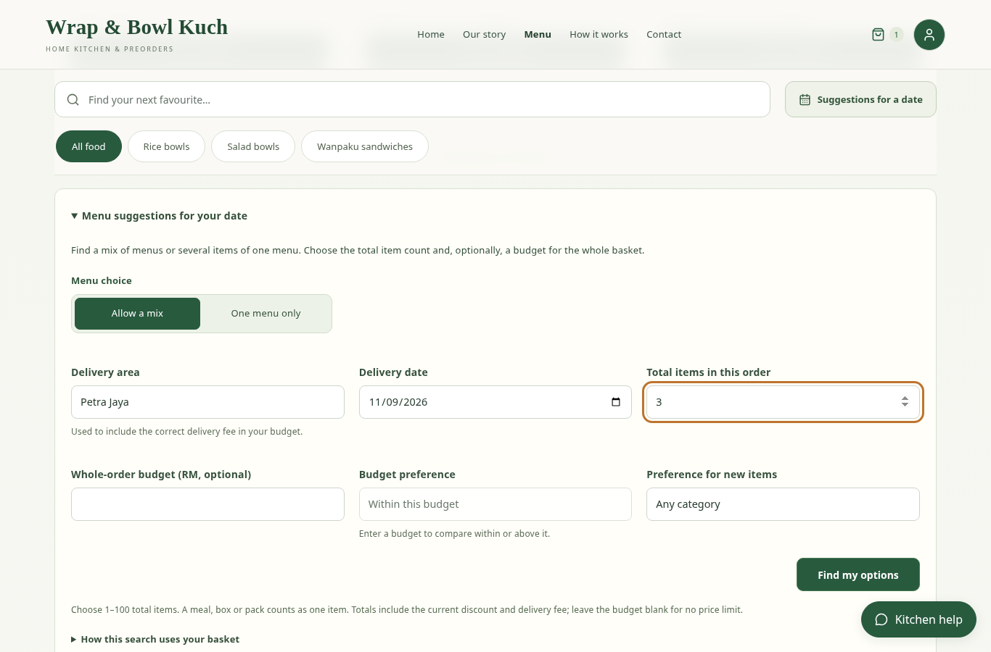
Figure 4.7: Date/quantity/budget finder and its one-menu versus mixed choice.
The current whole-order comparison includes food, the applicable bulk discount and the selected delivery fee. Leaving the budget blank means no price limit, so the within/above selector remains disabled until a budget is supplied. Within includes an exact match; Above is strictly greater. Where no above-budget basket is feasible, the interface explains that absence rather than inventing an expensive recommendation. Choosing times remains a checkout task; the finder checks the proposed date and complete basket without reserving an hour.
Personalisation is explainable through the available recorded history and category signals. It is not described as a trained dietary model or a proven causal conversion optimiser. A recommendation also does not establish allergen suitability; the customer is directed to check dietary needs with the kitchen.

4.4.4 BASKET REVIEW
The basket focuses on food, quantities, the food subtotal and continuation to checkout. Item details contain pack contents and individual menu schedules, while the compact ordering-day summary identifies common offered days. It does not repeat the delivery-area and time forms. Continuing from this page is therefore valid before those checkout-only fields are completed.
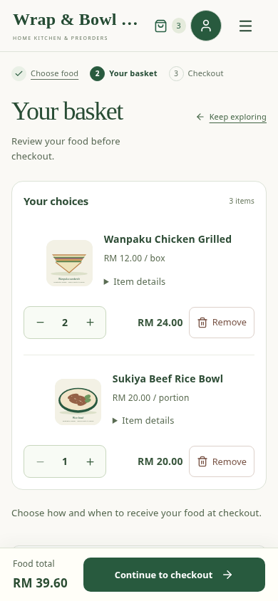
Figure 4.8: Basket quantities and optional item details without duplicate delivery forms.
A persistent basket shortcut is a navigation aid rather than a success notification. It can remain visible while the basket has items, provided it does not obscure content. Success notifications such as adding food or saving settings are transient; errors remain readable and actionable. The date finder keeps the basket shortcut in page flow while its larger form is open to avoid covering its controls.

4.4.5 DELIVERY, COLLECTION AND DATE SELECTION
Checkout first establishes fulfilment and time, then contact/address and payment. Delivery uses configured area choices and their fees. Collection appears only when the owner has enabled it and supplied a usable collection arrangement. A collection address on its own is not equivalent to an enabled service. The default client delivery period is 07:30–11:00 Malaysia time; owners can edit the supported minute-based bounds. Collection retains independently saved bounds.
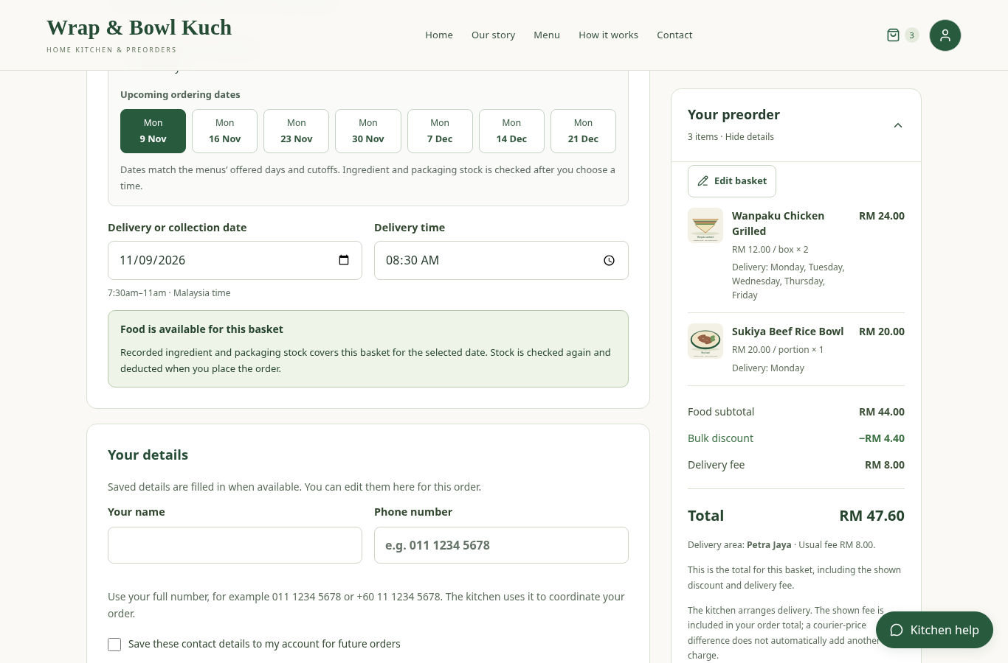
Figure 4.9: Checkout offered-day guidance, upcoming date shortcuts and minute-based time selection.
Offered weekdays, specific sale dates and cutoffs are combined across the basket. Upcoming date shortcuts make the common dates visible beside the date control rather than relying on customers to remember a note elsewhere. An invalid manual choice clears the old availability/quote before a new valid check. A date shortcut only satisfies the calendar rules; ingredient and packaging availability still need confirmation. New simple orders do not consult kitchen labour, oven bookings or cooking-task durations.
A complete delivery address and an order phone support handover. Saved name/phone values are prefilled; a customer can change this order’s details without being forced to leave checkout. Updating the account profile is explicit and, where required, reauthenticated. The accepted order stores a contact snapshot so subsequent profile changes do not rewrite the delivery instructions on an earlier order.

4.4.6 QR/BANK PAYMENT AND RECEIPT UPLOAD
For delivery, the current options are enabled QR/bank-transfer evidence or cash. Collection requires a receiving QR and proof. The kitchen supplies approved receiving details in Settings. The customer checks the recipient and exact amount in their own banking application. The website does not call a bank API, automatically inspect a bank statement or initiate a transfer. QR payment is not restricted to the Maybank brand; the receiving code must be supported by the paying application.
Payment evidence is an image upload, not an unrestricted document attachment. The current implementation accepts a single-frame JPG, PNG or WebP image up to 4 MB, decodes and re-encodes it, removes original-file metadata and limits the stored image size. PDF payment receipts are not an implemented checkout upload format. Customers must use an image/export supported by the form rather than assuming every PDF can be uploaded.
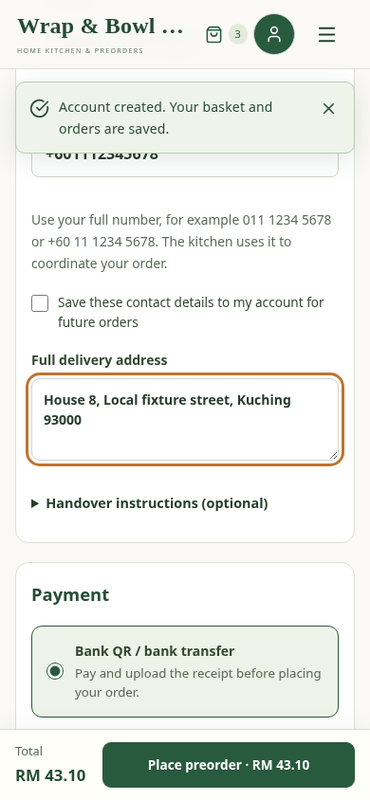
Figure 4.10: Checkout receipt-evidence state and enabled placement controls (synthetic local proof).
The image belongs to the authenticated account and is served from a private, no-store endpoint. Its selected price/fulfilment scope is checked again at placement. An uploaded receipt remains unverified and the order remains unpaid until staff compare it with bank records. If the customer has already transferred money and the amount changes, the interface directs them to review/contact the kitchen rather than paying again automatically. A file chooser cancellation preserves the already uploaded receipt.

4.4.7 MY ORDERS AND KITCHEN HELP
My orders shows accepted food, date/time, fulfilment information, payment state and whether the food has been received. Customer history is restricted to that account. Changes use eligible audited operations; they do not directly overwrite price or stock from the browser. Where reviews are available, they concern food from an eligible received order. A customer cannot infer that payment is verified merely because the food has been marked received.
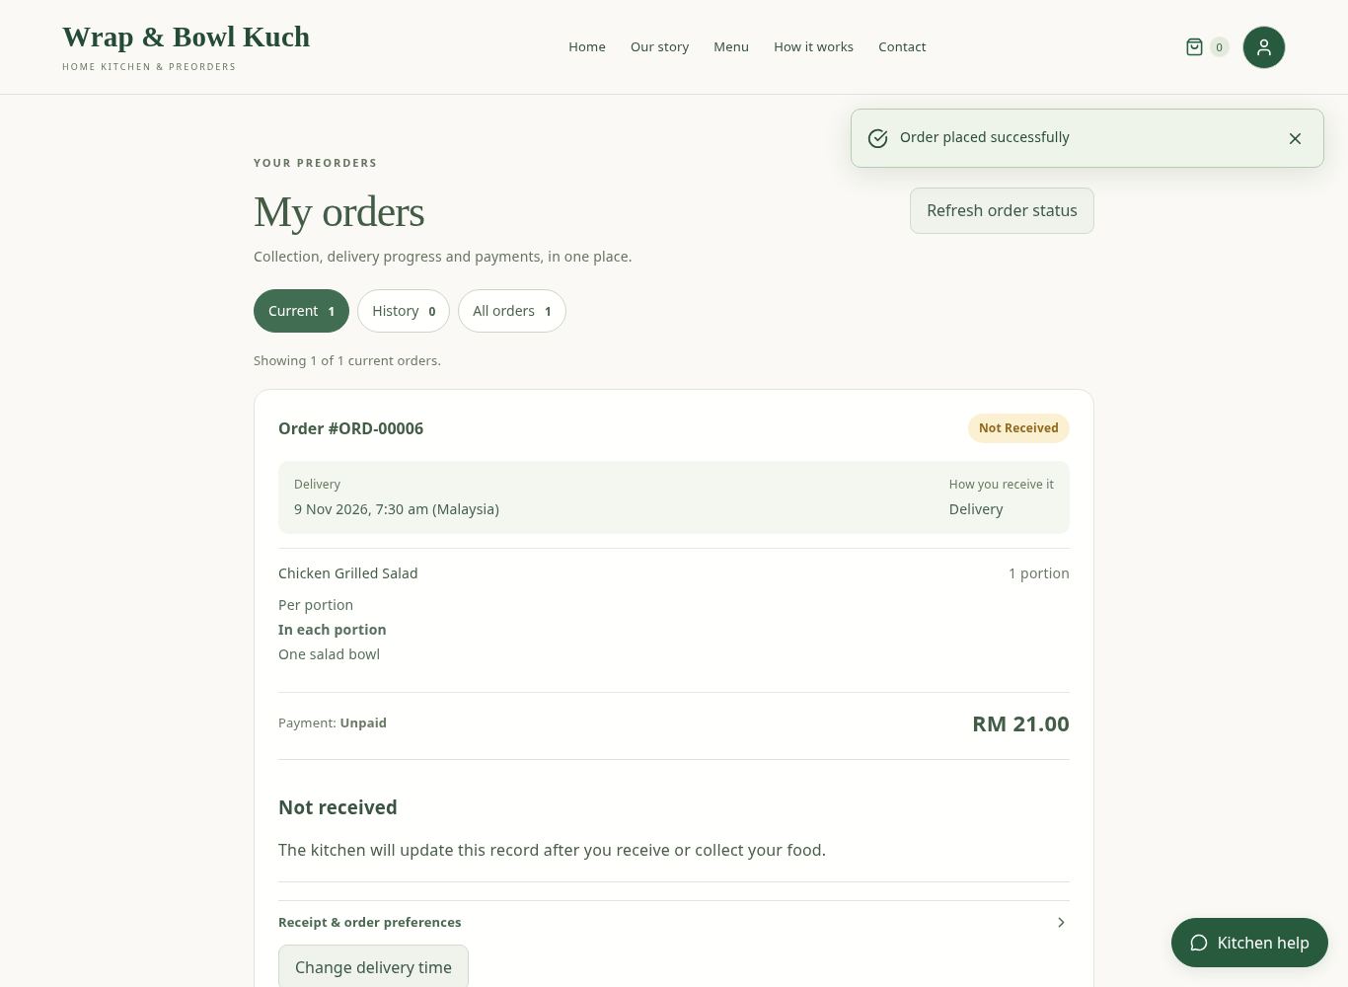
Figure 4.11: Customer order confirmation with separate food-receipt and payment states.
Kitchen help provides a compact route to supported questions, menu suggestions, order guidance and contact information. It should be treated as an assistant to the actual forms, not a source of authority to fabricate an order or promised delivery. External language-service availability can fail; core ordering remains subject to the same authoritative API. Clear close/back controls and readable phone layouts prevent the help panel from trapping the user.

4.5 OWNER INTERFACES

4.5.1 MENUS, CATEGORIES AND PHOTOS
Staff can create and edit menus, manage their categories, adjust offered days/date windows and maintain selling-unit contents. Pause/archive actions distinguish stopping future orders from deleting an unused record. A menu linked to history cannot simply be removed without respecting the server’s protection of those relationships. Menu names and current prices can change while accepted order lines retain their earlier values.
Menus support a public image URL and local-device image upload. The server applies image validation and sanitisation, so the feature is more than saving a file path from the owner’s computer. The eight client menus initially use clearly illustrative salad, sandwich and rice images; the owner can replace these with client-provided photographs. Ingredient quantities and standard packaging are editable estimates that must be checked against actual production before accepting real business decisions based on them.

4.5.2 INGREDIENT DIRECTORY AND BATCH INVENTORY
Raw materials record a name, inventory unit, optional cost assumption and optional storage guidance. The batch form records the actual received lot, quantity, receipt date, storage location and evidence supporting its planning deadline. A source such as wet market helps describe provenance but does not generate a shelf life automatically. The FoodSafety.gov cold-storage chart is a reference link; selecting the link does not validate a batch’s conditions or fill dates.
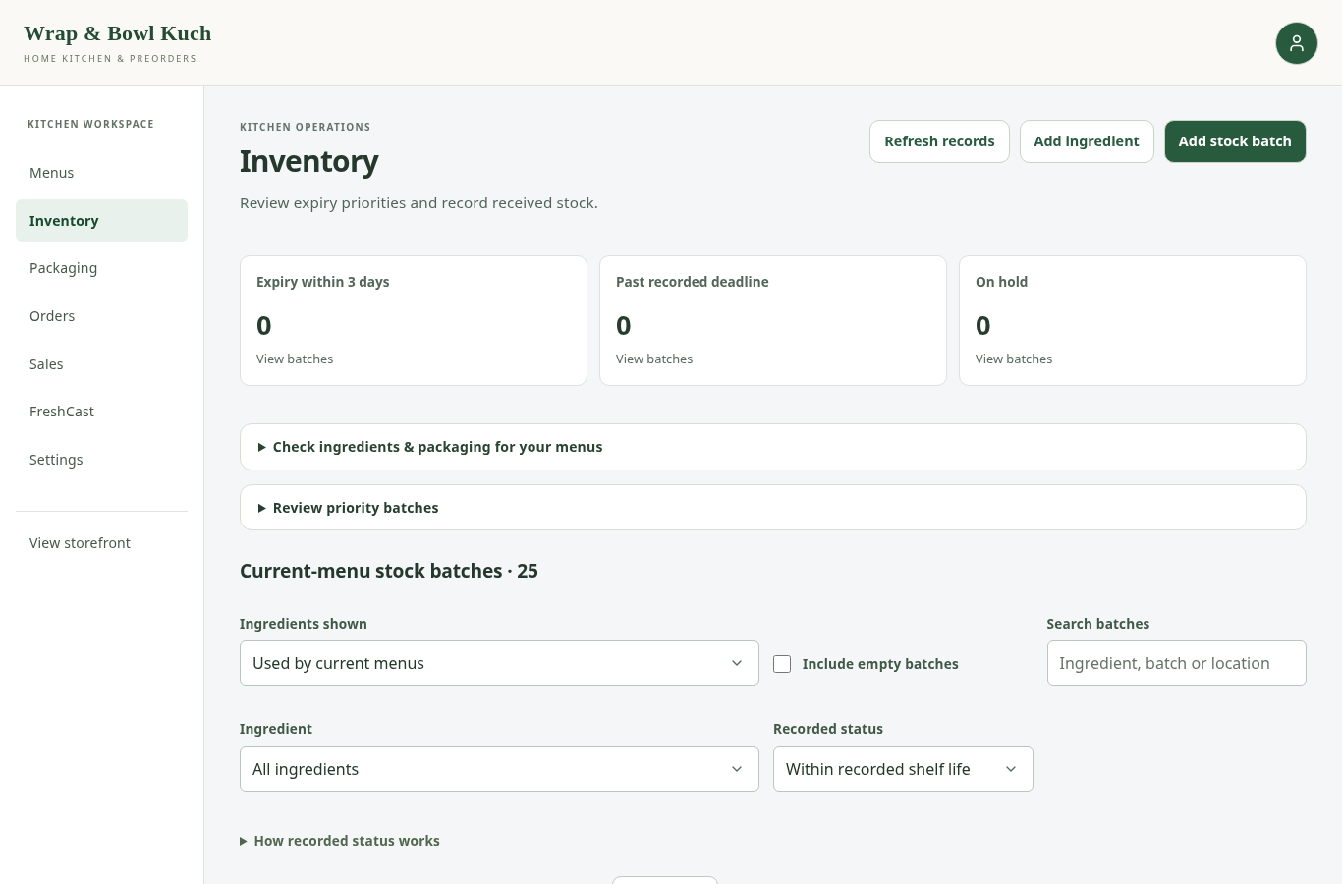
Figure 4.12: Inventory overview with ingredient filters, recorded status and batch actions.
For an unlabelled ingredient, the owner can use receipt-based documented storage life without first creating a compulsory guidance preset. If a matching preset has been saved for the ingredient/storage type, it can be selected to populate the unsaved batch form. The copied evidence remains part of that batch and is not retrospectively changed when the preset is edited. This balances repeat-entry convenience with a batch-specific record.
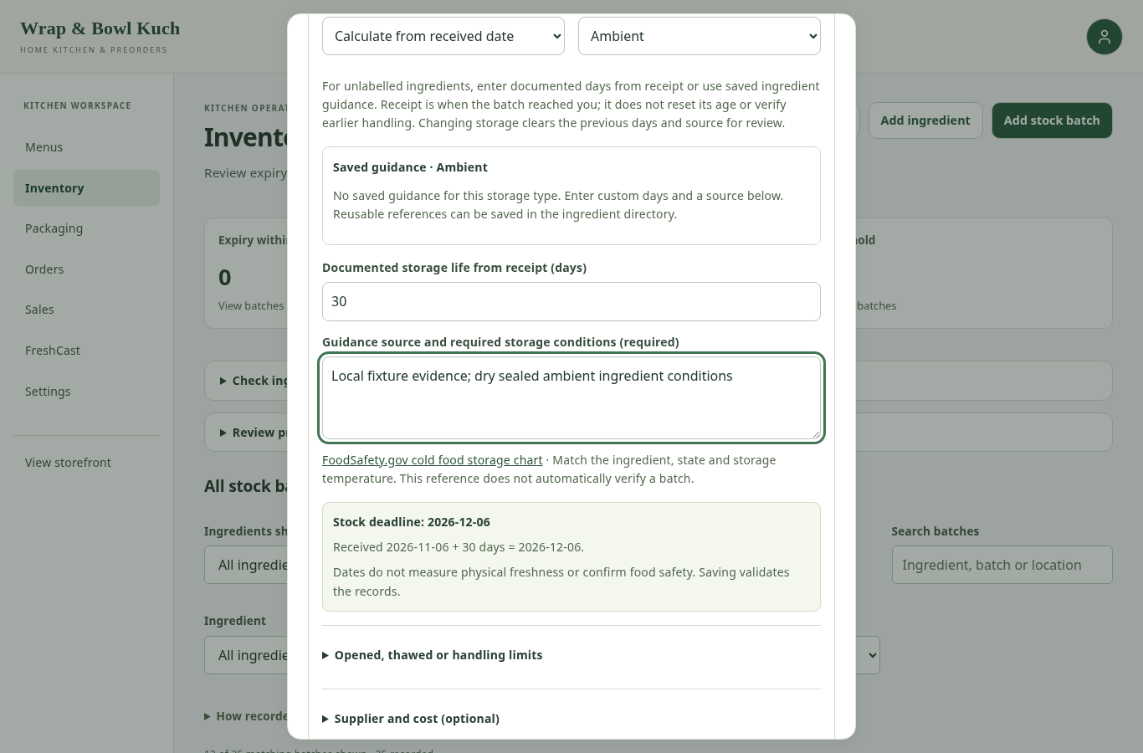
Figure 4.13: Batch evidence form with conditional date inputs and a planning-deadline preview.
Printed expiry/use-by is a supplier deadline; manufacture date is when the food was made; received date is when the kitchen obtained that batch. They are different events. Best-before is a quality date, although this system conservatively uses the recorded deadline as an allocation limit. Manufacture-plus-life uses the manufacture anchor, while receipt-plus-life uses receipt. An earlier original printed deadline, opening limit or thawing limit can cap a longer calculated life. This explains why entering 30 days may still produce a three-day effective deadline if an earlier recorded cap remains.
Inventory adjustments require an explanation where relevant and use a saved edit/version check. A stale form must not restore stock that an order has already consumed. The interface provides previews and field errors while the server remains authoritative. Ordinary low-impact quantity edits are distinct from explicit wastage, which also records cost evidence.

4.5.3 STOCK-SUPPORTED MENU QUANTITY AND TARGET CHECK
Stock-supported quantity is derived from current usable ingredient batches and assigned packaging. For each required material, usable stock is divided by the per-selling-unit recipe quantity and rounded down; the limiting ingredient or packaging item determines the menu quantity. Menus share stock, so individual displayed quantities cannot be added together as independent guarantees. Checkout combines all recipe requirements before acceptance.
The inventory target check asks a different planning question: is recorded stock enough for the same requested number of units of every menu offered on a chosen date? With 3 units and 8 offered menus, it checks 24 units in total. It is not a daily customer-order report and does not create new stock, reserve orders or enter procurement automatically. Results show target, available quantity, shortfall and the included menus. The downloadable worksheet leaves physical receipt/evidence fields for actual owner entry.
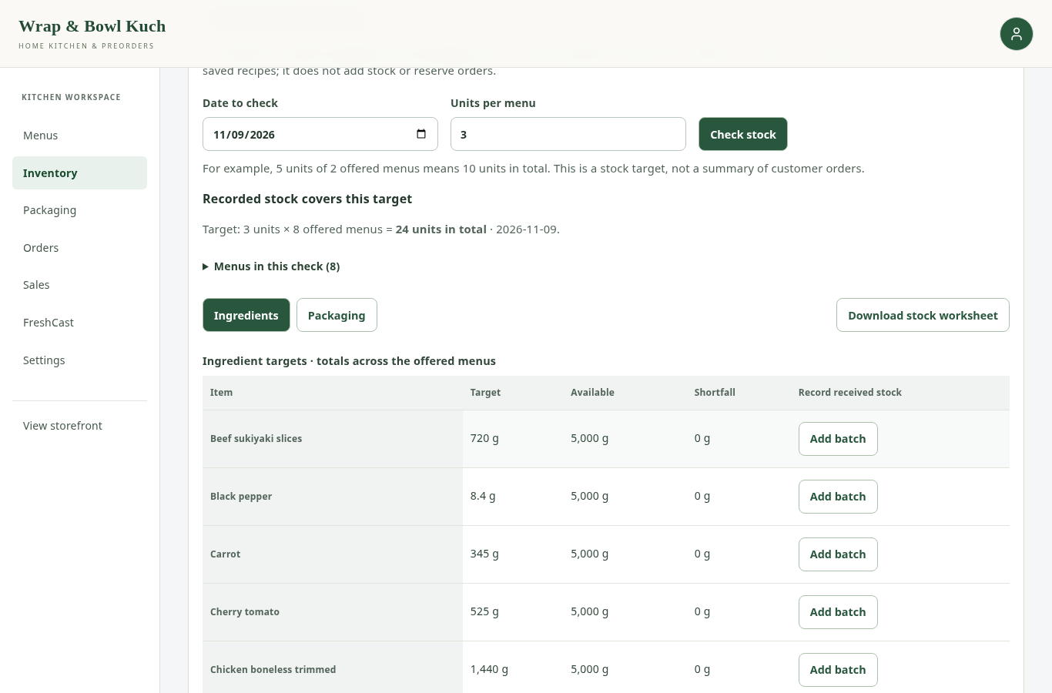
Figure 4.14: Aligned stock-target controls and totals across the offered menus.

4.5.4 PACKAGING STOCK AND MENU ASSIGNMENTS
Packaging has its own stock page, low-stock threshold, current pieces, unit cost and movement history. Receiving pieces and removing damaged/used pieces are deliberate operations. Removal first shows the proposed deduction and remaining balance. Menu packaging assigns containers, lids, cutlery, dressing cups, sheets and labels to one selling unit. This mapping is multiplied at placement, not manually re-entered for every customer order.
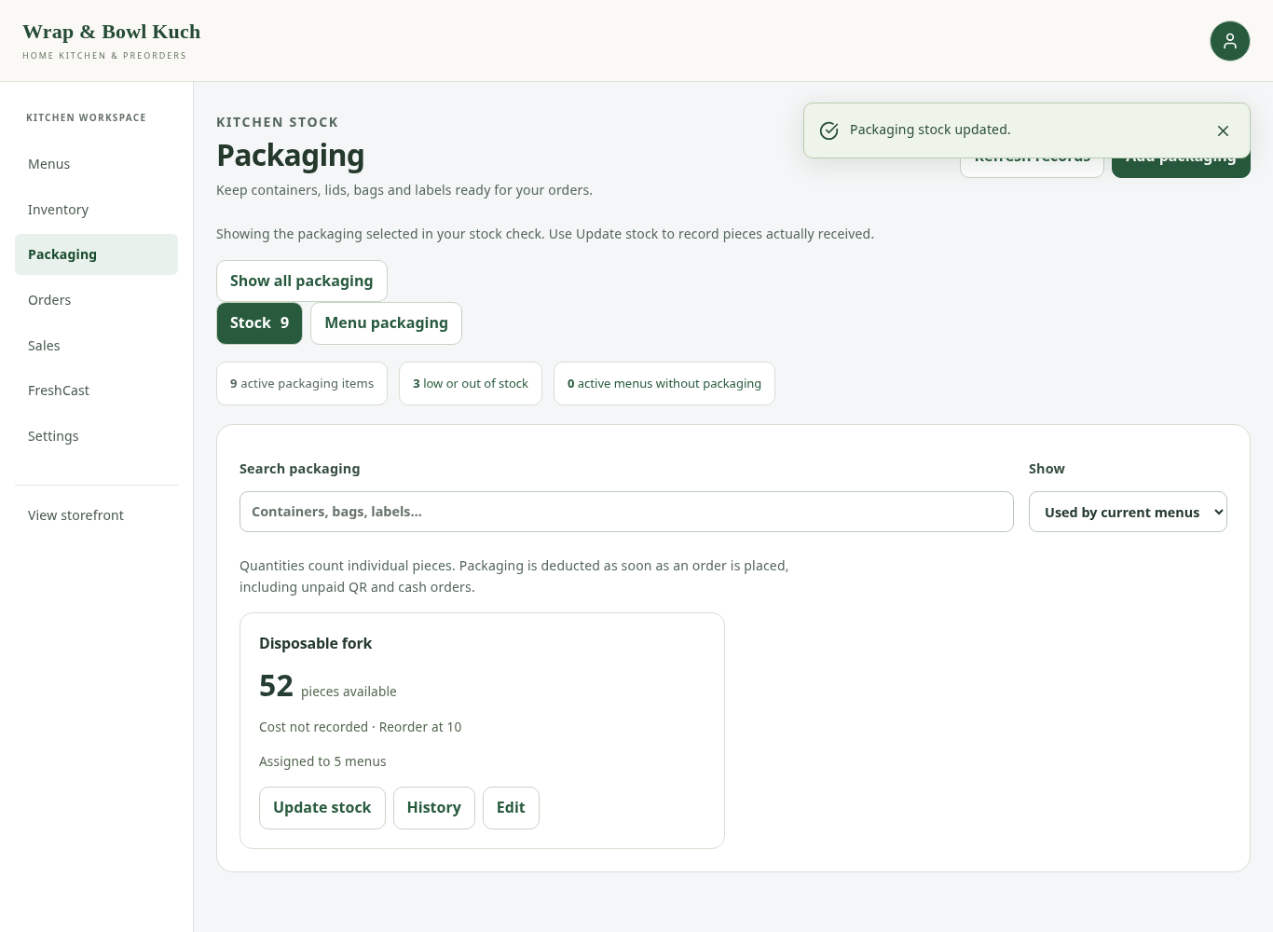
Figure 4.15: Packaging stock balance and actions for current menu supplies.
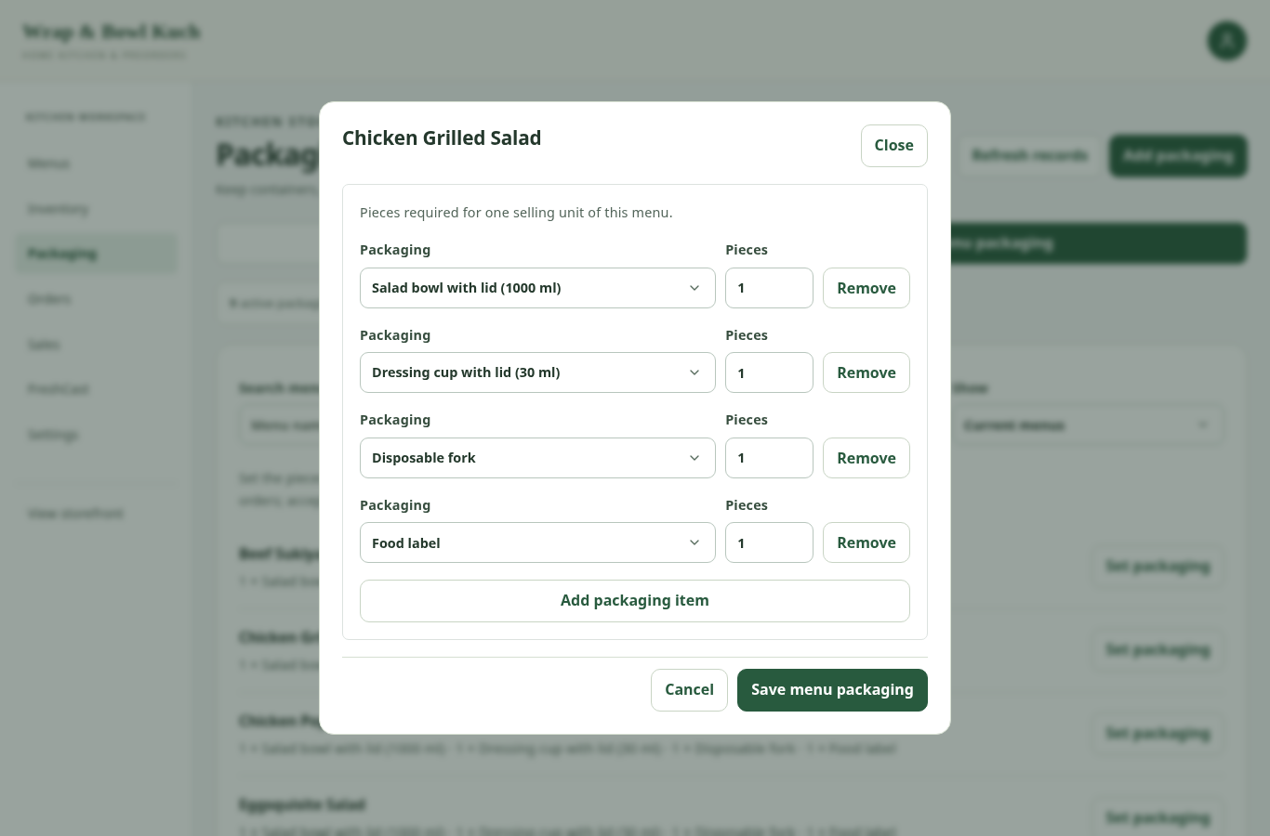
Figure 4.16: Packaging-assignment dialog with per-selling-unit quantities and aligned controls.
A salad bowl example uses its bowl/lid, dressing cup, fork and label. A Wanpaku sandwich uses a box, greaseproof sheet and label. These starting arrangements reflect the authorised project setup, not a confirmed packaging specification or supplier price list. Known assigned packaging costs are included in current menu-cost estimates. Missing prices remain unknown; an explicit zero means genuinely no cost, not a hidden default.

4.5.5 ORDERS, PAYMENTS AND ACTUAL RECEIPT
The current owner queue groups Not received, Received, Cancelled and All orders, with date sorting/filtering and selected-order actions. The simple display is intentionally narrower than the historical database status enum. New orders do not need processing, cooking or courier-dispatch confirmations before the owner can record an eligible actual receipt. Bulk receipt actions identify the selected orders and recheck their current versions. A correction records the actor and before/after evidence.
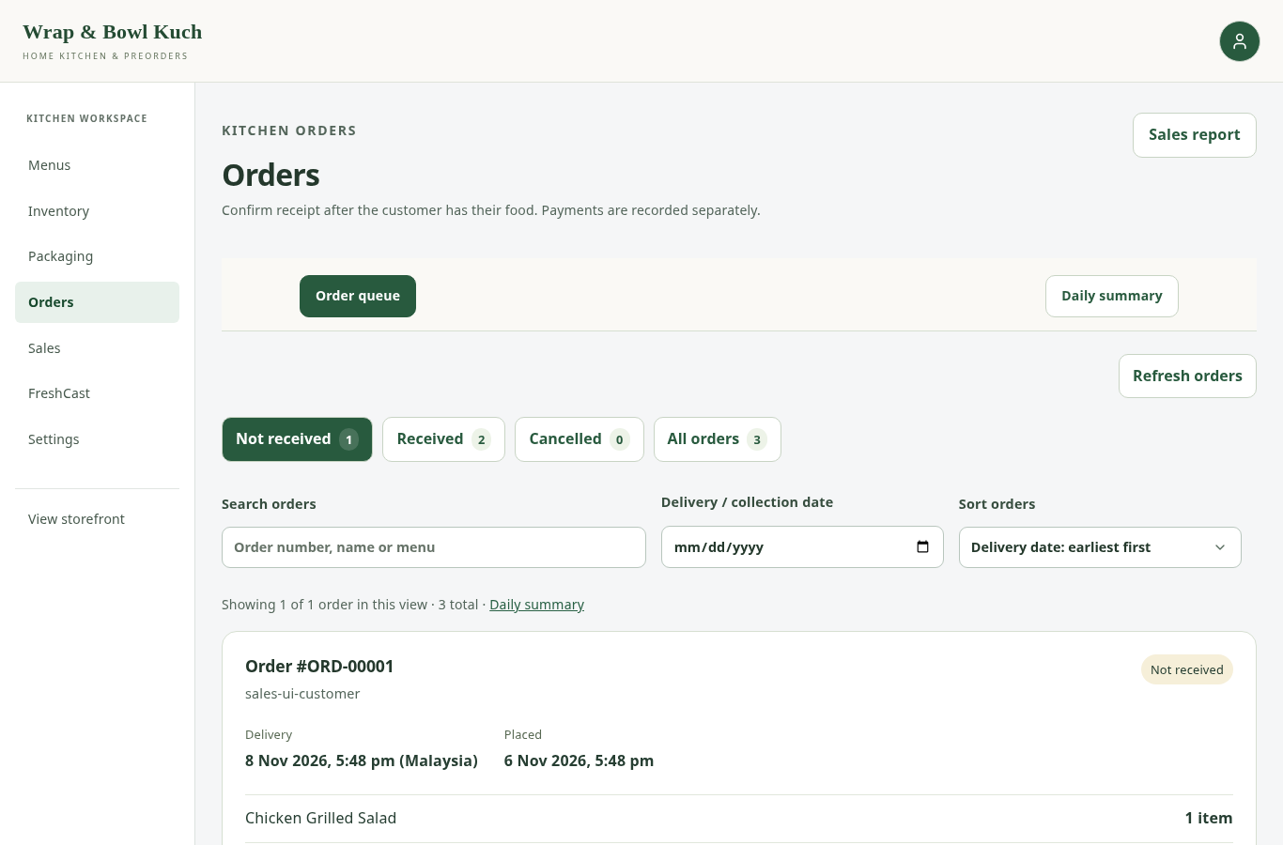
Figure 4.17: Owner order queue with receipt groups, filters and deliberate per-order actions.
Payment details open in a focused dialog. The owner sees the full expected amount, existing receipt/refund events and the customer proof link. A payment reference is a supplied bank/cash reference, not necessarily a database ID. The form makes clear that the owner is recording money verified outside the website. A refund action confirms an already completed external refund and does not send money. This protects the distinction between operational status and financial evidence.
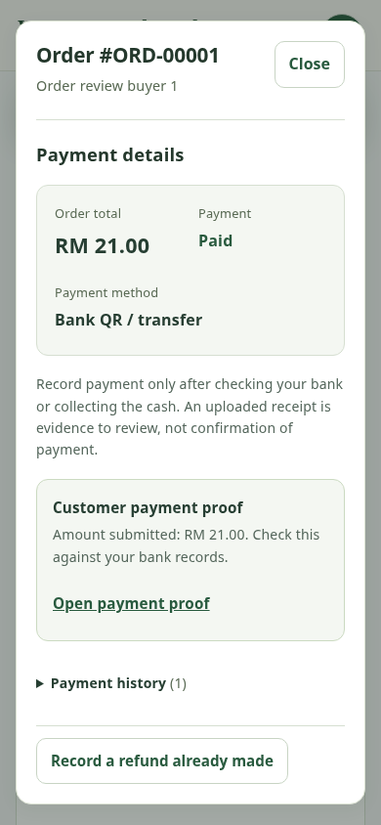
Figure 4.18: Payment-review dialog showing proof, amount and payment history.
Cancellation and unused-stock returns are separate from recording receipt. In the simple workflow, placement has already consumed recorded quantities for commitment purposes. An eligible unused cancellation can return allocations once; consumed/otherwise ineligible stock must not be restored blindly. The cancellation path and replay protections are verified by integration tests. No historical real customer/payment record was rewritten for this report.

4.5.6 DAILY ORDER SUMMARY AND PRINTING
Daily summary is located with Orders because it supports packing and handover: which accepted menus, in what quantities, for which date. It is not the same as a sales dashboard. The report can include unpaid open orders according to its documented scope, while cancelled/generated analytical records are excluded as specified. Undated historical records are reported as such instead of assigning their placement date as an invented handover date.
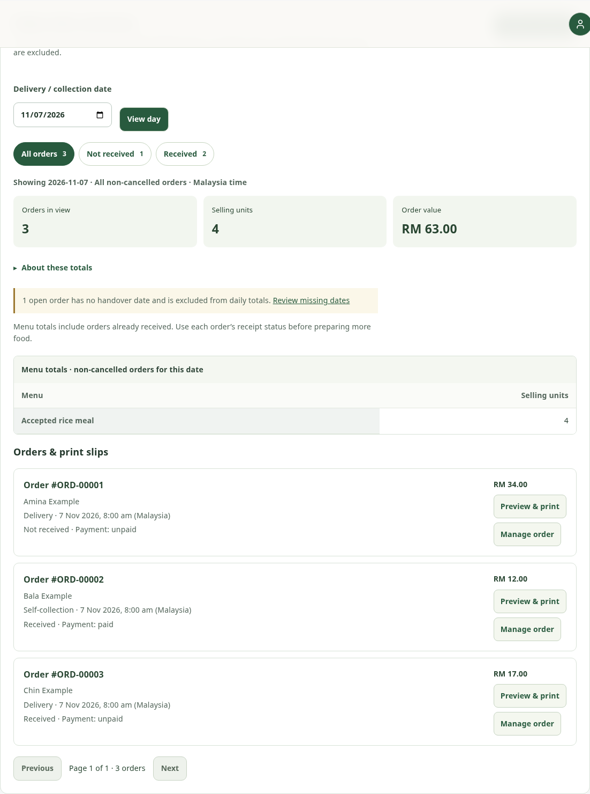
Figure 4.19: Daily order/menu-unit summary for kitchen work.
Each order can open a print preview containing the accepted customer name, full address where relevant, phone number, menu lines and agreed handover details. Collection slips use the collection snapshot rather than an old delivery address. The print action is explicit and read-only; a new tab uses safe browser attributes. An owner can use the browser’s Print / Save PDF function without the website marking the food received.
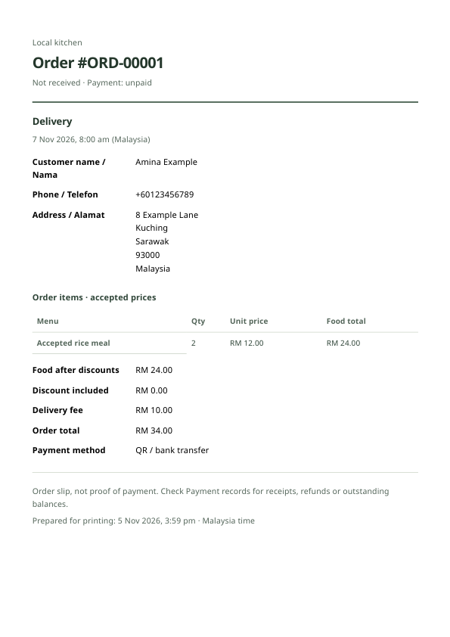
Figure 4.20: Order-slip print preview; an A4 preview is intentionally different from a web-page viewport.

4.5.7 SALES, COSTS, CONTRIBUTION AND WASTAGE
Sales overview uses the selected handover period and includes eligible paid-and-received orders. Food value, discount, net food sales and delivery income remain separate. Daily operational order value is not interchangeable with realised sales. CSV export respects report scope, bounds the date range/row count and escapes spreadsheet-formula text. Unknown dates or incomplete evidence are disclosed rather than silently counted as zero.
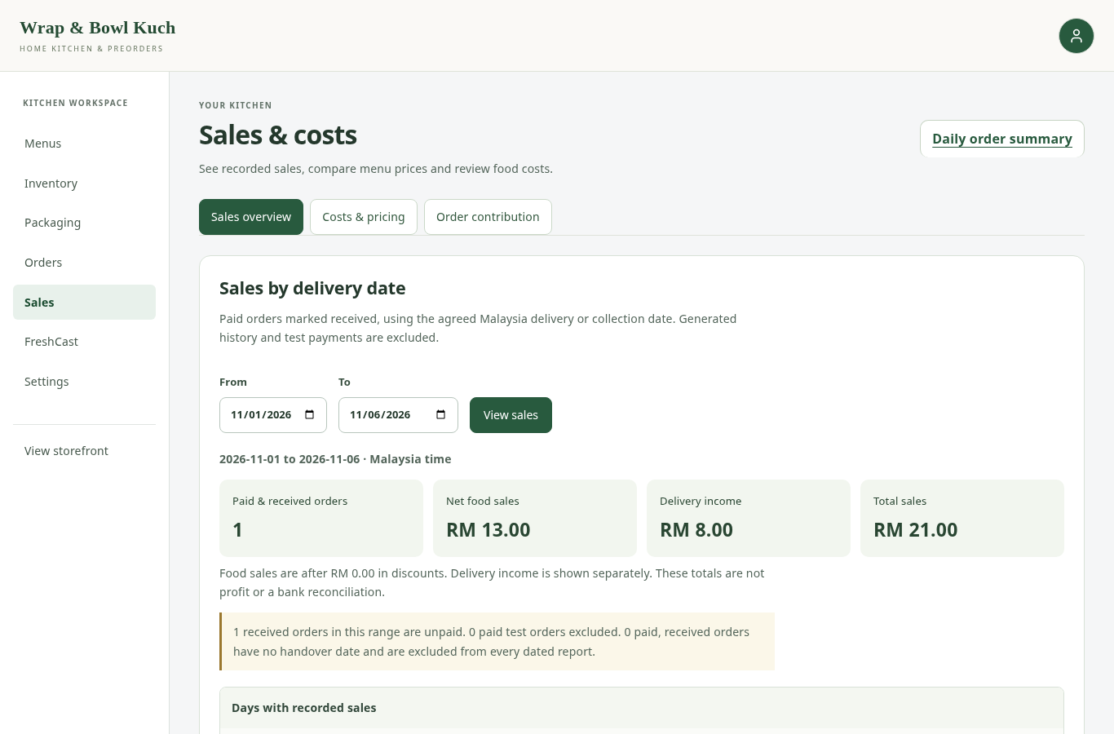
Figure 4.21: Sales overview with date filtering and separate food/delivery values.
Costs & pricing estimates recipe ingredients and assigned packaging at entered unit costs. A scenario compares a proposed selling price, quantity, discount and cost increase without saving a live promotion. Order contribution uses allocated ingredient batch costs and accepted packaging evidence. Its margin is a food-contribution margin, not net profit: labour, overhead, courier charges and payment fees can remain outside that food calculation. An unavailable contribution is evidence of missing required cost/payment records, not a numerical loss or a software-generated profit.
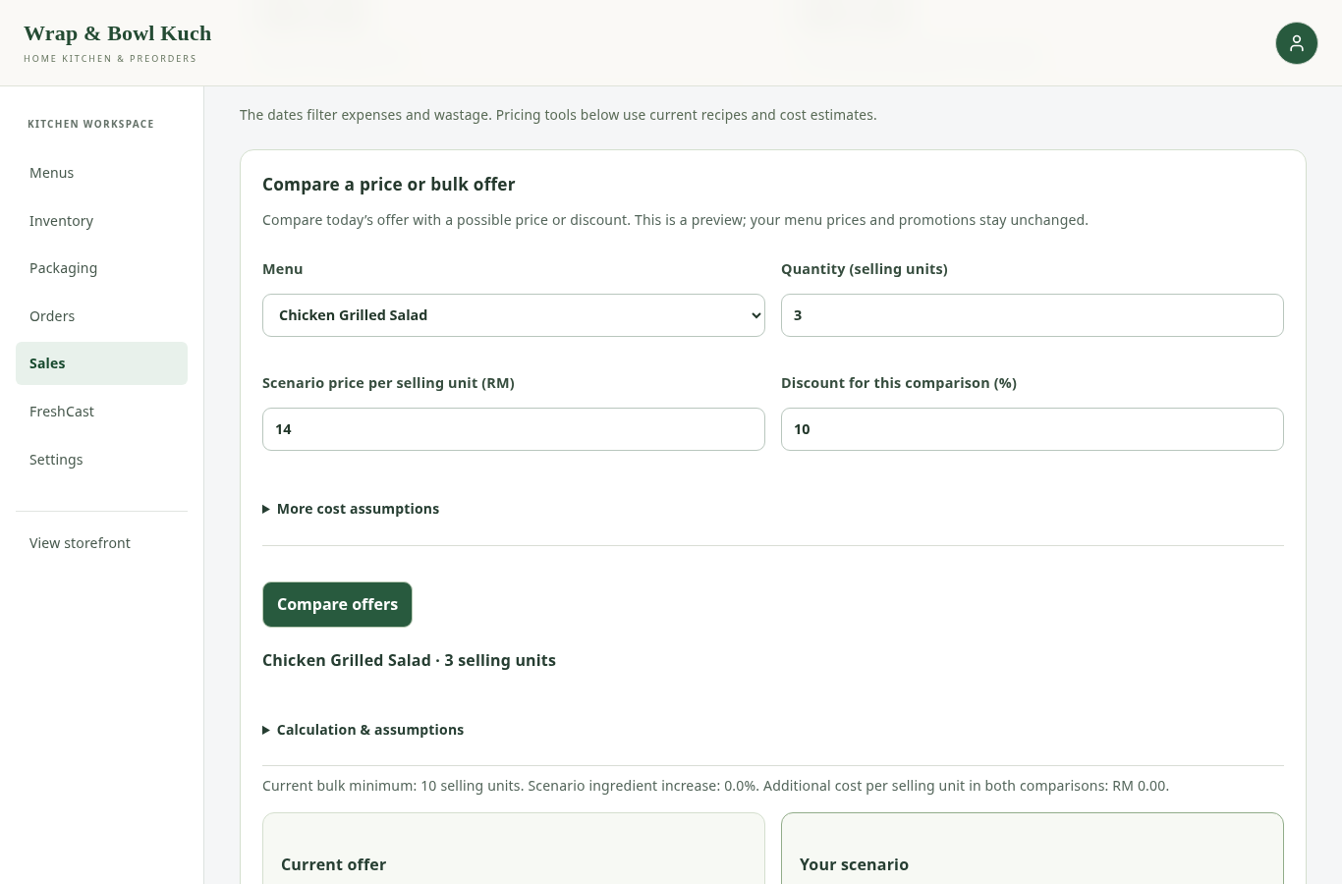
Figure 4.22: Read-only price/bulk-offer scenario and progressively disclosed cost records.
Ingredient cost entry supports understandable unit conversion. For example, RM12/kg is RM0.012/g; using RM12 as the per-gram cost would distort every recipe estimate. Packaging costs can be entered in pieces. Forcing an unknown value to zero would create misleading margins, so the application leaves that estimate unavailable until the necessary costs are supplied.
Operating expenses record overhead such as utilities, courier fees, labour and marketing. They should not duplicate ingredient/packaging purchases already counted as recipe costs. Wastage is relevant because discarded food changes both available inventory and the evidence behind purchasing decisions. The form reviews the batch, quantity, reason and remaining stock before deduction, then records the estimated cost at that time. It must not be used for food already deducted for an accepted order. Expense and wastage ledgers support review; they are not a complete general ledger or audited profit-and-loss statement.

4.5.8 SETTINGS AND SETUP CHECKS
Settings separates kitchen profile, business story, promotion, collection/delivery, payments, reminders and setup checks into manageable sections. Each save applies to its section, preserving unrelated unsaved drafts. Short delivery-area names are distinct from a descriptive service-area sentence and from a physical collection address. Listed areas are customer choices and fee keys; they do not geocode or verify that an entered address lies inside a geographical boundary.
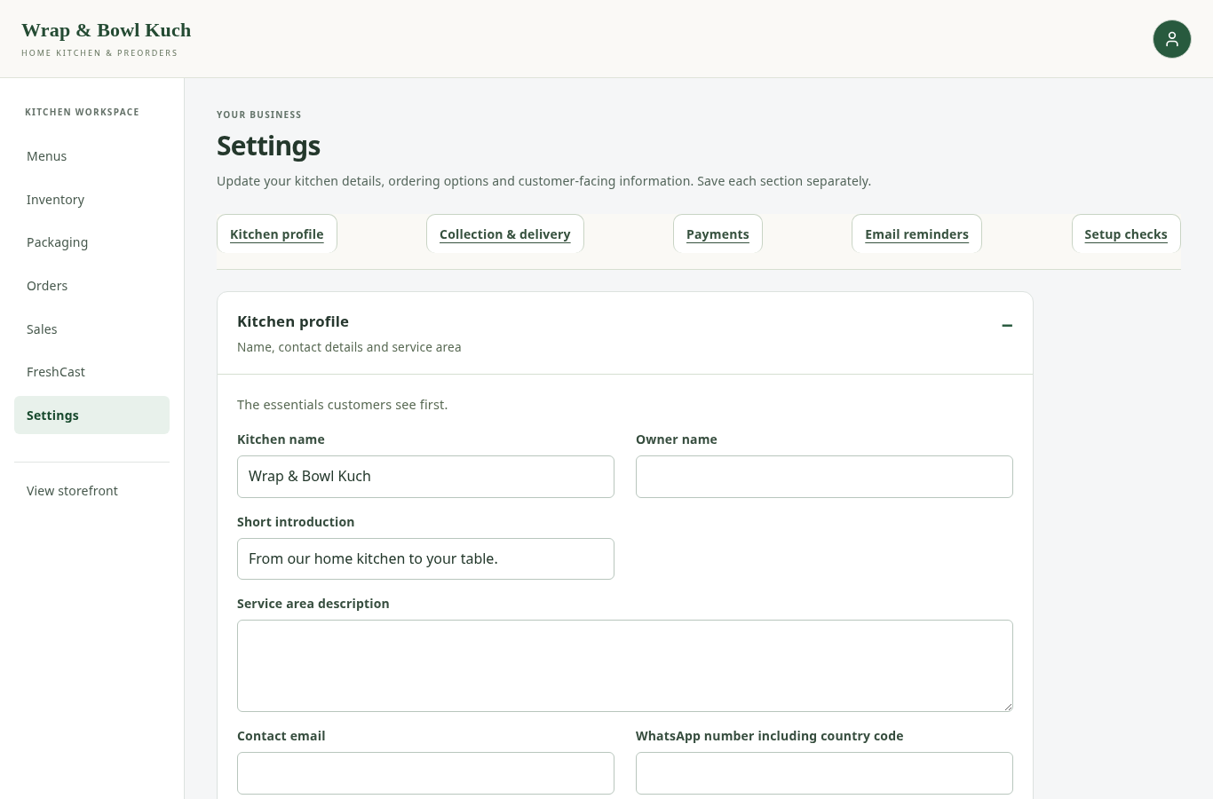
Figure 4.23: Section-based kitchen settings with explicit save scope.
Setup checks review recorded identity, recipe and cost requirements and identify missing information. They are not certificates of food safety or proof that an email or payment provider is working. The UI uses compact counts and optional detail rather than dense warnings. Technical website revision information remains under a less prominent support section so it is available for troubleshooting without dominating kitchen tasks.

4.6 CORE CALCULATIONS AND TRANSACTION RULES

4.6.1 EFFECTIVE DEADLINE AND DATE-BASED STATUS
The base deadline is either a printed date, manufacture date plus documented shelf-life days, or received date plus documented storage-life days. The effective planning deadline is the earliest valid applicable base/printed/opened/thawed limit. Date inputs cannot extend an earlier recorded deadline merely by supplying a longer duration. Held or expired lots are excluded from cooking stock, and uncertain handling can hold a batch even when its calculated date is in the future.
Table 4.3: Illustrative date calculation using explicit evidence
Evidence | Example value | Consequence
Received date | 1 November 2026 | Receipt-based storage clock begins
Documented storage life | 30 days | Base planning deadline is 1 December 2026
Original printed deadline | 4 November 2026 | Earlier supplier cap wins
Opened limit, if recorded | Opened 2 November; 1 documented day | Earlier handling deadline becomes 3 November
Handling breach | Known breach / held | Batch is excluded regardless of a future date

The public average describes the proportion of each recorded storage window remaining. A printed-date batch uses receipt-to-expiry; a manufacture-based batch uses manufacture-to-expiry. Each non-empty received batch has equal weight. Expired and held batches contribute zero, unknown records are excluded and reported separately, and the score is bounded from 0 to 100. These rules are deterministic, not random. They do not measure microorganisms, temperature exposure or actual remaining edible life.
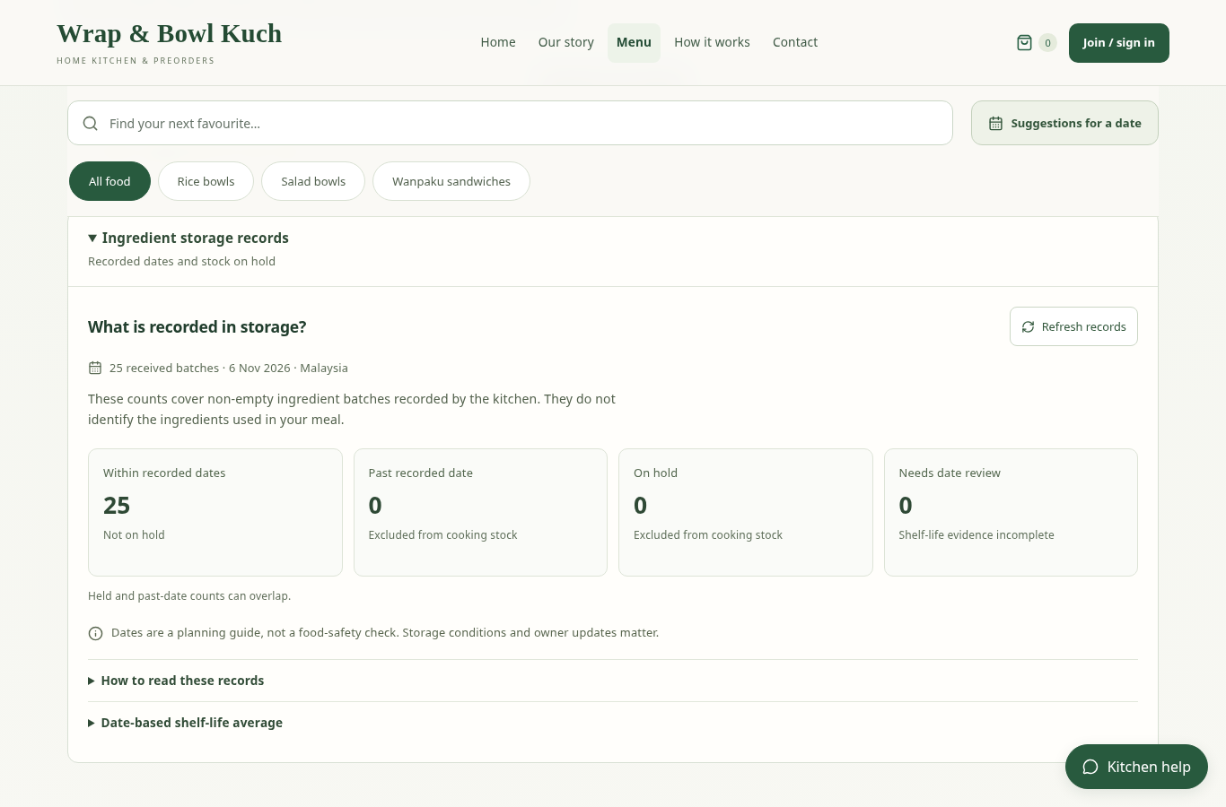
Figure 4.24: Compact public recorded-stock counts with an optional date-based average explanation.

4.6.2 INGREDIENT AND PACKAGING ALLOCATION
For ingredient r, total required quantity is the sum, across basket lines, of ordered units multiplied by the accepted recipe quantity for r. Eligible stock must already have been received, be positive, not held and cover the relevant date under the recorded deadline. Planned future purchases are not stock already available. FEFO consumes the eligible batches with the earliest expiry first, recording the quantities and batch-cost evidence.
Packaging requirement is the sum of ordered units multiplied by required pieces for each packaging type. Ingredients and packaging are rechecked and written in the same placement transaction. If any required item is short or a later write fails, the transaction rolls back. Repeating an accepted request identifier returns the same accepted result rather than deducting again. The order line’s accepted name, price, recipe and packaging survive later catalogue changes.

4.6.3 PRICING, BULK PROMOTION AND BUDGET COMPARISON
Food subtotal is the sum of unit price multiplied by quantity. If the saved bulk threshold is met, the configured percentage reduces food subtotal. Delivery is then calculated under the selected area/fulfilment and any saved free-delivery policy. Collection has no delivery fee. The accepted fee/discount is snapshotted and a later settings edit affects new quotes, not earlier accepted terms.
For example, 10 items at RM12 with a 10% food discount and RM5 delivery produce RM120 food, RM12 discount and RM113 payable. This is an arithmetic illustration, not an advertised client promotion. The finder’s whole-order budget comparison uses the same relevant pricing rules, preventing a recommendation from treating a per-item price as a complete order total. An exact RM100 total belongs within RM100, while RM100.01 belongs above it.

4.7 FRESHCAST AND SUPPORTING DECISION TOOLS
FreshCast remains a separate staff decision workspace. It distinguishes local database-based analysis, the external Genpact/CatBoost benchmark and an illustrative model-free walkthrough. Their data sources and meanings are not interchangeable. Local order history can describe the project scenario, but the fictional refreshed records do not establish accurate demand forecasting for Ayu’s actual business. The external model was not retrained to claim otherwise during this revision.
Current recipes connect menu quantities to ingredient demand. Recorded batches and their deadlines support expiry-risk and shopping discussions. Scenario controls compare hypothetical actions without automatically buying stock or changing accepted orders. A statistical association, saved forecast or scenario recommendation is not a verified saving. The previous externally evaluated model result is retained with its original data boundary in Chapter 5; it is not presented as measured accuracy on Wrap & Bowl Kuch sales.

4.8 REMINDERS, SECURITY AND DEPLOYMENT

4.8.1 OWNER HANDOVER REMINDERS
One scheduled authenticated worker serves the relevant queue. Simple mode checks owner delivery/collection events within its documented 24-hour eligibility window, including a bounded recent-overdue interval, and does not send preparation reminders merely because historical preparation fields exist. Settings offers a status refresh, recent run evidence and an explicit owner test-email action. Refreshing status is read-only and never starts an email send.
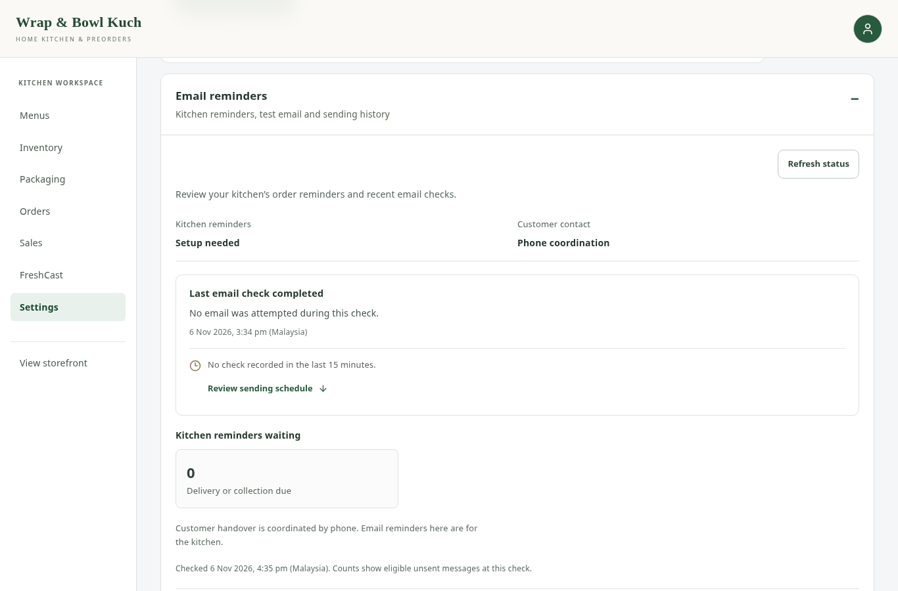
Figure 4.25: Owner email configuration/status and optional execution details.
The current customer account collects no email and is not automatically subscribed to email, SMS or WhatsApp. A phone number enables manual contact links where available; it does not authorise an automated WhatsApp service. Earlier explicitly consented email subscriptions are retained as compatibility behaviour. A GitHub schedule can be delayed, and authenticated manual calls also appear in history. A successful developer test or an old recorded run is not proof that the live scheduler is currently punctual.

4.8.2 SECURITY AND RECOVERY
Server permissions, session/CSRF validation, private evidence routes, bounded uploads, request identifiers and transactional stock checks address concrete application risks. They do not constitute an independent penetration test. Customer passkey challenges are short-lived, one-use and bound to the correct session/action/origin. Sensitive changes require recent verification, and staff/customer roles remain separate. Changes of browser/account cancel or discard stale private reads.
Backups of the database, source and external model are different recovery objects. A source ZIP cannot restore orders and stock. Receiving bank details, private proof images, database credentials and passkey private keys must not be published in a report package. Build-time migration checks detect missing schema but do not apply production migrations automatically. The final report identifies source publication and local verification separately from an observed Ready deployment.

4.9 INTERFACE AND ACCESSIBILITY DECISIONS
The supplied food-app references informed compact product cards, visible prices, familiar quantity controls and a clear basket/checkout path. They were not copied as a competing marketplace. Nielsen’s visibility, consistency, error-prevention and recovery principles guided progressively disclosed settings, shared form spacing, clear selected states and field-local errors (Nielsen, 1994). Native labels, keyboard-operable controls, visible focus and explicit dialog return paths support the relevant accessibility concerns described in WCAG 2.2 (W3C, 2023); full WCAG conformance has not been certified.
The green identity remains a deliberate client/fresh-food theme. Neutral surfaces and restrained status colour prevent every informational message from looking like an alarm. Ordinary navigation uses active, hover and focus states instead of inherited prose underlines, while meaningful inline links can remain underlined. Phone controls stack rather than overflowing; touch actions remain large enough to operate. A four-card public storage summary loads only when opened, reducing unnecessary work for ordinary menu browsing.
The implementation also corrects lifecycle issues that a static screenshot cannot reveal. Dialogs share scroll-lock ownership so closing an older dialog cannot leave the page frozen or unlock a remaining modal. Keyboard focus returns to a usable opener, and mobile navigation closes and restores focus when resizing to desktop. These decisions were checked through actual browser interactions as well as component rendering.

4.10 CONCLUSION
The current implementation supports the client’s simpler morning preorder business while preserving traceable accepted terms, dated stock and financial distinctions. Its main contribution is the integrated workflow: a branded single-vendor menu, secure low-memory account access, date/area-aware ordering, immediate ingredient/packaging commitment and practical reporting. The following chapter evaluates those implemented behaviours and identifies the user evidence still needed before claiming operational or behavioural improvement.

CHAPTER 5
TESTING AND RESULTS

5.1 INTRODUCTION
Testing evaluated whether the implemented rules behave as specified and whether the visible workflows can be completed in developer-controlled scenarios. It did not treat a successful screenshot, generated order or test receipt as evidence of real business performance. The current verification identifies application source 6edde5e1c24c9c9329ec4e756ebee19703686d39 and a clean source tree. This differs from the earlier report’s ab1a976 baseline and its test totals.
The supplied briefing emphasises suitable and verifiable testing, exception handling, security concerns and evaluation against the objectives. It does not explicitly mandate automated testing. The senior example provides useful behavioural test tables and objective-linked survey discussion; its participant counts and results cannot be reused for this project. This chapter therefore presents readable cases and outcomes first, supported by reproducible automated checks and developer browser evidence. Formal customer survey and client acceptance results have not yet been collected.

5.2 TESTING STRATEGY AND ENVIRONMENT

5.2.1 METHODS
Functional tests covered normal customer and owner tasks. Boundary and equivalence checks covered dates, times, phone formats, quantities, prices and file inputs. Integration tests checked that quotes, proof scope, order records, ingredients, packaging and payment state remain consistent. Failure-injection and replay checks tested rollback and idempotency. Role/session tests exercised unauthorised reads/writes and stale-account responses. Browser walkthroughs checked navigation, focus, layout and real control interactions beyond static rendering.
Automated tests are supporting evidence because stock deductions, scope changes and repeated submissions are difficult to verify thoroughly by repeatedly clicking a form. They do not replace manual exploratory testing or the client’s judgement of workflow suitability. A test named after an old feature can remain in the compatibility regression suite without making that feature part of the current client interface.

5.2.2 ISOLATION AND EVIDENCE
The fresh report verification ran on 6 November 2026 using an in-memory SQLite database, in-memory email and disabled dotenv loading. It did not connect to production Supabase, send a real message, perform a bank transfer or book a rider. The backend used the project virtual environment and the frontend used the installed dependency versions/lockfile. Command logs, exit codes, elapsed times and source revision are retained in the evidence package.
Table 5.1: Verification environment and interpretation
Evidence | Environment | Interpretation
Full Django application suite | Isolated in-memory SQLite; locmem email | Current functional/security regression results; explicit skips retained
Release/runtime harness | Local reduced runtime trees and mocked configuration/HTTP where relevant | Entrypoint, deployment-check and scheduler-runner behaviour, not a live Ready deployment
Frontend utilities and rendered components | Node/Vite test environment | Input/state/arithmetic/render contracts, not participant usability
Build and lint | Current source and installed frontend dependencies | Build succeeds and configured lint rules pass; bundle-size warning remains visible
Retained browser walkthroughs | Local built app, synthetic fixtures, desktop/phone Chromium; virtual authenticators | Observed developer interactions, not a physical-device user study
Client meetings | Project-author-supplied feedback and implemented revisions | Requirements refinement, not a fabricated interview or signed acceptance
Planned survey and acceptance form | Intended students/customer-role users and the client owner | Evaluation instruments prepared; responses pending

SQLite cannot establish PostgreSQL row-locking behaviour. Seventy-four PostgreSQL-dependent checks were skipped in this run, and two optional real-model-bundle checks were also skipped. Earlier repository evidence records isolated PostgreSQL exercises of relevant stock/account/reminder behaviours, but those dated runs are not relabelled as executions of every test at the final UI revision. A new production-like concurrency run remains a release-evidence task if the underlying transaction logic is changed.

5.3 DECISION TABLES AND BOUNDARIES

5.3.1 ACCOUNT AND CHECKOUT ACCESS
Table 5.2: Account eligibility and authentication decisions
Input/state | Expected behaviour | Reason
Public visitor browsing | Menu and business pages available | Browsing should not force registration
Browsing identity with no registered customer account | Cannot place or upload private proof | Name/phone alone must not authorise an order
Valid customer passkey | Own account and history available | Device response proves possession of the registered credential
Wrong session/origin/action, expired or replayed challenge | Reject | A challenge must be bound and single-use
Full Malaysian local or +60 phone | Normalise accepted contact | Formatting convenience without weakening authentication
Prefix 011 alone | Reject with useful field guidance | Prefix is not a complete phone number
Customer attempts staff action | Reject | Role boundary remains server-side

5.3.2 DATE, FULFILMENT AND PAYMENT POLICY
Table 5.3: Current handover and payment decisions
Condition | Expected result
Permitted future date within 90 days and valid menu schedule | Continue to stock/pricing check
Past time, date beyond horizon or unoffered weekday | Reject; clear stale quote and explain the relevant field
Default delivery at 07:29 or 11:01 | Outside 07:30–11:00 bounds
Default delivery at 07:30 or 11:00 | Within the time bounds, subject to all other rules
Unknown restricted delivery area | Request a configured area or kitchen contact; do not assume a free fee
Delivery QR/bank evidence | Private proof required; saved order remains unpaid until verification
Delivery cash | No advance receipt image; payment remains unpaid until cash is recorded
Collection cash | Reject; collection requires enabled QR evidence
QR/proof selection changed after a quote | Recheck scope and amount; do not automatically pay again

The minute boundaries concern the configured client default; they do not promise that the rider can physically arrive at an exact minute. Edited owner bounds are tested as settings rather than hardcoded assumptions. Calendar shortcuts show dates permitted by all basket menus, but do not bypass stock validation.

5.3.3 STOCK AND HISTORY INTEGRITY
Table 5.4: Stock allocation and history decisions
Condition | Expected result
Sufficient received, unheld, date-eligible ingredients and packaging | Allocate all requirements once with the accepted order
Any ingredient or packaging shortage | No partial placement or stock deduction; preserve basket
Expired, held or future-received batch | Do not use it to cover the requirement
Repeated accepted request identifier | Return the same order rather than deduct again
Current menu renamed or recipe/mapping edited | Existing accepted name, price and allocation remain unchanged
Stale inventory edit after a consumption | Reject/review version conflict instead of restoring consumed stock
Eligible unused cancellation | Return recorded allocations once according to server policy
Timer reaches planned time | Do not mark food received or payment paid

5.3.4 FRESHNESS AND BUDGET RULES
Table 5.5: Date evidence and recommendation boundaries
Case | Expected behaviour
Manufacture plus documented life | Use manufacture date as the base anchor
Received plus documented storage life | Use receipt date; no compulsory manufacture date or preset
Earlier supplier/opened/thawed deadline | Earliest applicable deadline wins
Missing/contradictory evidence | Field error or needs-review state, never invented food safety
Unknown average versus true zero | Display Not available versus 0%; do not merge them
Budget left blank | No price limit; within/above comparison disabled
Exact whole-order total equals budget | Within budget
Total is greater than budget | Above budget
Above/within alternatives requested | Partition eligible complete baskets before selecting the bounded result set

5.4 EXECUTED FUNCTIONAL AND SECURITY CASES
The following cases map representative requirements to executed test methods from the fresh backend log. PASS means that the automated fixture assertions passed for the stated behaviour. It does not mean that a participant performed the task or that a real bank accepted a payment. The compact source locator is included so the result can be traced back to its test, with full logs in the companion evidence.
Table 5.6: Executed functional cases TC-01–TC-05
Case / objective | Test action | Expected and observed behaviour | Recorded result
TC-01  Obj. 1  Account preserves basket | Register a browsing customer through a valid ceremony. | Same user/basket retained; no customer website password/email required. | PASS  Automated fixture  See Appendix G
TC-02  Obj. 1  Passkey challenge boundaries | Replay a challenge and supply wrong origin or missing required verification. | Reject the invalid ceremony without granting account access. | PASS  Automated fixture  See Appendix G
TC-03  Obj. 1  Phone formats | Submit 011 alone, then a complete valid local number. | Incomplete prefix rejected; full contact accepted and normalised. | PASS  Automated fixture  See Appendix G
TC-04  Obj. 1  Account gate | Attempt placement/proof from a browsing identity with contact details. | Registered-account requirement enforced. | PASS  Automated fixture  See Appendix G
TC-05  Obj. 1  Delivery fees | Choose an area and submit an outdated client total. | Server fee authoritative; stale total cannot create an order. | PASS  Automated fixture  See Appendix G

Table 5.7: Executed functional cases TC-06–TC-10
Case / objective | Test action | Expected and observed behaviour | Recorded result
TC-06  Obj. 1  Morning time boundaries | Check the minute boundaries around configured morning hours. | Quote/slot behaviour agrees at allowed and disallowed edges. | PASS  Automated fixture  See Appendix G
TC-07  Obj. 1  Cash delivery | Place eligible delivery cash preorder. | Saved contact/address/fee and stock allocations agree; payment remains unpaid. | PASS  Automated fixture  See Appendix G
TC-08  Obj. 1  QR versus collection policy | Configure bank details without a pickup QR. | Bank-only delivery option does not bypass collection QR requirement. | PASS  Automated fixture  See Appendix G
TC-09  Obj. 1  Bulk promotion consistency | Use qualifying quantity and compare quote, proof and accepted total. | Food discount, delivery and saved total match. | PASS  Automated fixture  See Appendix G
TC-10  Obj. 1,2  All eight menus allocated once | Place and replay the complete eight-menu client basket. | Ingredient and packaging deductions occur exactly once. | PASS  Automated fixture  See Appendix G

Table 5.8: Executed functional cases TC-11–TC-15
Case / objective | Test action | Expected and observed behaviour | Recorded result
TC-11  Obj. 1,2  Shortage rollback | Submit a basket with insufficient assigned packaging. | No partial order/deduction; basket preserved. | PASS  Automated fixture  See Appendix G
TC-12  Obj. 1,2  No cooking-plan requirement | Place a valid simple-mode order despite legacy cooking constraints. | No preparation plan required; current date/stock policy still applies. | PASS  Automated fixture  See Appendix G
TC-13  Obj. 2  Date anchors differ | Use manufacture-based and receipt-based evidence. | Each documented duration uses its correct anchor. | PASS  Automated fixture  See Appendix G
TC-14  Obj. 2  Earlier cap wins | Combine calculated life, supplier cap and opened limit. | Earliest applicable recorded deadline is used. | PASS  Automated fixture  See Appendix G
TC-15  Obj. 2  Uncertain handling hold | Record uncertain handling alongside a future deadline. | Batch remains held/excluded. | PASS  Automated fixture  See Appendix G

Table 5.9: Executed functional cases TC-16–TC-20
Case / objective | Test action | Expected and observed behaviour | Recorded result
TC-16  Obj. 2  Optional guidance | Create documented unlabelled receipt-based batch without a preset. | Valid manual evidence accepted without forcing manufacture/preset fields. | PASS  Automated fixture  See Appendix G
TC-17  Obj. 2  Read-only target totals | Check several menus sharing ingredients and packaging. | Requirements/shortfalls aggregate correctly; no stock/log/order writes. | PASS  Automated fixture  See Appendix G
TC-18  Obj. 2,4  Accepted packaging survives edits | Change a current menu mapping after acceptance. | Earlier allocated packaging quantities/costs remain unchanged. | PASS  Automated fixture  See Appendix G
TC-19  Obj. 4  Operational report scope | Create open, received, cancelled and generated records; request a daily summary. | Only documented operational scope contributes to totals. | PASS  Automated fixture  See Appendix G
TC-20  Obj. 4  Sales excludes test payments | Request sales with generated/test-payment records. | They do not become real-business sales. | PASS  Automated fixture  See Appendix G

Table 5.10: Executed functional cases TC-21–TC-25
Case / objective | Test action | Expected and observed behaviour | Recorded result
TC-21  Obj. 4  Private formula-safe CSV | Export scoped report containing spreadsheet-sensitive text. | Complete authorised export; formula-like values escaped. | PASS  Automated fixture  See Appendix G
TC-22  Obj. 4  Collection slip contact | Preview a collection order with an older address on the account. | Slip uses accepted customer phone and collection terms. | PASS  Automated fixture  See Appendix G
TC-23  Obj. 4  Unknown costs | Leave an assigned packaging cost unknown. | Estimate unavailable rather than invented profit. | PASS  Automated fixture  See Appendix G
TC-24  Obj. 5  Whole-order budget boundary | Search at an exact budget and invalid input boundaries. | Exact total is within; invalid inputs rejected. | PASS  Automated fixture  See Appendix G
TC-25  Obj. 5  Budget partition before limit | Request within/above alternatives with more than three candidates. | Eligible budget ranges processed before bounded result selection. | PASS  Automated fixture  See Appendix G

Table 5.11: Executed functional cases TC-26–TC-26
Case / objective | Test action | Expected and observed behaviour | Recorded result
TC-26  Obj. 5  Complete basket pricing | Search with discount/fee/collection conditions. | Budget filtering uses the relevant whole-basket total. | PASS  Automated fixture  See Appendix G

5.5 CURRENT REGRESSION RESULTS
The full backend suite discovered and ran 1,046 tests: 970 passed and 76 were skipped, with no failures or errors reported. The 76 skips are not counted as passes. They comprise 74 PostgreSQL-dependent checks and two checks requiring a provisioned evaluated/real model bundle. The source runner also completed 37 local release/runtime tests with no failures. These groups are reported separately because adding them into a single headline pass count would conceal their different scopes.
Table 5.12: Fresh verification summary at source 6edde5e
Check group | Recorded result | Scope/limitation
Django application regression | 1,046 run; 970 passed; 76 skipped | SQLite; legacy and current features; no live records
Release/runtime harness | 37 passed | Local runtime/configuration checks; provider calls mocked where required
Frontend core utilities/rendering | Command passed | Includes existing compatibility behaviour
UI/UX and checkout suites | Commands passed | Forms, state, dates, payment selection and presentation
Recommendation/account/stock/report suites | Commands passed | Relevant current client workflows and bounded responses
Predictive frontend checks | Command passed | Data-source/decision presentation, not a new forecast evaluation
Repository frontend lint | Passed, exit code 0 | Configured static checks, not proof of absence of all defects
Production frontend build | Passed, exit code 0 | Existing large-main-chunk warning remains

The frontend command groups are not converted into an invented total number of end-to-end user tests. Some scripts contain several assertions, rendered states or nested test groups. The report therefore retains command-level outcomes and exact logs rather than conflating assertions with people, journeys or independent experiments.

5.6 BROWSER FINDINGS, DEFECTS AND RETESTING

5.6.1 TASK AND LAYOUT CHECKS
Retained developer browser evidence exercises native customer registration using a virtual authenticator, staff/customer dialog returns, checkout continuity, menu alternatives, whole-basket pricing, image-proof selection and private owner views. Phone-width checks cover compact cards, stacked form controls and reachable footer/basket actions. These observations supplement the backend tests by checking what a user can actually focus, click, read and recover from.
A late stock-check refinement measured input/button bottom-edge differences of 0 pixels at 1366, 1024 and 768 pixel widths. At 390 and 320 pixels the controls stack with equal widths and no detected page overflow. The same browser check confirmed that 5 units across eight offered Monday menus display 40 units, editing to 3 clears the stale result, and rerunning displays 24. Only GET requests were used for that check.
The public storage disclosure made zero summary requests before opening, then reused the dated snapshot on reopening. Explicit refresh and retry were tested alongside malformed responses, real zero, unknown averages, empty records and overlapping held/expired counts. This improves both comprehension and unnecessary-request behaviour, but it is not a laboratory measure of physical freshness.

5.6.2 DEFECTS AND CORRECTIONS
Table 5.13: Representative defects, corrections and observed retests
Defect | Correction | Observed result
Overlapping dialogs could restore overflow:hidden after both closed | Shared lock ownership with final-owner cleanup | Both closing orders, repeated switches, staff login and wheel scrolling passed
Stock button sat lower than its adjacent inputs | Scoped grid and reset label/control margins | Equal bottom edges at desktop/tablet widths; stacked phone layout
Per-menu stock target could be mistaken for order demand | Example, total-unit calculation and included-menu list | 5 × 8 = 40 and changed 3 × 8 = 24 confirmed
Manual invalid weekday left an old availability result visible | Invalidate selected quote and explain offered-day intersection | No invalid quote submission; shortcut selection recovers
Receipt chooser cancellation could lose a valid upload | Preserve existing proof when no replacement file selected | Existing evidence remains attached; invalid replacement still reports an error
Account navigation obscured the return from staff to customer | Explicit back/return controls and preserved unsent draft | Customer/staff switch and checkout return path passed
Stale or malformed stock summary could imply healthy/zero records | Validate response and show retry without invented counts | Unknown, empty, zero and bad responses remain distinct

These are actual developer findings and retests, not evidence that intended users have accepted the final interface. The student survey should still ask whether date selection, quantity, area fee and payment-proof status are understood without assistance.

5.6.3 SECURITY AND PERFORMANCE INTERPRETATION
Permission tests reject unauthorised staff operations and cross-customer evidence access. Passkey tests cover challenge reuse, wrong session/origin/action, required user verification, credential signatures and account isolation. Upload tests check real image decoding and private reads. Placement tests cover rollback, scope changes and replay. CSV checks prevent user-supplied text from becoming a spreadsheet formula.
Performance-oriented checks verify bounded searches/exports and selected query behaviour, while lazy disclosures reduce unnecessary reads. The build warning identifies a remaining opportunity to split the main JavaScript bundle. No controlled concurrent-load benchmark, production latency distribution or independent penetration test was conducted for this report. Those limitations must not be replaced by unsupported claims that the application is infinitely scalable or fully secure.

5.7 FORECAST EVALUATION AND DATA LIMITS
The application retains the external Genpact/CatBoost material described in the previous report. Its archived holdout evidence recorded 28.23494% WAPE compared with 34.80762% for its stated baseline, a difference of approximately 6.57 percentage points. These are the earlier external-data results, not a model rerun or a measurement on Wrap & Bowl Kuch orders. The current revision did not retrain the model, modify the evaluated artifact or turn generated order history into real client sales.
The local operational records used for development are fictional scenario data, as confirmed by the project author. They permit deterministic demonstrations of charts, stock allocation and report inclusion rules, but cannot establish genuine forecast accuracy, profit, food-waste reduction or customer conversion. Two optional real-model-bundle tests were skipped in the fresh SQLite run. The source/evidence distinction is visible so a reader can separate implemented decision support from externally evaluated and still-unmeasured claims.

5.8 EVALUATION AGAINST THE UNCHANGED OBJECTIVES
Table 5.14: Objective evidence and remaining validation
Objective | Implemented and developer-verified evidence | Remaining empirical evidence
1: Flexible date-based preordering and scheduling | Offered dates/cutoffs, 90-day horizon, minute-based delivery/collection, area fees and accepted-term changes | Client task completion and practicality of the morning handover workflow
2: Shelf-life/storage-duration monitoring | Evidence-based deadlines, handling caps, holds, date-derived status and eligible FEFO allocation | Owner comprehension and accuracy of actual stock/evidence entry; no food-safety certification
3: Personalised single-vendor storefront | Client identity/story, own categories/menu/images and no competitor listings | Customer recognition and clarity ratings; owner branding acceptance
4: Sales analytics supporting decisions | Daily operations versus paid/received sales, print slips, CSV, known-cost contribution and what-if pricing | Owner’s interpretation and usefulness for actual decisions with real cost records
5: Recommendations reducing fatigue/improving conversion | Date-free suggestions and optional complete-basket finder with mix/same, budget and eligibility rules | Comparative decision time, completion/abandonment and non-leading customer feedback

The implementation and test evidence supports functional achievement, while the behavioural effects in Objectives 3–5 require participant or operational observations. In particular, successful recommendation generation is not itself proof that decision fatigue decreased or paid purchase conversion increased.

5.9 CLIENT AND CUSTOMER EVALUATION PLAN

5.9.1 WHAT HAS AND HAS NOT BEEN COLLECTED
The project author met the client, discussed requested changes and implemented follow-ups. No completed interview transcript, structured answer sheet, signed acceptance record or student survey dataset has been provided for this revision. The report records the supplied feedback as informal requirements input and does not retrospectively create quotes or scores. Formal evaluation results remain pending.
The briefing’s annotated example links surveys to objectives, but it does not establish that this student must use the senior’s exact sample size, location or participant mix. The supervisor should confirm the intended recruitment and required institutional forms. Appendices E and F supply a client task/acceptance record and a student customer-usability questionnaire. A full interview is not necessary merely to make the earlier meeting appear formal; a brief present-tense follow-up can document which current tasks the client actually tried and which changes remain.

5.9.2 ROLE-APPROPRIATE TASKS
The owner should inspect menu/recipe and packaging settings, receive a batch, interpret a deadline/hold, check a stock target, review an order/payment, confirm actual receipt, open a daily summary/print preview and interpret a sales/cost report. The test should use a non-production fixture or supervised reversible scenario without a real bank transfer. The evaluator records success without help, success with help, failure or not attempted, together with the client’s actual comments.
Students should evaluate the customer journey: identify the kitchen, find menus for a permitted date, understand a selling unit, use optional recommendations, compare complete-basket totals, review the basket, understand passkey sign-in, select area/time and recognise that uploaded evidence is not confirmed payment. Students should not rate whether ingredient formulas, staff reports or real kitchen handling are accurate unless they were specifically qualified and shown those functions.

5.9.3 RECOMMENDATION COMPARISON
A practical comparison can ask each consenting participant to select the same total number of items under a similar budget and offered-date constraint. One task uses ordinary browsing; a matched task uses recommendations. Alternate task order across participants to reduce learning bias, use comparable menus/constraints and record whether help was given. Start and stop timing at defined points, record task completion/abandonment, then ask balanced clarity and effort questions.
The analysis should report valid response counts, missing items and recruitment context. For time data, report medians and spread as well as any justified comparisons; for rating questions, show the full distribution rather than only favourable percentages. A test-checkout completion rate is not real paid conversion. If no actual transaction study is conducted, report purchase intention and task completion with those names, not increased revenue.

5.9.4 CONSENT, PRIVACY AND ACCEPTANCE
Participation should be voluntary, with a short purpose/withdrawal notice. Use anonymous respondent codes and avoid collecting payment receipts, private passkey material or unnecessary phone/email details. If the passkey step is tested on a participant device, explain its account effect and cleanup/backup options; do not imply that the website reads fingerprints. An unsupported device is an important access finding and should be recorded, not silently removed as a failed respondent.
The client form distinguishes an accepted task, an issue needing revision and a function not tried. A signature or date is left for the real client and is not generated by the developer. After collection, replace the pending results subsection with the actual sample, method, distributions, observed issues, changes and retest evidence. Keep the original anonymised response export separately from the report.

5.10 DISCUSSION IN RELATION TO THE LITERATURE
The proposal literature identifies a need for accessible digital support around ordering, food quality records and small-business decisions. The implemented single-kitchen storefront addresses the integration problem by connecting the customer order to accepted recipes, dated batches and packaging rather than treating each as a disconnected list. The date/stock/payment test results show that these links can be implemented consistently in the tested scenarios; they do not establish that the broader commercial problem has disappeared.
The client revision also demonstrates a contextual trade-off. Detailed cooking-task scheduling added expressive power but imposed data-entry and planning work the client did not want. Retaining dated fulfilment while removing that operational requirement better reflects this case study. Similar trade-offs appear in registration: contact-only forms feel simple, but private history needs authentication. Passkeys reduce memorised credentials while introducing device/support and recovery considerations that require evaluation.
Consistent with the literature’s quality concerns, documented shelf life makes stock decisions more traceable but cannot substitute for proper handling or temperature measurement. Recommendation filters reduce the size of a choice set, but actual decision effort and conversion remain empirical questions. The proposed contribution is this implemented combination for the client context, not a claim of a universally novel algorithm or proven business uplift.

5.11 CONCLUSION
Current developer verification supports the specified account, pricing, date, stock, packaging, payment-evidence, receipt and reporting behaviours. The full SQLite run, release checks and selected frontend suites passed with explicit skips and deployment/model limitations. Client feedback has informed the system, but formal acceptance and student customer evaluation have not yet been completed. The final chapter therefore distinguishes the implemented achievement from the further evidence and operational work required.

CHAPTER 6
CONCLUSION AND SUGGESTIONS

6.1 INTRODUCTION
This final chapter evaluates the implemented project against the five unchanged objectives and discusses its strengths, limitations and next steps. Chapters 1–3 establish the rationale and updated design; Chapter 4 explains the client-oriented implementation; Chapter 5 supplies developer verification and a clear plan for the evaluation still to be collected. Chapter 6 is the final main chapter in the supplied report/example structure, followed by references and appendices.
The final case-study application is Wrap & Bowl Kuch, a home-based business in Kuching. Its customer-facing workflow supports morning preorders, area-based delivery charges, optional collection, a name/phone passkey account and private QR/bank-transfer evidence or delivery cash. Its staff workflow connects menus to ingredient and packaging records, order/payment review, actual receipt, daily print summaries, sales/cost information and configurable branding. These changes were made to fit the client’s requests rather than adding technology solely for presentation.

6.2 ACHIEVEMENT OF THE ORIGINAL OBJECTIVES

6.2.1 FLEXIBLE DATE-BASED FOOD PREORDERING AND SCHEDULING
The application supports permitted future dates, menu weekdays and specific-date windows, cutoffs, configurable delivery/collection hours and accepted handover information. Upcoming common dates help customers choose around the contents of the whole basket. Delivery fees are calculated for an owner-managed area list and saved with the order. Server rechecks and request replay protection coordinate these choices with stock at acceptance.
Scheduling in the current client workflow refers to handover scheduling. The owner is not required to model cooking resources or confirm preparation plans. The client explicitly requested removal of that operational workflow. Retained historical scheduling modules therefore do not define how the final case-study checkout should be explained or assessed. Functional support for the objective is demonstrated by the implementation and tests; punctual physical delivery remains dependent on actual preparation, rider availability and customer coordination.

6.2.2 INGREDIENT SHELF LIFE AND STORAGE DURATION
The batch model records received/manufacture/printed dates, documented duration and storage evidence, plus earlier opening/thawing limits and handling holds. Effective deadlines and date-derived indicators follow deterministic rules. Unlabelled ingredients can use documented receipt-based guidance without a compulsory preset. Current eligible stock and FEFO allocation connect this monitoring to orders rather than displaying an unrelated status badge.
This achieves the monitoring feature at the level of recorded evidence and calendar rules. The system does not measure physical spoilage, validate a supplier’s date or certify safe handling. Using a general reference chart responsibly still requires matching the ingredient, condition and purpose of the guidance. Owner evaluation should check whether those distinctions are understood in the batch form.

6.2.3 PERSONALISED SINGLE-VENDOR STOREFRONT
The storefront presents one kitchen’s name, story, founder introduction, menu/category structure, food images and contact/fulfilment terms. It applies the actual client identity and advertised menu without placing competitor listings beside it. The owner can change those details through section-based settings and can replace illustrative images with authorised food photographs.
The implemented controls support the branding objective. Stronger recognition, trust or loyalty has not been measured through the fictional development records. The planned student questionnaire therefore asks whether users can identify the kitchen, understand its offer and find the relevant information, while the owner acceptance form checks control over the published presentation.

6.2.4 SALES ANALYTICS FOR BUSINESS DECISIONS
Daily summaries and print slips support packing/handover, while period sales applies its documented paid-and-received scope. Food, discounts and delivery income are separated. Ingredient and packaging cost estimates, order contribution, expenses, wastage and read-only price scenarios support practical questions about quantities and prices. Missing costs remain unavailable, preventing a blank purchase cost from becoming an invented profit.
These features provide data and calculations for decisions. They are not an audited accounting system and do not prove net profitability. Genuine supplier prices, operating expenses, actual paid/received records and client interpretation are needed before judging real financial benefit. The external forecast benchmark must also remain separate from any claimed accuracy on the client’s own sales.

6.2.5 MENU RECOMMENDATIONS, DECISION FATIGUE AND CONVERSION
The system implements complementary date-free discovery and an optional complete-basket finder. The finder supports mixed or repeated-menu alternatives, a total item count, an optional whole-order budget, category preference and current eligibility rules. It explains selected signals and asks before replacing an existing basket. Within/above budget partitioning and whole-basket totals address the lecturer’s requested comparison while maintaining purchase consistency.
The functionality needed to investigate this objective is implemented and developer-verified. Reduced decision fatigue and increased conversion are not demonstrated by passing algorithm tests. The planned comparison of ordinary browsing and recommendations can measure selection time, task completion and perceived effort. Real paid conversion or revenue claims require a separately designed operational study.

6.3 DEVELOPMENT CHALLENGES AND RESPONSES

6.3.1 FITTING THE CLIENT WITHOUT CHANGING THE OBJECTIVES
The earlier system’s more detailed preparation model did not match the client’s desired workload. The project responded by simplifying the active flow while preserving the recipe and history data needed for stock and analysis. This shows why feature quantity is not the same as client fit. The report records the revised scope explicitly instead of describing removed requirements as still mandatory or silently changing the objectives to match the code.

6.3.2 LOW-MEMORY ACCOUNTS AND PRIVATE HISTORY
The client wanted customers to enter familiar contact details rather than memorise a username/password. Allowing a name and phone alone to authenticate would expose private history to anyone who knew those details. Passkeys offer a practical compromise: a short profile plus device-mediated verification. The remaining challenge is compatible access, synchronisation and recovery; an unsupported browser or lost credential is a user-experience issue requiring honest guidance.

6.3.3 STOCK CONSISTENCY ACROSS RECIPES AND PACKAGING
Food quantities and packaging pieces cannot be handled as independent afterthoughts. A complete basket can share ingredients across several menus. Placement therefore captures accepted requirements, rechecks current records and allocates the union transactionally. Shortage, rollback, cancellation and replay cases were important because an extra click or failed later write must not consume quantities twice. The stock-target checker adds a clear planning aid without pretending that a calculated need is a received purchase.

6.3.4 HISTORICAL TERMS AND CHANGING CATALOGUES
Order lines intentionally keep accepted names and prices as well as their menu foreign key. Recipe and packaging snapshots extend the same principle. The duplicated historical description is useful rather than a normalisation mistake: it prevents a menu rename or new recipe from rewriting what the customer bought. It also permits an old order to remain interpretable when a current product link is absent. This accuracy is the primary justification; avoiding a join for displayed snapshot fields is a secondary benefit, not a universal performance guarantee.

6.3.5 MANUAL PAYMENT AND PHYSICAL HANDOVER
The website can store a proof image and a payment event, but it cannot know that a transfer settled without reliable bank evidence. Likewise, an elapsed time cannot prove that a customer received food. The project keeps manual verification explicit and provides contact/print information around external banking and courier tasks. This is proportionate to the client scope, while still requiring the owner to carry out those checks.

6.3.6 INTERFACE CONSISTENCY AND RECOVERY
Repeated feedback identified dense explanations, mismatched controls, duplicated forms and unclear return paths. The refinements used progressive disclosure, common form sizing, clearer dates and separate state/error messages. The scrollbar defect further showed that a page can look correct in a screenshot but fail after a dialog transition. Browser lifecycle testing was therefore a useful complement to conventional behavioural case tables.

6.4 STRENGTHS OF THE IMPLEMENTED SYSTEM
The project brings a single-vendor storefront, dated food ordering, evidence-based inventory records, packaging allocations and owner reports into one coherent data flow. Customers can review prices and quantities before checkout, use optional suggestions and see accepted terms afterwards. Owners can maintain the current catalogue while preserving earlier purchase facts. Explicit scope and transactional rules reduce the chance of a misleading success state or an untraceable stock change.
Another strength is the separation of concepts that are easily confused in a small business: current menu versus accepted order, stock target versus physical stock, payment proof versus verified payment, received food versus paid order, operational order value versus sales, and contribution versus net profit. These distinctions make the data more interpretable and support later evaluation and maintenance.

6.5 LIMITATIONS
Table 6.1: Limitations and their practical implications
Limitation | Practical implication
Formal owner acceptance and student evaluation pending | Client fit and behavioural improvement are not yet empirically established
Recipes, packaging and operational history include authorised estimates/fictional records | Actual production quantities, costs and sales must replace assumptions before business reliance
Calendar dates and owner evidence do not measure physical safety | Correct storage, handling and professional food-safety practices remain necessary
No live bank or courier API | Payment verification and rider coordination remain manual; no automatic delivery-event claim
Passkeys depend on device/browser support and retained credentials | Backup/synchronisation and an accessible support policy are important
No automatic customer email/SMS/WhatsApp subscription | A name/phone account does not guarantee advance reminders reach the customer
Scheduler/SMTP and production deployment not observed as continuously reliable | Local tests and status history cannot prove live punctuality or inbox receipt
Current full run used SQLite with PostgreSQL/model skips | Database locking and optional model execution need their own environment/evidence
Selected browser checks are not full accessibility/load/penetration certification | Further independent and representative testing is required
Main JavaScript bundle retains a size warning | Further code splitting and measured performance work are possible

The client’s real ingredient freshness, delivery punctuality, customer no-shows and profitability cannot be solved completely through interface changes. The website can reduce ambiguity, record commitments and surface outstanding work. It cannot make an owner cook on time, ensure a rider finds the address, or guarantee that the customer answers a call. Safe in-person handover and agreed instructions remain operational responsibilities.

6.6 PRIORITISED FUTURE WORK

6.6.1 COMPLETE AND ANALYSE THE USER EVALUATION
The immediate priority is to use the prepared instruments with the client and consenting customer-role participants. Record the actual tasks tried, assistance, unsupported-device cases, comments and remaining defects. Compare matched browsing/recommendation tasks where feasible. Report the sample and missing responses transparently, and revise the interface based on observed difficulty rather than favourable scores alone. Insert genuine results into Chapter 5 only after collection.

6.6.2 VALIDATE BUSINESS INPUTS
Review all estimated recipes, selling-unit yields, packaging mappings, purchase costs, advertised areas/fees and collection arrangements with the owner. Receive real stock with truthful evidence and distinguish opening balances from later purchase receipts. Keep physical counts and the system reconciled. The implementation should not refill quantities automatically just to make an out-of-stock message disappear.

6.6.3 IMPROVE RELIABILITY AND ACCESSIBILITY EVIDENCE
A production-like PostgreSQL concurrency run should accompany transaction changes. Add measured performance targets, real supported-device tests, keyboard/screen-reader review and monitored backup restoration. Keep a single intended reminder schedule active and inspect actual worker results without assuming that configuration alone proves operation. Improve JavaScript splitting based on measured loading behaviour rather than speculative removal of repository folders.

6.6.4 CONSIDER INTEGRATIONS ONLY WHEN JUSTIFIED
A bank/acquirer or courier integration could reduce manual work if approved documentation, access, cost and trustworthy events become available. Such work requires verified webhooks, replay protection, failure recovery and an agreed operating process. A WhatsApp service also needs the appropriate provider setup, consent and message policy. These are optional future projects, not missing claims to be disguised as implemented features in the current FYP.

6.6.5 EVALUATE FORECASTS WITH REPRESENTATIVE DATA
Collect enough genuine, correctly dated client demand and stock outcomes to establish an appropriate baseline before assessing local forecasts. Separate training, validation and holdout periods and retain provenance. A useful forecast should improve a relevant decision under realistic constraints, not simply reproduce a generated pattern. Recommendation outcomes similarly need their own behavioural evaluation rather than being inferred from the external Genpact model.

6.7 HANDOVER AND MAINTENANCE
The owner guide in Appendix H summarises routine setup, stock receiving, payment review, receipt confirmation, reports and troubleshooting. Staff should keep credentials and private receiving/payment records out of public source and screenshots. Customer account guidance should explain backup passkeys and the distinction between contact data and authentication. Private database recovery copies must be maintained separately from the source download and model archive.
Future releases should identify the tested source revision, required migrations and observed deployment status. The frozen earlier report/integration baseline must not be confused with current main. A missing migration should be applied and verified against the correct database rather than bypassing the release check. After release, verify actual customer/staff flows on the stable production origin because passkey origins, provider configuration and deployment settings can differ from a local test environment.

6.8 CONCLUSION
The project implements the original objectives through a client-oriented single-vendor preorder application with dated ingredient monitoring, editable branding, practical sales/cost reporting and explainable menu recommendations. The final changes simplify the client’s daily work without abandoning account security, stock integrity or accepted history. Current developer tests provide verifiable evidence of the specified behaviours, with explicit environment and evaluation limits.
The next evidence required is formal client acceptance and customer-role survey/task evaluation. Completing that work will allow the report to assess usability and decision support with actual responses rather than assumption. The resulting project is therefore an implemented and developer-verified system with a defined path to client validation, not a claim that all delivery, food-safety or commercial risks have been eliminated.

REFERENCES
Beck, K., Beedle, M., van Bennekum, A., Cockburn, A., Cunningham, W., Fowler, M., Grenning, J., Highsmith, J., Hunt, A., Jeffries, R., Marick, B., Martin, R. C., Mellor, S., Schwaber, K., Sutherland, J., & Thomas, D. (2001). Manifesto for Agile Software Development. Agilemanifesto.org
Bernama. (2022, April 7). Malaysia’s e-commerce income can breach RM1 trillion again this year - MDEC. https://www.bernama.com/en/business/news.php?id=2069812
Department of Statistics Malaysia. (2025, November 26). Malaysia digital economy (#276): Contribution of ICT to GDP in 2024. https://www.dosm.gov.my/uploads/release-content/file_20260327194302.pdf
Django Software Foundation. (2026). Meet Django. Djangoproject.com
Django Software Foundation. (n.d.). Database transactions. Django documentation. https://docs.djangoproject.com/en/5.2/topics/db/transactions/
Django Software Foundation. (n.d.). User authentication in Django. Django documentation. https://docs.djangoproject.com/en/5.2/topics/auth/
Eu, E. Z. R., & Sameeha, M. J. (2021). Consumers’ perceptions of healthy food availability in online food delivery applications and its association with food choices among public university students in Malaysia. Frontiers in Nutrition, 8, 674427. https://doi.org/10.3389/fnut.2021.674427
Food poisoning turns fatal. (2024, June 12). The Star. https://www.thestar.com.my/news/nation/2024/06/12/food-poisoning-turns-fatal
foodpanda. (2012). Backgrounder: foodpanda APAC. https://www.foodpanda.com/wp-content/uploads/2021/01/EN-Backgrounder-foodpanda-APAC.pdf
FoodSafety.gov. (n.d.). Cold food storage chart. https://www.foodsafety.gov/food-safety-charts/cold-food-storage-charts
Gogliettino, M., Balestrieri, M., Ambrosio, R. L., Anastasio, A., Smaldone, G., Proroga, Y. T. R., Moretta, R., Rea, I., De Stefano, L., Agrillo, B., & Palmieri, G. (2020). Extending the shelf- life of meat and dairy products via PET-modified packaging activated with the antimicrobial peptide MTP1. Frontiers in microbiology, 10, 2963. https://www.frontiersin.org/journals/microbiology/articles/10.3389/fmicb.2019.02963/full
Google. (2026). Firebase documentation. Google Cloud. https://firebase.google.com/docs
Gou, Z., Gamage, W., Lau, S. S. Y., & Lau, S. S. Y. (2018). An investigation of thermal comfort and adaptive behaviors in naturally ventilated residential buildings In tropical climates: A pilot study. Buildings, 8(1), 1-17. https://doi.org/10.3390/buildings8010005
Grab. (2018, May 28). Grab launches GrabFood beta and unveils vision to be an everyday app. Grab Press Centre. https://www.grab.com/sg/press/business/grab-launches-grabfood-beta-and-unveils-vision-to-be-an-everyday-app/
Hansen, C. (2026). Preorder and freshness: Wrap & Bowl Kuch [Computer software and verification evidence, revision 6edde5e]. GitHub. https://github.com/CHplus2/preorder-freshness/tree/6edde5e
i-CATS University College. (2026). IT Project 2 briefing on 17 September [Annotated briefing supplied by the project author].
Islam, A. K. M. Z., & Ferworn, A. (2020). A comparison between agile and traditional software development methodologies. Global Journal of Computer Science and Technology, 20(2), 7-42. https://globaljournals.org/GJCST_Volume20/2-A-Comparison-between-Agile.pdf
Kandoli, L. (2022). Effect of food shelf life on food quality. Journal of Advances in Humanities and Social Sciences, 8(1), 38-42. http://www.tafpublications.com/gip_content/paper/jahss-8.1.5.pdf
Leau, Y. B., Loo, W. K., Tham, W. Y., & Tan, S. F. (2012). Software development life cycle AGILE vs traditional approaches. In International Conference on Information and Network Technology (Vol. 37, No. 1, pp. 162-167). https://ku-fpg.github.io/files/agile-traditional.pdf
Lok, Y. H., Liou, Z. Y., Teoh, K. B., Lim, J. T., Lim, K. E., Lim, P. E., & Kee, D. M. H. (2024). Influencing Factors on Customer Behavioral Intentions to Use a Food Delivery App: A Study of GrabFood in Malaysia. Advances in Global Economics and Business Journal, 5(1), 1-14. https://www.agebj.org/index.php/agebj/article/view/92
Nielsen, J. (1994, April 24). 10 usability heuristics for user interface design. Nielsen Norman Group. https://www.nngroup.com/articles/ten-usability-heuristics/
OpenJS Foundation. (2026). Express documentation (Version 4.21). https://expressjs.com/
OWASP Foundation. (n.d.). File upload cheat sheet. OWASP Cheat Sheet Series. https://cheatsheetseries.owasp.org/cheatsheets/File_Upload_Cheat_Sheet.html
Pallianysamy, S., Abdul-Mutalib, N. A., Abidin, U. F. U. Z., Rashid, N. K. M., & Ahmad, N. H. (2025). Home-based Foods in Malaysia: A Food Safety Perspective. Pertanika Journal of Tropical Agricultural Science, 48(3). http://pertanika2.upm.edu.my/resources/files/Pertanika%20PAPERS/JTAS%20Vol.%204 8%20(3)%20May.%202025/01%20JTAS-3151-2024.pdf
PayPal. (n.d.). Orders API v2. PayPal Developer. https://developer.paypal.com/docs/api/orders/v2/
Peres, F. A. P., Bondarczuk, B. A., Gomes, L. D. C., Jardim, L. D. C., Corrêa, R. G. D. F., & Baierle, I. C. (2025). Advances in food quality management driven by Industry 4.0: A systematic review-based framework. Foods, 14(14), 2429. https://www.mdpi.com/2304-8158/14/14/2429
PostgreSQL Global Development Group. (2026). PostgreSQL 18.4 documentation. https://www.postgresql.org/docs/
Prokhorenkova, L., Gusev, G., Vorobev, A., Dorogush, A. V., & Gulin, A. (2018). CatBoost: Unbiased boosting with categorical features. Advances in Neural Information Processing Systems, 31. https://arxiv.org/abs/1706.09516
Royce, W. W. (1970). Managing the development of large software systems. Proceedings of IEEE WESCON, 26(August), 1-9.
Sixty-five Sungai Petani primary school pupils suffer food poisoning. (2024, May 21). The Star. https://www.thestar.com.my/news/nation/2024/05/21/65-sungai-petani-primary-school-pupils-suffer-food-poisoning
Sommerville, I. (2016). Software Engineering (10th ed.). Pearson Education Limited.
Statista. (2024). Online food delivery-Malaysia. https://www.statista.com/outlook/emo/online-food-delivery/malaysia
Susanto, D. A., Suef, M., Karningsih, P. D., & Prasetya, B. (2026). Quality Management System Model for Food SMEs. Sustainability, 18(2), 890. https://www.mdpi.com/2071-1050/18/2/890
Tan, H., & Kim, V. W. E. (2021). Examining the factors that influence consumer satisfaction with online food delivery in Klang Valley, Malaysia. Journal of Management Theory and Practice, 2(2). https://doi.org/10.37231/jmtp.2021.2.2.115
Teo, S. C., Liew, T. W., & Lim, H. Y. (2024). Factors influencing consumers’ continuance purchase intention of local food via online food delivery services. Cogent Business & Management, 11(1). https://doi.org/10.1080/23311975.2024.2316919
Tsang, Y. P., Choy, K. L., Wu, C. H., Ho, G. T. S., & Lam, H. Y. (2019, August). An internet of things (IoT)-based shelf life management system in perishable food e-commerce businesses. In 2019 Portland International Conference on Management of Engineering and Technology (PICMET) (pp. 1-8). IEEE. https://ieeexplore.ieee.org/abstract/document/8893684
Violi, A., De Maio, A., & Fattoruso, G. (2024). Inventory management and delivery of perishable products with stochastic demands and risks consideration. Procedia Computer Science, 232, 2941-2949. https://www.sciencedirect.com/science/article/pii/S1877050924002886
World Wide Web Consortium (W3C). (2021, April 8). Web Authentication: An API for accessing public key credentials, Level 2. https://www.w3.org/TR/webauthn-2/
World Wide Web Consortium (W3C). (2023, October 5). Web Content Accessibility Guidelines (WCAG) 2.2. https://www.w3.org/TR/WCAG22/
Wrap & Bowl Kuch. (n.d.). Menu poster and founder introduction [Client materials supplied by the project author].
Zhou, X., Tang, J., Jacobs, T. L., & Saguy, I. S. (2025). Transforming food supply chains through digital tracking and monitoring technologies. Trends in Food Science & Technology, 163, 105142. https://doi.org/10.1016/j.tifs.2025.105142

APPENDIX A — SUPERVISOR CONSULTATION RECORD
Attach the actual completed institutional consultation log. The supplied briefing indicates eight consultations. This report revision does not generate attendance, meeting dates, supervisor approval or signatures.

APPENDIX B — ORIGINALITY / SIMILARITY RECORD
Attach the genuine institution-approved similarity/originality record and required submission forms after the author has reviewed the report. The briefing specifies a plagiarism check and inclusion of the summary page. No similarity percentage or approval is claimed here.

APPENDIX C — DECLARATION OF INTEGRITY
The source declaration is retained below for author review. Use the current official institutional form if required; the report does not supply a signature or certify originality on the author’s behalf.
I hereby declare that the submitted work together with this form is my original work. The following are further details of this declaration which I approve.
All references and sources relevant to this submission (from prints or the Internet) are inspirations to my written idea and creativity as well as my understanding of used references and sources.
I did not copy any other people’s work, be it from amongst the people I know in real life or from random sources on the Internet. Similarities are expected for common facts but I understand that my worded works should not be too similar to other people’s works at an acceptable amount set by the college.
If I fail to satisfy my pledge, I am responsible for any errors or negligence that might occur in this submission and I accept the final decision made by the lecturer and the university college. I understand the risk of non-compliance to this pledge may result in a reduction of marks or failure.

APPENDIX D — CURRENT APPLICATION DATA DICTIONARY
Generated from the current Django model metadata without reading production rows. The application contains 35 models, in addition to Django’s built-in user/session/auth tables. Diagrams show selected attributes; this dictionary lists all model columns. A retained field is not evidence that a legacy payment or Planner feature is enabled in the client interface. Nullable means the database accepts no value; application validation can impose further conditions.

MenuPhoto — myapp_menuphoto
Column | Django type | Storage / relationship properties
digest | CharField | PK; Not null; Max 64
content | BinaryField | Not null
width | PositiveIntegerField | Not null
height | PositiveIntegerField | Not null
created_at | DateTimeField | Not null

Category — myapp_category
Column | Django type | Storage / relationship properties
id | BigAutoField | PK; Not null
name | CharField | Unique; Not null; Max 100
created_at | DateTimeField | Not null

Product — myapp_product
Column | Django type | Storage / relationship properties
id | BigAutoField | PK; Not null
selling_details | JSONField | Not null
delivery_weekdays | JSONField | Not null
delivery_dates | JSONField | Not null
order_cutoff_time | TimeField | Nullable
order_cutoff_days_before | PositiveSmallIntegerField | Not null
selling_status | CharField | Not null; Max 10
packaging_cost | DecimalField | Nullable; 2 decimal places
lead_hours | PositiveIntegerField | Not null
preparation_minutes | PositiveIntegerField | Not null
preparation_tasks | JSONField | Not null
max_preparation_days | PositiveIntegerField | Not null
batch_size | PositiveIntegerField | Not null
additional_batch_minutes | PositiveIntegerField | Not null
packing_minutes_per_portion | PositiveIntegerField | Not null
max_early_minutes | PositiveIntegerField | Not null
daily_capacity | PositiveIntegerField | Not null
social_url | CharField | Not null; Max 200
name | CharField | Not null; Max 200
description | TextField | Not null
ai_summary | TextField | Not null
category_id | ForeignKey | FK → Category; SET_NULL; Nullable
price | DecimalField | Not null; 2 decimal places
image_url | CharField | Not null; Max 200
created_at | DateTimeField | Not null
updated_at | DateTimeField | Not null

RawMaterial — myapp_rawmaterial
Column | Django type | Storage / relationship properties
id | BigAutoField | PK; Not null
estimated_unit_cost | DecimalField | Nullable; 6 decimal places
storage_guidance | JSONField | Not null
name | CharField | Unique; Not null; Max 100
unit | CharField | Not null; Max 10
created_at | DateTimeField | Not null

ProductIngredient — myapp_productingredient
Column | Django type | Storage / relationship properties
id | BigAutoField | PK; Not null
product_id | ForeignKey | FK → Product; CASCADE; Not null
raw_material_id | ForeignKey | FK → RawMaterial; CASCADE; Not null
quantity_required | DecimalField | Not null; 3 decimal places

InventoryItem — myapp_inventoryitem
Column | Django type | Storage / relationship properties
id | BigAutoField | PK; Not null
supplier | CharField | Not null; Max 160
source_type | CharField | Not null; Max 20
label_date_type | CharField | Not null; Max 20
original_expiry_date | DateField | Nullable
opened_date | DateField | Nullable
after_open_days | PositiveIntegerField | Nullable
thawed_date | DateField | Nullable
after_thaw_days | PositiveIntegerField | Nullable
handling_history | CharField | Not null; Max 20
handling_note | CharField | Not null; Max 500
unit_cost | DecimalField | Nullable; 6 decimal places
expiry_basis | CharField | Not null; Max 20
manufactured_date | DateField | Nullable
shelf_life_days | PositiveIntegerField | Nullable
storage_type | CharField | Not null; Max 20
guidance_note | CharField | Not null; Max 300
quarantined | BooleanField | Not null
raw_material_id | ForeignKey | FK → RawMaterial; PROTECT; Not null
quantity | DecimalField | Not null; 3 decimal places
batch_code | CharField | Not null; Max 100
storage_location | CharField | Not null; Max 200
received_date | DateField | Not null
expiry_date | DateField | Not null
created_at | DateTimeField | Not null
updated_at | DateTimeField | Not null

Wallet — myapp_wallet
Retained compatibility/supporting entity; not part of the client’s required checkout flow.
Column | Django type | Storage / relationship properties
id | BigAutoField | PK; Not null
user_id | OneToOneField | FK → User; CASCADE; Unique; Not null
balance | DecimalField | Not null; 10 decimal places
wallet_address | CharField | Unique; Not null; Max 255
is_external | BooleanField | Not null
created_at | DateTimeField | Not null
updated_at | DateTimeField | Not null

WalletTransaction — myapp_wallettransaction
Retained compatibility/supporting entity; not part of the client’s required checkout flow.
Column | Django type | Storage / relationship properties
id | BigAutoField | PK; Not null
wallet_id | ForeignKey | FK → Wallet; CASCADE; Not null
amount | DecimalField | Not null; 10 decimal places
type | CharField | Not null; Max 20
reference | CharField | Not null; Max 255
created_at | DateTimeField | Not null

Address — myapp_address
Column | Django type | Storage / relationship properties
id | BigAutoField | PK; Not null
recipient_name | CharField | Not null; Max 150
user_id | ForeignKey | FK → User; CASCADE; Not null
line1 | CharField | Not null; Max 255
line2 | CharField | Not null; Max 255
city | CharField | Not null; Max 100
state | CharField | Not null; Max 100
postal_code | CharField | Not null; Max 20
country | CharField | Not null; Max 100
phone | CharField | Not null; Max 20
is_default | BooleanField | Not null

CartItem — myapp_cartitem
Column | Django type | Storage / relationship properties
id | BigAutoField | PK; Not null
user_id | ForeignKey | FK → User; CASCADE; Not null
product_id | ForeignKey | FK → Product; CASCADE; Not null
quantity | PositiveIntegerField | Not null
added_at | DateTimeField | Not null

Order — myapp_order
Includes accepted fulfilment/pricing fields and retained historical preparation fields. Current simple-mode presentation is Received / Not received with cancellation; the stored status choices remain broader.
Column | Django type | Storage / relationship properties
id | BigAutoField | PK; Not null
ordering_mode | CharField | Not null; Max 12
stock_returned_at | DateTimeField | Nullable
fulfilment_snapshot | JSONField | Not null
checkout_request_id | UUIDField | Unique; Nullable; Max 32
payment_method | CharField | Not null; Max 20
payment_instructions | JSONField | Not null
preparation_end_at | DateTimeField | Nullable
preparation_plan | JSONField | Not null
delivery_address | JSONField | Not null
delivery_at | DateTimeField | Nullable
preparation_at | DateTimeField | Nullable
delivery_method | CharField | Not null; Max 20
inventory_deducted | BooleanField | Not null
user_id | ForeignKey | FK → User; PROTECT; Not null
address_id | ForeignKey | FK → Address; SET_NULL; Nullable
total_amount | DecimalField | Not null; 2 decimal places
discount_amount | DecimalField | Not null; 2 decimal places
shipping_fee | DecimalField | Not null; 2 decimal places
status | CharField | Not null; Max 20
payment_status | CharField | Not null; Max 20
created_at | DateTimeField | Not null
updated_at | DateTimeField | Not null

OrderItem — myapp_orderitem
product_id links to the current menu where available; product_name and unit_price preserve the accepted historical name/price.
Column | Django type | Storage / relationship properties
id | BigAutoField | PK; Not null
recipe_source | CharField | Not null; Max 30
preparation_snapshot | JSONField | Not null
packaging_unit_cost | DecimalField | Nullable; 6 decimal places
order_id | ForeignKey | FK → Order; CASCADE; Not null
product_id | ForeignKey | FK → Product; SET_NULL; Nullable
product_name | CharField | Not null; Max 200
unit_price | DecimalField | Not null; 2 decimal places
quantity | PositiveIntegerField | Not null
subtotal | DecimalField | Not null; 2 decimal places

InventoryLog — myapp_inventorylog
Column | Django type | Storage / relationship properties
id | BigAutoField | PK; Not null
inventory_item_id | ForeignKey | FK → InventoryItem; SET_NULL; Nullable
change | DecimalField | Not null; 3 decimal places
reason | CharField | Not null; Max 255
reference | CharField | Not null; Max 255
admin_id | ForeignKey | FK → User; SET_NULL; Nullable
created_at | DateTimeField | Not null

Storefront — myapp_storefront
Column | Django type | Storage / relationship properties
id | BigAutoField | PK; Not null
ordering_mode | CharField | Not null; Max 12
delivery_start_time | TimeField | Not null
delivery_end_time | TimeField | Not null
pickup_start_time | TimeField | Not null
pickup_end_time | TimeField | Not null
delivery_area_fees | JSONField | Not null
delivery_enabled | BooleanField | Not null
pickup_enabled | BooleanField | Not null
pickup_location | CharField | Not null; Max 250
pickup_instructions | TextField | Not null; Max 1000
delivery_open_hour | PositiveSmallIntegerField | Not null
delivery_close_hour | PositiveSmallIntegerField | Not null
pickup_open_hour | PositiveSmallIntegerField | Not null
pickup_close_hour | PositiveSmallIntegerField | Not null
delivery_areas | JSONField | Not null
delivery_fee_myr | DecimalField | Not null; 2 decimal places
free_delivery_minimum_myr | DecimalField | Nullable; 2 decimal places
manual_payment_enabled | BooleanField | Not null
bank_transfer_instructions | TextField | Not null; Max 1000
duitnow_qr_url | CharField | Not null; Max 200
kitchen_open_hour | PositiveSmallIntegerField | Not null
kitchen_close_hour | PositiveSmallIntegerField | Not null
founder_name | CharField | Not null; Max 100
founder_intro | CharField | Not null; Max 250
founding_story | TextField | Not null
food_philosophy | TextField | Not null
signature_food | CharField | Not null; Max 200
service_area | CharField | Not null; Max 200
whatsapp_number | CharField | Not null; Max 20
founder_image_url | CharField | Not null; Max 200
name | CharField | Not null; Max 100
tagline | CharField | Not null; Max 200
story | TextField | Not null
social_url | CharField | Not null; Max 200
contact_email | CharField | Not null; Max 254
delivery_buffer_minutes | PositiveIntegerField | Not null
bulk_minimum | PositiveIntegerField | Not null
bulk_discount_percent | PositiveIntegerField | Not null

Review — myapp_review
Column | Django type | Storage / relationship properties
id | BigAutoField | PK; Not null
product_id | ForeignKey | FK → Product; CASCADE; Not null
user_id | ForeignKey | FK → User; CASCADE; Not null
rating | PositiveSmallIntegerField | Not null
comment | CharField | Not null; Max 1000
created_at | DateTimeField | Not null

OrderReminder — myapp_orderreminder
Column | Django type | Storage / relationship properties
id | BigAutoField | PK; Not null
order_id | ForeignKey | FK → Order; CASCADE; Not null
event | CharField | Not null; Max 20
sent_at | DateTimeField | Not null

KitchenBlock — myapp_kitchenblock
Retained compatibility/supporting entity; not part of the client’s required checkout flow.
Column | Django type | Storage / relationship properties
id | BigAutoField | PK; Not null
start_at | DateTimeField | Not null
end_at | DateTimeField | Not null
reason | CharField | Not null; Max 160

OperatingExpense — myapp_operatingexpense
Column | Django type | Storage / relationship properties
id | BigAutoField | PK; Not null
request_id | UUIDField | Unique; Not null; Max 32
voided | BooleanField | Not null
date | DateField | Not null
category | CharField | Not null; Max 20
amount | DecimalField | Not null; 2 decimal places
note | CharField | Not null; Max 300
created_at | DateTimeField | Not null

WasteRecord — myapp_wasterecord
Column | Django type | Storage / relationship properties
id | BigAutoField | PK; Not null
request_id | UUIDField | Unique; Not null; Max 32
inventory_item_id | ForeignKey | FK → InventoryItem; PROTECT; Not null
quantity | DecimalField | Not null; 3 decimal places
estimated_cost | DecimalField | Nullable; 2 decimal places
reason | CharField | Not null; Max 300
created_at | DateTimeField | Not null

OrderIngredient — myapp_orderingredient
Column | Django type | Storage / relationship properties
id | BigAutoField | PK; Not null
order_item_id | ForeignKey | FK → OrderItem; CASCADE; Not null
raw_material_id | ForeignKey | FK → RawMaterial; PROTECT; Not null
material_name | CharField | Not null; Max 100
unit | CharField | Not null; Max 10
quantity_per_portion | DecimalField | Not null; 3 decimal places

IngredientConsumption — myapp_ingredientconsumption
Column | Django type | Storage / relationship properties
id | BigAutoField | PK; Not null
allocation_stage | CharField | Not null; Max 12
returned_at | DateTimeField | Nullable
order_item_id | ForeignKey | FK → OrderItem; PROTECT; Not null
inventory_item_id | ForeignKey | FK → InventoryItem; PROTECT; Not null
material_name | CharField | Not null; Max 100
batch_code | CharField | Not null; Max 100
unit | CharField | Not null; Max 10
quantity | DecimalField | Not null; 3 decimal places
unit_cost | DecimalField | Nullable; 6 decimal places
recorded_expiry | DateField | Not null
created_at | DateTimeField | Not null

PaymentEvent — myapp_paymentevent
Column | Django type | Storage / relationship properties
id | BigAutoField | PK; Not null
order_id | ForeignKey | FK → Order; PROTECT; Not null
request_id | UUIDField | Unique; Not null; Max 32
kind | CharField | Not null; Max 10
outcome | CharField | Not null; Max 12
amount | DecimalField | Not null; 2 decimal places
method | CharField | Not null; Max 20
reference | CharField | Not null; Max 200
note | CharField | Not null; Max 500
source | CharField | Not null; Max 30
resolves_id | OneToOneField | FK → PaymentEvent; PROTECT; Unique; Nullable
actor_id | ForeignKey | FK → User; SET_NULL; Nullable
created_at | DateTimeField | Not null

AuthAttempt — myapp_authattempt
Column | Django type | Storage / relationship properties
id | BigAutoField | PK; Not null
key | CharField | Not null; Max 64
created_at | DateTimeField | Not null

OrderAmendment — myapp_orderamendment
Column | Django type | Storage / relationship properties
id | BigAutoField | PK; Not null
order_id | ForeignKey | FK → Order; PROTECT; Not null
actor_id | ForeignKey | FK → User; SET_NULL; Nullable
before | JSONField | Not null
after | JSONField | Not null
created_at | DateTimeField | Not null

RecommendationSession — myapp_recommendationsession
Column | Django type | Storage / relationship properties
id | UUIDField | PK; Not null; Max 32
owner_key | CharField | Not null; Max 64
variant | CharField | Not null; Max 20
context | JSONField | Not null
products | JSONField | Not null
created_at | DateTimeField | Not null

RecommendationEvent — myapp_recommendationevent
Column | Django type | Storage / relationship properties
id | BigAutoField | PK; Not null
session_id | ForeignKey | FK → RecommendationSession; CASCADE; Not null
event | CharField | Not null; Max 20
product_id | ForeignKey | FK → Product; SET_NULL; Nullable
order_id | OneToOneField | FK → Order; SET_NULL; Unique; Nullable
request_id | UUIDField | Unique; Not null; Max 32
created_at | DateTimeField | Not null

PackagingItem — myapp_packagingitem
Column | Django type | Storage / relationship properties
id | BigAutoField | PK; Not null
name | CharField | Unique; Not null; Max 100
quantity | PositiveIntegerField | Not null
reorder_level | PositiveIntegerField | Not null
unit_cost | DecimalField | Nullable; 6 decimal places
is_active | BooleanField | Not null
created_at | DateTimeField | Not null
updated_at | DateTimeField | Not null

ProductPackaging — myapp_productpackaging
Column | Django type | Storage / relationship properties
id | BigAutoField | PK; Not null
product_id | ForeignKey | FK → Product; CASCADE; Not null
packaging_item_id | ForeignKey | FK → PackagingItem; PROTECT; Not null
quantity_per_item | PositiveIntegerField | Not null

OrderPackaging — myapp_orderpackaging
Column | Django type | Storage / relationship properties
id | BigAutoField | PK; Not null
order_item_id | ForeignKey | FK → OrderItem; PROTECT; Not null
packaging_item_id | ForeignKey | FK → PackagingItem; PROTECT; Not null
packaging_name | CharField | Not null; Max 100
quantity | PositiveIntegerField | Not null
unit_cost | DecimalField | Nullable; 6 decimal places
allocated_at | DateTimeField | Nullable
released_at | DateTimeField | Nullable

PackagingMovement — myapp_packagingmovement
Column | Django type | Storage / relationship properties
id | BigAutoField | PK; Not null
packaging_item_id | ForeignKey | FK → PackagingItem; PROTECT; Not null
order_packaging_id | ForeignKey | FK → OrderPackaging; PROTECT; Nullable
request_id | UUIDField | Unique; Nullable; Max 32
kind | CharField | Not null; Max 10
change | IntegerField | Not null
balance_after | PositiveIntegerField | Not null
reason | CharField | Not null; Max 200
actor_id | ForeignKey | FK → User; SET_NULL; Nullable
created_at | DateTimeField | Not null

GuestCustomer — myapp_guestcustomer
Column | Django type | Storage / relationship properties
id | BigAutoField | PK; Not null
user_id | OneToOneField | FK → User; CASCADE; Unique; Not null
created_at | DateTimeField | Not null

CheckoutProof — myapp_checkoutproof
Column | Django type | Storage / relationship properties
id | UUIDField | PK; Not null; Max 32
user_id | ForeignKey | FK → User; CASCADE; Not null
order_id | OneToOneField | FK → Order; PROTECT; Unique; Nullable
content | BinaryField | Not null
digest | CharField | Not null; Max 64
scope_digest | CharField | Not null; Max 64
amount | DecimalField | Not null; 2 decimal places
created_at | DateTimeField | Not null

CustomerAccount — myapp_customeraccount
Customer authentication support. Public credentials and session-bound challenges are stored; biometric templates, device PINs and private keys are not.
Column | Django type | Storage / relationship properties
id | BigAutoField | PK; Not null
user_id | OneToOneField | FK → User; CASCADE; Unique; Not null
user_handle | UUIDField | Unique; Not null; Max 32
name | CharField | Not null; Max 150
phone | CharField | Not null; Max 30
created_at | DateTimeField | Not null
updated_at | DateTimeField | Not null

CustomerPasskey — myapp_customerpasskey
Customer authentication support. Public credentials and session-bound challenges are stored; biometric templates, device PINs and private keys are not.
Column | Django type | Storage / relationship properties
id | BigAutoField | PK; Not null
account_id | ForeignKey | FK → CustomerAccount; CASCADE; Not null
credential_id | CharField | Unique; Not null; Max 1400
public_key | BinaryField | Not null
sign_count | PositiveBigIntegerField | Not null
label | CharField | Not null; Max 80
device_type | CharField | Not null; Max 32
backed_up | BooleanField | Not null
created_at | DateTimeField | Not null
last_used_at | DateTimeField | Nullable

PasskeyCeremony — myapp_passkeyceremony
Customer authentication support. Public credentials and session-bound challenges are stored; biometric templates, device PINs and private keys are not.
Column | Django type | Storage / relationship properties
id | UUIDField | PK; Not null; Max 32
session_digest | CharField | Not null; Max 64
user_id | ForeignKey | FK → User; CASCADE; Nullable
action | CharField | Not null; Max 12
challenge | CharField | Not null; Max 64
origin | CharField | Not null; Max 255
rp_id | CharField | Not null; Max 253
context | JSONField | Not null
expires_at | DateTimeField | Not null
consumed_at | DateTimeField | Nullable

APPENDIX E — CLIENT FOLLOW-UP AND ACCEPTANCE FORM
Use this after the client tries the current system. The earlier meetings remain informal requirements feedback; this form must not be backdated or filled with invented answers. Use isolated/reversible test records. No actual bank transfer, customer message or unsafe stock change is required.
Field | Response
Client / business | Ayu Shafinaz / Wrap & Bowl Kuch (confirm with client)
Evaluator and date | ________________
Website revision / device | ________________
Permission to record feedback | [ ] Agreed [ ] Not agreed

Task outcome codes: I = completed independently; H = completed with help; F = failed; N = not attempted. Record actual comments rather than assuming that a demonstration implies acceptance.
Task / objective | Task to observe | Outcome / issue
C1 / O3 | Find and change the kitchen story or a menu detail in a supervised test record. | I / H / F / N  Comments: __________
C2 / O1, O3 | Set/check delivery areas, their fees, 07:30–11:00 hours and enabled collection. | I / H / F / N  Comments: __________
C3 / O2 | Create a received ingredient batch using the appropriate printed or documented-life mode; explain its effective deadline. | I / H / F / N  Comments: __________
C4 / O2 | Explain why a held, expired or future-received batch is excluded from available stock. | I / H / F / N  Comments: __________
C5 / O1, O2 | Check 3 units of every offered menu; identify the total units and a shortfall without adding stock. | I / H / F / N  Comments: __________
C6 / O1, O4 | Check packaging assignment and the ingredient/packaging movement for a prepared test order. | I / H / F / N  Comments: __________
C7 / O1, O4 | Review a synthetic receipt, distinguish unverified proof from paid status, and explain the cash versus collection rule. | I / H / F / N  Comments: __________
C8 / O1 | Confirm actual food receipt for eligible test orders; explain why payment is separate. | I / H / F / N  Comments: __________
C9 / O1, O4 | Open a daily menu summary and print preview; check the saved name, address and phone. | I / H / F / N  Comments: __________
C10 / O4 | Read a sales period and a price scenario; distinguish sales, known-cost contribution and net profit. | I / H / F / N  Comments: __________
C11 / O5 | Review one-menu/mixed suggestions and their whole-order budget totals. | I / H / F / N  Comments: __________
C12 / O1, O3 | Try customer/staff access and discuss whether passkeys and contact entry are practical for this business. | I / H / F / N  Comments: __________

1. Which parts fit your actual ordering, stock and handover routine?
Response: __________________________________________________________
2. Which steps were unclear, unnecessary or difficult? Please refer to a task or screen.
Response: __________________________________________________________
3. Are the current menu prices/days, estimated recipes, packaging and area fees correct? List any corrections; estimates must not be treated as verified production data.
Response: __________________________________________________________
4. Is requiring a passkey account acceptable for your customers? What device/access or support concern remains?
Response: __________________________________________________________
5. What must change before you would use this with genuine customer orders?
Response: __________________________________________________________
6. Which decisions could the sales/stock information help you make, and what information is still missing?
Response: __________________________________________________________
Overall decision: [ ] Suitable for the tested use [ ] Suitable after listed changes [ ] Not yet suitable [ ] Not enough tried to decide.
Agreed change / priority | Responsible person | Retest date / actual result
________________ | ________________ | ________________
________________ | ________________ | ________________
________________ | ________________ | ________________

Client name / optional signature: ____________________ Actual date: ____________________
A signature records the client’s actual assessment of the tasks tried; it is not academic marking, a food-safety certificate or approval of untested features.

APPENDIX F — STUDENT CUSTOMER-USABILITY QUESTIONNAIRE
Purpose: evaluate the customer experience of a home-kitchen preorder website. Participation is voluntary. Do not enter real bank details or upload a personal payment receipt. Use the supervised test setup and assigned contact details. Stop before making a real payment or placing an actual customer order. Responses are for this academic project, not for marketing.
Before recruitment, confirm the supervisor’s ethics/consent requirements. Suggested eligibility: a consenting adult able to try the customer tasks. No institutional ethics approval, respondent count or result is asserted by this blank instrument.
Field | Response
Anonymous participant code | ________________
Date / device / browser | ________________
Consent | [ ] I have read the purpose and agree to take part. [ ] I do not agree (stop).
Experience | [ ] Never [ ] Occasionally [ ] Frequently order food online
Passkey access | [ ] Supported/tested [ ] Not supported [ ] Not attempted

Customer tasks: identify the kitchen and selling units; select 3 items for an offered date and a feasible whole-order budget; inspect area fee, basket and checkout guidance; explain account access and payment-proof status. Use ordinary browsing and the date suggestions in matched tasks. Stop before actual payment/order submission.
Task | Method / order | Success / help / time
A: select 3 items within RM60, agreed area and offered date | Ordinary browsing; task order assigned by evaluator | I / H / F / N  Seconds: ______
B: select 3 items within a comparable budget/date constraint | Suggestions; counterbalance order across participants | I / H / F / N  Seconds: ______

For S1–S10: 1 = strongly disagree, 2 = disagree, 3 = neither agree nor disagree, 4 = agree, 5 = strongly agree; N/A = not tried or not applicable. Do not rate a function you did not try.
Item / objective | Statement | Response
S1 / O3 | I could identify which kitchen I was ordering from. | 1 2 3 4 5 N/A
S2 / O3 | The menu price and the meaning of a meal, box or pack were clear. | 1 2 3 4 5 N/A
S3 / O1 | I could find an offered date and an allowed delivery/collection time. | 1 2 3 4 5 N/A
S4 / O1 | I could see the delivery fee and complete order total before placing an order. | 1 2 3 4 5 N/A
S5 / O1 | I understood that uploading a receipt does not mean the kitchen has verified payment. | 1 2 3 4 5 N/A
S6 / O1 | The customer account and passkey sign-in instructions were understandable. | 1 2 3 4 5 N/A
S7 / O1, O3 | I could return from a dialog or recover from an input error without losing my place. | 1 2 3 4 5 N/A
S8 / O5 | The suggestions were relevant to the date, quantity and preferences in my task. | 1 2 3 4 5 N/A
S9 / O5 | I understood the difference between Allow a mix and One menu only. | 1 2 3 4 5 N/A
S10 / O5 | I could tell whether the suggested complete basket was within or above my budget. | 1 2 3 4 5 N/A

S11 / O5: Compared with ordinary browsing, the suggestions required: [ ] Much less effort [ ] Less effort [ ] About the same [ ] More effort [ ] Much more effort [ ] Not compared.
S12 / O5: If the real menu, price and date suited you, how likely would you be to preorder? [ ] Very unlikely [ ] Unlikely [ ] Unsure [ ] Likely [ ] Very likely. This is purchase intention, not a paid conversion result.
S13 / O2 comprehension: Do the recorded batch dates alone guarantee that food is physically fresh and safe? [ ] Yes [ ] No [ ] Not sure. Do not provide the correct answer before the participant responds.
S14: Which screen or step was most confusing, and why?
Response: __________________________________________________________
S15: What would you change to make ordering easier?
Response: __________________________________________________________
S16: Was there anything you could not test, including passkey/device access?
Response: __________________________________________________________
Evaluator notes: record missing answers, assistance, invalid/unoffered dates and unsupported devices. Report anonymous valid counts and rating distributions. Students evaluate the customer tasks, not the accuracy of hidden staff calculations. Do not invent responses or present intention as real purchases.

APPENDIX G — IMPLEMENTATION AND TEST EVIDENCE MAP
The report source is 6edde5e1c24c9c9329ec4e756ebee19703686d39. Fresh checks used a clean source tree. The companion evidence includes verification.json, verbose backend/release logs, frontend command logs, schema metadata and editable diagram sources. These artefacts contain test evidence, not private production rows or bank credentials.
TC-01 — Account preserves basket
myapp.​test_​passkeys.​PasskeyTests.​test_​registration_​upgrades_​same_​user_​basket_​orders_​and_​no_​password_​email
TC-02 — Passkey challenge boundaries
myapp.​test_​passkeys.​PasskeyTests.​test_​challenge_​single_​use_​wrong_​origin_​and_​uv_​rejected
TC-03 — Phone formats
myapp.​test_​passkeys.​PasskeyTests.​test_​registration_​rejects_​prefix_​only_​then_​accepts_​full_​011_​mobile
TC-04 — Account gate
myapp.​test_​guest_​checkout.​GuestCheckoutTests.​test_​browsing_​guest_​cannot_​place_​or_​upload_​even_​with_​contact_​details
TC-05 — Delivery fees
myapp.​test_​guest_​checkout.​GuestCheckoutTests.​test_​area_​fee_​is_​authoritative_​and_​stale_​client_​total_​does_​not_​place
TC-06 — Morning time boundaries
myapp.​test_​guest_​checkout.​GuestCheckoutTests.​test_​delivery_​window_​minute_​edges_​and_​slot_​search_​are_​consistent
TC-07 — Cash delivery
myapp.​test_​guest_​checkout.​GuestCheckoutTests.​test_​cash_​delivery_​saves_​name_​phone_​full_​address_​fee_​and_​stock
TC-08 — QR versus collection policy
myapp.​test_​guest_​checkout.​GuestCheckoutTests.​test_​bank_​only_​configuration_​cannot_​replace_​pickup_​qr_​rule
TC-09 — Bulk promotion consistency
myapp.​test_​guest_​checkout.​GuestCheckoutTests.​test_​bulk_​promotion_​matches_​quote_​proof_​and_​placed_​order
TC-10 — All eight menus allocated once
myapp.​test_​stock_​readiness.​ClientRecipeAllocationTests.​test_​all_​eight_​client_​recipes_​and_​packaging_​deduct_​once_​using_​current_​materials
TC-11 — Shortage rollback
myapp.​test_​packaging_​stock.​PackagingCheckoutTests.​test_​checkout_​shortage_​rolls_​back_​order_​and_​preserves_​basket
TC-12 — No cooking-plan requirement
myapp.​test_​simple_​ordering.​SimpleOrderingTests.​test_​default_​has_​no_​preparation_​plan_​and_​ignores_​capacity_​and_​worker_​closures
TC-13 — Date anchors differ
myapp.​test_​expiry_​evidence.​ExpiryEvidenceTests.​test_​manufacture_​and_​storage_​have_​different_​anchors
TC-14 — Earlier cap wins
myapp.​test_​expiry_​evidence.​ExpiryEvidenceTests.​test_​printed_​limit_​caps_​calculated_​life_​and_​opening_​can_​shorten_​it
TC-15 — Uncertain handling hold
myapp.​test_​expiry_​evidence.​ExpiryEvidenceTests.​test_​uncertain_​handling_​is_​held_​even_​with_​a_​future_​computed_​deadline
TC-16 — Optional guidance
myapp.​test_​expiry_​evidence.​ExpiryEvidenceTests.​test_​unlabelled_​storage_​needs_​no_​manufacture_​or_​raw_​material_​preset
TC-17 — Read-only target totals
myapp.​test_​stock_​readiness.​StockReadinessTests.​test_​combines_​shared_​recipes_​and_​packaging_​and_​uses_​checkout_​stock_​filter
TC-18 — Accepted packaging survives edits
myapp.​test_​packaging_​stock.​PackagingStockTests.​test_​accepted_​mapping_​and_​cost_​survive_​later_​menu_​edits
TC-19 — Operational report scope
myapp.​test_​client_​reports.​ClientReportTests.​test_​daily_​has_​all_​active_​statuses_​but_​not_​cancelled_​or_​generated
TC-20 — Sales excludes test payments
myapp.​test_​client_​reports.​ClientReportTests.​test_​generated_​and_​completed_​test_​payments_​do_​not_​become_​sales
TC-21 — Private formula-safe CSV
myapp.​test_​client_​reports.​ClientReportTests.​test_​csv_​is_​complete_​private_​and_​formula_​safe
TC-22 — Collection slip contact
myapp.​test_​client_​reports.​ClientReportTests.​test_​pickup_​slip_​has_​customer_​phone_​and_​collection_​snapshot_​not_​old_​address
TC-23 — Unknown costs
myapp.​test_​pricing.​PricingPreviewTests.​test_​unpriced_​assigned_​packaging_​blocks_​profit_​estimate
TC-24 — Whole-order budget boundary
myapp.​test_​basket_​guide.​BasketGuideTests.​test_​exact_​whole_​order_​total_​is_​within_​and_​input_​ranges_​are_​validated
TC-25 — Budget partition before limit
myapp.​test_​basket_​guide.​BasketGuideTests.​test_​budget_​ranges_​are_​partitioned_​before_​three_​result_​limit
TC-26 — Complete basket pricing
myapp.​test_​basket_​guide.​BasketGuideTests.​test_​current_​discount_​free_​delivery_​and_​pickup_​are_​quoted_​before_​budget_​filter
Representative current source locations: backend/myapp/models.py; services/simple_ordering.py; services/packaging.py; services/freshness.py; views/checkout_proofs.py; views/passkeys.py; views/client_reports.py; views/stock_readiness.py; frontend/src/pages/customer/SimpleCheckoutPage.jsx; frontend/src/components/GuidedMenu.jsx; frontend/src/pages/admin/SimpleOrdersPage.jsx; frontend/src/components/StockReadiness.jsx. Paths identify implementation evidence; they are not instructions to expose the application’s private configuration.

APPENDIX H — SHORT OWNER OPERATING GUIDE

H.1 Prepare the kitchen profile
Sign in through Kitchen staff sign in. Review the name/story, approved public contact and actual service description. Save each section separately.

H.2 Confirm delivery and collection
Use short area names with their own fees; keep descriptive sentences in the service description. Check minute-based morning hours. Enable collection explicitly and provide a genuine arrangement. Test a new quote after saving.

H.3 Configure receiving payment
Use business-approved QR/bank receiving details. Collection needs a QR image. Verify the displayed recipient and test only with authorised evidence; uploading an image does not verify a transfer.

H.4 Review menus and packaging
Check prices, offered weekdays/dates, selling units and contents. Confirm estimated recipes and packaging pieces with the actual kitchen. Enter known costs or leave them unknown; do not use zero merely to remove a warning.

H.5 Receive ingredients
Select the correct ingredient/unit and actual received date. Choose printed or documented-life evidence, actual storage and any opened/thawed limits. Review the earliest planning deadline before saving. Hold uncertain handling.

H.6 Receive packaging
Record actual received whole pieces and reason. Map the pieces used by one selling unit of each menu. Review removals and movement history; do not duplicate an automatic order allocation.

H.7 Check a stock target
Choose a date and units per offered menu. Read the total units and included-menu list. Replenish only quantities actually obtained; the check and worksheet do not create inventory.

H.8 Accept and review orders
Use the order queue and date filters. Placement already allocates ingredients and packaging. Review shortages and bank/cash evidence without repeating deductions manually.

H.9 Record payment and receipt separately
Compare a transfer with actual bank records before confirming money received. Confirm food received only after handover/collection. Review the exact selected set before bulk confirmation. Use corrections/cancellation with reasons rather than rewriting history.

H.10 Print and interpret reports
Open Daily summary for packing quantities and Preview & print for customer name/address/phone. Use Sales for paid-and-received periods. Contribution needs known costs and is not net profit; a price scenario changes no live price.

H.11 Review reminders and contact
Refresh status to inspect recent worker activity; it does not send email. An explicit test-email button sends only its stated test. Current phone/passkey customers are not automatically subscribed to email/SMS/WhatsApp. Arrange external rider/customer contact as agreed.

H.12 Recover and maintain
Keep database backups separate from source/model downloads. Use backup/synchronised passkeys for customer access. Record the website revision when reporting an error. Verify deployment and required migrations instead of bypassing release checks.

