This document gives a detail explanation about how to run the code of the proposed algorithm (Hybrid of memory and prediction strategies for dynamic multiobjective optimization, namely HMPS), which can help you better understand the proposed algorithm.

Step1. Firstly, the proposed algorithm is implemented by using the c++ programming language. It is worth noting that the source code is a VS project. You should install Visual Studio Integrated Development Environment(IDE) which can help you run the VS project, such as Visual Studio 2013, Visual Studio 2015. VS2015 is adopted in our experiment.

Step2. Secondly, you need to decompress the source code archive (HMPS.zip).

Step3. Thirdly, you can open the file HMPS, open the HMPS project via using Visual Studio 2015. The yellow-marked file in the following figure. Then, you can see the details of HMPS project in the IDE.
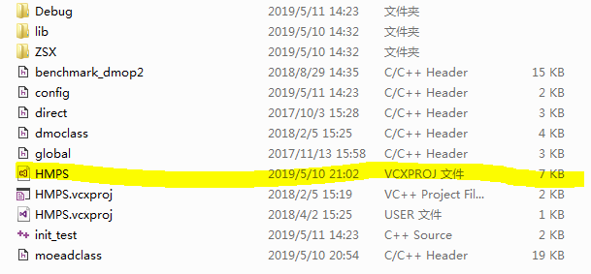
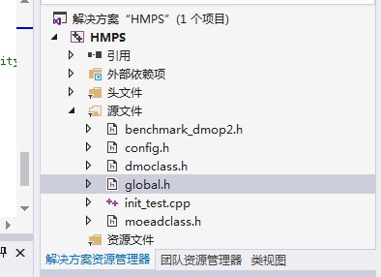

Step 4. You can compile and run the HMPS project by using Visual Studio 2015. You can use shortcut keys (F5) to run the project quickly, and the following figure shows the code works.

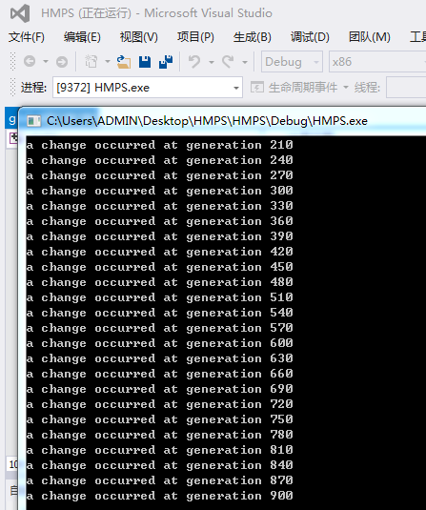

Here, we will explain the configuration of some key files. In the init_test.cpp, some vital parameters are illustrated in the following figure.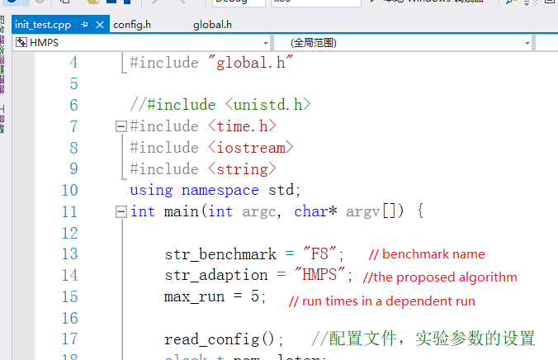
Int the config.h you can set the parameters, such as change frequency, change severity, and the upper and lower boundaries of the test problems, etc. It is worth noting that the settings of upper and lower boundaries are based on the problem. In the following figures, the setting of upper and lower boundaries of decision variables are corresponding to F8 test problem.
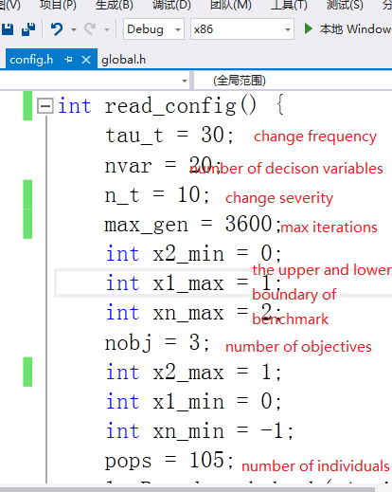

In the moeadclass.h, you can set the output path of the obtained populations at the end of every time step, which can seen in the following figures. In our experiment, the change frequency is set to 30, therefore the population at 30,60,90,...is output.
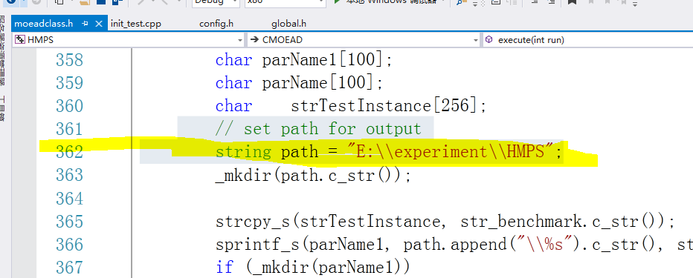


Finally, you can combine the output populations and the true PFs at every time step to calculate the MIGD, MHV or other performance metrics. In our experiment, the method of calculating the true PFs is based on PPS. (A Population Prediction Strategy for Evolutionary Dynamic Multiobjective Optimization, PPS). You can also choose other reasonable methods. GOOD LUCK!

