DAPA CLIMATE DATABASE

*Brief description about the CIAT-DAPA climate database*

**Authors**

**Carlos Navarro**

[c.e.navarro@cgiar.org](mailto:c.e.navarro@cgiar.org)

**Jaime Tarapues**

[j.e.tarapues@cgiar.org](mailto:j.e.tarapues@cgiar.org)

**September 2013**

# 

# Contents

1) Access to DAPADFS (DAPA - Distributed File System) 3

2) Climate Data Directories 5

# Access to DAPADFS (DAPA - Distributed File System)

1. Make sure that you are inside of IS environment.
2. Go to Start, then “Run...” (or in keyboard + R). Write \\dapadfs

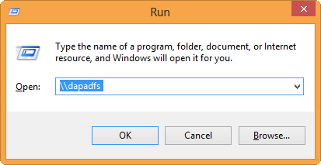

If it doesn’t work try with \\dapadfs.ciat.cgiarad.org

1. You will find the main shares directories of DAPA cluster storage.

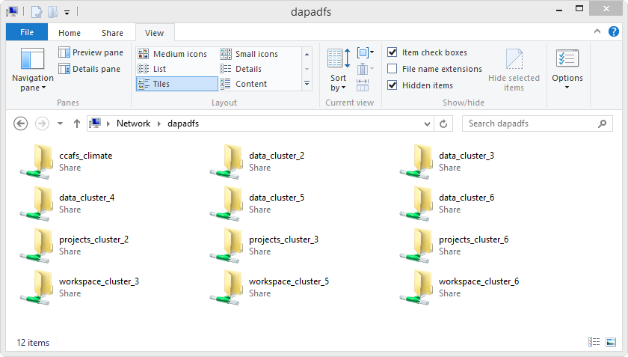

Each partition (e.g. “cluster_3”) has ~25TB of storage.

Three kind of folder compose the each cluster partition:

* Data: Mainly houses climate data, maps, rasters and tables.
* Projects: Information about finished projects used in the CIAT institutional memory.
* Workspace: Processing and temporal storage of unfinished or unorganized projects.

1. If you want to add a share directory as a network drive, right-click on the directory and choose “Map Network drive”, assign a letter unit and you will see the directory in your network locations.

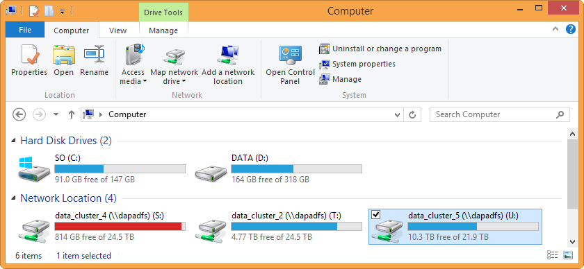

# Climate Data Directories

The DAPA Climate Database contains historical and future data mainly in ESRI-Ascii, ESRI-Grid and text plain format.

The following table summarizes the climate information available in DAPADFS (last actualization September 2013). See this on the following link (frequently update):

<https://docs.google.com/spreadsheet/ccc?key=0AoTsjp1q3QCOdE52dEx4c29NTmU3LUVId0p6YWFBcGc&pli=1#gid=0>

|  |  |  |  |  |  |
| --- | --- | --- | --- | --- | --- |
| **Directory** | **1st level** | **2nd level** | **3er level** | **Description** | **Availability** |
| **\data_cluster2** | \gcm | \cmip5 | \baseinfo | Necessary info for downscaling method process | Available |
| \interpolations | Interpolated AR5 anomalies at 1km of resolution | Available |
| \raw | Original GCM data (average and filled info) | Available |
| \mri | \_describes | Statistics of MRI grids | Restricted |
| \_scripts | Tools for MRI processing | Restricted |
| \mri_grids | Present and future climatological MRI data in ESRI grid format | Restricted |
| \MRI_inputs | Present and future climatological MRI data in dtr format | Restricted |
| \MRI_outputs | Present and future climatological MRI data in NetCDF format | Restricted |
| \MRI_Validation | Validation data files of MRI over South America | Restricted |
| \MRIAAIgrid | Present and future climatological MRI data in Esri-Ascii format | Restricted |
| \rcm | \cordex | \AFR-44 | CORDEX Africa raw files | Restricted |
| \ANT-44 | CORDEX Antarctica raw files | Restricted |
| \ARC-44 | CORDEX Arctic raw files | Restricted |
| \NAM-44 | CORDEX North America raw files | Restricted |
| \eta | \raw_data | Current and Future ETA model data at 40km | Restricted |
| \precis | \_describes | Describe info by variable (69 variables available) | Available |
| \boundary_conditions | Lateral Boundary Conditions for PRECIS runs | Available |
| \post_processed | Daily, Monthly, 30yr avg PRECIS data in ESRI-Grid/Ascii format | Available |
| \raw_data | Setting data for run PRECIS | Available |
| \software | PRECIS software and libraries | Restricted |
| \srtm |  |  | Processed STRM Data Version 4.1. | Available |
| **\data_cluster3** | \LANDSAT | \tree_cover_GLCF | \procesed | Mosaics created from raw tree cover data | Available |
|  | \raw | Raw Tree cover organized by Path-Row Landsat from the University of Maryland | Available |
| \marksim-files | \gcm4data |  | Binary files (.bin) with data for the GCM regression interpolation | Available |
| \MarkDat |  | Clustering data | Available |
| \rnf from markov base |  | rnf MarkSim files | Available |
| \Setup |  | Installation MarkSim files and coverages | Available |
| \MODIS | \_modis_tiles_densified |  | Global MODIS coverage by tile in shapefile format | Available |
| \_MODIS_tools |  | Software for processing MODIS images | Available |
| \MODXXX |  | Files from different MODIS products in their raw format (HDF) and other processed formats (geoTIFF, GRID) | Available |
| \WATER_MASK_MOD |  | Water mask created from MOD35 imagery | Available |
| \trmm | \3b42\V7 | \ASC | Tropical Rainfall Measuring Mission (TRMM) in ASC format | Available |
| \BIN | Tropical Rainfall Measuring Mission (TRMM) in BIN format | Available |
| **\data_cluster4** | \admin_boundaries |  |  | Administrative Boundaries at global, country, adm1, adm2 levels. | Available |
| \gcm | \cmip3 | \anomalies | AR4 anomalies in the raw GCM resolution | Available |
| \baseinfo | Necessary info for downscaling method process | Available |
| \disaggregated | Disaggregated of CMIP3 GCM outputs. Technical details at http://www.ccafs-climate.org/downloads/docs/Disaggregation-WP-02.pdf | Available |
| \downscaled | Deltha Method downscaled of CMIP3 GCM outputs. Technical details at http://www.ccafs-climate.org/downloads/docs/Downscaling-WP-01.pdf | Available |
| \interpolations | Interpolated AR4 anomalies at 1km of resolution | Available |
| \pattern_scaling_marksim | Future climatological data derived from the application of MarkSim daily weather generator | Available |
| \performance | Evaluation of the GCM skill | Available |
| \raw_data | Original GCM data (average and filled info) | Available |
| \observed | \gridded_products | \arc | Gridded precipitation estimates (RFE and ARC) from CPC/FEWS | Available |
| \cmorph | NOAA CPC Morphing Technique ("CMORPH") data | Available |
| \cpc | NOAA Climate Prediction Center (CPC) data | Available |
| \cru-ts | CRU-TS Historic Climate Database for GIS | Available |
| \cru-ts-v3-1 | CRU-TS v3.10.01 Historic Climate Database for GIS | Available |
| \cru-ts-v3-21 | CRU-TS v3.21 Historic Climate Database for GIS | Available |
| \fews | Gridded precipitation estimates (RFE and ARC) from CPC/FEWS | Available |
| \ghcn-gsod-merge | Interpolated anomalies from merged GHCN/GSSD daily climate database | Available |
| \ncep-cfsr | NCEP Climate Forecast System Reanalysis (CFSR) data | Available |
| \rfe | Decadal (10-day) Rainfall Estimate (RFE) | Available |
| \srtm | Shuttle Radar Topography Mission data | Available |
| \tamsat | Tropical Applications of Meteorology using Satellite data | Available |
| \trmm-v3b42 | Tropical Rainfall Measuring Mission (TRMM) - NASA data | Available |
| \worldclim | Global Climate Data from WorldClim | Available |
| \weather_station | \beaumont_data | Set of stations for Africa and Asian countries | Restricted |
| \ciat-pjones | Set of stations filtered by Peter Jones | Restricted |
| \cru-station | Land Stations used by the Climatic Research Unit within CRUTEM3 | Available |
| \ghcn | Global Historical Climatology Network data - NOAA | Available |
| \gsod | Global Surface Summary of Day data - NOAA | Available |
| \ideam-col | Weather stations info from Instituto de Hidrología, Meteorología y Estudios Ambientales of Colombia | Restricted |
| \smn-mex | Weather stations from Servicio Meteorológico Nacional of Mexico | Restricted |
| \worldclim | Global Climate Station Data from WorldClim | Available |
| \portals | \amkn-gcm-data |  | AMKN portal data | Restricted |
| \ccafs_climate |  | CCAFS-Climate portal data | Restricted |
| \ccafs-analogues |  | Analogues portal data | Restricted |
| **\data_cluster5** | \rcm | \eta | \raw | Climatology for ETA Model by 10km for Colombia and Ecuador | Restricted |
| \software | Software and libraries for installation of ETA Model | Restricted |
| \test_runs | Sazonal test runs | Restricted |