DAPA TOOLBOX GUIDE

*Common tools for spatial data processing in python*

**Authors**

**Jaime Tarapues**

[j.e.tarapues@cgiar.org](mailto:j.e.tarapues@cgiar.org)

**Carlos Navarro**

[c.e.navarro@cgiar.org](mailto:c.e.navarro@cgiar.org)

**September 2013**

# Contents

1) About This Guide 3

2) How To Import The Dapa-Toolbox In ArcGis 3

3) How To Run A Script In Cmd 5

4) Code Documentation For General Functions 6

4.1) Ascii2Grid 6

4.2) Copy Rasters 6

4.3) DescribeGrid 7

4.4) ExtractByMask 7

4.5) ExtractCRU_v3_1 8

4.6) Grid2Ascii 8

4.7) Grid2OtherFormat 9

4.8) Resample 10

4.9) ZonalStatisticsAsTable 10

4.10) Cut_WordClim 11

5) Code Documentation For CMIP3Data Processing 12

5.1) AverageGCM_CMIP3 12

5.2) CutGCM_CMIP3 13

5.3) ExtractValuesGCM_CMIP3 14

5.4) DescribeGCM_CMIP3 16

5.5) ResampleGCM_CMIP3 17

5.6) ZonalStatisticsGCM_CMIP3 19

# About This Guide

This general guide will enable you to:

* Import the DAPA Toolbox into ArcGIS
* Identify which script you need
* Run scripts successfully through the correct use of syntax

All the codes are in Python language, Windows Operating System and require ArcGis Workstation and ArcGis 9.1, 9.2, 9.3, 10 or 10.1.

# How To Import The Dapa-Toolbox In ArcGis

1. Decompress the DAPA-Toolbox.zip
2. Copy the DAPA-Toolbox folder to the ArcToolbox folder of ArcGIS.

C:\Program Files (x86)\ArcGIS\Desktop10.0\ArcToolbox\Toolboxes

Note: The toolbox path changes depending on the version of the installed ArcGIS.

1. Open **ArcMap**, in the **ArcToolbox** window, **right-click** on the toolbox and click **Add > Toolbox** (See Figure 1), then navigate to the location of the toolbox, select the tool and then click Open (See Figure 2).

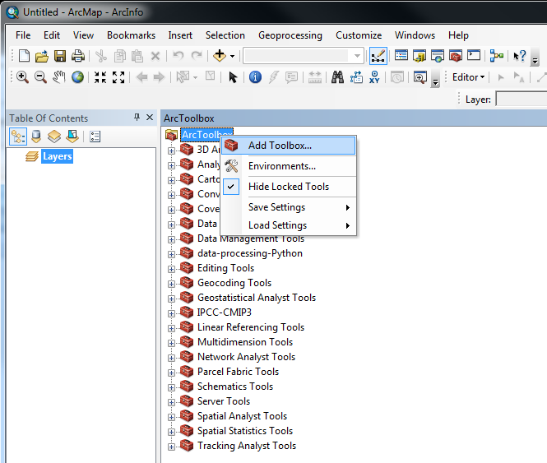

*Figure 1. Adding the toolbox*

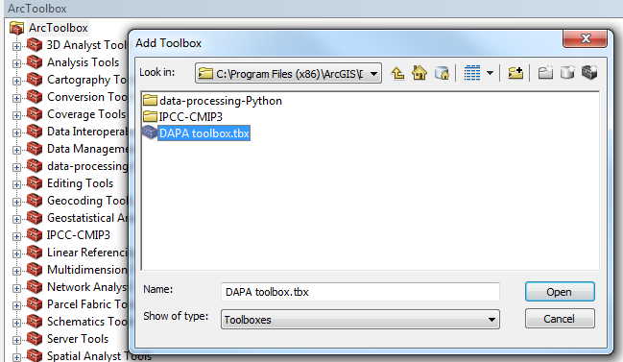

*Figure 2. Selecting the toolbox*

1. After adding the toolbox, you will need to add the relative path of the script file. To do this, **right-click** on the toolbox, click **Properties** **> Source**, and then navigate to the location of the script file (See Figure 3).

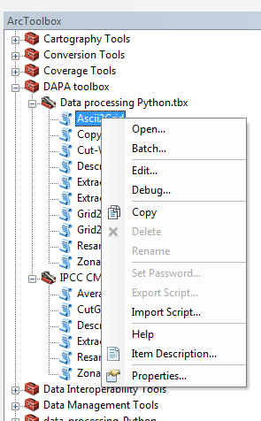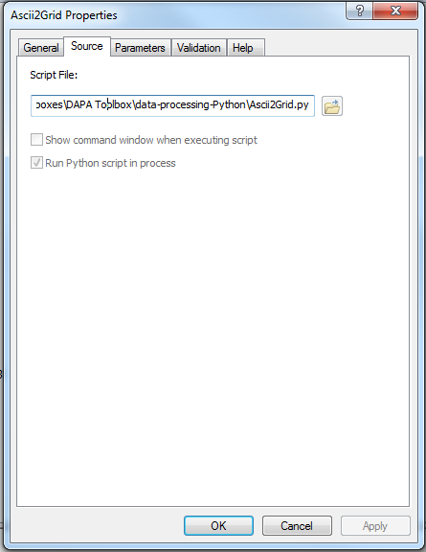

*Figure 3. Add script file path*

# How To Run A Script In Cmd

To run a script you must first set the working directory, this establishes where the script is located. The next step is to copy the line of code (syntax scripts) to a **CMD** (in this case Windows), before finally running the script. For example, to run the script *“****DescribeGCM_CMIP3.py***” you must first open the *CMD* window and enter the address of the folder where the script is located (see Figure 4), the second step is to copy the syntax of the code with the parameters set (see Figure 5), finally, press the ENTER key to run the script.

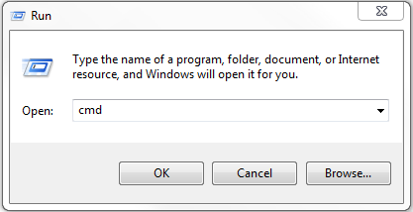 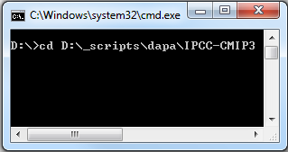

*Figure 4. Accessing the CMD and entering the folder of Scripts*

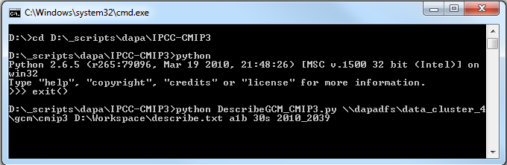

*Figure 5. Syntax of the script to run*

# Code Documentation For General Functions

## **Ascii2Grid**

|  |  |  |
| --- | --- | --- |
| Ascii2Grid | | |
| Summary | Convert asciis to grids in a workspace | |
| Syntax | python Ascii2Grid.py <dirbase> <dirout> <wildcard> <type> <remove> | |
| Example | python Ascii2Grid.py D:\Workspace D:\Workspace prec INTEGER NO | |
| **Parameter** | **Explanation** | **Data Type** |
| dirbase | Is the folder where your ESRI-Asciis files are located | Folder |
| dirout | Is the folder where the ESRI-grids files are created | Folder |
| wildcard | Search files with matching key name; e.g. if you want all precipitation data *(prec_1, prec_2, ..., prec_n)*, you must write *"prec"*. Use *"ALL"* to convert all data in the workspace. | String |
| type | The data type of the output raster dataset.  INTEGER — An integer raster dataset will be created.  FLOAT — A floating-point raster dataset will be created. | String |
| remove | Remove ESRI-Ascii files of base directory after converted | String |

## Copy Rasters

|  |  |  |
| --- | --- | --- |
| CopyRasters | | |
| Summary | Copy grids files to another location | |
| Syntax | python CopyRasters.py <dirbase> <dirout> <wildcard> <switch> | |
| Example | python CopyRasters.py D:\Workspace D:\Workspace ALL NO | |
| **Parameter** | **Explanation** | **Data Type** |
| dirbase | Is the folder where your ESRI-Grid files are located | Folder |
| dirout | Is the folder where the ESRI-grids files are created | Folder |
| wildcard | Search files with matching key name; e.g. if you want all precipitation data *(prec_1, prec_2, ..., prec_n)*, you must write *"prec"*. Use *"ALL"* to convert all data in the workspace. | String |
| switch | Remove ESRI-Grid files of base directory after copied | String |

## DescribeGrid

|  |  |  |
| --- | --- | --- |
| DescribeGrids | | |
| Summary | Returns the properties of a raster dataset | |
| Syntax | python DescribeGrids.py <dirbase> <diroutfile> <wildcard> | |
| Example | python DescribeGrids.py D:\Workspace D:\Workspace\describe.txt prec | |
| **Parameter** | **Explanation** | **Data Type** |
| dirbase | Is the folder where your ESRI-Grid files are located | Folder |
| diroutfile | Is the folder where you want to create description file to outputs Rasters | Folder |
| wildcard | Search files with matching key name; e.g. if you want all precipitation data *(prec_1, prec_2, ..., prec_n)*, you must write *"prec"*. Use *"ALL"* to convert all data in the workspace. | String |

## ExtractByMask

|  |  |  |
| --- | --- | --- |
| ExtractByMask | | |
| Summary | Extracts the cells of a raster that correspond to the areas defined by a mask | |
| Syntax | python ExtractByMask.py <dirbase> <dirout> <mask> <wildcard> | |
| Example | python ExtractByMask.py D:\Workspace D:\Workspace\_cut D:\Workspace \mask ALL | |
| **Parameter** | **Explanation** | **Data Type** |
| dirbase | Is the folder where your ESRI-Grid files are located | Folder |
| dirout | Is the folder where the cut ESRI-Grid files are created | Folder |
| mask | Input mask data defining areas to extract (ESRI-grid file or shapefile). | Dataset |
| wildcard | Search files with matching key name; e.g. if you want all precipitation data *(prec_1, prec_2, ..., prec_n)*, you must write *"prec"*. Use *"ALL"* to convert all data in the workspace. | String |

## ExtractCRU_v3_1

|  |  |  |
| --- | --- | --- |
| ExtractCRU_v3_1 | | |
| Summary | Extract data by points or by mask from CRU-TS3.1 grids. | |
| Syntax | python ExtractCRU_v3_1.py <dirbase> <dirout> <mask> <startyear> <endyear> <variable> <mode> | |
| Example | python ExtractCRU_v3_1.py \\dapadfs\data_cluster_4\observed\gridded_products\cru-ts-v3-1\monthly_grids D:\Workspace\Output D:\Workspace\mask 2005 2009 ALL 1 | |
| **Parameter** | **Explanation** | **Data Type** |
| dirbase | Is the folder where your ESRI-Grid CRU data are located | Folder |
| mask | Input mask data defining areas to extract (ESRI-grid file or shapefile). | Dataset |
| dirout | Is the folder where the output files are created (ESRI-Grid files or DBF files) | Folder |
| startyear | Start year of extraction (1901-2009) | String |
| endyear | End year of extraction (1901-2009) | String |
| variable | Search files with matching key name; e.g. if you want all precipitation data (pre_1, pre_2, ..., pre_n), you must write 'pre'. Use 'ALL' to convert all data in the workspace. The possibilities are: tmn(daily minimun temperature), tmx(daily maxmium temperature), pre(precipitation) and tmp(daily mean temperature) | String |
| Mode | Modes:  1. Extract by points and groups by variables 2. Extract by mask 3. Extract by points and group for MarkSim | Integer |

## Grid2Ascii

|  |  |  |
| --- | --- | --- |
| Grid2Ascii | | |
| Summary | Convert ESRI-Grid to ESRI-Ascii files in a workspace | |
| Syntax | python Grid2Ascii.py <dirbase> <dirout> <wildcard> <switch> | |
| Example | python Grid2Ascii.py D:\Workspace D:\Workspace\_grids ALL YES | |
| **Parameter** | **Explanation** | **Data Type** |
| dirbase | Is the folder where your ESRI-Grid files are located | Folder |
| dirout | Is the folder where the ESRI-Asciis files are created | Folder |
| wildcard | Search files with matching key name; e.g. if you want all precipitation data *(prec_1, prec_2, ..., prec_n)*, you must write *"prec"*. Use *"ALL"* to convert all data in the workspace. | Dataset |
| switch | Remove ESRI-Grid files of base directory after converted | String |

## Grid2OtherFormat

|  |  |  |
| --- | --- | --- |
| Grid2OtherFormat | | |
| Summary | Convert ESRI-Grid files to other format in a workspace | |
| Syntax | python Grid2OtherFormat.py <dirbase> <dirout> <wildcard> <format> <switch> | |
| Example | python Grid2OtherFormat.py D:\Workspace D:\Workspace ALL TIFF YES | |
| **Parameter** | **Explanation** | **Data Type** |
| dirbase | Is the folder where your ESRI-Grid files are located | Folder |
| dirout | Is the folder where the output rasters are created | Folder |
| wildcard | Search files with matching key name; e.g. if you want all precipitation data *(prec_1, prec_2, ..., prec_n)*, you must write *"prec"*. Use *"ALL"* to convert all data in the workspace. | Dataset |
| format | The format of the output raster dataset.  BIL—ESRI Band Interleaved by Line file. BIP—ESRI Band Interleaved by Pixel file. BMP—Bitmap graphic raster dataset format. BSQ—ESRI Band Sequential file. DAT—ENVI DAT file GIF—Graphic Interchange Format for raster datasets GRID—ESRI's GRID raster dataset format IMAGINE Image—ERDAS IMAGINE raster data format JP2000—JPEG 2000 raster dataset format JPEG—Joint Photographic Experts Group raster dataset format PNG—Portable Network Graphic raster dataset format TIFF—Tag Image File Format for raster datasets |  |
| switch | Remove ESRI-Grid files of base directory after converted | String |

## Resample

|  |  |  |
| --- | --- | --- |
| Resample | | |
| Summary | Resample ESRI-Grid files in a workspace | |
| Syntax | python Resample.py <dirbase> <dirout> <resolution> <method> <wildcard> | |
| Example | python Resample.py D:\Workspace D:\Workspace\_resampled 0.5 NEAREST ALL | |
| **Parameter** | **Explanation** | **Data Type** |
| dirbase | Is the folder where your ESRI-Grid files are located | Folder |
| dirout | Is the folder where the resampled ESRI-Grid files are created | Folder |
| resolution | Is a numeric value indicating the resolution of the output files in arc-minutes. | Float |
| method | The resampling algorithm to be used. The default is NEAREST.  NEAREST—Nearest neighbor assignment BILINEAR—Bilinear interpolation CUBIC—Cubic convolution MAJORITY—Majority resampling | String |
| wildcard | Search files with matching key name; e.g. if you want all precipitation data *(prec_1, prec_2, ..., prec_n)*, you must write *"prec"*. Use *"ALL"* to convert all data in the workspace. | Dataset |

## ZonalStatisticsAsTable

|  |  |  |
| --- | --- | --- |
| ZonalStatisticsAsTable | | |
| Summary | Calculate Zonal Statistics as Table of ESRI-Grid files in a workspace | |
| Syntax | python ZonalStatisticsAsTable.py <dirbase> <dirout> <mask> <wildcard> | |
| Example | python ZonalStatisticsAsTable.py D:\Workspace D:\Workspace D:\Workspace\mask\shapefile.shp ALL | |
| **Parameter** | **Explanation** | **Data Type** |
| dirbase | Is the folder where your ESRI-Grid files are located | Folder |
| dirout | Is the folder where the zonal statistics tables are created | Folder |
| Mask | Polygon shapefile with full path and extension | Folder |
| wildcard | Search files with matching key name; e.g. if you want all precipitation data *(prec_1, prec_2, ..., prec_n)*, you must write *"prec"*. Use *"ALL"* to convert all data in the workspace. | Dataset |

## Cut_WordClim

|  |  |  |
| --- | --- | --- |
| Cut_WordClim | | |
| Summary | Cut by mask worldclim data and Extraction by mask of points | |
| Syntax | <Extract_MaskGCM.py> <dirbase> <mask> <dirout> <resolution> <variable> <ascii> <describe> | |
| Example | python Cut_WordClim.py \\dapadfs\data_cluster_4\observed\gridded_products\worldclim D:\mask D:\Workspace\Output 30s prec NO NO | |
| **Parameter** | **Explanation** | **Data Type** |
| dirbase | Is the folder where your ESRI-Grid files are located | Folder |
| dirout | Is the folder where the ESRI-Grid files are created | Folder |
| Mask | Input mask data defining area to extract (ESRI-grid file or shapefile). | Dataset |
| Resolution | Is a numeric value indicating the resolution of the input files in arc-minutes. The possibilities are 30s, 2_5 min, 5min, 10min | String |
| variable | The possibilities are: bio(bioclimatic), prec(precipitation), tmax(maximum temperature), tmin(minimum temperature), tmean(average temperature).  If you want to choose some variables, only separated with commas without spaces; e.g. "*prec,tmax,tmin*"*.* Use "AL" to use all data in the workspace. | Dataset |
| ascii | Convert outputs ESRI-Grid files to Ascii | String |
| describe | Create description file to outputs Rasters | String |

# Code Documentation For CMIP3Data Processing

## **5.1) AverageGCM_CMIP3**

|  |  |  |
| --- | --- | --- |
| AverageGCM_CMIP3 | | |
| Summary | Calculates the mean (average) and  the standard deviation of models from downscaled, disaggregated, anomalies or interpolated GCM data. | |
| Syntax | <AverageGCM_CMIP3.py> <dirbase> <dirout> <mask> <sres> <resolution> <period> <wildcard> | |
| Example | python AverageGCM_CMIP3.py \\dapadfs\data_cluster_4\gcm\cmip3\downscaled D:\Workspace\output D:\Workspace\mask a1b 30s 2010_2039 ALL | |
| **Parameter** | **Explanation** | **Data Type** |
| dirbase | Is the folder where are located GCM data | Folder |
| dirout | Is the folder where the output files are created | Folder |
| mask | Input mask data defining areas to extract (ESRI-grid file or shapefile). | Dataset |
| sres | IPCC Emission Escenario. The possibilities are a1b, a2, b1. | String |
| resolution | Is a numeric value indicating the input resolution in arc-minutes. The possibilities are 30s, 2_5min, 5min, 10min | String |
| periods | Future 30yr periods  The possibilities are: 2010_2039, 2020_2049, 2030_2059, 2040_2069, 2050_2079, 2060_2089, 2070_2099  If you want to choose some periods, enter them separated by commas without spaces; e.g. "2010_2039,2020_2049,2030_2059". Use *"ALL"* to process all the periods. | String |
| wildcard | Search files with matching key name; e.g. if you want all precipitation data *(prec_1, prec_2, ..., prec_n)*, you must write *"prec"*. Use *"ALL"* to convert all data in the workspace.  The possibilities are: bio, prec, tmin, tmax, tmean | String |

## **5.2) CutGCM_CMIP3**

|  |  |  |
| --- | --- | --- |
| CutGCM_CMIP3 | | |
| Summary | Extract by mask downscaled, disaggregated, anomalies or interpolated GCM data. | |
| Syntax | <Extract_MaskGCM.py> <dirbase> <dirout> <mask> <dataset> <sres> <resolution> <models> <periods> <variable> <ascii> <descfile> | |
| Example | python CutGCM_CMIP3.py \\dapadfs\data_cluster_4\gcm\cmip3 D:\Workspace\output D:\Workspace\mask downscaled A2 30s cnrm_cm3,bccr_bcm2_0 2010_2039 prec YES YES | |
| **Parameter** | **Explanation** | **Data Type** |
| dirbase | Is the folder where are located GCM data | Folder |
| dirout | Is the folder where the output files are created | Folder |
| mask | Input mask data defining areas to extract (ESRI-grid file or shapefile). | Dataset |
| dataset | The possibilities are: Downscaled, Disaggregated, interpolations, and anomalies dataset. | String |
| sres | IPCC Emission Escenario. The possibilities are a1b, a2, b1. | String |
| resolution | Is a numeric value indicating the input resolution in arc-minutes. The possibilities are 30s, 2_5min, 5min, 10min | String |
| models | The possibilities of Global Climate Models are:  A1B Scenario: bccr_bcm2_0,cccma_cgcm3_1_t47,cccma_cgcm3_1_t63,cnrm_cm3,csiro_mk3_0,csiro_mk3_5,gfdl_cm2_0,gfdl_cm2_1,giss_aom,giss_model_eh,giss_model_er,iap_fgoals1_0_g,ingv_echam4,inm_cm3_0,ipsl_cm4,miroc3_2_hires,miroc3_2_medres,ncar_ccsm3_0,miub_echo_g,mpi_echam5,mri_cgcm2_3_2a,ncar_pcm1,ukmo_hadcm3,ukmo_hadgem1  A2 Scenario: bccr_bcm2_0,cccma_cgcm3_1_t47,cnrm_cm3,csiro_mk3_0,csiro_mk3_5,gfdl_cm2_0,gfdl_cm2_1,giss_model_er,ingv_echam4,inm_cm3_0,ipsl_cm4,miroc3_2_medres,miub_echo_g,mpi_echam5,mri_cgcm2_3_2a,ncar_ccsm3_0,ncar_pcm1,ukmo_hadcm3,ukmo_hadgem1  B1 Scenario: bccr_bcm2_0,cccma_cgcm3_1_t47,cccma_cgcm3_1_t63,cnrm_cm3,csiro_mk3_0,csiro_mk3_5,gfdl_cm2_0,gfdl_cm2_1,giss_aom,giss_model_er,iap_fgoals1_0_g,inm_cm3_0,ipsl_cm4,miroc3_2_hires,miroc3_2_medres,miub_echo_g,mpi_echam5,mri_cgcm2_3_2a,ncar_ccsm3_0,ukmo_hadcm3  Note: If you want to choose some models, only separated with commas without spaces. Use *"ALL"* to choose all available models. | String |
| periods | Future 30yr periods  The possibilities are: 2010_2039, 2020_2049, 2030_2059, 2040_2069, 2050_2079, 2060_2089, 2070_2099  If you want to choose some periods, enter them separated by commas without spaces; e.g. "2010_2039, 2020_2049, 2030_2059". Use *"ALL"* to process all the periods. | String |
| variable | The possibilities are: bio(bioclimatic), prec(precipitation), tmax(maximum temperature), tmin(minimum temperature), tmean(average temperature).  If you want to choose some variables, only separated with commas without spaces; e.g. *"prec,tmax,tmin"*. Use *"ALL"* to use all data in the workspace. | String |
| ascii | Convert outputs ESRI-Grid files to Ascii | String |
| descfile | Describe properties of outputs ESRI-Grid files | String |

## **5.3) ExtractValuesGCM_CMIP3**

|  |  |  |
| --- | --- | --- |
| ExtractValuesGCM_CMIP3 | | |
| Summary | Extraction by mask of points, downscaled, diseggregated or interpolated GCM data. | |
| Syntax | <Extract_MaskGCM.py> <dirbase> <dirout> <mask> <dataset> <sres> <resolution> <models> <periods> <variable> | |
| Example | python ExtractValuesGCM_CMIP3.py \\dapadfs\data_cluster_4\gcm\cmip3 D:\Workspace\output D:\Workspace\Pluviometros.shp downscaled A2 5min bccr_bcm2_0,cccma_cgcm3_1_t47 2020_2049,2040_2069 prec | |
| **Parameter** | **Explanation** | **Data Type** |
| dirbase | Is the root GCM folder | Folder |
| dirout | Is the folder where the tables (Dbf) are created | Folder |
| mask | Input mask data defining points to extract (ShapeFile file). | Dataset |
| dataset | The possibilities are: Downscaled, Disaggregated, interpolations, and anomalies dataset. | String |
| sres | IPCC Emission Escenario. The possibilities are a1b, a2, b1. | String |
| resolution | Is a numeric value indicating the input resolution in arc-minutes. The possibilities are 30s, 2_5min, 5min, 10min | String |
| models | The possibilities of Global Climate Models are:  A1B Scenario: bccr_bcm2_0,cccma_cgcm3_1_t47,cccma_cgcm3_1_t63,cnrm_cm3,csiro_mk3_0,csiro_mk3_5,gfdl_cm2_0,gfdl_cm2_1,giss_aom,giss_model_eh,giss_model_er,iap_fgoals1_0_g,ingv_echam4,inm_cm3_0,ipsl_cm4,miroc3_2_hires,miroc3_2_medres,ncar_ccsm3_0,miub_echo_g,mpi_echam5,mri_cgcm2_3_2a,ncar_pcm1,ukmo_hadcm3,ukmo_hadgem1  A2 Scenario: bccr_bcm2_0,cccma_cgcm3_1_t47,cnrm_cm3,csiro_mk3_0,csiro_mk3_5,gfdl_cm2_0,gfdl_cm2_1,giss_model_er,ingv_echam4,inm_cm3_0,ipsl_cm4,miroc3_2_medres,miub_echo_g,mpi_echam5,mri_cgcm2_3_2a,ncar_ccsm3_0,ncar_pcm1,ukmo_hadcm3,ukmo_hadgem1  B1 Scenario: bccr_bcm2_0,cccma_cgcm3_1_t47,cccma_cgcm3_1_t63,cnrm_cm3,csiro_mk3_0,csiro_mk3_5,gfdl_cm2_0,gfdl_cm2_1,giss_aom,giss_model_er,iap_fgoals1_0_g,inm_cm3_0,ipsl_cm4,miroc3_2_hires,miroc3_2_medres,miub_echo_g,mpi_echam5,mri_cgcm2_3_2a,ncar_ccsm3_0,ukmo_hadcm3  Note: If you want to choose some models, only separated with commas without spaces. Use *"ALL"* to choose all available models. | String |
| periods | Future 30yr interval  The possibilities are: 2010_2039, 2020_2049, 2030_2059, 2040_2069, 2050_2079, 2060_2089, 2070_2099  if you want to choose some periods, enter them separated by commas without spaces; e.g. "2010_2039,2020_2049, 2030_2059". If you want to choose all the periods, you can input only "ALL" | String |
| variable | The possibilities are: bio(bioclimatic), prec(precipitation), tmax(maximum temperature), tmin(minimum temperature), tmean(average temperature).  If you want to choose some variables, only separated with commas without spaces; e.g. *"prec,tmax,tmin"*. Use *"ALL"* to use all data in the workspace. | String |

## 5.4) DescribeGCM_CMIP3

|  |  |  |
| --- | --- | --- |
| DescribeGCM_CMIP3 | | |
| Summary | Describe properties of ESRI-Grid Downscaled, Disaggregated, anomalies or Interpolated datasets | |
| Syntax | <DescribeGCM_CMIP3.py> <dirbase> <descfile> <sres> <resolution>  <models> <periods> <variable> | |
| Example | python DescribeGCM_CMIP3.py \\dapadfs\data_cluster_4\gcm\cmip3\downscaled D:\Workspace\output a1b 30s cnrm_cm3,bccr_bcm2_0 2010_2039 ALL | |
| **Parameter** | **Explanation** | **Data Type** |
| dirbase | Is the root GCM folder | Folder |
| Output_file | Is the folder where you want to create description file to outputs Rasters | Folder |
| sres | IPCC Emission Escenario. The possibilities are a1b, a2, b1. | String |
| Resolution | Is a numeric value indicating the input resolution in arc-minutes. The possibilities are 30s, 2_5min, 5min, 10min | String |
| models | The possibilities of Global Climate Models are:  A1B Scenario:  bccr_bcm2_0,cccma_cgcm3_1_t47,cccma_cgcm3_1_t63,cnrm_cm3,csiro_mk3_0,csiro_mk3_5,gfdl_cm2_0,gfdl_cm2_1,giss_aom,giss_model_eh,giss_model_er,iap_fgoals1_0_g,ingv_echam4,inm_cm3_0,ipsl_cm4,miroc3_2_hires,miroc3_2_medres,ncar_ccsm3_0, miub_echo_g,mpi_echam5,mri_cgcm2_3_2a,ncar_pcm1,ukmo_hadcm3,ukmo_hadgem1  A2 Scenario:  bccr_bcm2_0,cccma_cgcm3_1_t47,cnrm_cm3,csiro_mk3_0,csiro_mk3_5,gfdl_cm2_0,gfdl_cm2_1,giss_model_er,ingv_echam4,inm_cm3_0,ipsl_cm4,miroc3_2_medres,miub_echo_g,mpi_echam5,mri_cgcm2_3_2a,ncar_ccsm3_0,ncar_pcm1,ukmo_hadcm3,ukmo_hadgem1  B1 Scenario:  bccr_bcm2_0,cccma_cgcm3_1_t47,cccma_cgcm3_1_t63,cnrm_cm3,csiro_mk3_0,csiro_mk3_5,gfdl_cm2_0,gfdl_cm2_1,giss_aom,giss_model_er,iap_fgoals1_0_g,inm_cm3_0,ipsl_cm4,miroc3_2_hires,miroc3_2_medres,miub_echo_g,mpi_echam5,mri_cgcm2_3_2a,ncar_ccsm3_0,ukmo_hadcm3  Note: If you want to choose some models, only separated with commas without spaces. Use *"ALL"* to choose all available models. | String |
| Periods | Future 30yr periods  The possibilities are: 2010_2039,2020_2049,2030_2059,2040_2069,  2050_2079,2060_2089,2070_2099  If you want to choose some periods, enter them separated by commas without spaces; e.g."2010_2039,2020_2049,2030_2059". Use *"ALL"* to process all the periods. | String |
| variable | Search files with matching key name; e.g. if you want all precipitation data *(prec_1, prec_2, ..., prec_n)*, you must write *"prec"*. Use *"ALL"* to convert all data in the workspace.  The possibilities are: bio, prec, tmin, tmax, tmean | String |

## 5.5) ResampleGCM_CMIP3

|  |  |  |
| --- | --- | --- |
| ResampleGCM_CMIP3 | | |
| Summary | Resample ESRI-Grid files anomalies, disaggregated, interpolated or downscaled GCM data | |
| Syntax | <ResampleGCM_CMIP3.py> <dirbase> <dirout> <sres> <resolution> <resol_resample> <models> <periods> <wildcard> <method> | |
| Example | python ResampleGCM_CMIP3.py \\dapadfs\data_cluster_4\gcm\cmip3\downscaled D:\Workspace\output B1 5min 10min ALL ALL prec NEAREST | |
| **Parameter** | **Explanation** | **Data Type** |
| dirbase | Is the root GCM folder | Folder |
| dirout | Is the folder where the output files are created | Folder |
| sres | IPCC Emission Escenario. The possibilities are a1b, a2, b1. | String |
| resolution | Is a numeric value indicating the input resolution in arc-minutes. The possibilities are 30s, 2_5min, 5min y 10min | String |
| resol_resample | Is a numeric value indicating the output resolution in arc-minutes. The possibilities are 30s, 2_5min, 5min y 10min | String |
| models | The possibilities of Global Climate Models are:  A1B Scenario: bccr_bcm2_0,cccma_cgcm3_1_t47,cccma_cgcm3_1_t63,cnrm_cm3,csiro_mk3_0,csiro_mk3_5,gfdl_cm2_0,gfdl_cm2_1,giss_aom,giss_model_eh,giss_model_er,iap_fgoals1_0_g,ingv_echam4,inm_cm3_0,ipsl_cm4,miroc3_2_hires,miroc3_2_medres,ncar_ccsm3_0,miub_echo_g,mpi_echam5,mri_cgcm2_3_2a,ncar_pcm1,ukmo_hadcm3,ukmo_hadgem1  A2 Scenario: bccr_bcm2_0,cccma_cgcm3_1_t47,cnrm_cm3,csiro_mk3_0,csiro_mk3_5,gfdl_cm2_0,gfdl_cm2_1,giss_model_er,ingv_echam4,inm_cm3_0,ipsl_cm4,miroc3_2_medres,miub_echo_g,mpi_echam5,mri_cgcm2_3_2a,ncar_ccsm3_0,ncar_pcm1,ukmo_hadcm3,ukmo_hadgem1  B1 Scenario: bccr_bcm2_0,cccma_cgcm3_1_t47,cccma_cgcm3_1_t63,cnrm_cm3,csiro_mk3_0,csiro_mk3_5,gfdl_cm2_0,gfdl_cm2_1,giss_aom,giss_model_er,iap_fgoals1_0_g,inm_cm3_0,ipsl_cm4,miroc3_2_hires,miroc3_2_medres,miub_echo_g,mpi_echam5,mri_cgcm2_3_2a,ncar_ccsm3_0,ukmo_hadcm3  Note: If you want to choose some models, only separated with commas without spaces. Use *"ALL"* to choose all available models. | String |
| periods | Future 30yr periods  The possibilities are: 2010_2039, 2020_2049, 2030_2059, 2040_2069, 2050_2079, 2060_2089, 2070_2099  If you want to choose some periods, enter them separated by commas without spaces; e.g. "2010_2039,2020_2049, 2030_2059". Use *"ALL"* to process all the periods. | String |
| wildcard | Search files with matching key name. E.g. if you want all precipitation data *(prec_1, prec_2, ..., prec_n)*, you must write *"prec"*. Use *"ALL"* to convert all data in the workspace.  The possibilities are: prec, tmin, tmax, tmean | String |
| method | The resampling algorithm to be used. The default is NEAREST.  NEAREST—Nearest neighbor assignment  BILINEAR—Bilinear interpolation  CUBIC—Cubic convolution  MAJORITY—Majority resampling | String |

## 5.6) ZonalStatisticsGCM_CMIP3

|  |  |  |
| --- | --- | --- |
| ZonalStatisticsGCM_CMIP3 | | |
| Summary | Calculate Zonal Statistics as table of ESRI-Grid files in a workspace | |
| Syntax | <ZonalStatisticsGCM_CMIP3.py> <dirbase> <dirout> <mask> <dataset> <sres> <resolution> <models> periods> <wildcard> | |
| Example | python ZonalStatisticsGCM_CMIP3.py \\dapadfs\data_cluster_4\gcm\cmip3 D:\Workspace\output D:\Workspace\polygon.shp downscaled b1 10min bccr_bcm2_0 2020_2049 prec | |
| **Parameter** | **Explanation** | **Data Type** |
| dirbase | Is the root GCM folder | Folder |
| dirout | Is the folder where the output files are created | Folder |
| mask | Polygon shapefile with full path and extension | Dataset |
| dataset | The possibilities are: Downscaled, Disaggregated, interpolations, and anomalies dataset. | String |
| sres | IPCC Emission Escenario. The possibilities are a1b, a2, b1. | String |
| resolution | Is a numeric value indicating the input resolution in arc-minutes. The possibilities are 30s, 2_5min, 5min, 10min | String |
| models | The possibilities of Global Climate Models are:  A1B Scenario: bccr_bcm2_0,cccma_cgcm3_1_t47,cccma_cgcm3_1_t63,cnrm_cm3,csiro_mk3_0,csiro_mk3_5,gfdl_cm2_0,gfdl_cm2_1,giss_aom,giss_model_eh,giss_model_er,iap_fgoals1_0_g,ingv_echam4,inm_cm3_0,ipsl_cm4,miroc3_2_hires,miroc3_2_medres,ncar_ccsm3_0,miub_echo_g,mpi_echam5,mri_cgcm2_3_2a,ncar_pcm1,ukmo_hadcm3,ukmo_hadgem1  A2 Scenario: bccr_bcm2_0,cccma_cgcm3_1_t47,cnrm_cm3,csiro_mk3_0,csiro_mk3_5,gfdl_cm2_0,gfdl_cm2_1,giss_model_er,ingv_echam4,inm_cm3_0,ipsl_cm4,miroc3_2_medres,miub_echo_g,mpi_echam5,mri_cgcm2_3_2a,ncar_ccsm3_0,ncar_pcm1,ukmo_hadcm3,ukmo_hadgem1  B1 Scenario: bccr_bcm2_0,cccma_cgcm3_1_t47,cccma_cgcm3_1_t63,cnrm_cm3,csiro_mk3_0,csiro_mk3_5,gfdl_cm2_0,gfdl_cm2_1,giss_aom,giss_model_er,iap_fgoals1_0_g,inm_cm3_0,ipsl_cm4,miroc3_2_hires,miroc3_2_medres,miub_echo_g,mpi_echam5,mri_cgcm2_3_2a,ncar_ccsm3_0,ukmo_hadcm3  Note: If you want to choose some models, only separated with commas without spaces. Use *"ALL"* to choose all available models. | String |
| periods | Future 30yr periods  The possibilities are: 2010_2039, 2020_2049, 2030_2059, 2040_2069, 2050_2079, 2060_2089, 2070_2099  If you want to choose some periods, enter them separated by commas without spaces; e.g. "2010_2039,2020_2049,2030_2059". Use *"ALL"* to process all the periods. | String |
| wildcard | The possibilities are: bio(bioclimatic), prec(precipitation), tmax(maximum temperature), tmin(minimum temperature), tmean(average temperature).  If you want to choose some variables, only separated with commas without spaces; e.g. *"prec,tmax,tmin"*. Use *"ALL"* to use all data in the workspace. | Dataset |