According to the Ministry of Water and Environment (MWE) (2022), Uganda’s GHG emission, as indicated in the updated [Nationally Determined Contribution](https://undp.medium.com/what-are-the-ndcs-and-why-are-they-important-48f330b71612) (NDC) of Uganda in 2022, has shown an increase from 53.4 MtCO2e in 2005 to 90.1 MtCO2e in 2015. The Land Use and Land Cover Change and Forestry sector contributed the highest 59.5% (53.6 MtCO2e) to the total GHG emissions. The second and third largest sources of GHGs emission are agriculture and energy sectors with 26.9%, and 10.7% contribution, respectively, to the total GHG emission at the national level. Trends in GHG emissions of sectors is shown in Fig. G below. The annual greenhouse gas emission of Uganda has been increasing quasi-linearly since 1980s. Consequently, its contribution to the annual global share of CO2 emission has been increasing, although the magnitude is very small when compared to global emissions. Uganda’s annual share of global CO2 emission is shown in Fig. H below.

Figure G: Sectoral trends in GHG emissions for Ugandasource: MWE (2022)

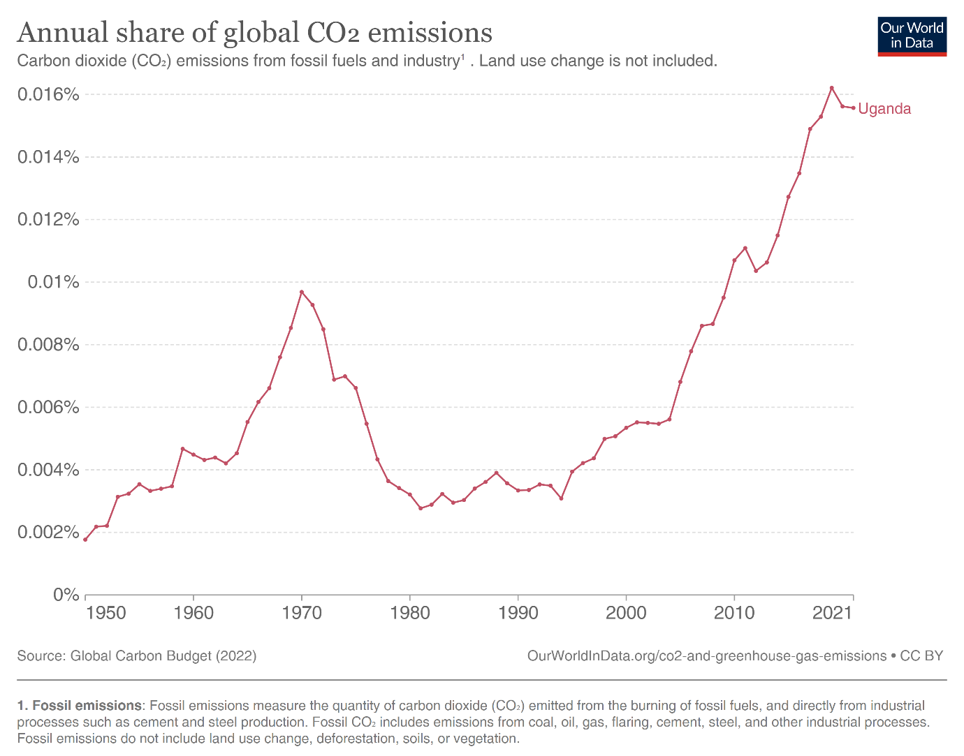

Figure H: Uganda’s annual share of global CO2 emission. Source: Global carbon budget (2023)

Furthermore, under the business-as-usual scenario, the total GHG emission of Uganda will continue to increase up to 240 MtCO2e by 2050 (Fig. I). Followed by agriculture, Land Use and Land Cover Change and Forestry sector will contribute the largest share to the total emission, even under the business-as-usual scenario.

Fig. I: Uganda's GHG emissions projection under the business-as-usual scenario.

Source: MWE (2022)

For the regions of interest in Northern Uganda, greenhouse gas emission is assessed using the dominant source of emission, the land use land cover change and forestry sector. The greenhouse gas emission analysis focused on quantifying emissions that land use land cover (LULC) change contributed. In assessing land use land cover changes in the historical period, land cover maps of 2000[1], and 2017[2] years are used. These datasets are the main products of the National LULC mapping for each epoch done by National Forestry Authority. They represent Uganda's LULC classified into 13 main classes and sub-classes according to the National Biomass Study (NBS) classification system. Following the methods laid out in the Uganda Forest Reference Emission Level (FREL) document (MWE 2018) our analysis focused on analysing conversions among non-forest land, woodland, plantation land cover classes. The LULC change analysis (Fig. J) shows that woodland has decreased in all regions of interest except a small increase in Maracha region. Agago and Abim are regions where the highest and the lowest percentage of loss in woodland cover occurred. The loss in the woodland cover in the aforementioned regions reached about 91% and 32%, respectively. The conversion of woodland to non-forest land between 2000 and 2017 is shown in Fig. K.

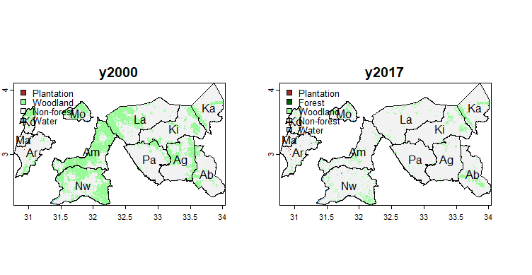

Fig. J: Land use land cover change of the regions of interest during the historical (2000-2017) period.

Fig. K: land use land cover conversions between 2000 and 2017, showing the dominant land cover conversion is from woodland to non-forest land cover.

The emission factor for LULC changes is converted to GHG emissions using emission factors the from Forest Reference Emission Level (FREL) of Uganda (MWE, 2018). The emission factor for woodland is 91 t CO2e ha-1 and for plantations it is 260.3 t CO2e ha-1. During the period of analysis used, the highest GHG emissions from woodland conversion is about 19, 15 and 13 MtCO2e in Amuru, Nwoya and Lamwo regions, respectively (Table 1). Following the losses in woodland cover in the regions of interest, the compound rate of change for woodland cover, with negative signs, shows decrease in all the regions, excluding Karenga and Maracha. The compound rate of change ranges from -0.34 in Agagao to -0.022 in Abim, with no change in Maracha and small positive compound rate (0.043) in Karenga (Table 1). Furthermore, using the compound rate of change from the historical period of analysis, GHG emissions from woodland conversion are forecasted one year forward as an indicator of current forest loss rates and associated emissions. GHG emissions from woodland loss have increased in nearly all the regions of interest in Northern Uganda (Table 1).

Table 1: Summary of land use land cover conversion and rates of change for the regions of interest

|  |  |  |  |  |  |  |  |  |  |  |  |  |
| --- | --- | --- | --- | --- | --- | --- | --- | --- | --- | --- | --- | --- |
|  | Abim | Agago | Amuru | Arua | Karenga | Kitgum | Koboko | Lamwo | Maracha | Moyo | Nwoya | Pader |
| Non-forest | 207316 | 237920 | 110248 | 192761 | 205308 | 325613 | 44631 | 364057 | 42609 | 46309 | 228772 | 289673 |
| Woodland->Non-forest | 35605 | 103734 | 220126 | 23719 | 9685 | 57092 | 25131 | 159828 | 120 | 31750 | 182203 | 35110 |
| Non-forest->Woodland | 20615 | 2629 | 2824 | 5954 | 9468 | 13820 | 2338 | 9008 | 296 | 2944 | 9413 | 4249 |
| Non-forest->Forest | 0 | 0 | 0 | 17 | 0 | 0 | 0 | 0 | 0 | 0 | 0 | 0 |
| woodland_net | -14990 | -101105 | -217302 | -17765 | -217 | -43272 | -22793 | -150820 | 176 | -28806 | -172790 | -30861 |
| woodland_00 | 47186 | 110696 | 243837 | 30926 | 39469 | 75544 | 28838 | 170648 | 170 | 51351 | 224477 | 35564 |
| woodland_17 | 32196 | 9591 | 26535 | 13161 | 39252 | 32272 | 6045 | 19828 | 346 | 22545 | 51687 | 4703 |
| woodland_change_perc | -31.8 | -91.3 | -89.1 | -57.4 | -0.5 | -57.3 | -79 | -88.4 | 103.5 | -56.1 | -77 | -86.8 |
| compound_rate_perc | -2.2 | -13.4 | -12.2 | -4.9 | 0 | -4.9 | -8.8 | -11.9 | 4.3 | -4.7 | -8.3 | -11.2 |
| woodland_emissions_tot_mt | 1.364 | 9.201 | 19.774 | 1.617 | 0.02 | 3.938 | 2.074 | 13.725 | -0.016 | 2.621 | 15.724 | 2.808 |

The government of Uganda has increased its ambition, in the revised NDC, to reduce GHGs emissions by 24.7% below the business-as-usual scenario in 2030. As shown above in Table 1, the Land Use and Land cover Change and Forestry sector is the largest GHG emission contributor. In addition, the same sector substantial contribution is found for the regions of interest. The government of Uganda planned for 24.7% emission reduction relative to the business-as-usual emission scenario. Emphasizing on emission reduction interventions on the land use land cover change and forestry sector alone enables to make substantial reduction (30.4 MtCO2e which is about 20.5%) in GHG emission from the planned 24.7% reduction of GHGs by 2030.

For potential mitigation interventions, the 12 administrative regions are prioritized using total woodland emissions (in mt) (Fig. M). The subregions of the 12 administrative regions are also prioritized using total woodland emissions (in mt) and compound rate (in %) in Fig. N) and Fig. O, respectively. Interventions in all regions at the same time can be challenging given limited resources available. Therefore, mitigation efforts that emphasize on regions of higher CO2 emission enable to bring accelerated result in achieving the ambitions of the government. Figures N and O, due to higher spatial scale, can be used in implementing mitigation option, although they are alternative options to Figure M.

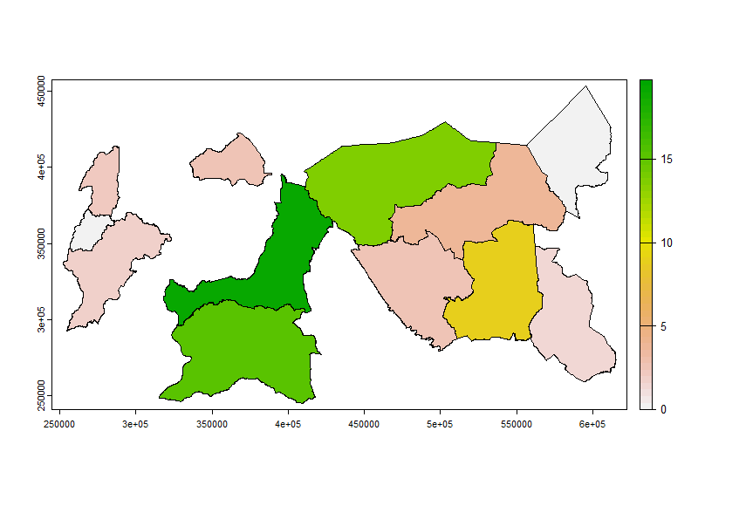

Fig. M: Total woodland emission (in MtCO2e)

Fig. N. Total woodland emissions (in MtCO2e)

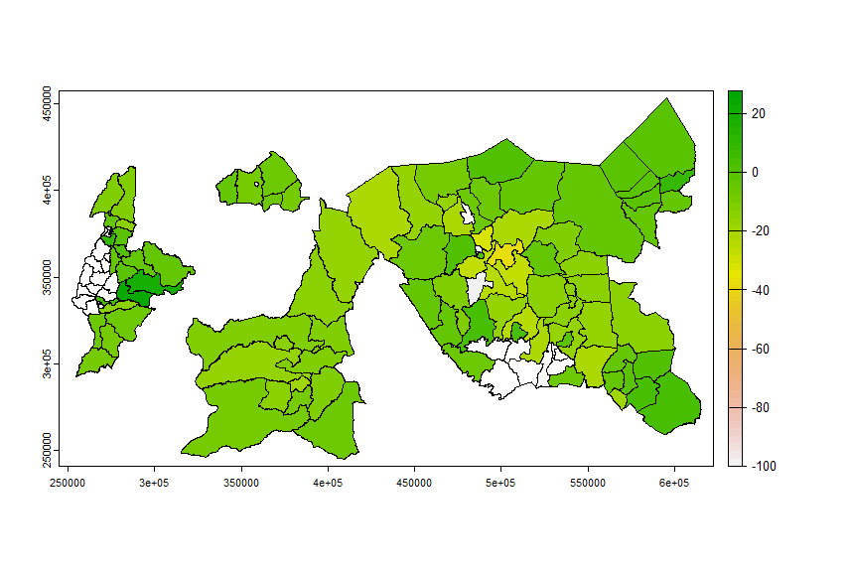

Fig. O. Compound rate of change in percentage

**References**

Global Carbon Budget. (2023). Uganda: CO2 Country Profile. Available at: <https://ourworldindata.org/co2/country/uganda>. Access date: 06 September 2023.

MWE. (2022). Updated Nationally Determined Contribution (NDC). Available at: <https://faolex.fao.org/docs/pdf/uga216549.pdf> . Access date: 06 September 2023

MWE. (2018). Proposed Forest Reference Level for Uganda. Available at <https://www.mwe.go.ug/sites/default/files/library/Final%20-%20Uganda%20Forest%20Reference%20Emission%20Level%20Document%20-February%202018.pdf> Access date: 06 September 2023

Ministry of Water and Environment. (2018). Final - Uganda Forest Reference Emission Level Document - February 2018. Retrieved from <https://www.mwe.go.ug/sites/default/files/library/Final%20-%20Uganda%20Forest%20Reference%20Emission%20Level%20Document%20-February%202018.pdf>

Nakakaawa, C. A., Vedeld, P. O., & Aune, J. B. (2011). Spatial and temporal land use and carbon stock changes in Uganda: implications for a future REDD strategy. *Mitigation and Adaptation Strategies for Global Change*, *16*, 25-62. doi: 10.1007/s11027-010-9251-0

1. Uganda LULC for the year 2000 <https://data.apps.fao.org/map/catalog/static/api/records/00956087-b187-4327-b05e-ce7539a150b2>
2. Uganda LULC for the year 2017 <https://data.apps.fao.org/map/catalog/static/api/records/1fb87d5b-225c-401a-b146-5ce37ae50146>