|  |  |  |
| --- | --- | --- |
| **LIMO EEG tutorial** | March 19  2015 | |
| We present the main functionalities of the LIMO EEG toolbox through examples. The data sets used are available on the LIMO EEG website or the EEGLAB website. | | How to analyze data with the LIMO EEG toolbox – a user guide |

**LIMO EEG tutorial**

*Cyril Pernet, & Guillaume Rousselet*

**To use the toolbox you need EEGLAB (**[**http://sccn.ucsd.edu/eeglab/**](http://sccn.ucsd.edu/eeglab/)**) installed and also Matlab (**[**http://www.mathworks.co.uk/products/matlab/**](http://www.mathworks.co.uk/products/matlab/)**) with several functions from the Matlab Statistics and Image processing toolboxes.**

**Octave (**[**http://www.gnu.org/software/octave/**](http://www.gnu.org/software/octave/)**) functions adapted for Matlab® can be downloaded from our website, which should substitute to the Statistics Toolbox functions – simply unzip those functions into your limo_eeg directory. The only image processing toolbox function needed is bwlabel which allows creating clusters. As an alternative in our code we also call spm_bwlabel (**[**http://www.fil.ion.ucl.ac.uk/spm/**](http://www.fil.ion.ucl.ac.uk/spm/)**).**

Table of Contents

Get Started 4

Continuous data set 5

1. 1st level analysis 5

1.1. Analysis of 1 subject using the GUI 5

1.2. Import data and make a design matrix 6

1.3. Visualizing single subject results 8

1.4. Contrasts 11

1.5. Partial correlation coefficients 13

2. 2nd level analysis 14

2.1. Make a matrix of expected channels and neighbouring channels 14

2.2. One sample t-test 15

2.3. Regression analysis 17

2.4. Create an electrode optimized vector 18

2.5. Analysis based on one (optimized) electrode 19

2.6. Two samples t-test 20

2.7. N-way ANOVA 21

2.8. ANCOVA 22

2.9. Paired t-test 23

2.10. Repeated Measure ANOVA 23

LIMO Utilities 24

1. Basic Stats 24

1.1. Central tendency and CI – Plot Central tendency and CI 24

1.2. Make and plot a difference 25

1.3. Parameters plot 25

2. Batch mode for 1st level analyses 26

2.1 Model Specification 27

2.1 Contrasts 28

# Getting Started

LIMO has been validated successfully with EEGLAB v 13.

To install LIMO, create a directory in EEGLAB\PLUGINS – for instance EGGLAB\PLUGINS\LIMO and unzip all files. You should then have a set of matlab files as well as 3 other directories called external, help and limo_cluster_functions.

Within Matlab®, add to the ‘path’ the following folders (with subfolders):

…\eeglabXX\functions

…\eeglabXX\plugins\LIMO

Now, you can use LIMO with or without EEGLAB loaded. If you use LIMO without EEGLAB loaded, simply type limo_eeg in the Matlab® command window ; the paths you just set will allow you to use EEGLAB functions within LIMO. This will call the LIMO EEG primary user interface (Figure 1.)

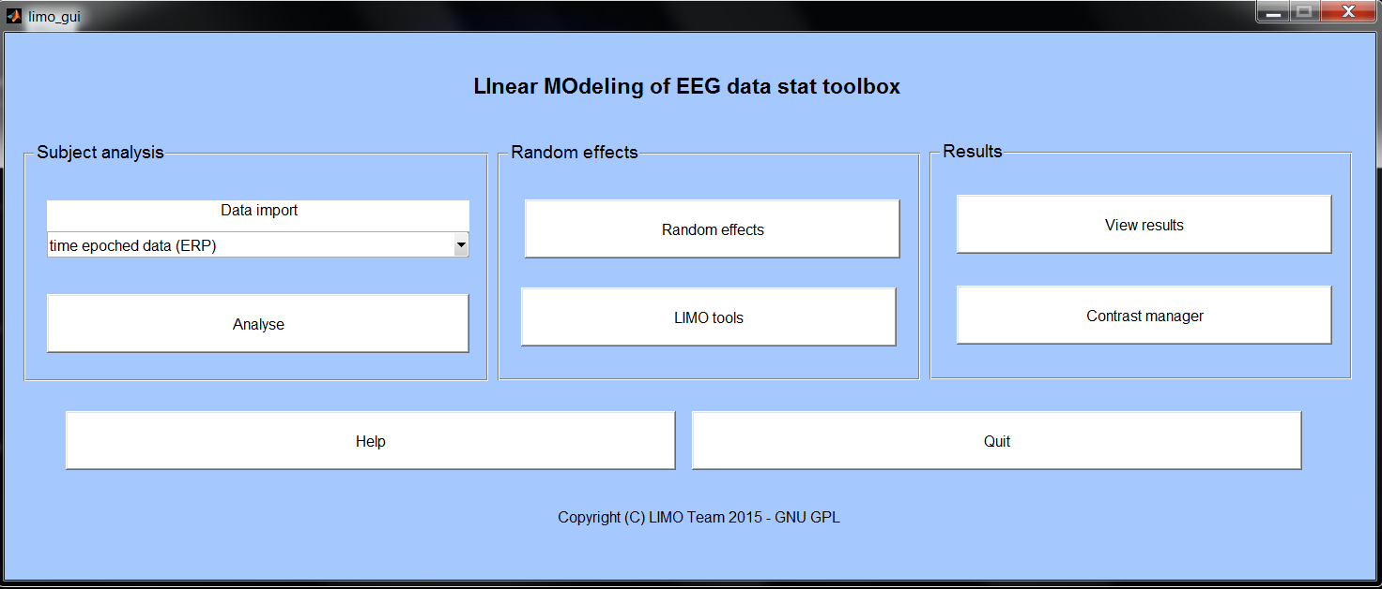

*Figure 1. LIMO EEG primary user interface.*

For each GUI a help button is available to remind you what the different options are. Also, **the help folder contains several documents explaining how the analyses are performed, and which functions to use in a script.**

# 1. Preparing your data

LIMO EEG is designed to analyse all of the data, which means single trials, across space/time/frequencies. The best way to do prepare your data is to 1 – save a matrix of single trials and 2 – update the EEG.etc field telling LIMO EEG where the data are, as well as a few other information.

* Export single trials automatically using limo_create_single_trials.m

From the LIMO EEG primary interface (Figure 1), call LIMO Tools (Figure 2) and select ‘create single trials’

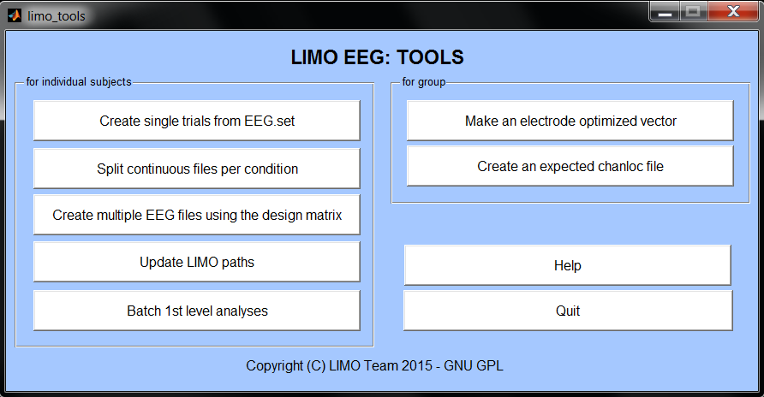

*Figure 2. LIMO EEG tools interface.*

This calls a new GUI (Figure 3) in which you can select what to do. From the EEG.set file you can create single trials for ERP, Spectrum, ERSP, ITC for the scalp data as well as for the Components of your ICA. Note also that any components that were rejected in EEGLAB are also rejected here (that is the scalp data are ‘cleaned’ and only remaining component are used if single trials requested). Importantly, the parameter used to create the single trials are default parameters of std.erp.m, expect that data are not interpolated for bad channels. **For multiple subjects, instead of selecting a single EEG.set, you can select either a text file (.txt) that lists all the EEG.set of interest or select a study (.study) created in EEGLAB.** Creation of single trials matrices for all the subjects can also be obtained using EEGLAB through STUDY (where you could change the default parameters).

WARNING FOR MULTIPLE SESSIONS: if you specified multiple sessions in EEGLAB but do not want to use some sessions, either remove the data or input NaN in your categorical and/or continuous variable (see below) – by default all of the data are written down.

*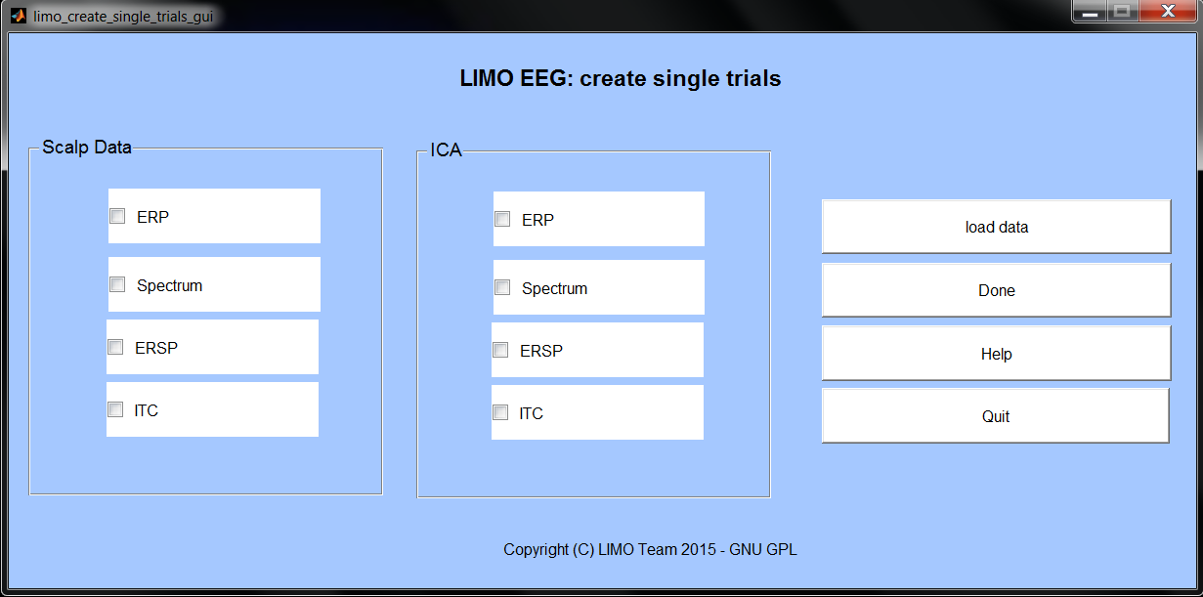Figure 3. LIMO EEG Single trial export interface.*

## What fields are created?

EEG.etc.datafiles a structure which indicates where the single trials matrices are saved, with the following subfields: .daterp, .datspec, .datersp, .datitc, icaerp, icaspec, icaersp, icaitc.

For ERP: EEG.etc.timeerp vector of time frames

For Spectrum:

For ERSP and ITC:

# 2. ERP analyses for group studies: example with continuous data

This tutorial uses data from 18 subjects from an experiment described in:

Rousselet et al. *BMC Neuroscience* 2009

<http://www.biomedcentral.com/1471-2202/9/98>

Rousselet et al. *Frontiers in Psychology* 2010

http://www.frontiersin.org/perception_science/10.3389/fpsyg.2010.00019/abs

tract

*In short, subjects of different ages had to answer by button press which one of two faces was presented to them. The task was made more or less difficult by having varying degree of noise in the images. The noise was in fact a scrambling of the phase of the image (i.e. take an image into the Fourier domain, misalign some of the phases and reconstruct the image). Analyses thus focus on how much of the neuronal signal is sensitive modulated to by phase information.*

*At the 1st level, i.e. for each subject, data are modelled using face as categorical factor (face 1 and face 2), as well as and the local phase coherence measured on in each stimulus as covariate. At the 2nd level, i.e. group analyses, we can use different tests depending on the question: (i) using a one sample t-test on the phase coherence parameter we can test across subjects where and when phase coherence influenced the EEG signal; (ii) we can check using a paired t-test that there was no differences between face 1 and 2, which could have been confounded in the experimental design; (iii) using a regression analysis of age on the phase coherence parameter we can test if the phase coherence effect changes linearly with age; (iv) using a two-sample t-test or an ANOVA with 2 groups, we can test if the phase coherence effect differs between young and old subjects (rather than doing a regression); (v) finally we can also test with an ANCOVA if the phase coherence effect changes with age after controlling for the group difference, that is testing the linear effect of age versus a non linear split young / old.*

## 2.1 First level analysis

In the 1st level analysis, EEG data are analysed one subject at a time to extract parameters from the general linear model. In the 2nd level analysis, these parameters are combined across subjects. 1st level parameters reflect the within subject variance, that is to say the variance across trials. 2nd level results reflect the between subject variance. Thus, LIMO EEG uses a hierarchical linear model approach allowing random effect analyses.

### Analysis of 1 subject using the GUI

Lets’ process subject S1. To be able to use LIMO EEG you need:

1. your EEG data epoched and organized in the EEGLAB .set format;

2. .txt or .mat files that describe all the trials in this .set.

For instance, in the S1 folder, you will find a categorical_variable.txt file and a continuous_variable.mat file. In the categorical_variable.txt, you will see a series of 1s and 2s. These numbers describe the 2 faces that were presented to the subjects during the experiment and match the trials of the daterp or icaerp files you just created (see 1. Preparing your data). Now open the continuous_variable.mat inside Matlab. You will see a series of numbers corresponding to the level of noise in each image. Again, the order of the noise levels matches the trial order in the daterp or icaerp files. To discard trials, simply input a NaN instead of a value. **At least one file is necessary for any analyses – and can be either .txt or .mat**. Such files can be created semi-automatically using a STUDY in EEGLAB.

### Import scalp data and make a design matrix

Bring the LIMO general GUI by starting LIMO EEG (Figure1) and click under *Data* *Import* select *‘time epoched data (ERP)’*, which will bring the limo_import GUI (Figure 4). Click the button *Import data set* and select the data set for subject 1 (S1). Once loaded, a message 'Data set limo_dataset_S1.set loaded' is displayed in the Matlab command window.

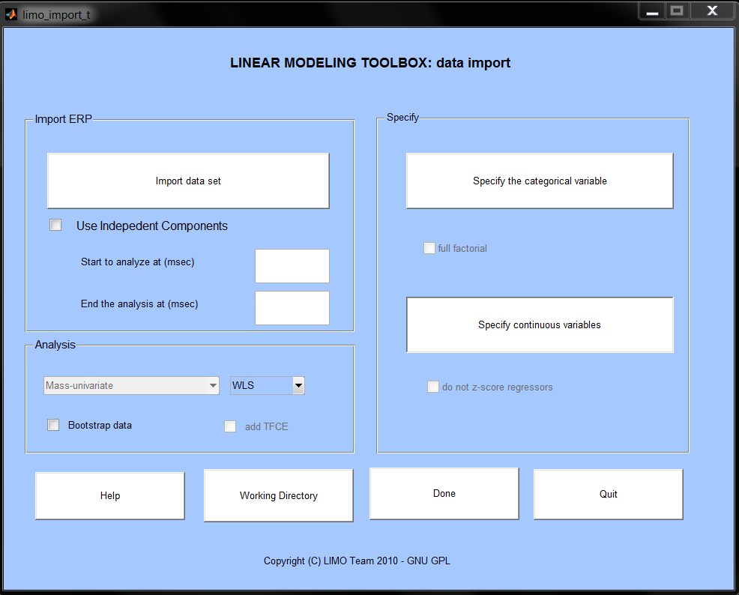

*Figure 4. LIMO EEG import GUI*

The next step is to specify the onsets (*Start to analyze at*) and offsets (*End the analysis at*) of the signal to analyse. The data may be from -500 to +2500ms but we can analyze the data in a time window of interest – here for instance -50 + 400ms. A dialogue box will appear to inform you about the actual start and end points. Indeed, data cannot start at ‐50 ms and end at 400 ms because of our sampling rate and are therefore adjusted.

Finally, we need to inform LIMO EEG about the categorical variables (face 1 and face 2) and the continuous variables (noise levels) associated with the single‐trial ERPs. Click on *Specify the categorical variable* and select the *categorical_variable.txt* file. Click on *Specify continuous variables* and select the *continuous_variable.mat* file. Press *Done* to create the design matrix and associated files. To analyze the whole time, simply leave the *Start* and *End* fields blank. The command window will show the message *making up the design matrix and data files...*, followed by *design matrix done*. At this stage a figure of the design matrix pops out (Figure 5) as well as a question box asking you if you want to start the analysis. If your design matrix looks like the one in Figure 5 press *Yes;* otherwise retry creating the design matrix following the instructions above. After pressing *Yes*, the analysis will run 1 electrode at a time, and the command window will display which electrode is currently analyzed. When the analysis is finished, the limo_gui pops up. You are now ready to look at the results for this subject.

You would have noticed other tick boxes on the interface. If the categorical variable has multiple columns, this is taken to indicate a factorial design. In this case, the option to make it *full factorial* (i.e. compute the interactions) is also proposed. More details about this are presented in section 5, dedicated to single subject analyses. Similarly, once the continuous file is loaded, it is possible to *not z-score regressors*. By default, continuous regressors are z-scored so that they have the same scale, which allows comparing them statistically. Unless, you have reason to not z-score them, do not tick that box.

Under analysis, other options are also available. For the mas-univariate approach used here, different ‘solutions’ are possible. By default we recommend ‘WLS’ (Weighted Least Squares) in which, at each channel, each trial is given a weight based on its similarity with the other trials. Other options are ‘IRLS’ (Iterative Reweighted Least Squares) in which, at each channel, each trial and each time frame a different weight is computed; or ‘OLS’ (Ordinary Least Squares) for which no weight is applied. In addition, it is possible to bootstrap the data and compute ‘TFCE’ – these are discussed in section 5, dedicated to single subject analyses.

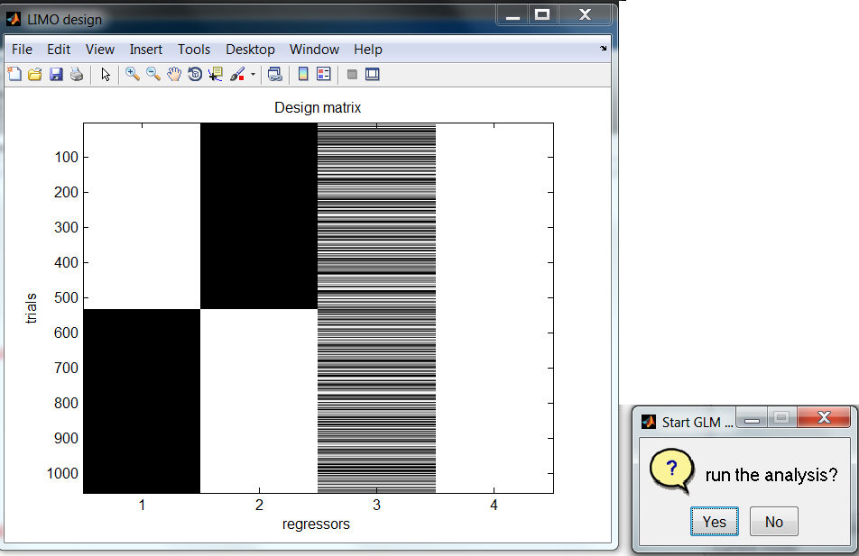

*Figure 5. Design matrix for subject 1.*

### Visualizing single subject results

From limo_gui (Figure 1) select *View Results* to call the limo_results GUI (Figure 6). At this stage, no correction for multiple comparisons is possible because you have not computed the data under H0 (bootstrap and/or TFCE). To perform a group level analysis (2nd level), only the model parameters (beta) or contrasts (con) are needed, and bootstrapping at the subject level has no added value.

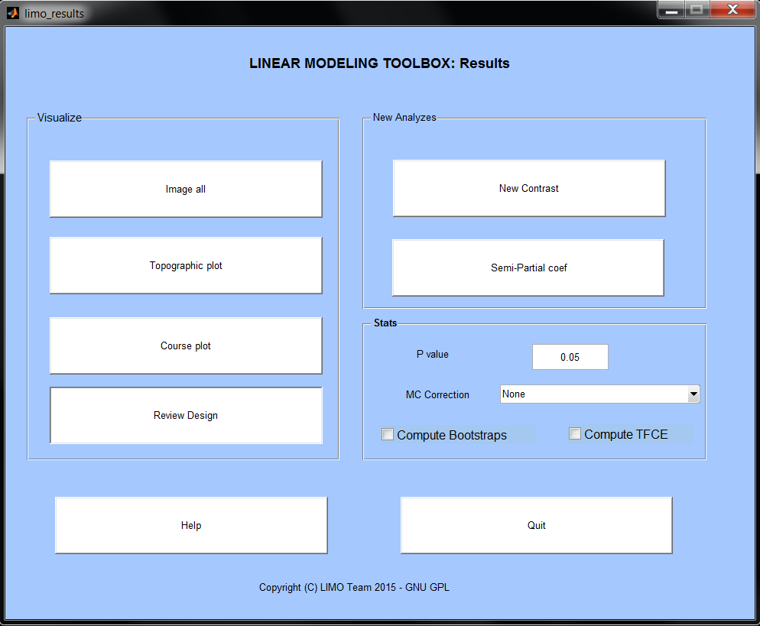

*Figure 6. LIMO EEG results GUI.*

From the general linear model, we obtain the percentage of variance explained (R2.mat), the condition effect, i.e. the difference between face 1 and face 2 (Condition_effect_1.mat), and the effect of the covariate, i.e. the effect of stimulus noise on the ERP (Continuous_effect_1.mat). These results are saved in the folder specified at the import (along with a LIMO.mat file) and can be visualized by clicking the buttons *Image all* and *Topographic plot* (Figure 7).

Click *Image all* to show the results at all electrodes and all time frames – the figure is dynamic, so that if you click somewhere, (1) the time shows up at the top right along with a topographic plot at that time, and (2) the electrode shows up at the bottom right along with a plot of the effect at that electrode. Simply right click anywhere to exit. At this stage, if you look into the Matlab workspace, 3 variables are showing up: F values, p values and mask. Each time you do a plot, LIMO EEG returns the statistical values in the workspace, the p values and the logical mask corresponding to significant/non-significant values.

This information can be useful if you want to report precisely an effect. Now click *Topographic plot,* this will bring up the EEGLAB pop‐up window and plot F values at the times you specify.

*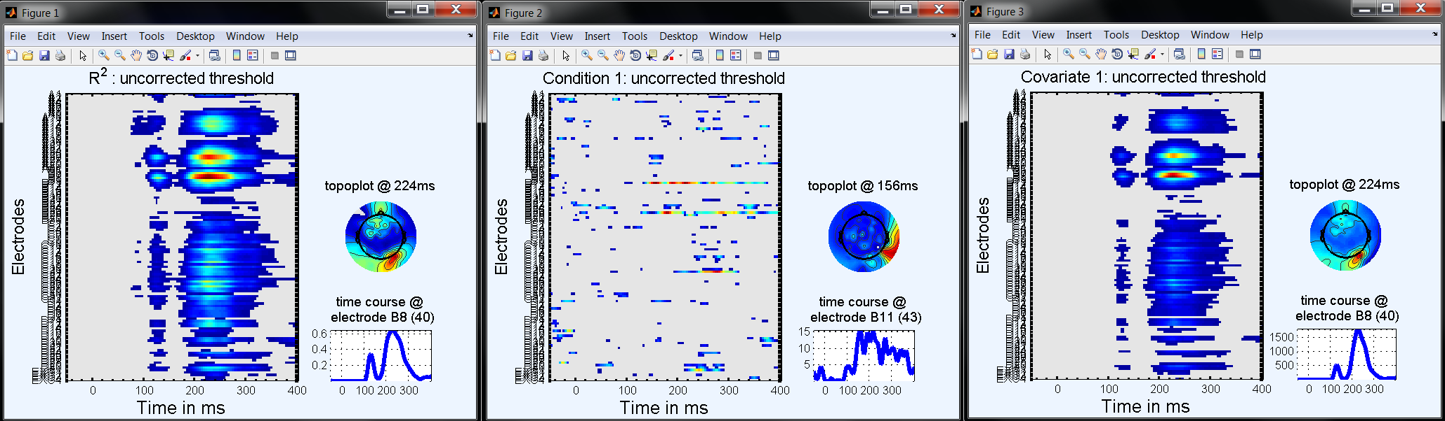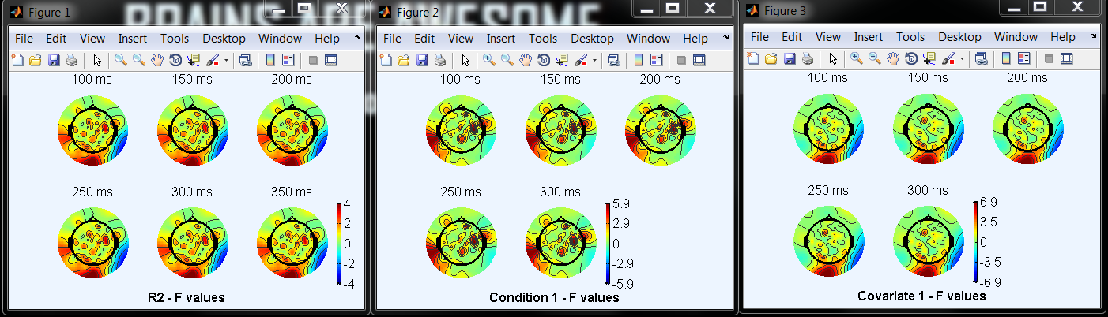Figure 7.**Visualization of the R2 values (left), Condition effect (center) and of the Continuous regressor (right). Grey areas are not statistically significant at the alpha specified in limo_result GUI, here p=0.05 uncorrected.*

Clicking '*Course plot*' prompts you to load a LIMO.mat file and allows you to plot ERPs for the different experimental conditions. For categorical regressors, the mean amplitude is plotted as a function of time. For continuous regressors, single‐trial amplitude is plotted as a function of time and sorted levels of the continuous predictor (noise of the stimuli in this case). Three plotting options are offered:

* *original data*: enter [1:2] for the regressors to plot original ERPs for face 1 and face 2 along with significant time frames - or entre 3 to see all trials sorted by noise level.
* *modelled data*: enter [1:2] for the regressors to plot the modelled ERPs for face 1 and face 2 along with significant time frames. If you enter 3 for modelled ERP, you will get a 3D plot of the effect of the continuous regressor on the ERPs, trial by trial. For continuous designs/variables, this is the preferred option to visualized continuous regressors as it shows how a regressor is fitted to the data. Modelled data are only the regressors scaled by the beta parameter (i.e. does not show the data) – but if significant this is how you modelled variations in the data.
* *adjusted data*: enter [1:2] for the regressors to plot original ERPs for face 1 and face 2 minus the part explained by regressor 3, along with significant time frames. Conversely enter 3 to plot the original single trials sorted by noise level minus the effect of [face 1 - face 2]. For categorical designs/variables, this is the preferred option showing the behaviour of the data for the effect you are looking at (i.e. once accounting for continuous regressors).

For all plotting options, if you leave the 'which electrode to plot' question box empty, LIMO EEG will plot the data at the electrode showing the largest R2 (Figure 8). For categorical variables, the shaded area around the mean is the 1-p confidence interval. For instance, in the limo_results GUI the default p value is set to 5% and thus the shaded area represents the 95% confidence interval at each time frame. Similarly, the red dots at the bottom of the plots are the significant time frames at the specified p value.

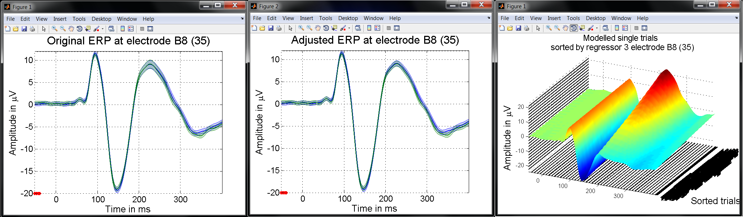

*Figure 8. ERP plotting options. Left: original ERPs for each experimental condition (face 1 vs. face 2). Middle: adjusted ERP (original ERP – effect of continuous regressors) for each experimental condition (face 1 vs. face 2). Right: modelled ERPs for each experimental trial.*

### Contrasts

At this stage, one can also do some other analyses, such as looking at the difference between experimental conditions (face 1 vs. face 2) or sum of conditions (face 1 + face 2). Of course, the 1st effect (face 1 vs. face 2) can be seen in the Condition_effect.mat. However, the Condition_effect.mat only shows F values without the orientation of the effect. Using a T contrast, one can test which condition is significantly stronger or weaker from the other (for instance you can test if face 1>face 2 with a contrast 1 -1 and the other way around). In addition, if you had more than 2 conditions, the F test computed by default would only tell you that at least one condition differs from any others. Linear contrasts are needed to determine the origin of the main effect.

From the LIMO EEG primary GUI (Figure 1) select ‘*Contrast Manager*’ or from the LIMO EEG result GUI (Figure 6) select *'New Contrast*' and select the LIMO.mat file of subject 1. This brings the contrast manager GUI (Figure 9). Enter [-1 1] in the box *New Contrast* and press enter to see which columns are contrasted, then click Done. This will perform a T-test, looking for each electrode and time frame where face 1 < face 2, still controlling for the effect of the continuous regressor. Do the same with a contrast [1 -1]. Use the visualization buttons to explore the results (image all, select the con_1 or con_2 file – and plot course, select regressors [1 2] – Figure 10). Select again New contrast but this time enter [1 1], tick *diagonalize (F test)* and press enter – then click Done. This will perform a F test (saved as ess_3), simply testing where faces (1+2) differ from 0.

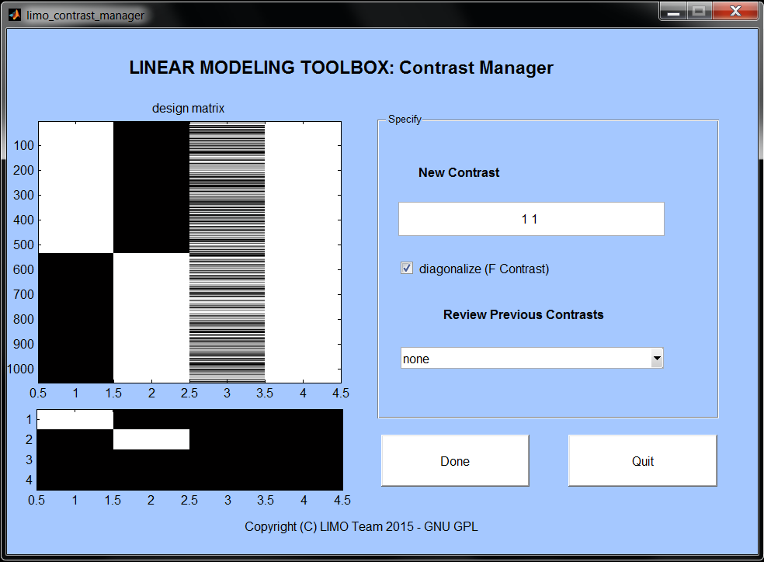

*Figure 9. Contrast Manager GUI. This GUI shows the design matrix and below it the contrast to be tested.*

### Partial correlation coefficients

An F contrast like [0 0 1] (covariate_effect_1.mat) will reveal how much unique variance is explained by the regressor (here the global phase coherence from the stimuli) relative to the other regressors (that is the amount of variance that this regressor explains in the model). However, it is also interesting to know how much total variance it can explain, i.e. the amount of variance in the data. From the limo_results GUI, click on *Semi*-*Partial correlation coef*. This will compute a semi‐partial correlation coefficients for each predictor, which represents the part of variance explained by a predictor compared to the total variance (this is the difference between the variance explained by the full model and the variance explained by a reduced model that excludes the predictor of interest). Then explore the results saved as semi_partial_coefficient_XX.mat using the visualization tools.

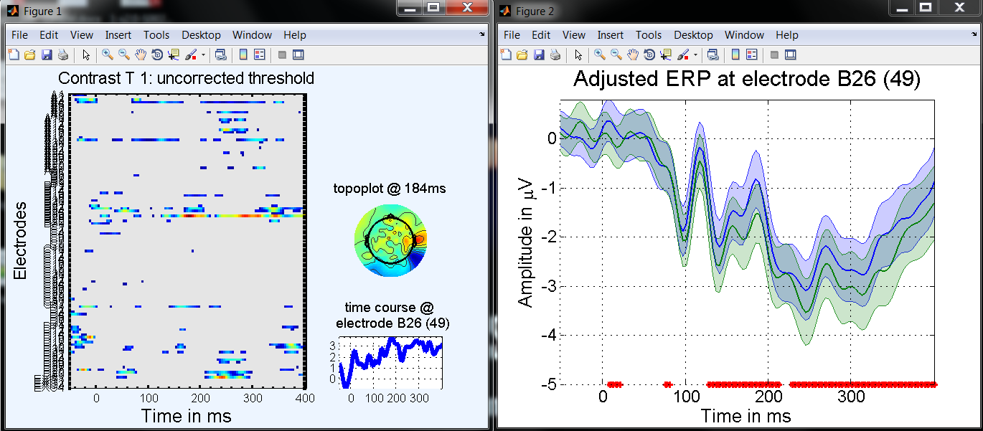

*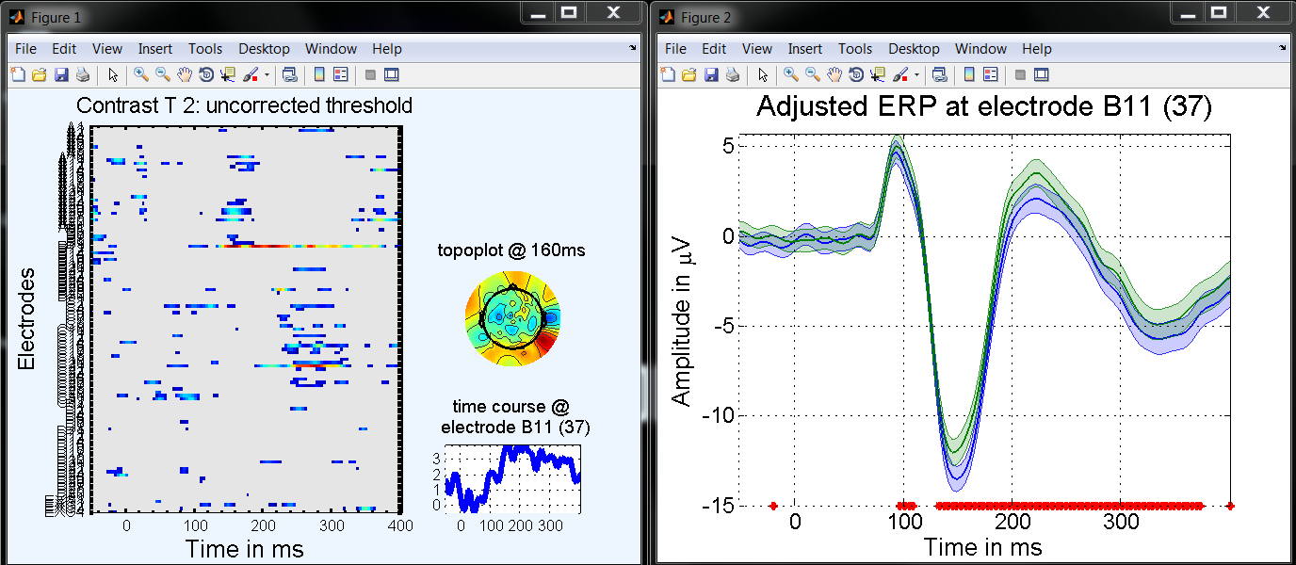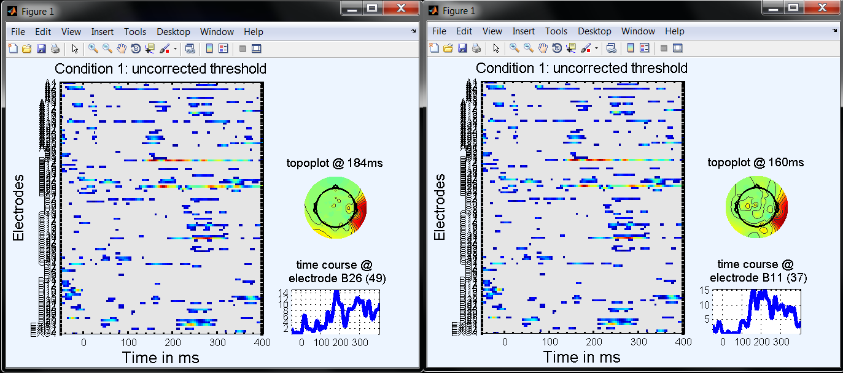Figure 10. From top to bottom: Results from the T contrast [1 -1 0] at p=.05, showing where face 1(blue) > face 2 (green), from the contrast [-1 1 0] at p=.05, showing where face 2 (green) > face 1 (blue), the F contrast [1 -1 0] at p=.1, i.e. the condition_effect.mat (compare with the condition_effect.mat – figure 7). Note that a F test is bilateral and thus each side is tested at p=.025 (figure 7). To ‘see’ the effect at p=.05 corresponding to each T-test we need to adjust the p value at .1.*

## Analysing all subjects using the batch mode

Importing the data, accepting the model, running contrasts can be time consuming when we have many subjects to analyse. LIMO EEG has a batch mode allowing preparing and then processing all the subjects at once. From the LIMO EEG primary interface (Figure 1), call LIMO Tools (Figure 2) and select ‘Batch 1st level analyses’.

Note that limo_batch is using PSOM (The pipeline system for Octave and Matlab - Bellec et al. 2012 - Front Neuroinform. 2012; 6: 7), so please cite this paper too. You could write something like: *“1st level analyses were performed using the LIMO EEG batch mode and PSOM (Bellec et al. 2012). The model included 1 categorical variable with X conditions and M continuous variables. Parameters estimates were computed from –xx ms to +xx ms using single trial weighted least squares (Pernet et al. 2015).”* If you are versed into computing, you can edit the top of limo_batch.m to make PSOM run e.g. on multiple node of a grid engine (see PSOM help for details).

Before opening the interface, you are prompted to choose if you want specify models, or contrasts, or both. This means that you can simply import and make models to get the parameter estimates for each subject, adding or not contrasts. If you already have estimated all the parameters of all the subjects, but want to compute contrasts only – this is possible too. Once open, the limo_batch GUI (Figure 11) looks like the import GUI. The main difference here is that you do not provide a single .set or .mat, but a .txt file that lists all files to analyse. For instance, in ‘import subjects sets’ you provide a text file that contain on each row the full path of a .set. Depending on the analysis, you can also specify the starting and ending time and/or frequency frames of the analysis. Note that by default the scalp data are analysed, but you can un-tick or simply also add the analysis of independent components.

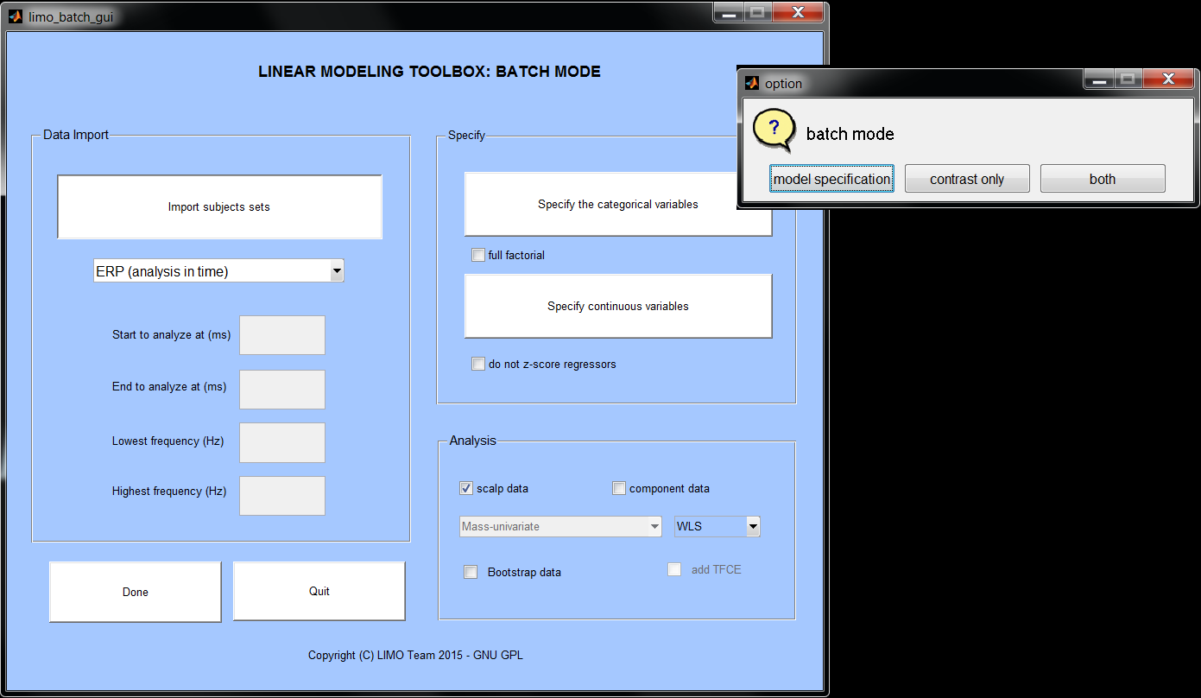

*Figure 11. LIMO Batch GUI.*

## Second level analysis

**Statistics at the second level depend on bootstrap or permutation. We suggest running the analyses without bootstrap (boot = 0) and, if you have strong effects, add the bootstrap (600 to 1000) – this will save you unnecessary computational time. Bootstrapping won’t magically make effects to appear but it is more accurate to control type 1 error rate than analytical approaches.**

### Make a matrix of expected channels and neighbouring channels

It is likely that some of your subjects have missing electrodes. To group subjects in a common space, you need to create an 'expected chanlocs' file. This file has the same structure as the EEG.chanlocs from an EEGLAB file. The *expected_chanlocs.mat* file should be downloaded from the website for the data set used here. You cannot create one yourself because we did not include EEGLAB .set files. However follow the procedure below to create your own file when using your own data.

In *LIMO tools*, accessible from the main LIMO GUI (figure 10), click on '*Create an expected chanloc file*' and select '*Set*' when asked what you want to do. This option allows you to load multiple subjects' LIMO files to search for the subject who has the largest number (possibly all) of channels. Here, LIMO chooses subject 11 who has 132 electrodes. It then asks you to enter a neighbouring distance. Here we choose 0.37, which is an appropriate distance for the BIOSEMI 128 channels system. In the current directory, there is now an *expected_chanlocs.mat* file. If all your subjects have the same number of electrodes, then you need only to load anyone of their LIMO files.

The neighbouring distance is the threshold distance that defines neighbour electrodes. The document LIMO_Clustering.pdf (in the help folder) provides more detail about choosing the neighbouring distance and creating a neighbourhood matrix. A neighbourhood matrix is a simple binary matrix describing which electrodes go together. To create this file, you need to know the configuration of your cap and you will need to check the accuracy of the results before you attempt to correct your analyses for multiple comparisons using the cluster approach or TFCE. In other word: do not attempt to use the cluster approach or TFCE until you are confident you have an accurate neighbourhood matrix.

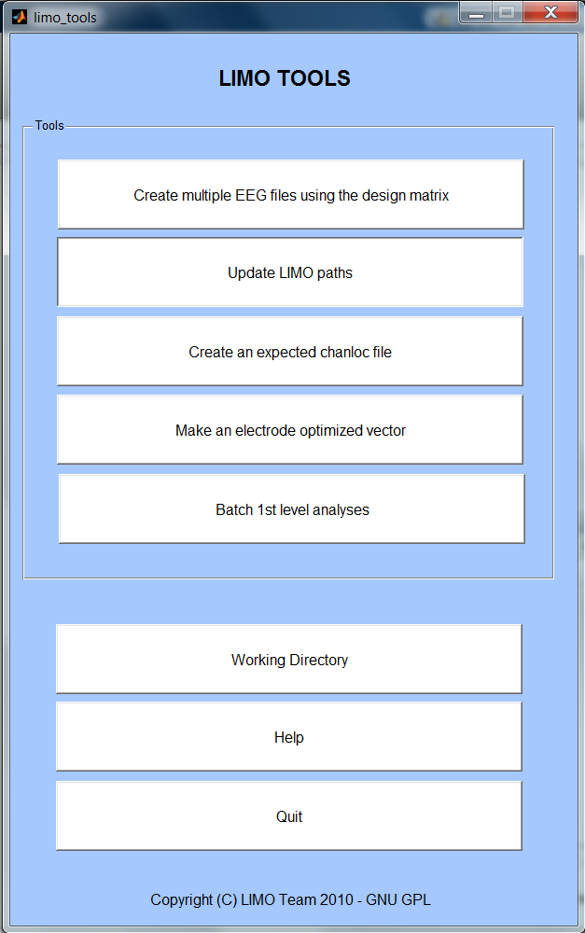

**Figure 10.** LIMO Tools GUI

### One sample t-test

Here we test the effect of phase coherence (regressor 3) at all electrodes and time frames.

Create a new directory for your analysis and go to the limo_random_effect interface (figure 11). Click *Working Directory* to cd to your analysis directory, then load the expected chanlocs file (*Load Channel Loc*). Leave the number of resamples for the bootstrap analyses to 1000, and tick the TFCE box.

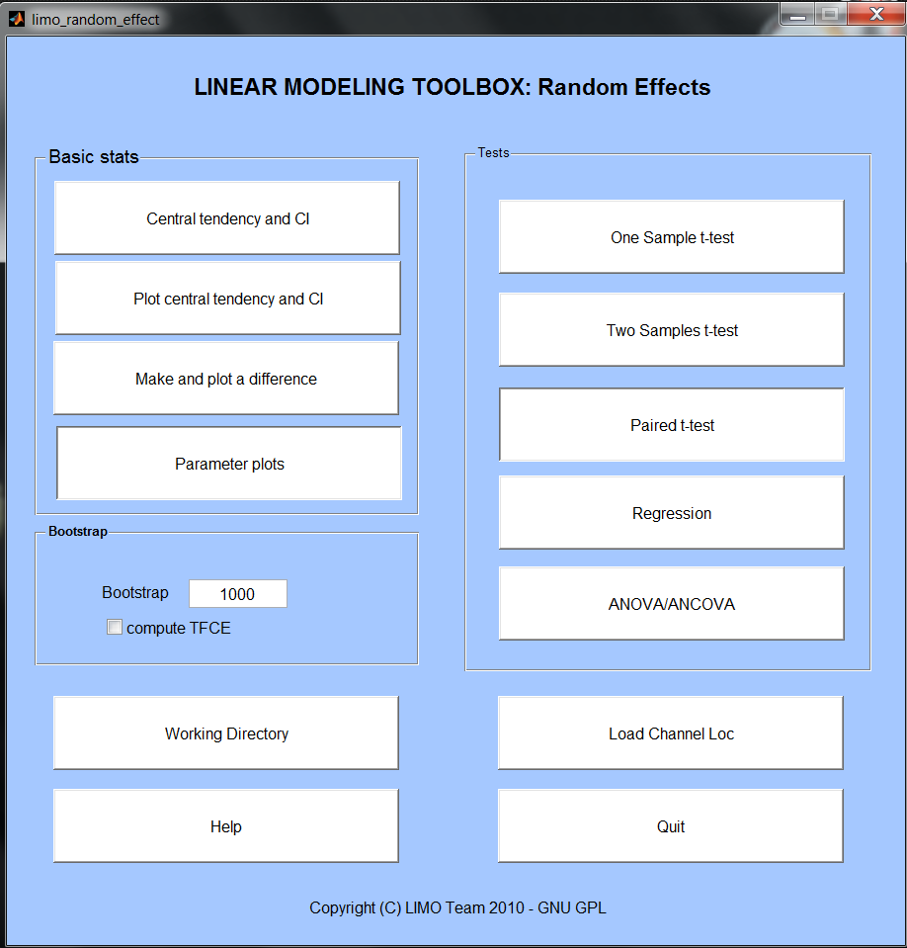

**Figure 11: Random Effect GUI**

Now click on one sample t test. Select the Betas.mat files for the 18 subjects and choose regressor 3 (this is the phase coherence computed in the 1st level analysis). Note you can also create a .txt file which list all the Beta.s.mat files (i.e. full name of the files with directory information – when prompted to select the 1st subject, pick this list instead, and all data get loaded).

Once the analysis if done, press Quit, View results. You can look at the results using different thresholding techniques (Figure 12). To do that, in the Stats panel change the p value and the multiple comparison correction technique, then press Image all electrodes. You will be prompted to choose a file: pick one_sample_ttest_parameter_3.mat. It might take some time before a figure with the results pops up. Similarly, you can use the ERP plots to plots the time course of group level effects. The shaded area shows the 1-p confidence interval of the trimmed mean of the parameters.

As you can see, most of the effects appear in the time window 110 to 300 ms post-stimulus.

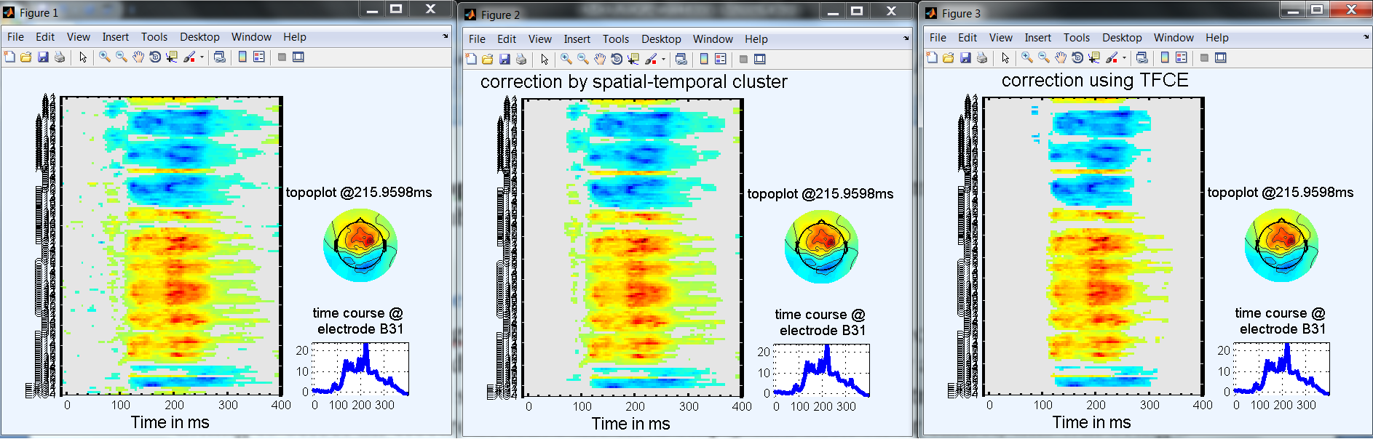

**Figure 12. One** sample t-test at all electrodes and time frames. **Left: no correction for multiple comparisons (some effects appear in the baseline). Middle:** spatial-temporal clustering correction. **Right:** TFCE correction. After correction for multiple comparisons, no effects are significant in the baseline.

### Regression analysis

As we showed in Rousselet et al. 2009 and 2010, sensitivity to image information changes with age. To investigate this effect, create a new directory for this new analysis and call the limo_random_effect interface. Once again cd to the new directory, load the expected chanloc file and click on *regression analysis*. Select the Betas.mat file of each subject from S1 to S18 and choose regressor 3. Finally, load the file called 'limo_dataset_age.mat' which came with the data set. It is essential that you select the Betas.mat files in order from S1 to S18 because subjects’ ages are in this order.

Explore the results (Figure 13). In the one‐sample test we looked at where and when phase coherence influenced the EEG signal (from 100 to 300 ms). In the regression, we determined where and when the EEG modulation changed with age (130 to 160 ms and 240 to 350 ms), which explains why we have different results.

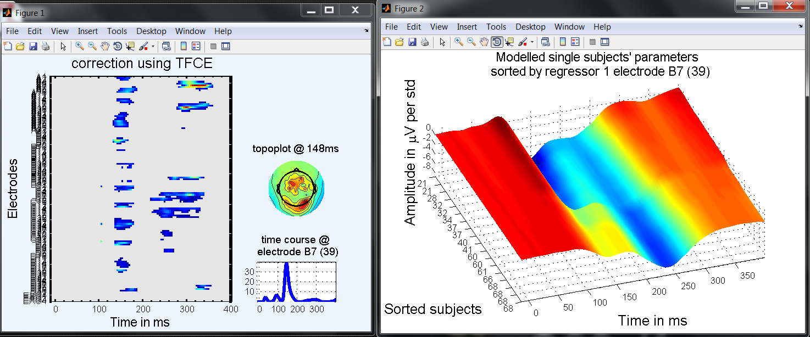

**Figure 13. Regression of phase coherence effect with age. On the right side the 3D plots shows the modelled effect (beta parameter) per age.**

With a little bit of Matlab command line we can get a better picture of what’s going on. Redo the all electrode/time-frame image of the one-sample t-test with TFCE, exit the figure (right click) and save the mask as a different variable, for instance:

one_sample_mask = mask;

Then redo the all electrode/time-frame image of the regression with TFCE, exit the figure and save it as a different variable:

regression_mask = mask;

Now we can directly compare these outputs:

A = single((one_sample_mask-regression_mask) > 0);

B = single((regression_mask-one_sample_mask) > 0);

C = single((regression_mask+one_sample_mask) == 2);

load LIMO; figure;

timevect = [LIMO.data.start:1/LIMO.data.sampling_rate:LIMO.data.end];

imagesc(timevect,[1:132],[A.*10+B.*20+C.*30]);

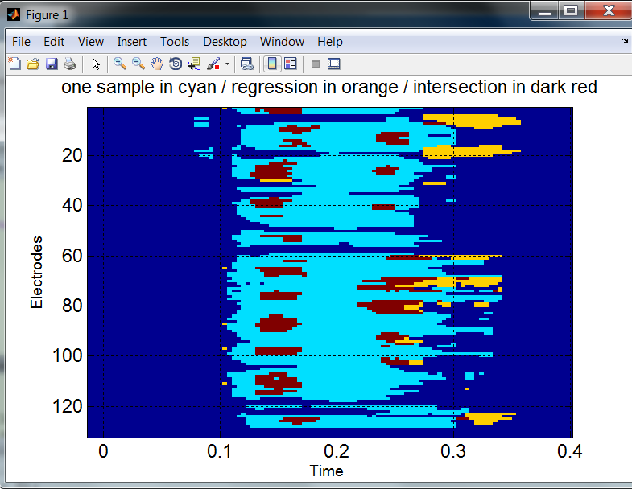

**Figure 14. Comparison of the one-sample t-test and regression analyses.**

### 

### Create an electrode optimized vector

Typical group analyses use the same physical electrodes across subjects. Alternatively, you can group the same 'functional' electrodes. For instance, one could analyse the EEG signal at the electrode with the strongest phase effect in each participant. Typically, that would be occipital‐temporal electrodes but the location of the 'best' electrode will change from subject to subject due to changes in the orientation of the underlying generators and hemispheric differences. As Scott Makeig would tell you: “Your Cz is not necessarily my Cz”.

A vector of optimized electrodes contains the names of the best electrode for each subject. In the *LIMO tools* interface, click *Make an electrode optimized vector* and, going through each subject's folder, select the *R2.mat* file. After you select a file from the last subject, press cancel and you will be prompted to enter a name under which to save the vector. For instance you could use *R2_optimized_electrode.mat* if your best electrode is based on the maximum R2 of each subject. This vector now contains the name of the electrode showing the strongest effect for every subject. Press ok and a frequency map of the location of the optimized electrodes will appear (Figure 15). For *Continuous* and *Condition_effect* files, the optimization uses the maximum F values. Alternatively, you can create your own vector of optimized electrodes and load it when doing a random effect analysis at one electrode.

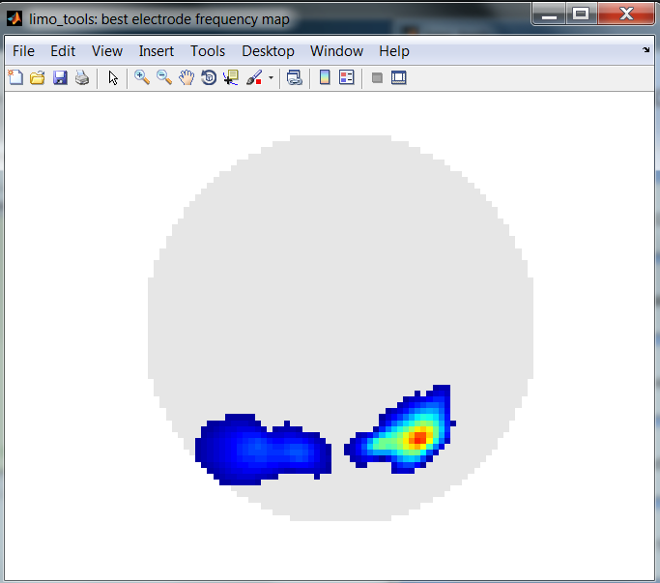

**Figure 15. Frequency map of the optimized electrodes.** In this example the optimization was done using the R2 of the 18 subjects.

### Analysis based on one (optimized) electrode

We can replicate the regression analysis using the optimized electrode vector instead of a full brain approach. Create a new directory for this analysis and run a new analysis. When it comes to choosing between full scalp and one electrode, choose one electrode and in the next box asking to select an electrode leave the field empty and click ok or cancel, which will bring a new selection box where you can select the *R2_optimized_electrode.mat* you created earlier. Then the analysis proceeds as before (Figure 16).

Compared to the full brain analysis, the optimized electrode approach precludes inferences about space but improves the brain dynamics accuracy. Assuming that different subjects show effects with different spatial distributions but similar dynamics, using an optimized functional electrode we found effects starting at 120 ms, rather than 130 ms using a whole brain analysis.

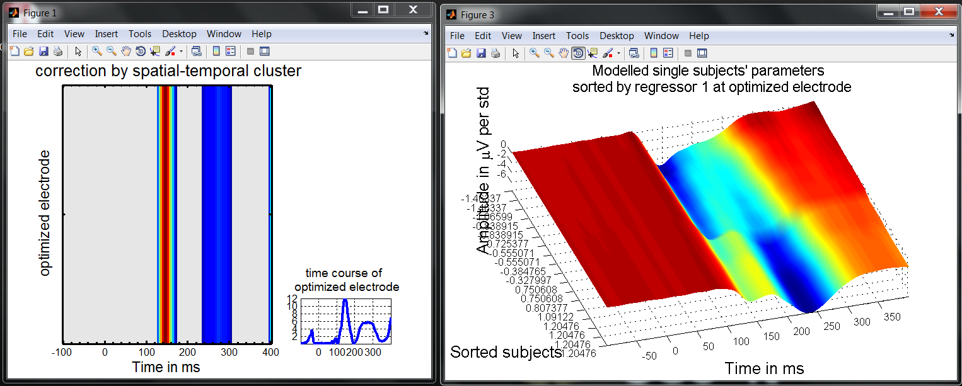

**Figure 16. Regression analysis using an optimized electrode vector.**

### Two samples t-test

Instead of a regression analysis, we can test the difference between young and old subjects. In the data set, young subjects (10 subjects) are S3 S5 S6 S9 S10 S12 S13 S14 S17 S18, and old subjects (8 subjects) are S1 S2 S4 S7 S8 S11 S15 S16. The difference in sample sizes is handled easily by the two‐sample t‐test because it uses an independent variance estimate for each group.

Click *Two Samples t-test* and select the first set of Betas files, click cancel when done, then select the second set of Betas files, and click cancel again when done. Current group and subject numbers appear in the title of the selection box. Once you have entered all the subjects, a window pops up asking which parameter you want to analyse: type 3 to analyse the continuous noise predictor. Once this analysis is done, press *Quit* and *View results* (Figure 17).

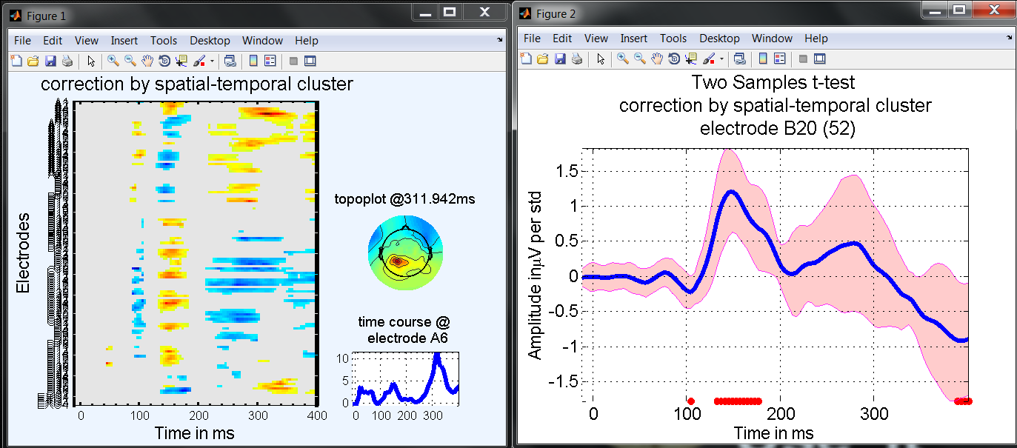

**Figure 17. Differences between groups using a two-samples t-test.**

The ERP plot option shows the computed differences and confidence intervals. To visualize the actual parameters per group, use the ‘Make and Plot a difference’ from the Random Effect GUI. When the two-samples t-test was computed, the data from each group were saved to disk as Y1r.mat and Y2r.mat. Use these data to compute and display the data and their differences. Two figures will pop out: the first figure shows differences between trimmed means and is thus the same as the one in figure 15; the second figure shows the trimmed means for each group (figure 18).

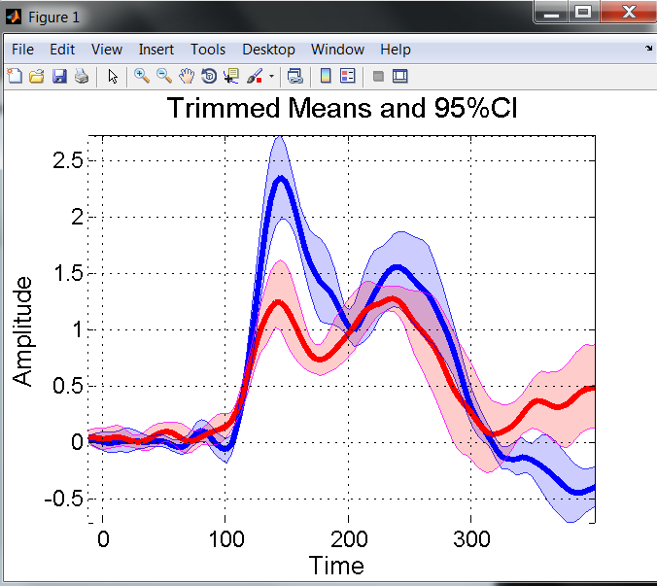

**Figure 18. Trimmed means values per group.**

### 2.7. N-way ANOVA

Instead of using a two‐samples t‐test, you can use an N‐way ANOVA to test differences between young and old subjects. Obviously for two groups only, we recommend the two‐sample t‐tests but the ANOVA handles any number of factors and groups. One important difference between the two approaches is that the two-samples t-test is based on trimmed means whereas the ANOVA uses an Ordinary Least Squares approach, which means that in the t-test the 20% of most extreme subjects are discarded, whereas in the ANOVA all subjects have the same weight.

Click *ANOVA/ANCOVA* and select the N-Ways ANOVA model. When prompted enter 2 independent groups and select the first set of Betas files (S3 S5 S6 S9 S10 S12 S13 S14 S17 S18), click cancel when done, and choose parameter 3. Next select the second set of Betas files (S1 S2 S4 S7 S8 S11 S15 S16), click cancel when done and select again parameter 3. Current group and subject numbers appear in the title of the selection box. The reason for having to enter the parameter twice is that you can then compare different parameters if the 2 groups come from 2 studies in which you have modelled the data differently at the 1st level.

The design matrix will appear and you will be prompted to confirm to go ahead with the analyses. Once this analysis is done, press *Quit* and *View results*. Results are similar to those obtained using a two‐sample t‐test using spatial-temporal clustering (Figure 19). TFCE returns quite different results, removing almost all of the effects in the ANOVA model.

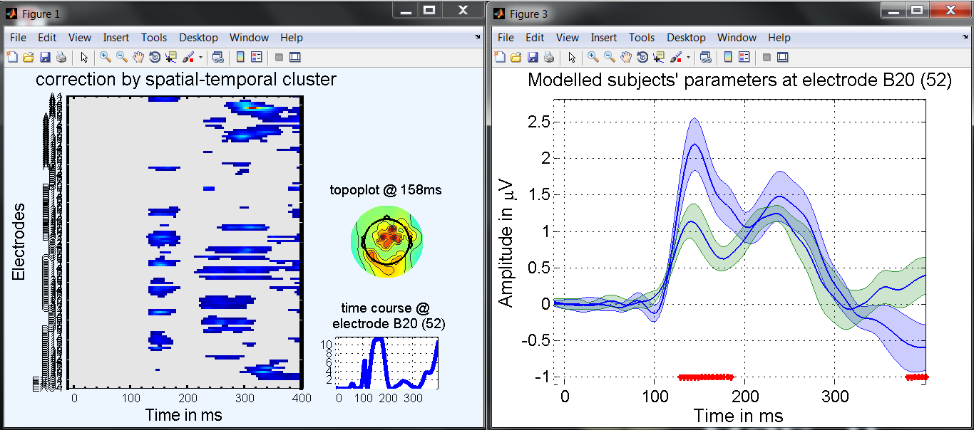

**Figure 19. Differences between groups using the ANOVA model.**

### 2.8. ANCOVA

You can repeat the N‐way ANOVA analysis and this time add age as a covariate. In this case we test for differences between young and old, but accounting for the linear effect of age across subjects. If phase coherence influences the EEG linearly as we get older, there should be nothing to explain in the data and the group difference should be null.

To do this you need to reorganize the age regressor in the order of the subjects in each group and use this new file. This can be done quickly in the Matlab command window by typing:

>> load limo_dataset_age

>> limo_dataset_age_ancova = limo_dataset_age([3 5 6 9 10 12 13 14 17 18 1 2 4 7 8 11 15 16]);

>> save limo_dataset_age_ancova.mat limo_dataset_age_ancova

Select group as for the ANOVA and use the new age regressor. The design matrix should look like the one in Figure 20.

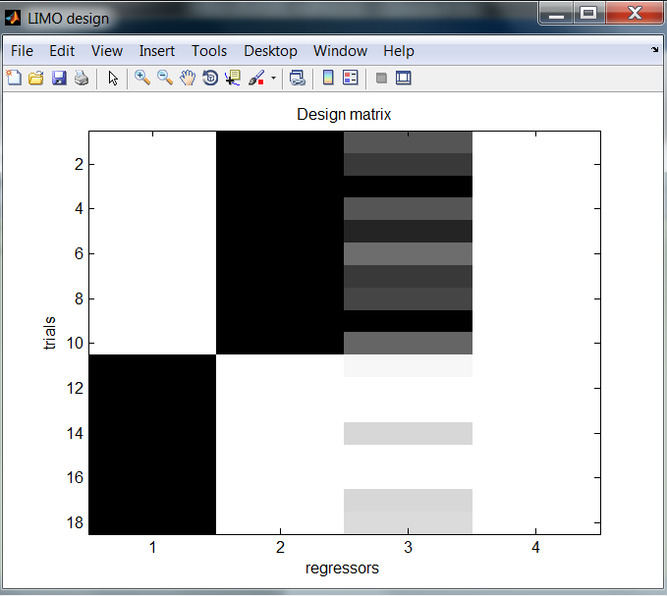

**Figure 20. Design matrix for the group level ANCOVA design.**

The results, shown in Figure 21, suggest that group and age groups factors are confounded with results observed in the two samples t-test and the regression now ‘shared’ between the categorical and continuous regressors. Usually we would not perform such analysis because we know that groups and age are confounded – however for this tutorial this is a useful analysis because (i) it illustrates the ANCOVA model , and (ii) it illustrates that if variables are confounded the results end-up split between effects, just as collinear regressors in a multiple regression.

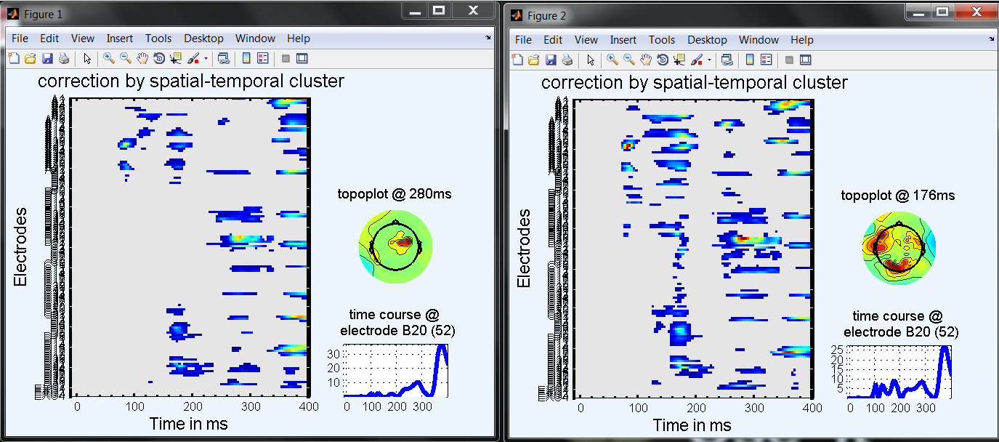

**Figure 21.: ANCOVA group (left) and age results (right).**

### 

# 4. Spectral analyses for group studies: example with a factorial design

### 2.9. Paired t-test

Since subject could still perform the task above a given threshold of noise, they could perceive 2 different faces. Using a paired t-test we can investigate where and when the EEG signal differs between the two faces, while accounting for (removing) the effect of local phase coherence.

Click *Paired t-test* and select the Betas files from the 18 subjects, click cancel when done. The current subject number appears in the title of the selection box. Once you have selected all the subjects’ files, a window pops up asking which parameters you want to analyze; type [1 2] to analyse face1 vs. face 2. Once this analysis is done, press *Quit* and *View results.* No effect survives multiple comparison correction.

### 

### 2.10. Repeated Measure ANOVA

Instead of a paired t-test, you can run a repeated measure ANOVA. Make a new directory for the repeated measure ANOVA, click ANOVA/ANCOVA in the random effect GUI and select Repeated Measures. Few questions pop out:

How many independent groups? Here type 0 or 1 - it doesn’t matter

How many repeated factors? 2

Which files to analyze con or beta? beta 🡪 select beta files

Which parameters to tests? Type [1 2] to test face 1 vs. face 2

Once this analysis is done, press *Quit* and *View results.* No effect survives multiple comparison correction.

# 5. Single subject analyses - application to independent components

# 6. LIMO Utilities

## 1. Basic Stats

### 1.1. Central tendency and CI – Plot Central tendency and CI

This simple tool (Figure 22) computes and plots estimators of central tendency: the mean, the 20% trimmed mean, the median, the Harrell- Davis estimator of the median. The tool can be applied to original data (standard ERPs) or to beta parameters. In both cases it identifies conditions from the design matrix of each subject.

Because analyses always proceed in 2 steps, you also have the choice of the summary statistic per subject and across subjects. As illustrated for the two samples t-test (Figure 18), in most situations, we want to plot the data to reflect our analyses. In LIMO EEG, the corresponding summary stats are the mean at the subject level and either the trimmed mean (t-tests and repeated measures ANOVA) or the weighted mean (regression, N-ways ANOVA/ANCOVA) across subjects.

However, you might as well do some analyses on your own using LIMO functions, for instance to compare trimmed means between conditions within subjects. Using the plot tool, you can superimpose as many results as you want, which can be useful to compare the behaviour of estimators.

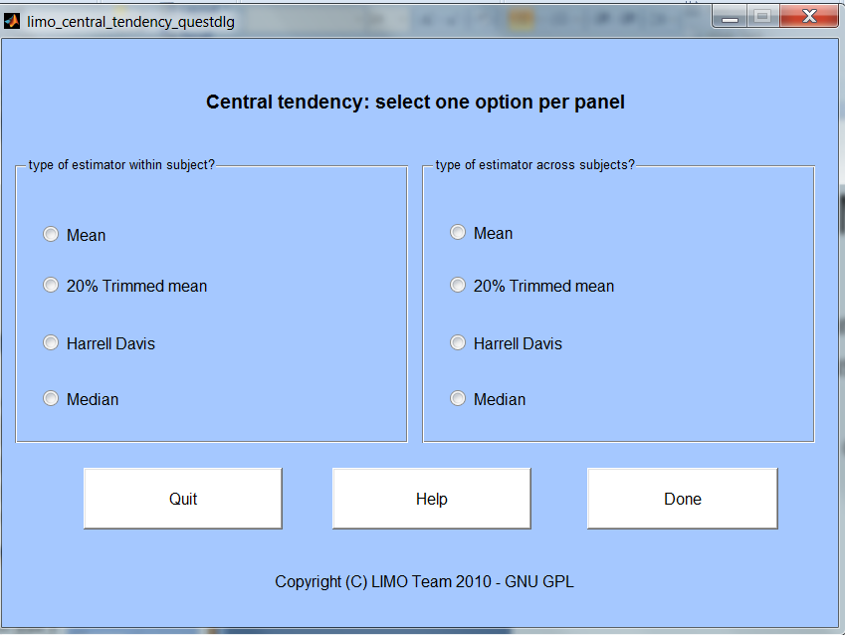

**Figure 22.** **Computing central tendency.**

### 1.2. Make and plot a difference

*Make and plot a difference* computes 20% trimmed means with 95% percentile bootstrap confidence intervals (non corrected for multiple comparisons) for 2 conditions and their difference. This is performed differently for independent and paired designs with different vs. common variance estimates. In both cases results are saved to disk and 2 figures pop up: one for the 2 conditions and another one for the difference (Figure 23).

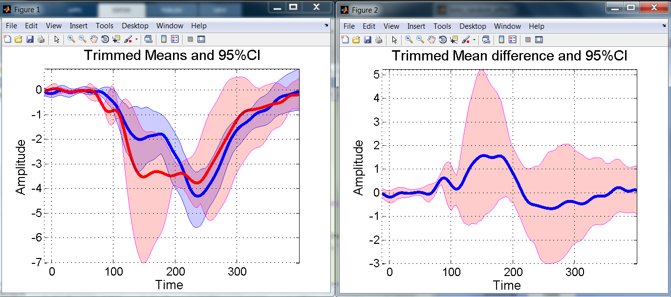

**Figure 23.** Graphical outputs from the tool Make and plot a difference.

### 1.3. Parameters plot

## *Parameters plot* calls a small menu to visually investigate beta parameters obtained at the 1st level:

## - *Surf ERP space* plots the average Betas values in 3D (amplitude x electrodes x time frames)

## - *Correlation matrices* plots the correlations across all electrodes (e.g. for one time frame test the correlation between values at all electrodes against the values across electrodes of each of the time frames) and across time courses (e.g. for one electrode test the correlation between its’ time course against the time courses of each of the other electrodes);

## - *Joint scatter plots* to investigate how a set of parameters changes separately and jointly over time;

## - *Box Plots* to look at the dispersion of parameters in time.

## These outputs are illustrated in Figure 24.

## 

**Figure 24. Examples of graphical outputs from the tool Parameter plots.**