Interhemispheric neural connectivity of the human visual motion complex (hMT+) distinguishes between global perceptual integration and segregation
Alexandre Sayal ^{1,2}, Bruno Direito ^{1,2,3}, Teresa Sousa ^{1,2,6}, João V. Duarte ^{1,4}, Sónia Afonso ^{1,5}, Miguel Castelo-Branco ^{1,2,5,6}
1 - Coimbra Institute for Biomedical Imaging and Translational Research (CIBIT), University of Coimbra, Portugal
2 - Intelligent Systems Associate Laboratory (LASI), Portugal
3 - Centre for Informatics and Systems (CISUC), University of Coimbra, Portugal
4 - Champalimaud Foundation, Portugal
5 - Institute of Nuclear Sciences Applied to Health (ICNAS), University of Coimbra, Portugal
6 - Faculty of Medicine, University of Coimbra, Portugal
Corresponding author:
Miguel Castelo-Branco (mcbranco@fmed.uc.pt)
ICNAS - Universidade de Coimbra
Azinhaga de Santa Comba
3000-548 Coimbra
Portugal
Keywords: Visual perception, bistable motion, interhemispheric connectivity, multiband, fMRI
Abstract
Functional magnetic resonance imaging (fMRI) has transformed our understanding of brain function, yet the association between long-range functional connectivity and perceptual integration versus segregation remains controversial. We tested the hypothesis that interhemispheric connectivity reflects global perceptual integration. We used plaid stimuli that yield either coherent or incoherent percepts, reflecting integration or segregation, respectively, and predicted that these states would correspond to interhemispheric binding or its loss, indexed by the interhemispheric functional connectivity of the human visual motion complex (hMT+). We acquired data using multiband echo-planar imaging at four temporal resolutions (TR = 0.5, 0.75, 1.0, and 2.5 s) at 3 T and applied dynamic functional connectivity analysis. We found that interhemispheric connectivity between homologous hMT+ regions increased during transitions to the coherent (bound) percept and decreased during transitions to the incoherent (unbound) percept. This effect was consistent across all temporal resolutions. In sum, interhemispheric synchrony in hMT+, as measured by BOLD fMRI, indexes coherent versus incoherent perceptual states even for spatially overlapped stimuli, reflecting the dominance of global integration over segregation processes.

Introduction
The human brain is constantly faced with the task of constructing a coherent and unified perception of the world from sensory information that is processed early on in a distributed manner across various processing pathways (Burwick 2014). This challenge is known as the binding problem, which refers to the neural processes by which distinct features of sensory inputs, such as color, form, motion, and location, are integrated to form unified representations of objects.
Perceptual switches, which occur when viewing ambiguous stimuli that can be interpreted in multiple alternative ways, offer a unique and valuable window into the dynamic neural mechanisms underlying this binding process. These switches often involve the brain alternating between interpretations that require either the integration of separate visual elements into a unified percept or the segregation of a stimulus into distinct, unbound components (Sousa et al. 2021; Burwick 2014; Costa et al. 2024). A coherent interpretation implies a globally bound representation across space (integration), whereas an incoherent interpretation corresponds to a spatially unbound representation (segregation). A study of Costa et al. 2024, highlighted the relation to brain oscillatory dynamics, with higher Beta power during coherent states and higher Gamma power during incoherent (unbound) states (Costa et al. 2024). Recent evidence has shown that these switches may rely on the temporal coordination of neural activity across spatially distinct brain areas, with several studies indicating that interhemispheric transfer of information is correlated and may even predict perceptual experiences (Genç et al. 2011; Sterzer et al. 2002; Shimono, Mano, and Niki 2012; Chaumillon, Blouin, and Guillaume 2018; Pan et al. 2013; Schölvinck et al. 2010; Duarte et al. 2017).
Here, we use fMRI to explore how interhemispheric communication between homologous visual areas, left and right hMT+, changes in relation to perceptual integration vs. segregation of visual surfaces. The human middle temporal area (hMT+) is known for its role in processing motion and is implicated in perceptual binding of moving elements - its activity and functional connectivity patterns with other brain regions fluctuate as perception shifts between bound and unbound states (Sousa et al. 2019; Duarte et al. 2017; Sousa et al. 2021). By mapping spatiotemporal dynamics during perceptual switches of ambiguous stimuli, we dive into the neural mechanisms that enable the brain to solve the binding problem, contributing to understanding visual awareness, perceptual organization, and the continuous resolution of ambiguity inherent to sensory processing.
We have previously shown that perceptual integration of spatially non-overlapping elements may be linked to interhemispheric functional connectivity in hMT+ (Sousa et al. 2019). This 7 T study remains the only one suggesting that interhemispheric functional connectivity, at the scale of fMRI temporal resolution, reflects visual perceptual binding. However, it remains unknown whether this relationship generalizes to integration versus segregation of spatially overlapped stimuli. Using a bistable perceptual coherence paradigm with spatially overlapped stimuli at 3 T, we aimed to test this hypothesis and to replicate it across different fMRI temporal resolutions using multiband echo-planar imaging (MB-EPI) sequences (Feinberg et al. 2010). These sequences show more detailed BOLD signals with superior temporal resolution and contrast-to-noise ratio, pivotal features for detecting nuanced responses of neuronal populations (Zhang et al. 2024, Wall 2023).
We use a moving plaid, a bistable visual stimulus that can be perceived either as two gratings sliding over each other and moving in different directions (incoherent motion) or as a single surface in which the two gratings are perceptually integrated and move coherently in a direction intermediate to those of the individual gratings (coherent motion) (Sayal et al. 2020; Sousa et al. 2024; 2018). When the visual system interprets the plaid stimulus as a unified object moving in a single direction, we hypothesize that interhemispheric coupling may support the binding of motion signals across visual fields. In contrast, during incoherent perception, where motion is interpreted as independent gratings, such integration may be reduced or unnecessary, leading to weaker coupling, according to our prediction.
In this study, we evaluated interhemispheric functional connectivity in hMT+ during a bistable visual motion task to test the hypothesis that it reflects perceptual integration versus segregation. Finally, we investigated key characteristics of the interhemispheric connectivity signal during perceptual transitions, using dynamic functional connectivity.

Methods

Participants
Fifteen healthy participants were recruited for this experiment (mean age 29.7 ± 8.4 years, 6 females) with normal or corrected-to-normal vision and no history of neurological or psychiatric diseases. All participants were right-handed, as confirmed by a handedness questionnaire adapted from (Oldfield 1971): mean laterality index of 85.0 ± 9.0. All gave informed written consent before participating in accordance with the Declaration of Helsinki, and the study followed the safety guidelines for magnetic resonance imaging research on humans. The work was approved by the Ethics Committee of the Faculty of Medicine of the University of Coimbra.

fMRI data acquisition
Scanning was performed on a 3T Siemens Magnetom Prisma fit, using a 64-channel head/neck coil, at the Institute of Nuclear Sciences Applied to Health (ICNAS), University of Coimbra, Portugal. The scanning session started with the acquisition of one 3D anatomical magnetization-prepared rapid acquisition gradient echo (MPRAGE) pulse sequence (TR = 2530 ms, echo time (TE) = 3.42 ms, flip angle (FA) = 7°, 176 slices, voxel size 1.0 × 1.0 × 1.0 mm³, field of view (FOV) = 256 × 256 mm²).
The functional runs were acquired using 2D multi-band (MB) gradient-echo (GE) echo-planar imaging (EPI) sequences from the Center for Magnetic Resonance Research, University of Minnesota (Release R016a). We tested four different temporal resolutions: TR = 0.5 s (MB factor = 6, FA = 53º, 42 slices), TR = 0.75 s (MB factor = 4, FA = 63º, 40 slices), TR = 1 s (MB factor = 3, FA = 68º, 42 slices), TR = 2.5 s (MB factor = 1, FA = 85º, 42 slices). These resolutions were selected to represent the typical range used in fMRI experiments while maintaining whole-brain coverage. The remaining parameters were matched: TE = 30.2 ms, interleaved slices with 0.5 mm gap, voxel size 2.5 × 2.5 × 2.5 mm³, FoV 192 × 192 mm² (Table 1).
Table 1 - Main parameters of the four fMRI sequences.
Sequence | 1 | 2 | 3 | 4
TR (s) | 0.5 | 0.75 | 1 | 2.5
TE (ms) | 30.2
MB factor | 6 | 4 | 3 | 1
Voxel size (mm) | 2.5
Slice gap (mm) | 0.5
Number of slices | 42 | 40 | 42 | 42
Flip Angle (º) | 53 | 63 | 68 | 85
Bandwidth (Hz/px) | 2742 | 2742 | 2632 | 1994
Echo Spacing (ms) | 0.51 | 0.49 | 0.49 | 0.59
Excite pulse duration (us) | 2560 | 2560 | 2560 | 4840
EPI factor | 76
GRAPPA | Off | Off | Off | 2
LeakBlock | On | On | On | Off
For mapping and correction of image distortions related to magnetic field inhomogeneities, we acquired a pair of spin-echo images with anterior-posterior (AP) and posterior-anterior (PA) phase encoding polarity with matching geometry and echo-spacing to each of the functional scans. These were acquired before the functional runs.
The stimulus was presented on an LCD screen (70 × 39.5 cm, 1920 × 1080 pixel resolution, 60 Hz refresh rate), which the participants viewed through a mirror mounted above their eyes at an effective distance of 156 cm. Participants’ reports were recorded using a fiber-optical MR-compatible response box (Cedrus Lumina LSC-400B). To confirm whether participants maintained central fixation during the acquisition session, individually calibrated eyetracking data (sample frequency of 500 Hz) were recorded inside the scanner using Eyelink 1000 software (SR Research, Ottawa, Canada). Participants’ ocular activity revealed an average central fixation duration, within a centered circular area of 4 degrees in visual angle, of 73 ± 22 %.

Stimuli and functional paradigms
We implemented three functional tasks – a localizer, an ambiguous task, and an unambiguous task - based on a moving plaid stimulus. The plaid is created by superimposing two moving gratings (Figure 1). This superimposition creates an intrinsically ambiguous and bistable stimulus that can be perceived as a single coherently moving surface or two incoherent surfaces (Sousa et al. 2018). The tendency/probability of perceiving coherence has been previously manipulated in several ways (Adelson and Movshon 1982; Sayal et al. 2020; Sousa et al. 2019; Kozak and Castelo-Branco 2009; Duarte et al. 2017). During the unambiguous runs, to force the perception of one of these equally possible motion interpretations, we added dots to the plaid, which help disambiguate motion while keeping the observer’s focus on the plaid itself. Depending on the relative percentage of dots that move vertically or horizontally, we induce a given level of coherence, and hence a perceptual interpretation to the observer. The complete description of the stimulus properties is provided in Table S1, and a short video of the moving stimulus is provided as Supplementary Material.
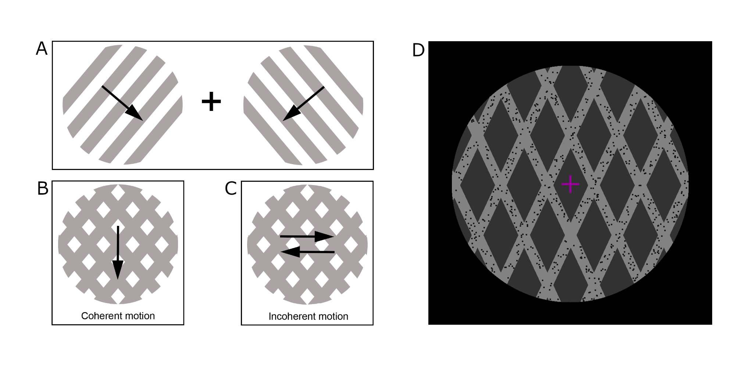
Figure 1 - Stimuli used in the experiment. Panels A, B, and C illustrate the creation of a plaid stimulus. By superimposing two gratings (A), moving orthogonally to the lines, an ambiguous stimulus is created, which can be perceived as moving coherently (B) as a single surface or incoherently (C) as two separate surfaces sliding over each other. The arrows illustrate the direction of perceived motion. D) By adding dots to the plaid stimulus, the tendency of perceiving coherency can be manipulated, as done during the unambiguous runs. Depending on the moving dots' direction, the otherwise ambiguous stimulus was readily perceived as a plaid moving coherently or incoherently. Adapted from (Sousa et al. 2018).

The first task is a localizer for the region of interest - hMT+. For this purpose, we created three conditions: i. ‘Fixation’ - a fixation cross; ii. ‘Static plaid’ - a stationary plaid; iii. ‘moving plaid’ - a moving plaid, which is inherently a bistable stimulus. The run lasted for 2.9 min and was composed of nine trials with the sequential presentation of each condition for 6 seconds. We used the sequence with TR = 1 s for this paradigm.
We named the following two tasks as ‘ambiguous’ and ‘unambiguous’ runs. These runs are composed of trials considering three conditions: ‘static’ (30 seconds of the static plaid), ‘motion’ (ambiguous or unambiguous moving plaid for 120 seconds), and ‘MAE’ (a 15-second period showing the static plaid, during which motion aftereffect is expected). During the ambiguous runs, the ‘motion’ condition showed the participants the moving plaid without any overlaid dots. As such, the stimulus is entirely ambiguous (the percept alternates between coherent and incoherent). Here, the participants were instructed to report the perceived type of motion (coherent or incoherent) using two buttons of a response box. During the unambiguous runs, the plaid is shown with overlaid dots moving either coherently down or incoherently inwards, which disambiguates the perception of the plaid. Based on the responses given by the participant in the previous ambiguous run, we manipulated the switches between coherent and incoherent motion in the unambiguous runs to match the previous responses precisely. This matched the time of each percept across both types of runs. The participants received the same instruction - to report the perceived type of motion at all times. We ran the two tasks with each of the four MR sequences, totaling eight runs per participant.
In this work, we considered the ambiguous and unambiguous runs together, taking into account they correspond to natural or induced perceptual switches, in line with previous work (Sterzer and Kleinschmidt 2007; Brouwer and Van Ee 2007). The results for each of these run types are provided separately in Supplementary Materials and are accordingly very similar.

fMRI data preprocessing
The data were organized according to the Brain Imaging Data Structure (BIDS) (K. J. Gorgolewski et al. 2016), using BIDSkit (Tyszka 2023) and dcm2niix (Li et al. 2016). Results included in this manuscript were obtained after data preprocessing performed using fMRIPrep 23.0.2 (Esteban et al. 2023, 23), which is based on Nipype 1.8.6 (K. Gorgolewski et al. 2011; Esteban et al. 2022). For a detailed description of the fMRIPrep pipeline, please see the supplementary materials. To perform quality checks on the anatomical and functional images and extract metrics for further analysis and sequence comparison, we ran mriqc 23.0.1 (Esteban et al. 2017). All subsequent analyses were performed in Python using Nilearn (Abraham et al. 2014).

fMRI data analysis
Regarding the localizer data, hMT+ was functionally localized for each subject using a standard GLM analysis. The design matrix included predictors for all experimental conditions (‘fixation’, ‘static plaid', ‘moving plaid’) and confound regressors based on the mean and first derivative of the voxels in the CSF and the six head motion parameters and their derivatives. Temporal high-pass filtering (cut-off = 0.03 Hz) and spatial smoothing (FWHM = 6 mm) were applied. hMT+ was manually selected on both hemispheres based on the activation map for the contrast ‘moving plaid > static plaid’ corrected with Bonferroni p=0.05, cluster threshold k=50, and confirmed using the hMT+ mask of Neurosynth (Yarkoni et al. 2011). Then, a spherical mask was designed around the center coordinates of each defined ROI (radius = 6 mm).
The first step to analyzing the main runs was the definition of the coherent and incoherent predictors. Perceptual reports were recorded continuously using button presses, with participants holding down one of two buttons to indicate their current perceptual state (coherent or component). These responses were sampled at 60 Hz, allowing us to detect changes in perception with high temporal resolution, down to the level of single stimulus frames. To align behavioral data with fMRI acquisition, we segmented the button press data into windows with the duration of the repetition time (TR). For each volume, we calculated the proportion of time within that window during which the participant reported the coherent percept. If this proportion was greater than or equal to 50%, the volume was labeled as “coherent”; otherwise, it was labeled as “incoherent.” This binarized perceptual label was then used to construct the design matrix, with each volume assigned to a perceptual condition accordingly.
We estimated the functional activation maps of the main runs for each TR condition using a GLM. The design matrix included predictors for all experimental conditions (‘static’, ‘motion’, ‘MAE’) and confound regressors based on the mean and first derivative of the voxels in the CSF and the six head motion parameters and their derivatives. Temporal high-pass filtering (cut-off = 0.003 Hz) was applied before extracting ROI activation measures (beta statistic and t-value). At this stage, we are contrasting ‘motion’ with ‘static’ conditions to define the brain networks that underlie motion perception.
We then used a different design matrix, replacing the ‘motion’ predictor with predictors for coherent and incoherent percepts. As in the previous model, we extract the ROI beta statistic and t-value for the contrasts between coherent/incoherent and static plaid.
For the following analyses, we extract the time course of the ROI, regress the abovementioned confounds, and normalize it as a percent signal change to the mean value across time. We use the time courses of the left and right hMT+ to estimate Pearson’s correlation over time, a measure of inter-hemispheric functional connectivity. We use a sliding window of 6 seconds for the three lower TRs and of 7.5 seconds for the higher TR (a minimum of 3 data points was considered for obtaining a measurable correlation value). Using the perceptual report information, we center all correlation windows at the transitions between coherent and incoherent percepts and average them across trials and participants. Given the size of the windows, we only considered coherent and incoherent events that lasted at least 7.5 seconds.
To study the characteristics of the functional connectivity information, we defined that successful automatic detection of a perceptual transition meant a 10% minimum increase or decrease in correlation, for coherent and incoherent trials, respectively. We chose this threshold based on (Sousa et al. 2019), which reported an average difference in correlation between percepts of 0.13 ± 0.04. Based on this rule, we extract the transitions’ detection ratio and the time to detection from the first correlation window that includes the volume of transition. The detection ratio is computed as the number of perceptual transitions that are successfully detected (i.e., marked by a change in functional connectivity classification) divided by the total number of transitions in the data. The time to detection is calculated for each transition as the temporal distance (in seconds) between the first correlation window that contains the transition volume and the first subsequent window in which a change in connectivity pattern consistent with the perceptual switch is detected. This gives us a measure of how promptly the method can track perceptual changes via functional connectivity.

Results

Localizer for hMT+
We defined the left and right hMT+ ROIs in the localizer map of each individual, considering the contrast ‘moving’ vs. ‘static’, a voxel-wise correction with Bonferroni’s method (p=0.05), and cluster-wise with a minimum cluster size of 50 voxels (Figure 2). The MNI coordinates of the center of the left and right hMT+ clusters for each subject are reported in Table S2. The group activation map is shown in Figure S3, and the average MNI coordinates of the center of the left and right clusters are (-42,-72,4) and (48,-66,6), respectively.
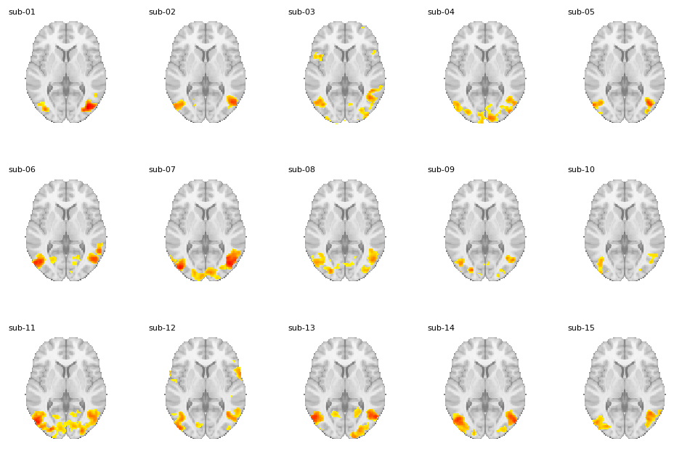
Figure 2 - GLM maps for the hMT+ localizer of each participant, contrasting the moving with the static plaid conditions (z-values corrected voxel-wise with Bonferroni’s correction and threshold p = 0.05 and cluster-wise with a minimum cluster size of 50 voxels). The maps show z-values between the estimated threshold per subject and 20, over the axial slice with Z = 4.

GLM statistical values of hMT+
Activation profiles were analyzed using GLMs applied to the normalized BOLD signals from the motion runs (the average BOLD time courses are shown in Supplementary Figures S4 and S5). Figure 3 presents the results of the GLM analyses across different TR values, showing that they are essentially the same across TRs, and can be pooled across TRs. In the first column, we plot the beta and t-values of the contrast ‘motion vs. static’. There is no difference in the beta values between TRs, in spite of larger t values for the lowest TRs. Similar findings were found for the coherent and incoherent contrasts.

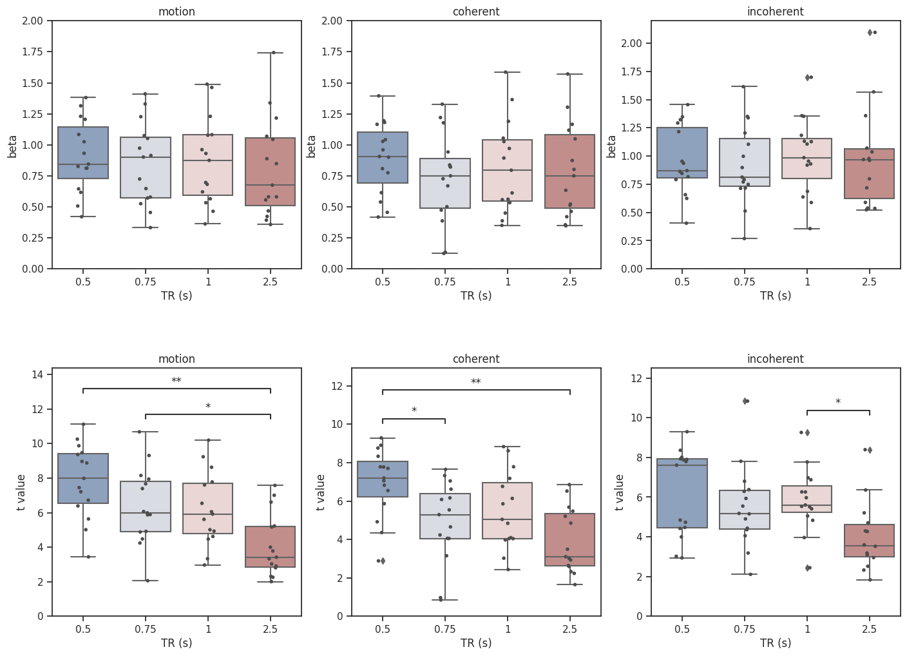
Figure 3 – Comparison of the beta and t-values for the activation of hMT+ during the functional runs for each TR and contrast of interest - ‘motion’, ‘coherent’, and ‘incoherent’ vs. ‘static’. We display boxplots (median, quartiles, standard deviation) with overlaid data points, and the statistical pairwise comparison was performed using two-sided Mann-Whitney-Wilcoxon tests with Bonferroni’s correction (p=0.05). Each data point corresponds to one subject, and only significant comparisons are drawn.

Interhemispheric connectivity
In Figure 4, we display the time courses of interhemispheric correlation of hMT+ for all the sequences with different temporal resolutions, centered on the perceptual switches between coherent and incoherent states and vice versa. The results are consistent across TRs, showing that they can be pooled - the transition to the coherent percept is linked to an increase in interhemispheric connectivity, while the transition to the incoherent percept is linked to a decrease in connectivity.
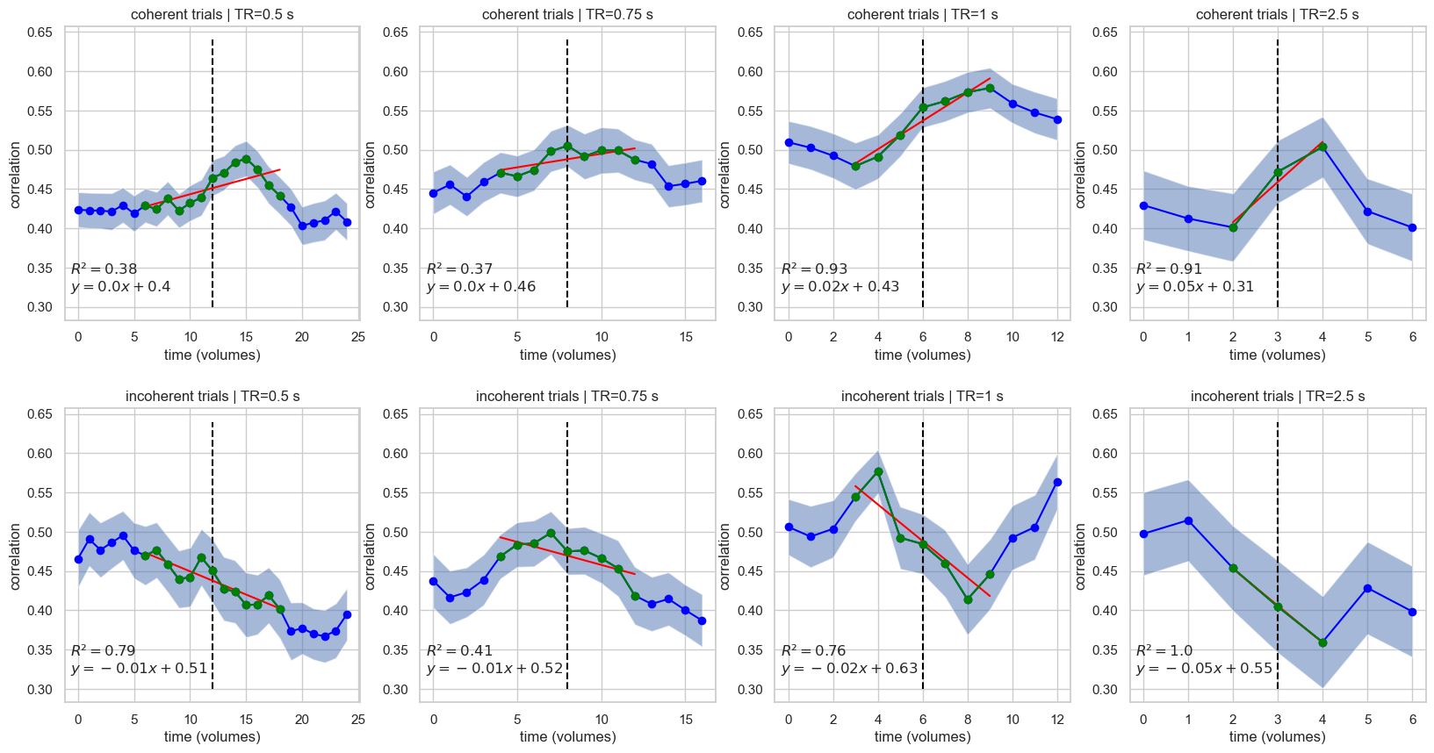
Figure 4 - Inter-hemispheric hMT+ correlation time courses (window size of 6 seconds / 7.5 seconds for TR=2.5s) per TR centered on coherent (top row) and incoherent (bottom row) perceptual switches. A dashed vertical line indicates the volume of transition. The first and last correlation points correspond to windows that do not include the volume of transition. Linear regression was performed on the datapoints highlighted in green using ordinary least squares.

Perceptual switch characteristics based on interhemispheric functional connectivity
Here, we investigated two characteristics of the signal based on interhemispheric hMT+ functional connectivity at different resolutions. Based on a rule that could distinguish coherent or incoherent perception, we calculated the percentage of detected switches (Figure 5) and the time it took to detect such switches (Figure 6) since the volume of transition for each sequence. The average number of switches per run was 5 ± 3 (see also Figures S6 and S7). The results show statistically significant differences in both metrics between the sequence with a TR of 2.5 seconds and the other three sequences.
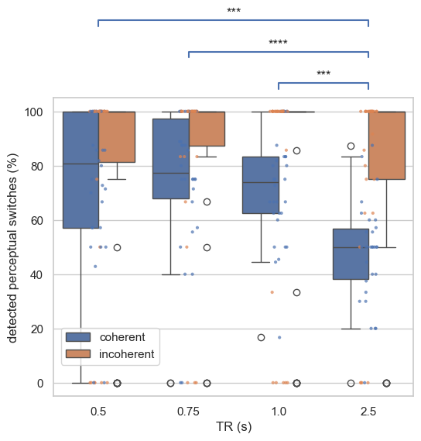
Figure 5 - Percentage of identified perceptual switches based on the correlation signal over the total number of perceptual switches reported by the participant for each TR condition, based on the rule of 10% increase or decrease in correlation for coherent and incoherent trials, respectively. We display the results of a two-tailed Mann-Whitney-Wilcoxon test with Bonferroni correction (p = 0.05) on the coherent trials data in blue.

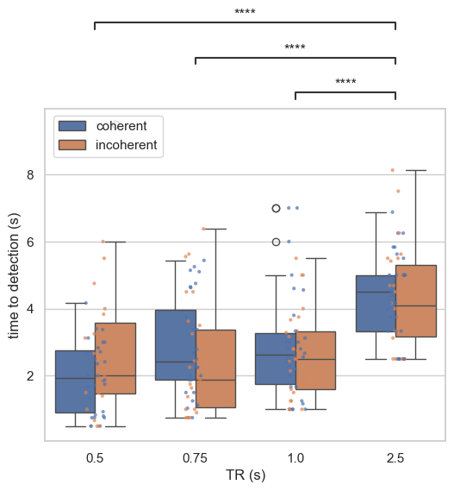
Figure 6 - Boxplot representation of the time to detection. For each sequence, we estimate the time required to detect the perceptual switch. A two-tailed Mann-Whitney-Wilcoxon test with Bonferroni correction (p = 0.05) was applied to the coherent and incoherent trial data.

Discussion
In this work, we used high temporal resolution fMRI to identify a link between interhemispheric connectivity and global motion integration versus segregation.

Visual motion network recruitment and short events
We used a moving plaid paradigm known to elicit bistable coherent/incoherent percepts while engaging a perceptual decision-making network, where motion-selective hMT+ plays a core role (Sayal et al. 2020; Sousa et al. 2024; 2018). It is known that the activity in this region depends on the perceptual decision state, coherent or incoherent (Duarte et al. 2017) , and we previously found evidence for the role of adaptation and inhibition strengths in this region to determine the resulting percepts (Sousa et al. 2024). However, the role of interhemispheric synchrony in integration versus segregation processes, in particular for spatially overlapping stimuli, remained an open question.
As a first step, we show that activation metrics are similar across temporal resolutions for each of the conditions, coherent and incoherent motion percepts (similar beta values, despite larger t-values for the lower TRs).

Validating the hypothesis that functional interhemispheric connectivity reflects perceptual integration versus segregation
Here, we aimed to robustly test this controversial hypothesis by studying the impact of perceptual coherence on functional connectivity by using a distinct bistable stimulus with spatially overlapping components at different temporal resolutions at 3 T. A previous single study (Sousa et al. 2019), suggested for the first time, at the scale of fMRI, a relation between interhemispheric functional connectivity and perceptual binding for spatially non-overlapping stimuli.
The identification of increased interhemispheric synchronization at the time scale of the BOLD signal is intriguing and suggests that it is related to the dynamics of local field potential (LFPs), a metric that correlates well with the BOLD (Magri et al. 2012; Logothetis et al. 2001). These studies show that BOLD responses correlate more strongly with the LFPs than with spiking activity, particularly in the low-frequency range, leading to the view of BOLD as a hemodynamic proxy for integrated synaptic activity. In fact, there is direct evidence for this correlation in MT (Lippert et al. 2010).
The results of (Sousa et al. 2019) showed opposing variations in hMT+ interhemispheric correlation when changing either to coherent or incoherent percepts of an ambiguous visual stimulus made of separate spatial elements. The connectivity between the left and right hMT+ was shown to be critical in interpreting spatially segregated visual moving stimuli. When studying the “motion quartet”, an ambiguous stimulus that generates horizontal or vertical apparent motion, it was found that its perception relates to distinct structural interhemispheric connectivity (Genç et al. 2011). The authors were able to predict the perception based on structural connectivity data of callosal segments linking both hMT+ regions. However, functional data connectivity was not addressed in this study. An indirect way of manipulating connectivity has been attempted by using transcranial magnetic stimulation, which increased the sensitivity to one of the possible percepts (Chiappini et al. 2022).
When we analyze the volumes around the transition between coherent and incoherent perceptual states, as reported by the participants, we found a decrease in interhemispheric correlation after switching to the incoherent percept and an increase after switching to the coherent percept (Figure 4), generalizing the findings of (Sousa et al. 2019) to even spatially overlapping elements.
As a control analysis, we also estimated partial correlation using subject-specific primary visual cortex (V1) ROIs as control regions. This allowed us to exclude possible coactivation effects and the contribution of low-level features of the stimulation. The connectivity results, which can be found in supplementary materials, allow for the same conclusions. We then confirm the role of hMT+ in processing moving stimuli that require perceptual integration, a finding which was replicated for all TRs.

Functional connectivity as a candidate marker of perceptual transitions
We found interhemispheric functional connectivity of hMT+ can be replicated across different TRs, although it was more informative of the type of perceptual transition for the higher-resolution sequences (Figures 5 and 6) when a simple rule was used to determine a perceptual switch. We emphasise that the connectivity effect itself was consistent across all temporal resolutions, and that only the detection metrics derived from a simple thresholding rule differed for the lowest-resolution sequence (TR = 2.5 s). These results position interhemispheric connectivity as a promising candidate marker of perceptual state, with full validation as a biomarker to be established in future work assessing its predictive value at the single-trial or single-subject level. This information could be helpful if, in future studies, one wishes to develop an automatic, real-time perceptual switch detection system.

Trade-offs and compromises
The neural processes studied with fMRI can be interpreted as a representation of a low-pass filter of the local field potentials, showing that neural patterns can also be found in the BOLD signal, a particularly relevant feature for connectivity methods applied to fMRI data (Fernandes et al. 2020). While the temporal resolution of this neuroimaging technique is far from others, such as electroencephalography, lowering the TR can provide us with a better sampling of the HRF and more certainty when studying brain connectivity with functional MRI.
Distinguishing between MT and MST responses would provide valuable insight, particularly at high field strength (7T), where the increased spatial resolution could help resolve the known functional differences between these subregions - such as MT’s preference for contralateral, retinotopically organized motion and MST’s involvement in more global, integrative motion processing (Huk, Dougherty, and Heeger 2002). Our analyses were conducted at the level of the broader hMT+ complex, which may combine MT and MST signals; because the stimulus was physically constant across percepts, however, this is unlikely to account for the percept-dependent modulation of interhemispheric coupling that we observe.

Conclusion
In conclusion, our study generalizes the hypothesis that interhemispheric connectivity reflects perceptual integration and binding even for spatially segregated elements, which was replicated at multiple temporal resolutions at 3 T.

Conflict of Interest
The authors declare that the research was conducted in the absence of any commercial or financial relationships that could be construed as a potential conflict of interest.

Author contributions
Conceptualization: AS, BD, TS, JVD, SA, MCB; Data curation: AS; Formal analysis: AS; Funding acquisition: MCB; Methodology: AS, BD, TS, JVD, MCB; Supervision: BD, TS, MCB; Visualization: AS, BD, TS; Writing – original draft: AS, BD, TS; Writing – review and editing: AS, BD, TS, JVD, SA, MCB.

Funding
This work was supported by the Portuguese Foundation for Science and Technology (FCT) (UIDB/04950/2025, UIDP/04950/2025, MedImSig, Centro2030-2024-76 2022.02963.PTDC ,https://doi.org/10.54499/2022.02963.PTDC, LA/P/0104/2020, UIDB/00326/2020, 2023.04365.BD, CEECINST/00117/2021/CP2784/CT0002, 2022.04701.PTDC, 2021.01469.CEECIND, CEECINSTLA/00026/2022) and Siemens Healthineers Portugal (PhD grant).

Data Availability Statement
The datasets generated and analyzed for this study, together with the analysis code, can be found in the [REPOSITORY NAME] repository: [LINK].

References
Abraham, Alexandre, Fabian Pedregosa, Michael Eickenberg, Philippe Gervais, Andreas Mueller, Jean Kossaifi, Alexandre Gramfort, Bertrand Thirion, and Gaël Varoquaux. 2014. ‘Machine Learning for Neuroimaging with Scikit-Learn’. Frontiers in Neuroinformatics 8. https://doi.org/10.3389/fninf.2014.00014.
Adelson, Edward H., and J. Anthony Movshon. 1982. ‘Phenomenal Coherence of Moving Visual Patterns’. Nature 300 (5892): 523–25. https://doi.org/10.1038/300523a0.
Bhandari, Ritu, Evgeniya Kirilina, Matthan Caan, Judith Suttrup, Teresa De Sanctis, Lorenzo De Angelis, Christian Keysers, and Valeria Gazzola. 2020. ‘Does Higher Sampling Rate (Multiband + SENSE) Improve Group Statistics - An Example from Social Neuroscience Block Design at 3T’. NeuroImage 213 (June):116731. https://doi.org/10.1016/j.neuroimage.2020.116731.
Brouwer, Gijs Joost, and Raymond Van Ee. 2007. ‘Visual Cortex Allows Prediction of Perceptual States during Ambiguous Structure-From-Motion’. The Journal of Neuroscience 27 (5): 1015–23. https://doi.org/10.1523/JNEUROSCI.4593-06.2007.
Burwick, Thomas. 2014. ‘The Binding Problem’. WIREs Cognitive Science 5 (3): 305–15. https://doi.org/10.1002/wcs.1279.
Chaumillon, Romain, Jean Blouin, and Alain Guillaume. 2018. ‘Interhemispheric Transfer Time Asymmetry of Visual Information Depends on Eye Dominance: An Electrophysiological Study’. Frontiers in Neuroscience 12 (February):72. https://doi.org/10.3389/fnins.2018.00072.
Chen, L., A. T. Vu, J. Xu, S. Moeller, K. Ugurbil, E. Yacoub, and D.A. Feinberg. 2015. ‘Evaluation of Highly Accelerated Simultaneous Multi-Slice EPI for fMRI’. NeuroImage 104 (January):452–59. https://doi.org/10.1016/j.neuroimage.2014.10.027.
Chiappini, Emilio, Alejandra Sel, Paul B. Hibbard, Alessio Avenanti, and Vincenzo Romei. 2022. ‘Increasing Interhemispheric Connectivity between Human Visual Motion Areas Uncovers Asymmetric Sensitivity to Horizontal Motion’. Current Biology 32 (18): 4064-4070.e3. https://doi.org/10.1016/j.cub.2022.07.050.
Costa, Gabriel Nascimento, Michael Schaum, João Valente Duarte, Ricardo Martins, Isabel Catarina Duarte, João Castelhano, Michael Wibral, and Miguel Castelo‐Branco. 2024. ‘Distinct Oscillatory Patterns Differentiate between Segregation and Integration Processes in Perceptual Grouping’. Human Brain Mapping 45 (12): e26779. https://doi.org/10.1002/hbm.26779.
Darányi, Virág, Petra Hermann, István Homolya, Zoltán Vidnyánszky, and Zoltan Nagy. 2021. ‘An Empirical Investigation of the Benefit of Increasing the Temporal Resolution of Task-Evoked fMRI Data with Multi-Band Imaging’. Magnetic Resonance Materials in Physics, Biology and Medicine 34 (5): 667–76. https://doi.org/10.1007/s10334-021-00918-z.
Demetriou, Lysia, Oliwia S. Kowalczyk, Gabriella Tyson, Thomas Bello, Rexford D. Newbould, and Matthew B. Wall. 2018. ‘A Comprehensive Evaluation of Increasing Temporal Resolution with Multiband-Accelerated Protocols and Effects on Statistical Outcome Measures in fMRI’. NeuroImage 176 (August):404–16. https://doi.org/10.1016/j.neuroimage.2018.05.011.
Duarte, João Valente, Gabriel Nascimento Costa, Ricardo Martins, and Miguel Castelo‐Branco. 2017. ‘Pivotal Role of hMT+ in Long‐range Disambiguation of Interhemispheric Bistable Surface Motion’. Human Brain Mapping 38 (10): 4882–97. https://doi.org/10.1002/hbm.23701.
Esteban, Oscar, Daniel Birman, Marie Schaer, Oluwasanmi O. Koyejo, Russell A. Poldrack, and Krzysztof J. Gorgolewski. 2017. ‘MRIQC: Advancing the Automatic Prediction of Image Quality in MRI from Unseen Sites’. Edited by Boris C Bernhardt. PLOS ONE 12 (9): e0184661. https://doi.org/10.1371/journal.pone.0184661.
Esteban, Oscar, Christopher J. Markiewicz, Christopher Burns, Mathias Goncalves, Dorota Jarecka, Erik Ziegler, Shoshana Berleant, et al. 2022. ‘Nipy/Nipype: 1.8.3’. Zenodo. https://doi.org/10.5281/ZENODO.596855.
Esteban, Oscar, Christopher J. Markiewicz, Mathias Goncalves, Céline Provins, James D. Kent, Elizabeth DuPre, Taylor Salo, et al. 2023. ‘fMRIPrep: A Robust Preprocessing Pipeline for Functional MRI’. Zenodo. https://doi.org/10.5281/ZENODO.852659.
Feinberg, David A., Steen Moeller, Stephen M. Smith, Edward Auerbach, Sudhir Ramanna, Matt F. Glasser, Karla L. Miller, Kamil Ugurbil, and Essa Yacoub. 2010. ‘Multiplexed Echo Planar Imaging for Sub-Second Whole Brain FMRI and Fast Diffusion Imaging’. PLOS ONE 5 (12): e15710. https://doi.org/10.1371/journal.pone.0015710.
Fernandes, Tiago Timóteo, Bruno Direito, Alexandre Sayal, João Pereira, Alexandre Andrade, and Miguel Castelo-Branco. 2020. ‘The Boundaries of State-Space Granger Causality Analysis Applied to BOLD Simulated Data: A Comparative Modelling and Simulation Approach’. Journal of Neuroscience Methods 341 (July):108758. https://doi.org/10.1016/j.jneumeth.2020.108758.
Genç, Erhan, Johanna Bergmann, Wolf Singer, and Axel Kohler. 2011. ‘Interhemispheric Connections Shape Subjective Experience of Bistable Motion’. Current Biology 21 (17): 1494–99. https://doi.org/10.1016/j.cub.2011.08.003.
Gorgolewski, Krzysztof, Christopher D. Burns, Cindee Madison, Dav Clark, Yaroslav O. Halchenko, Michael L. Waskom, and Satrajit S. Ghosh. 2011. ‘Nipype: A Flexible, Lightweight and Extensible Neuroimaging Data Processing Framework in Python’. Frontiers in Neuroinformatics 5. https://doi.org/10.3389/fninf.2011.00013.
Gorgolewski, Krzysztof J., Tibor Auer, Vince D. Calhoun, R. Cameron Craddock, Samir Das, Eugene P. Duff, Guillaume Flandin, et al. 2016. ‘The Brain Imaging Data Structure, a Format for Organizing and Describing Outputs of Neuroimaging Experiments’. Scientific Data 3 (1): 160044. https://doi.org/10.1038/sdata.2016.44.
Huk, Alexander C., Robert F. Dougherty, and David J. Heeger. 2002. ‘Retinotopy and Functional Subdivision of Human Areas MT and MST’. The Journal of Neuroscience 22 (16): 7195–7205. https://doi.org/10.1523/JNEUROSCI.22-16-07195.2002.
Jahanian, Hesamoddin, Samantha Holdsworth, Thomas Christen, Hua Wu, Kangrong Zhu, Adam B. Kerr, Matthew J. Middione, Robert F. Dougherty, Michael Moseley, and Greg Zaharchuk. 2019. ‘Advantages of Short Repetition Time Resting-State Functional MRI Enabled by Simultaneous Multi-Slice Imaging’. Journal of Neuroscience Methods 311 (January):122–32. https://doi.org/10.1016/j.jneumeth.2018.09.033.
Kozak, Lajos R., and Miguel Castelo-Branco. 2009. ‘Peripheral Influences on Motion Integration in Foveal Vision Are Modulated by Central Local Ambiguity and Center-Surround Congruence’. Investigative Opthalmology & Visual Science 50 (2): 980. https://doi.org/10.1167/iovs.08-2094.
Li, Xiangrui, Paul S. Morgan, John Ashburner, Jolinda Smith, and Christopher Rorden. 2016. ‘The First Step for Neuroimaging Data Analysis: DICOM to NIfTI Conversion’. Journal of Neuroscience Methods 264 (May):47–56. https://doi.org/10.1016/j.jneumeth.2016.03.001.
Lippert, Michael T., Thomas Steudel, Frank Ohl, Nikos K. Logothetis, and Christoph Kayser. 2010. ‘Coupling of Neural Activity and fMRI-BOLD in the Motion Area MT’. Magnetic Resonance Imaging 28 (8): 1087–94. https://doi.org/10.1016/j.mri.2009.12.028.
Logothetis, Nikos K., Jon Pauls, Mark Augath, Torsten Trinath, and Axel Oeltermann. 2001. ‘Neurophysiological Investigation of the Basis of the fMRI Signal’. Nature 412 (6843): 150–57. https://doi.org/10.1038/35084005.
Magri, Cesare, Ulrich Schridde, Yusuke Murayama, Stefano Panzeri, and Nikos K. Logothetis. 2012. ‘The Amplitude and Timing of the BOLD Signal Reflects the Relationship between Local Field Potential Power at Different Frequencies’. The Journal of Neuroscience 32 (4): 1395–1407. https://doi.org/10.1523/JNEUROSCI.3985-11.2012.
Oldfield, R.C. 1971. ‘The Assessment and Analysis of Handedness: The Edinburgh Inventory’. Neuropsychologia 9 (1): 97–113. https://doi.org/10.1016/0028-3932(71)90067-4.
Pan, Wen-Ju, Garth John Thompson, Matthew Evan Magnuson, Dieter Jaeger, and Shella Keilholz. 2013. ‘Infraslow LFP Correlates to Resting-State fMRI BOLD Signals’. NeuroImage 74 (July):288–97. https://doi.org/10.1016/j.neuroimage.2013.02.035.
Renz, Malika P., Francesca Zidda, Jamila Andoh, Marcel Prager, Markus Sack, Robert Becker, Matthias Ruf, et al. 2023. ‘Practical Challenges of Continuous Real‐time Functional Magnetic Resonance Imaging Neurofeedback with Multiband Accelerated Echo‐planar Imaging and Short Repetition Times’. Human Brain Mapping 44 (3): 1278–82. https://doi.org/10.1002/hbm.26154.
Risk, Benjamin B., Raphiel J. Murden, Junjie Wu, Mary Beth Nebel, Arun Venkataraman, Zhengwu Zhang, and Deqiang Qiu. 2021. ‘Which Multiband Factor Should You Choose for Your Resting-State fMRI Study?’ NeuroImage 234 (July):117965. https://doi.org/10.1016/j.neuroimage.2021.117965.
Sayal, Alexandre, Teresa Sousa, João V. Duarte, Gabriel N. Costa, Ricardo Martins, and Miguel Castelo-Branco. 2020. ‘Identification of Competing Neural Mechanisms Underlying Positive and Negative Perceptual Hysteresis in the Human Visual System’. NeuroImage 221 (November):117153. https://doi.org/10.1016/j.neuroimage.2020.117153.
Schölvinck, Marieke L., Alexander Maier, Frank Q. Ye, Jeff H. Duyn, and David A. Leopold. 2010. ‘Neural Basis of Global Resting-State fMRI Activity’. Proceedings of the National Academy of Sciences 107 (22): 10238–43. https://doi.org/10.1073/pnas.0913110107.
Seth, Anil K., Paul Chorley, and Lionel C. Barnett. 2013. ‘Granger Causality Analysis of fMRI BOLD Signals Is Invariant to Hemodynamic Convolution but Not Downsampling’. NeuroImage 65 (January):540–55. https://doi.org/10.1016/j.neuroimage.2012.09.049.
Shimono, M., H. Mano, and K. Niki. 2012. ‘The Brain Structural Hub of Interhemispheric Information Integration for Visual Motion Perception’. Cerebral Cortex 22 (2): 337–44. https://doi.org/10.1093/cercor/bhr108.
Sousa, Teresa, João V. Duarte, Gabriel N. Costa, Valentin G. Kemper, Ricardo Martins, Rainer Goebel, and Miguel Castelo-Branco. 2019. ‘Tracking Perceptual Decision Mechanisms through Changes in Interhemispheric Functional Connectivity in Human Visual Cortex’. Scientific Reports 9 (1): 1242. https://doi.org/10.1038/s41598-018-37822-x.
Sousa, Teresa, João V. Duarte, Gabriel N. Costa, Valentin G. Kemper, Ricardo Martins, Rainer Goebel, and Miguel Castelo‐Branco. 2021. ‘The Dual Nature of the BOLD Signal: Responses in Visual Area hMT+ Reflect Both Input Properties and Perceptual Decision’. Human Brain Mapping 42 (6): 1920–29. https://doi.org/10.1002/hbm.25339.
Sousa, Teresa, Alexandre Sayal, João V. Duarte, Gabriel N. Costa, and Miguel Castelo-Branco. 2024. ‘A Human Cortical Adaptive Mutual Inhibition Circuit Underlying Competition for Perceptual Decision and Repetition Suppression Reversal’. NeuroImage 285 (January):120488. https://doi.org/10.1016/j.neuroimage.2023.120488.
Sousa, Teresa, Alexandre Sayal, João V. Duarte, Gabriel N. Costa, Ricardo Martins, and Miguel Castelo-Branco. 2018. ‘Evidence for Distinct Levels of Neural Adaptation to Both Coherent and Incoherently Moving Visual Surfaces in Visual Area hMT+’. NeuroImage 179 (October):540–47. https://doi.org/10.1016/j.neuroimage.2018.06.075.
Srirangarajan, Tara, Leili Mortazavi, Tiago Bortolini, Jorge Moll, and Brian Knutson. 2021. ‘Multi‐band FMRI Compromises Detection of Mesolimbic Reward Responses’. NeuroImage 244 (December):118617. https://doi.org/10.1016/j.neuroimage.2021.118617.
Sterzer, Philipp, and Andreas Kleinschmidt. 2007. ‘A Neural Basis for Inference in Perceptual Ambiguity’. Proceedings of the National Academy of Sciences 104 (1): 323–28. https://doi.org/10.1073/pnas.0609006104.
Sterzer, Philipp, Michael O. Russ, Christine Preibisch, and Andreas Kleinschmidt. 2002. ‘Neural Correlates of Spontaneous Direction Reversals in Ambiguous Apparent Visual Motion’. NeuroImage 15 (4): 908–16. https://doi.org/10.1006/nimg.2001.1030.
Todd, Nick, Oliver Josephs, Peter Zeidman, Guillaume Flandin, Steen Moeller, and Nikolaus Weiskopf. 2017. ‘Functional Sensitivity of 2D Simultaneous Multi-Slice Echo-Planar Imaging: Effects of Acceleration on g-Factor and Physiological Noise’. Frontiers in Neuroscience 11 (March). https://doi.org/10.3389/fnins.2017.00158.
Todd, Nick, Steen Moeller, Edward J. Auerbach, Essa Yacoub, Guillaume Flandin, and Nikolaus Weiskopf. 2016. ‘Evaluation of 2D Multiband EPI Imaging for High-Resolution, Whole-Brain, Task-Based fMRI Studies at 3T: Sensitivity and Slice Leakage Artifacts’. NeuroImage 124 (January):32–42. https://doi.org/10.1016/j.neuroimage.2015.08.056.
Tyszka, Mike. 2023. ‘Bidskit: Utility Functions for Working with DICOM and BIDS Neuroimaging Data’. https://github.com/jmtyszka/bidskit.
Wall, Matthew B. 2023. ‘Multiband Acquisition Sequences for fMRI: Proceed with Caution’. Aperture Neuro 3 (December). https://doi.org/10.52294/001c.91292.
Yarkoni, Tal, Russell A Poldrack, Thomas E Nichols, David C Van Essen, and Tor D Wager. 2011. ‘Large-Scale Automated Synthesis of Human Functional Neuroimaging Data’. Nature Methods 8 (8): 665–70. https://doi.org/10.1038/nmeth.1635.
Zhang, Yiteng, Zheng Ye, Chunchao Xia, Yuqi Tan, Meng Zhang, Xinyang Lv, Jing Tang, and Zhenlin Li. 2024. ‘Clinical Applications and Recent Updates of Simultaneous Multi-Slice Technique in Accelerated MRI’. Academic Radiology, January, S1076633223007109. https://doi.org/10.1016/j.acra.2023.12.032.

