**SUPPLEMENTAL TABLES:**

**Table 1.** Anti-coronavirus drugs with experimental data support

|  |  |  |  |
| --- | --- | --- | --- |
| **Chemical Ingredients**  **(Drug name)** | **Targeted virus(es)** | **Ontology IDs** | **PUBMED IDs** |
| ***Inhibit viral entry*** | | | |
| Aloxistatin (E-64d) | S2 | C: 101381 | 32142651 |
| Amodiaquine | S | C: 2674, D: 00012403, N: N0000147704,  DB00613 | 32366720, 30700611 |
| Arbidol | S2 | C: 134730, DB13609 | 32373347 |
| Benztropine mesylate | S, M | C: 3049, D: 00059818, N: N0000146182,  DB00245 | 26202243, 24841273 |
| Bufalin | M | C: 517248 | 26868298 |
| Camostat | S, M | C: 135632, DB13729 | 28855003, 25666761 |
| Camostat mesylate | S2 | C: 135632, DB13729 | 32142651 |
| Chloroquine | S, M, S2 | C: 3638, D: 00001135, N: N0000147767, DB00608 | 16837072, 27344959,  27916837, 32150618, 32020029 |
| Chloroquine phosphate | S, M, S2 | N: N0000146559, DB00608 | 24841273, 32150618, 32074550 |
| Chlorpromazine | M, S2 | C: 3647, D: 00021685, N: N0000146214, DB00477 | 27344959, 24841269, 32387014 |
| Chlorpromazine hydrochloride | S, M | C: 3649, D: 00061920, N: N0000146213,  DB00477 | 24841273 |
| Dalbavancin | S, M | C: 82721, N: N0000171775, D: 00750811, DB06219 | 26953343, 28855003, 16081529 |
| Dasatinib | S, M | C: 49375, D:00018901, N: N0000176043,  DB01254 | 24841273, 26868298 |
| Emetine | O | C: 4781, D: 00017078, N: N0000147834,  DB13393 | 30918074 |
| Hexachlorophene | S | C: 5693, D: 00014863, N: N0000146582,  DB00756 | 32366720, 31027241 |
| Hydroxychloroquine | S2 | C: 5801, N: N0000147871, D: 00010111, DB01611 | 32150618, 32205204 |
| Hydroxychloroquine sulfate | S, M | D: 00061833, N: N0000146583, DB01611 | 32150618, 24841273 |
| Imatinib | S, M | C: 45783, D: 00018693, N: N0000148698, DB00619 | 30711575 |
| Imatinib mesylate | S, M | C: 31690, N: N0000148699, DB00619 | 24841273 |
| Mefloquine | S, M | C: 63609, D: 00022383, N: N0000147900,  DB00358 | 19258267, 24841273 |
| Nafamostat | S, M | C: 135466, DB12598 | 28855003,30711575,  27550352 |
| Nafamostat mesylate | S2 | C: 31890, DB12598 | 32020029 |
| Nelfinavir mesylate | S2 | C: 7497, N: N0000148479, DB00220 | 32374457 |
| Nilotinib | S | C: 52172, N: N0000176124, D:00018985, DB04868 | 24841273, 29557770 |
| Oritavancin | S, M | C: 82699, D: 00750820, DB04911 | 26953343, 28855003, 16081529 |
| Ouabain | S, M | C: 472805, D:00015446, DB01092 | 26868298 |
| Tamoxifen citrate | S, M | C: 9397, D: 00075906, N: N0000146786,  DB00675 | 23785035, 24841273 |
| Teicoplanin | S, M | D: 00012681, DB06149 | 26953343, 28855003 |
| Telavancin | S, M | C: 71229, N: N0000180310, D: 00019459, DB06402 | 26953343, 28855003, 16081529 |
| Terconazole | S, M | C: 9451, D: 00013976, N: N0000147638, DB00251 | 30893774, 24841273 |
| Toremifene citrate | S, M | C: 9636, N: N0000148546, DB00539 | 23785035, 24841273 |
| Triflupromazine hydrochloride | S, M | C: 9712, N: N0000146110, DB00508 | 24841273 |
| Triparanol | S, M | C: 135714, N: N0000166394 | 30893774, 24841273 |
| Valinomycin | S | C: 28545, N: N0000170352, DB14057 | 30858482, 16837072 |
| ***Inhibit viral replication*** | | | |
| 6-mercaptopurine | S, M | C: 50667, N: N0000006010, DB01033 | 27344959, 28855003 |
| 6-thioguanine | S, M | C: 9555, DB00352 | 27344959, 28855003 |
| Abemaciclib | S | D: 00803385, DB12001 | 32366720 |
| Anisomycin | S, M | C: 338412, N: N0000167149, DB07374 | 24841273 |
| Arbidol | S2 | C: 134730, DB13609 | 32373347 |
| Azithromycin | S2 | C: 2955, N: N0000148074, D: 00024808, DB00207 | 32205204 |
| Cepharanthine | S, O | C: 3546 | 32366720, 31690059 |
| Berbamine | S | C: 3063 | 32366720, 29305616 |
| Chloroquine | S, M, S2 | C: 3638, D: 00001135, N: N0000147767, DB00608 | 16837072, 27344959,  27916837, 32150618, 32020029 |
| Chloroquine phosphate | S, M, S2 | N: N0000146559, DB00608 | 24841273, 32150618 |
| Cinanserin | S | N: N0000166641 | 16837072 |
| Cycloheximide | S, M | C: 27641, N: N0000167211 | 24841273 |
| Cyclosporine | S, M | C: 4031, D: 00023979, N: N0000147064 DB00091 | 27478032, 27344959 |
| Digitoxin | S | C: 28544, D: 00016250, N: N0000145817, DB01396 | 32366720, 29321306 |
| Digoxin | S | C: 4551, D: 00012840, N: N0000146388,  DB00390 | 32366720 |
| Everolimus | M | C: 68478, D:00018224 N: N0000178379,  DB01590 | 26868298 |
| Fangchinoline | O | C: 132893 | 31690059 |
| Favipiravir | S2 | C: 134722, DB12466 | 32020029;  Doi:10.1101/2020.03.17.20037432 |
| Gemcitabine hydrochloride | S, M | C: 31647, N: N0000022977, DB00441 | 24841273 |
| Geranylgeranylacetone (GGA) | S | C: 31649 | 30711575 |
| Gilteritinib | S | C: 145372, D: 00837869, DB12141 | 32366720 |
| Glycyrrhizin (  Glycyrrhizic acid) | S | C: 29807, D: 00723537, DB13751 | 21762538, 16837072 |
| Hydroxychloroquine sulfate | S, M | D: 00061833, N: N0000146583, DB01611 | 32150618, 24841273 |
| Indinavir | S | D: 00013621, DB00224 | 15144898 |
| Ivacaftor | S | C: 66901, D: 00020190, DB08820 | 32366720 |
| Ivermectin | S2 | C: 6078, N: N0000148510, D: 00020654, DB00602 | 32251768, 21297106 |
| Lopinavir | S, M | C: 31781, D: 00016421, N: N0000148672, DB01601 | 27344959, 26868298  16837072 |
| Lycorine | O, M, L, V | C: 6601 | 30918074 |
| Mefloquine | S, M | C: 63609, D: 00022383, N: N0000147900,  DB00358 | 19258267, 24841273 |
| Mycophenolate mofetil | O, M, L, V | C: 8764, D: 00013779, N: N0000148406,  DB00688 | 30918074 |
| Mycophenolic acid | M | C:168396, D:00016769, N: N0000148832, DB01024 | 27344959 |
| Niclosamide | S | C: 7553 D: 00015957, N: N0000146594,  DB06803 | 32366720, 32361588 |
| Nitazoxanide | M, S2 | C: 94807, D: 00015413, N: N0000148784,  DB00507 | 30918074, 25108173 |
| Nocodazole | M | C: 34892, N: N0000166936, DB08313 | 27783035, 24841273 |
| Omacetaxine mepesuccinate | S, M | C: 71019, D: 00018264, DB04865 | 24841273 |
| Oxyclozanide | S | N: N0000166893 | 32366720, 30626902 |
| Penciclovir | S2 | C: 7956, N: N0000148462, D: 00013349, DB00299 | 32020029 |
| Pyrvinium pamoate (Pyrvinium) | O, M, L, V | C: 8688, DB06816 | 30918074 |
| Rapamycin (sirolimus) | M | C: 9168, D: 00024510, DB00877 | 25487801, 26868298 |
| Remdesivir | S, M, S2 | C: 145994, D: 00882939,DB14761 | 30849247, 32275812, 32020029 |
| Ritonavir | S, M | C: 45409, D: 00023321, N: N0000148436,  DB00503 | 27344959, 15226499  16837072 |
| Ribavirin | S, M, O | C: 63580, D: 00025187, N: N0000147496,  DB00811 | 27344959, 26868298  15200845, 16837072 |
| Salinomycin | S | C: 80025, DB11544 | 32366720, 30282713 |
| SB203580 | S, M | C: 90705 | 24699705, 27344959 |
| SG85 | S, M | C: 147346 | 25039866, 27344959 |
| Selumetinib | M | C: 90227, D: 00877833, DB11689 | 26868298 |
| Silvestrol | M | C: 66484 | 30711575 |
| Rimantadine | S | C: 49886, N: N0000021902, D: 00017006, DB00478 | 15288617 |
| Tetrandrine | S, O | C: 49, DB14066 | 32366720, 31690059 |
| Trametinib | M | C: 75991, D: 00750784, DB08911 | 26868298 |
| ***Modulate immune response*** | | | |
| Azithromycin | S2 | C: 2955, N: N0000148074, D: 00024808, DB00207 | 32533455 |
| Cepharanthine | S, O | C: 3546 | 32366720, 31690059 |
| Ciclesonide | S | C: 31397, D: 00019082, N: N0000176150,  DB01410 | 32366720 |
| Fangchinoline | O | C: 132893 | 31690059 |
| IFNα2a | M | C: 5937, D: 00016915, N: N0000020127,  DB00034 | 26868298, 25278221 |
| IFNβ1b | M | C: 5938, D: 00027247, N: N0000021905, DB00068 | 27344959, 15200845 |
| Wellferon | S | D: 00013637, DB00011 | 15200845 |
| Glycyrrhizin | S | C: 29807, D: 00723537 | 21762538, 16837072 |
| Nitazoxanide | M, S2 | C: 94807, D: 00015413, N: N0000148784,  DB00507 | 30918074, 25108173 |
| Tetrandrine | S, O | C: 49, DB14066 | 32366720, 31690059 |
| Tocilizumab | S2 | N: N0000180629, D: 00019607, DB06273 | 32350134 |
| ***Unknown mechanism*** | | | |
| Fluspirilene | S, M | D: 00014099, N: N0000167366, DB04842 | 24841273 |
| Thiothixene | S, M | C: 9571, D: 00012220, N: N0000148032,  DB01623 | 24841273 |
| Fluphenazine hydrochloride | S, M | C: 5126, D: 00059506, N: N0000146092,  DB00623 | 24841273 |
| Promethazine hydrochloride | S, M | C: 8462, D: 00061963, N: N0000146203,  DB01069 | 24841273 |
| Astemizole | S, M | C: 2896, D: 00017043, N: N0000147536, DB00637 | 24841273 |
| Chlorphenoxamine hydrochloride | S, M | C: 135288, DB09007 | 24841273 |
| Thiethylperazine maleate | S, M | C: 32216, N: N0000147331, DB00372 | 24841273 |
| Clomipramine hydrochloride | S, M | C: 3755, D: 00058882, N: N0000147612,  DB01242 | 24841273 |
| Monensin | M | C: 27617, N: N0000167131, DB11430 | 24841273 |
| Aescin | S | C: 2500 | 15226499 |
| Reserpine | S | C: 28487, D: 00023295, N: N0000145891, DB00206 | 15226499 |
| Phenazopyridine | O, M, L,V | C: 71416, D: 00016762, N: N0000147969,  DB01438 | 30918074 |
| Cetylpyridinium chloride (Cetylpyridinium) | O, M, L, V | C: 32915, D:00050843, N: N0000147354, DB11073 | 30918074 |
| Oligomycin | O,M, L, V | C: 25675, N: N0000168432 | 30918074 |
| Harmine | O, M, L, V | C: 28121, N: N0000167259, DB07919 | 30918074 |
| Conessine | O, M, L, V | C: 27965 | 30918074 |
| Loperamide | S, O, M | C: 6532, D: 00000908, N: N0000147893,  DB00836 | 30918074, 27344959, 32366720 |
| Proscillaridin | S | C: 32065, D: 00012193, N: N0000168447,  DB13307 | 32366720 |
| Hydroxyprogesterone caproate | S | C: 5812, D: 00064769, N: N0000145993, DB06789 | 32366720 |
| Anidulafungin | S | C: 55346, D: 00018854, N: N0000171752, DB00362 | 32366720 |
| Bazedoxifene | S | C: 135947, D: 00750789, DB06401 | 32366720 |
| Eltrombopag | S | C: 85010, D: 00019163, N: N0000177933,  DB06210 | 32366720 |
| Baicalin | S | C: 2981, N: N0000179808 | 15288617 |
| Emetine dihydrochloride hydrate | S, M | C: 146000 | 24841273, 29557770 |

** Notation: For targeted virus, M: MERS-CoV, S: SARS-CoV, S2: SARS-CoV 2, O: HCoV-OC43, L: HCoV-NL63, V: MHV-A59. For ontologies, C: ChEBI, D: DRON, N: NDF-RT. Noted that Azithromycin was newly added due to its very recent online publication on May 17, 2020 49.

**Table 2:** Anti-coronavirus antibodies annotated from the literature and clinical trials

|  |  |  |  |  |
| --- | --- | --- | --- | --- |
| **Antibody name** | **Antigen** | **Efficacy test** | **Type** | **PMID or clinical trial IDs** |
| ***Targeting SARS-CoV*** | | | | |
| S3.1 | spike protein | *in vitro*/ *in vivo* mouse | monoclonal | 15247913, 17620608 |
| CR3014 | spike protein | *in vitro*/*in vivo* ferrets | monoclonal | 15220038, 15650189, 17620608 |
| S230.15 | S1 RBD* | *in vitro* | monoclonal | 17620608 |
| m396 | S1 RBD | *in vitro* | monoclonal | 17620608 |
| 80R | S1 | *in vitro* | monoclonal | 14983044, 17620608 |
| 201 | S1 RBD | *in vitro* | monoclonal | 15655773, 17620608 |
| scFv B1 | S2 | *in vitro* | monoclonal | 15939399, 17620608 |
| ***Targeting MERS-CoV*** | | | | |
| m332 | spike protein | *in vivo* (rabbits) | monoclonal | 27344959 |
| 311B-N1 | spike protein | *in vivo* (rhesus macaques) | monoclonal | 27344959 |
| REGN3051 | spike protein | *In vitro*/*in vivo* (mouse) | monoclonal | 26315600 |
| REGN3048 | spike protein | *In vitro*/*in vivo* (mouse) | monoclonal | 26315600 |
| 4C2 | S1 RBD* | *in vitro*/*in vivo* (mouse) | monoclonal | 28855003, 26391698 |
| Mersmab | S1 RBD | *In vitro* | monoclonal | 28855003 |
| m336 | S1 RBD | *In vitro*/*in vivo* (mouse, rabbit) | monoclonal | 28855003 |
| m337 | S1 RBD | *In vitro* | monoclonal | 28855003 |
| m338 | S1 RBD | *In vitro* | monoclonal | 28855003 |
| MERS-4 | S1 RBD | *In vitro* | monoclonal | 28855003 |
| MERS-27 | S1 RBD | *In vitro* | monoclonal | 28855003 |
| hMS-1 | S1 RBD | *In vitro*/*in vivo* (mouse) | monoclonal | 28855003 |
| LCA60 | S1 RBD | *In vitro*/*in vivo* (mouse) | monoclonal | 28855003 |
| 3B11-N | S1 RBD | *In vitro*/*in vivo* (rhesus monkeys) | monoclonal | 28855003 |
| 2E6 | S1 RBD | *in vitro* | polyclonal | 26391698 |
| 2F9 | DPP4 | *In vitro* | monoclonal | 28855003 |
| 1F7 | DPP4 | *In vitro* | monoclonal | 28855003 |
| YS110 | DPP4 | *In vitro* | monoclonal | 28855003, 26315600 |
| anti-CD26 | DPP4 | *in vitro* | polyclonal | 26315600 |
| ***Targeting SARS CoV- 2*** | | | | |
| 47D11 | Spike protein | *In vitro* | monoclonal | 32366817 |
| S309 | Spike protein | *In vitro* | monoclonal | 32422645 |
| CB6 | RBD | *In vitro/* *in vivo (rhesus*  *monkeys)* | monoclonal | 32454512 |
| CA1 | ACE2/S protein | *In vitro* | monoclonal | 32454512 |
| 4A8 | N terminal domain (NTD) of the S protein | *In vitro* | monoclonal | 32571838 |

*RBD: spike receptor-binding domain.

**SUPPLEMENTAL FIGURES:**



**Supplemental Fig. 1. Top 30 most significantly enriched KEGG pathways among the known host targets of anti-coronavirus drug.** Ourin-house enrichment analysis R package RichR was used to perform the enrichment analysis and generate a dot plot. This plot lists the top 30 KEGG pathways with their significance levels. The rich factor is the proportion of known drug targets to all genes in the human genome belonging to each KEGG term. The size of the dot corresponds to the numbers of known drug targets annotated with the corresponding KEGG pathways. The color gradient (see color scale right of the figure) indicates the level of significance, represented by –log10(Pvalue).

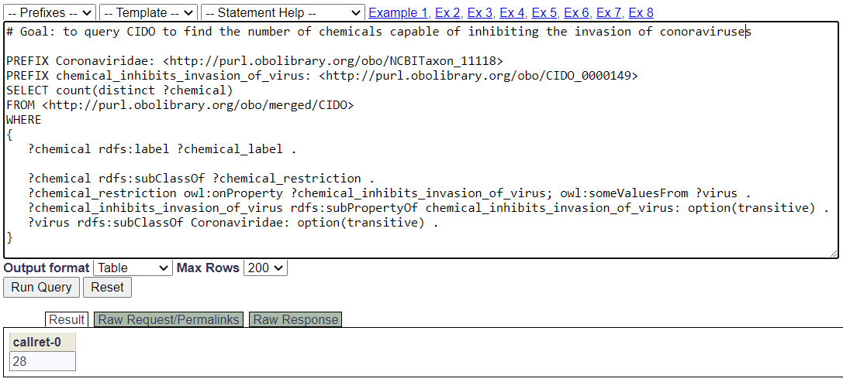

**Supplemental Fig. 2. SPARQL query demonstration.** This SPARQL query identified 28 chemicals that are capable of inhibiting the invasion of coronaviruses *in vitro* or *in vivo*. The query was performed using the Ontobee SPARQL endpoint (<http://www.ontobee.org/sparql>).

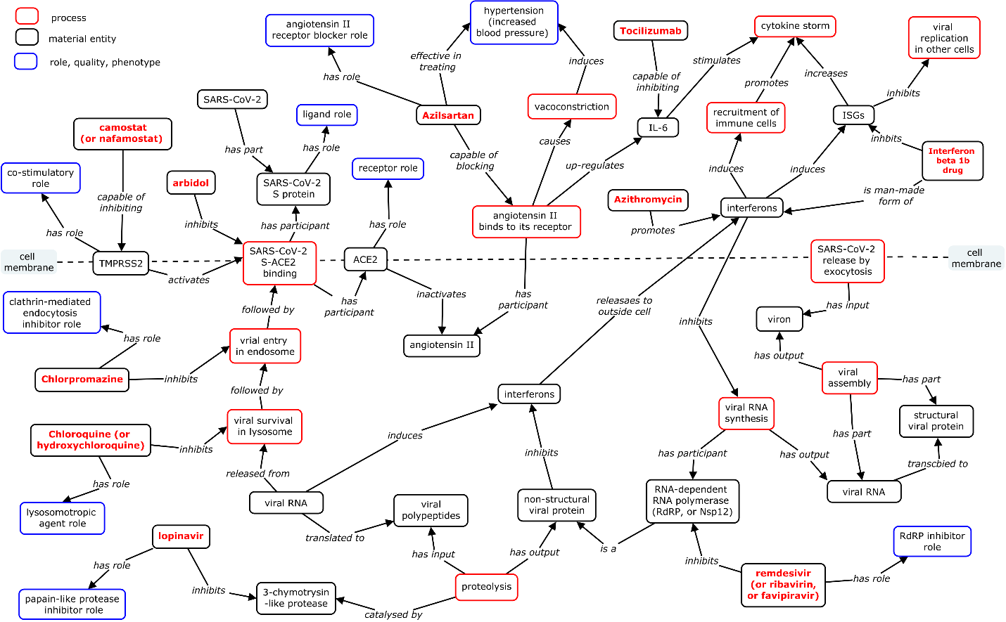

**Supplemental Fig. 3. Ontological representation of host-coronavirus interactions and drugs targeting the interactions.** The boxes enclosed in red, black, and blue colors represent biological processes, material entities (e.g., cells, molecules, and drugs), and roles or phenotypes, respectively. Red text in bold represents drugs. The text labeled in the middle of lines represents relations. The knowledge was obtained by our manual annotation of peer-reviewed publications.