CIJE • UPDATED EDITION
The Spiromatic Unkit-Kit
Teachers Guide
A Step-by-Step Guide to Building an Automated Art Machine
Student work gallery: images and videos are from student work at TABC (see the shared Google Photos album).

What's new in this edition
- Build Progression Reference — stage-by-stage pictures of the machine as it grows (one motor → two → sensor → final), for your own reference while guiding builds.
- New troubleshooting notes — step-delay pitfalls and the "spinning or vibrating?" test, based on classroom feedback.
- Pen Setup — Before Art Day — a dedicated section on pen pressure, the most common end-of-project frustration.
- Lesson 5: Drawing with Math — shape recipes (flower, heart, square, mandala...), a slide deck, an on-screen simulator, and leveled challenges with a teacher answer key.
- Appendix A — a one-page troubleshooting quick reference to keep open during class.

Objectives
By the end of this unit, students will be able to:
- Build a working art machine from random upcycled materials through open-ended design
- Understand the principles of generative art and explore the philosophical underpinnings of machine-made art
- Differentiate between stepper motors and servo motors, understanding when to use each
- Drive a stepper motor without the use of a library by directly controlling coil sequences
- Implement IR object detection for homing and position tracking
- Experiment with code parameters to create unique artistic outputs
- Connect a single math idea — cos(angle) — to the shapes the machine draws (Lesson 5)

Materials Included in the Unkit-Kit
- Arduino board and USB cable
- Stepper motors (2) with driver boards (ULN2003 or similar)
- Servo motor
- IR sensor module
- Jumper wires and breadboard
- Assorted cardboard, popsicle sticks, and random craft materials
- Pens/markers of various thicknesses (felt-tip markers strongly recommended — see Pen Setup)
- Circular paper for drawing surface

Background: Understanding Stepper Motors
Before students begin building, it is important they understand the core technology driving the Spiromatic: stepper motors. This section provides a concise primer you can use as a mini-lecture or handout. A video tutorial ("Stepper Motor Tutorial", YouTube) offers a visual introduction.

What Is a Stepper Motor?
A stepper motor is a type of electric motor that divides a full rotation into a series of equal, discrete steps. Unlike a standard DC motor that spins freely when powered, a stepper motor moves in precise increments, making it ideal for applications that require exact positioning.

How It Works
Inside a stepper motor are multiple sets of wire coils (usually four) arranged around a toothed gear-shaped rotor. By energizing the coils in a specific sequence, the rotor advances one step at a time. The 28BYJ-48 stepper motor commonly used in classroom kits has 2,048 steps per full revolution, giving it fine-grained control.
The key idea: by controlling the order and timing in which the coils receive power, we control both the direction and speed of the motor. This is why we can drive a stepper without a library — we simply send HIGH and LOW signals to the four control pins in the right sequence.

Stepper vs. Servo: Key Differences
Feature | Stepper Motor | Servo Motor
Movement | Continuous rotation in precise steps | Rotates to a specific angle (typically 0–180°)
Control | Sequence of coil pulses (4 pins) | PWM signal on a single pin
Precision | High (thousands of steps per revolution) | Moderate (degree-level accuracy)
Use in Spiromatic | Drawing platter rotation and arm sweep | Pen lift, fine positioning, or the arm in the simplified Lesson 5 build
Library needed? | No – we drive it manually in this project | Yes – typically uses the Servo library

The 4-Step Coil Sequence
To rotate the stepper motor one step at a time, we energize the four coils (IN1–IN4) in a repeating pattern. Below is the basic full-step sequence:
Step | IN1 | IN2 | IN3 | IN4
1 | HIGH | LOW | LOW | LOW
2 | LOW | HIGH | LOW | LOW
3 | LOW | LOW | HIGH | LOW
4 | LOW | LOW | LOW | HIGH

Running this sequence forward (1→2→3→4) rotates the motor in one direction. Reversing the sequence (4→3→2→1) rotates it the other way. The delay between each step controls the speed.
Teacher Tip: Have students slow the step delay way down (e.g., 50–100 ms) and watch the LEDs on the driver board light up one at a time. This makes the sequence visible and helps them understand what the code is doing.
New — watch out: Step-delay safe range: keep the delay between steps roughly 2–15 ms while drawing. Below ~2 ms the 28BYJ-48 can't keep up — it buzzes and vibrates instead of turning. Very long delays make motion jerky, and blocking delays in combined code will freeze the other motor (see Lesson 3).
New — quick test: Spinning or just vibrating? Tape a paper clip or small cardboard flag to the motor shaft (or clip an LED wire around it). If the flag turns, the motor is really rotating; if it just trembles, check the wire order and the step delay. This 10-second test saves long debugging sessions.

Build Progression Reference (for the teacher)
These staged pictures show how a typical Spiromatic grows, so you can see at a glance what "done" looks like at each phase. They are a teacher reference, not a student blueprint — every upcycled build will look different, and that's the point. The checkpoint under each stage is the gate: don't let a group move on until it passes.
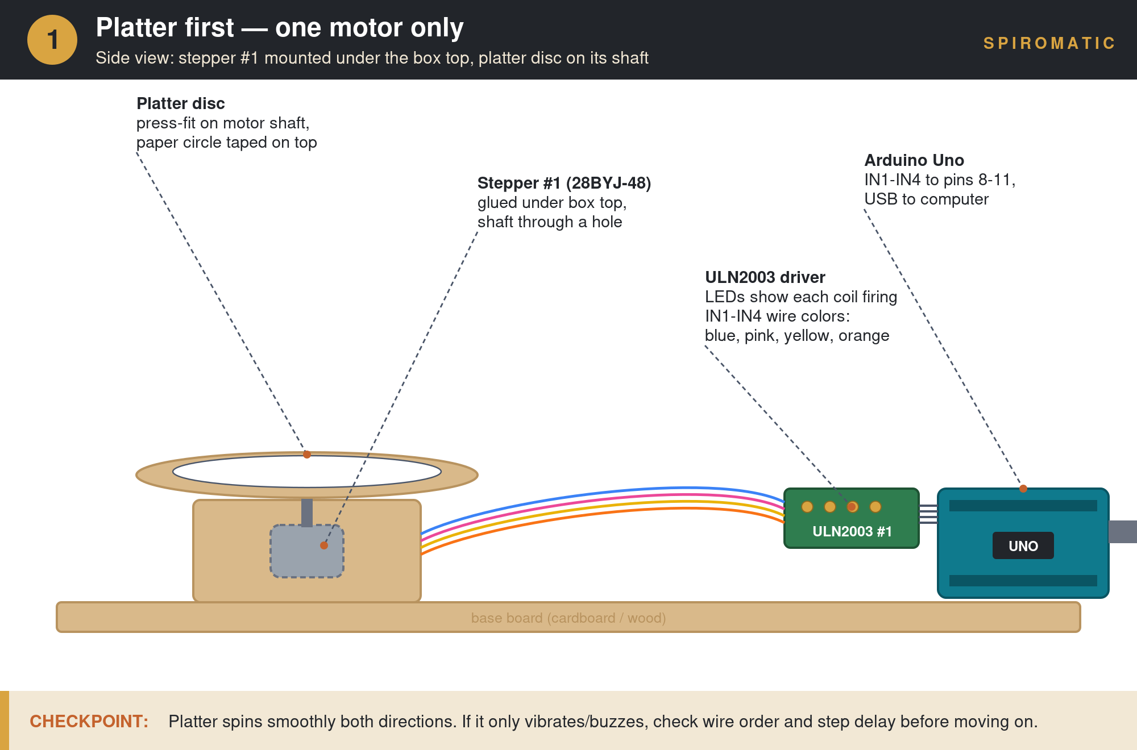
Stage 1 — Platter first: one stepper, one driver, spinning disc. (Pairs with Lesson 1.)
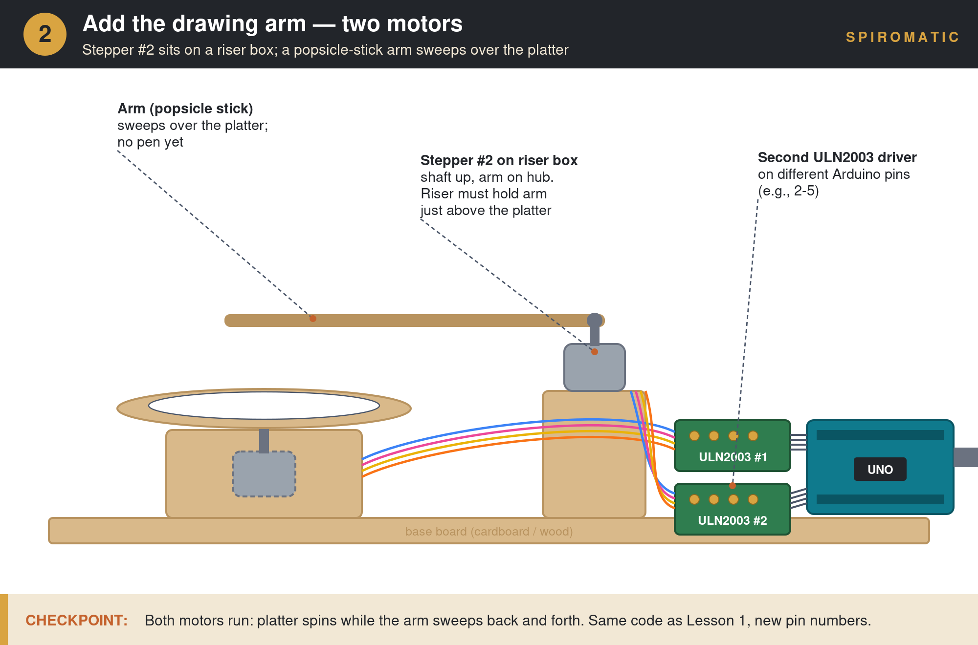
Stage 2 — Add the drawing arm: second stepper on a riser box. (Pairs with Lesson 2.)
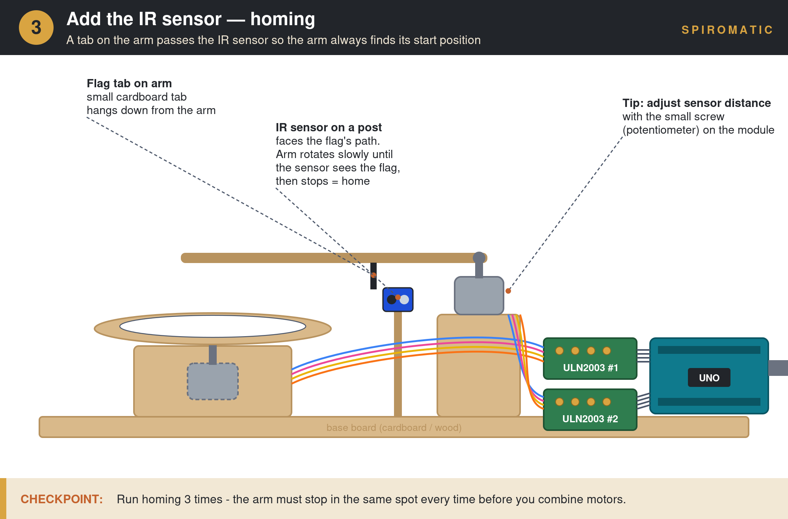
Stage 3 — Add the IR sensor: a flag on the arm passes the sensor for homing. (Pairs with Lesson 3.)
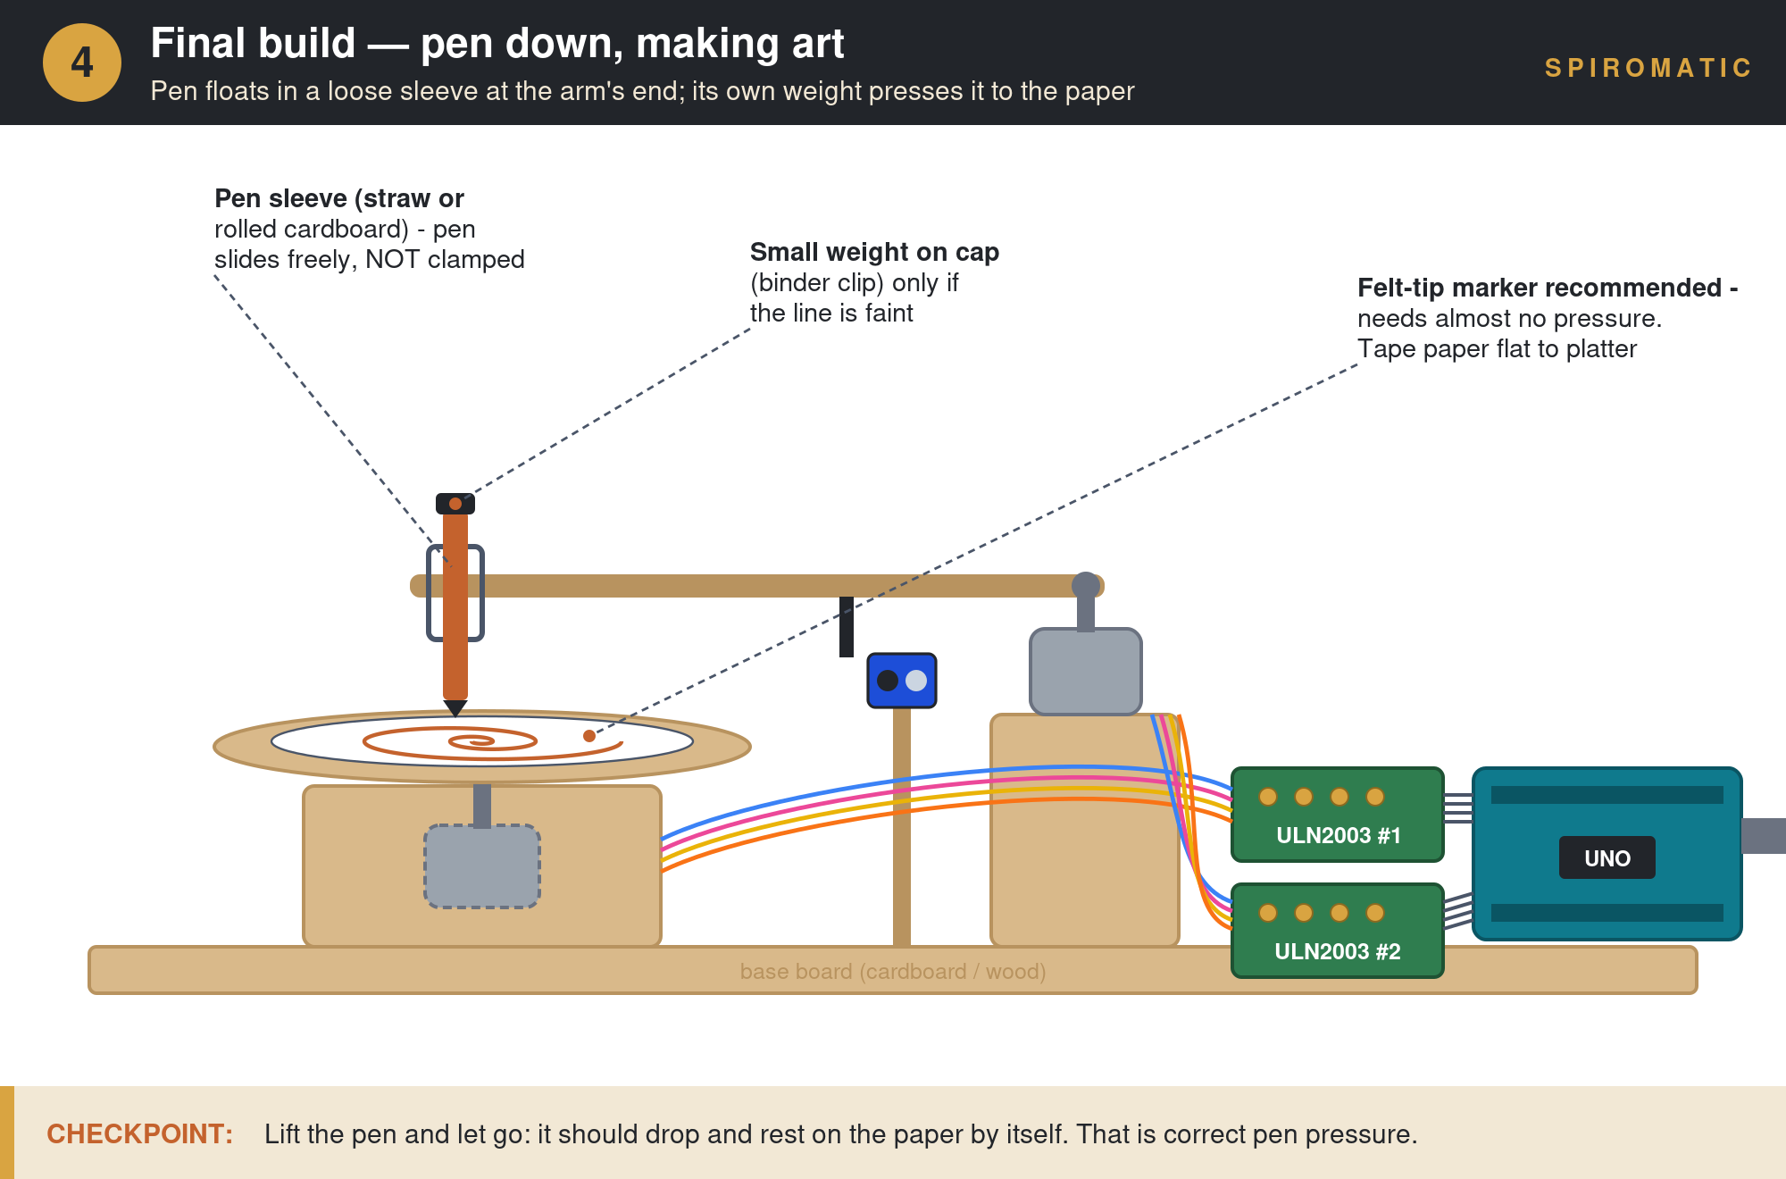
Stage 4 — Final build: pen floats in a loose sleeve, drawing on the platter. (Pairs with Pen Setup and Lesson 4.)

Introductory Lesson: Framing the Project
This lesson explores geometric shapes as inspiration for art, introduces students to generative art, and examines the philosophical underpinnings of machine-made art. It provides framing on how to drive the creative process and ensures deep engagement with the project. Once the Spiromatic is fully built, coded, and operational, it can be utilized as an art machine.

Discussion Prompts
- What makes art “art”? Can a machine create art, or is it only the tool?
- What is generative art? How does randomness play a role in creativity?
- How do geometric shapes and spirograph-style patterns appear in nature, architecture, and culture?

Getting Started: Building the Machine
Students will assemble their machine using the assortment of cardboard, popsicle sticks, and random materials from the Spiromatic unkit-kit.
Driving Prompt: Using at least two motors, create an automatic art machine.

Design Planning Questions
- What components do you need? What type of motors will you use?
- How many motors will you utilize in your bot?
- How do you plan on laying them out? Sketch a top-down view.
- How does it look from a side view (height)? Is the center of gravity stable?
- How will you grip the pen? How can you reduce pen mass if needed?
Teacher Tip: Encourage students to sketch their designs on paper before building. A quick side-view and top-view drawing helps catch structural problems early.

Lesson 1: Stepper Control for the Drawing Platter (No Library)
Skills: Stepper motors, for loops, functions, digital output

Lesson Overview
In this lesson, students will wire up their first stepper motor and learn to control it by directly writing the coil sequence in code — no library required. By the end, the drawing platter should spin smoothly in both directions. (See Build Progression Reference, Stage 1.)

Step-by-Step Instructions
Step 1: Review How Stepper Motors Work
Use the stepper motor background section (or accompanying PowerPoint) to walk through coil sequences and the relationship between pulse timing and motor speed.
Step 2: Wire the Drawing Platter Motor
Students connect the stepper motor to the Arduino via the ULN2003 driver board using the wiring diagram provided. Double-check that IN1–IN4 map to the correct Arduino pins.
Step 3: Upload and Run the Base Code
Students upload the provided platter test code. The motor should begin spinning. If it vibrates but does not rotate, check the wiring order — and use the paper-clip flag test from the Background section to confirm real rotation.
Step 4: Slow It Down to Observe
Have students increase the step delay (e.g., to 50–100 ms) so they can watch the LEDs on the driver board energize and rotate in sequence. This makes the coil pattern visible.
Step 5: Create Functions for Direction Control
Students write two functions — one for forward rotation and one for reverse. Hold a class discussion on naming conventions: should they use Increment/Decrement, Forward/Backward, Clockwise/Counterclockwise? Emphasize that professionals agree on variable names so code is shareable.
Step 6: Use a For Loop for Timed Rotation
Students write a for loop that spins the platter in one direction for a set number of steps, then reverses. Introduce the concept of an index variable to track how many rotations have been made.
Teacher Tip: Changing direction is about reversing the sequence of powering the coils. Challenge students to figure this out from the coil table before giving them the answer.
New — from classroom feedback: The delay length matters more than students expect. Below ~2 ms the motor stalls and buzzes; from experience, an over-long delay elsewhere in the sketch can also interrupt the stepper's rhythm and make it stutter. When a working motor suddenly misbehaves after a code change, check what changed about timing first.

Check for Understanding
- Can the student spin the platter forward and backward on command?
- Can they explain which coil fires in which order?
- Can they adjust the speed by changing the delay value?

Lesson 2: Stepper Control for the Drawing Arm (No Library)
Skills: Code replication, second motor wiring, function reuse

Lesson Overview
Students will add a second stepper motor — the drawing arm — replicating and adapting the code from Lesson 1. This reinforces their understanding while introducing the challenge of managing two independent motors. (See Build Progression Reference, Stage 2.)

Step-by-Step Instructions
Step 1: Wire the Second Stepper Motor
Connect the arm stepper motor to a new set of Arduino pins via its own driver board. Refer to the wiring diagram for pin assignments.
Step 2: Replicate the Code
Students copy and adapt the platter code to create a new set of functions for the arm motor (e.g., armForward and armReverse). Use the stepper_arm_test_code as a reference.
Step 3: Test Both Directions
Verify the arm moves smoothly in both directions using the newly created functions. Debug any wiring issues.
Step 4: Discuss Code Organization
How should the code be organized now that there are two motors? Discuss the importance of clear function names and comments as complexity grows.
Teacher Tip: If students are struggling, have them compare their platter code side-by-side with the arm code. The structure is identical — only pin numbers change.

Check for Understanding
- Can the student independently control the arm motor in both directions?
- Is their code organized with clearly named functions for each motor?

Lesson 3: Combining the Arm and Platter
Skills: Multitasking, IR homing, position tracking

Lesson Overview
Students combine both motors into a single program, learn to home the arm to a known position using the IR sensor, and use simple multitasking techniques to move both motors simultaneously. (See Build Progression Reference, Stage 3.)

Step-by-Step Instructions
Step 1: Test the IR Sensor
Wire the IR object detection sensor and verify it reads correctly. Students should be able to detect when the arm passes a reference point.
Step 2: Home the Stepper Arm
Write a homing routine: the arm slowly rotates until the IR sensor detects the reference point, then stops. This establishes a known starting position so the arm's location is always trackable.
Step 3: Combine Both Motors in One Program
Merge the platter and arm code into a single sketch. Use the stepper_arm_simple_multitasking_code as a starting point. The key challenge: both motors need to move at the same time.
Step 4: Understand Simple Multitasking
Since Arduino runs one line at a time, true parallel motion requires interleaving steps: one step for the platter, one step for the arm, repeat. Discuss why blocking delays prevent simultaneous movement and how alternating steps solves this.
Step 5: Test and Tune
Run the combined code. Adjust step counts and delays to create smooth, coordinated movement. The platter should spin while the arm sweeps back and forth.
Teacher Tip: Homing is a real-world engineering concept used in CNC machines, 3D printers, and robotics. Point this out to students — they are using professional techniques.
New — from classroom feedback: This is where delay problems bite hardest: a long delay() anywhere in the combined sketch freezes BOTH motors, and an interrupted coil rhythm makes the stepper stall. If the combined program misbehaves but each motor works alone, hunt for a blocking delay before touching the wiring.

Check for Understanding
- Can both motors move at the same time?
- Does the arm home to a consistent starting position?
- Can the student explain why simple multitasking is needed on Arduino?

Pen Setup — Before Art Day (new)
Faint or skipping lines are the single most common frustration at the end of this project — and they are almost always a setup issue, not a student error. Do this section as a class before Lesson 4. The core principle: gravity does the work. The pen must float in a loose sleeve so its own weight presses it to the paper.
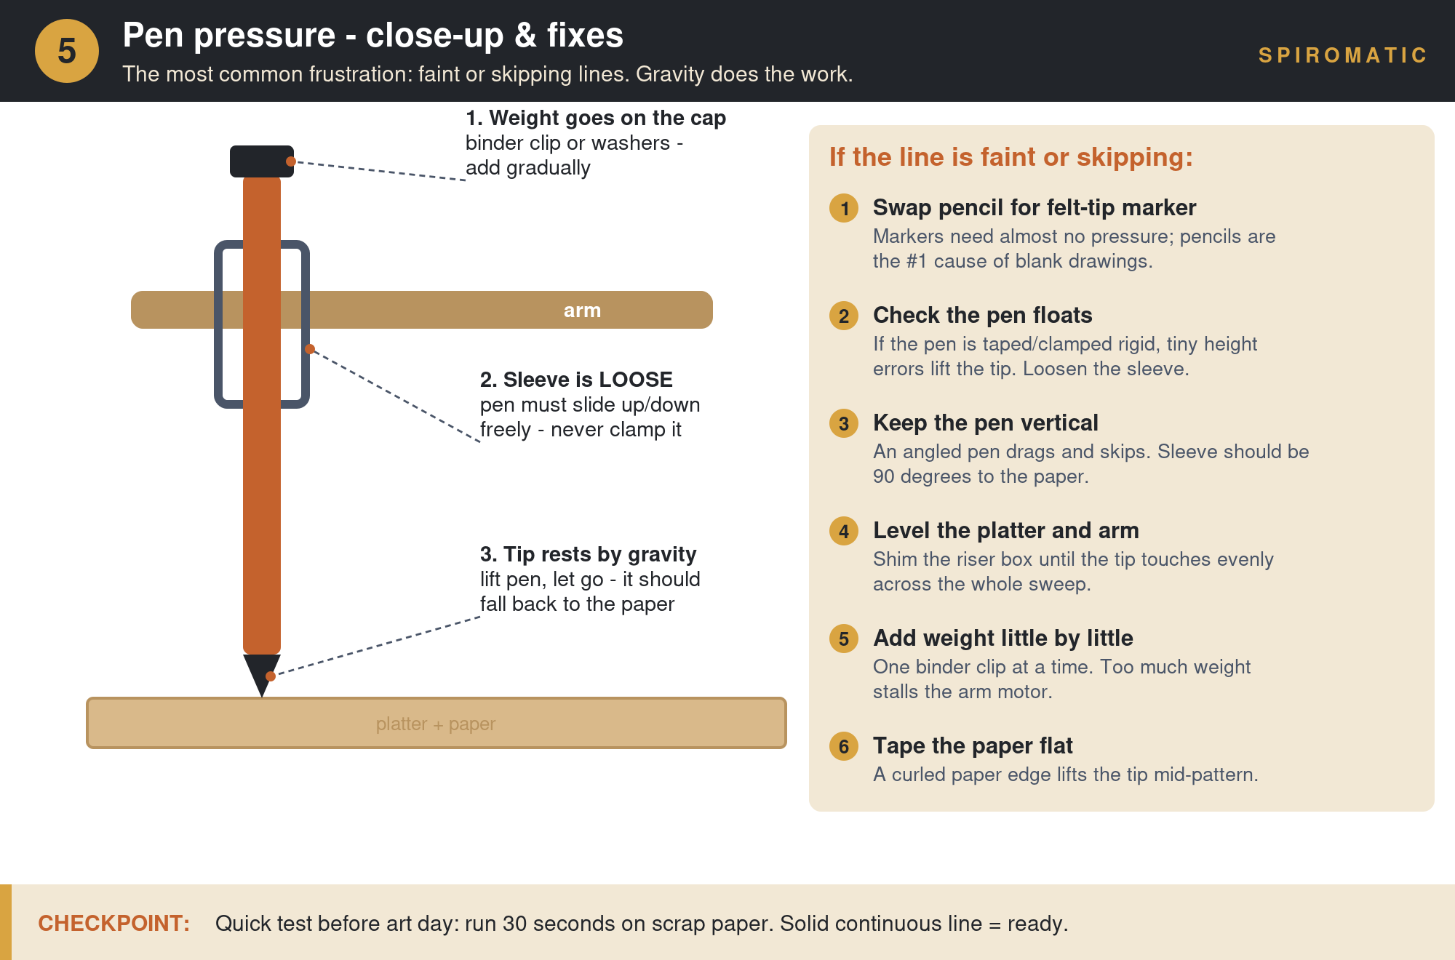
The floating-pen setup and the six fixes, in order of likelihood.

If the line is faint or skipping
- 1. Swap pencil for felt-tip marker. Markers need almost no pressure; pencils are the #1 cause of blank drawings.
- 2. Check the pen floats. If the pen is taped or clamped rigid, tiny height errors lift the tip. Loosen the sleeve so the pen slides up and down freely.
- 3. Keep the pen vertical. An angled pen drags and skips. The sleeve should be 90° to the paper.
- 4. Level the platter and arm. Shim the riser box until the tip touches evenly across the whole sweep.
- 5. Add weight little by little. One binder clip on the pen cap at a time. Too much weight stalls the arm motor.
- 6. Tape the paper flat. A curled paper edge lifts the tip mid-pattern.
CHECKPOINT: Quick test before art day: run 30 seconds on scrap paper. A solid continuous line = ready. Lift the pen and let go — it should fall back to the paper on its own.

Lesson 4: Creating Art
Skills: Code manipulation, creative experimentation, artistic expression

Lesson Overview
With a fully operational Spiromatic, students now shift from engineering to artistry. They will manipulate code parameters to produce unique patterns and create a piece of art that represents the mood and meaning of a Jewish month. (Complete Pen Setup first.)

Step-by-Step Instructions
Step 1: Experiment with Parameters
Have students change step counts, delays, direction-change intervals, and arm sweep ranges. Encourage them to document what each change does to the pattern produced.
Step 2: Choose a Jewish Month
Each student or group selects a Jewish month to represent. They should research the historical background, themes, and emotional tone of that month.
Step 3: Plan the Artistic Piece
Students make deliberate choices about color paper, pen colors, pen thickness, pattern density, and motion style to convey the meaning of their chosen month.
Step 4: Create the Art
Run the Spiromatic with the chosen settings to produce the artwork. Students may need several attempts to refine their output.
Step 5: Write an Artist Statement
On a separate circular piece of paper, students write: the month they chose, the historical background they referenced, and how their choices of shape, color, and texture convey that month's meaning.
Teacher Tip: This is where the open-ended, upcycled nature of the project shines. No two machines are alike, so no two artworks will be alike either. Celebrate the variation.
Bridge to Lesson 5: Want deliberate shapes instead of happy accidents? Lesson 5 gives students recipes for flowers, hearts, squares, and mandalas — density and drift read as mood, which pairs beautifully with the Jewish month theme.

Lesson 5: Drawing with Math — Shape Recipes (new)
Skills: Trigonometry intuition (cosine), polar thinking, parameter-driven design, prediction and testing

Lesson Overview
Students discover that every shape the machine draws is a rule — “when the paper is at THIS angle, put the pen at THAT distance” — and that one math function, cos(angle), generates flowers, hearts, squares, triangles, stars, ellipses, and mandalas. The math is deliberately gentle: cos is introduced as “a number between −1 and +1 that breathes,” not as triangle ratios. No trig prerequisite.

The Simplified Build (stepper + servo)
This lesson uses a simpler machine than Lessons 1–4: the platter stays on its stepper, but the arm becomes the kit's servo — one wire (signal to pin 6, plus 5V and GND), no second driver board, no interleaved multitasking. This also finally gives the kit's servo a starring role and makes the stepper-vs-servo comparison hands-on. Classes that already have the two-stepper build can keep it; the recipes adapt.

Companion Files
File | What it is
spiromatic_math_deck.pptx | 24-slide deck: the math (animated), stepper vs. servo, the code line by line, challenges. GIF animations play in slideshow mode (F5).
spiromatic_shapes.ino | One sketch, six shape recipes. Students change SHAPE = 1–6, then tune the orange-commented numbers.
spiromatic_stepper_servo.ino | The simpler spiral sketch — a good first upload for this build.
spiromatic_simulator.html | On-screen machine in any browser (offline). Shape picker plus dials for petal count, push size, and speed — same numbers as the sketch.
spiromatic_teacher_answer_key.docx | Worked answers for all six challenges, grading guidance for the open-ended one, and in-class troubleshooting.

Suggested Flow (2–3 sessions)
Step 1: The Math, Gently (deck slides 1–12)
Two numbers (SPIN and REACH), circles are free, cos breathes, corners are pushes, petals are a dial, and the 6.1-petal mandala that drifts. Pause on the animations and let students predict before revealing.
Step 2: Simulator Exploration (15–20 min)
Pairs open spiromatic_simulator.html and hunt for their favorite settings. The rule readout shows the live formula, so the math stays visible while they play.
Step 3: The Motors and the Code (deck slides 13–21)
Stepper vs. servo face-off, then the three-line heart of the program: where is the paper? how far out should the pen be? tell the servo.
Step 4: Upload and Draw
Students transfer their favorite simulator numbers into spiromatic_shapes.ino and draw for real. Expect calibration — that IS the lesson. Slow the platter (stepDelay 15–20) for polygons and stars.
Step 5: Challenges (deck slide 23)
Six leveled challenges from warm-up to boss. Answers, common mistakes, and the mandala math are in the answer key.
Teacher Tip: The 20-turn mandala takes about 8 minutes of real machine time. That's a feature — it's the “watch the machine work” moment — but schedule it, and have the class predict the final pattern while it runs.
Discussion gold: Ask: what CAN'T this machine draw? (Anything where a line from the center crosses the outline twice — no crescents, no letters.) Students figuring out why is a better lesson than any single shape.

Extension Projects
Once students have completed the core lessons, these extensions offer additional challenges and deeper exploration.

Interactive Art
Add user controls — a potentiometer, ultrasonic sensor, or buttons — to let the operator adjust speed and direction of each pen wand in real time. This transforms the Spiromatic from an automated machine into an interactive art tool where the human and machine collaborate.

Generative Art
Use random number generators in the code to produce computer-generated variations in arm sweep, platter speed, direction changes, and timing. Each run produces a unique, unrepeatable design. This connects to broader concepts in generative and algorithmic art. (Lesson 5's “invent recipe 7” challenge is a natural on-ramp.)

The Rotary Datalogger
Connect environmental sensors (temperature, humidity, light) to drive the wand parameters. Instead of random inputs, real-world data shapes the art. The resulting patterns become a visual record of environmental conditions — data visualization through physical drawing.
Teacher Tip: Each extension builds on the core skills while introducing new concepts. Interactive Art adds analog input; Generative Art introduces randomness and algorithmic thinking; the Datalogger connects to data science and environmental awareness.

Appendix A: Troubleshooting Quick Reference
Keep this page open during class. Symptoms are ordered by how often they actually happen.
Symptom | Most likely cause | Fix
Motor buzzes/vibrates, doesn't spin | Step delay too short (< 2 ms) or IN1–IN4 wired out of order | Raise stepDelay to 3–5; use the paper-clip flag test; re-check wire order against the diagram
Motor was fine, now stutters after a code change | A new delay is interrupting the coil rhythm | Find what changed about timing; keep per-step delays 2–15 ms
Both motors freeze in combined code | A blocking delay() somewhere in the sketch | Replace long delays with interleaved steps (Lesson 3) or millis() timing (Lesson 5)
Faint or skipping lines | Pencil instead of marker, or pen clamped rigid | Pen Setup section: felt-tip marker, floating sleeve, weight added one clip at a time
Line fades on one side of the paper | Platter and arm not level | Shim the riser box until the tip touches evenly across the sweep
Corners of squares/triangles look rounded | Platter too fast for the arm | Raise stepDelay to 15–20 for polygons and stars
Arm homes to a different spot each run | IR sensor distance or flag alignment | Adjust the module's potentiometer screw; enlarge the flag; run homing 3 times to verify
Pattern drifts off-center between runs | Arm was moved by hand while powered off | Re-run the sketch (servo re-homes in setup) or re-home the stepper arm

Appendix B: File Manifest
Everything referenced in this guide, in one list:
- spiromatic_math_deck.pptx — Lesson 5 slide deck (keep GIF files in the same folder until first opened)
- spiromatic_shapes.ino — six shape recipes, one sketch
- spiromatic_stepper_servo.ino — simplified stepper + servo spiral sketch
- spiromatic_square.ino — the square, fully commented for 8th graders
- spiromatic_simulator.html — offline browser simulator with adjustable dials
- spiromatic_teacher_answer_key.docx — challenge answers and grading guidance
- spiromatic_stage1–4 .png + spiromatic_pen_pressure.png — the build progression and pen setup images used in this guide

