
CIJE • STEPPER + SERVO EDITION
The Spiromatic Unkit-Kit
Teachers Guide
A Step-by-Step Guide to Building an Automated Art Machine
Student work gallery: images and videos are from student work at TABC (see the shared Google Photos album).

What's new in this edition
- Rebuilt around the stepper + servo architecture. The platter keeps its library-free stepper; the drawing arm is now the kit's servo. One driver board, three servo wires, no interleaved multitasking, no homing sensor. The old two-stepper + IR build is preserved as an advanced extension.
- The cosine shape engine. The curriculum now aims at one destination: every shape is a rule, distance = f(angle), and cos(angle) generates almost all of them. Lesson 5 teaches it with a deck, a browser simulator, and leveled challenges.
- Build Progression Reference — stage-by-stage pictures of the machine as it grows, for your own reference while guiding builds.
- Pen Setup — Before Art Day — a dedicated section on pen pressure, plus classroom-tested troubleshooting notes (step-delay pitfalls, the "spinning or vibrating?" test).
- Appendix A — a one-page troubleshooting quick reference to keep open during class.

Objectives
By the end of this unit, students will be able to:
- Build a working art machine from random upcycled materials through open-ended design
- Understand the principles of generative art and explore the philosophical underpinnings of machine-made art
- Differentiate between stepper motors and servo motors, understanding when to use each — and use BOTH in one machine
- Drive a stepper motor without the use of a library by directly controlling coil sequences
- Command a servo by angle, and time its motion with millis() instead of blocking delays
- Track position by counting steps (stepCount) — the software version of homing
- Connect a single math idea — cos(angle) — to the shapes the machine draws, and invent shape rules of their own

Materials Included in the Unkit-Kit
- Arduino board and USB cable
- Stepper motor (28BYJ-48) with ULN2003 driver board — the platter
- SG90 micro servo — the drawing arm
- Second stepper + driver and IR sensor module (used only in the Legacy Two-Stepper extension)
- Jumper wires and breadboard
- Assorted cardboard, popsicle sticks, and random craft materials
- Pens/markers of various thicknesses (felt-tip markers strongly recommended — see Pen Setup)
- Circular paper for drawing surface

Background: The Two Motors
Before students begin building, it is important they understand the two technologies driving the Spiromatic: a stepper motor for the platter and a servo for the arm. This section is a concise primer you can use as a mini-lecture or handout. A video tutorial ("Stepper Motor Tutorial", YouTube) offers a visual introduction.

What Is a Stepper Motor?
A stepper motor is a type of electric motor that divides a full rotation into a series of equal, discrete steps. Unlike a standard DC motor that spins freely when powered, a stepper motor moves in precise increments, making it ideal for applications that require exact positioning.

How the Stepper Works
Inside a stepper motor are multiple sets of wire coils (usually four) arranged around a toothed gear-shaped rotor. By energizing the coils in a specific sequence, the rotor advances one step at a time. The 28BYJ-48 stepper motor in the kit takes 2,048 steps per full revolution, giving it fine-grained control.
The key idea: by controlling the order and timing in which the coils receive power, we control both the direction and speed of the motor. This is why we can drive a stepper without a library — we simply send HIGH and LOW signals to the four control pins in the right sequence.

What Is a Servo?
A servo is the stepper's easygoing cousin. You do not manage its coils and you do not pulse it constantly — you simply tell it an angle, arm.write(135), and it goes there and holds position on its own. It connects with three wires (signal, 5V, ground) and uses the built-in Servo library. Its limit: it can only point within a half circle, 0–180°. It can never spin all the way around — which is exactly why the platter is a stepper and the arm is a servo.

Stepper vs. Servo: Key Differences
Feature | Stepper Motor | Servo Motor
Movement | Continuous rotation in precise steps | Rotates to a specific angle (0–180°) and holds it
Control | Sequence of coil pulses (4 pins) | One command on a single signal pin
Precision | High (2,048 steps per revolution) | Moderate (degree-level accuracy)
Attention needed | Constant — no pulses, no motion | None between commands — it holds position itself
Use in Spiromatic | Drawing platter (endless, precise spin) | Drawing arm (simple, steady sweep)
Library needed? | No – we drive it manually in this project | Yes – the built-in Servo library

The 4-Step Coil Sequence
To rotate the stepper motor one step at a time, we energize the four coils (IN1–IN4) in a repeating pattern. Below is the basic full-step sequence:
Step | IN1 | IN2 | IN3 | IN4
1 | HIGH | LOW | LOW | LOW
2 | LOW | HIGH | LOW | LOW
3 | LOW | LOW | HIGH | LOW
4 | LOW | LOW | LOW | HIGH

Running this sequence forward (1→2→3→4) rotates the motor in one direction. Reversing the sequence (4→3→2→1) rotates it the other way. The delay between each step controls the speed.
Teacher Tip: Have students slow the step delay way down (e.g., 50–100 ms) and watch the LEDs on the driver board light up one at a time. This makes the sequence visible and helps them understand what the code is doing.
Watch out: Step-delay safe range: keep the delay between steps roughly 2–15 ms while drawing. Below ~2 ms the 28BYJ-48 can't keep up — it buzzes and vibrates instead of turning. And any long blocking delay() elsewhere in the sketch interrupts the coil rhythm (see Lesson 3).
Quick test: Spinning or just vibrating? Tape a paper clip or small cardboard flag to the motor shaft. If the flag turns, the motor is really rotating; if it just trembles, check the wire order and the step delay. This 10-second test saves long debugging sessions.

Wiring Diagram
Every connection in the project, on one page. Lessons 1 and 2 reference this diagram; keep it projected during wiring sessions. The breadboard power rail matters: the driver board and the servo share the Arduino's 5V and GND through the rail, so everything has a common ground.
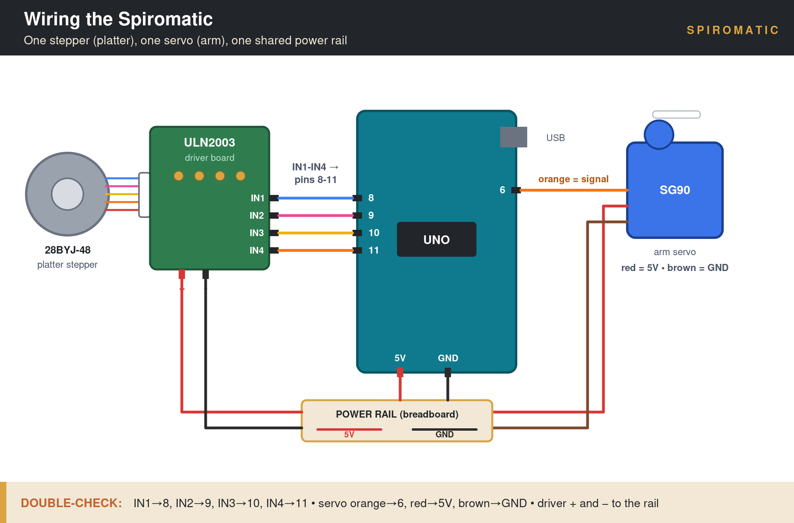
The complete wiring: stepper → driver → pins 8–11; servo signal → pin 6; power shared on the rail.

Part by part
Three connections, three close-ups. Wire them in this order, and pass each CHECK before moving to the next.
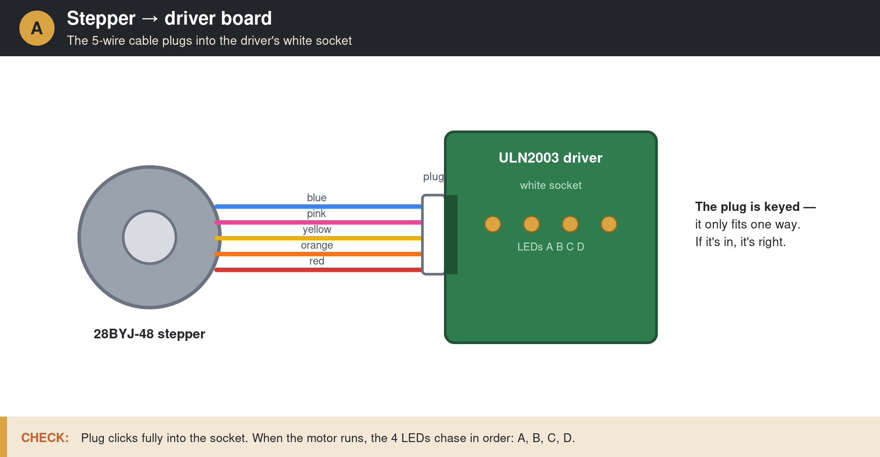
Part A — Stepper to driver: the keyed 5-wire plug. (Lesson 1, Step 2.)
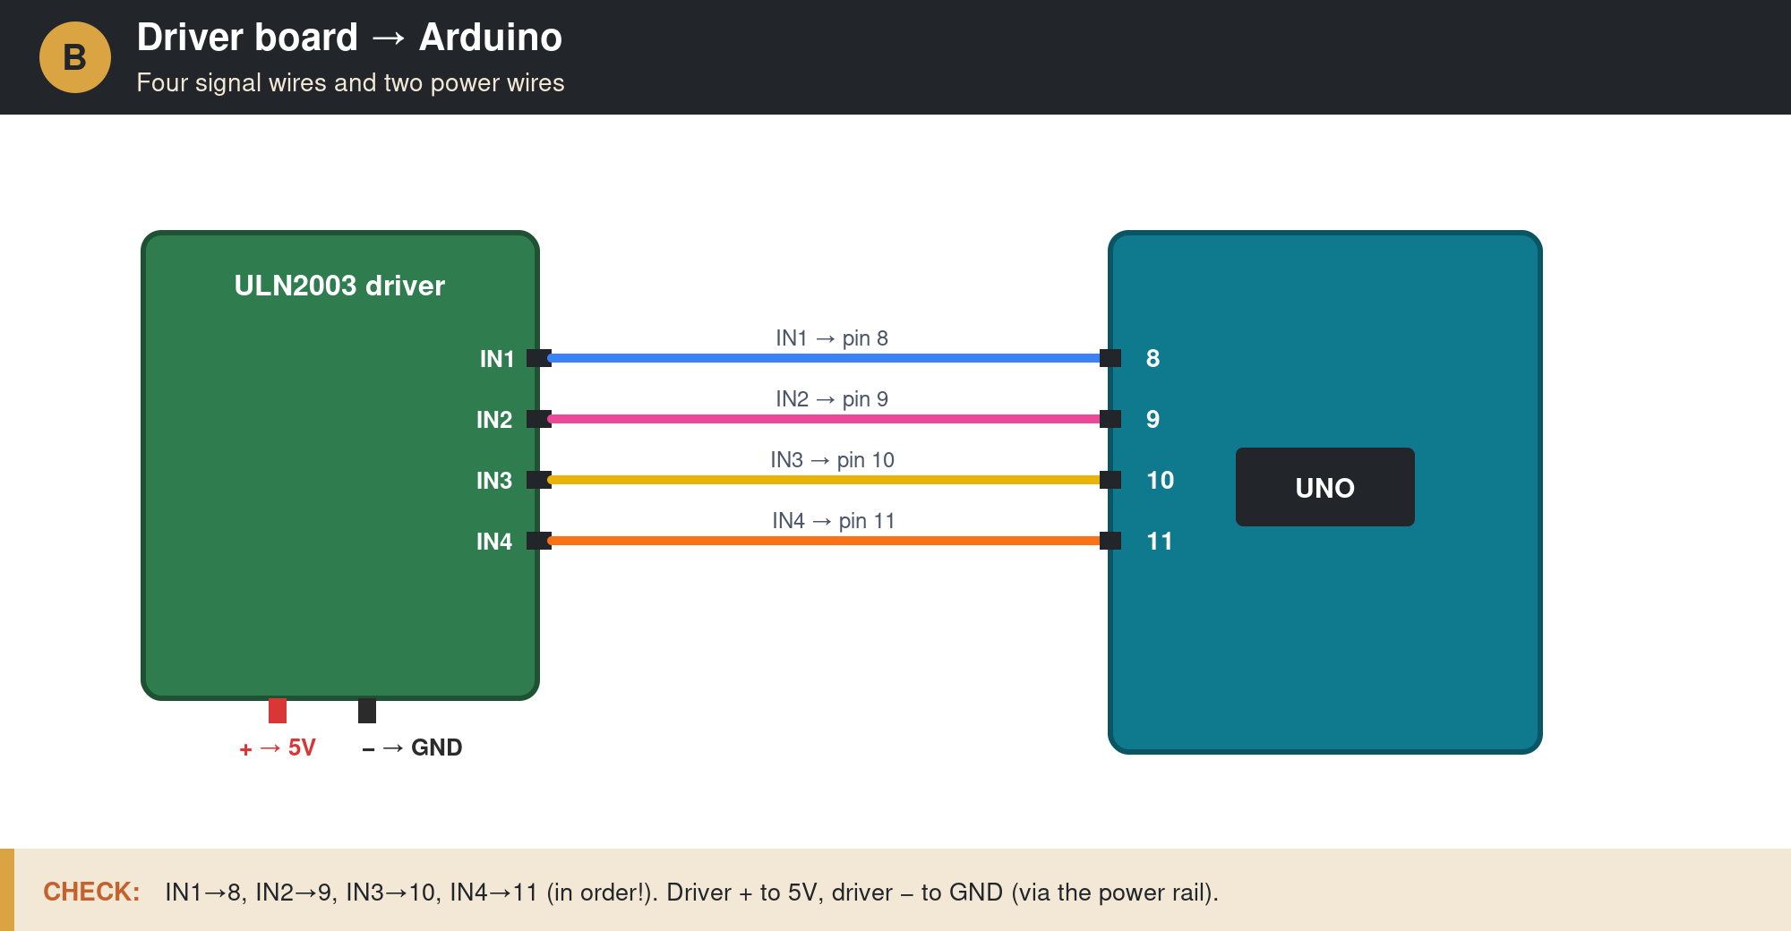
Part B — Driver to Arduino: IN1–IN4 to pins 8–11, plus power to the rail. (Lesson 1, Step 2.)
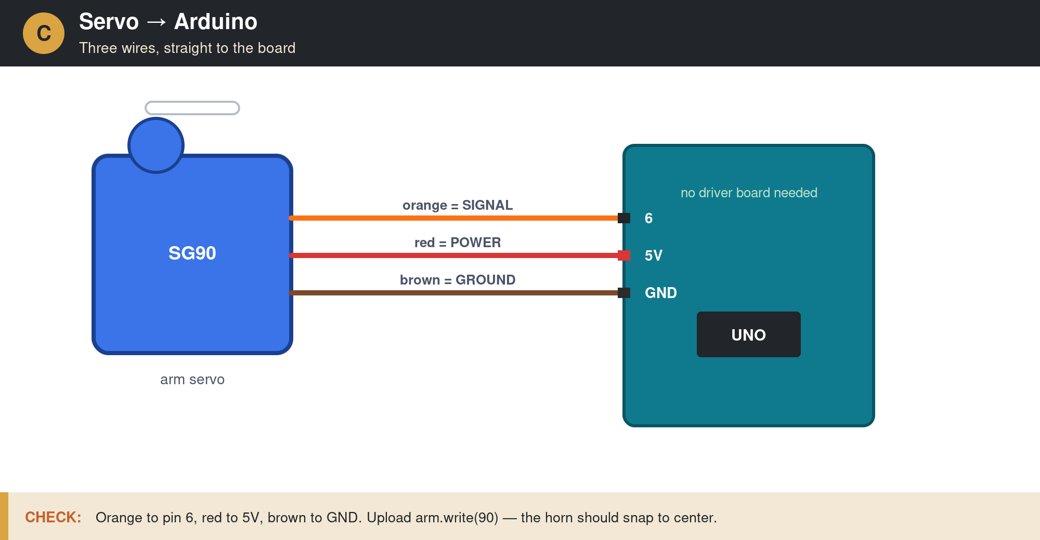
Part C — Servo to Arduino: three wires, no driver board. (Lesson 2, Step 1.)
Teacher Tip: Wire color discipline saves class time: insist that every group uses the same color for the same job (e.g., orange is always the servo signal). Debugging someone else's rainbow is a lesson nobody needs twice.

Build Progression Reference (for the teacher)
These staged pictures show how a typical Spiromatic grows, so you can see at a glance what "done" looks like at each phase. They are a teacher reference, not a student blueprint — every upcycled build will look different, and that's the point. The checkpoint under each stage is the gate: don't let a group move on until it passes.
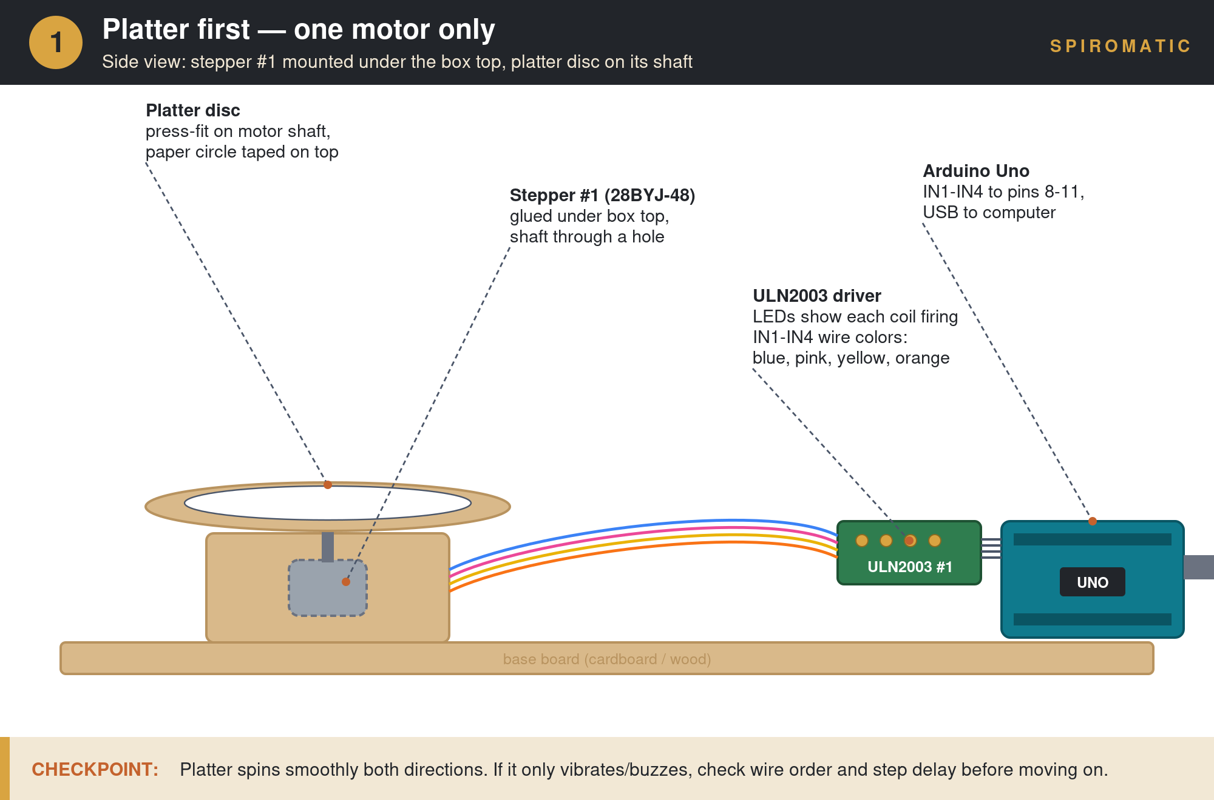
Stage 1 — Platter first: one stepper, one driver, spinning disc. (Pairs with Lesson 1.)
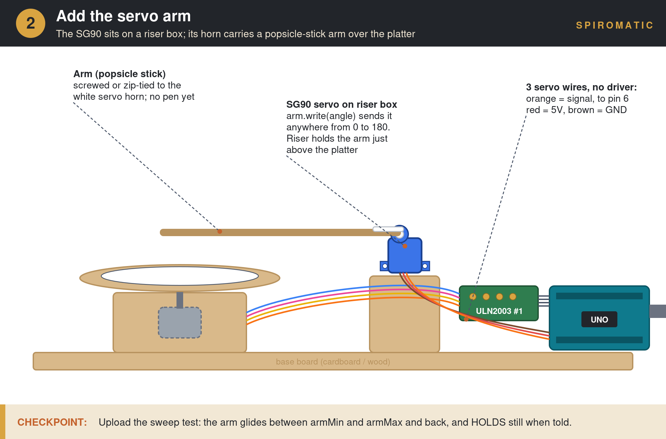
Stage 2 — Add the servo arm: SG90 on a riser box, arm on the horn, three wires straight to the Arduino. (Pairs with Lesson 2.)
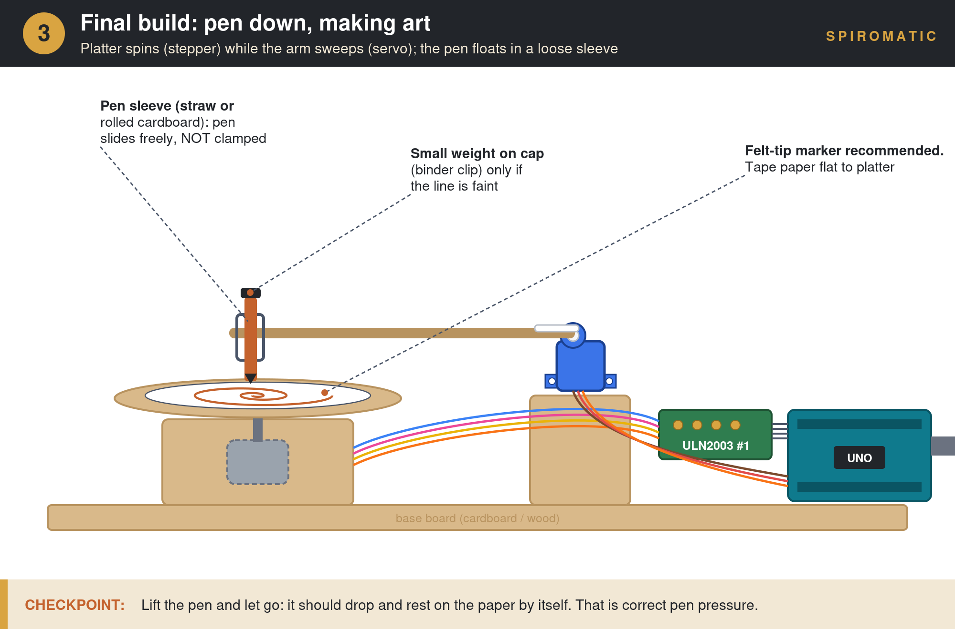
Stage 3 — Final build: both motors running, pen floating in a loose sleeve. (Pairs with Lesson 3, Pen Setup, and Lesson 4.)

Introductory Lesson: Framing the Project
This lesson explores geometric shapes as inspiration for art, introduces students to generative art, and examines the philosophical underpinnings of machine-made art. It provides framing on how to drive the creative process and ensures deep engagement with the project. Once the Spiromatic is fully built, coded, and operational, it can be utilized as an art machine.

Discussion Prompts
- What makes art “art”? Can a machine create art, or is it only the tool?
- What is generative art? How does randomness play a role in creativity?
- How do geometric shapes and spirograph-style patterns appear in nature, architecture, and culture?

Getting Started: Building the Machine
Students will assemble their machine using the assortment of cardboard, popsicle sticks, and random materials from the Spiromatic unkit-kit.
Driving Prompt: Using at least two motors, create an automatic art machine.

Design Planning Questions
- What components do you need? Which motor should spin forever, and which should swing back and forth?
- How do you plan on laying them out? Sketch a top-down view.
- How does it look from a side view (height)? Is the center of gravity stable?
- How will you grip the pen? How can you reduce pen mass if needed?
Teacher Tip: Encourage students to sketch their designs on paper before building. A quick side-view and top-view drawing helps catch structural problems early.

Lesson 1: Stepper Control for the Drawing Platter (No Library)
Skills: Stepper motors, for loops, functions, digital output

Lesson Overview
In this lesson, students will wire up the platter stepper and learn to control it by directly writing the coil sequence in code — no library required. By the end, the drawing platter should spin smoothly in both directions. (See Build Progression Reference, Stage 1.)

Step-by-Step Instructions
Step 1: Review How Stepper Motors Work
Use the stepper motor background section (or accompanying PowerPoint) to walk through coil sequences and the relationship between pulse timing and motor speed.
Step 2: Wire the Drawing Platter Motor
Students connect the stepper motor to the Arduino via the ULN2003 driver board using the wiring diagram provided (IN1–IN4 to pins 8–11).
Step 3: Upload and Run the Base Code
Students upload the provided platter test code. The motor should begin spinning. If it vibrates but does not rotate, check the wiring order — and use the paper-clip flag test from the Background section to confirm real rotation.
Step 4: Slow It Down to Observe
Have students increase the step delay (e.g., to 50–100 ms) so they can watch the LEDs on the driver board energize and rotate in sequence. This makes the coil pattern visible.
Step 5: Create Functions for Direction Control
Students write two functions — one for forward rotation and one for reverse. Hold a class discussion on naming conventions: should they use Increment/Decrement, Forward/Backward, Clockwise/Counterclockwise? Emphasize that professionals agree on variable names so code is shareable.
Step 6: Count Every Step
Introduce stepCount — a variable that goes up by one on every single step, forever. It seems pointless now; it becomes the hero of Lesson 3, because if you know where you started and count every step, you always know the paper's exact angle. This is how CNC machines, 3D printers, and hospital scanners know where they are.
Teacher Tip: Changing direction is about reversing the sequence of powering the coils. Challenge students to figure this out from the coil table before giving them the answer.
From classroom feedback: The delay length matters more than students expect. Below ~2 ms the motor stalls and buzzes; an over-long delay elsewhere in the sketch can also interrupt the stepper's rhythm and make it stutter. When a working motor suddenly misbehaves after a code change, check what changed about timing first.

Check for Understanding
- Can the student spin the platter forward and backward on command?
- Can they explain which coil fires in which order?
- Can they adjust the speed by changing the delay value?

Lesson 2: The Servo Arm
Skills: Servo control, angles, using a library, functions with parameters

Lesson Overview
Students add the second motor — the SG90 servo that will carry the drawing arm — and discover how differently it behaves from the stepper they just tamed. Where Lesson 1 was about constant attention (feed the coils or nothing moves), this lesson is about delegation: tell the servo an angle and it handles the rest. (See Build Progression Reference, Stage 2.)

Step-by-Step Instructions
Step 1: Wire the Servo
Three wires, no driver board: orange (signal) to pin 6, red to 5V, brown to GND. Have students compare this to the stepper's wiring — four control pins plus a whole driver board. Ask why the servo needs so much less (the "driver" is built into the servo's case).
Step 2: Say Hello with One Line
Include the Servo library, attach the servo, and send it somewhere:
#include <Servo.h>
Servo arm;
arm.attach(6);
arm.write(90); // go to 90 degrees... and that's it
Let students change the number and re-upload a few times. The point lands by itself: with the stepper WE did everything; the servo does it for us.
Step 3: Sweep with a For Loop
Students reuse the for-loop skill from Lesson 1 to sweep the arm smoothly: a loop from armMin to armMax, arm.write(angle) with a short delay each degree, then a loop back down. Introduce armMin and armMax as named variables — the same tuning knobs used in every sketch for the rest of the unit.
Step 4: Mount the Arm
Attach a popsicle-stick arm to the servo horn (the small screw or a zip tie both work) and mount the servo on a riser box so the arm sweeps just above the platter. No pen yet.
Step 5: Compare the Two Motors Out Loud
Close with the stepper-vs-servo table from the Background section — except now every row is something they have physically felt. Ask: why is the platter a stepper and the arm a servo, and not the other way around? (The platter must spin forever; the arm only needs a half circle.)
Teacher Tip: Never force the horn around by hand while the servo is powered — command it with arm.write instead. Hand-forcing a powered servo strips its gears, and it will fight back confusingly.
Good to know: A cheap servo may hum or tremble slightly while holding position. That's normal — it is constantly correcting itself. If it bothers the build, nudge the target angle by one degree.

Check for Understanding
- Can the student send the arm to any angle on command?
- Can they sweep it smoothly using a for loop and their own armMin/armMax variables?
- Can they explain, in their own words, the difference between commanding a stepper and commanding a servo?

Lesson 3: Both Motors at Once
Skills: Non-blocking timing with millis(), program structure, position tracking

Lesson Overview
Students combine the platter and the arm into one program and hit the unit's most important coding wall: the stepper needs constant attention, so the arm must never make the program stop and wait. The fix — checking the clock with millis() instead of freezing with delay() — is the same technique behind every responsive device they own. The reference sketch is spiromatic_stepper_servo.ino, which draws a smooth spiral when everything works. (See Build Progression Reference, Stage 3.)

Step-by-Step Instructions
Step 1: Predict the Problem
Before writing anything, ask: the platter needs a coil pulse every few milliseconds, and the arm wants to pause between moves. What happens if the arm's pause uses delay(500)? Let them argue, then run it: the platter freezes half a second at a time and the motion falls apart. Blocking delays stop EVERYTHING.
Step 2: Meet millis()
millis() is the Arduino's clock: the number of milliseconds since power-on. Instead of freezing, the arm peeks at the clock each time through loop(): "has enough time passed since my last move? If yes, move one degree and remember when." The platter never stops.
if (millis() - lastArmMove >= armSpeed) {
lastArmMove = millis();
armPos = armPos + armDir; // one degree
if (armPos >= armMax || armPos <= armMin) armDir = -armDir;
arm.write(armPos);
}
Step 3: Assemble the Full Loop
The whole program is three jobs, repeated forever: platterStep() (one coil pulse), updateArm() (the millis check above), delay(stepDelay) (which sets platter speed). Students who built Lessons 1 and 2 already own two of the three.
Step 4: Position Without a Sensor
Ask: how does the machine know where the paper is pointing? No sensor — it counts. stepCount from Lesson 1 divided into 2,048 gives the platter's exact angle, always. And the arm? A servo always knows its own angle — that's its whole job. This is homing without hardware, and it's what makes the math of Lesson 5 possible.
Step 5: Run the Spiral
Upload spiromatic_stepper_servo.ino and let it draw (arm sweeping slowly, platter spinning). Tune stepDelay, armMin/armMax, and armSpeed and watch the spiral's character change. This is the machine's first artwork — hang it up.
From classroom feedback: This is where delay problems bite hardest: one long delay() anywhere freezes BOTH motors. If the combined program misbehaves but each motor works alone, hunt for a blocking delay before touching the wiring.
Teacher Tip: millis() vs delay() is a professional-grade concept — it's how phones stay responsive while doing ten things. Students who get this have learned real embedded programming, not toy programming.

Check for Understanding
- Can both motors move at the same time, smoothly?
- Can the student explain why the arm uses millis() instead of delay()?
- Can they explain how the code knows the platter's angle without any sensor?

Pen Setup — Before Art Day
Faint or skipping lines are the single most common frustration at the end of this project — and they are almost always a setup issue, not a student error. Do this section as a class before Lesson 4. The core principle: gravity does the work. The pen must float in a loose sleeve so its own weight presses it to the paper.
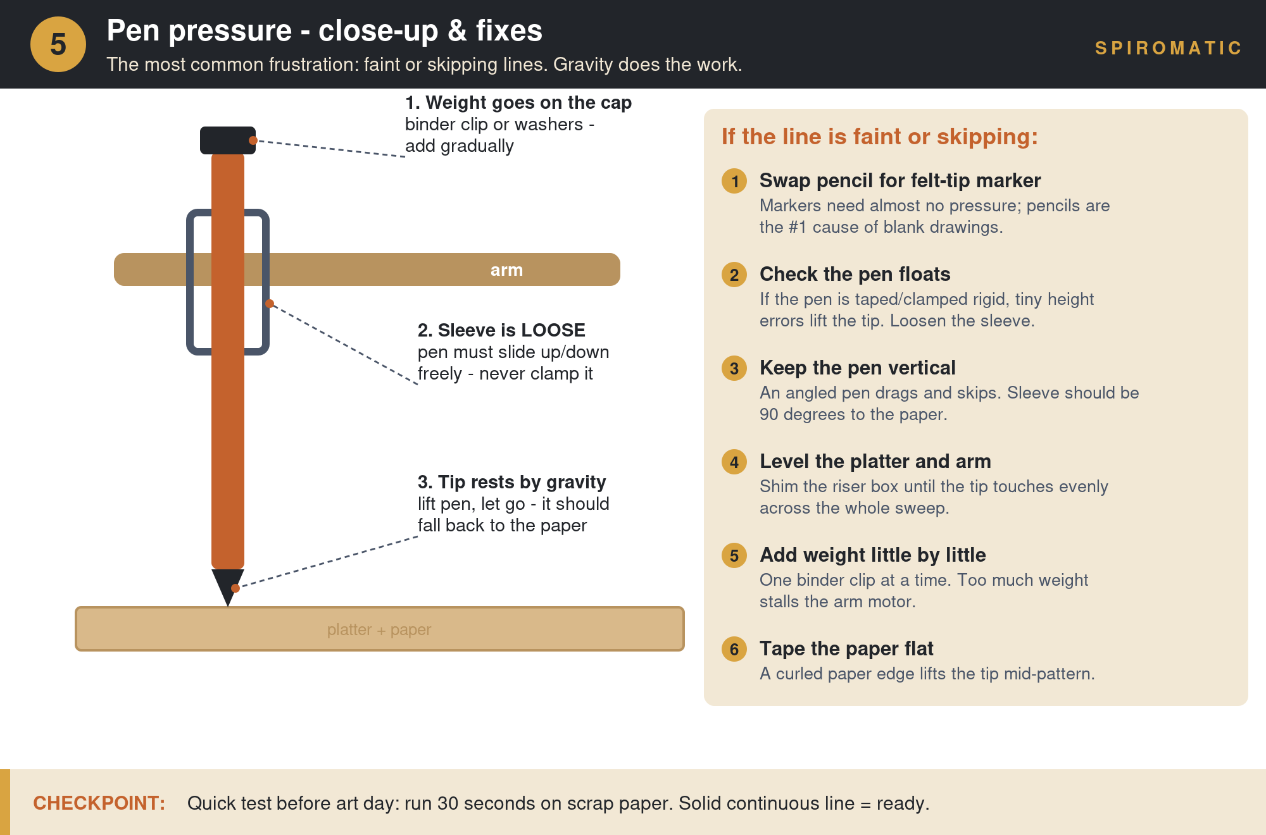
The floating-pen setup and the six fixes, in order of likelihood.

If the line is faint or skipping
- 1. Swap pencil for felt-tip marker. Markers need almost no pressure; pencils are the #1 cause of blank drawings.
- 2. Check the pen floats. If the pen is taped or clamped rigid, tiny height errors lift the tip. Loosen the sleeve so the pen slides up and down freely.
- 3. Keep the pen vertical. An angled pen drags and skips. The sleeve should be 90° to the paper.
- 4. Level the platter and arm. Shim the riser box until the tip touches evenly across the whole sweep.
- 5. Add weight little by little. One binder clip on the pen cap at a time. Too much weight strains the servo.
- 6. Tape the paper flat. A curled paper edge lifts the tip mid-pattern.
CHECKPOINT: Quick test before art day: run 30 seconds on scrap paper. A solid continuous line = ready. Lift the pen and let go — it should fall back to the paper on its own.

Lesson 4: Creating Art
Skills: Code manipulation, creative experimentation, artistic expression

Lesson Overview
With a fully operational Spiromatic, students now shift from engineering to artistry. They will manipulate code parameters to produce unique patterns and create a piece of art that represents the mood and meaning of a Jewish month. (Complete Pen Setup first.)

Step-by-Step Instructions
Step 1: Experiment with the Tuning Knobs
Every sketch in this unit has the same control panel: stepDelay (platter speed), platterDir (direction), armMin/armMax (how much paper the pen covers), armSpeed (sweep speed). Have students change one knob at a time and document what each does to the pattern. Slow arm + fast platter = tight rings; wide armMin–armMax = patterns that breathe across the whole page.
Step 2: Choose a Jewish Month
Each student or group selects a Jewish month to represent. They should research the historical background, themes, and emotional tone of that month.
Step 3: Plan the Artistic Piece
Students make deliberate choices about color paper, pen colors, pen thickness, pattern density, and motion style to convey the meaning of their chosen month.
Step 4: Create the Art
Run the Spiromatic with the chosen settings to produce the artwork. Students may need several attempts to refine their output.
Step 5: Write an Artist Statement
On a separate circular piece of paper, students write: the month they chose, the historical background they referenced, and how their choices of shape, color, and texture convey that month's meaning.
Teacher Tip: This is where the open-ended, upcycled nature of the project shines. No two machines are alike, so no two artworks will be alike either. Celebrate the variation.
Bridge to Lesson 5: Want deliberate shapes instead of happy accidents? Lesson 5 gives students recipes for flowers, hearts, squares, and mandalas — density and drift read as mood, which pairs beautifully with the Jewish month theme.

Lesson 5: Drawing with Math — Shape Recipes
Skills: Trigonometry intuition (cosine), polar thinking, parameter-driven design, prediction and testing

Lesson Overview
This is the destination the whole unit has been walking toward. Students discover that every shape the machine draws is a rule — “when the paper is at THIS angle, put the pen at THAT distance” — and that one math function, cos(angle), generates flowers, hearts, squares, triangles, stars, ellipses, and mandalas. The math is deliberately gentle: cos is introduced as “a number between −1 and +1 that breathes,” not as triangle ratios. No trig prerequisite. It runs on exactly the machine students built in Lessons 1–3: the code simply replaces the arm's back-and-forth sweep with an aim — angle in, distance out.

Companion Files
File | What it is
spiromatic_math_deck.pptx | 25-slide deck: the math (animated), stepper vs. servo, the code line by line, real-world uses of the same math, challenges. GIF animations play in slideshow mode (F5).
spiromatic_shapes.ino | One sketch, six shape recipes. Students change SHAPE = 1–6, then tune the marked numbers.
spiromatic_square.ino | The square, fully commented, with a triangle challenge inside.
spiromatic_simulator.html | On-screen machine in any browser (offline). Shape picker plus dials for petal count, push size, and speed — same numbers as the sketch.
spiromatic_teacher_answer_key.docx | Worked answers for all six challenges, plain-language explanations of the five real-world examples, grading guidance, and in-class troubleshooting.

Suggested Flow (2–3 sessions)
Step 1: The Math, Gently (deck slides 1–13)
Two numbers (SPIN and REACH), circles are free, cos breathes, corners are pushes, petals are a dial, the 6.1-petal mandala that drifts, and where the same math runs the real world. Pause on the animations and let students predict before revealing.
Step 2: Simulator Exploration (15–20 min)
Pairs open spiromatic_simulator.html and hunt for their favorite settings. The rule readout shows the live formula, so the math stays visible while they play.
Step 3: The Motors and the Code (deck slides 14–22)
Stepper vs. servo face-off — now a review of lived experience — then the three-line heart of the program: where is the paper? how far out should the pen be? tell the servo.
Step 4: Upload and Draw
Students transfer their favorite simulator numbers into spiromatic_shapes.ino and draw for real. Expect calibration — that IS the lesson. Slow the platter (stepDelay 15–20) for polygons and stars.
Step 5: Challenges (deck slide 24)
Six leveled challenges from warm-up to boss. Answers, common mistakes, and the mandala math are in the answer key.
Teacher Tip: The 20-turn mandala takes about 8 minutes of real machine time. That's a feature — it's the “watch the machine work” moment — but schedule it, and have the class predict the final pattern while it runs.
Discussion gold: Ask: what CAN'T this machine draw? (Anything where a line from the center crosses the outline twice — no crescents, no letters.) Students figuring out why is a better lesson than any single shape.

Extension Projects
Once students have completed the core lessons, these extensions offer additional challenges and deeper exploration.

Interactive Art
Add user controls — a potentiometer, ultrasonic sensor, or buttons — to let the operator adjust platter speed and arm sweep in real time. This transforms the Spiromatic from an automated machine into an interactive art tool where the human and machine collaborate.

Generative Art
Use random number generators in the code to produce computer-generated variations in arm sweep, platter speed, direction changes, and timing. Each run produces a unique, unrepeatable design. (Lesson 5's “invent recipe 7” challenge is a natural on-ramp.)

The Rotary Datalogger
Connect environmental sensors (temperature, humidity, light) to drive the arm parameters. Instead of random inputs, real-world data shapes the art. The resulting patterns become a visual record of environmental conditions — data visualization through physical drawing.

Legacy Build: Two Steppers + IR Homing (advanced)
The kit includes a second stepper, its driver, and an IR sensor for the Spiromatic's original architecture — a stepper-driven arm instead of the servo. It is harder in exactly the ways that make it a great capstone for strong groups: the arm stepper doesn't know its own angle, so students must build a homing routine (rotate slowly until a cardboard flag on the arm passes the IR sensor, then stop — a known starting position, the hardware version of what stepCount does in software). And because two steppers both need constant coil pulses, delay-based timing fails completely; students must interleave steps — one platter pulse, one arm pulse, repeat. Replicating the Lesson 1 code for a second motor (new pins, e.g., 2–5) is itself a worthwhile exercise in code organization and naming.
Teacher Tip: Homing is a real-world engineering concept used in CNC machines, 3D printers, and robotics. Point out to students doing this extension that they are using professional techniques — and that the servo build got the same guarantee for free.
Teacher Tip: Each extension builds on the core skills while introducing new concepts. Interactive Art adds analog input; Generative Art introduces randomness; the Datalogger connects to data science; the Legacy Build teaches homing and interleaved multitasking.

Appendix A: Troubleshooting Quick Reference
Keep this page open during class. Symptoms are ordered by how often they actually happen.
Symptom | Most likely cause | Fix
Stepper buzzes/vibrates, doesn't spin | Step delay too short (< 2 ms) or IN1–IN4 wired out of order | Raise stepDelay to 3–5; use the paper-clip flag test; re-check wire order against the diagram
Stepper was fine, now stutters after a code change | A new delay is interrupting the coil rhythm | Find what changed about timing; keep per-step delays 2–15 ms
Everything freezes in the combined sketch | A blocking delay() somewhere in the code | Replace long delays with the millis() pattern from Lesson 3
Servo doesn't move at all | Signal wire on the wrong pin, or arm.attach() missing | Orange wire to pin 6; confirm arm.attach(6) runs in setup()
Servo hums or trembles while holding | Normal self-correction on a small servo | Usually fine; if it bothers the build, nudge the target angle by one degree
Arm sweeps the wrong range or hits the build | armMin/armMax values, or horn seated at the wrong angle | Re-center: command arm.write(90), then re-seat the horn so the arm points mid-sweep
Faint or skipping lines | Pencil instead of marker, or pen clamped rigid | Pen Setup section: felt-tip marker, floating sleeve, weight added one clip at a time
Line fades on one side of the paper | Platter and arm not level | Shim the riser box until the tip touches evenly across the sweep
Corners of squares/triangles look rounded | Platter too fast for the arm | Raise stepDelay to 15–20 for polygons and stars
Pattern drifts off-center between runs | Arm was moved by hand while powered off | Just re-run the sketch — the servo re-homes itself in setup()
Legacy build: arm homes to a different spot each run | IR sensor distance or flag alignment | Adjust the module's potentiometer screw; enlarge the flag; run homing 3 times to verify

Appendix B: File Manifest
Everything referenced in this guide, in one list:
- spiromatic_math_deck.pptx — Lesson 5 slide deck (25 slides, animated)
- spiromatic_stepper_servo.ino — the Lesson 3 reference sketch: platter + servo arm, millis() timing, draws a spiral
- spiromatic_shapes.ino — six shape recipes, one sketch (Lesson 5)
- spiromatic_square.ino — the square, fully commented for 9th graders
- spiromatic_simulator.html — offline browser simulator with adjustable dials
- spiromatic_teacher_answer_key.docx — challenge answers, real-world explanations, grading guidance
- spiromatic_stage1–3 .png + spiromatic_pen_pressure.png — the build progression and pen setup images used in this guide

