CIM TECHNOLOGIES, INC.
CIM OffBoarding
Admin User Manual

Version 1.0 · Revised October 16, 2026
CIM Technologies, Inc. — Confidential, internal use

Table of Contents
Right-click this area and choose "Update Field" (or press F9) to populate the table of contents from the headings below.
Table of Contents 2
CIM OffBoarding — Admin User Manual 3
Introduction and scope 3
Table of contents 3
1. Sign-in and first-time password change 3
Signing in 4
Changing your initial password 4
Forgotten password 5
Account lockout 5
2. Admin modules 6
A. Dashboard 6
B. User Profile 7
Electronic signature 8
C. Offboarding Checklist 9
Checklists 10
General Signatory 12
Final Approver 12
D. Offboardee 12
E. Employee Master 14
F. Approval 16
G. Calendar 17
H. Email and Notification 18
I. Separation Type 19
J. Reports 20
1. Offboarding Processing Time 21
2. Pending Offboarding Cases 21
3. Completion Rates by Separation Type 21
K. Roles and Permissions 21
L. Users 22
M. Logs 23
N. Mail Settings 24
3. The complete offboarding process, step by step 25
Step 1 — Prepare the required configuration 25
Step 2 — Create a new offboarding request 25
Step 3 — Checklist generation and assignment 26
Step 4 — Email and in-app notifications 26
Step 5 — Approver and Task Assignee actions 27
Step 6 — Monitor offboarding progress 28
Step 7 — Handle exceptions 28
Step 8 — Final Approval and clearance documentation 28
4. Status definitions and terminology 29
Glossary 29
Status reference 30
5. Common errors and troubleshooting 31
6. Frequently asked questions 32

CIM OffBoarding — Admin User Manual

Table of contents
- Sign-in and first-time password change
- Admin modules
  - A. Dashboard
  - B. User Profile
  - C. Offboarding Checklist
  - D. Offboardee
  - E. Employee Master
  - F. Approval
  - G. Calendar
  - H. Email and Notification
  - I. Separation Type
  - J. Reports
  - K. Roles and Permissions
  - L. Users
  - M. Logs
  - N. Mail Settings
- The complete offboarding process, step by step
- Status definitions and terminology
- Common errors and troubleshooting
- Frequently asked questions
A separate, more detailed walkthrough of the end-to-end workflow (with a diagram) is also available as offboarding-workflow.md / offboarding-workflow.pdf.

1. Sign-in and first-time password change
Access: No permission required — anyone with an account can sign in.

Signing in
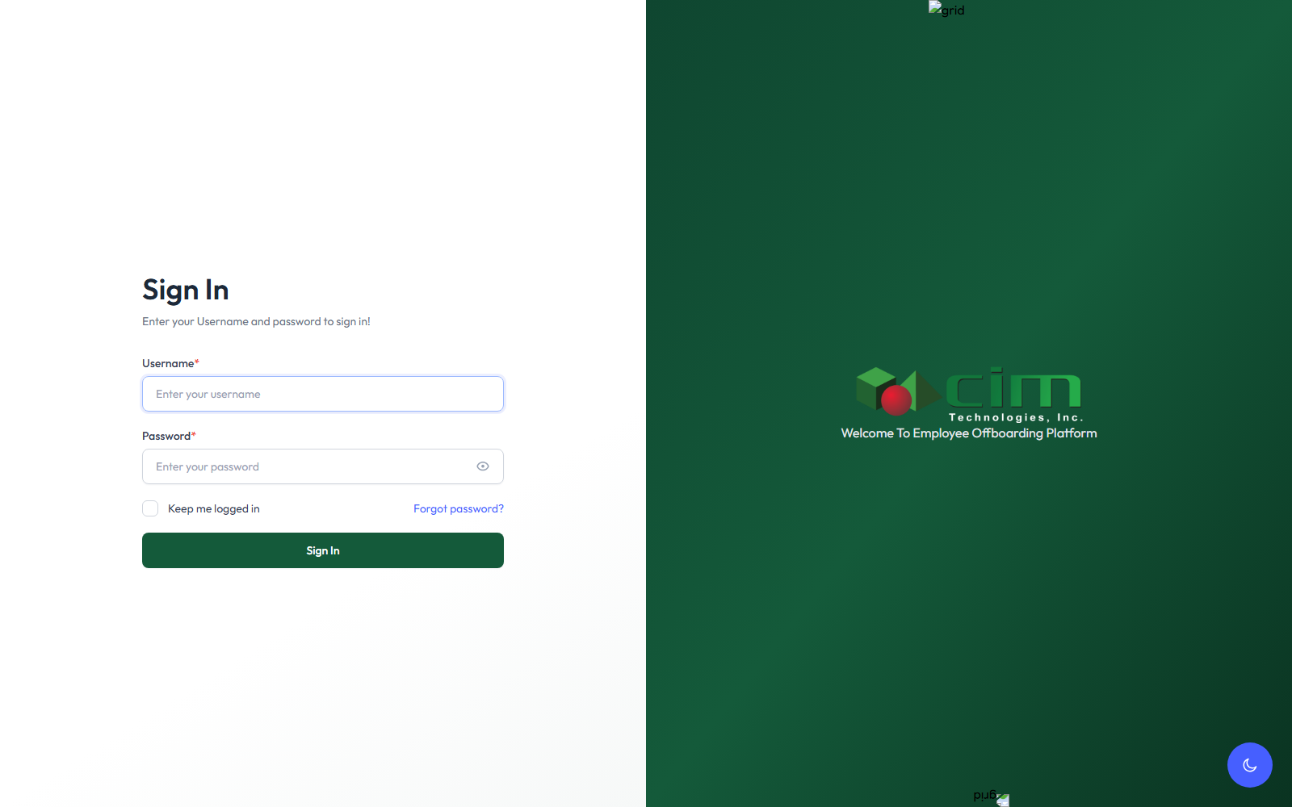
Sign-In page
- Open the CIM OffBoarding application's Sign In page.
- In the Username field, enter your employee number without the "EMP" prefix (for example, employee number EMP03050 signs in as 03050).
- In the Password field, enter your password. For an account that still has its initial default credentials, the password is the same value as the username — this is only true for an account that hasn't had its password changed yet; it is not the permanent password for every account, and does not apply once someone has already set their own password.
- Optionally tick "Keep me logged in."
- Click Sign In.

If your password still matches your username, the system detects this automatically and redirects you to the Change Password page — you cannot access any other page until you do this.

Changing your initial password
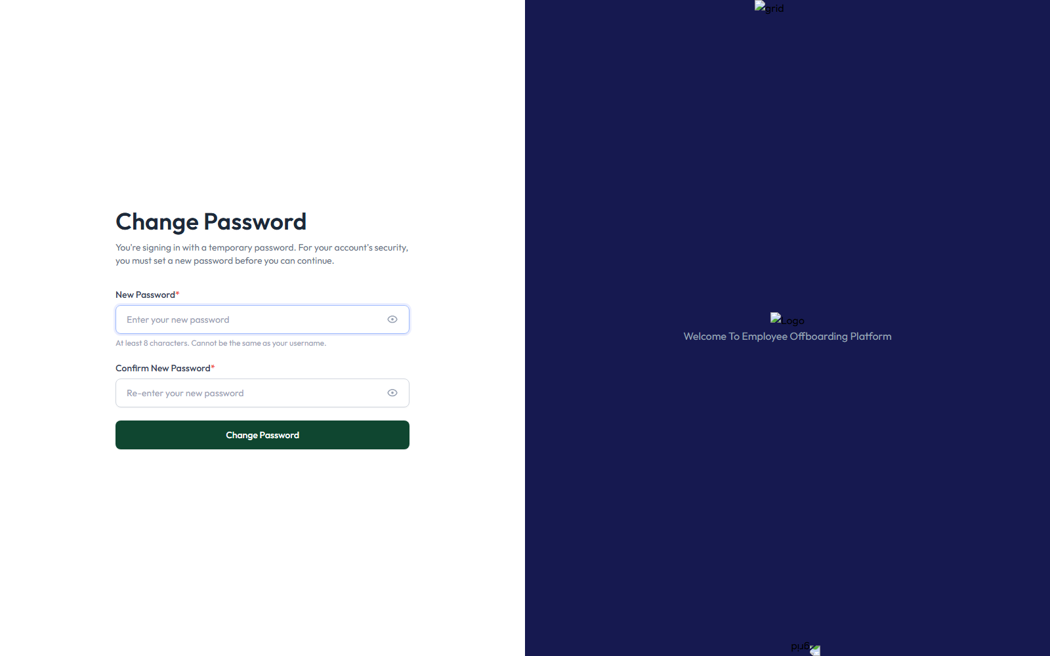
Change Password page
On the Change Password page:
- Enter a New Password* — it must be at least 8 characters, and it cannot be the same as your username.
- Re-enter the same value in Confirm New Password* (it must match exactly).
- Click Change Password.
On success, you're taken straight to the Dashboard with the confirmation message "Your password has been changed successfully." There is no separate "current password" field on this particular form — it is reached only immediately after signing in with the still-valid temporary password, so the application already knows who you are.

Forgotten password
If you don't remember your password at all (rather than just having an unchanged temporary one), click "Forgot password?" on the Sign In page, enter your email address, and follow the link sent to you — that link expires after 5 minutes and can only be used once.

Account lockout
Three incorrect password attempts in a row permanently blocks the account (it does not unlock itself over time). An Admin must reactivate it from the Users page

Admin Dashboard after successful sign-in

2. Admin modules

A. Dashboard

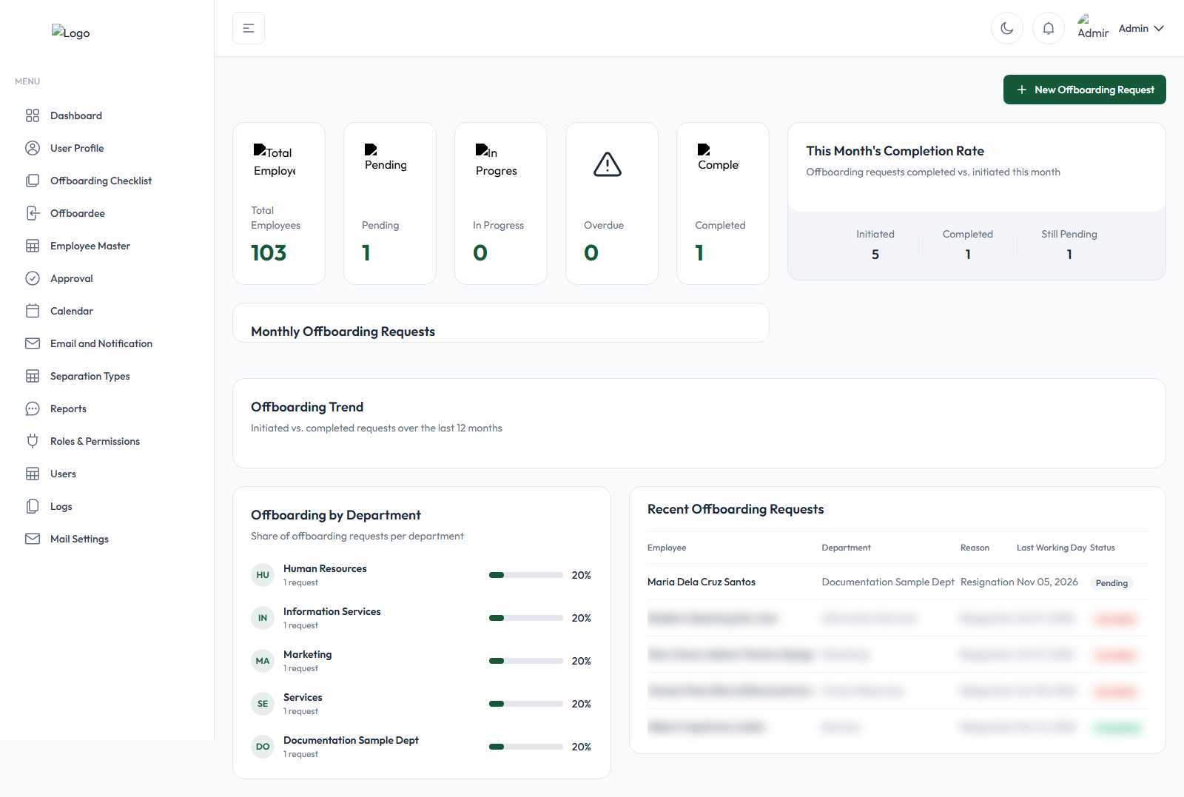
Admin Dashboard

The Dashboard shows:
Element | What it actually shows
Total Employees | Every employee whose status is not "Offboarded" — i.e. everyone currently active or mid-offboarding.
Active Employees | Employees whose status is specifically "Active" (not mid-offboarding, not yet offboarded).
Pending | Count of offboarding requests whose displayed status is Pending.
In Progress | Count of offboarding requests currently In Progress.
Overdue | Count of requests with at least one checklist past its due date.
Completed | Count of requests whose stored status is Completed.
This Month's Completion Rate | For the current calendar month: how many requests were initiated vs. how many were completed, with a completion percentage, plus how many are still pending from that same group.
Monthly Offboarding Requests / Offboarding Trend chart | A 12-month chart comparing the number of requests initiated each month against the number completed each month.
Offboarding by Department | A breakdown of how many offboarding requests have come from each department, as a percentage of the total.
Recent Offboarding Requests | A table of the 6 most recently created requests — employee, department, reason, Last Working Day, and status.

B. User Profile
Purpose: View and maintain your own account details, including the electronic signature used on approvals and the Clearance Form
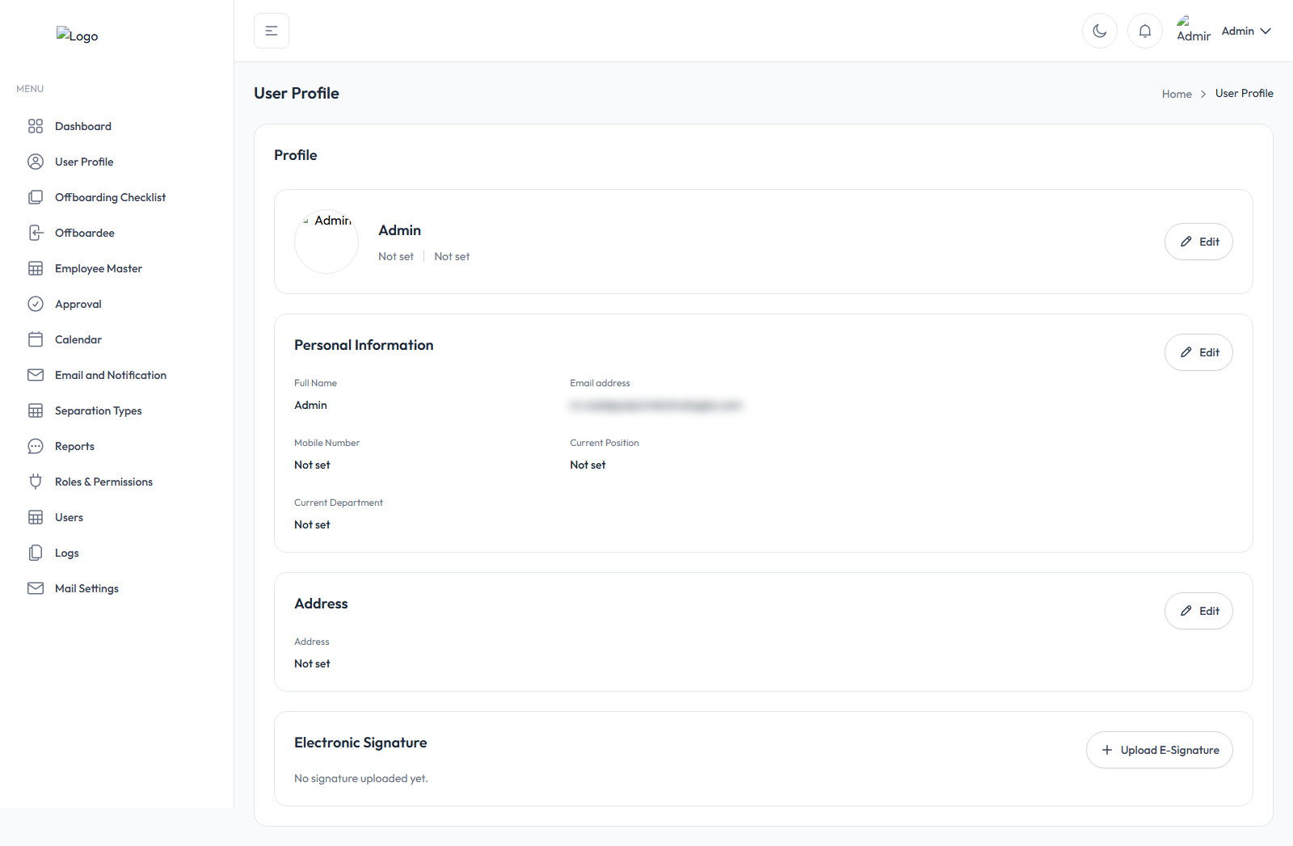
User Profile page
The page is organized as a header card plus four stacked cards: Employment Information → Personal Information → Address → Electronic Signature.
Employment Information — fully read-only (Employee Number, Full Name, Position, Department, Email, Date Hired): "Employment information is managed by HR and cannot be edited here."
Personal Information — click "Edit" to open the "Edit Personal Information" modal: Full Name, Email Address, Mobile Number, Current Position, Current Department. Any field you lack edit permission for appears greyed out. Click Save Changes. Full Name and Email Address are required; Email must be a valid, unique address.
Address — click "Edit" on the Address card to update the free-text Address field (up to 500 characters), then Save Changes.
Profile Photo — click the avatar (if you have photo-edit permission) to open "Upload Profile Photo." Accepts PNG or JPG, up to 2MB. After choosing a file you'll see a preview before saving; "Remove Photo" reverts to the default image.

Electronic signature
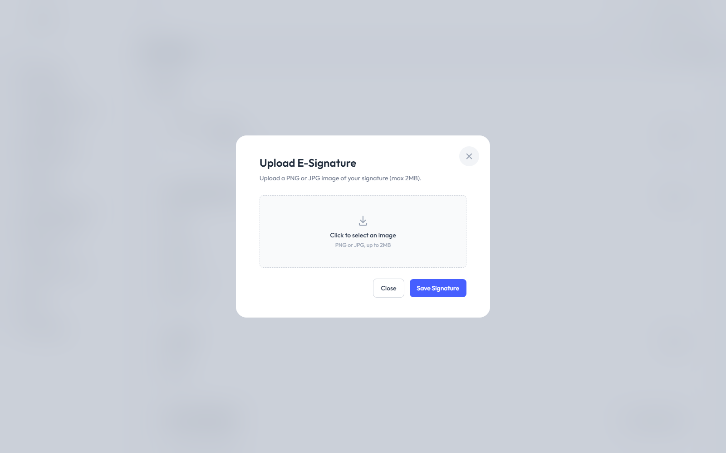
Electronic Signature card
Your e-signature is what actually appears on approvals and the Clearance Form, and it's required before you can approve anything — a checklist, a General Signatory assignment, or a Final Approval will all redirect you back here with an error message if you try to approve without one on file.
To upload or replace your signature:
- Scroll to the "Electronic Signature" card.
- Click "Upload E-Signature" (or "Update Signature" if you already have one).
- Click "Click to select an image" and choose a PNG or JPG file.
- Review the preview shown (or click "Choose a different file" to pick a different image).
- Click "Save Signature."
How to confirm it worked: after saving, you're returned to this page with the green banner "E-signature uploaded." — and the card itself now displays your signature image directly (this image preview, not just the success message, is the actual confirmation that the upload succeeded and is on file).
To remove it, click "Remove Signature" and confirm — you'll need to upload a new one before you can approve anything again.

C. Offboarding Checklist
Purpose: Build the reusable clearance checklists that get attached to offboarding requests, and configure the Department Signatory and Final Approver settings that apply company-wide.

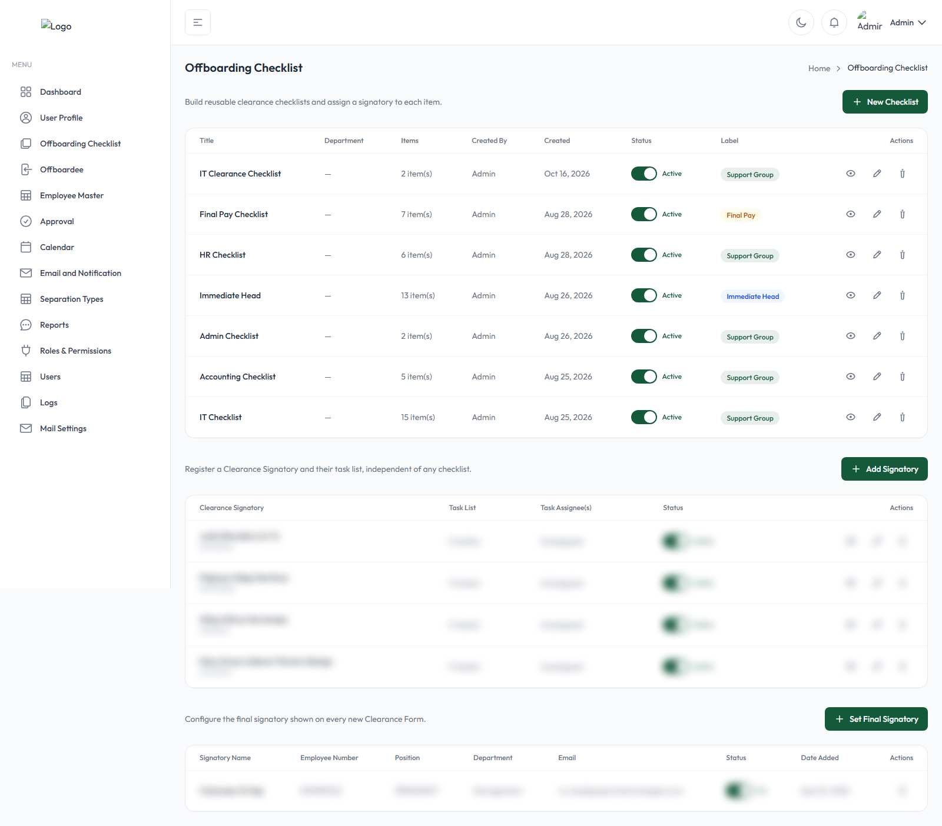
Offboarding Checklist page

The page has three sections:

Checklists
Click "New Checklist" (or Edit on an existing card) to open the template form:
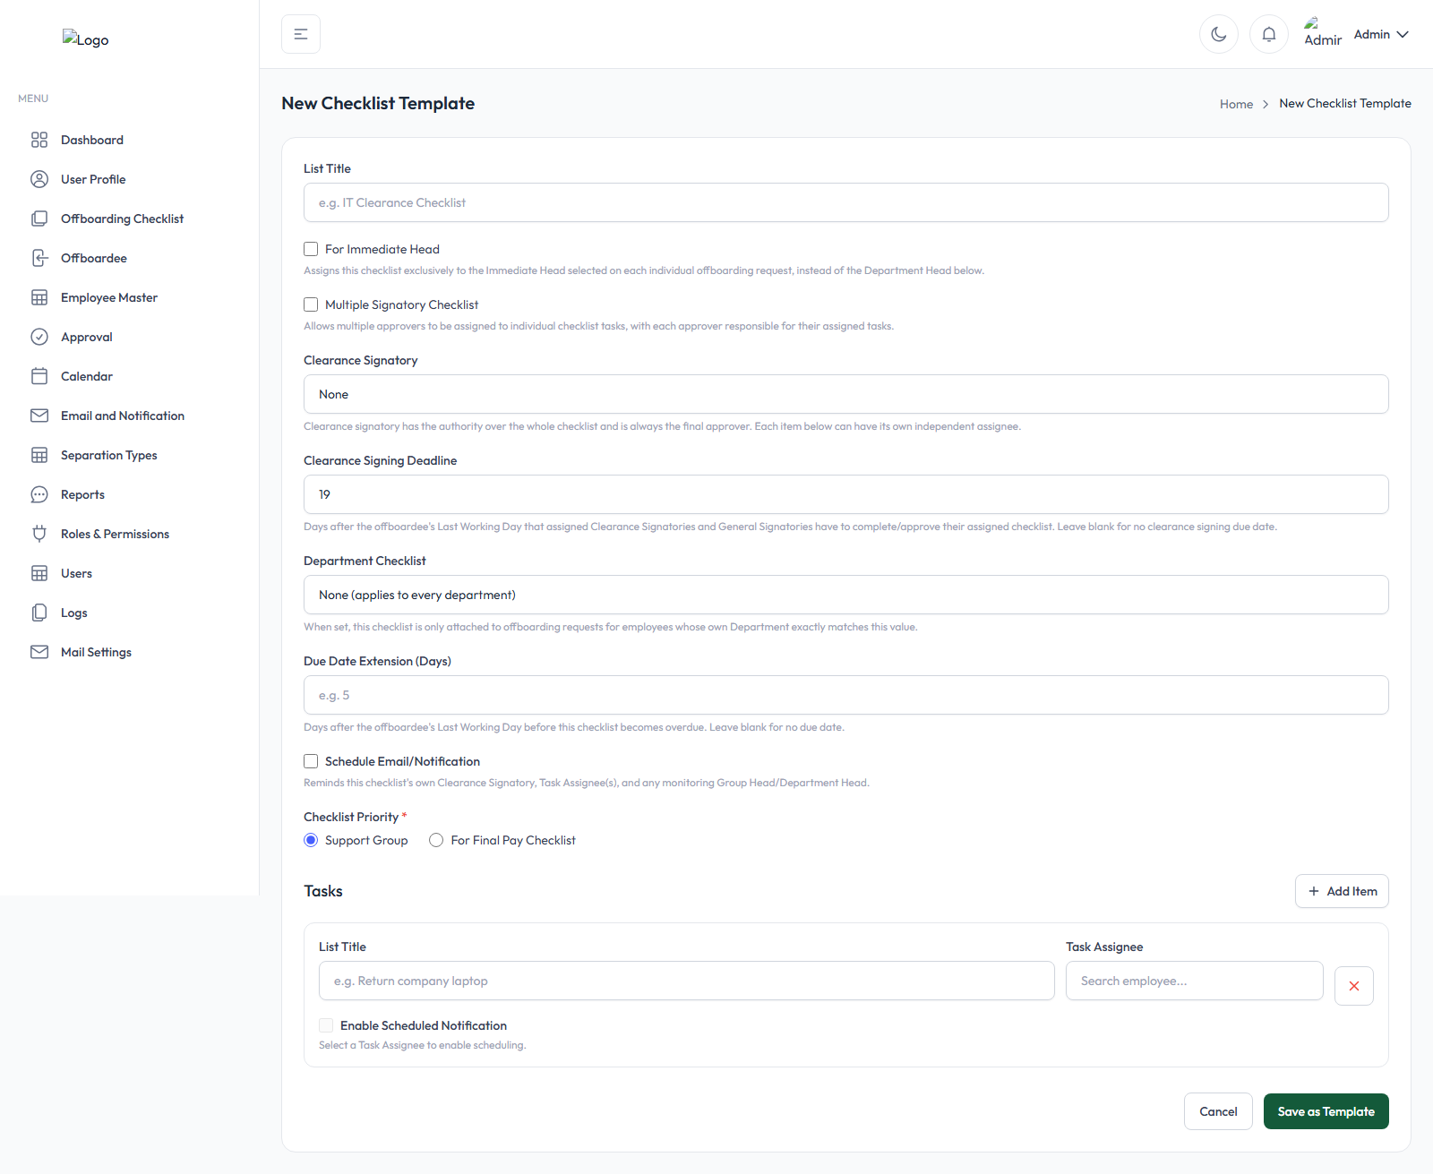
New Checklist template form
Field | What it does
List Title | The checklist's name, e.g. "IT Clearance Checklist."
For Immediate Head (checkbox) | Assigns this checklist to the offboarding request's own Immediate Head instead of a department group.
Multiple Signatory Checklist (checkbox) | No single Clearance Signatory — each item is signed off by its own Task Assignee instead (see below).
Clearance Signatory | Pick an Employee Master group; that group's Group Head becomes the person who gives final approval on this checklist.
Clearance Signing Deadline | Days after the offboardee's Last Working Day the signatory has to sign (defaults to 19).
Department Checklist | Restrict this checklist to one specific department, or leave as "None" so it applies to every department.
Due Date Extension (Days) | Days after Last Working Day before this checklist becomes overdue. Leaving it blank makes the checklist due exactly on the Last Working Day itself — it does not mean "no due date."
Schedule Email/Notification | Optional automatic reminder emails for this checklist — pick a template, how many days before the due date, and (optionally) a repeat interval.
Checklist Priority* | "Support Group" (the normal option) or "For Final Pay Checklist" — a Final Pay checklist only attaches once every other checklist and General Signatory on the request is already approved.
Tasks | Click "Add Item" for each clearance task; optionally assign a specific Task Assignee to that one item.

Click "Save as Template" (or "Update Template").
Standard checklist vs. Multiple Signatory Checklist:
- A standard checklist has one designated Clearance Signatory (the group's Group Head, or the request's Immediate Head) who personally reviews every item and clicks the final Approve.
- A Multiple Signatory Checklist has no single owner — each item is completed and effectively "signed" by its own individual Task Assignee, and the checklist approves itself automatically the moment every item is checked (with that assignee's own head approving behind the scenes where required). Nobody clicks a final Approve button on this type.

Department Signatory
A Department Signatory is configured once and automatically attaches to every offboarding request, independent of any specific checklist or department:
- Click "Add Signatory."
- Search and select the Clearance Signatory — any employee, not limited to group heads.
- Set the Clearance Signing Deadline (defaults to 19 days).
- Choose Checklist Priority — "Core" or "For Final Pay Checklist."
- Optionally add Task List rows — informational only; a General Signatory can approve regardless of whether their listed tasks are checked off.
- Click Save.

Final Approver
This is where you configure who gives the very last sign-off on every completed offboarding case. Click "Set Final Signatory," fill in their details, and use the row's Active/Inactive switch to control which configured signatory is currently in effect. An offboarding request cannot even be created unless an active Final Approver is configured here first.
How configuration affects new requests: when a request is created, every active, department-matching checklist and every active General Signatory is attached to it automatically.

D. Offboardee

Purpose: Create new offboarding requests and manage every request currently in progress.

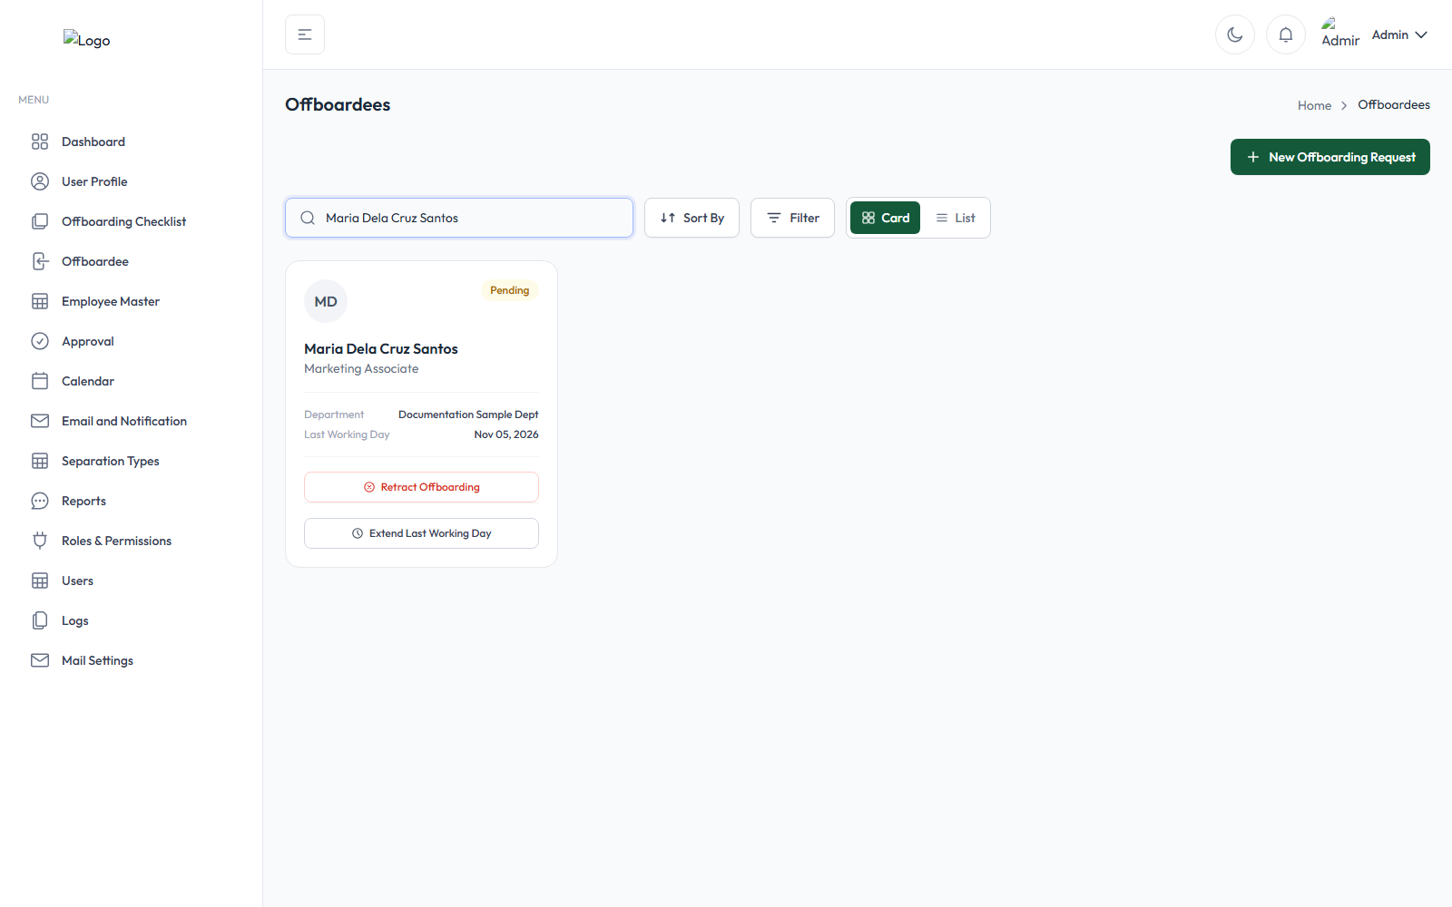
Offboardee page
Viewing the list: search by name, sort by Newest/Oldest Created, and filter by Status (Pending/In Progress/Overdue/Completed/Retracted) or Department. Lists of 20+ requests automatically switch to a compact table view.
Creating a new offboarding request — click "New Offboarding Request"
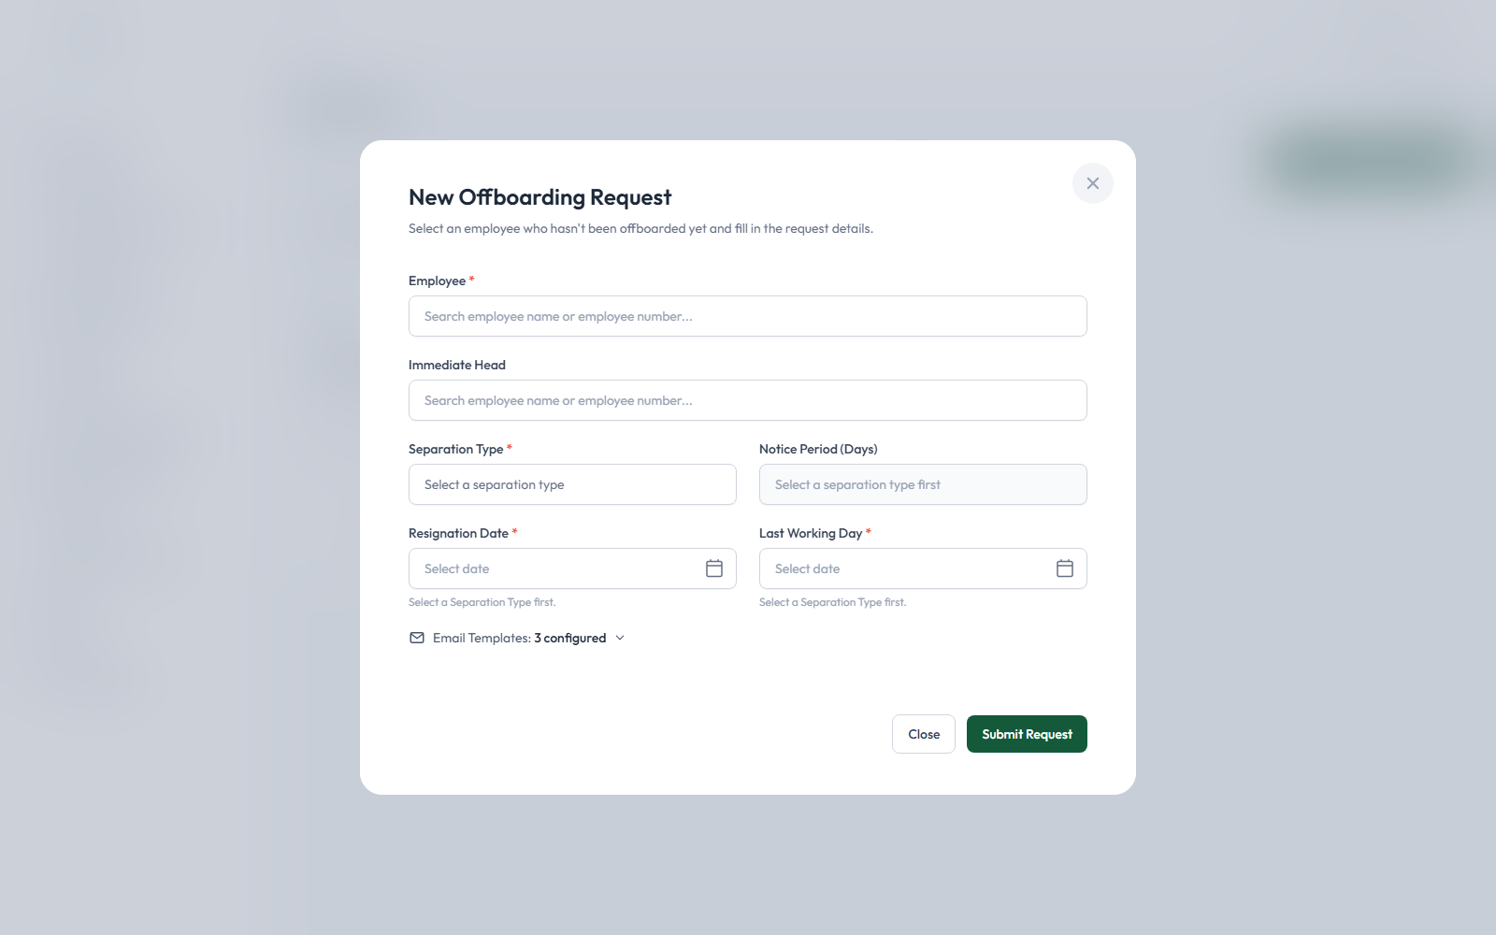
New Offboarding Request form
- Employee* — search and select an active employee (only employees not already mid-offboarding can be picked).
- Immediate Head — auto-filled from the employee's own record if one is on file; you can change it.
- Separation Type* — choose one; its written policy description appears automatically.
- Resignation Date* and Last Working Day* — Last Working Day is suggested automatically (Resignation Date + the Separation Type's Notice Period) but you can override it with any date.
- Optionally expand Email Templates to override which template is used for the Department Head, Offboardee, or General Signatory notification.
- Click "Submit Request," then confirm.
Request-level restrictions, verified from the actual code (do not assume these are always available):
- Retract (button: "Retract Offboarding") only appears while the Last Working Day hasn't passed yet and no checklist on the request has been approved yet. A written reason is always required, and this action can never be undone once confirmed — the request becomes a permanent, read-only record (nothing is deleted).
- Extend Last Working Day only appears while at least one checklist is still pending with a due date — it does not need to already be overdue. The new date must be strictly later than the current one; a written reason is required.
Monitoring a request: click any card to open the Offboarding Status/Timeline window:
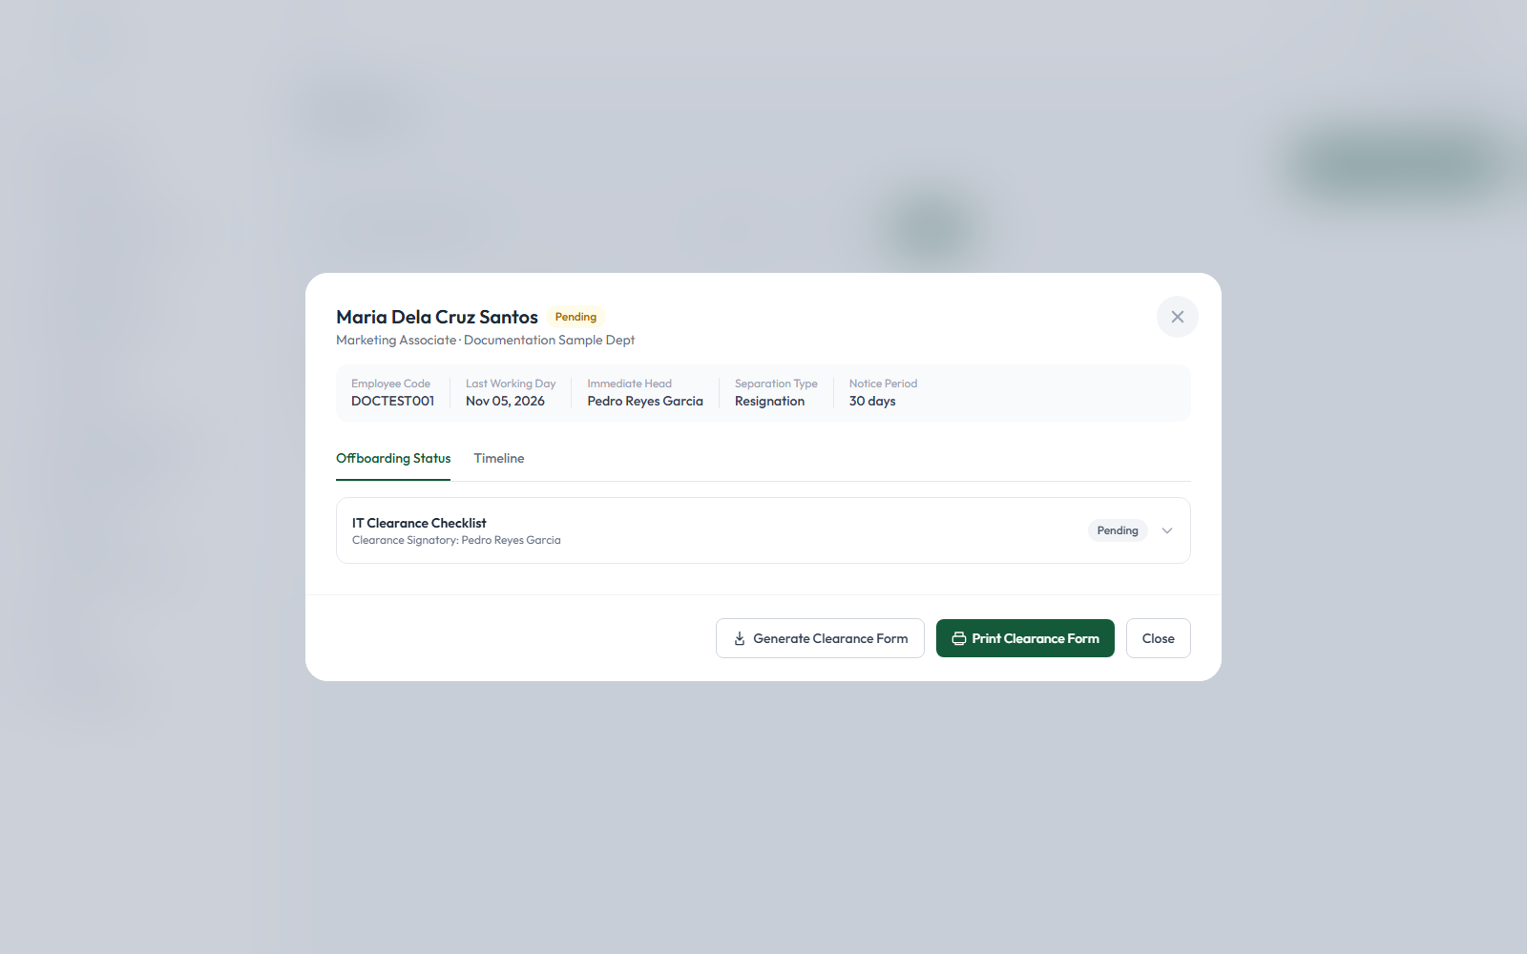
Offboarding Status/Timeline modal
- "Offboarding Status" tab — one row per checklist/General Signatory, each with its own status badge; expand a row for assigned dates, who first viewed it, hold history, and remarks. Admins also see a "Notify Approver" button here to manually resend a reminder.
- "Timeline" tab — the complete chronological history of the request.

E. Employee Master

Purpose: The single source of truth for every employee record — used throughout the rest of the application for offboarding requests, task assignment, and signatory selection

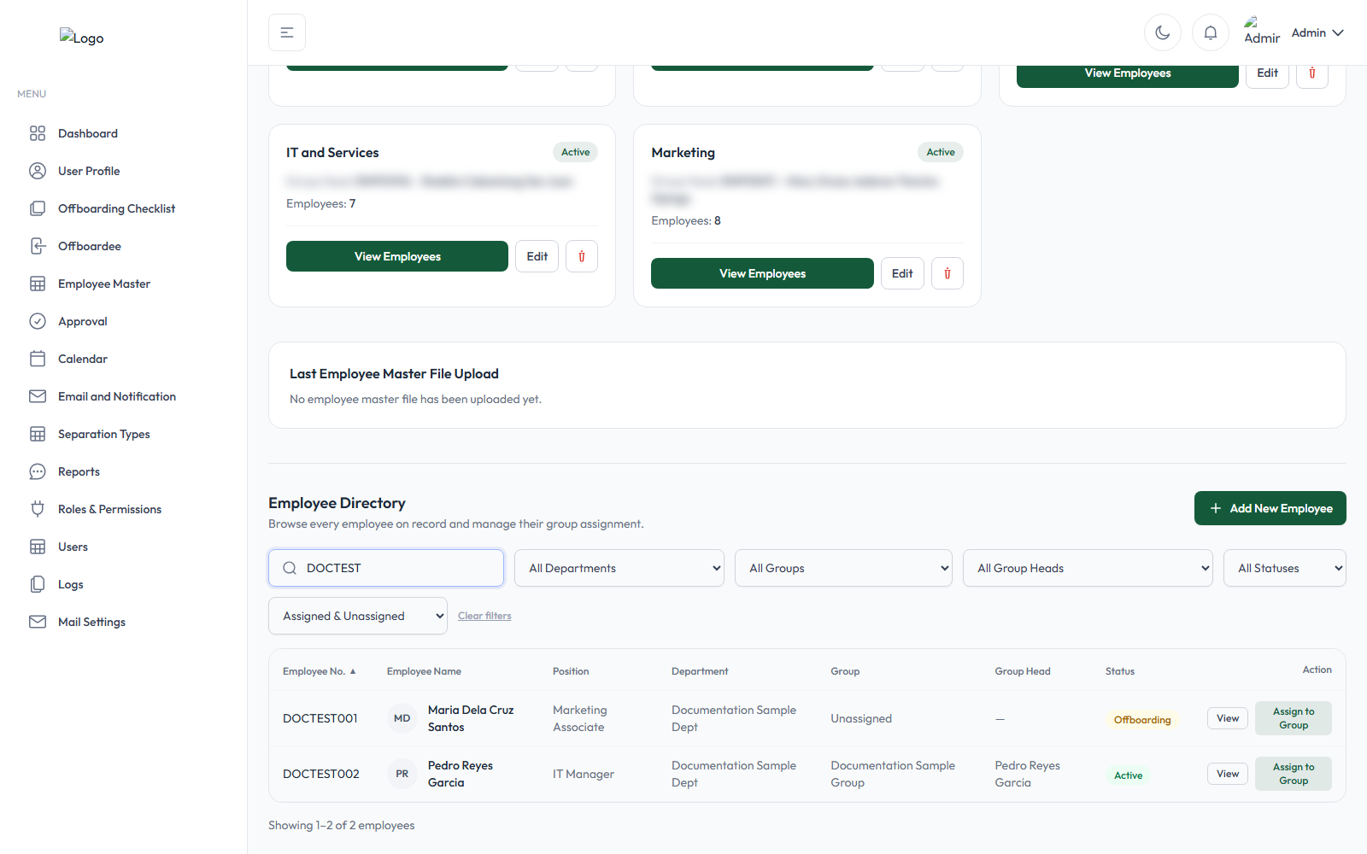
Employee Master — Employee Directory
Uploading an employee master file: click "Upload Excel" and choose an .xlsx/.xls file.

This replaces the entire roster. Confirming "Upload & Replace" means any employee not listed in the uploaded file is permanently deleted. Always verify the file is complete first.

A card near the top of the page always shows the most recent upload's File Name, Uploaded date/time, Uploaded By, Upload Status (Successful/Failed), Total Records, Successfully Imported, Skipped/Duplicate, and Failed counts. Manually adding one employee never changes what this card shows.

Manually adding one employee — click "Add New Employee":

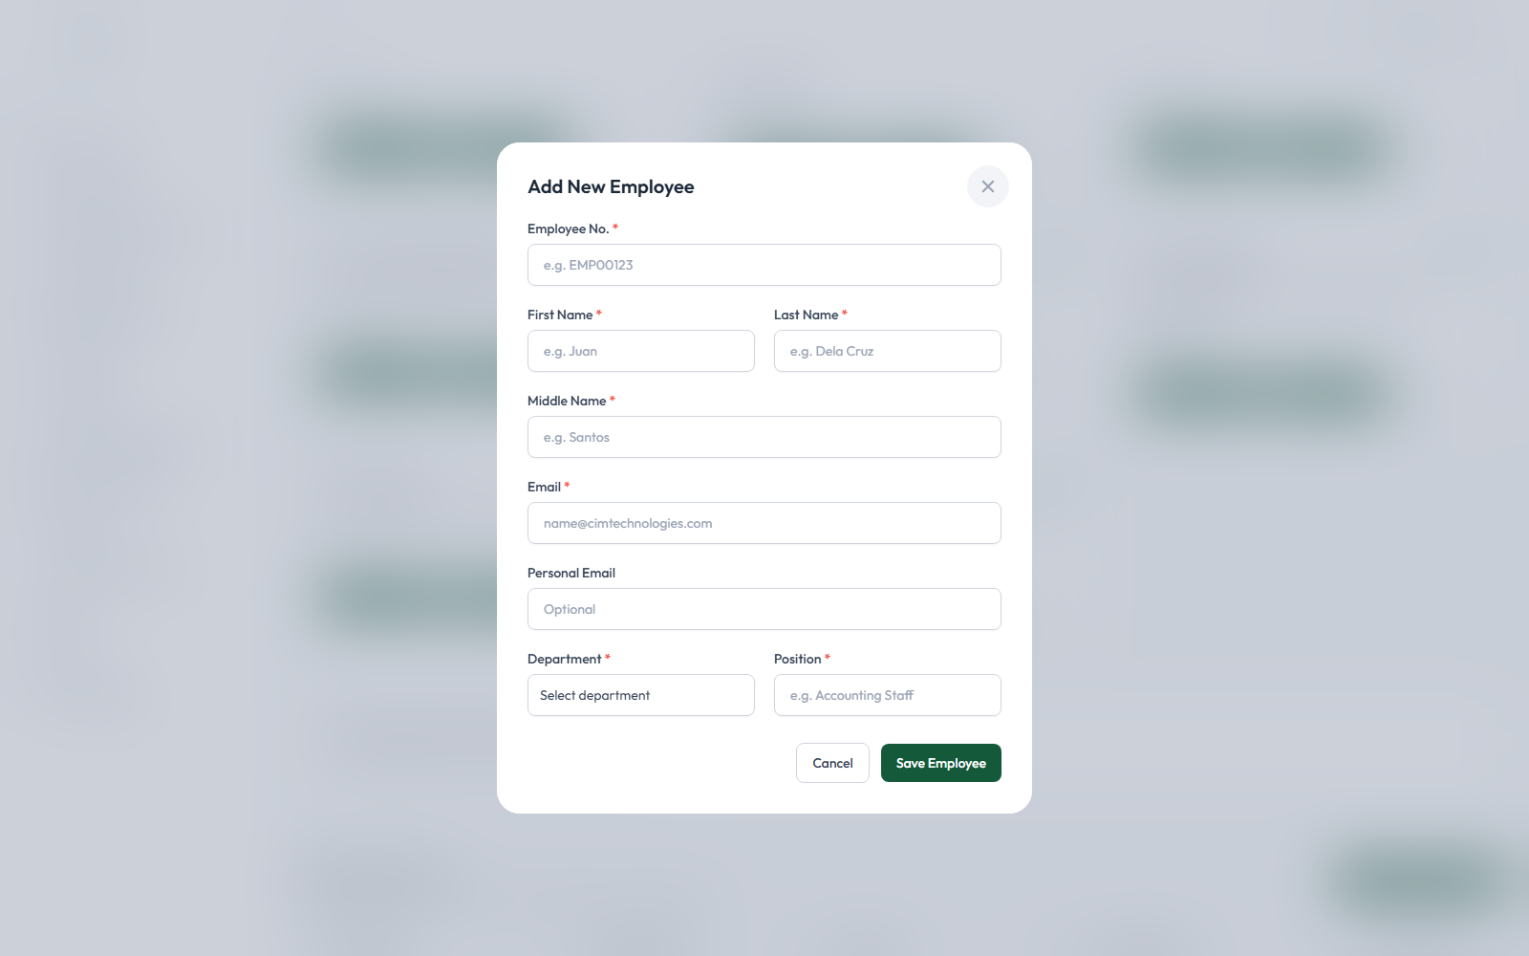
Add New Employee modal
Employee No., First/Last/Middle Name, Email, Department, and Position are all required. The system checks for a duplicate person by name — even under a different employee number — before allowing the save: "An employee with the same name already exists in the system. Please verify the employee details before proceeding."
Groups: each Employee Master group has a Group Head. "Auto-Add Group Members" (ticked by default when creating/editing a group) automatically moves every employee in that head's department into the group. A new employee with no group assigned shows as Unassigned; you can assign them via "Assign to Group" on any row.

F. Approval

Purpose: Monitor every checklist and signatory assignment across the entire organization, not just your own. As an Admin, you see every checklist and General Signatory assignment system-wide — a regular Approver only sees their own.
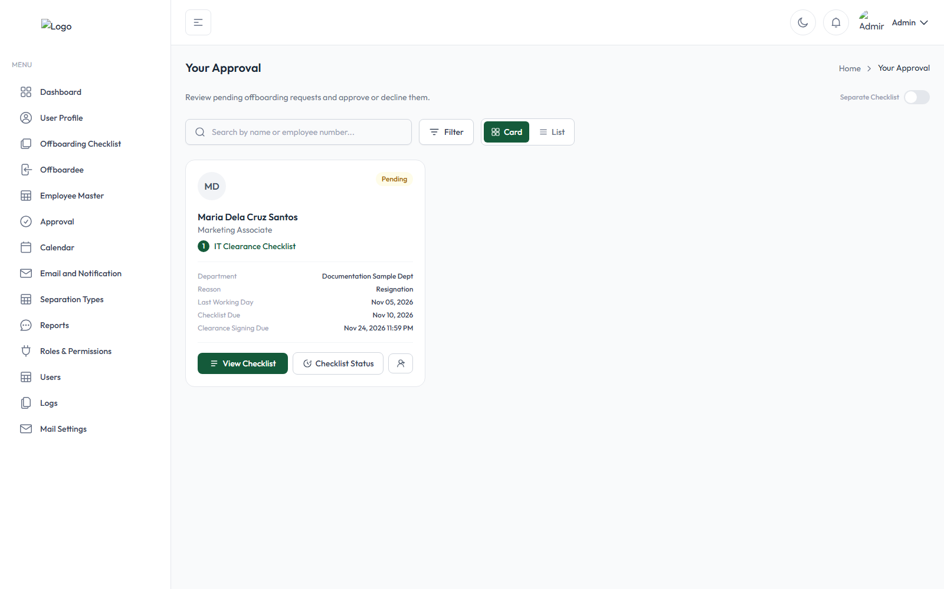
Approval page — Admin's system-wide view
Use the Search box (by name or employee number), the Filter dropdown (Status / Department / Checklist Title), and the Card/List view toggle to find a specific case among every assignment in the system. Click any card to open its checklist (or, for a General Signatory/Final Approval card, its "Review & Approve" detail window) and see exactly the same information the assigned signatory themselves would see — status, due dates, items, and remarks.
What Admin can do here vs. what's restricted to the designated approver: an Admin can view every card and its full detail, and can reassign a checklist or item the same way a Clearance Signatory can — but giving the actual Approve/Decline for a checklist, or approving a General Signatory assignment, still follows the same rule as for anyone else: only that specific checklist's own Clearance Signatory (or an Admin acting on their behalf) can do it. The different roles — Clearance Signatory, Immediate Head, General Signatory, regular Task Assignee — are explained in full in the Glossary below.

G. Calendar
Purpose: A read-only, automatically-generated visual overview of every offboardee's Last Working Day
Screenshot not included: the Calendar page has no admin-side filtering of any kind, and always displays every current/recent offboarding case's real employee name with no way to scope it down to sample data alone — capturing it would unavoidably expose real personal information, which this manual does not do. See screenshots/README.md for the full list of omitted screenshots and why.
What appears on it: one event per employee who has any offboarding request (using their most recent request), placed on that request's Last Working Day. The event shows the employee's real name, so treat anything on this page the same way you would any other page containing personal employee data. A retracted request's event is shown in red with a "Retracted" badge; every other event carries a small "Notice: Upcoming / Today / Past" badge based on the request's Notification Date.
Navigating: use the prev/next arrows and the Month / Week / Day view buttons across the top. There is no "Today" shortcut button and no list view.
Clicking an event opens the same Offboarding Status/Timeline window used elsewhere in the app, but showing only its Timeline tab (the "Offboarding Status" tab is not available from here).
The Calendar is entirely read-only — there is no way to create, edit, drag, or filter events from this page; everything shown is generated automatically from existing offboarding requests.

H. Email and Notification
Purpose: The Email and Notification module allows Admin users to create, manage, and maintain email templates used for automated and manual notifications throughout the CIM OffBoarding process. Its purpose is to ensure that employees, approvers, task assignees, department heads, and other authorized signatories receive timely, accurate, and consistent information regarding offboarding requests.
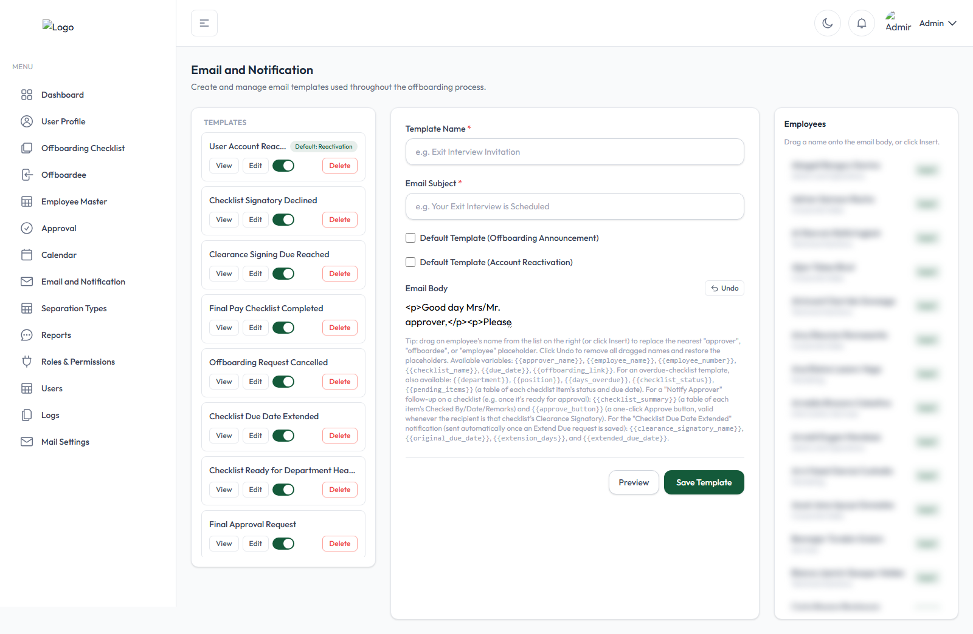
Email Templates workspace
- Click "New Template" (or edit an existing card).
- Fill in Template Name* and Email Subject*.
- Optionally mark it as the Default Template for Offboarding Announcements or Account Reactivation (only one template can hold each flag at a time).
- Write the Email Body in the rich-text editor — drag an employee's name from the right-hand panel onto the body, or click Insert, to replace a placeholder.
- Click Preview, then Save Template.
Available placeholders include {{employee_name}}, {{employee_number}}, {{checklist_name}}, {{due_date}}, and {{offboarding_link}}, plus several more that only apply to specific automated emails (the page's own help text lists which placeholders apply to which event).
Email vs. in-app notifications: most of the system's notifications are sent by email only. A small number of events (e.g. an overdue checklist, a clearance-signing deadline being reached) also raise an in-app notification visible to the relevant user inside the application itself, in addition to the email.
When notifications actually fire (verified from the code, not assumed): request creation, checklist assignment/reassignment, a checklist becoming ready for approval, a checklist being declined, a request being retracted, a Last Working Day extension, overdue checklists, clearance-signing deadlines, and final completion. Each of these is described at the point it happens in §3.

I. Separation Type
Purpose: Maintain the list of separation reasons (Resignation, Retirement, etc.) offered when creating a new offboarding request.

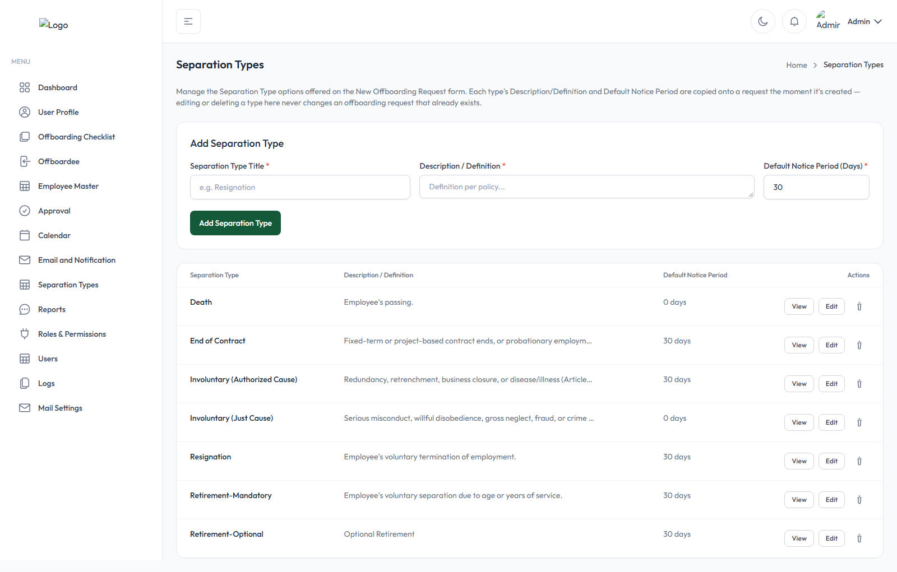
Separation Types page
The page's own description explains its purpose precisely: "Each type's Description/Definition and Default Notice Period are copied onto a request the moment it's created — editing or deleting a type here never changes an offboarding request that already exists."
Creating one:
- Under "Add Separation Type," fill in Separation Type Title* (must be unique), Description / Definition* (shown to the admin as the policy text when this type is selected on the request form), and Default Notice Period (Days)* (defaults to 30).
- Click "Add Separation Type."
Use View to see a type's full text, Edit to change any of the three fields, or the trash icon to delete one — deleting never affects any offboarding request that already used it.
How a Separation Type's values actually get used elsewhere (this goes well beyond just the Notice Period default):
- Its Title becomes the new request's stored "reason," which also fills the {{reason}} placeholder in outgoing notification emails.
- Its Description becomes that request's own frozen "Definition per Policy" text.
- Its Default Notice Period (Days) sets both the Last Working Day suggestion and the request's Notification Date (creation date + this many days) — which is what drives the Calendar's "Notice: Upcoming/Today/Past" badge.
- It also appears as a filter and grouping option on the Reports page, including an entire report ("Completion Rates by Separation Type") built around it.
Because every one of these values is copied onto the request at the moment it's created, changing a Separation Type's description or notice period later only affects future requests, never ones already in progress.

J. Reports
Purpose: Generate filtered, exportable reports on offboarding activity. Access: Menu item Reports (needs reports.view).
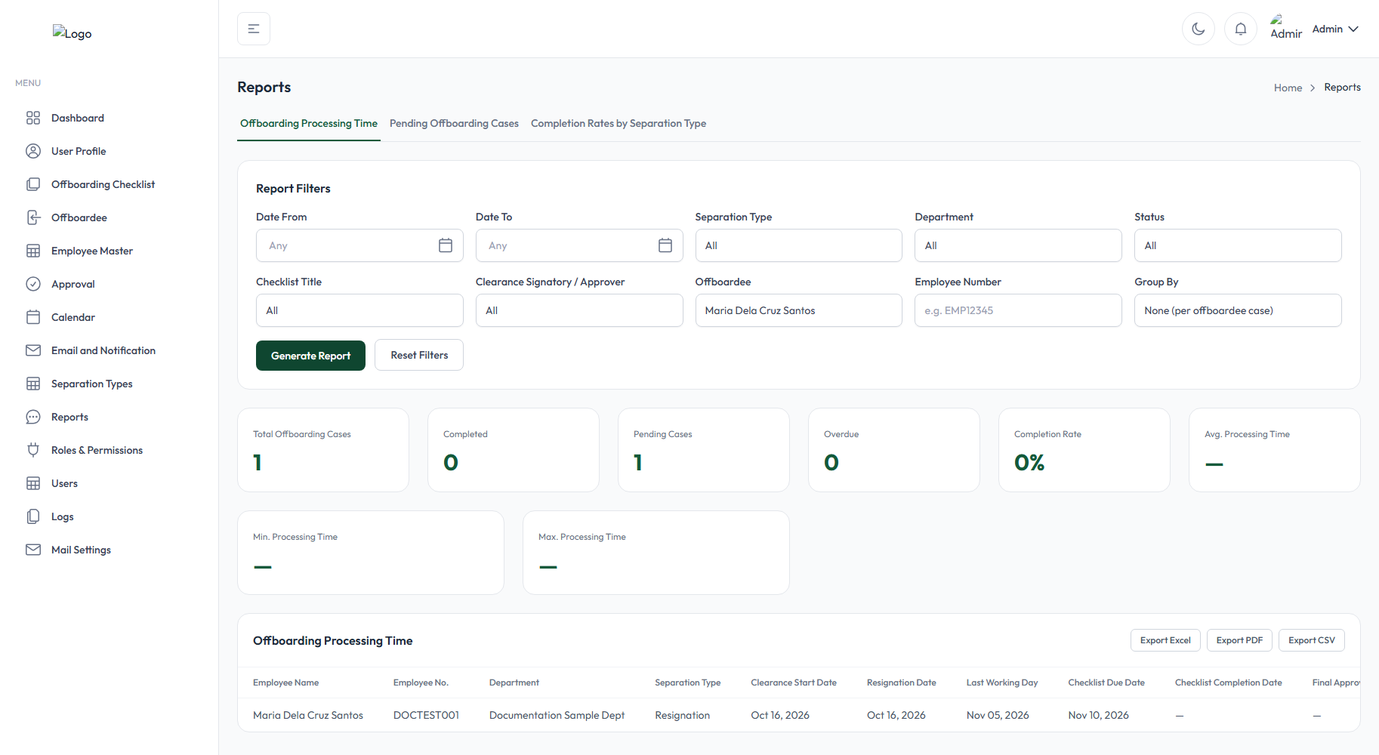
Reports page

- Offboarding Processing Time
- Pending Offboarding Cases
- Completion Rates by Separation Type
Filters (apply across all three tabs): Date From/To (filters by request creation date), Separation Type, Department, Status, Checklist Title, Clearance Signatory/Approver, Offboardee (name), and Employee Number. Click "Generate Report" to run it, or "Reset Filters" to clear everything.

1. Offboarding Processing Time
Purpose: Measure how long offboarding cases are taking. Set Group By to "None" for one detailed row per case (Employee, Department, Separation Type, every key date from Clearance Start through Offboarding Completion, Total Processing Time, and Current Status) — or group it by Offboardee, Department, Checklist, or Separation Type for summarized averages (Total Cases, Completed, Avg./Min./Max. Processing Time) per group instead.

2. Pending Offboarding Cases
Purpose: See exactly which cases are still open and what's holding each one up. Only includes requests still Pending or In Progress. Columns include the employee, which checklist stage it's currently waiting on, a "N/M cleared" checklist progress count, who the assigned signatory is, the due date, how many days it's been pending, and whether it's currently Overdue.

3. Completion Rates by Separation Type
Purpose: Compare how different separation reasons perform. One row per Separation Type: Total Cases, Completed, Pending/In Progress, Overdue, Completion Rate (%), and Average Processing Time (days). Retracted cases are excluded from this report.
Exporting: every report can be exported as Excel, PDF, or CSV via the buttons above the results table — each export uses whatever tab and filters are currently applied, and contains the same columns shown on screen.

K. Roles and Permissions
Purpose: The Roles and Permissions module allows Admin users to create, manage, and configure application roles and control access to specific modules, features, and actions within the CIM Offboarding application. Its primary purpose is to ensure that each user has access only to the functions and information necessary to perform their assigned responsibilities.
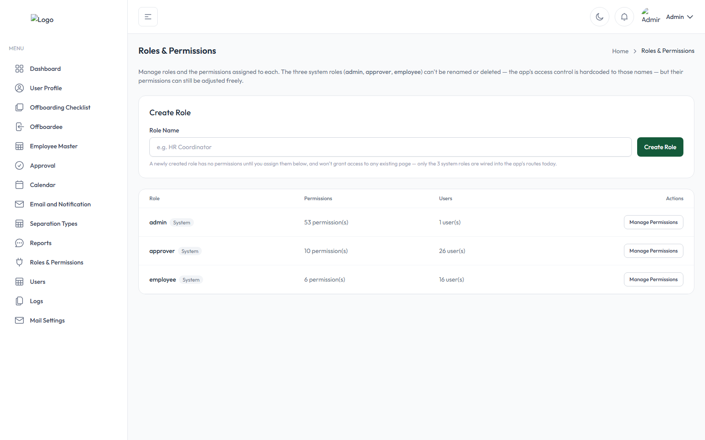
Roles & Permissions page
The three built-in roles — admin, approver, employee — can have their permissions freely adjusted, but their names cannot be changed or deleted, since the application's access control is hardcoded to those three names.
- Under "Create Role," type a Role Name and click Create Role — it starts with no permissions at all.
- Click "Manage Permissions" on any role's row, tick every permission that role should have (grouped by module), and click Save Permissions — this replaces the role's entire permission list with exactly what's ticked.
A role currently assigned to any user account cannot be deleted until those users are reassigned to a different role.
How roles relate to accounts: permissions are attached to roles, and a user account can hold one or more roles — they get everything those roles allow, combined. Whether a sidebar menu item or a specific button even appears to a given user is controlled directly by their role's permissions (see §L for how roles get assigned to individual people).

L. Users
Purpose: See every employee's account status, assign roles, and reactivate blocked accounts.
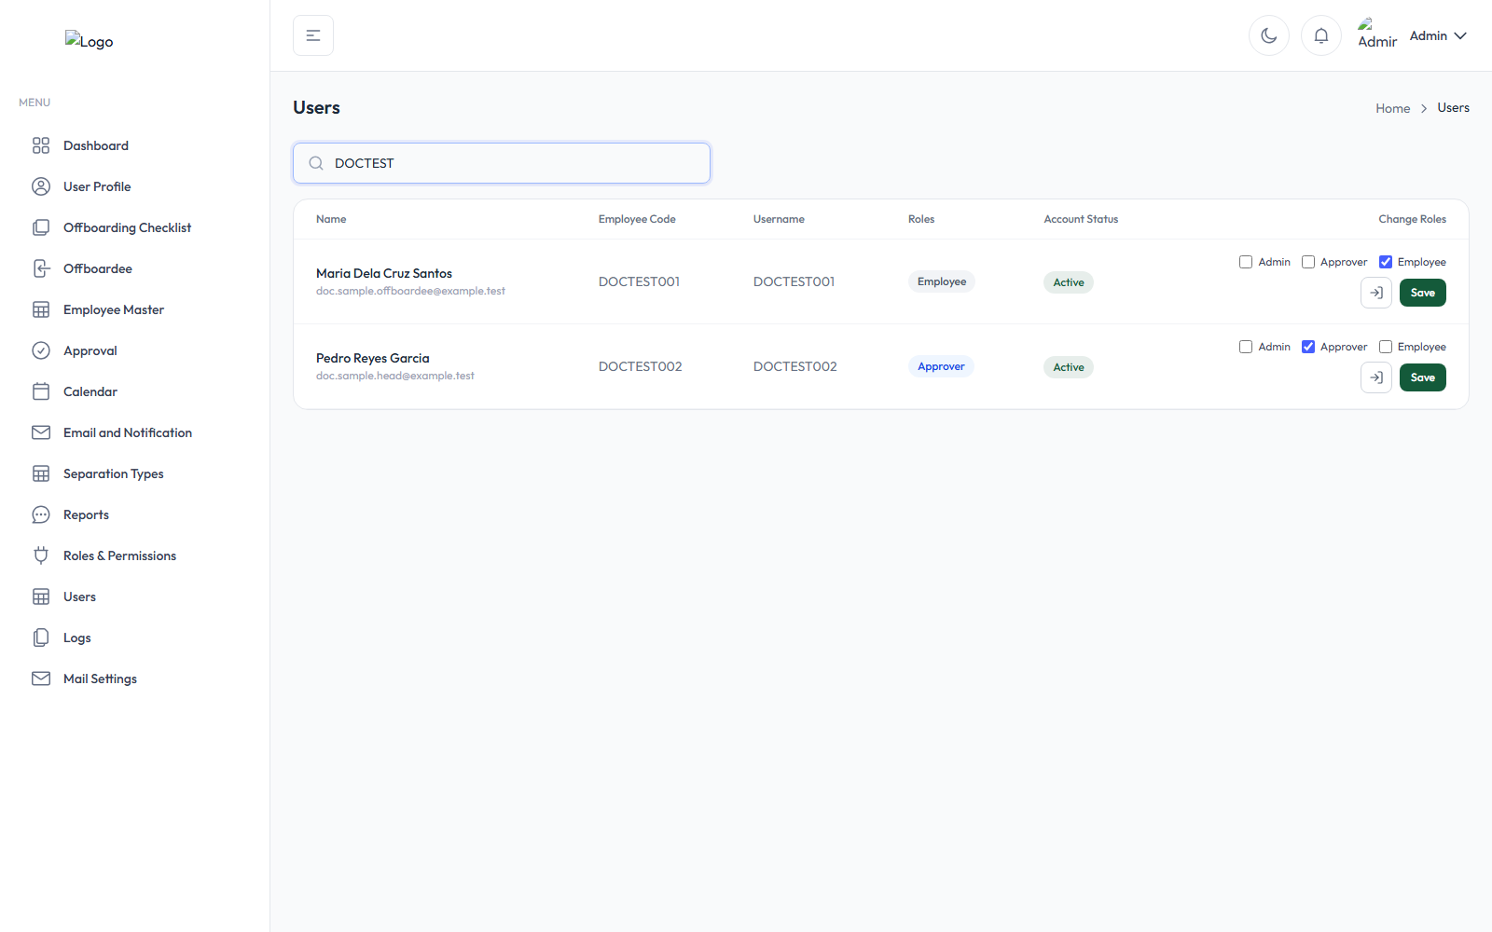
Users page
The page lists every employee in Employee Master, whether or not they have a login account yet.
Account status, exactly as the application defines it:
- Active — the employee has a login account and it is not currently blocked.
- Inactive — covers two distinct underlying situations that the badge itself does not visually separate: (1) the employee simply has no login account yet at all, or (2) the employee has an account but it is currently blocked (three failed login attempts). You can always tell which case you're looking at because a genuinely blocked account additionally shows "Blocked {date/time}" and a "Reactivate" button right under the badge — an employee who just doesn't have an account yet shows neither of those, and their Username column instead reads "Not yet created — will use {employee code}."
Changing someone's role(s): tick/untick the role checkboxes in their row (at least one must stay ticked) and click Save, then confirm. If the employee had no account yet, one is created automatically at this moment, and a "User Account Created" pop-up shows their Initial Password one time only — share it with them immediately, since it is never shown again.
Reactivating a blocked account: click "Reactivate," review the shown details, optionally pick a different notification email template, and confirm. This clears the block, generates a brand-new random temporary password (sent only by email, never shown on screen), and flags the account to require a password change on next login.
"Login As User": click the icon with the tooltip "Login As User" (only available for accounts that already exist) to open a new browser tab signed in as that person — useful for troubleshooting what they're seeing. An amber banner on every page reminds you (and them, if they're also logged in elsewhere) that this is an impersonation session, with a "Return to My Account" button to end it. You cannot impersonate your own account, a blocked account, or start a second impersonation while already impersonating someone.

M. Logs
Purpose: The Logs module provides Admin and other authorized users with a centralized record of user activities and transactions within the CIM Offboarding application. Its primary purpose is to promote transparency, accountability, security, and traceability by recording important user activities, from logging in and logging out to performing actions related to employee records.

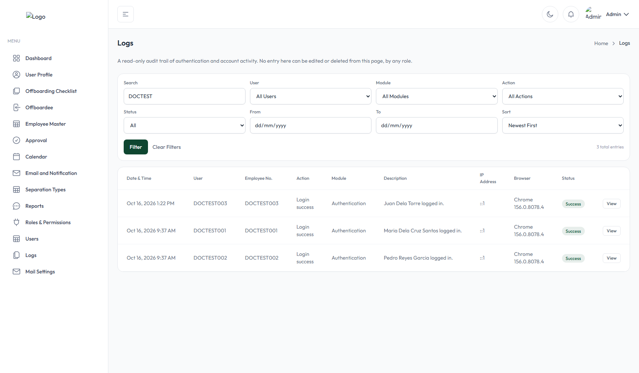
Logs page

N. Mail Settings
Purpose: The Mail Settings module allows authorized Admin users to configure and manage the Simple Mail Transfer Protocol (SMTP) settings used by the CIM Offboarding application.
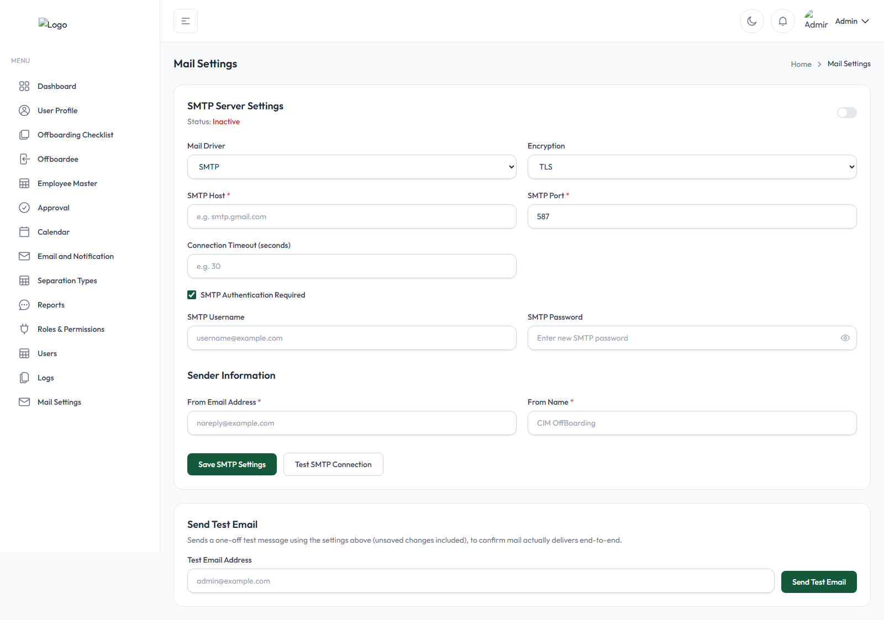
Mail Settings page
- Choose a Mail Driver — SMTP is the normal choice for real delivery.
- Fill in SMTP Host* and SMTP Port* (587 is the typical default), and choose an Encryption method — None, TLS, or SSL.
- If your mail server requires a login, tick "SMTP Authentication Required" and fill in SMTP Username and SMTP Password. (If a password was already saved, the field shows as dots with a "Change Password" option — leaving it untouched keeps the existing password.)
- Optionally set a Connection Timeout (seconds).
- Fill in From Email Address* and From Name* — these appear as the sender on every email the system sends.
- Switch Status to Active, then click "Save SMTP Settings."
Testing: click "Test SMTP Connection" to check connectivity without sending anything, or enter an address under "Send Test Email" and click Send Test Email to receive an actual message.

These settings only take effect while Status is Active; otherwise the server's own underlying default mail configuration is used instead. Never share or screenshot a real SMTP password — the field is masked by the interface itself, but avoid typing a real production password into any copy of this manual.

3. The complete offboarding process, step by step

Step 1 — Prepare the required configuration
Before creating your very first offboarding request, make sure the following are set up. Items marked Mandatory will actually block request creation if missing; items marked Optional simply won't apply to that request if skipped.
Configuration | Required? | Why
Employee Master records | Mandatory | You can only select an employee who already exists and is Active (see §E).
An active Final Approver | Mandatory | The system refuses to create any request at all without one active Final Approver configured somewhere (see §C).
Separation Types | Mandatory (at least one) | The request form requires picking one.
Checklist templates | Optional, but practically essential | A request with no matching checklists will have nothing for anyone to clear — but the system doesn't block you from creating one.
Department Heads / Group Heads / General Signatories | Optional | Only relevant if you've configured checklists or General Signatories that depend on them.
Task assignments on checklist items | Optional | Items left unassigned simply have no default Task Assignee until someone is assigned later.
Email templates | Optional, but strongly recommended | Several system notifications are matched by exact template name — if the relevant one is missing, that specific email is silently skipped (logged, but no error shown to anyone).
SMTP / Mail Settings | Optional | Without a working mail configuration, every notification email above fails to send — the rest of the workflow still proceeds normally in-app.

Step 2 — Create a new offboarding request
- Open the Offboardee page (or click "New Offboarding Request" directly from the Dashboard).
- Click "New Offboarding Request."
- Search for and select the Employee.
- Confirm or change the auto-filled Immediate Head.
- Select the Separation Type — its policy description appears automatically.
- Review the auto-filled Notice Period (Days) (read-only, from the Separation Type).
- Set the Resignation Date.
- Set or verify the Last Working Day — it is auto-suggested from the Resignation Date and Notice Period but can be freely overridden.
- Review everything, including any Email Template overrides you want to set.
- Click "Submit Request," then confirm "Create Offboarding Request?"
- Verify success — the toast confirms "Offboarding request submitted," and the new card appears on the Offboardee page with status Pending.

Step 3 — Checklist generation and assignment
The moment the request is created, the system automatically works out which checklists and General Signatories apply and attaches them — you do not manually assign the "first round" yourself:
- Every active checklist template whose Department field is blank, or exactly matches the offboardee's own department, is attached.
- Every active General Signatory is attached, independent of department.
- Each checklist's Clearance Signatory is resolved automatically from its own configuration — the relevant Employee Master group's Group Head, or (for an "For Immediate Head" checklist) the request's own Immediate Head.
- A checklist marked "For Final Pay Checklist" is deliberately not attached at this point — it only attaches once every other checklist and General Signatory is fully approved.
The people involved, and how their roles differ:
Role | What they're responsible for
Clearance Signatory / Department Head | The one person with final authority over a standard checklist — reviews every item and personally clicks the final Approve.
Immediate Head | Same authority as a Clearance Signatory, but specifically for a checklist flagged "For Immediate Head" — resolved from whoever was picked (or auto-filled) as that request's Immediate Head.
General Signatory | A completely separate, company-wide approval track attached to every request — not tied to any specific checklist.
Regular Approver / individual Task Assignee | On a standard checklist, completes the specific item(s) assigned to them, but relies on the Clearance Signatory for the actual final approval.
Final Signatory | Gives the very last sign-off, only after the entire request reaches Completed status (see Step 8).

Standard checklist vs. Multiple Signatory Checklist: a standard checklist has one Clearance Signatory who personally approves the whole thing. A Multiple Signatory Checklist has no single owner at all — each item is independently signed off by its own Task Assignee, and the checklist approves itself automatically the instant every item is checked (with that assignee's own head approving behind the scenes if required). Nobody clicks a final "Approve" button on this type.

Step 4 — Email and in-app notifications
Event | Who is notified | Template used
Request created | Department Heads/Clearance Signatories of every attached checklist, the offboardee, and every attached General Signatory | "Offboarding Request Notification" (signatories), the offboardee's own announcement template, "General Signatory Offboarding Notification"
A checklist becomes fully checked and ready | That checklist's Clearance Signatory | "Checklist Ready for Department Head Approval"
A checklist is declined (placed on hold) | The request's creator | "Checklist Signatory Declined"
A Multiple Signatory Checklist item needs head sign-off | The relevant head | "Checklist Item Pending Head Approval"
A checklist or clearance-signing due date is reached | The responsible signatory (and, for an overdue checklist, every Admin too) | "Offboarding Overdue Notice" / "Clearance Signing Due Reached"
Last Working Day extended | The signatories of every checklist whose due date just changed | "Checklist Due Date Extended"
Request retracted | The offboardee, Immediate Head, every Clearance Signatory, and every Task Assignee | "Offboarding Request Cancelled"
All regular checklists + General Signatories approved (Final Pay stage begins) | The Final Pay checklist's Clearance Signatory | "Final Pay Checklist Approval"
Request fully Completed | Every Admin, plus the request's creator (with the combined Clearance Form + Timeline PDF attached) | "Final Pay Checklist Completed"
Final Approval sent | The configured Final Signatory | "Final Approval Request"

A notification is silently skipped (not shown as an error to anyone) if its named email template is missing or has been deactivated — the event itself still happens normally; only the email doesn't go out. This manual does not claim an email was actually delivered — only that the application attempted to send it; delivery itself depends on your SMTP configuration (see §N) and the hosting server's background task scheduler actually running. Check the Logs page (§M) for evidence of what was actually recorded.

Step 5 — Approver and Task Assignee actions
Each assigned person opens their own Approval page and works through their checklist:
- Review the checklist item(s) assigned to them.
- Check off an item, optionally adding a remark.
- Save Progress to record partial work without finishing the whole checklist yet.
- If something is blocking a specific item, click Hold instead (a written remark is required).
- Once every item on a standard checklist is checked, the Clearance Signatory clicks Approve (remarks become required if the checklist's due date has already passed) — or clicks Decline instead, which places the entire checklist On Hold with a required reason.
- A Clearance Signatory can reassign an item or an entire checklist to a different eligible employee at any point before it's approved.
Each of these actions moves the checklist's own status forward (Pending → In Progress → Approved, or → On Hold if declined) — see §4 for exactly what each status badge means.

Step 6 — Monitor offboarding progress
Use these pages together to track where any case stands:
- Dashboard (§A) — organization-wide counts and trends.
- Offboardee page (§D) — per-request status, with the full Status/Timeline window available on every card.
- Approval page (§F) — every individual checklist/signatory assignment, system-wide.
- Reports (§J) — the Pending Offboarding Cases report specifically highlights exactly what's holding up every still-open case.
A request's overall status becomes Overdue the moment any one of its checklists passes its due date without being approved — this is calculated automatically, not something anyone sets manually.

Step 7 — Handle exceptions
Situation | What to do
A checklist was declined / placed on hold | The Clearance Signatory (or an Admin) reviews the stated reason, resolves whatever's blocking it, then clicks "Remove On Hold" with their own reason — the checklist returns to Pending and can be acted on again.
A task needs to go to someone else | The checklist's Clearance Signatory (or an Admin) reassigns the whole checklist or just the one item from the Approval page (see §F).
The request needs to be called off entirely | Retract it from the Offboardee page — only possible while the Last Working Day hasn't passed and no checklist has been approved yet; a reason is required, and the action is permanent (though nothing is actually deleted — it becomes a read-only record).
The Last Working Day needs to move | Extend Last Working Day from the Offboardee page — only forward, never backward; a reason is required; every still-pending checklist's due date recalculates automatically.
An email notification failed to send | Check the Logs page for the related entry, confirm the named email template exists and is active, and confirm Mail Settings are correctly configured — see §5, Troubleshooting.
A checklist can't be approved — "all items must be checked" | Every single item on that checklist must be checked off before the final Approve button will work — there is no partial approval of a checklist.

Step 8 — Final Approval and clearance documentation
The condition for completion: a request's status becomes Completed only once every regular checklist, every Final Pay checklist, and every General Signatory (including their own Final Pay tier) has been approved. Approving one checklist, even the last visible one, does not by itself complete the request if a General Signatory assignment or a Final Pay checklist is still outstanding — all of them must clear.
Sending Final Approval (only once the request shows Completed):
- On the Offboardee page, click "Final Approval" (or "Resend Final Approval" if one is already pending).
- Confirm.
The configured Final Signatory is emailed the Clearance Form attached, and also receives a card on their own Approval page — either path lets them give approval.
When a signature actually appears on the Clearance Form — this is the single most commonly misunderstood rule, so read it carefully:
- Each signatory gets one merged row, which can represent more than one responsibility they hold on that request (e.g. they might be a Clearance Signatory on one checklist and a Task Assignee on another, and a General Signatory — all combined into their one row).
- Their signature image only appears once every single one of those responsibilities is fully cleared — not just the most recent one you approved. Until then, their row shows "In Progress" or "Pending" with no signature, even if they already cleared several of their own checklists.
- The Immediate Head's row is the one exception — it depends only on their own Immediate Head checklist, regardless of any other role they separately hold.
- The Final Approver's signature only appears once their own Final Approval is actually given — not merely once the request reaches Completed.
- Nobody's signature can appear at all unless they've uploaded an e-signature on their own User Profile (§B).
Viewing/generating the Clearance Form: available at any stage of the process, not only once Completed — click "Generate Clearance Form" (opens inline in a new tab) or "Print Clearance Form" (opens a print-ready page) from the Status/Timeline window. A combined Clearance Form + full Offboarding Timeline PDF is also generated automatically and emailed once the request reaches Completed — that specific combined version is attachment-only; there is currently no button to view or re-download it on demand.
See also offboarding-workflow.md for a diagram-first version of this same process.

4. Status definitions and terminology

Glossary
Term | Meaning
Clearance Signatory | The one person with final authority over an entire standard checklist.
Immediate Head | Either the offboardee's own recorded head (from their Employee Master record), or — separately — whoever is set as the Immediate Head on one specific offboarding request; the latter is who signs that request's "For Immediate Head" checklist.
Department Signatory | A company-wide signer attached automatically to every offboarding request, independent of department or checklist configuration, with their own independent Approve/Decline action.
Task Assignee | The person responsible for one specific checklist item.
Multiple Signatory Checklist | A checklist with no single Clearance Signatory — each item is signed off by its own Task Assignee, and the whole checklist self-approves once every item is done.
Final Pay Checklist | A checklist that only attaches once every other checklist and General Signatory on the request is approved; completing all Final Pay checklists (plus the General Signatories' own Final Pay tier) is what moves the request to Completed.
Final Approver / Final Signatory | The person who gives the very last sign-off, only after the request is already Completed.
Retract | Internally named "Cancel" in the code and database, but always labelled "Retract" in the interface — a permanent, read-only closure of a request; nothing is deleted.
Extend Last Working Day | Moves a request's Last Working Day forward (never backward) and recalculates every still-pending checklist's due date from the new date.
Notification Date | A date calculated automatically (request creation date + the Separation Type's Notice Period) — not shown on most pages, but drives the Calendar's "Notice" badges.

Status reference
Offboarding Request status
Shown as | Meaning
Pending | Created; nothing actioned yet.
In Progress | At least one signatory has started acting on it.
Overdue | At least one checklist has passed its due date, unapproved.
Completed | Every checklist, Final Pay checklist, and General Signatory has been approved.
Retracted | Closed by an Admin; permanently read-only. (Stored internally as "Cancelled" — the Reports page's Status filter specifically still shows this option as "Cancelled.")

Checklist / signatory status
Shown as | Meaning
Cleared / Completed / Approved | Fully approved (different pages use slightly different wording for the same state).
On Hold / Declined | Paused — a Clearance Signatory declined it, or an individual item was placed on hold. In the current application, these always mean the same underlying "on hold" condition; a truly separate "Declined" state exists in the data model but nothing currently sets it.
Overdue | Past its due date, still not approved.
In Progress | Work has started on it.
Pending | Not yet started.
Ready for Approval | (General Signatory only) No task list configured for this signatory — nothing further is needed from anyone else before they can act.
"Completed Late" | Not a separate status — it's the same "Cleared/Completed" state, just flagged (in a red legend color, with the note "— Completed Beyond Deadline") because it was approved on or after its due date.

Employee status
Status | Meaning
Active | Not currently involved in any offboarding process.
Offboarding | Currently has an offboarding request in progress.
Offboarded | Completed the offboarding process.

