CIM OffBoarding
Approver User Manual
Department Head / Clearance Signatory Guide
Version 1.0

Quick Reference
Button | What it does
View Checklist | Open the checklist to review tasks, save progress, decline/hold, or approve.
Checklist Status | View a read-only timeline of the employee’s full offboarding progress.
Assign Checklist | Reassign unfinished tasks on this checklist to another employee.
Save Progress | Record which task(s) you have checked/cleared.
Decline | Place the checklist on hold, with a required reason.
Remove On Hold | Resume a held checklist, with a required remark.
Approve | Submit final approval — only enabled once every task is checked.

Introduction
This manual explains how to use the CIM OffBoarding system as an Approver — a Department Head or Clearance Signatory responsible for reviewing and approving checklist items assigned during an employee’s offboarding process.
As an Approver, you will:
- Log in to the system using your own username and password.
- Review offboarding checklists assigned to you from the Approval page.
- Check off completed tasks, or delegate them to the appropriate task assignee.
- Approve, decline (place on hold), or resume a checklist as needed.
- Receive notifications — in-app and by email — as checklists become ready for your review.
- Approve a checklist directly from an email link, without logging in, once supported conditions are met.

1. Logging In
Open the CIM OffBoarding application in your browser and sign in using the username and password provided to you by HR/Admin.
1. Enter your Username in the Username field.
2. Enter your Password in the Password field.
3. Click Sign In.
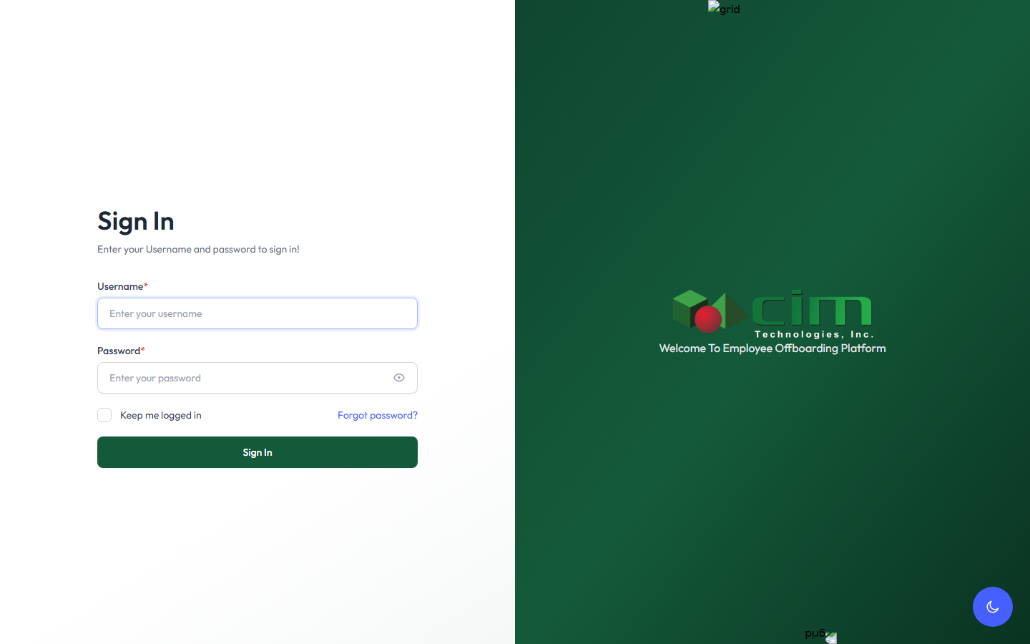
Figure 1.1 — The Sign In page.

2. Navigating to the Approval Module
Once logged in, you will be directed to your dashboard. Go to the Approval page (labeled “Your Approval”) to review every offboarding checklist currently assigned to you and awaiting your action.
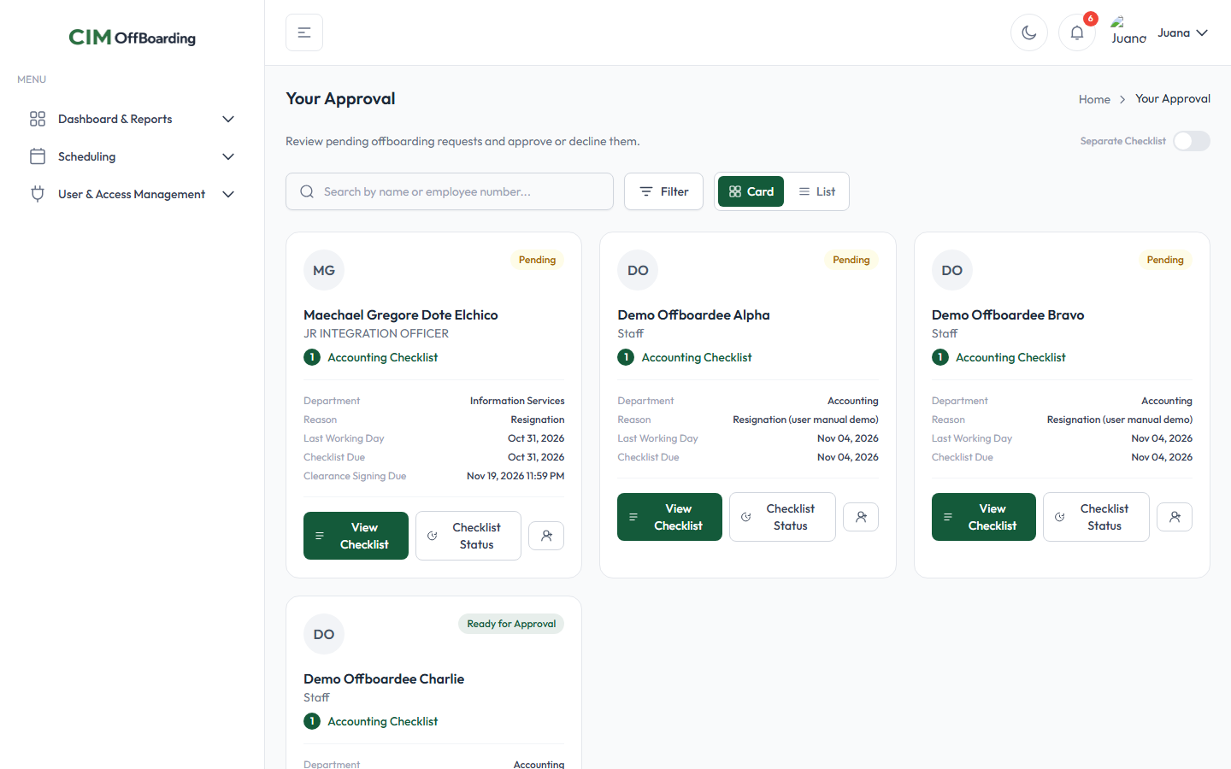
Figure 2.1 — The Your Approval page, listing every checklist currently assigned to you.
Each card on this page represents one checklist assigned to you for a specific employee being offboarded. The colored badge in the top-right corner of each card (e.g. “Pending”, “Ready for Approval”) shows the checklist’s current status at a glance.

3. The Checklist Card — View Checklist, Checklist Status, Assign Checklist

Each checklist card provides three actions:
- View Checklist — opens the checklist itself, where you review tasks, check off completed items, save progress, decline/hold, or approve. You can open this either by clicking this button or by clicking anywhere on the card.
- Checklist Status — opens a read-only timeline showing the full history and current progress of this employee’s offboarding, including every action taken so far (submitted, viewed, declined, hold removed, etc.).
- Assign Checklist (icon-only button) — lets you reassign every not-yet-completed task on this checklist to another employee, when needed.
Figure 3.1 — A checklist card showing the View Checklist, Checklist Status, and Assign Checklist buttons.

4. Viewing a Checklist — Task Status, Saving Progress, Declining, Holding, and Approving
Clicking the card itself or the View Checklist button opens the full checklist. Here you can see every task, who it is assigned to, and its current status, and you can act on it.
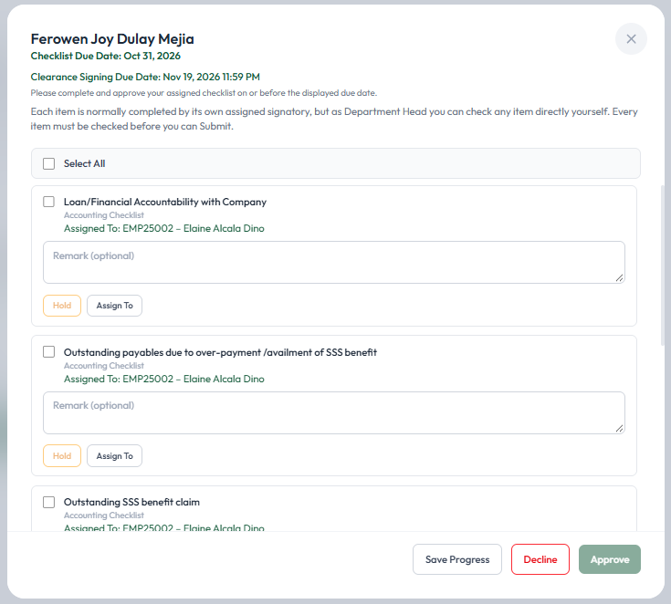
Figure 4.1 — The checklist view, listing every task with its assignee and a Remark field.

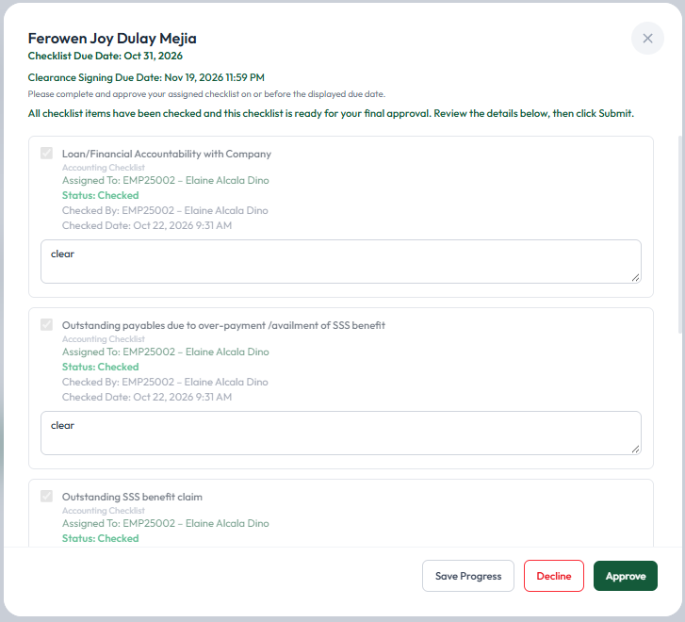
Figure 4.2 — The checklist view, listing every task cleared by its assignee and their remark.

As the Department Head/Clearance Signatory, you are able to check any item yourself, even if it is normally completed by its own assigned signatory. Every item must be checked before the checklist can be submitted for approval.

5. Save Progress
If you want to mark one or more tasks as checked/cleared, tick the checkbox for each completed task, then click Save Progress. This records that the selected task(s) have been checked by you, the Department Head/Clearance Signatory.

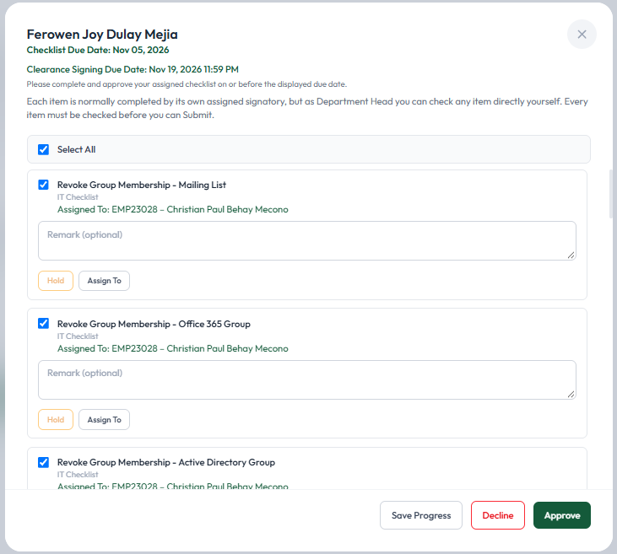
Figure 5.1 — Tasks checked and ready to save.
Once saved, a confirmation notification appears and the checklist’s progress is updated immediately — no need to reload the page.
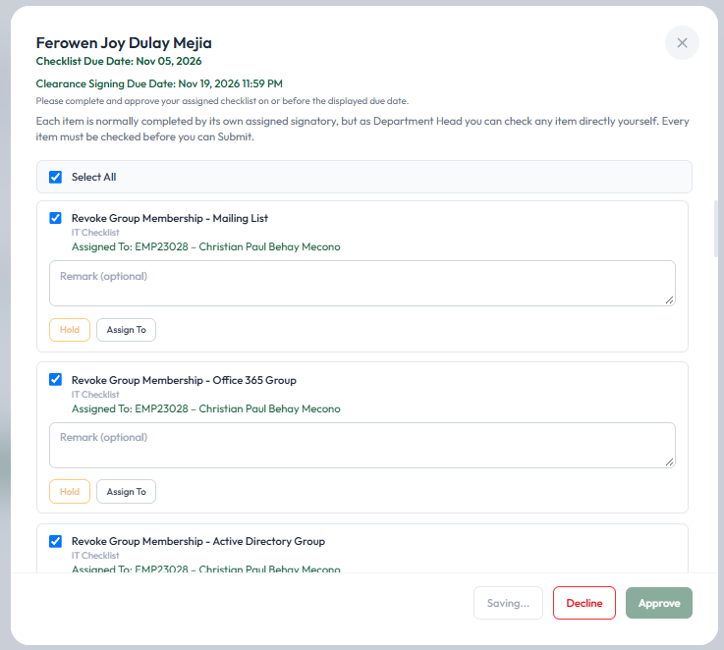
Figure 5.2 — Progress is being saved.

6. Decline (Place On Hold)
If you need to hold the checklist for some reason — for example, pending clearance, a personal reason, or any other valid cause — click Decline. You will be required to provide a remark explaining why the checklist is being declined/held before you can confirm.

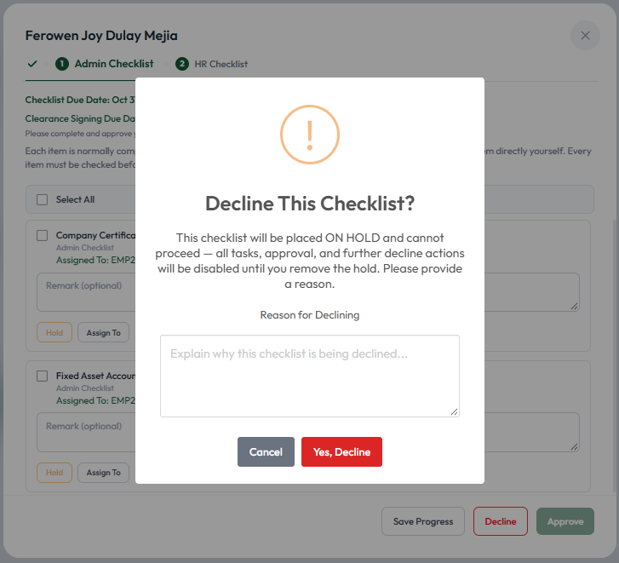
Figure 6.1 — The Decline confirmation prompt, requiring a reason.
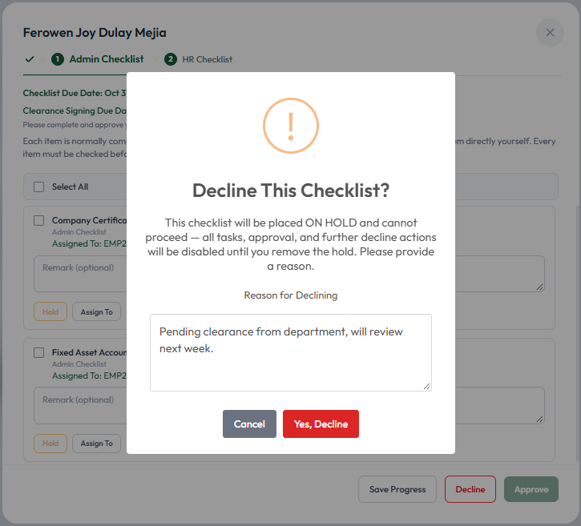
Figure 6.2 — Reason entered, ready to confirm with “Yes, Decline”.
Once confirmed, the checklist is placed On Hold. All tasks, approval, and further decline actions are disabled until the hold is removed. The reason you provided is recorded and shown on the checklist.

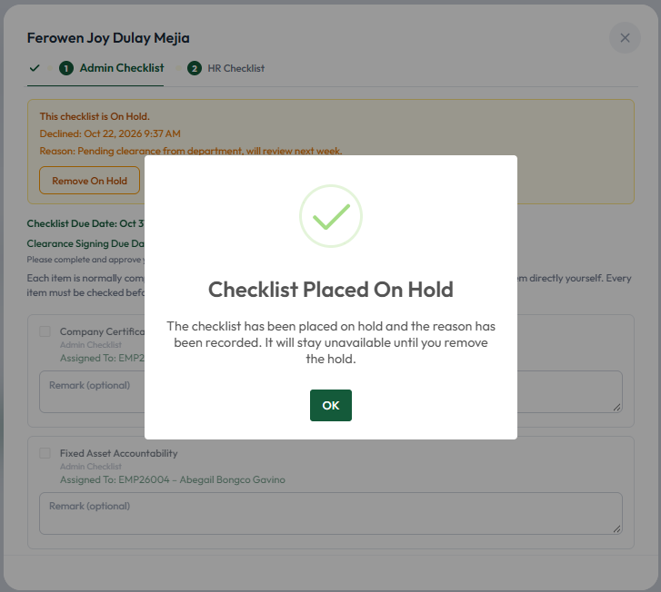
Figure 6.3 — The checklist is now On Hold, with the recorded reason displayed.

7. Remove On Hold
When you are ready to resume processing a checklist you previously placed on hold, click Remove On Hold. This changes the checklist’s status from On Hold back to in progress, which means you can now continue working on and eventually approve the checklist. You are required to provide a remark when removing the hold as well.

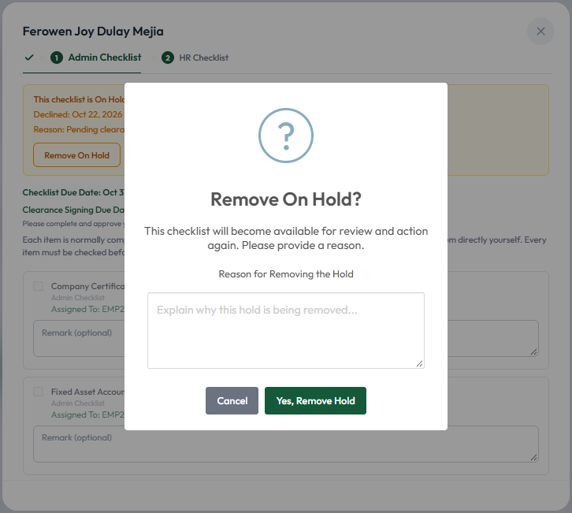
Figure 7.1 — Confirming the removal of the hold, with a remark.
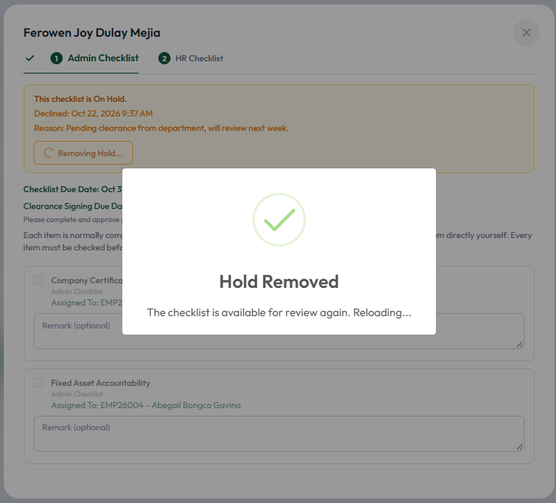
Figure 7.2 — Hold successfully removed; the checklist is available for review again.

8. Approve
The Approve button only becomes available once every task on the checklist has been checked/cleared — whether by the task assignee(s) themselves or by you directly. Once all items are checked, review the details, then click Approve to submit your final approval for this checklist.

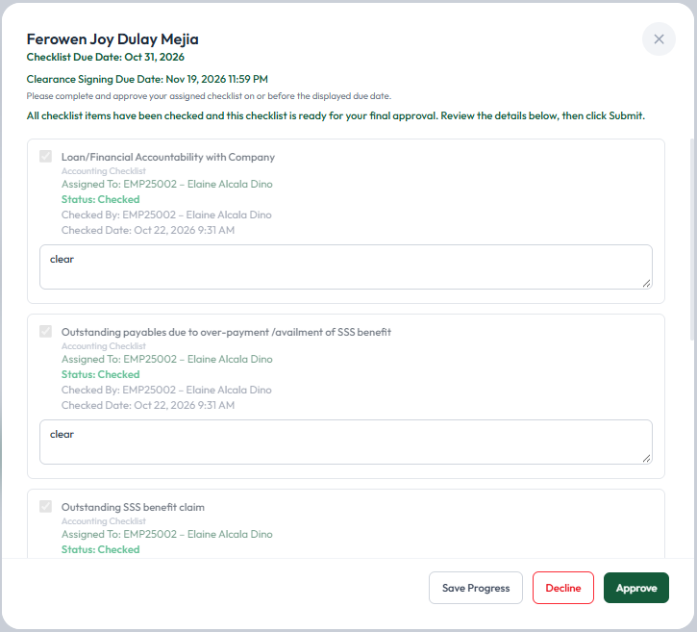
Figure 8.1 — All items checked; Approve is now enabled.
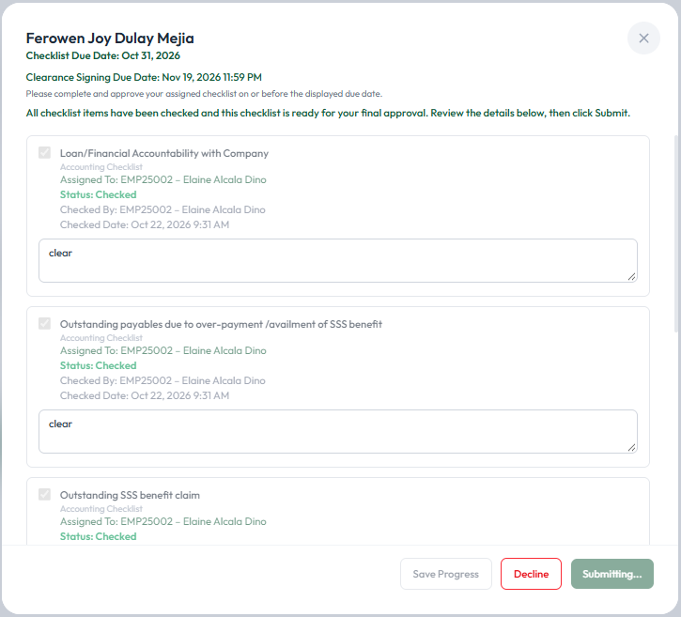
Figure 8.2 — Submitting the approval.

9. Notifications

Upon successfully Saving Progress, Declining, Removing a Hold, or Approving a checklist, the system automatically generates a confirmation notification so you always know your action was recorded.
In addition, once every task on a checklist assigned to you has been completed by the task assignee(s), the system automatically notifies you — both as an in-app notification (via the bell icon) and by email — that the checklist is now ready for your review and final approval.

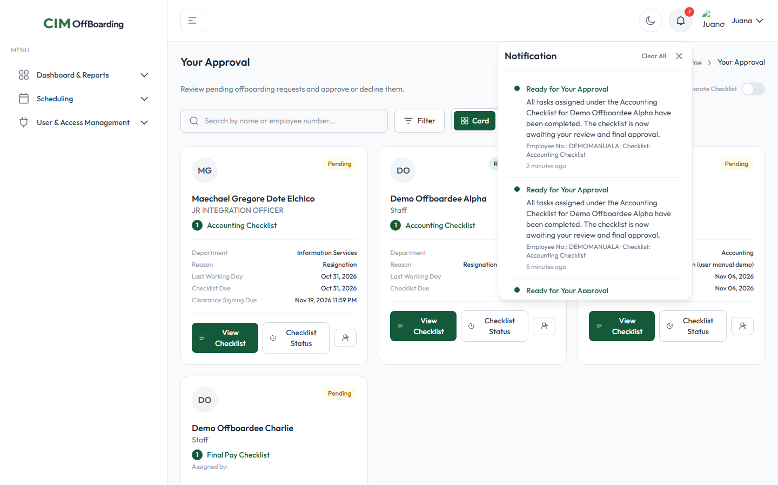
Figure 9.1 — An in-app “Ready for Your Approval” notification in the bell dropdown.

10. Approving a Checklist via Email
You do not always need to log in to approve a checklist. When a checklist assigned to you is fully completed and ready, the email notification you receive includes a secure link. Opening that link shows a confirmation page where you can approve the checklist with a single click, without needing to sign in.

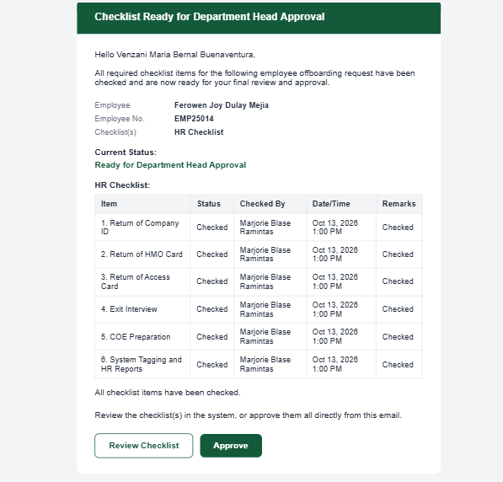
Figure 10 — The email notification format received by assigned Approver.

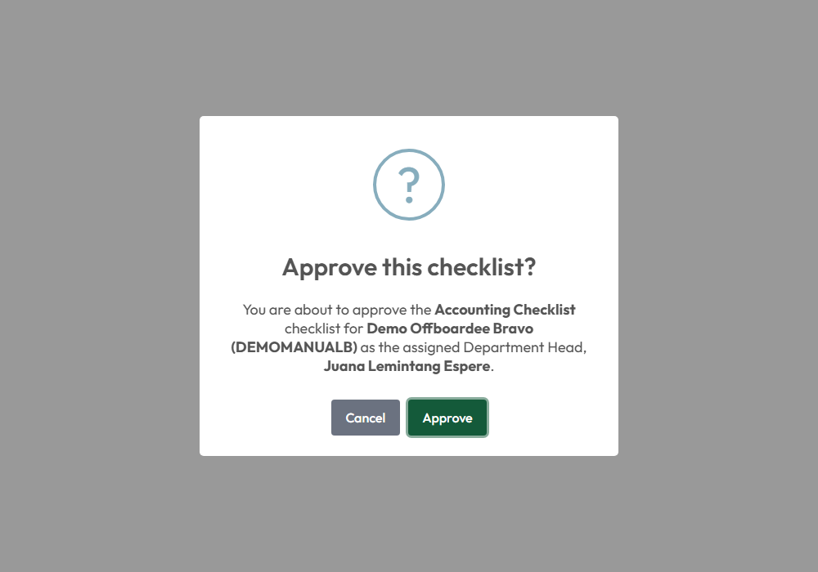
Figure 10.1 — The email approval confirmation page, reached directly from the notification email.

11. Checklist Status — Viewing Offboarding Progress

To see the complete history and current progress of an employee’s offboarding — not just this one checklist, but every milestone reached so far — click Checklist Status on the card. This opens a read-only timeline.

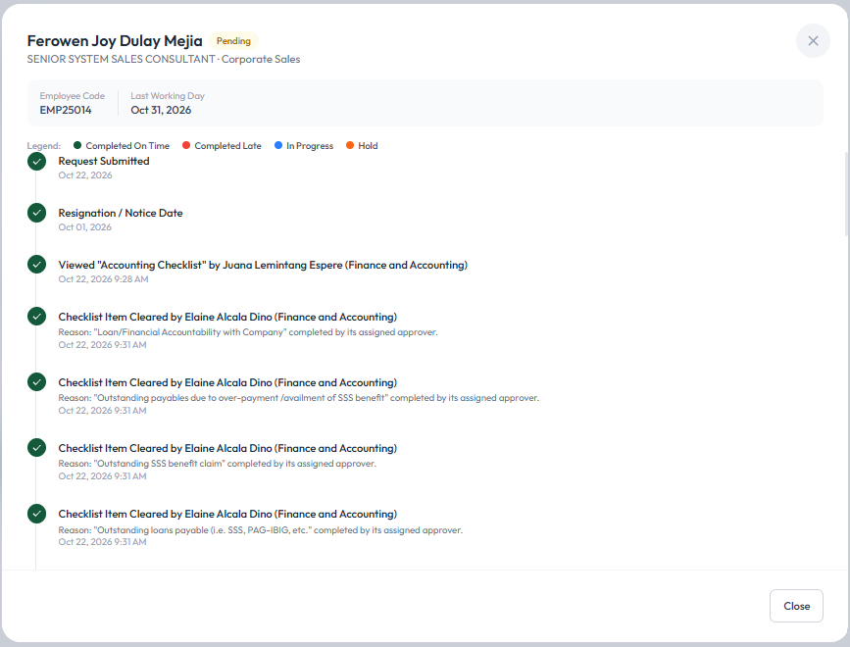
Figure 11.1 — The Checklist Status timeline, showing every action taken on this offboarding case so far.

12. Assign Checklist — Assigning/Reassigning Tasks

If a checklist (or part of it) needs to be handled by someone else, click the Assign Checklist button on the card. This lets you reassign every not-yet-completed task on the checklist to another employee. The original assignee, if any, keeps access to their own previously assigned tasks.

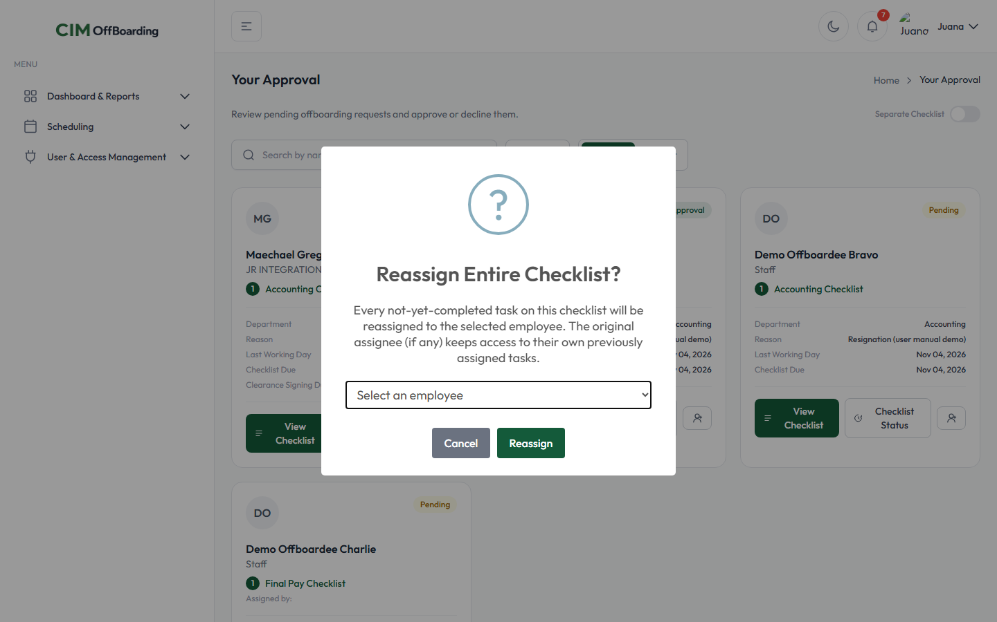
Figure 12.1 — Reassigning an entire checklist to another employee.

13. After Approval
Once you approve a checklist, it is considered fully resolved on your end. The checklist automatically disappears from your Approval page — it no longer requires any action from you. (If every regular checklist for that employee has also been completed, the system may automatically move the case forward to its next stage, such as a Final Pay Checklist, which will then appear on your Approval page if you are responsible for it.)

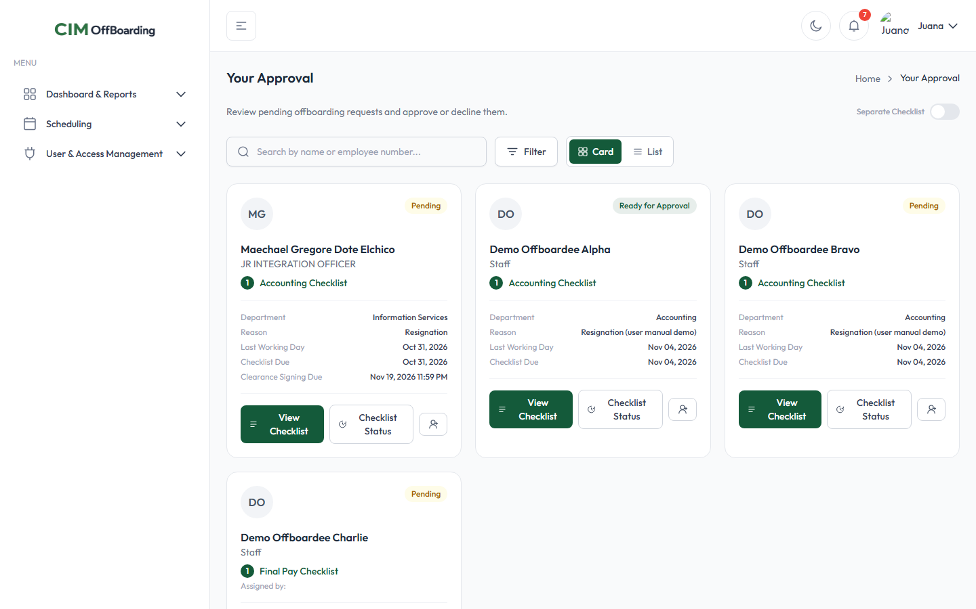
Figure 13.1 — The Approval page after approving a checklist — it no longer appears in the list.

