CIM OffBoarding
Task Assignee User Manual
How to Sign In, Find Your Assigned Tasks, and Clear or Hold Them
Version 1.0

1. Introduction
This manual is for Task Assignees — employees handed one or more individual checklist tasks within someone else’s offboarding checklist, without owning the whole checklist themselves. It walks through signing in, finding your assigned tasks, checking or clearing them, placing a task on hold, and claiming a visible-but-unassigned task through "Process Task List."
Every screenshot in this manual is a real, step-by-step capture from the running application using disposable demo data — no real employee’s personal information appears anywhere in it.

2. Signing In
Go to the CIM OffBoarding sign-in page and enter the username and password given to you by HR/Admin.

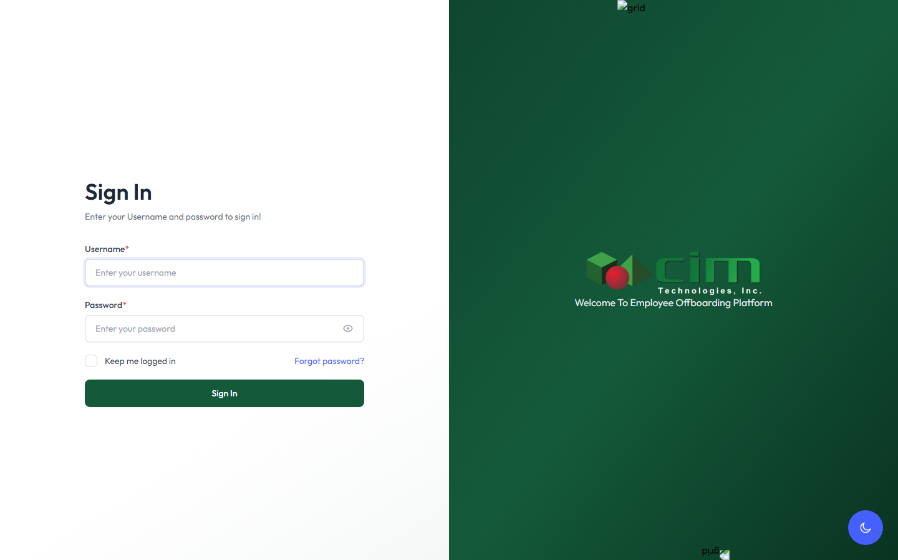
Figure 1 — The sign-in page.
Fill in your username and password, then click Sign In.
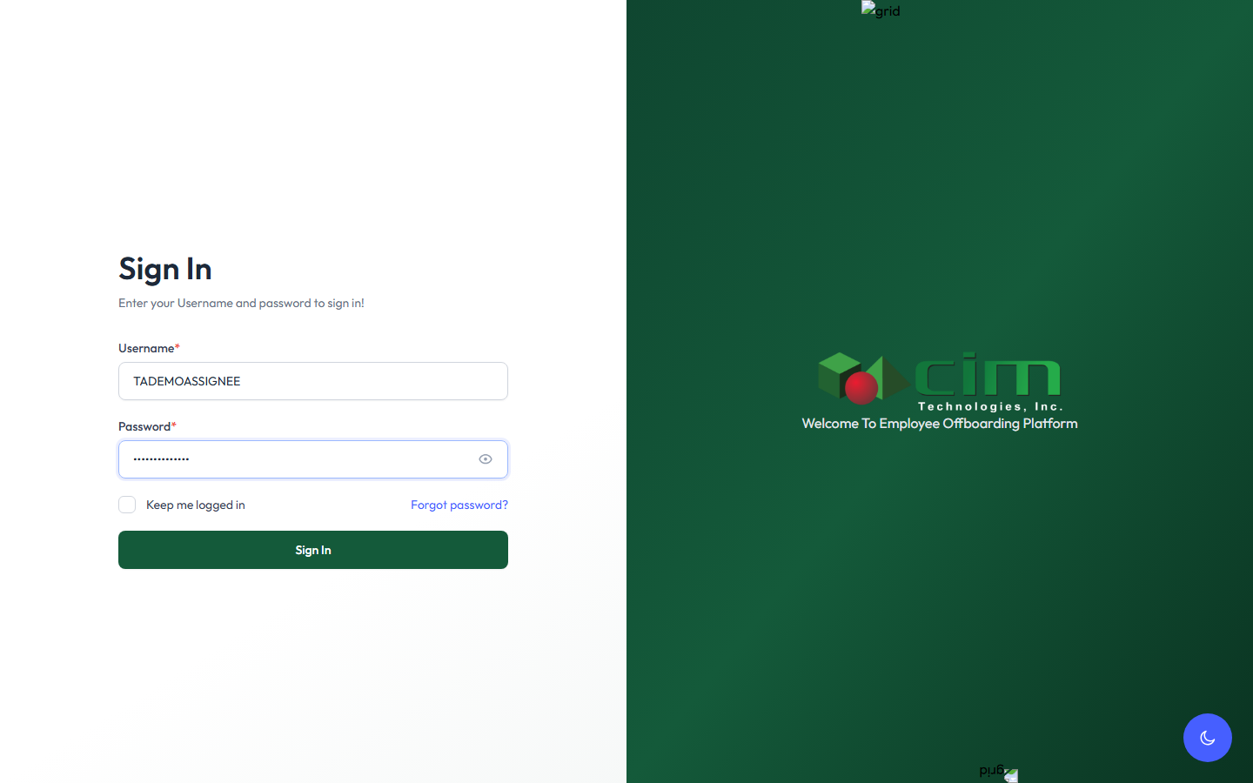
Figure 2 — Credentials entered, ready to sign in.

3. Navigating to the Approval Module
Once signed in, open Approval under the Dashboard & Reports menu on the left sidebar. This page lists every checklist that has at least one task assigned to you.
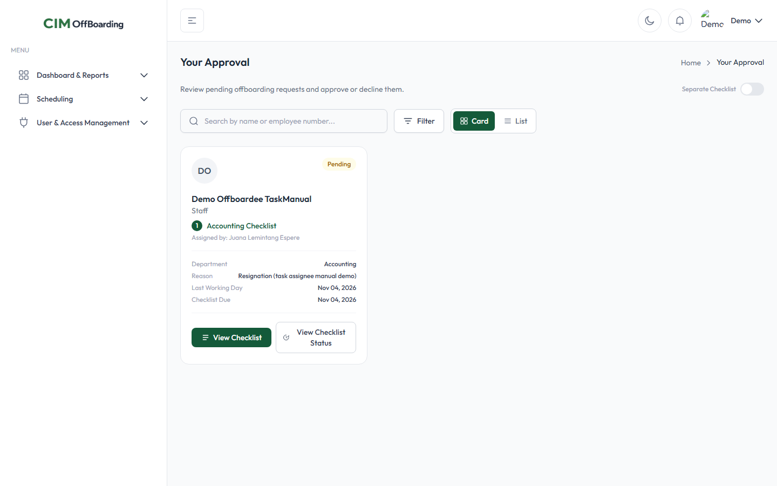
Figure 3 — The Approval page, reached from Dashboard & Reports.

4. Viewing Your Task Status
Each card represents one offboardee’s checklist. To view your task status, process your task list, or check/clear a task, either click the card itself or click the View Checklist button on it.
Figure 4 — A checklist card: View Checklist and View Checklist Status buttons.
Clicking either one opens the same checklist window, showing every task on that checklist — including which ones are assigned to you ("Assigned To: ... (You)") and which belong to someone else.

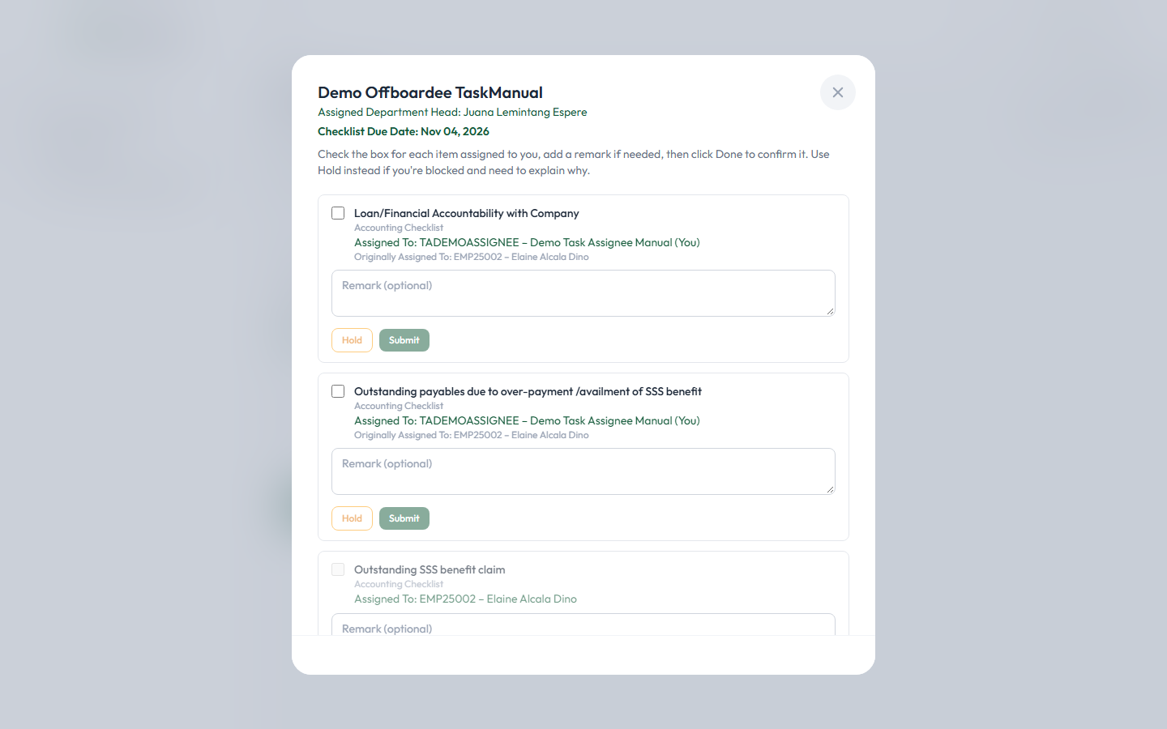
Figure 5 — The checklist window. Tasks assigned to you show Hold/Submit; a task not assigned to you shows Process Task List instead.

5. Checking or Clearing a Task

For a task assigned to you, tick its checkbox first. You can also add a remark explaining what you did, if needed — remarks are optional here. Once ready, click Submit.
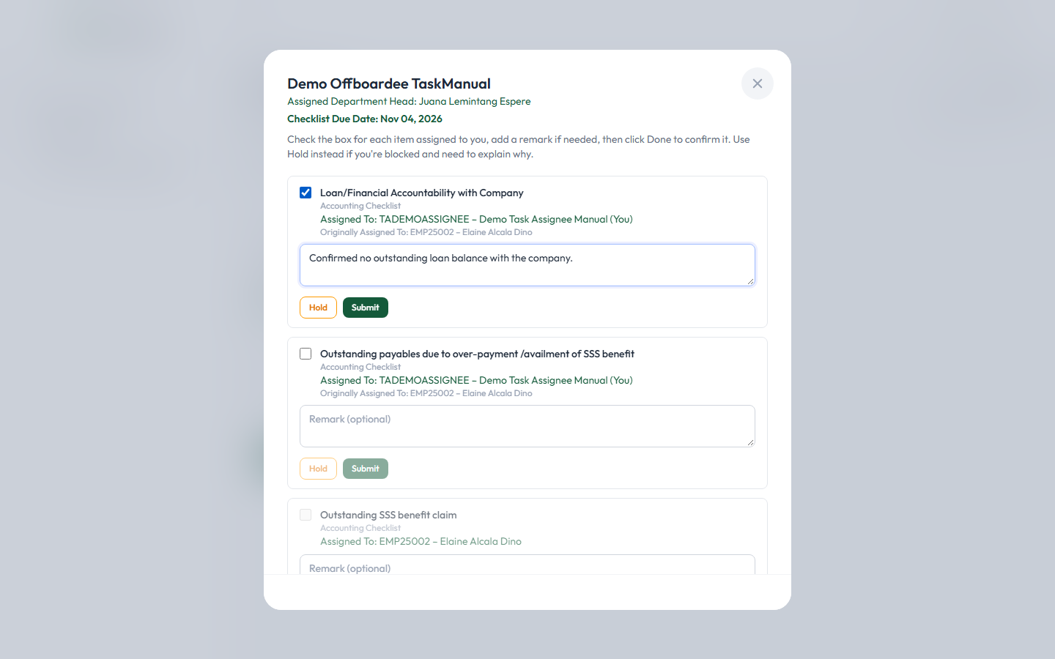
Figure 6 — A task ticked, with an optional remark added.
After clicking Submit, the task is saved immediately — you’ll see a confirmation toast, and the task’s checkbox and remark box become locked, showing who checked it and when. There is no "uncheck" action anywhere in the application once a task is submitted this way, so be sure before confirming.

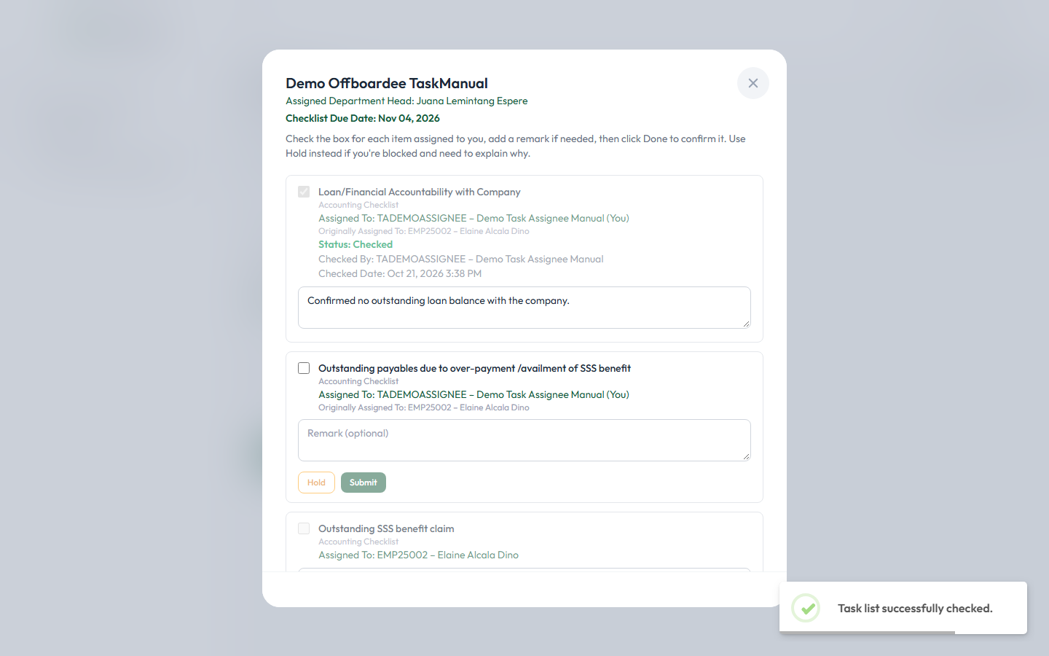
Figure 7 — Confirmation toast after a task is successfully submitted.

6. Placing a Task on Hold

If you need to pause a task instead of completing it, use Hold. A remark is required before you can hold a task — the Hold button itself stays disabled (greyed out) until you’ve typed something in the remark box.
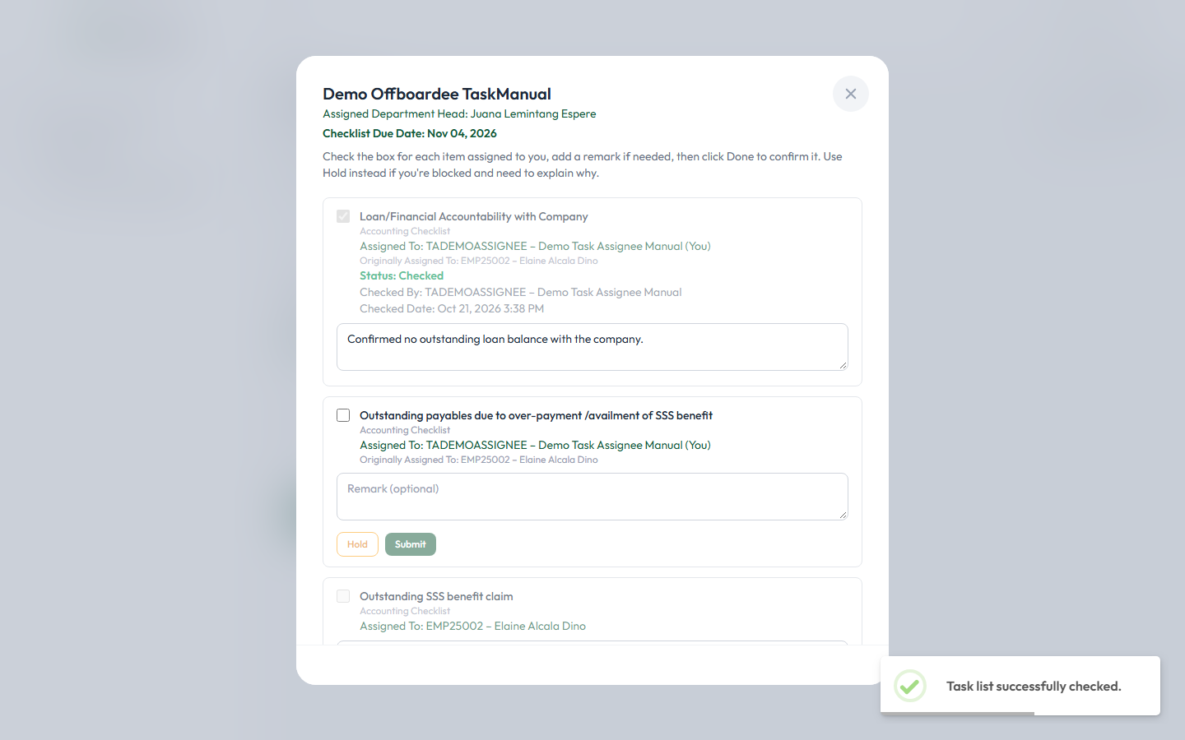
Figure 8 — With no remark typed yet, the Hold button is disabled.
Type your remark explaining why the task is blocked, then the Hold button becomes clickable.

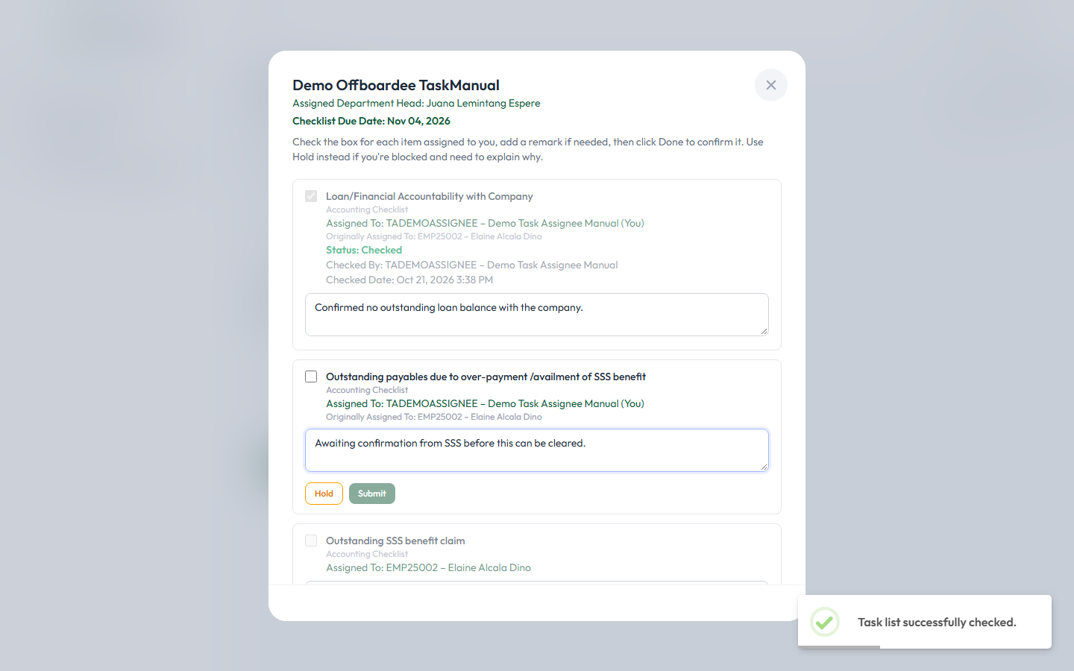
Figure 9 — A remark typed in; Hold is now enabled.
Click Hold to place the task on hold. Unlike a checked task, a held task is not locked — you can still check it or hold it again later with an updated remark.

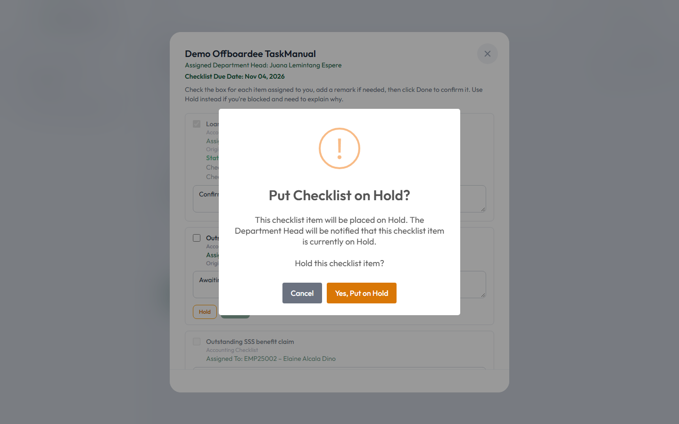
Figure 10 — The task now shows "Status: Hold."

7. Claiming a Task Not Yet Assigned to You — Process Task List
Sometimes a task list is visible on your checklist card, but isn’t assigned to you specifically — its checkbox and Hold/Submit buttons stay disabled, and a Process Task List button appears instead. Clicking it lets you voluntarily take full responsibility for that task.
Clicking Process Task List asks you to confirm — once you do, you are taking responsibility for checking, clearing, or holding that task yourself.
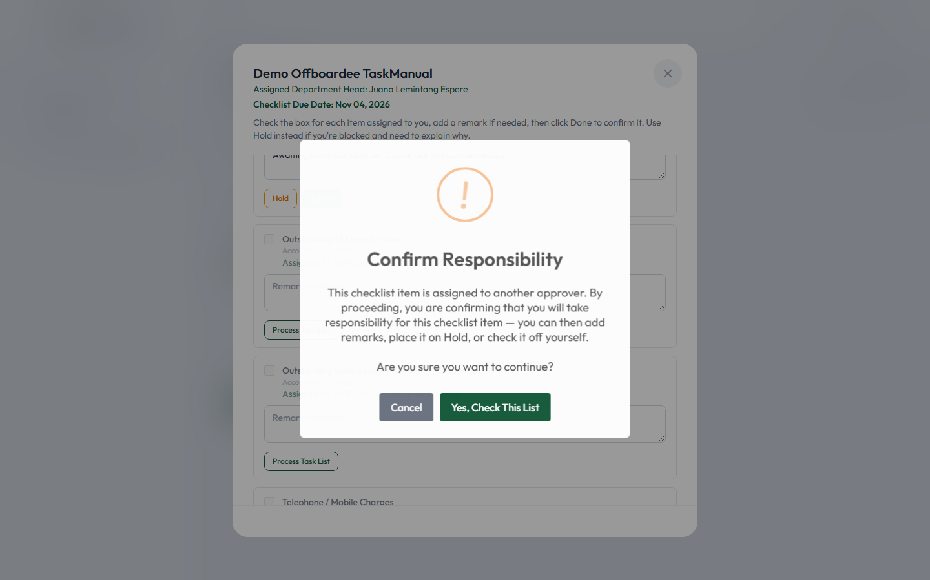
Figure 11 — The confirmation prompt shown after clicking Process Task List.
Once confirmed, the task’s checkbox, remark box, Hold button, and Submit button all become available — exactly like a task that was assigned to you directly.

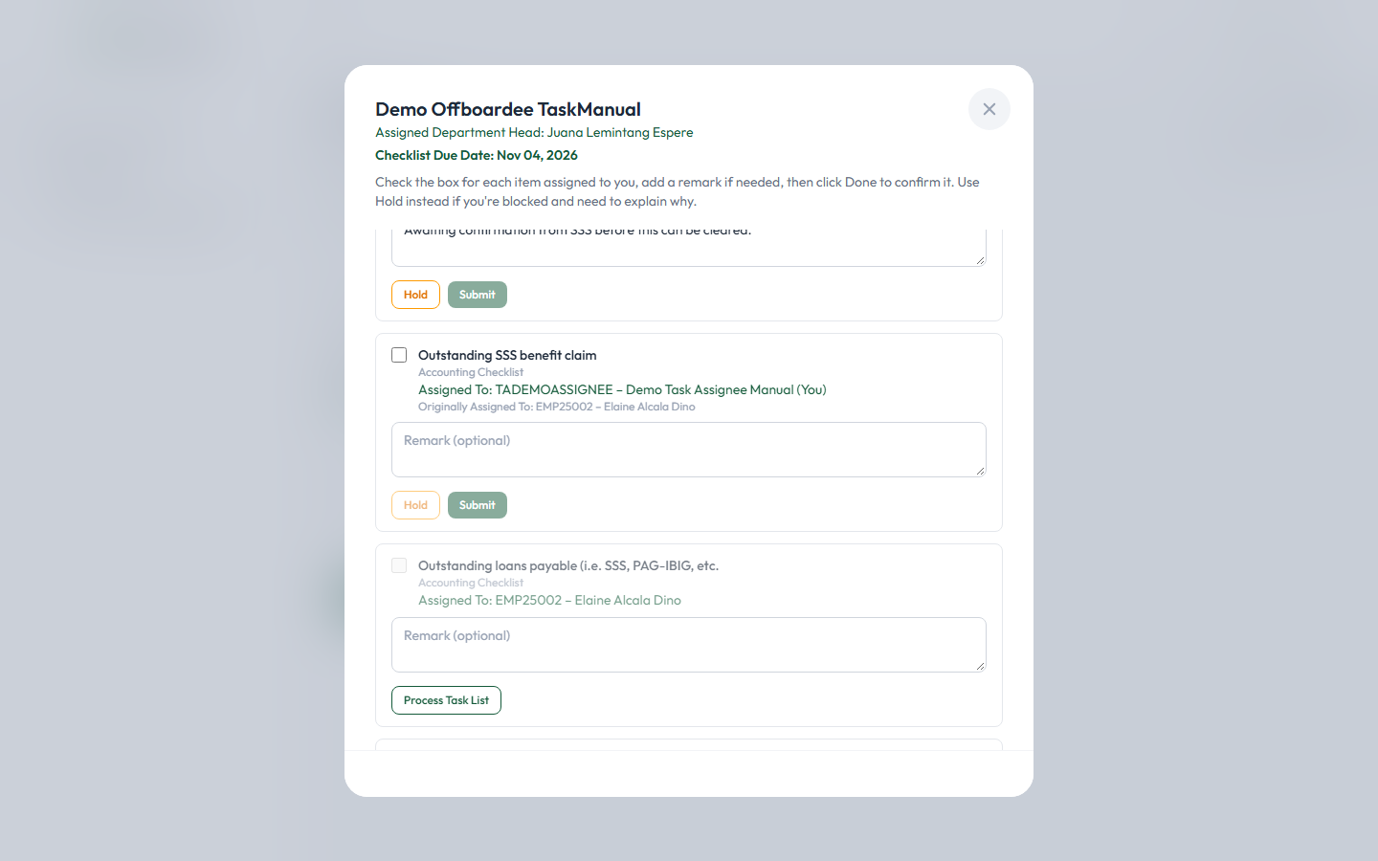
Figure 12 — After confirming, the task becomes fully editable, now showing "Assigned To: ... (You)."
Only claim a task through Process Task List when you’re genuinely the right person to handle it — this action is meant for a real, voluntary pickup, not for acting on a coworker’s task on their behalf.

8. Viewing Your Offboarding Progress
To see the full timeline of an offboarding request — including every action taken on its checklist so far — click the View Checklist Status button on the card.

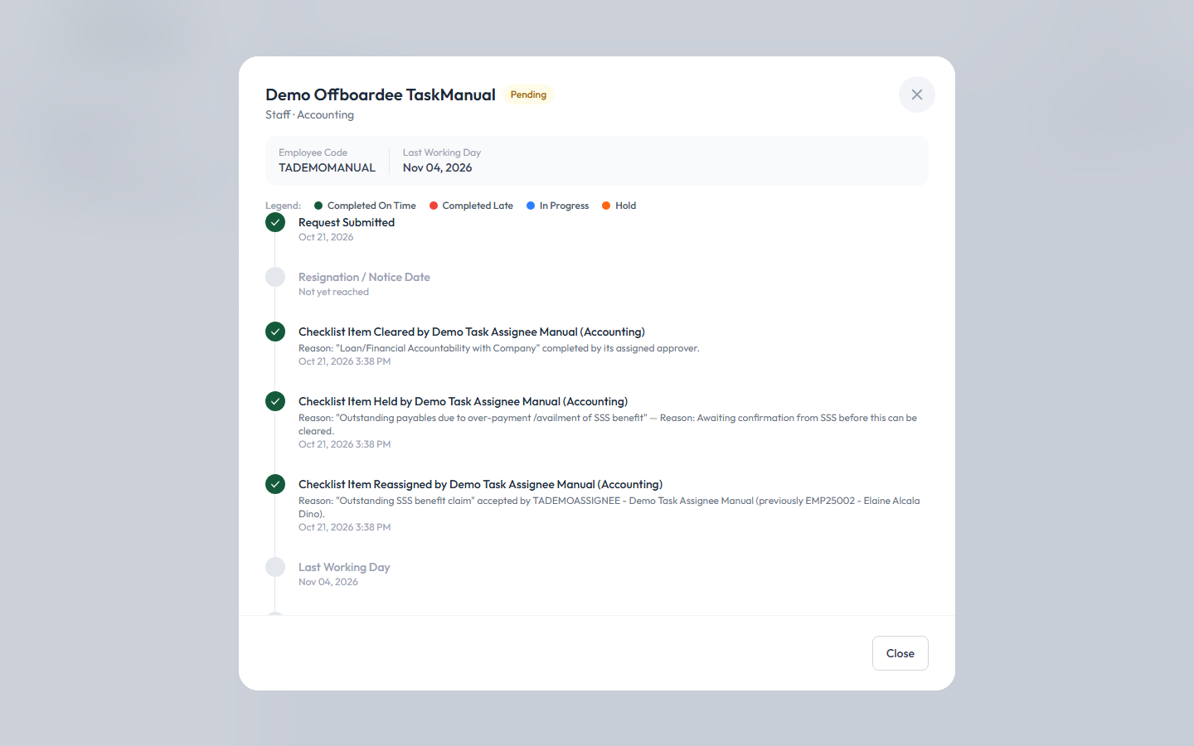
Figure 13 — The Offboarding Status timeline, showing every checklist action with who did it and when.

9. What Happens After You Finish Your Tasks

Completing your own task(s) does not by itself approve the whole checklist. Once every task on the checklist — not just the ones assigned to you — is checked, the checklist’s Clearance Signatory is automatically notified (by email and in-app) that it’s ready for their review and final approval.
The checklist itself stays visible on your Approval page, now showing your own tasks as fully checked (or on hold), until the Clearance Signatory actually gives their approval — at that point it disappears from the Approval page for everyone involved, including you. You don’t need to do anything further once you’ve submitted your own tasks.

10. Quick Reference
Action | What It Does
View Checklist (click the card or the button) | Opens the checklist window showing all tasks, including yours and others’.
Tick checkbox + Submit | Checks off a task assigned to you. Locked once submitted — cannot be undone.
Remark box + Hold | Pauses a task assigned to you. A remark is required before Hold becomes clickable.
Process Task List | Voluntarily claims a visible task not yet assigned to you, unlocking it for you to check, clear, or hold.
View Checklist Status | Opens the full offboarding timeline for that request.

