Clinical trial report: three treatments for anxiety
  - Día 4 · Bloque 2 — Ejercicio 3 (SOLUCIONES)
Filip Andras - CIMCYC, Universidad de Granada
2026-10-15

Introduction
A randomised clinical trial compared two treatments for anxiety, cognitive-behavioural therapy (CBT) and pharmacological treatment, against a control group. Anxiety was measured with the Beck Anxiety Inventory (BAI) (Beck et al., 1988) before and after treatment. This report describes the sample, visualises the change and tests whether the change in anxiety depends on the treatment.
Note. The data are synthetic: they were simulated for the course Introducción a la programación y análisis de datos en R (CIMCYC, Universidad de Granada) to practise the full workflow, from data to report. No real patients took part, and no clinical conclusion should be drawn from the results.

Data
All analyses were run in R (R Core Team, 2026), using RStudio (Posit team, 2026) as the development environment, with the packages afex (Singmann et al., 2025), emmeans (Lenth & Piaskowski, 2026), ggplot2 (Wickham, 2016) and gtsummary (Sjoberg et al., 2021); the versions are listed in the session information at the end.
The trial included 300 patients, allocated to three groups of 100, 100 and 100 patients (CBT, control, pharmacological). Table 1 summarises the sample before and after treatment.

Table 1: the sample by group
Table 1: Anxiety (BAI) by treatment group before and after treatment: n, mean and SD
Group | n | Mean before | SD before | Mean after | SD after
CBT | 100 | 15.1 | 2.1 | 10.8 | 2.8
control | 100 | 15.7 | 2.1 | 15.2 | 2.5
pharmacological | 100 | 15.7 | 2.2 | 12.7 | 2.7

Figure 1: anxiety before and after treatment
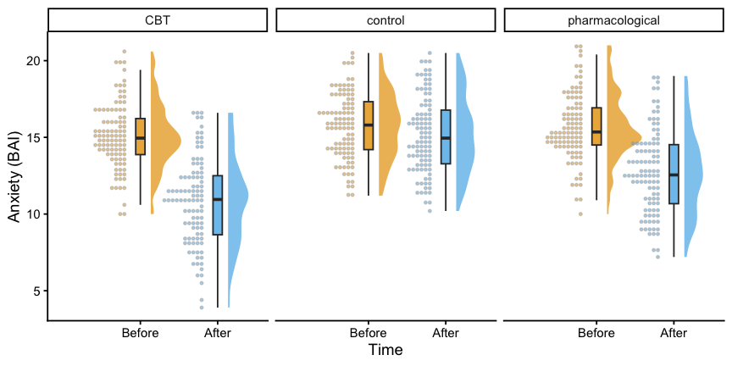
Figure 1: Anxiety (BAI) before and after treatment in each group. Cloud: density; box: median and quartiles; dots: individual patients.
As Figure 1 shows, the three groups are similar before treatment; afterwards, the control group remains above the two treated groups.

Analysis: does the change in anxiety depend on the treatment?

The model
The design has one between-subjects factor (group: CBT, pharmacological, control) and one within-subjects factor (time: before vs. after), so the question is a mixed ANOVA (Day 3): the effect of interest is the group × time interaction, i.e. whether the change from before to after differs between groups.

Assumptions
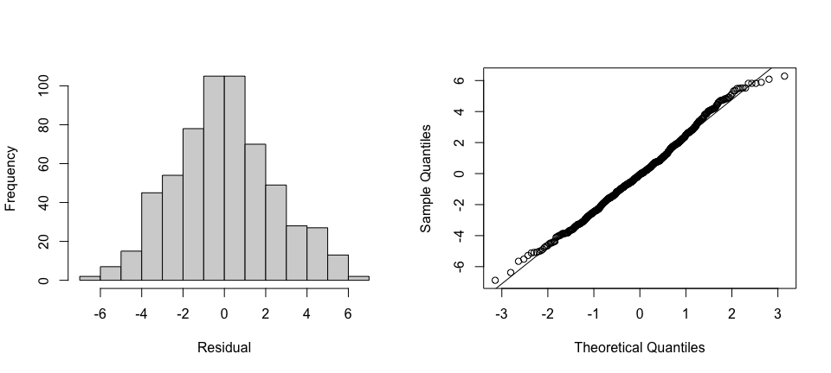
Figure 2: Residuals of the mixed ANOVA. Left: histogram; right: normal Q-Q plot.
Figure 2 shows residuals that are close to normal, with a slightly short lower tail, and no pattern that would question the model. Sphericity is not an issue with only two levels of the within-subjects factor (a single difference, after − before).

Results
Anxiety decreased from before to after treatment overall, main effect of time: F(1, 297) = 788.06, p <0.001, η²_{g} = 0.22; and the groups differed on average, main effect of group: F(2, 297) = 29.99, p <0.001, η²_{g} = 0.15. Crucially, the group × time interaction was significant, F(2, 297) = 138.91, p <0.001, η²_{g} = 0.09: the change in anxiety depended on the treatment.
Every number in that sentence is inline code that indexes tabla_mixto with [row, column]; it is written by hand because, unlike the correlation and the t-test (Day 3), a mixed ANOVA cannot yet be reported automatically with easystats::report(). To unpack the interaction, Table 2 reports the before − after change within each group (simple effects of time), and Table 3 compares the three groups at each time point, before and after treatment; both with the Holm correction (Holm, 1979).
Table 2: Change in anxiety (before - after) within each group: simple effects of time (Holm correction)
Group | Comparison | Mean difference | SE | p (Holm)
CBT | Before - After | 4.303 | 0.161 | <0.001
control | Before - After | 0.564 | 0.161 | <0.001
pharmacological | Before - After | 2.939 | 0.161 | <0.001

Table 3: Differences between groups at each time point, before and after treatment (Holm correction)
Time | Comparison | Mean difference | SE | p (Holm)
Before | CBT - control | -0.654 | 0.305 | 0.099
Before | CBT - pharmacological | -0.572 | 0.305 | 0.124
Before | control - pharmacological | 0.082 | 0.305 | 0.788
After | CBT - control | -4.393 | 0.381 | <0.001
After | CBT - pharmacological | -1.936 | 0.381 | <0.001
After | control - pharmacological | 2.457 | 0.381 | <0.001

Anxiety fell by 4.3 points in the CBT group and by 2.9 points in the pharmacological group, against 0.6 points in the control group (Table 2). Before treatment, no group differed from another; after treatment, all three pairwise differences were significant (Table 3).

Conclusion
After treatment, mean anxiety was 10.8 points in the CBT group, 12.7 in the pharmacological group and 15.2 in the control group. Both treatments reduced anxiety more than the control condition did, CBT somewhat more than medication, as the group × time interaction shows; the three-month follow-up is not yet included in this report.

References
Beck, A. T., Epstein, N., Brown, G., & Steer, R. A. (1988). An inventory for measuring clinical anxiety: Psychometric properties. Journal of Consulting and Clinical Psychology, 56(6), 893–897. https://doi.org/10.1037/0022-006X.56.6.893
Holm, S. (1979). A simple sequentially rejective multiple test procedure. Scandinavian Journal of Statistics, 6(2), 65–70.
Lenth, R. V., & Piaskowski, J. (2026). Emmeans: Estimated marginal means, aka least-squares means. https://doi.org/10.32614/CRAN.package.emmeans
Posit team. (2026). RStudio: Integrated development environment for r. Posit Software, PBC. https://posit.co/
R Core Team. (2026). R: A language and environment for statistical computing. R Foundation for Statistical Computing. https://doi.org/10.32614/R.manuals
Singmann, H., Bolker, B., Westfall, J., Aust, F., & Ben-Shachar, M. S. (2025). Afex: Analysis of factorial experiments. https://doi.org/10.32614/CRAN.package.afex
Sjoberg, D. D., Whiting, K., Curry, M., Lavery, J. A., & Larmarange, J. (2021). Reproducible summary tables with the gtsummary package. The R Journal, 13, 570–580. https://doi.org/10.32614/RJ-2021-053
Wickham, H. (2016). ggplot2: Elegant graphics for data analysis. Springer-Verlag New York. https://ggplot2.tidyverse.org

Session information for reproducibility
Which R, which packages and which versions produced this report: anyone can check them if a result does not reproduce.
R version 4.6.1 (2026-06-24)
Platform: aarch64-apple-darwin23
Running under: macOS Tahoe 26.4.1
Matrix products: default
BLAS: /Library/Frameworks/R.framework/Versions/4.6/Resources/lib/libRblas.0.dylib
LAPACK: /Library/Frameworks/R.framework/Versions/4.6/Resources/lib/libRlapack.dylib; LAPACK version 3.12.1
locale:
[1] C
time zone: Europe/Madrid
tzcode source: internal
attached base packages:
[1] stats graphics grDevices utils datasets methods base
other attached packages:
[1] ggdist_3.3.3 emmeans_2.0.4 afex_1.5-1 lme4_2.0-6 Matrix_1.7-6 here_1.0.2 lubridate_1.9.5
[8] forcats_1.0.1 stringr_1.6.0 dplyr_1.2.1 purrr_1.2.2 readr_2.2.0 tidyr_1.3.2 tibble_3.3.1
[15] ggplot2_4.0.3 tidyverse_2.0.0
loaded via a namespace (and not attached):
[1] tidyselect_1.2.1 farver_2.1.2 S7_0.2.2 fastmap_1.2.0 TH.data_1.1-5
[6] digest_0.6.39 estimability_2.0.0 timechange_0.4.0 lifecycle_1.0.5 survival_3.8-12
[11] magrittr_2.0.5 compiler_4.6.1 rlang_1.3.0 tools_4.6.1 yaml_2.3.12
[16] knitr_1.52 labeling_0.4.3 bit_4.6.0 plyr_1.8.9 RColorBrewer_1.1-3
[21] abind_1.4-8 multcomp_1.4-32 withr_3.0.3 numDeriv_2016.8-1.1 grid_4.6.1
[26] xtable_1.8-8 scales_1.4.0 MASS_7.3-66 cli_3.6.6 mvtnorm_1.4-2
[31] rmarkdown_2.32 crayon_1.5.3 reformulas_0.4.4 generics_0.1.4 otel_0.2.0
[36] reshape2_1.4.5 tzdb_0.5.0 minqa_1.2.8 splines_4.6.1 parallel_4.6.1
[41] vctrs_0.7.3 boot_1.3-32 sandwich_3.1-3 jsonlite_2.0.0 carData_3.0-6
[46] car_3.1-5 hms_1.1.4 bit64_4.8.6 Formula_1.2-6 glue_1.8.1
[51] nloptr_2.2.1 codetools_0.2-20 distributional_0.9.0 stringi_1.8.9 gtable_0.3.6
[56] quadprog_1.5-8 lmerTest_3.2-1 pillar_1.11.1 htmltools_0.5.9 R6_2.6.1
[61] Rdpack_2.6.6 rprojroot_2.1.1 vroom_1.7.1 evaluate_1.0.5 lattice_0.23-1
[66] rbibutils_2.4.1 Rcpp_1.1.2 coda_0.19-4.1 nlme_3.1-171 xfun_0.61
[71] zoo_1.9-1 pkgconfig_2.0.3

