How to use this document
This document provides you with the general structure of an IEC publication and some information about individual elements. Links to more detailed information can be found in the individual sections.
Basic formatting instructions are provided for Word 2007 and later.
Typographical conventions in this template
- Content in red needs to be provided by you. Please revert the font colour to black once you have adapted it.
- Content in black is boilerplate text and cannot be modified.
- Additional explanations appear in blue with a red border; a special style (IEC INSTRUCTIONS) was created for this purpose.

To format text, use the styles from the IEC template.
Some are available in the IEC tools tab:
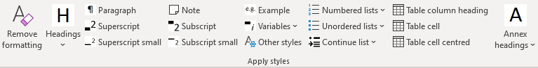
Others can be accessed from Word's Styles panel – consult the user guide to the IEC template for more information.

Table of contents
- To update the table of contents below, click on it and press F9. Do the same for the list of figures and the list of tables.
- To create a new table of contents, delete the old one and click on Table of contents in the IEC tools tab.
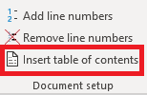
- If updating the table of contents produces an error message, please use Word's built-in feature to create a table of contents (in the Reference tab, click on Table of contents and select one you like). At CDV stage, we will insert the correct table at the IEC.

CONTENTS

FOREWORD 3
INTRODUCTION 5
1 Scope 6
2 Normative references 6
Standard boilerplate text: 6
Boilerplate text if no references are listed: 6
3 Terms and definitions 6
Standard boilerplate text: 6
Terms and definitions listed in a different document: 6
No terms and definitions listed: 7
4 Title of next clause (heading level 1) 8
4.1 Title of subclause (heading level 2) 8
4.1.1 Title of next subclause (heading level 3) 8
Annex A (informative/normative) Annex title 11
A.1 First annex heading (optional) 11
Bibliography 13

Figure 1 – Figure title 8
Figure A.1 – Figure title 10
Figure A.2 – Figure title 11

Table 1 – Table title 8
Table A.1 – Table title 11
Table A.2 – Table title 11

INTERNATIONAL ELECTROTECHNICAL COMMISSION
____________

MAIN TITLE IN CAPITAL LETTERS

Part X: Second part of the title in normal letters

For rules on the drafting of the title, refer to the ISO/IEC Directives, Part 2:2021, Clause 11.

The foreword is a mandatory element of the text.
For rules on the drafting of the foreword, refer to the ISO/IEC Directives, Part 2:2021, Clause 12.

FOREWORD
1) The International Electrotechnical Commission (IEC) is a worldwide organization for standardization comprising all national electrotechnical committees (IEC National Committees). The object of IEC is to promote international co-operation on all questions concerning standardization in the electrical and electronic fields. To this end and in addition to other activities, IEC publishes International Standards, Technical Specifications, Technical Reports, Publicly Available Specifications (PAS) and Guides (hereafter referred to as “IEC Publication(s)”). Their preparation is entrusted to technical committees; any IEC National Committee interested in the subject dealt with may participate in this preparatory work. International, governmental and non-governmental organizations liaising with the IEC also participate in this preparation. IEC collaborates closely with the International Organization for Standardization (ISO) in accordance with conditions determined by agreement between the two organizations.
2) The formal decisions or agreements of IEC on technical matters express, as nearly as possible, an international consensus of opinion on the relevant subjects since each technical committee has representation from all interested IEC National Committees.
3) IEC Publications have the form of recommendations for international use and are accepted by IEC National Committees in that sense. While all reasonable efforts are made to ensure that the technical content of IEC Publications is accurate, IEC cannot be held responsible for the way in which they are used or for any misinterpretation by any end user.
4) In order to promote international uniformity, IEC National Committees undertake to apply IEC Publications transparently to the maximum extent possible in their national and regional publications. Any divergence between any IEC Publication and the corresponding national or regional publication shall be clearly indicated in the latter.
5) IEC itself does not provide any attestation of conformity. Independent certification bodies provide conformity assessment services and, in some areas, access to IEC marks of conformity. IEC is not responsible for any services carried out by independent certification bodies.
6) All users should ensure that they have the latest edition of this publication.
7) No liability shall attach to IEC or its directors, employees, servants or agents including individual experts and members of its technical committees and IEC National Committees for any personal injury, property damage or other damage of any nature whatsoever, whether direct or indirect, or for costs (including legal fees) and expenses arising out of the publication, use of, or reliance upon, this IEC Publication or any other IEC Publications.
8) Attention is drawn to the Normative references cited in this publication. Use of the referenced publications is indispensable for the correct application of this publication.
9) Attention is drawn to the possibility that some of the elements of this IEC Publication may be the subject of patent rights. IEC shall not be held responsible for identifying any or all such patent rights.
IEC 6XXXX has been prepared by subcommittee XX: TITLE, of IEC technical committee XX: TITLE. It is […an International Standard, a Technical Specification: specify document type…].
In the case of a new edition replacing a previous edition, complete the following text. In the case of a first edition, delete it, as it does not apply.
This XXX edition cancels and replaces the XXX edition published in [publication_date], Amendment 1:[publication_date] and Amendment 2:[publication_date]. This edition constitutes a technical revision.
This edition includes the following significant technical changes with respect to the previous edition:
- ...;

The text of this […International Standard, Technical Specification: specify document type…] is based on the following documents:
Draft | Report on voting
XX/XX/FDIS | XX/XX/RVD
Full information on the voting for its approval can be found in the report on voting indicated in the above table.
The language used for the development of this […International Standard, Technical Specification: specify document type…] is English [change language if necessary].
This document was drafted in accordance with ISO/IEC Directives, Part 2, and developed in accordance with ISO/IEC Directives, Part 1 and ISO/IEC Directives, IEC Supplement, available at https://www.iec.ch/members_experts/refdocs. The main document types developed by IEC are described in greater detail at https://www.iec.ch/standardsdev/publications.
The committee has decided that the contents of this document will remain unchanged until the stability date indicated on the IEC website under webstore.iec.ch in the data related to the specific document. At this date, the document will be
- reconfirmed,
- withdrawn,
- replaced by a revised edition, or
- amended.

INTRODUCTION
The introduction is an optional/conditional element of the text.
For rules on the drafting of the introduction, refer to the ISO/IEC Directives, Part 2:2021, Clause 13.
If patent rights have been identified, register the relevant declarations in the IEC patents database (https://patents.iec.ch) and include the notice below in the introduction. If the document is not affected by patent declarations, delete the text below.
For rules on patents, see ISO/IEC Directives, Part 1.
The International Electrotechnical Commission (IEC) draws attention to the fact that it is claimed that compliance with this document may involve the use of a patent. IEC takes no position concerning the evidence, validity, and scope of this patent right.
The holder of this patent right has assured IEC that s/he is willing to negotiate licences under reasonable and non-discriminatory terms and conditions with applicants throughout the world. In this respect, the statement of the holder of this patent right is registered with IEC. Information may be obtained from the patent database available at https://patents.iec.ch/.
Attention is drawn to the possibility that some of the elements of this document may be the subject of patent rights other than those in the patent database. IEC shall not be held responsible for identifying any or all such patent rights.

MAIN TITLE IN CAPITAL LETTERS

Part X: Second part of the title in normal letters

Scope
This document / This part of IEC 6XXXX specifies / establishes / ...
Delete the text that does not apply.
The Scope clause is a mandatory element of the text.
For rules on the drafting of the Scope, refer to the ISO/IEC Directives, Part 2:2021, Clause 14.

Normative references
The Normative references clause is a mandatory element of the text.
For rules on the drafting of the Normative references, refer to the ISO/IEC Directives, Part 2:2021, Clause 15.
There are two different options for the Normative reference boilerplate text –
select the one that corresponds to your case.

Standard boilerplate text:
The following documents are referred to in the text in such a way that some or all of their content constitutes requirements of this document. For dated references, only the edition cited applies. For undated references, the latest edition of the referenced document (including any amendments) applies.

Boilerplate text if no references are listed:
There are no normative references in this document.

Terms and definitions

Standard boilerplate text:
For the purposes of this document, the following terms and definitions apply.
ISO and IEC maintain terminological databases for use in standardization at the following addresses:
- IEC Electropedia: available at https://www.electropedia.org/
- ISO Online browsing platform: available at https://www.iso.org/obp

Terms and definitions listed in a different document:
For the purposes of this document, the terms and definitions given in [external document reference] apply.
ISO and IEC maintain terminological databases for use in standardization at the following addresses:
- IEC Electropedia: available at https://www.electropedia.org/
- ISO Online browsing platform: available at https://www.iso.org/obp

Terms and definitions listed in a different document and in this document:
For the purposes of this document, the terms and definitions given in [external document reference] and the following apply.
ISO and IEC maintain terminological databases for use in standardization at the following addresses:
- IEC Electropedia: available at https://www.electropedia.org/
- ISO Online browsing platform: available at https://www.iso.org/obp

No terms and definitions listed:
No terms and definitions are listed in this document.
ISO and IEC maintain terminological databases for use in standardization at the following addresses:
- IEC Electropedia: available at https://www.electropedia.org/
- ISO Online browsing platform: available at https://www.iso.org/obp

To insert terms and definitions, use the Insert term form from the IEC tools tab.
If the tab does not appear on your screen, make sure the IEC template is attached to your working document, and consult the user guide.
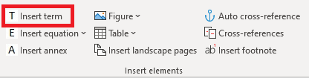

The Terms and definitions clause is a mandatory element of the text.
For rules on the drafting of the Terms and definitions, refer to the ISO/IEC Directives, Part 2:2021, Clause 16.
There are two different options for the Terms and definitions boilerplate text –
select the one that corresponds to your case.

term 1
definition 1
EXAMPLE 1 First example for term 1.
EXAMPLE 2 Second example for term 1.
Note 1 to entry: First note for term 1.
Note 2 to entry: Second note for term 1.
[SOURCE: where definition 1 was found]

term 2
definition 2
EXAMPLE Only one example for term 2 – no numbering.
Note 1 to entry: Only one note for term 2 – still needs to be numbered.

Title of next clause (heading level 1)

Title of subclause (heading level 2)

Title of next subclause (heading level 3)

Title of next subclause (heading level 4)

Title of next subclause (heading level 5)

Title of next subclause (heading level 6 – maximum level for IEC publications)

Organization and subdivision of an IEC document
The full requirements are described in the ISO/IEC Directives, Part 2:2021, Clause 6.

For rules on the drafting of figures, refer to the ISO/IEC Directives, Part 2:2021, Clause 28.

To create a new figure title / table title with automatic numbering, click on Figure / Table in the IEC tools tab. A new title will be inserted, with the corresponding sequential numbering value.
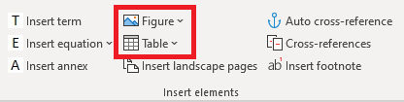
There are five options for both Figure and Table:
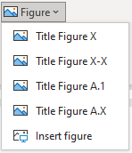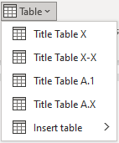
- Title Figure X/Title Table X: inserts a figure/table title with sequential numbering.
- Title Figure X-X/Title Table X-X: inserts a figure/table title with sequential numbering preceded by the clause number in which the figure/table appears (e.g. Figure 4-3 is the third figure of Clause 4).
Important: do not mix the Figure X/Table X and Figure X-X/Table X-X numbering formats within a document. Figure X/Table X is the preferred numbering format; if you use Figure X-X/Table X-X, this numbering format must be applied consistently in all documents of a series (see the ISO/IEC Directives, Part 2:2021, 28.3 and 29.3).
- Title Figure A.1/Title Table A.1: inserts a figure/table title with sequential numbering reset to 1. To be used for the first figure/table of an annex.
- Title Figure A.X/Title Table A.X: inserts a figure/table title with sequential numbering after the first figure/table of an annex.
- Insert figure/Insert table: opens Word's built-in controls for inserting figures and tables.
Important: When you insert a new title above other titles with automatic numbering, these numbers will not update by themselves.
To update the numbers of figure and table titles, select them and press F9.


Figure 1 – Figure title

For rules on the drafting of tables, refer to the ISO/IEC Directives, Part 2:2021, Clause 29.
Table 1 – Table title
Column heading 1 | Column heading 2 | Column heading 3
Table text – centred | Table text – left aligned | Table text – left aligned
Table text – centred | Table text – left aligned | Table text – left aligned

For rules on the drafting of mathematical formulae, refer to the ISO/IEC Directives, Part 2:2021, Clause 27.

Mathematical formulae
To insert a formula, click on the Insert Equation button on the IEC tools tab
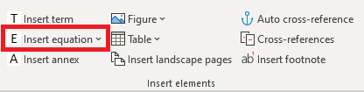
The following options appear:
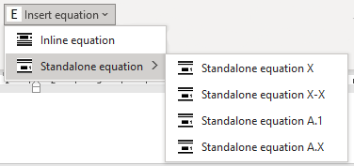
- Inline equation: use this option to insert an equation within continuous text.
- Standalone equation: inserts an equation centred on the page, on a new line, with sequential numbering. The numbering options are:
  - X: from 1 to n in the main text of the document;
  - X-X: from 1 to n preceded by the clause number in which the equation appears (format [Clause]-[Equation number], similar to Figure/Table X-X) (see the ISO/IEC Directives, Part 2:2021, 27.3);
  - A.1: use for the first equation of an annex;
  - A.X: use for subsequent equations in an annex.
- Also adds a list for the descriptions of symbols used in the equation.
The parameters for fonts and font size need to be configured on your computer. For details, see: https://www.iec.ch/standardsdev/%20resources/draftingpublications/writing_editing/IEC_rules/equations.htm
Which equation editor to use
It is recommended to use MathType/Wiris for composing formulae in documents. The reason for this preference is that MathType produces consistent and repeatable results that are fit for publishing, even with complex expressions.
MS Word includes a basic equation tool in the Insert tab. However, we recommend to avoid using it because it is not capable of handling complex expressions reliably and because it does not allow to define the style settings required for IEC documents. Formulae composed using Microsoft's tool will be converted to MathType if they need to be edited by IEC staff.
IEC does not accept formulae submitted as
• Images or drawings
• LaTex
• MathCAD
Contact IEC if you need help composing or editing formulae.

Using MathType
To create a new equation, click on the MathType tab in MS Word, and select Inline or Display from the Insert Equations group. Inline equations are inserted inline with the text; Display equations are inserted on a new line.
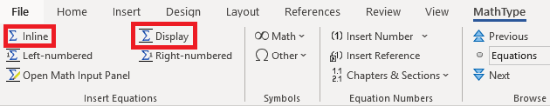
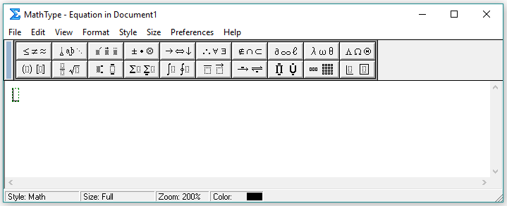

(1)

where
α is the…, expressed in …;
β is the…, expressed in…

- (informative/normative)
Annex title
  - First annex heading (optional)

Annexes are an optional element of the text.
For rules on the drafting of annexes, refer to the ISO/IEC Directives, Part 2:2021, Clause 20.
- To create new annexes, click on Insert annex in the IEC tools tab. A new annex title will be inserted, with a letter corresponding to the next sequential value.
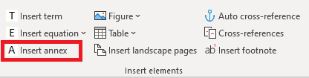
- To restart numbering figures / tables in a new annex (B.1, C.1, D.1...), click on Figure -> Title Figure A.1 / Table -> Title Table A.1. A new figure / table title will be inserted, numbered "A.1".
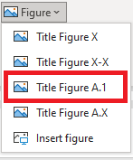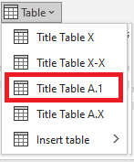
- To create a new figure / table title with continued numbering in an annex (A.2, A.3, A.4 / B.2, C.2...), click on Figure -> Title Figure A.X / Table -> Title Table A.X. A new figure/table title will be inserted, with sequential numbering.
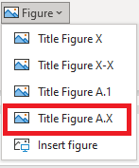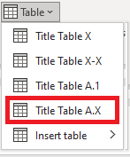
Important: When you move figures/tables and their titles to a different place in the document, or when you insert a new figure/table title above existing ones, the figure/table numbers will not update by themselves.
To update them, select them and press F9.

Figure A.1 – Figure title
Figure A.2 – Figure title
Table A.1 – Table title
Column heading 1 | Column heading 2 | Column heading 3
Table text – centred | Table text – left aligned | Table text – left aligned
Table text – centred | Table text – left aligned | Table text – left aligned

Table A.2 – Table title
Column heading 1 | Column heading 2 | Column heading 3
Table text – centred | Table text – left aligned | Table text – left aligned
Table text – centred | Table text – left aligned | Table text – left aligned

Bibliography

The Bibliography is a conditional element of the text.
For rules on the drafting of bibliographies, refer to the ISO/IEC Directives, Part 2:2021, Clause 21.
It is not necessary to number the bibliography, but if it is numbered:
- References shall be numbered consecutively in the order they appear in the text.
- Apply the IEC style BIBLIOGRAPHY-numbered to the references.
DO NOT use endnotes for creating a numbered bibliography.

Bibliographical reference 1
Bibliographical reference 2
Bibliographical reference 3
____________

