**Brief tutorial on the publicly available tools used in “Multi-omics data integration and network-based analysis drives a multiplex drug repurposing approach to a shortlist of candidate drugs against COVID-19”**

In our study we used four publicly available tools: *GeneMANIA (Cytoscape plugin), Pathwalks, CODReS and Chembioserver 2.0*. A brief tutorial for each tool is given below:

**GeneMANIA** (<http://apps.cytoscape.org/apps/genemania>):

GeneMANIA is a Cytoscape plugin that brings several gene function prediction capabilities. GeneMANIA identifies the most related genes to a query gene set using a guilt-by-association approach. It uses many large, publicly available biological datasets of functional interaction networks from multiple organisms and each related gene is identified to the source network used to make the prediction. Users can query their own gene list and create a network by selecting from 7 different interaction types such as: Co-expression, Physical Interaction, Genetic interaction, Attributes, Co-localization, Pathway and Predicted**.**

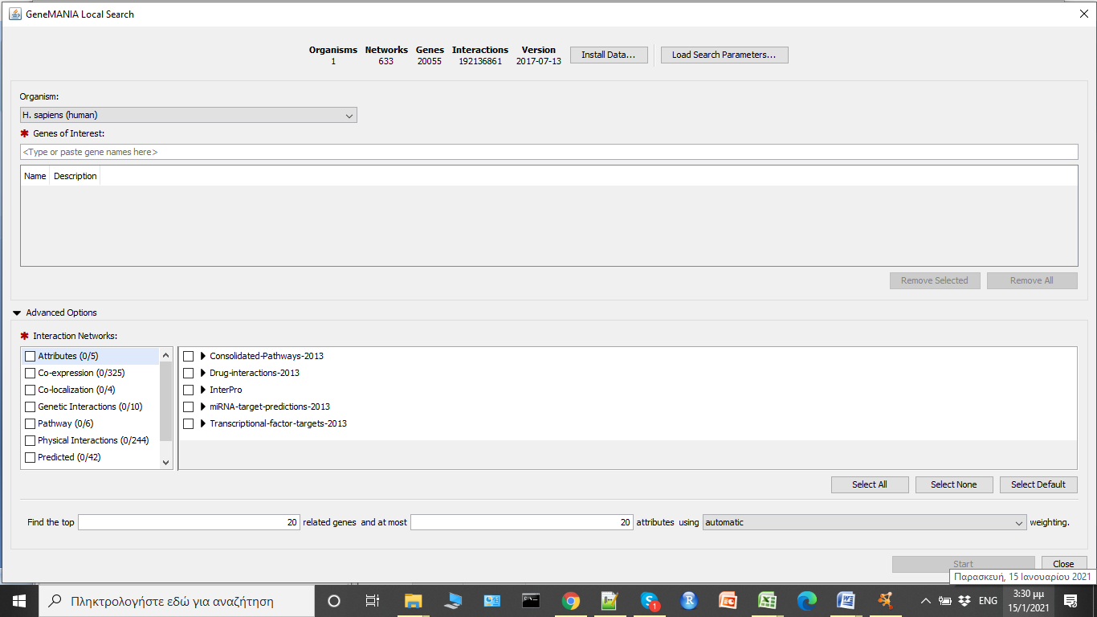

In our study we used as input to GeneMANIA the top 1001 top scored genes based on their score from the integration procedure and we selected the following interaction types: Co-expression, Co-localization, Genetic interaction and Physical interaction to construct the network.

**Pathwalks_parallel** (<https://github.com/vagkaratzas/PathWalks>)

PathWalks is a random walk based algorithm, developed in R language, where a walker crosses a pathway-to-pathway network using a disease-related map. The disease-related map is a gene network that is constructed by integrating multiple information for a specific disease. The most frequent routes of the walker correspond to pathway communities that are expected to be strongly related to the disease of interest.

Pathwalks_parallel is the multi-thread PathWalks version based on the number of input cores and total steps per walker. Pathwalks_parallel required the igraph and do Parallel R packages and as arguments: a gene network, a pathway network, the number of cores to use (default 6), number of steps per core (default 1000), gene restart timer (default 50). The two network files must be in an edgelist form and the gene network must contain gene symbols. Moreover, the pathway network must contain KEGG hsa pathway ids, representing the functional relations between pathways where edge weight corresponds to the number of common genes between two pathways.

In our approach we utilized the Pathwalks_parallel algorithm by giving as a disease-related map our synthetic gene network generated from the integration procedure. For our calculations, we used as arguments 15 walkers, 10000 steps per walker and restart every 50 steps.

**CoDReS** (<http://bioinformatics.cing.ac.cy/codres/>)

CoDReS (Composite Drug Reranking Scoring) is a drug (re-)ranking web-based tool, which combines an initial a-priori score of drugs (e.g. enrichment score) with a functional score of each drug related to the disease of interest as well as with a structural score derived from potential drugability violations. CoDReS calculates a composite (CoDReS) score for each drug, as the normalized weighted sum of the initial a-priori score (aS) with a functional (FS) and a structural score (StS). The default weights for all three components are 1.

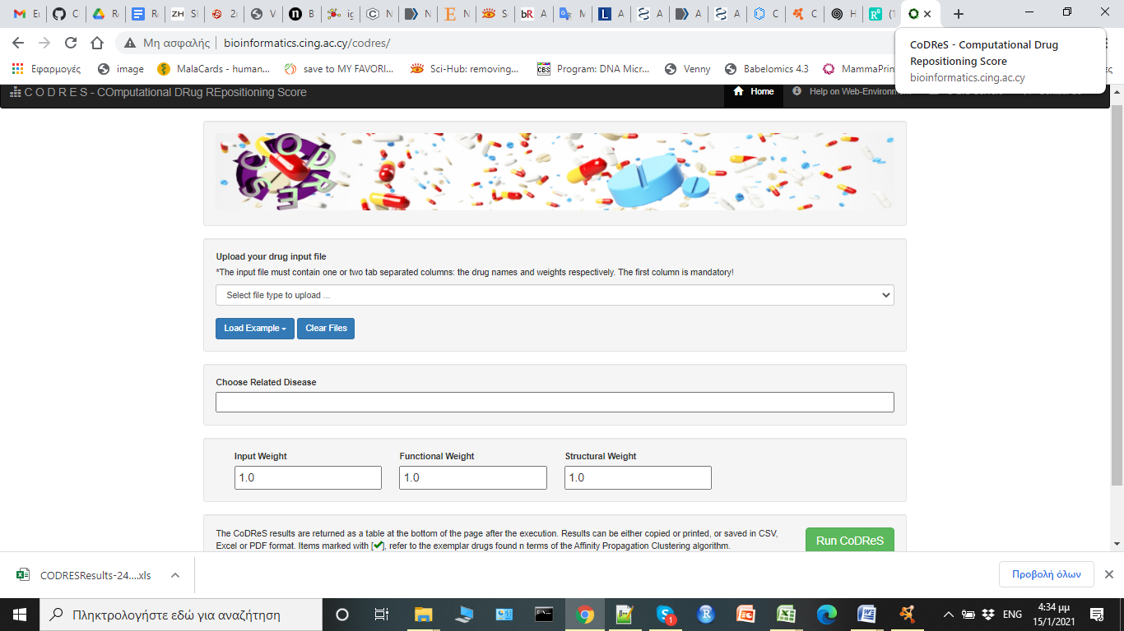

In our study the top 50 host-targeting drugs from the 10 lists were used as input to CoDReS using as a priori score the initial normalized ranking from the repurposing tools and for the case of functional and structural scores the 1001 genes from the integration analysis were used with their disease association scores and the structures (SMILES format) of each drug respectively. The weights that determine the desired influence of each part to the final score of our drugs, were defined as: waS =0.45, wFS =0.45 and wStS =0.1.

ChemBioServer 2.0 (<https://chembioserver.vi-seem.eu/>)

ChemBioServer 2.0 is a web server for filtering, clustering and networking of chemical compound libraries facilitating both drug discovery and repurposing. ChemBioServer 2.0 provides two clustering methods: hierarchical and affinity propagation clustering. Both methods return structural clusters of the input compounds to the users together with their distance matrix as well as a graphical visualization. In the [Hierarchical clustering](https://chembioserver.vi-seem.eu/Dendrogram.php)section, the user is able to upload a file with the structural information of the compounds and then proceed with clustering based on their similar characteristics. Furthermore, users should select the distance and clustering method and the corresponding threshold. The default parameters for the Hierarchical Clustering are: tanimoto coefficient for distance, Ward for linkage and 1 for clustering threshold.

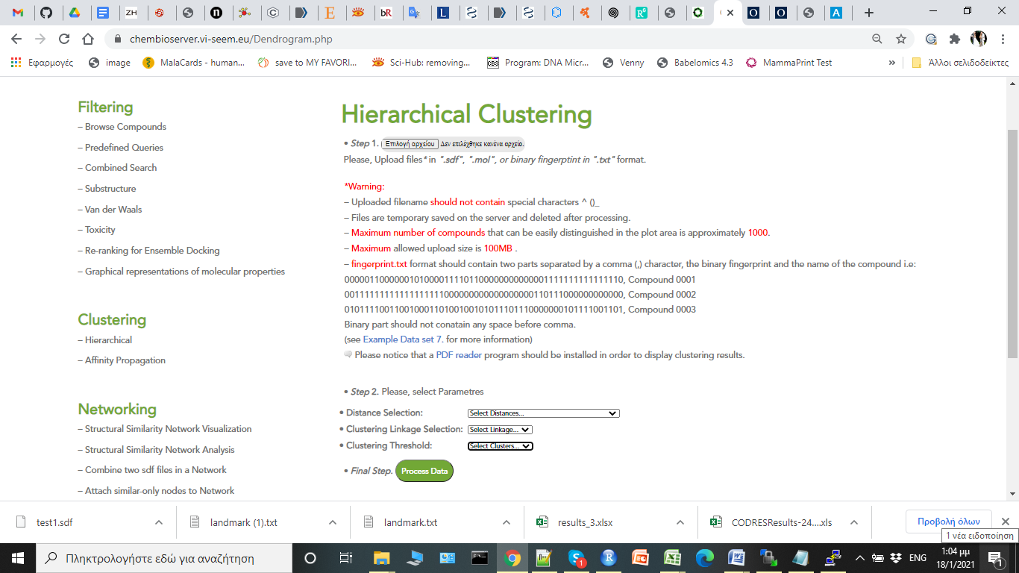

In our study we used the tanimoto coefficient with the ward linkage using as clustering threshold 0.2.