**PhotonSTR-19**

**Structure of this manual**

1. PC requirements.

2. Objective.

3. Scope.

4. Program installation.

5. Program operation.

6. Glossary.

7. References.

1. PC requirements.

Since this program is developed in LabVIEW2017, it can run in any operative system which is capable of running this versión of LabVIEW, nevertheless it is preferable to run in a computer with more or equal to 8Gb of RAM memory.

2. Objective.

The objective of this program is the statistical analysis of processes that vary over time. PhotonSTR-T18 is capable of handling long data batches of scattered photon history and calculate not only the intensity correlation and structure functions in auto mode but, from two independent channels, also in the cross mode of two channels.

3. Scope.

PhotonSTR-T18 can be used to obtain the calculation of the intensity correlation and structure functions from the measurement of the time of arrival of scattered photons described in the Dynamic light scattering theory.

This software can be used in the field of photon correlation spectroscopy, which is possibly the most popular technique used in the field of the study of structural, dynamical and mechanical properties of soft condensed matter systems.

4. Software installation

To install this program, you must copy the project placed in <https://github.com/CINVESTAV-T18/PhotonSTR-18> in a folder on your computer. This software uses 13 sub-Vis (Auto_corr.vi, beta.vi, Correlation_PM1.vi, Correlation_PM2.vi, Cross_corr.vi, Data_select.vi, Menu, multi-tau_time.vi, n3.vi, Normalizer.vi, PhotonCount.vi, ReadFilesOnes.vi, Segmentation.vi) placed in the folder with the name subVis in the same project. When running for the first time Photon-STR18.vi LabVIEW Will ask for the SubVis location, then you must select the folder where the subVis are located and it will automatically load all necesary files into memory, and will be available every time the main Vi is intialized.

5. Program operation.

5.1. Flux diagram

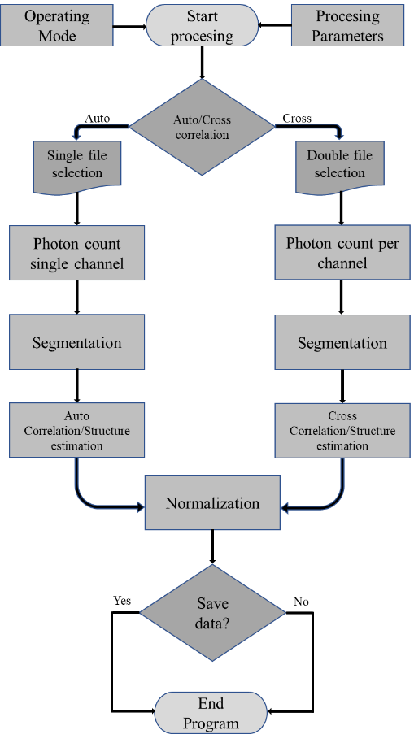

5.2. Main screen elements.

Main screen has the following elements:

1. Open File: allows you to upload data to be processed.
2. Save Data: allows you to save the output correlation and structure function data.
3. Exit: Exits program.
4. Parameters:
   1. P: Allows you to set the P parameter in the multi-tau scheme[1].
   2. m: Allows you to set the m parameter in the multi-tau scheme[1].
   3. Sample Time: Allows you to set the size of the lag time at which the P channels increase.
5. Opration Mode

IV. Analysis: List of options of the type of analysis to be made; Autocorrelation of channel A, Autocorrelation of channel B, Cross correlation of channel A x B or Cross correlation of channel B x A.

V. Data type: This software version can process data in the form of ASCII (typically obtained from hardware correlators) or Binary (stream of bits typically obtained from photon counting units).

VI. Half data: This switch allows you to cut the data vector in half in case the amount of data can’t be processed by the computer.

1. Duration: Estimates the time of the experiment based on the amount of thata in the file.
2. Total of Photons: Estimates the total number of measured photons.
3. Size: Estimates the size of the stream of data of the file.
4. Number of Channels: Estimate the number of channels of the multi-tau scheme provided the P and m configuration.
5. Elapsed time: Estimate the time used to obtain the correlation and structure function.
6. Graphics: The obtained correlation and structure function are presented in the bottom graphs

Each part of the program described above is presented in Figure1.

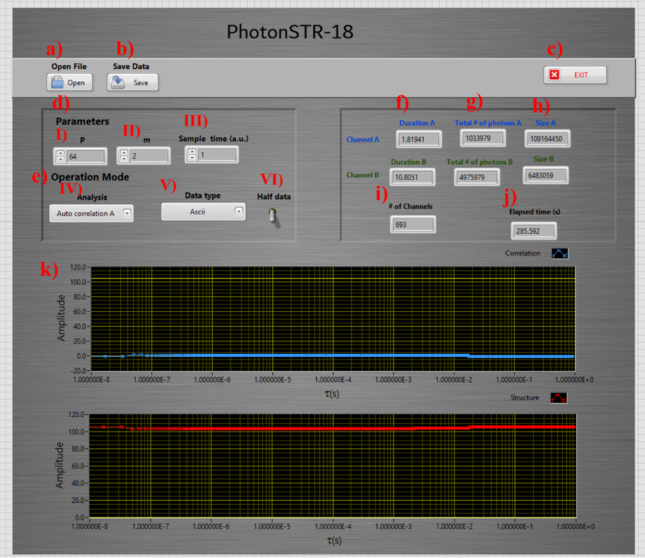

Figure 1. Main window of the Photon STR-18

5.3. Operation:

1) Start the Vi.

2) Set the parameters and the operation mode.

3) Select Open File

4) From the pup up menu, select the file(s) to operate.

5) When the program finishes the computation of the data, it asks to the user if he wants to save the output. If the user answer yes, then he must select the location and the name of the file to be created. Even if the user selects no, he can save the last generated data with the save button.

6) The correlation and structure function will be presented in the graphs at the bottom of the main window As shown in Figure2.

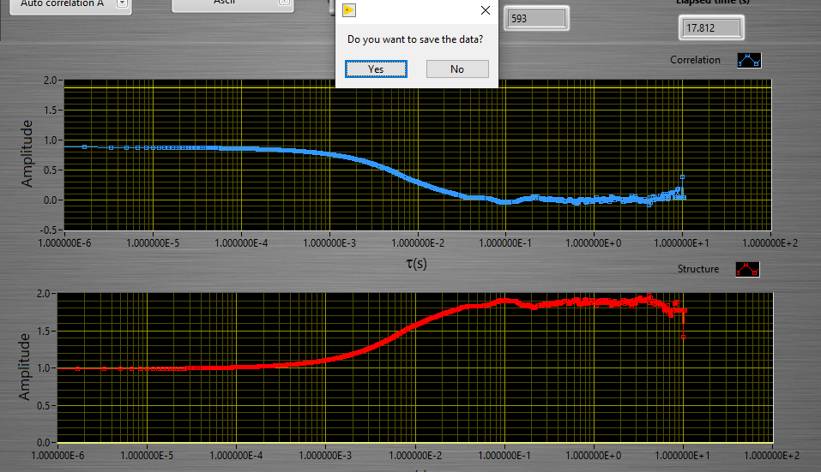

Figure . Typical output of the correlation and structure function.

7) The output data that can be saved contains:

- First column: the logaritmic time generated from the total amount of time estimated from the original data.

- Second column: the estimated correlation function.

- Third column; the estimated structure function.

References.

1. D. Magatti, F. Ferri, "*Fast multi-tau real-time software correlator for dynamic light scattering*" Appl. Opt. 40, 4011-4021 (2001).