PhotonSTR-19 V2.1
Structure of this manual
1. PC requirements.
2. Objective.
3. Scope.
4. Program installation.
5. Program operation.
6. Glossary.
7. References.

1. PC requirements.
Since this program is developed in LabVIEW2017 and Matlab R2023b, it can run in any operative system which is capable of running this versións of LabVIEW and Matlab or greater, nevertheless it is preferable to run in a computer with more or equal to 8Gb of RAM memory.
2. Objective.
The objective of this program is the statistical analysis of processes that vary over time. PhotonSTR-T18 V2.1 is capable of handling long data batches of scattered photon history and calculate not only the intensity correlation and structure functions in auto mode but, from two independent channels, also in the cross mode of two channels.
3. Scope.
PhotonSTR-T18 V2.1 can be used to obtain the calculation of the intensity correlation and structure functions from the measurement of the time of arrival of scattered photons described in the Dynamic light scattering theory.
This software can be used in the field of photon correlation spectroscopy, which is possibly the most popular technique used in the field of the study of structural, dynamical and mechanical properties of soft condensed matter systems.
4. Software installation
To install this program, you must copy the project placed in https://github.com/CINVESTAV-T18/PhotonSTR-18V2.1/ in a folder on your computer. This software uses 13 sub-Vis (Auto_corr.vi, beta.vi, Correlation_PM1.vi, Correlation_PM2.vi, Cross_corr.vi, Data_select.vi, Menu, multi-tau_time.vi, n3.vi, Normalizer.vi, PhotonCount.vi, ReadFilesOnes.vi, Segmentation.vi) placed in the folder with the name subVis in the same project. When running for the first time Photon-STR18V2_1.vi LabVIEW Will ask for the SubVis location, then you must select the folder where the subVis are located and it will automatically load all necesary files into memory, and will be available every time the main Vi is intialized.
5. Program operation.
5.1. Flux diagram
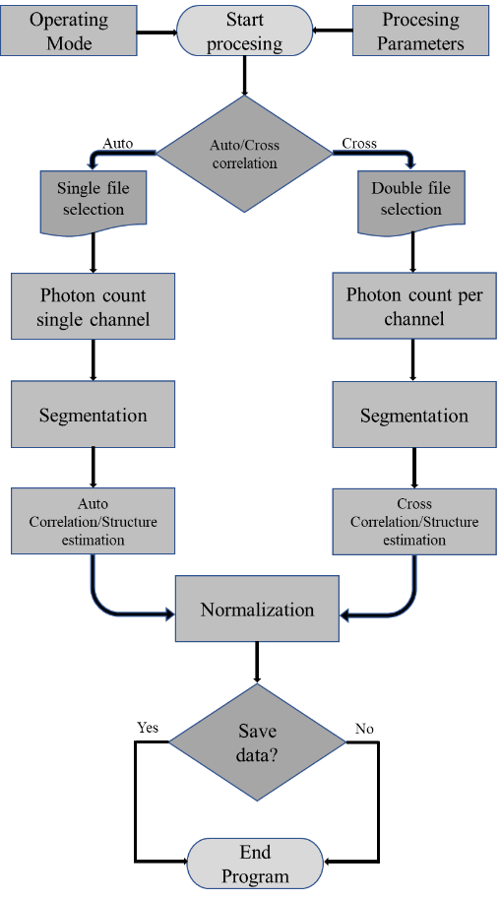
5.2. Main screen elements.
Main screen has the following elements:
- Open File: allows you to upload data to be processed.
- Exit: Exits program.
- Parameters:
  - P: Allows you to set the P parameter in the multi-tau scheme[1].
  - m: Allows you to set the m parameter in the multi-tau scheme[1].
  - Sample Time: Allows you to set the size of the lag time at which the P channels increase.
IV. List of options of the type of analysis to be made; Autocorrelation of channel A, or Cross correlation of channel A x B.
- Duration: Estimates the time of the experiment based on the amount of thata in the file.
- Total of Photons: Estimates the total number of measured photons.
- Size: Estimates the size of the stream of data of the file.
- Mean events: mean events per channel
- Number of Channels: Estimate the number of channels of the multi-tau scheme provided the P and m configuration.
- Elapsed time: Estimate the time used to obtain the correlation and structure function.
- AxB estimated beta: $β_{AxB}$
- Graphics: The obtained correlation and structure function with its correspondent noise reducted equivalent [2].
Each part of the program described above is presented in Figure1.
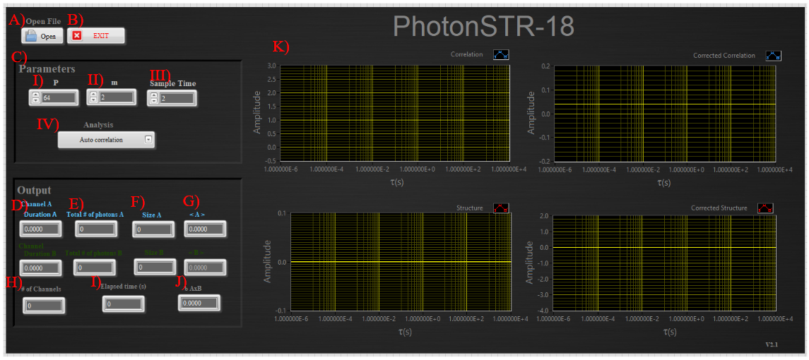
Figure 1. Main window of the Photon STR-18 V2.1

5.3. Operation:
1) Start the Vi.
2) Set the parameters
3) Select Open File
4) From the pup up menu, select the file(s) to process.
5) When the program finishes the computation of the data, it asks to the user if he wants to save the output. The user must select the location and the name of the file to be created.
6) The correlation and structure function will be presented in the graphs at the side of the main window As shown in Figure2.

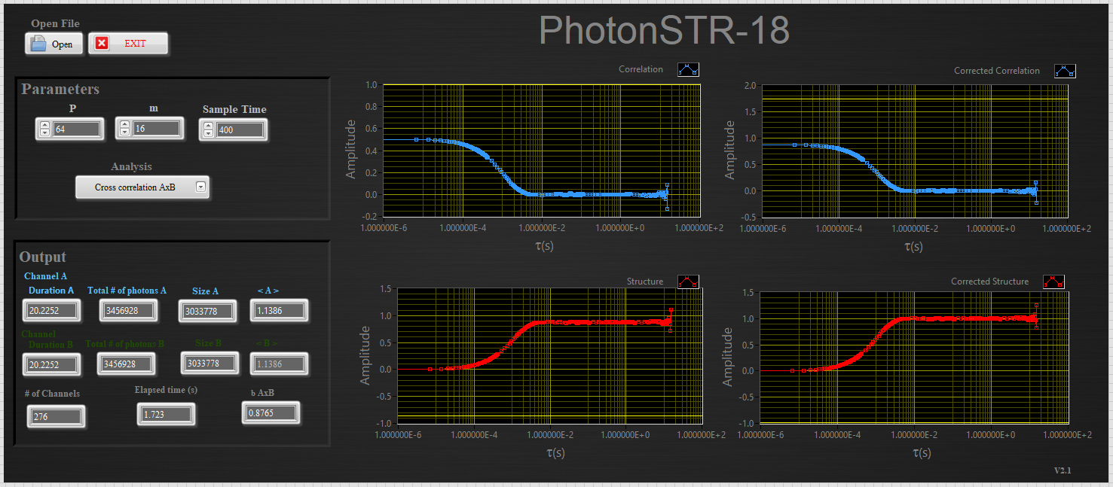
Figure 2. Typical output of the correlation and structure function.
7) The output data that can be saved contains:
- First column: the logaritmic time generated from the total amount of time estimated from the original data.
- Second column: the estimated correlation function.
-third column: the estimated correlation function with its numerical correction [2] .
- fourth column; the estimated structure function.
- fifth column; the estimated normalized structure function [2].

References.
[1] D. Magatti, F. Ferri, "Fast multi-tau real-time software correlator for dynamic light scattering" Appl. Opt. 40, 4011-4021 (2001).
[2] A. de J. Aguilar-Uribe, C. A. García-Cadena, J. Bocanegra-Flores, and L. F. Rojas-Ochoa. “Structure function as a robust alternative to the correlation function in photon-count analysis”. Phys. Rev. A 112, 063524. (2025).

