I want the main to be like below .

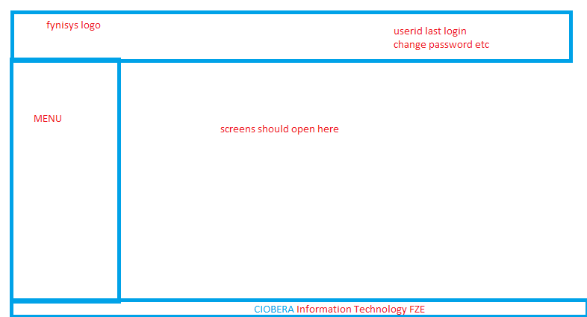

|  |  |
| --- | --- |
|  | I want same like this side menu  Later i will give images for below button names . you should read the images from the server .  System Parameters  Trading Management  Accounting Module  Payroll  Fixed Assets  Compliance Reports  MIS Reports  Logout  When user click each button it should show Tree view menu and it should show what the screen he was given access .  You can suggest me the table how u want for the tree view user screen access. |

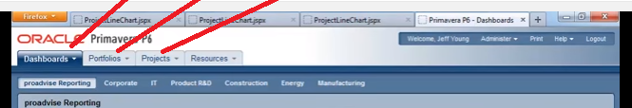

When ever user click any screen it should open in tab page as shown above . this will help user to open many screens and he can shift from one screen to another