ANOVA for a RCBD trial: SPYLPT2013_GH-Tono

RSIMON using HIDAP

May 06, 2016, 14:45h

Table of Contents

# This is an automatedly created report.  
  
# See more details in section on materials.

Alternate formats:

PDF DOCX

# Abstract

This trial has the identifier SPYLPT2013_GH-Tono. It was conducted under the supervision of x y as a Advanced Trial as part of a Yield Breeding Program in Tono, Ghana, Z in 2016. A total of 163 clones (including reference clones) were evaluated for 26 traits.

# Materials and Methods

## Location characterization

### Installation

### Geographic and climate characterization

### Weather during planting season

### Soil

### Field management

### Observations on special events

## Materials

## Trait descriptions (from ontology)

## Model specification and data description

There is data from 163 treatments, evaluated using a randomize complete block design with 1, 2 blocks. The statistical model is

$$y_{ij}=μ+τ_{i}+β_{j}+ϵ_{ij}$$

where

* $y_{ij}$ is the observed response with treatment $i$ and block $j$.
* $μ$ is the mean response over all treatments and blocks.
* $τ_{i}$ is the effect for treatment $i$.
* $β_{j}$ is the effect for block $j$.
* $ϵ_{ij}$ is the error term.

In this model we assume that the errors are independent and have a normal distribution with common variance, that is, $ϵ_{ij}∼N(0,σ_{ϵ}^{2})$.

The following traits are analyzed: **Beta carotene content measuring mg per 100g, Content of iron on dry weight basis measuring mg per 100g, Content of zinc on dry weight basis measuring mg per 100g, Dry weight of storage root samples measuring g of sample, Fresh weight of storage root samples measuring g of sample, Fructose content measuring percent, Glucose content measuring percent, Harvest index computing percent, Number of commercial storage roots counting number per plot, Number of non-commercial storage roots counting number per plot, Plants harvested counting number per plot, Plants planted counting number per plot, Plants with storage roots counting number per plot, Protein content measuring percent, Storage root damages estimatimg 1-9, Storage root dry matter content computing percent, Storage root size estimating 1-9, Storage root starch content measuring percent, Sucrose content measuring percent, Survival index computing percent, Sweet potato weevil symptoms 1 estimating 1-9, Vine vigor 1 estimating 1-9, Virus symptoms 2 estimating 1-9, Weight of commercial storage roots measuring kg per plot, Weight of non-commercial storage roots measuring kg per plot, Weight of vines measuring kg per plot**.

The following germplasm was analyzed: PG12012-1, PG12012-2, PG12151-19, PG12151-73, PG12088-10, PG12085-16, PG12149-5, PG12166-4, PG12151-75, PG12149-18, PG12155-30, PG12155-50, PG12005-88, PG12005-52, PG12165-42, PG12078-4, PG12149-9, PG12165-36, PG12165-20, PG12086-5, Ogyefo, PG12005-1, PG12155-110, PG12167-5, PG12078-3, PG12165-31, PG12005-24, PG12155-32, PG12083-11, PG12005-82, PG12086-11, PG12165-3, PG12165-43, PG12086-17, PG12165-30, PG12151-4, PG12005-35, PG12084-10, PG12149-20, PG12149-49, PG12150-7, PG12146-13, PG12146-27, PG12089-5, PG12012-4, PG12011-7, PG12089-14, PG12160-51, PG12080-15, PG12160-104, PG12163-151, PG12162-10, PG12162-39, PG12162-9, PG12162-43, PG12162-3, PG12162-5, PG12160-72, PG12071-6, PG12146-23, PG12162-19, PG12118-5, PGB12162-4, PG12162-56, Sauti, PG12047-3, PG12163-163, PG12163-117, PG12164-21, PG12081-3, PG12076-5, PG12089-13, PG12163-173, PG12070-14, PG12162-16, PG12163-167, PG12162-54, PG12162-31, PG12160-47, PG12058-15, PG12153-2, PG12163-133, PG12153-21, PG12010-15, PG12149-40, PG12136-2, PG12153-14, PG12151-32, PG12021-10, PG12149-8, PG12079-29, PG12168-2, PG12164-26, PG12086-18, PG12153-35, PG12166-30, PG12059-14, PG12005-55, PG12153-29, PG12061-13, PG12155-22, PG12151-88, PG12151-61, PG12170-4, PG12082-18, PG12108-3, PG12059-8, PG12153-24, PG12147-5, PG12135-2, PG12076-13, PG12005-79, PG12166-11, PG12151-65, PG12149-28, PG12078-17, PG12145-2, PG12164-43, PG12005-105, PG12147-1, PG12028-4, PG12014-2, PG12088-29, PG12088-2, PG12088-4, PG12146-19, PG12021-7, PG12148-6, PG12153-16, PG12108-4, PG12154-1, PG12055-14, PG12088-27, PG12088-8, PG12057-14, PG12150-53, PG12101-3, PG12151-36, PG12064-5, PG12169-5, PG12089-3, PG12175-3, PG12149-19, PG12088-19, PG12148-26, PG12090-31, PG12148-39, PG12155-8, PG12073-12, PG12155-17, PG12155-20, PG12155-12, PG12083-20, PG12155-106, PG12151-53, PG12151-24, PG12166-26, PG12152-29, PG12152-33, PG12151-26, PG12069-11, PG12146-21, Apomuden.

## Computational tools

This report was created using i386-w64-mingw32, i386, mingw32, i386, mingw32, Revised, 3, 2.4, 2016, 03, 16, 70336, R, R version 3.2.4 Revised (2016-03-16 r70336), Very Secure Dishes on a i386-w64-mingw32/i386 (32-bit) running Windows 7 x64 (build 7601) Service Pack 1 in . The following base packages were loaded: **stats, graphics, grDevices, utils, datasets, methods, base** and the following additional packages: **magrittr, knitr, shiny**.

# Results

## Raw data

## Trait summaries

## Trait analyses

The following traits were not analyzed since they had too many missing values (>= 10%): Beta carotene content measuring mg per 100g, Content of iron on dry weight basis measuring mg per 100g, Content of zinc on dry weight basis measuring mg per 100g, Dry weight of storage root samples measuring g of sample, Fresh weight of storage root samples measuring g of sample, Fructose content measuring percent, Glucose content measuring percent, Harvest index computing percent, Number of commercial storage roots counting number per plot, Number of non-commercial storage roots counting number per plot, Plants with storage roots counting number per plot, Protein content measuring percent, Storage root dry matter content computing percent, Storage root starch content measuring percent, Sucrose content measuring percent, Weight of commercial storage roots measuring kg per plot, Weight of non-commercial storage roots measuring kg per plot. For the remaining traits missing values were imputed using all available information.

Valid traits: **Plants harvested counting number per plot, Plants planted counting number per plot, Storage root damages estimatimg 1-9, Storage root size estimating 1-9, Survival index computing percent, Sweet potato weevil symptoms 1 estimating 1-9, Vine vigor 1 estimating 1-9, Virus symptoms 2 estimating 1-9, Weight of vines measuring kg per plot**.

### Analysis of **Plants harvested counting number per plot**

You have fitted a linear model for a RCBD. The ANOVA table for your model is:

|  |  |  |  |  |  |
| --- | --- | --- | --- | --- | --- |
|  | Df | Sum Sq | Mean Sq | F value | Pr(>F) |
| **germplasmName** | 162 | 1736.09 | 10.7166 | 2.60676 | 1.13389e-09 |
| **REP** | 1 | 1.22865 | 1.22865 | 0.298864 | 0.585348 |
| **Residuals** | 162 | 665.993 | 4.11107 | NA | NA |

The p-value for treatments is 0.00000000113389 which is significant at the 5% level.

The means of your treatments are:

|  |  |
| --- | --- |
| germplasmName | Plants harvested counting number per plot |
| Apomuden | 8.5 |
| Ogyefo | 7.5 |
| PG12005-1 | 8.5 |
| PG12005-105 | 5 |
| PG12005-24 | 5 |
| PG12005-35 | 8 |
| PG12005-52 | 10 |
| PG12005-55 | 2 |
| PG12005-79 | 4.5 |
| PG12005-82 | 8.5 |
| PG12005-88 | 7.5 |
| PG12010-15 | 8 |
| PG12011-7 | 2.88 |
| PG12012-1 | 4.5 |
| PG12012-2 | 3.5 |
| PG12012-4 | 2 |
| PG12014-2 | 2 |
| PG12021-10 | 5 |
| PG12021-7 | 3.17 |
| PG12028-4 | 2 |
| PG12047-3 | 7.5 |
| PG12055-14 | 4.56 |
| PG12057-14 | 3 |
| PG12058-15 | 2.22 |
| PG12059-14 | 3.5 |
| PG12059-8 | 4 |
| PG12061-13 | 7 |
| PG12064-5 | 3.81 |
| PG12069-11 | 3.07 |
| PG12070-14 | 1 |
| PG12071-6 | 5 |
| PG12073-12 | 4.44 |
| PG12076-13 | 2.06 |
| PG12076-5 | 2 |
| PG12078-17 | 4 |
| PG12078-3 | 2.43 |
| PG12078-4 | 5 |
| PG12079-29 | 1.57 |
| PG12080-15 | 3 |
| PG12081-3 | 2.5 |
| PG12082-18 | 2.01 |
| PG12083-11 | 1.71 |
| PG12083-20 | 6 |
| PG12084-10 | 1 |
| PG12085-16 | 10 |
| PG12086-11 | 1.99 |
| PG12086-17 | 5 |
| PG12086-18 | 10 |
| PG12086-5 | 1.5 |
| PG12088-10 | 7 |
| PG12088-19 | 5.67 |
| PG12088-2 | 5 |
| PG12088-27 | 2.58 |
| PG12088-29 | 4.5 |
| PG12088-4 | 3.75 |
| PG12088-8 | 3.32 |
| PG12089-13 | 5.5 |
| PG12089-14 | 7 |
| PG12089-3 | 7.5 |
| PG12089-5 | 2 |
| PG12090-31 | 1.51 |
| PG12101-3 | 9.5 |
| PG12108-3 | 2.07 |
| PG12108-4 | 3.5 |
| PG12118-5 | 4.11 |
| PG12135-2 | 3 |
| PG12136-2 | 7 |
| PG12145-2 | 9.5 |
| PG12146-13 | 4.5 |
| PG12146-19 | 2 |
| PG12146-21 | 5.85 |
| PG12146-23 | 1.82 |
| PG12146-27 | 2.23 |
| PG12147-1 | 8.5 |
| PG12147-5 | 3 |
| PG12148-26 | 2.5 |
| PG12148-39 | 6.5 |
| PG12148-6 | 4.26 |
| PG12149-18 | 1.81 |
| PG12149-19 | 4.5 |
| PG12149-20 | 5.5 |
| PG12149-28 | 5.5 |
| PG12149-40 | 2.5 |
| PG12149-49 | 7.5 |
| PG12149-5 | 4 |
| PG12149-8 | 10 |
| PG12149-9 | 6 |
| PG12150-53 | 1.93 |
| PG12150-7 | 5.5 |
| PG12151-19 | 4.46 |
| PG12151-24 | 4 |
| PG12151-26 | 4.76 |
| PG12151-32 | 6.79 |
| PG12151-36 | 6.54 |
| PG12151-4 | 2.37 |
| PG12151-53 | 6 |
| PG12151-61 | 8.5 |
| PG12151-65 | 4 |
| PG12151-73 | 10 |
| PG12151-75 | 5.21 |
| PG12151-88 | 1 |
| PG12152-29 | 3.97 |
| PG12152-33 | 7.5 |
| PG12153-14 | 4 |
| PG12153-16 | 2 |
| PG12153-2 | 2 |
| PG12153-21 | 5 |
| PG12153-24 | 7 |
| PG12153-29 | 4 |
| PG12153-35 | 2.29 |
| PG12154-1 | 3.78 |
| PG12155-106 | 9 |
| PG12155-110 | 2.43 |
| PG12155-12 | 5 |
| PG12155-17 | 3.5 |
| PG12155-20 | 5 |
| PG12155-22 | 8 |
| PG12155-30 | 5.5 |
| PG12155-32 | 3.53 |
| PG12155-50 | 2.9 |
| PG12155-8 | 4.07 |
| PG12160-104 | 4.76 |
| PG12160-47 | 5 |
| PG12160-51 | 3 |
| PG12160-72 | 6.5 |
| PG12162-10 | 4.5 |
| PG12162-16 | 2 |
| PG12162-19 | 4 |
| PG12162-3 | 2 |
| PG12162-31 | 2.5 |
| PG12162-39 | 5 |
| PG12162-43 | 2.5 |
| PG12162-5 | 4.26 |
| PG12162-54 | 2.99 |
| PG12162-56 | 4 |
| PG12162-9 | 4 |
| PG12163-117 | 2.5 |
| PG12163-133 | 5.25 |
| PG12163-151 | 7.5 |
| PG12163-163 | 5 |
| PG12163-167 | 5 |
| PG12163-173 | 3.68 |
| PG12164-21 | 10 |
| PG12164-26 | 9 |
| PG12164-43 | 6.5 |
| PG12165-20 | 5.61 |
| PG12165-3 | 3.5 |
| PG12165-30 | 2.17 |
| PG12165-31 | 3.5 |
| PG12165-36 | 8 |
| PG12165-42 | 4 |
| PG12165-43 | 4 |
| PG12166-11 | 5 |
| PG12166-26 | 5.5 |
| PG12166-30 | 5.71 |
| PG12166-4 | 3.41 |
| PG12167-5 | 2.5 |
| PG12168-2 | 8.5 |
| PG12169-5 | 5.5 |
| PG12170-4 | 8 |
| PG12175-3 | 6.06 |
| PGB12162-4 | 3.5 |
| Sauti | 8.14 |

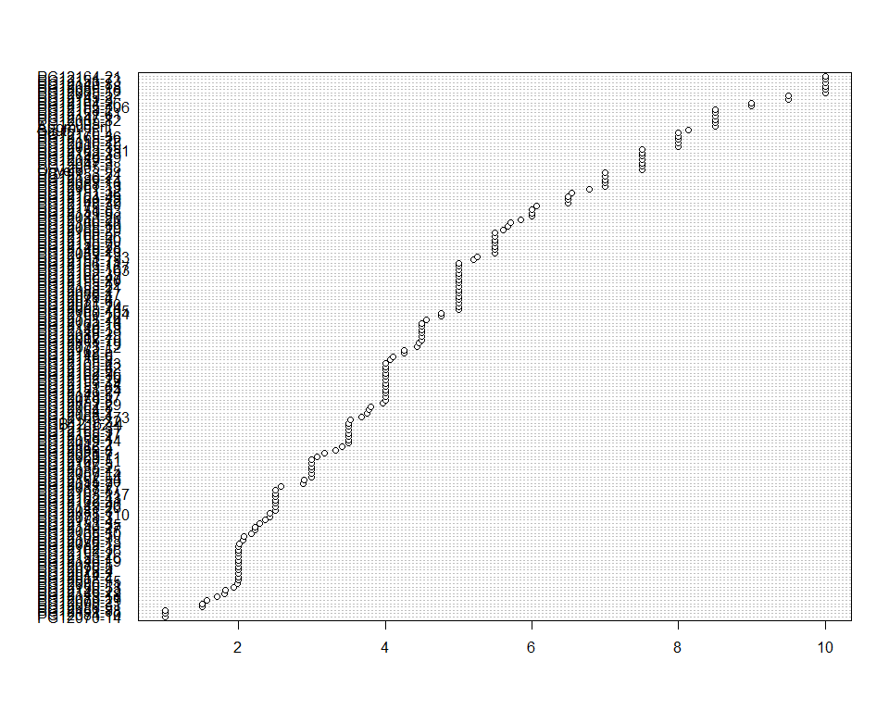

Do not forget the assumptions of the model. It is supposed that the error has a normal distribution with the same variance for all the treatments. The following plots must help you evaluate this:

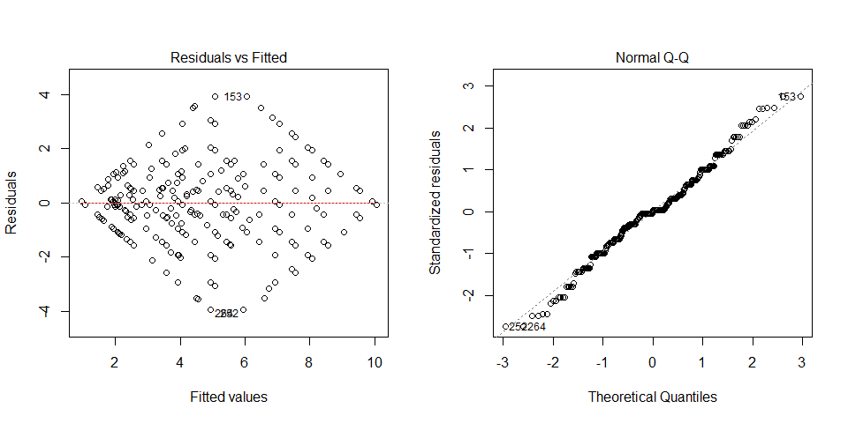

Funnel shapes for the first plot may suggest heterogeneity of variances while departures from the theoretical normal line are symptoms of lack of normality.

### Analysis of **Plants planted counting number per plot**

You have fitted a linear model for a RCBD. The ANOVA table for your model is:

|  |  |  |  |  |  |
| --- | --- | --- | --- | --- | --- |
|  | Df | Sum Sq | Mean Sq | F value | Pr(>F) |
| **germplasmName** | 162 | 3.91816e-29 | 2.41861e-31 | 1 | 0.5 |
| **REP** | 1 | 2.41861e-31 | 2.41861e-31 | 1 | 0.318802 |
| **Residuals** | 162 | 3.91816e-29 | 2.41861e-31 | NA | NA |

The means of your treatments are:

|  |  |
| --- | --- |
| germplasmName | Plants planted counting number per plot |
| Apomuden | 10 |
| Ogyefo | 10 |
| PG12005-1 | 10 |
| PG12005-105 | 10 |
| PG12005-24 | 10 |
| PG12005-35 | 10 |
| PG12005-52 | 10 |
| PG12005-55 | 10 |
| PG12005-79 | 10 |
| PG12005-82 | 10 |
| PG12005-88 | 10 |
| PG12010-15 | 10 |
| PG12011-7 | 10 |
| PG12012-1 | 10 |
| PG12012-2 | 10 |
| PG12012-4 | 10 |
| PG12014-2 | 10 |
| PG12021-10 | 10 |
| PG12021-7 | 10 |
| PG12028-4 | 10 |
| PG12047-3 | 10 |
| PG12055-14 | 10 |
| PG12057-14 | 10 |
| PG12058-15 | 10 |
| PG12059-14 | 10 |
| PG12059-8 | 10 |
| PG12061-13 | 10 |
| PG12064-5 | 10 |
| PG12069-11 | 10 |
| PG12070-14 | 10 |
| PG12071-6 | 10 |
| PG12073-12 | 10 |
| PG12076-13 | 10 |
| PG12076-5 | 10 |
| PG12078-17 | 10 |
| PG12078-3 | 10 |
| PG12078-4 | 10 |
| PG12079-29 | 10 |
| PG12080-15 | 10 |
| PG12081-3 | 10 |
| PG12082-18 | 10 |
| PG12083-11 | 10 |
| PG12083-20 | 10 |
| PG12084-10 | 10 |
| PG12085-16 | 10 |
| PG12086-11 | 10 |
| PG12086-17 | 10 |
| PG12086-18 | 10 |
| PG12086-5 | 10 |
| PG12088-10 | 10 |
| PG12088-19 | 10 |
| PG12088-2 | 10 |
| PG12088-27 | 10 |
| PG12088-29 | 10 |
| PG12088-4 | 10 |
| PG12088-8 | 10 |
| PG12089-13 | 10 |
| PG12089-14 | 10 |
| PG12089-3 | 10 |
| PG12089-5 | 10 |
| PG12090-31 | 10 |
| PG12101-3 | 10 |
| PG12108-3 | 10 |
| PG12108-4 | 10 |
| PG12118-5 | 10 |
| PG12135-2 | 10 |
| PG12136-2 | 10 |
| PG12145-2 | 10 |
| PG12146-13 | 10 |
| PG12146-19 | 10 |
| PG12146-21 | 10 |
| PG12146-23 | 10 |
| PG12146-27 | 10 |
| PG12147-1 | 10 |
| PG12147-5 | 10 |
| PG12148-26 | 10 |
| PG12148-39 | 10 |
| PG12148-6 | 10 |
| PG12149-18 | 10 |
| PG12149-19 | 10 |
| PG12149-20 | 10 |
| PG12149-28 | 10 |
| PG12149-40 | 10 |
| PG12149-49 | 10 |
| PG12149-5 | 10 |
| PG12149-8 | 10 |
| PG12149-9 | 10 |
| PG12150-53 | 10 |
| PG12150-7 | 10 |
| PG12151-19 | 10 |
| PG12151-24 | 10 |
| PG12151-26 | 10 |
| PG12151-32 | 10 |
| PG12151-36 | 10 |
| PG12151-4 | 10 |
| PG12151-53 | 10 |
| PG12151-61 | 10 |
| PG12151-65 | 10 |
| PG12151-73 | 10 |
| PG12151-75 | 10 |
| PG12151-88 | 10 |
| PG12152-29 | 10 |
| PG12152-33 | 10 |
| PG12153-14 | 10 |
| PG12153-16 | 10 |
| PG12153-2 | 10 |
| PG12153-21 | 10 |
| PG12153-24 | 10 |
| PG12153-29 | 10 |
| PG12153-35 | 10 |
| PG12154-1 | 10 |
| PG12155-106 | 10 |
| PG12155-110 | 10 |
| PG12155-12 | 10 |
| PG12155-17 | 10 |
| PG12155-20 | 10 |
| PG12155-22 | 10 |
| PG12155-30 | 10 |
| PG12155-32 | 10 |
| PG12155-50 | 10 |
| PG12155-8 | 10 |
| PG12160-104 | 10 |
| PG12160-47 | 10 |
| PG12160-51 | 10 |
| PG12160-72 | 10 |
| PG12162-10 | 10 |
| PG12162-16 | 10 |
| PG12162-19 | 10 |
| PG12162-3 | 10 |
| PG12162-31 | 10 |
| PG12162-39 | 10 |
| PG12162-43 | 10 |
| PG12162-5 | 10 |
| PG12162-54 | 10 |
| PG12162-56 | 10 |
| PG12162-9 | 10 |
| PG12163-117 | 10 |
| PG12163-133 | 10 |
| PG12163-151 | 10 |
| PG12163-163 | 10 |
| PG12163-167 | 10 |
| PG12163-173 | 10 |
| PG12164-21 | 10 |
| PG12164-26 | 10 |
| PG12164-43 | 10 |
| PG12165-20 | 10 |
| PG12165-3 | 10 |
| PG12165-30 | 10 |
| PG12165-31 | 10 |
| PG12165-36 | 10 |
| PG12165-42 | 10 |
| PG12165-43 | 10 |
| PG12166-11 | 10 |
| PG12166-26 | 10 |
| PG12166-30 | 10 |
| PG12166-4 | 10 |
| PG12167-5 | 10 |
| PG12168-2 | 10 |
| PG12169-5 | 10 |
| PG12170-4 | 10 |
| PG12175-3 | 10 |
| PGB12162-4 | 10 |
| Sauti | 10 |

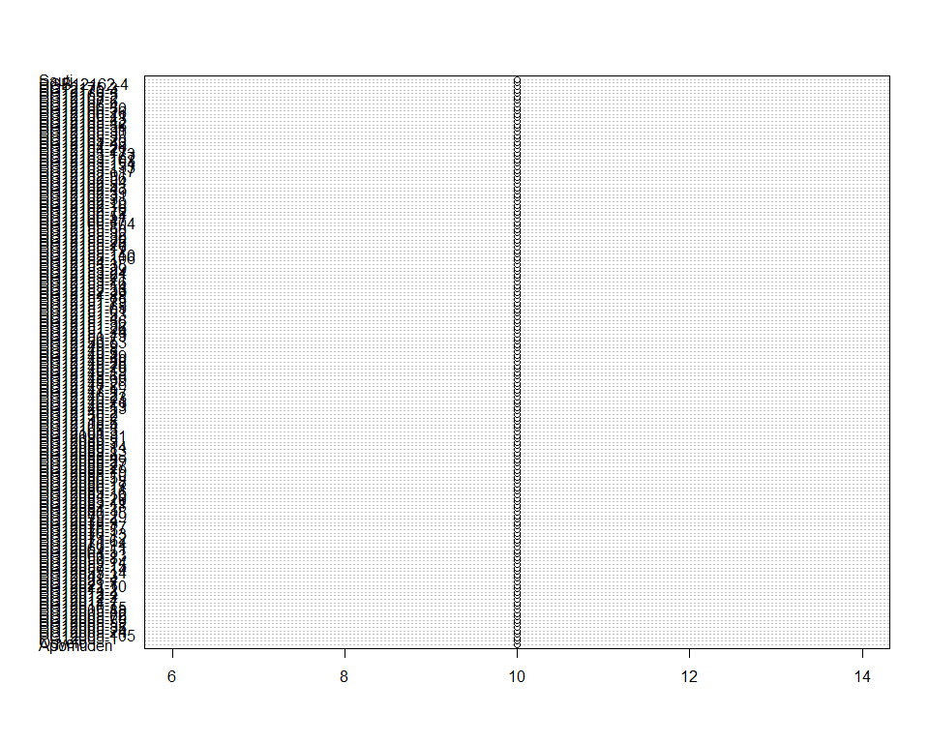

Do not forget the assumptions of the model. It is supposed that the error has a normal distribution with the same variance for all the treatments. The following plots must help you evaluate this:

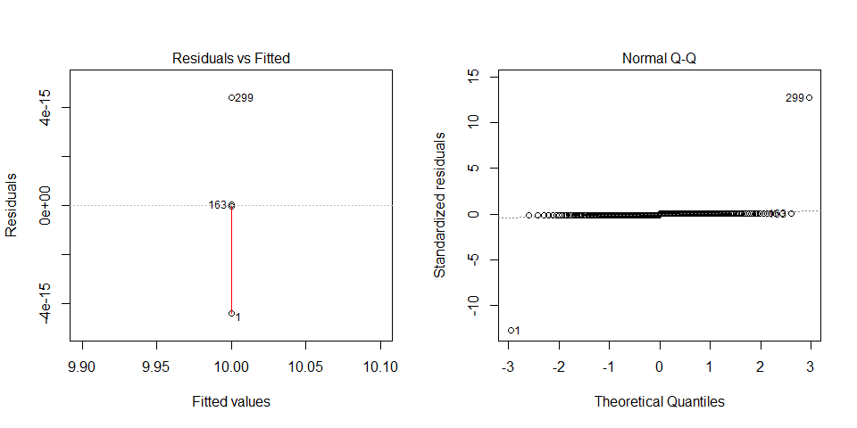

Funnel shapes for the first plot may suggest heterogeneity of variances while departures from the theoretical normal line are symptoms of lack of normality.

### Analysis of **Storage root damages estimatimg 1-9**

You have fitted a linear model for a RCBD. The ANOVA table for your model is:

|  |  |  |  |  |  |
| --- | --- | --- | --- | --- | --- |
|  | Df | Sum Sq | Mean Sq | F value | Pr(>F) |
| **germplasmName** | 162 | 458.331 | 2.82921 | 2.1394 | 8.93278e-07 |
| **REP** | 1 | 1.76687 | 1.76687 | 1.33608 | 0.249428 |
| **Residuals** | 162 | 214.233 | 1.32243 | NA | NA |

The p-value for treatments is 0.000000893278 which is significant at the 5% level.

The means of your treatments are:

|  |  |
| --- | --- |
| germplasmName | Storage root damages estimatimg 1-9 |
| Apomuden | 6.5 |
| Ogyefo | 1.5 |
| PG12005-1 | 2 |
| PG12005-105 | 1.5 |
| PG12005-24 | 1 |
| PG12005-35 | 1.5 |
| PG12005-52 | 1 |
| PG12005-55 | 4 |
| PG12005-79 | 1.5 |
| PG12005-82 | 1 |
| PG12005-88 | 2 |
| PG12010-15 | 1.5 |
| PG12011-7 | 1 |
| PG12012-1 | 1.5 |
| PG12012-2 | 1.5 |
| PG12012-4 | 1.5 |
| PG12014-2 | 2 |
| PG12021-10 | 1 |
| PG12021-7 | 1 |
| PG12028-4 | 1 |
| PG12047-3 | 2 |
| PG12055-14 | 1 |
| PG12057-14 | 1 |
| PG12058-15 | 1 |
| PG12059-14 | 1 |
| PG12059-8 | 2 |
| PG12061-13 | 1 |
| PG12064-5 | 1 |
| PG12069-11 | 1 |
| PG12070-14 | 1 |
| PG12071-6 | 1.5 |
| PG12073-12 | 1 |
| PG12076-13 | 1 |
| PG12076-5 | 1 |
| PG12078-17 | 1.5 |
| PG12078-3 | 1.5 |
| PG12078-4 | 2 |
| PG12079-29 | 1 |
| PG12080-15 | 2 |
| PG12081-3 | 1.5 |
| PG12082-18 | 1 |
| PG12083-11 | 1 |
| PG12083-20 | 2 |
| PG12084-10 | 1 |
| PG12085-16 | 2.5 |
| PG12086-11 | 1 |
| PG12086-17 | 4 |
| PG12086-18 | 4.5 |
| PG12086-5 | 3 |
| PG12088-10 | 1.5 |
| PG12088-19 | 1 |
| PG12088-2 | 2 |
| PG12088-27 | 1 |
| PG12088-29 | 1.5 |
| PG12088-4 | 1.5 |
| PG12088-8 | 1.5 |
| PG12089-13 | 2 |
| PG12089-14 | 2 |
| PG12089-3 | 2 |
| PG12089-5 | 1.5 |
| PG12090-31 | 1 |
| PG12101-3 | 4 |
| PG12108-3 | 1 |
| PG12108-4 | 1 |
| PG12118-5 | 1.5 |
| PG12135-2 | 1.5 |
| PG12136-2 | 1.5 |
| PG12145-2 | 6 |
| PG12146-13 | 1 |
| PG12146-19 | 1 |
| PG12146-21 | 1.5 |
| PG12146-23 | 1 |
| PG12146-27 | 1 |
| PG12147-1 | 5 |
| PG12147-5 | 1 |
| PG12148-26 | 1.5 |
| PG12148-39 | 1.5 |
| PG12148-6 | 1 |
| PG12149-18 | 1.5 |
| PG12149-19 | 1 |
| PG12149-20 | 2 |
| PG12149-28 | 1.5 |
| PG12149-40 | 1 |
| PG12149-49 | 1.5 |
| PG12149-5 | 2.5 |
| PG12149-8 | 1 |
| PG12149-9 | 2 |
| PG12150-53 | 1.5 |
| PG12150-7 | 2 |
| PG12151-19 | 1 |
| PG12151-24 | 1.5 |
| PG12151-26 | 3.5 |
| PG12151-32 | 1.5 |
| PG12151-36 | 1.5 |
| PG12151-4 | 1 |
| PG12151-53 | 6.5 |
| PG12151-61 | 7.5 |
| PG12151-65 | 1.5 |
| PG12151-73 | 2 |
| PG12151-75 | 1 |
| PG12151-88 | 1 |
| PG12152-29 | 1 |
| PG12152-33 | 2 |
| PG12153-14 | 1.5 |
| PG12153-16 | 3.5 |
| PG12153-2 | 1.5 |
| PG12153-21 | 3 |
| PG12153-24 | 1 |
| PG12153-29 | 2 |
| PG12153-35 | 1 |
| PG12154-1 | 1 |
| PG12155-106 | 1.5 |
| PG12155-110 | 1.5 |
| PG12155-12 | 1 |
| PG12155-17 | 1.5 |
| PG12155-20 | 2 |
| PG12155-22 | 2 |
| PG12155-30 | 2 |
| PG12155-32 | 1.5 |
| PG12155-50 | 1 |
| PG12155-8 | 1 |
| PG12160-104 | 1.5 |
| PG12160-47 | 2 |
| PG12160-51 | 1 |
| PG12160-72 | 3.5 |
| PG12162-10 | 2 |
| PG12162-16 | 1 |
| PG12162-19 | 3.5 |
| PG12162-3 | 1.5 |
| PG12162-31 | 1 |
| PG12162-39 | 1.5 |
| PG12162-43 | 1 |
| PG12162-5 | 4 |
| PG12162-54 | 1 |
| PG12162-56 | 3 |
| PG12162-9 | 1.5 |
| PG12163-117 | 1.5 |
| PG12163-133 | 1 |
| PG12163-151 | 2 |
| PG12163-163 | 2.5 |
| PG12163-167 | 3 |
| PG12163-173 | 1.5 |
| PG12164-21 | 4.5 |
| PG12164-26 | 4 |
| PG12164-43 | 3.5 |
| PG12165-20 | 1 |
| PG12165-3 | 1.5 |
| PG12165-30 | 1 |
| PG12165-31 | 2 |
| PG12165-36 | 3.5 |
| PG12165-42 | 2 |
| PG12165-43 | 2 |
| PG12166-11 | 3 |
| PG12166-26 | 1 |
| PG12166-30 | 1.5 |
| PG12166-4 | 1.5 |
| PG12167-5 | 5.5 |
| PG12168-2 | 3.5 |
| PG12169-5 | 1.5 |
| PG12170-4 | 2.5 |
| PG12175-3 | 1 |
| PGB12162-4 | 2 |
| Sauti | 1 |

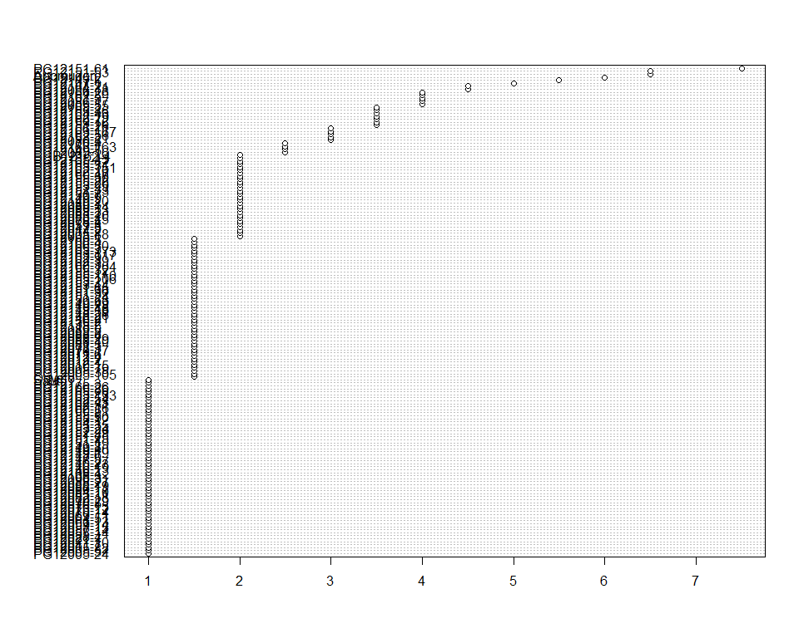

Do not forget the assumptions of the model. It is supposed that the error has a normal distribution with the same variance for all the treatments. The following plots must help you evaluate this:

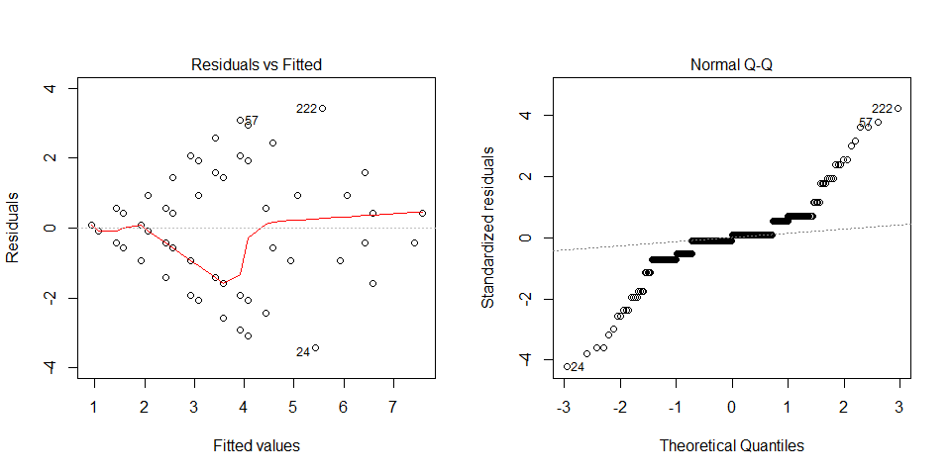

Funnel shapes for the first plot may suggest heterogeneity of variances while departures from the theoretical normal line are symptoms of lack of normality.

### Analysis of **Storage root size estimating 1-9**

You have fitted a linear model for a RCBD. The ANOVA table for your model is:

|  |  |  |  |  |  |
| --- | --- | --- | --- | --- | --- |
|  | Df | Sum Sq | Mean Sq | F value | Pr(>F) |
| **germplasmName** | 162 | 876.81 | 5.41241 | 2.03898 | 3.72307e-06 |
| **REP** | 1 | 3.97546 | 3.97546 | 1.49765 | 0.222811 |
| **Residuals** | 162 | 430.025 | 2.65447 | NA | NA |

The p-value for treatments is 0.00000372307 which is significant at the 5% level.

The means of your treatments are:

|  |  |
| --- | --- |
| germplasmName | Storage root size estimating 1-9 |
| Apomuden | 6 |
| Ogyefo | 2.5 |
| PG12005-1 | 4 |
| PG12005-105 | 2 |
| PG12005-24 | 1 |
| PG12005-35 | 2 |
| PG12005-52 | 1 |
| PG12005-55 | 1.5 |
| PG12005-79 | 2 |
| PG12005-82 | 1 |
| PG12005-88 | 2.5 |
| PG12010-15 | 4 |
| PG12011-7 | 1 |
| PG12012-1 | 3 |
| PG12012-2 | 2.5 |
| PG12012-4 | 2 |
| PG12014-2 | 2.5 |
| PG12021-10 | 1 |
| PG12021-7 | 1 |
| PG12028-4 | 1 |
| PG12047-3 | 3 |
| PG12055-14 | 1 |
| PG12057-14 | 1 |
| PG12058-15 | 1 |
| PG12059-14 | 1 |
| PG12059-8 | 3.5 |
| PG12061-13 | 1 |
| PG12064-5 | 1 |
| PG12069-11 | 1 |
| PG12070-14 | 1 |
| PG12071-6 | 2.5 |
| PG12073-12 | 1 |
| PG12076-13 | 1 |
| PG12076-5 | 1 |
| PG12078-17 | 1.5 |
| PG12078-3 | 1.5 |
| PG12078-4 | 2.5 |
| PG12079-29 | 1 |
| PG12080-15 | 4 |
| PG12081-3 | 2 |
| PG12082-18 | 1 |
| PG12083-11 | 1 |
| PG12083-20 | 2 |
| PG12084-10 | 1 |
| PG12085-16 | 7 |
| PG12086-11 | 1 |
| PG12086-17 | 3 |
| PG12086-18 | 3.5 |
| PG12086-5 | 1.5 |
| PG12088-10 | 2.5 |
| PG12088-19 | 1 |
| PG12088-2 | 5 |
| PG12088-27 | 1 |
| PG12088-29 | 1.5 |
| PG12088-4 | 1.5 |
| PG12088-8 | 2 |
| PG12089-13 | 5.5 |
| PG12089-14 | 6 |
| PG12089-3 | 3.5 |
| PG12089-5 | 3.5 |
| PG12090-31 | 1 |
| PG12101-3 | 5 |
| PG12108-3 | 1 |
| PG12108-4 | 1 |
| PG12118-5 | 2.5 |
| PG12135-2 | 3 |
| PG12136-2 | 3 |
| PG12145-2 | 6 |
| PG12146-13 | 1 |
| PG12146-19 | 1 |
| PG12146-21 | 2 |
| PG12146-23 | 1 |
| PG12146-27 | 1 |
| PG12147-1 | 6 |
| PG12147-5 | 1 |
| PG12148-26 | 2 |
| PG12148-39 | 3 |
| PG12148-6 | 1 |
| PG12149-18 | 2.5 |
| PG12149-19 | 1 |
| PG12149-20 | 2 |
| PG12149-28 | 3 |
| PG12149-40 | 1 |
| PG12149-49 | 2.5 |
| PG12149-5 | 6.5 |
| PG12149-8 | 1 |
| PG12149-9 | 2 |
| PG12150-53 | 2 |
| PG12150-7 | 2.5 |
| PG12151-19 | 1 |
| PG12151-24 | 2 |
| PG12151-26 | 3.5 |
| PG12151-32 | 3 |
| PG12151-36 | 4 |
| PG12151-4 | 1 |
| PG12151-53 | 6 |
| PG12151-61 | 2.5 |
| PG12151-65 | 1.5 |
| PG12151-73 | 8.5 |
| PG12151-75 | 1 |
| PG12151-88 | 1 |
| PG12152-29 | 1 |
| PG12152-33 | 2.5 |
| PG12153-14 | 2.5 |
| PG12153-16 | 3 |
| PG12153-2 | 2 |
| PG12153-21 | 4 |
| PG12153-24 | 1 |
| PG12153-29 | 3 |
| PG12153-35 | 1 |
| PG12154-1 | 1 |
| PG12155-106 | 4 |
| PG12155-110 | 1.5 |
| PG12155-12 | 1 |
| PG12155-17 | 3 |
| PG12155-20 | 5.5 |
| PG12155-22 | 3.5 |
| PG12155-30 | 3.5 |
| PG12155-32 | 1.5 |
| PG12155-50 | 1 |
| PG12155-8 | 1 |
| PG12160-104 | 3 |
| PG12160-47 | 5 |
| PG12160-51 | 1 |
| PG12160-72 | 5 |
| PG12162-10 | 2.5 |
| PG12162-16 | 1 |
| PG12162-19 | 4 |
| PG12162-3 | 1.5 |
| PG12162-31 | 1 |
| PG12162-39 | 1.5 |
| PG12162-43 | 1 |
| PG12162-5 | 1.5 |
| PG12162-54 | 1 |
| PG12162-56 | 2.5 |
| PG12162-9 | 2 |
| PG12163-117 | 2 |
| PG12163-133 | 1 |
| PG12163-151 | 6 |
| PG12163-163 | 4.5 |
| PG12163-167 | 6 |
| PG12163-173 | 1.5 |
| PG12164-21 | 6.5 |
| PG12164-26 | 5 |
| PG12164-43 | 3.5 |
| PG12165-20 | 1 |
| PG12165-3 | 3.5 |
| PG12165-30 | 1 |
| PG12165-31 | 5 |
| PG12165-36 | 3.5 |
| PG12165-42 | 2.5 |
| PG12165-43 | 4.5 |
| PG12166-11 | 2 |
| PG12166-26 | 1 |
| PG12166-30 | 2 |
| PG12166-4 | 2 |
| PG12167-5 | 3 |
| PG12168-2 | 5 |
| PG12169-5 | 4 |
| PG12170-4 | 3.5 |
| PG12175-3 | 1 |
| PGB12162-4 | 6 |
| Sauti | 1 |

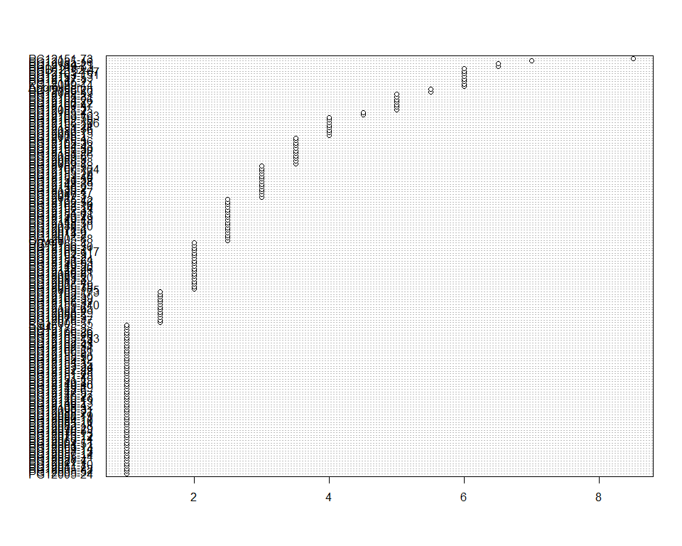

Do not forget the assumptions of the model. It is supposed that the error has a normal distribution with the same variance for all the treatments. The following plots must help you evaluate this:

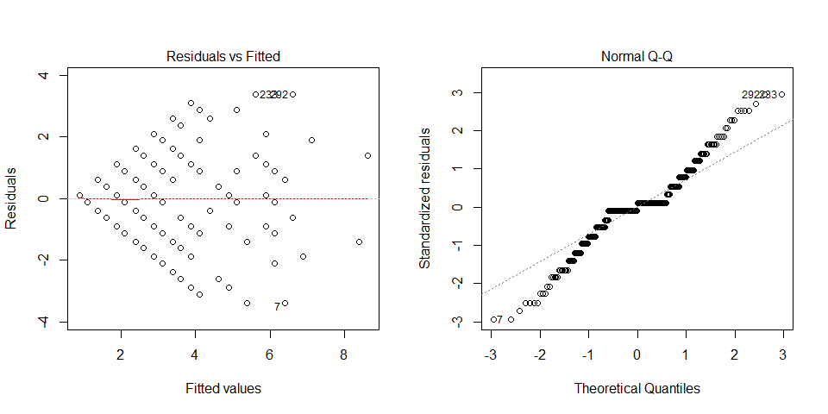

Funnel shapes for the first plot may suggest heterogeneity of variances while departures from the theoretical normal line are symptoms of lack of normality.

### Analysis of **Survival index computing percent**

You have fitted a linear model for a RCBD. The ANOVA table for your model is:

|  |  |  |  |  |  |
| --- | --- | --- | --- | --- | --- |
|  | Df | Sum Sq | Mean Sq | F value | Pr(>F) |
| **germplasmName** | 162 | 17.3609 | 0.107166 | 2.60676 | 1.13389e-09 |
| **REP** | 1 | 0.0122865 | 0.0122865 | 0.298864 | 0.585348 |
| **Residuals** | 162 | 6.65993 | 0.0411107 | NA | NA |

The p-value for treatments is 0.00000000113389 which is significant at the 5% level.

The means of your treatments are:

|  |  |
| --- | --- |
| germplasmName | Survival index computing percent |
| Apomuden | 0.85 |
| Ogyefo | 0.75 |
| PG12005-1 | 0.85 |
| PG12005-105 | 0.5 |
| PG12005-24 | 0.5 |
| PG12005-35 | 0.8 |
| PG12005-52 | 1 |
| PG12005-55 | 0.2 |
| PG12005-79 | 0.45 |
| PG12005-82 | 0.85 |
| PG12005-88 | 0.75 |
| PG12010-15 | 0.8 |
| PG12011-7 | 0.288 |
| PG12012-1 | 0.45 |
| PG12012-2 | 0.35 |
| PG12012-4 | 0.2 |
| PG12014-2 | 0.2 |
| PG12021-10 | 0.5 |
| PG12021-7 | 0.317 |
| PG12028-4 | 0.2 |
| PG12047-3 | 0.75 |
| PG12055-14 | 0.456 |
| PG12057-14 | 0.3 |
| PG12058-15 | 0.222 |
| PG12059-14 | 0.35 |
| PG12059-8 | 0.4 |
| PG12061-13 | 0.7 |
| PG12064-5 | 0.381 |
| PG12069-11 | 0.307 |
| PG12070-14 | 0.1 |
| PG12071-6 | 0.5 |
| PG12073-12 | 0.444 |
| PG12076-13 | 0.206 |
| PG12076-5 | 0.2 |
| PG12078-17 | 0.4 |
| PG12078-3 | 0.243 |
| PG12078-4 | 0.5 |
| PG12079-29 | 0.157 |
| PG12080-15 | 0.3 |
| PG12081-3 | 0.25 |
| PG12082-18 | 0.201 |
| PG12083-11 | 0.171 |
| PG12083-20 | 0.6 |
| PG12084-10 | 0.1 |
| PG12085-16 | 1 |
| PG12086-11 | 0.199 |
| PG12086-17 | 0.5 |
| PG12086-18 | 1 |
| PG12086-5 | 0.15 |
| PG12088-10 | 0.7 |
| PG12088-19 | 0.567 |
| PG12088-2 | 0.5 |
| PG12088-27 | 0.258 |
| PG12088-29 | 0.45 |
| PG12088-4 | 0.375 |
| PG12088-8 | 0.332 |
| PG12089-13 | 0.55 |
| PG12089-14 | 0.7 |
| PG12089-3 | 0.75 |
| PG12089-5 | 0.2 |
| PG12090-31 | 0.151 |
| PG12101-3 | 0.95 |
| PG12108-3 | 0.207 |
| PG12108-4 | 0.35 |
| PG12118-5 | 0.411 |
| PG12135-2 | 0.3 |
| PG12136-2 | 0.7 |
| PG12145-2 | 0.95 |
| PG12146-13 | 0.45 |
| PG12146-19 | 0.2 |
| PG12146-21 | 0.585 |
| PG12146-23 | 0.182 |
| PG12146-27 | 0.223 |
| PG12147-1 | 0.85 |
| PG12147-5 | 0.3 |
| PG12148-26 | 0.25 |
| PG12148-39 | 0.65 |
| PG12148-6 | 0.426 |
| PG12149-18 | 0.181 |
| PG12149-19 | 0.45 |
| PG12149-20 | 0.55 |
| PG12149-28 | 0.55 |
| PG12149-40 | 0.25 |
| PG12149-49 | 0.75 |
| PG12149-5 | 0.4 |
| PG12149-8 | 1 |
| PG12149-9 | 0.6 |
| PG12150-53 | 0.193 |
| PG12150-7 | 0.55 |
| PG12151-19 | 0.446 |
| PG12151-24 | 0.4 |
| PG12151-26 | 0.476 |
| PG12151-32 | 0.679 |
| PG12151-36 | 0.654 |
| PG12151-4 | 0.237 |
| PG12151-53 | 0.6 |
| PG12151-61 | 0.85 |
| PG12151-65 | 0.4 |
| PG12151-73 | 1 |
| PG12151-75 | 0.521 |
| PG12151-88 | 0.1 |
| PG12152-29 | 0.397 |
| PG12152-33 | 0.75 |
| PG12153-14 | 0.4 |
| PG12153-16 | 0.2 |
| PG12153-2 | 0.2 |
| PG12153-21 | 0.5 |
| PG12153-24 | 0.7 |
| PG12153-29 | 0.4 |
| PG12153-35 | 0.229 |
| PG12154-1 | 0.378 |
| PG12155-106 | 0.9 |
| PG12155-110 | 0.243 |
| PG12155-12 | 0.5 |
| PG12155-17 | 0.35 |
| PG12155-20 | 0.5 |
| PG12155-22 | 0.8 |
| PG12155-30 | 0.55 |
| PG12155-32 | 0.353 |
| PG12155-50 | 0.29 |
| PG12155-8 | 0.407 |
| PG12160-104 | 0.476 |
| PG12160-47 | 0.5 |
| PG12160-51 | 0.3 |
| PG12160-72 | 0.65 |
| PG12162-10 | 0.45 |
| PG12162-16 | 0.2 |
| PG12162-19 | 0.4 |
| PG12162-3 | 0.2 |
| PG12162-31 | 0.25 |
| PG12162-39 | 0.5 |
| PG12162-43 | 0.25 |
| PG12162-5 | 0.426 |
| PG12162-54 | 0.299 |
| PG12162-56 | 0.4 |
| PG12162-9 | 0.4 |
| PG12163-117 | 0.25 |
| PG12163-133 | 0.525 |
| PG12163-151 | 0.75 |
| PG12163-163 | 0.5 |
| PG12163-167 | 0.5 |
| PG12163-173 | 0.368 |
| PG12164-21 | 1 |
| PG12164-26 | 0.9 |
| PG12164-43 | 0.65 |
| PG12165-20 | 0.561 |
| PG12165-3 | 0.35 |
| PG12165-30 | 0.217 |
| PG12165-31 | 0.35 |
| PG12165-36 | 0.8 |
| PG12165-42 | 0.4 |
| PG12165-43 | 0.4 |
| PG12166-11 | 0.5 |
| PG12166-26 | 0.55 |
| PG12166-30 | 0.571 |
| PG12166-4 | 0.341 |
| PG12167-5 | 0.25 |
| PG12168-2 | 0.85 |
| PG12169-5 | 0.55 |
| PG12170-4 | 0.8 |
| PG12175-3 | 0.606 |
| PGB12162-4 | 0.35 |
| Sauti | 0.814 |

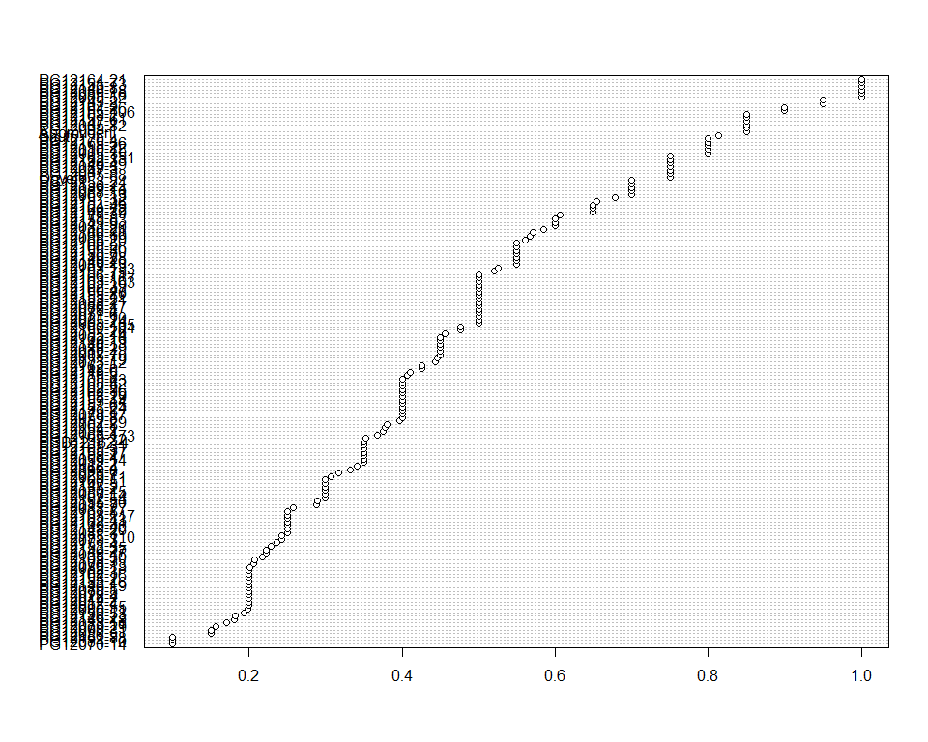

Do not forget the assumptions of the model. It is supposed that the error has a normal distribution with the same variance for all the treatments. The following plots must help you evaluate this:

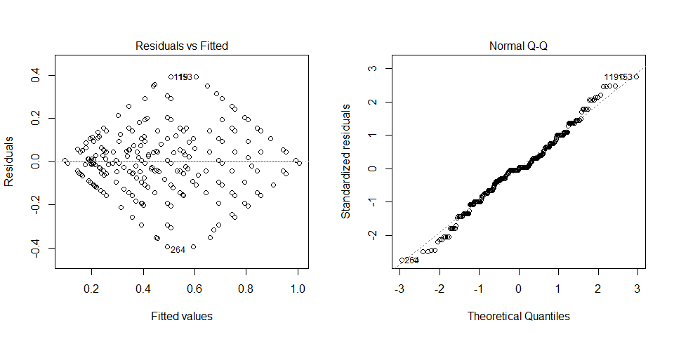

Funnel shapes for the first plot may suggest heterogeneity of variances while departures from the theoretical normal line are symptoms of lack of normality.

### Analysis of **Sweet potato weevil symptoms 1 estimating 1-9**

You have fitted a linear model for a RCBD. The ANOVA table for your model is:

|  |  |  |  |  |  |
| --- | --- | --- | --- | --- | --- |
|  | Df | Sum Sq | Mean Sq | F value | Pr(>F) |
| **germplasmName** | 162 | 149.16 | 0.920738 | 1.41742 | 0.013518 |
| **REP** | 1 | 1.76687 | 1.76687 | 2.71999 | 0.101036 |
| **Residuals** | 162 | 105.233 | 0.649587 | NA | NA |

The p-value for treatments is 0.013518 which is significant at the 5% level.

The means of your treatments are:

|  |  |
| --- | --- |
| germplasmName | Sweet potato weevil symptoms 1 estimating 1-9 |
| Apomuden | 4 |
| Ogyefo | 1.5 |
| PG12005-1 | 2 |
| PG12005-105 | 1.5 |
| PG12005-24 | 1 |
| PG12005-35 | 1.5 |
| PG12005-52 | 1 |
| PG12005-55 | 1.5 |
| PG12005-79 | 1.5 |
| PG12005-82 | 1 |
| PG12005-88 | 2 |
| PG12010-15 | 1.5 |
| PG12011-7 | 1 |
| PG12012-1 | 1.5 |
| PG12012-2 | 1.5 |
| PG12012-4 | 1.5 |
| PG12014-2 | 1.5 |
| PG12021-10 | 1 |
| PG12021-7 | 1 |
| PG12028-4 | 1 |
| PG12047-3 | 2 |
| PG12055-14 | 1 |
| PG12057-14 | 1 |
| PG12058-15 | 1 |
| PG12059-14 | 1 |
| PG12059-8 | 4 |
| PG12061-13 | 1 |
| PG12064-5 | 1 |
| PG12069-11 | 1 |
| PG12070-14 | 1 |
| PG12071-6 | 1.5 |
| PG12073-12 | 1 |
| PG12076-13 | 1 |
| PG12076-5 | 1 |
| PG12078-17 | 1.5 |
| PG12078-3 | 1.5 |
| PG12078-4 | 2 |
| PG12079-29 | 1 |
| PG12080-15 | 2 |
| PG12081-3 | 3 |
| PG12082-18 | 1 |
| PG12083-11 | 1 |
| PG12083-20 | 2 |
| PG12084-10 | 1 |
| PG12085-16 | 3 |
| PG12086-11 | 1 |
| PG12086-17 | 3.5 |
| PG12086-18 | 2 |
| PG12086-5 | 2 |
| PG12088-10 | 1.5 |
| PG12088-19 | 1 |
| PG12088-2 | 2 |
| PG12088-27 | 1 |
| PG12088-29 | 1.5 |
| PG12088-4 | 1.5 |
| PG12088-8 | 1.5 |
| PG12089-13 | 2 |
| PG12089-14 | 3.5 |
| PG12089-3 | 2 |
| PG12089-5 | 1.5 |
| PG12090-31 | 1 |
| PG12101-3 | 2 |
| PG12108-3 | 1 |
| PG12108-4 | 1 |
| PG12118-5 | 1.5 |
| PG12135-2 | 1.5 |
| PG12136-2 | 1.5 |
| PG12145-2 | 2 |
| PG12146-13 | 1 |
| PG12146-19 | 1 |
| PG12146-21 | 1.5 |
| PG12146-23 | 1 |
| PG12146-27 | 1 |
| PG12147-1 | 3 |
| PG12147-5 | 1 |
| PG12148-26 | 1.5 |
| PG12148-39 | 1.5 |
| PG12148-6 | 1 |
| PG12149-18 | 1.5 |
| PG12149-19 | 1 |
| PG12149-20 | 2 |
| PG12149-28 | 1.5 |
| PG12149-40 | 1 |
| PG12149-49 | 1.5 |
| PG12149-5 | 2 |
| PG12149-8 | 1 |
| PG12149-9 | 2 |
| PG12150-53 | 1.5 |
| PG12150-7 | 2 |
| PG12151-19 | 1 |
| PG12151-24 | 1.5 |
| PG12151-26 | 1.5 |
| PG12151-32 | 1.5 |
| PG12151-36 | 1.5 |
| PG12151-4 | 1 |
| PG12151-53 | 2 |
| PG12151-61 | 2 |
| PG12151-65 | 1.5 |
| PG12151-73 | 2 |
| PG12151-75 | 1 |
| PG12151-88 | 1 |
| PG12152-29 | 1 |
| PG12152-33 | 2 |
| PG12153-14 | 3 |
| PG12153-16 | 2 |
| PG12153-2 | 1.5 |
| PG12153-21 | 2 |
| PG12153-24 | 1 |
| PG12153-29 | 2 |
| PG12153-35 | 1 |
| PG12154-1 | 1 |
| PG12155-106 | 2 |
| PG12155-110 | 1.5 |
| PG12155-12 | 1 |
| PG12155-17 | 1.5 |
| PG12155-20 | 2 |
| PG12155-22 | 2 |
| PG12155-30 | 2 |
| PG12155-32 | 1.5 |
| PG12155-50 | 1 |
| PG12155-8 | 1 |
| PG12160-104 | 1.5 |
| PG12160-47 | 3.5 |
| PG12160-51 | 1 |
| PG12160-72 | 2 |
| PG12162-10 | 2 |
| PG12162-16 | 1 |
| PG12162-19 | 2 |
| PG12162-3 | 1.5 |
| PG12162-31 | 1 |
| PG12162-39 | 1.5 |
| PG12162-43 | 1 |
| PG12162-5 | 1.5 |
| PG12162-54 | 1 |
| PG12162-56 | 1.5 |
| PG12162-9 | 1.5 |
| PG12163-117 | 1.5 |
| PG12163-133 | 1 |
| PG12163-151 | 2 |
| PG12163-163 | 2 |
| PG12163-167 | 3.5 |
| PG12163-173 | 1.5 |
| PG12164-21 | 2 |
| PG12164-26 | 2 |
| PG12164-43 | 3.5 |
| PG12165-20 | 1 |
| PG12165-3 | 1.5 |
| PG12165-30 | 1 |
| PG12165-31 | 2 |
| PG12165-36 | 3.5 |
| PG12165-42 | 2 |
| PG12165-43 | 2 |
| PG12166-11 | 1.5 |
| PG12166-26 | 1 |
| PG12166-30 | 1.5 |
| PG12166-4 | 1.5 |
| PG12167-5 | 3.5 |
| PG12168-2 | 2 |
| PG12169-5 | 1.5 |
| PG12170-4 | 1.5 |
| PG12175-3 | 1 |
| PGB12162-4 | 3 |
| Sauti | 1 |

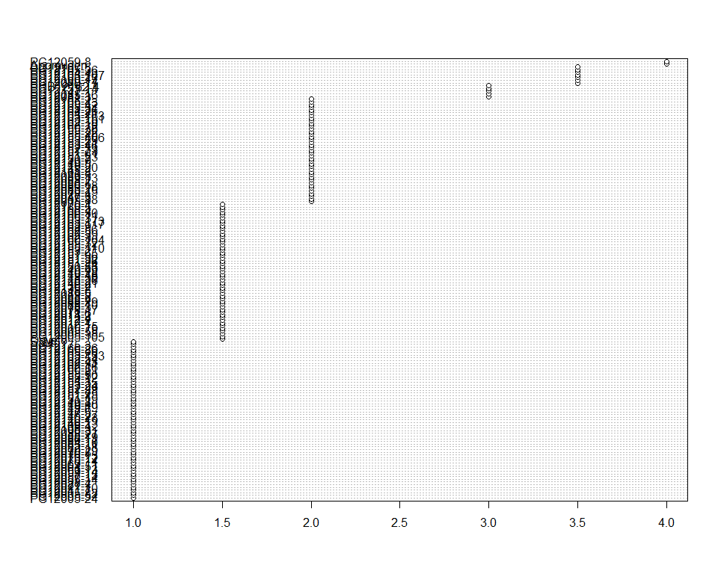

Do not forget the assumptions of the model. It is supposed that the error has a normal distribution with the same variance for all the treatments. The following plots must help you evaluate this:

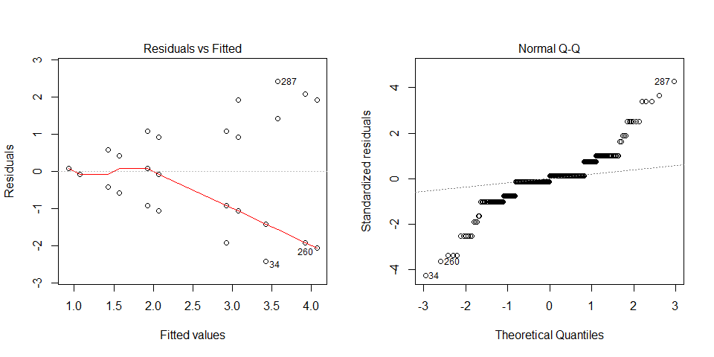

Funnel shapes for the first plot may suggest heterogeneity of variances while departures from the theoretical normal line are symptoms of lack of normality.

### Analysis of **Vine vigor 1 estimating 1-9**

You have fitted a linear model for a RCBD. The ANOVA table for your model is:

|  |  |  |  |  |  |
| --- | --- | --- | --- | --- | --- |
|  | Df | Sum Sq | Mean Sq | F value | Pr(>F) |
| **germplasmName** | 162 | 2434.2 | 15.0259 | 3.3211 | 6.07441e-14 |
| **REP** | 1 | 0.0490798 | 0.0490798 | 0.0108478 | 0.917177 |
| **Residuals** | 162 | 732.951 | 4.52439 | NA | NA |

The p-value for treatments is 0.0000000000000607441 which is significant at the 5% level.

The means of your treatments are:

|  |  |
| --- | --- |
| germplasmName | Vine vigor 1 estimating 1-9 |
| Apomuden | 7.5 |
| Ogyefo | 10 |
| PG12005-1 | 6.5 |
| PG12005-105 | 9 |
| PG12005-24 | 3 |
| PG12005-35 | 5 |
| PG12005-52 | 6.5 |
| PG12005-55 | 3.5 |
| PG12005-79 | 2 |
| PG12005-82 | 8.5 |
| PG12005-88 | 9 |
| PG12010-15 | 7 |
| PG12011-7 | 2 |
| PG12012-1 | 3 |
| PG12012-2 | 6.5 |
| PG12012-4 | 2 |
| PG12014-2 | 2 |
| PG12021-10 | 5.5 |
| PG12021-7 | 1 |
| PG12028-4 | 2.5 |
| PG12047-3 | 5 |
| PG12055-14 | 1 |
| PG12057-14 | 8.5 |
| PG12058-15 | 3.5 |
| PG12059-14 | 5.5 |
| PG12059-8 | 6.5 |
| PG12061-13 | 9 |
| PG12064-5 | 1.5 |
| PG12069-11 | 2 |
| PG12070-14 | 2 |
| PG12071-6 | 2 |
| PG12073-12 | 5 |
| PG12076-13 | 1.5 |
| PG12076-5 | 5 |
| PG12078-17 | 2 |
| PG12078-3 | 1.5 |
| PG12078-4 | 6 |
| PG12079-29 | 2 |
| PG12080-15 | 5 |
| PG12081-3 | 2.5 |
| PG12082-18 | 2 |
| PG12083-11 | 2 |
| PG12083-20 | 5.5 |
| PG12084-10 | 2 |
| PG12085-16 | 7 |
| PG12086-11 | 1.5 |
| PG12086-17 | 5 |
| PG12086-18 | 10 |
| PG12086-5 | 4 |
| PG12088-10 | 5 |
| PG12088-19 | 3.5 |
| PG12088-2 | 5.5 |
| PG12088-27 | 2 |
| PG12088-29 | 2 |
| PG12088-4 | 1.5 |
| PG12088-8 | 3 |
| PG12089-13 | 5.5 |
| PG12089-14 | 5 |
| PG12089-3 | 4 |
| PG12089-5 | 2 |
| PG12090-31 | 1.5 |
| PG12101-3 | 9.5 |
| PG12108-3 | 1.5 |
| PG12108-4 | 8 |
| PG12118-5 | 2.5 |
| PG12135-2 | 6 |
| PG12136-2 | 7.5 |
| PG12145-2 | 10 |
| PG12146-13 | 6 |
| PG12146-19 | 7 |
| PG12146-21 | 8.5 |
| PG12146-23 | 2.5 |
| PG12146-27 | 3 |
| PG12147-1 | 8.5 |
| PG12147-5 | 2.5 |
| PG12148-26 | 2 |
| PG12148-39 | 8 |
| PG12148-6 | 1 |
| PG12149-18 | 2.5 |
| PG12149-19 | 7 |
| PG12149-20 | 4.5 |
| PG12149-28 | 4.5 |
| PG12149-40 | 2.5 |
| PG12149-49 | 7 |
| PG12149-5 | 5 |
| PG12149-8 | 10 |
| PG12149-9 | 4 |
| PG12150-53 | 5 |
| PG12150-7 | 7.5 |
| PG12151-19 | 2 |
| PG12151-24 | 2 |
| PG12151-26 | 8 |
| PG12151-32 | 4.5 |
| PG12151-36 | 5.5 |
| PG12151-4 | 1 |
| PG12151-53 | 4.5 |
| PG12151-61 | 8 |
| PG12151-65 | 2 |
| PG12151-73 | 9.5 |
| PG12151-75 | 3 |
| PG12151-88 | 4 |
| PG12152-29 | 1.5 |
| PG12152-33 | 3 |
| PG12153-14 | 2 |
| PG12153-16 | 4.5 |
| PG12153-2 | 7.5 |
| PG12153-21 | 5.5 |
| PG12153-24 | 9.5 |
| PG12153-29 | 2 |
| PG12153-35 | 4 |
| PG12154-1 | 1 |
| PG12155-106 | 8 |
| PG12155-110 | 3 |
| PG12155-12 | 3.5 |
| PG12155-17 | 10 |
| PG12155-20 | 7 |
| PG12155-22 | 2 |
| PG12155-30 | 7.5 |
| PG12155-32 | 2 |
| PG12155-50 | 1.5 |
| PG12155-8 | 1.5 |
| PG12160-104 | 5 |
| PG12160-47 | 3.5 |
| PG12160-51 | 2 |
| PG12160-72 | 8 |
| PG12162-10 | 5 |
| PG12162-16 | 3 |
| PG12162-19 | 3 |
| PG12162-3 | 7.5 |
| PG12162-31 | 3.5 |
| PG12162-39 | 2.5 |
| PG12162-43 | 2.5 |
| PG12162-5 | 4.5 |
| PG12162-54 | 4 |
| PG12162-56 | 5.5 |
| PG12162-9 | 7.5 |
| PG12163-117 | 2.5 |
| PG12163-133 | 1.5 |
| PG12163-151 | 6 |
| PG12163-163 | 8 |
| PG12163-167 | 9.5 |
| PG12163-173 | 1.5 |
| PG12164-21 | 10 |
| PG12164-26 | 10 |
| PG12164-43 | 8.5 |
| PG12165-20 | 3.5 |
| PG12165-3 | 2 |
| PG12165-30 | 2 |
| PG12165-31 | 3 |
| PG12165-36 | 7 |
| PG12165-42 | 4 |
| PG12165-43 | 4.5 |
| PG12166-11 | 7.5 |
| PG12166-26 | 9.5 |
| PG12166-30 | 7 |
| PG12166-4 | 3.5 |
| PG12167-5 | 4.5 |
| PG12168-2 | 9.5 |
| PG12169-5 | 8.5 |
| PG12170-4 | 9 |
| PG12175-3 | 1 |
| PGB12162-4 | 5 |
| Sauti | 10 |

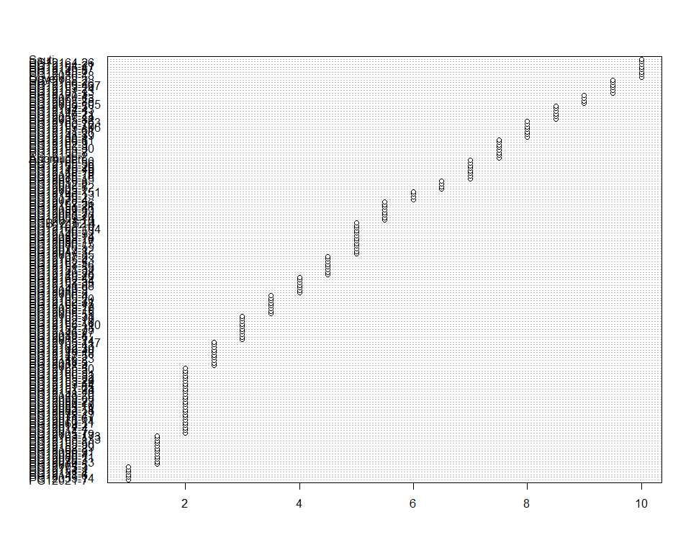

Do not forget the assumptions of the model. It is supposed that the error has a normal distribution with the same variance for all the treatments. The following plots must help you evaluate this:

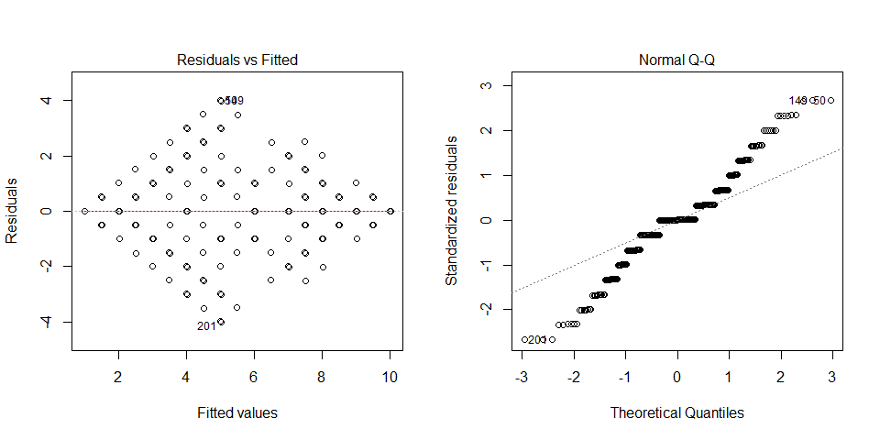

Funnel shapes for the first plot may suggest heterogeneity of variances while departures from the theoretical normal line are symptoms of lack of normality.

### Analysis of **Virus symptoms 2 estimating 1-9**

You have fitted a linear model for a RCBD. The ANOVA table for your model is:

|  |  |  |  |  |  |
| --- | --- | --- | --- | --- | --- |
|  | Df | Sum Sq | Mean Sq | F value | Pr(>F) |
| **germplasmName** | 162 | 1991.15 | 12.291 | 1.98412 | 8.07863e-06 |
| **REP** | 1 | 12.9601 | 12.9601 | 2.09213 | 0.149991 |
| **Residuals** | 162 | 1003.54 | 6.19469 | NA | NA |

The p-value for treatments is 0.00000807863 which is significant at the 5% level.

The means of your treatments are:

|  |  |
| --- | --- |
| germplasmName | Virus symptoms 2 estimating 1-9 |
| Apomuden | 4.5 |
| Ogyefo | 5 |
| PG12005-1 | 6 |
| PG12005-105 | 4 |
| PG12005-24 | 9.5 |
| PG12005-35 | 8.5 |
| PG12005-52 | 6.5 |
| PG12005-55 | 9.5 |
| PG12005-79 | 10 |
| PG12005-82 | 7 |
| PG12005-88 | 4.5 |
| PG12010-15 | 5.5 |
| PG12011-7 | 10 |
| PG12012-1 | 9.5 |
| PG12012-2 | 6 |
| PG12012-4 | 10 |
| PG12014-2 | 5 |
| PG12021-10 | 8.5 |
| PG12021-7 | 1 |
| PG12028-4 | 9.5 |
| PG12047-3 | 8.5 |
| PG12055-14 | 1 |
| PG12057-14 | 5 |
| PG12058-15 | 9 |
| PG12059-14 | 6.5 |
| PG12059-8 | 5.5 |
| PG12061-13 | 4.5 |
| PG12064-5 | 5.5 |
| PG12069-11 | 10 |
| PG12070-14 | 10 |
| PG12071-6 | 10 |
| PG12073-12 | 2.5 |
| PG12076-13 | 5.5 |
| PG12076-5 | 8 |
| PG12078-17 | 10 |
| PG12078-3 | 5.5 |
| PG12078-4 | 7 |
| PG12079-29 | 10 |
| PG12080-15 | 8 |
| PG12081-3 | 9.5 |
| PG12082-18 | 10 |
| PG12083-11 | 10 |
| PG12083-20 | 7.5 |
| PG12084-10 | 10 |
| PG12085-16 | 6.5 |
| PG12086-11 | 5.5 |
| PG12086-17 | 8 |
| PG12086-18 | 4.5 |
| PG12086-5 | 9 |
| PG12088-10 | 8.5 |
| PG12088-19 | 3 |
| PG12088-2 | 7.5 |
| PG12088-27 | 10 |
| PG12088-29 | 10 |
| PG12088-4 | 5.5 |
| PG12088-8 | 3.5 |
| PG12089-13 | 8 |
| PG12089-14 | 9 |
| PG12089-3 | 9.5 |
| PG12089-5 | 10 |
| PG12090-31 | 5.5 |
| PG12101-3 | 5 |
| PG12108-3 | 5.5 |
| PG12108-4 | 7 |
| PG12118-5 | 9.5 |
| PG12135-2 | 6.5 |
| PG12136-2 | 5 |
| PG12145-2 | 5.5 |
| PG12146-13 | 6 |
| PG12146-19 | 4 |
| PG12146-21 | 7.5 |
| PG12146-23 | 9.5 |
| PG12146-27 | 4 |
| PG12147-1 | 4.5 |
| PG12147-5 | 9.5 |
| PG12148-26 | 10 |
| PG12148-39 | 7 |
| PG12148-6 | 1 |
| PG12149-18 | 5 |
| PG12149-19 | 5.5 |
| PG12149-20 | 9 |
| PG12149-28 | 9 |
| PG12149-40 | 9.5 |
| PG12149-49 | 6.5 |
| PG12149-5 | 7 |
| PG12149-8 | 3.5 |
| PG12149-9 | 9 |
| PG12150-53 | 2 |
| PG12150-7 | 7.5 |
| PG12151-19 | 10 |
| PG12151-24 | 10 |
| PG12151-26 | 5.5 |
| PG12151-32 | 3.5 |
| PG12151-36 | 8 |
| PG12151-4 | 1 |
| PG12151-53 | 8.5 |
| PG12151-61 | 5.5 |
| PG12151-65 | 10 |
| PG12151-73 | 3.5 |
| PG12151-75 | 3.5 |
| PG12151-88 | 8 |
| PG12152-29 | 5.5 |
| PG12152-33 | 9.5 |
| PG12153-14 | 10 |
| PG12153-16 | 8 |
| PG12153-2 | 7 |
| PG12153-21 | 8.5 |
| PG12153-24 | 4.5 |
| PG12153-29 | 10 |
| PG12153-35 | 4 |
| PG12154-1 | 1 |
| PG12155-106 | 7.5 |
| PG12155-110 | 9 |
| PG12155-12 | 9 |
| PG12155-17 | 6 |
| PG12155-20 | 6.5 |
| PG12155-22 | 10 |
| PG12155-30 | 6 |
| PG12155-32 | 10 |
| PG12155-50 | 5.5 |
| PG12155-8 | 5.5 |
| PG12160-104 | 3 |
| PG12160-47 | 9 |
| PG12160-51 | 10 |
| PG12160-72 | 7 |
| PG12162-10 | 8.5 |
| PG12162-16 | 9.5 |
| PG12162-19 | 9.5 |
| PG12162-3 | 6 |
| PG12162-31 | 7.5 |
| PG12162-39 | 9.5 |
| PG12162-43 | 9.5 |
| PG12162-5 | 3.5 |
| PG12162-54 | 4 |
| PG12162-56 | 6.5 |
| PG12162-9 | 7 |
| PG12163-117 | 10 |
| PG12163-133 | 5.5 |
| PG12163-151 | 8 |
| PG12163-163 | 7.5 |
| PG12163-167 | 5.5 |
| PG12163-173 | 5.5 |
| PG12164-21 | 4 |
| PG12164-26 | 4.5 |
| PG12164-43 | 5 |
| PG12165-20 | 4.5 |
| PG12165-3 | 10 |
| PG12165-30 | 10 |
| PG12165-31 | 9.5 |
| PG12165-36 | 6 |
| PG12165-42 | 9.5 |
| PG12165-43 | 8.5 |
| PG12166-11 | 4.5 |
| PG12166-26 | 6.5 |
| PG12166-30 | 7.5 |
| PG12166-4 | 9 |
| PG12167-5 | 8 |
| PG12168-2 | 5 |
| PG12169-5 | 6 |
| PG12170-4 | 4 |
| PG12175-3 | 1 |
| PGB12162-4 | 9 |
| Sauti | 3.5 |

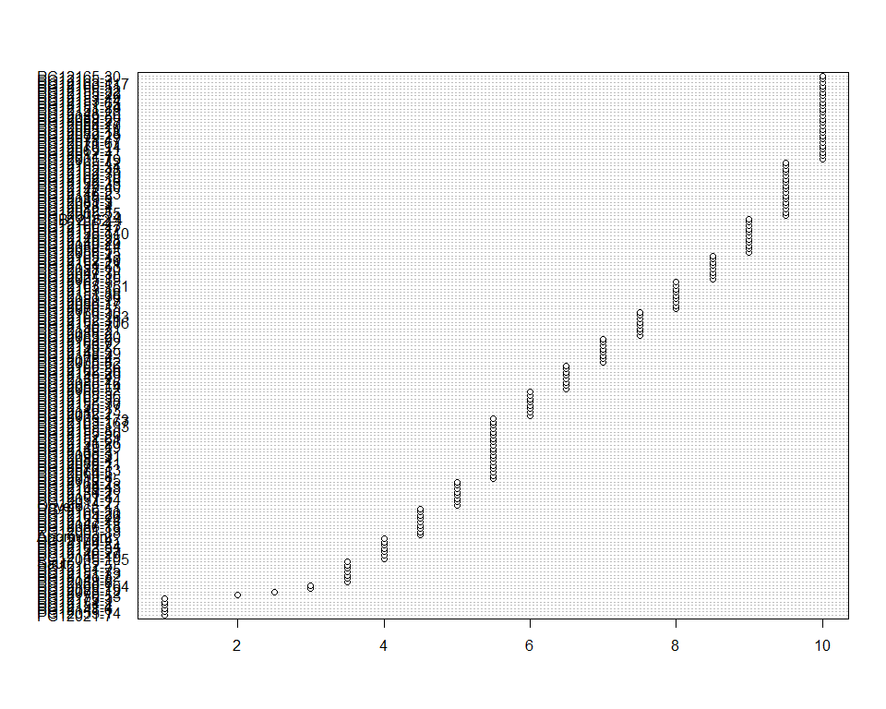

Do not forget the assumptions of the model. It is supposed that the error has a normal distribution with the same variance for all the treatments. The following plots must help you evaluate this:

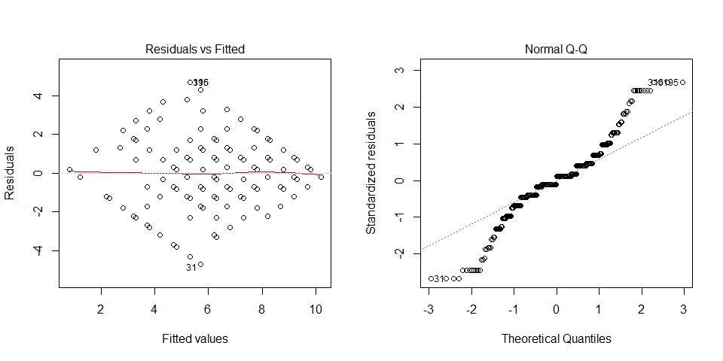

Funnel shapes for the first plot may suggest heterogeneity of variances while departures from the theoretical normal line are symptoms of lack of normality.

### Analysis of **Weight of vines measuring kg per plot**

You have fitted a linear model for a RCBD. The ANOVA table for your model is:

|  |  |  |  |  |  |
| --- | --- | --- | --- | --- | --- |
|  | Df | Sum Sq | Mean Sq | F value | Pr(>F) |
| **germplasmName** | 162 | 4068.62 | 25.1149 | 3.13929 | 6.97183e-13 |
| **REP** | 1 | 88.5053 | 88.5053 | 11.0629 | 0.00108962 |
| **Residuals** | 162 | 1296.03 | 8.00018 | NA | NA |

The p-value for treatments is 0.000000000000697183 which is significant at the 5% level.

The means of your treatments are:

|  |  |
| --- | --- |
| germplasmName | Weight of vines measuring kg per plot |
| Apomuden | 5.85 |
| Ogyefo | 9.4 |
| PG12005-1 | 6.15 |
| PG12005-105 | 9.6 |
| PG12005-24 | 3 |
| PG12005-35 | 5 |
| PG12005-52 | 16.4 |
| PG12005-55 | 1.85 |
| PG12005-79 | 2.5 |
| PG12005-82 | 10.7 |
| PG12005-88 | 10.8 |
| PG12010-15 | 5.3 |
| PG12011-7 | 1.86 |
| PG12012-1 | 0.9 |
| PG12012-2 | 2.25 |
| PG12012-4 | 1.29 |
| PG12014-2 | 3.47 |
| PG12021-10 | 2 |
| PG12021-7 | 1.96 |
| PG12028-4 | 1.35 |
| PG12047-3 | 3.33 |
| PG12055-14 | 3.48 |
| PG12057-14 | 3.65 |
| PG12058-15 | 0.874 |
| PG12059-14 | 5.85 |
| PG12059-8 | 6.75 |
| PG12061-13 | 9.35 |
| PG12064-5 | 1.87 |
| PG12069-11 | 1.4 |
| PG12070-14 | 0.75 |
| PG12071-6 | 0.75 |
| PG12073-12 | 3.78 |
| PG12076-13 | 0.851 |
| PG12076-5 | 1.65 |
| PG12078-17 | 1.45 |
| PG12078-3 | 0.817 |
| PG12078-4 | 1.5 |
| PG12079-29 | 1 |
| PG12080-15 | 0.75 |
| PG12081-3 | 4.2 |
| PG12082-18 | 0.923 |
| PG12083-11 | 0.998 |
| PG12083-20 | 2.55 |
| PG12084-10 | 0.7 |
| PG12085-16 | 7.35 |
| PG12086-11 | 1.2 |
| PG12086-17 | 0.75 |
| PG12086-18 | 15.9 |
| PG12086-5 | 1.05 |
| PG12088-10 | 2.75 |
| PG12088-19 | 4.71 |
| PG12088-2 | 4.65 |
| PG12088-27 | 1.03 |
| PG12088-29 | 1.55 |
| PG12088-4 | 2.12 |
| PG12088-8 | 1.53 |
| PG12089-13 | 1.8 |
| PG12089-14 | 2.45 |
| PG12089-3 | 2.8 |
| PG12089-5 | 1.05 |
| PG12090-31 | 0.838 |
| PG12101-3 | 7.6 |
| PG12108-3 | 1.3 |
| PG12108-4 | 6.25 |
| PG12118-5 | 2.34 |
| PG12135-2 | 2.1 |
| PG12136-2 | 4.95 |
| PG12145-2 | 15.4 |
| PG12146-13 | 2.6 |
| PG12146-19 | 2.3 |
| PG12146-21 | 8.1 |
| PG12146-23 | 0.81 |
| PG12146-27 | 2.93 |
| PG12147-1 | 4.5 |
| PG12147-5 | 1.02 |
| PG12148-26 | 1.1 |
| PG12148-39 | 3.8 |
| PG12148-6 | 3.63 |
| PG12149-18 | 1.08 |
| PG12149-19 | 4.65 |
| PG12149-20 | 1.8 |
| PG12149-28 | 3.85 |
| PG12149-40 | 1.35 |
| PG12149-49 | 4.15 |
| PG12149-5 | 5.34 |
| PG12149-8 | 15.2 |
| PG12149-9 | 4.55 |
| PG12150-53 | 2.5 |
| PG12150-7 | 5.2 |
| PG12151-19 | 3.22 |
| PG12151-24 | 2.65 |
| PG12151-26 | 4.95 |
| PG12151-32 | 2.74 |
| PG12151-36 | 4.44 |
| PG12151-4 | 1.2 |
| PG12151-53 | 3.82 |
| PG12151-61 | 5.7 |
| PG12151-65 | 1.83 |
| PG12151-73 | 16.9 |
| PG12151-75 | 2.62 |
| PG12151-88 | 0.95 |
| PG12152-29 | 3.04 |
| PG12152-33 | 3.05 |
| PG12153-14 | 0.8 |
| PG12153-16 | 1.45 |
| PG12153-2 | 2.35 |
| PG12153-21 | 8.9 |
| PG12153-24 | 8.9 |
| PG12153-29 | 1.4 |
| PG12153-35 | 2.01 |
| PG12154-1 | 2.99 |
| PG12155-106 | 9.7 |
| PG12155-110 | 1.17 |
| PG12155-12 | 5.5 |
| PG12155-17 | 9.4 |
| PG12155-20 | 4.95 |
| PG12155-22 | 3.9 |
| PG12155-30 | 5.7 |
| PG12155-32 | 1.13 |
| PG12155-50 | 1.89 |
| PG12155-8 | 4.74 |
| PG12160-104 | 4.74 |
| PG12160-47 | 1 |
| PG12160-51 | 1 |
| PG12160-72 | 5.85 |
| PG12162-10 | 1.2 |
| PG12162-16 | 0.5 |
| PG12162-19 | 1.25 |
| PG12162-3 | 2.2 |
| PG12162-31 | 0.5 |
| PG12162-39 | 0.75 |
| PG12162-43 | 0.75 |
| PG12162-5 | 2.45 |
| PG12162-54 | 2.58 |
| PG12162-56 | 3.55 |
| PG12162-9 | 2.75 |
| PG12163-117 | 0.959 |
| PG12163-133 | 4.9 |
| PG12163-151 | 3.15 |
| PG12163-163 | 4.7 |
| PG12163-167 | 5.45 |
| PG12163-173 | 2.11 |
| PG12164-21 | 9.4 |
| PG12164-26 | 11.5 |
| PG12164-43 | 5.25 |
| PG12165-20 | 3.36 |
| PG12165-3 | 1.45 |
| PG12165-30 | 0.953 |
| PG12165-31 | 1.75 |
| PG12165-36 | 2.95 |
| PG12165-42 | 1.85 |
| PG12165-43 | 2.95 |
| PG12166-11 | 5.25 |
| PG12166-26 | 8.2 |
| PG12166-30 | 4.6 |
| PG12166-4 | 2 |
| PG12167-5 | 1.75 |
| PG12168-2 | 12.2 |
| PG12169-5 | 7.9 |
| PG12170-4 | 5.1 |
| PG12175-3 | 2.61 |
| PGB12162-4 | 1.1 |
| Sauti | 17.4 |

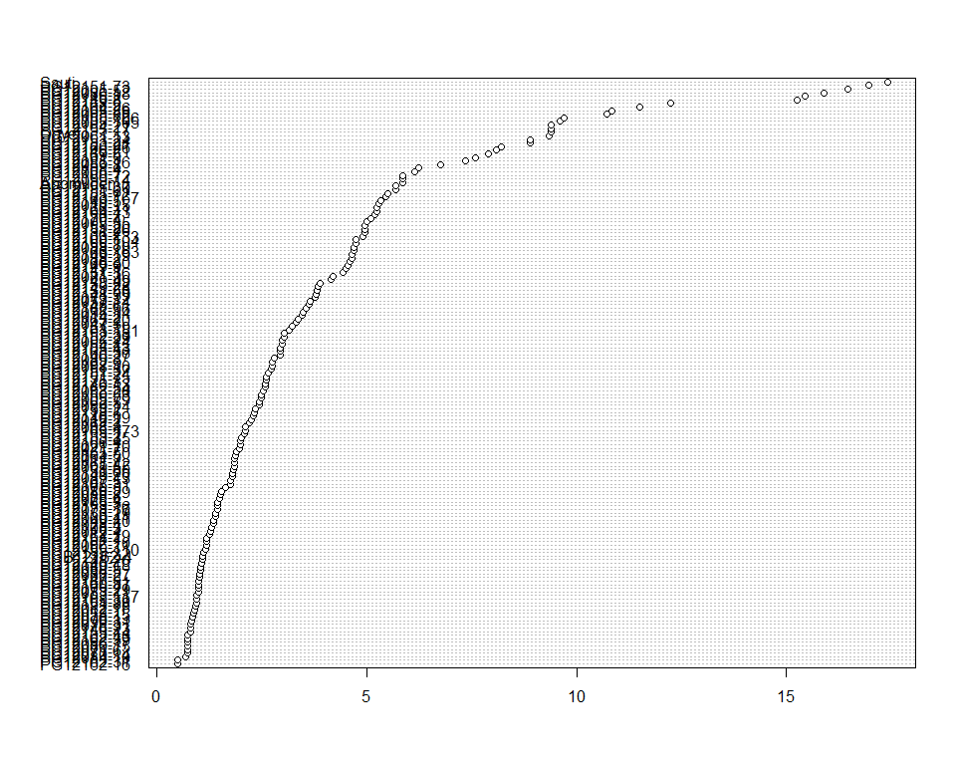

Do not forget the assumptions of the model. It is supposed that the error has a normal distribution with the same variance for all the treatments. The following plots must help you evaluate this:

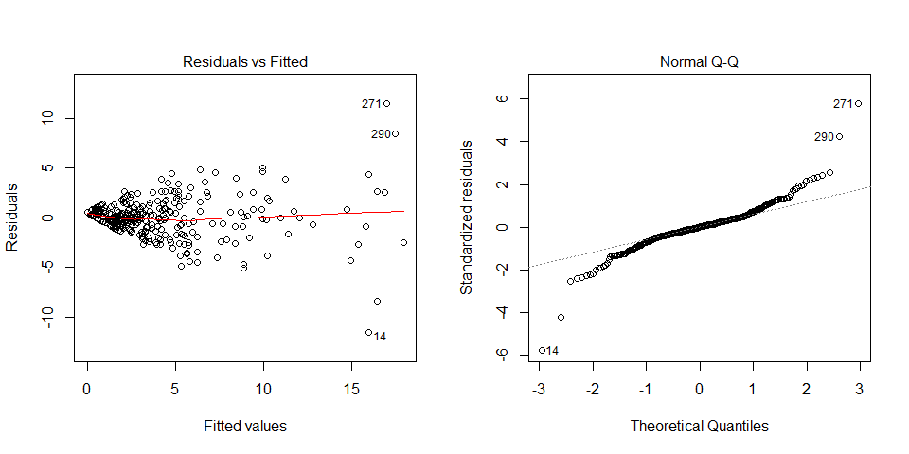

Funnel shapes for the first plot may suggest heterogeneity of variances while departures from the theoretical normal line are symptoms of lack of normality.

## Trait correlations

## Variety candidate selection

# Summary

# References

## Data sources

## Literature