Automatic report for a Completely Randomized Design (CRD)

International Potato Center

May 31, 2018

Table of Contents

# 1. Model specification and data description

There are data from 13 genotypes, evaluated using a completely randomized design. The statistical model is

$$y_{ij}=μ+τ_{i}+ϵ_{ij}$$

where

* $y_{ij}$ is the observed response with genotype $i$ and replication $j$.
* $μ$ is the mean response over all genotypes and replications.
* $τ_{i}$ is the effect for genotype $i$.
* $ϵ_{ij}$ is the error term.

In this model we assume that the errors are independent and have a normal distribution with common variance, that is, $ϵ_{ij}∼N(0,σ_{ϵ}^{2})$.

# 2. Analysis for trait Weight of commercial storage roots measuring kg per plot|CO_331:0000220

## 2.1. ANOVA

You have fitted a linear model for a CRD. The ANOVA table for your model is:

## Analysis of Variance Table  
##   
## Response: "Weight of commercial storage roots measuring kg per plot|CO_331:0000220"  
## Df Sum Sq Mean Sq F value Pr(>F)   
## germplasmName 12 965.97 80.497 13.555 1.957e-05 ***  
## Residuals 13 77.20 5.938   
## ---  
## Signif. codes: 0 '***' 0.001 '**' 0.01 '*' 0.05 '.' 0.1 ' ' 1

The coefficient of variation for this experiment is 34.43%. The p-value for genotypes is 1.957e-05 which is significant at the 5% level.

## 2.2. Assumptions

Don’t forget the assumptions of the model. It is supposed that the errors are independent with a normal distribution and with the same variance for all the genotypes. The following residuals plots must help you evaluate this:

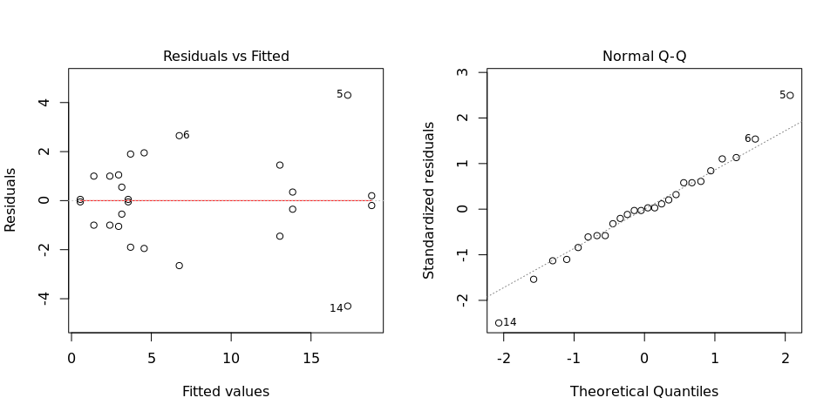

Any trend in the residuals in the left plot would violate the assumption of independence while a trend in the variability of the residuals –for instance a funnel shape– suggests heterogeneity of variances. Departures from the theoretical normal line on the right plot are symptoms of lack of normality.

## 2.3. Genotype means

Below are the sorted means for each genotype with letters indicating if there are significant differences using the multiple comparisons method of Tukey at the 5% level.

## data[, traits[i]] groups  
## Mohc 18.80 a  
## Apomuden 17.30 a  
## Kemb37 13.85 ab  
## Ningshu-1 13.05 abc  
## Beauregard 6.75 bcd  
## Cemsa74-228 4.55 bcd  
## Tanzania 3.70 cd  
## Jonathan 3.55 cd  
## Huambanchero 3.15 d  
## Blesbok 2.95 d  
## SPK004 2.40 d  
## Resisto 1.40 d  
## Wagabolige 0.55 d

## 2.4. Variance components

Below are the variance components for this model, under the assumption that genotypes are random. Here the model is fitted using REML.

## Variance Std.Dev.  
## germplasmName 37.279359 6.105683  
## Residual 5.938462 2.436896