Automatic report for a Completely Randomized Design (CRD)

International Potato Center

May 31, 2018

Table of Contents

# 1. Model specification and data description

There are data from 13 genotypes, evaluated using a completely randomized design. The statistical model is

$$y_{ij}=μ+τ_{i}+ϵ_{ij}$$

where

* $y_{ij}$ is the observed response with genotype $i$ and replication $j$.
* $μ$ is the mean response over all genotypes and replications.
* $τ_{i}$ is the effect for genotype $i$.
* $ϵ_{ij}$ is the error term.

In this model we assume that the errors are independent and have a normal distribution with common variance, that is, $ϵ_{ij}∼N(0,σ_{ϵ}^{2})$.

# 2. Analysis for trait Fresh weight of storage root samples measuring g of sample|CO_331:0000243

## 2.1. ANOVA

You have fitted a linear model for a CRD. The ANOVA table for your model is:

## Analysis of Variance Table  
##   
## Response: "Fresh weight of storage root samples measuring g of sample|CO_331:0000243"  
## Df Sum Sq Mean Sq F value Pr(>F)  
## germplasmName 12 5.6154 0.46795 2.0278 0.1103  
## Residuals 13 3.0000 0.23077

The coefficient of variation for this experiment is 27.15%. The p-value for genotypes is 0.1103 which is not significant at the 5% level.

## 2.2. Assumptions

Don’t forget the assumptions of the model. It is supposed that the errors are independent with a normal distribution and with the same variance for all the genotypes. The following residuals plots must help you evaluate this:

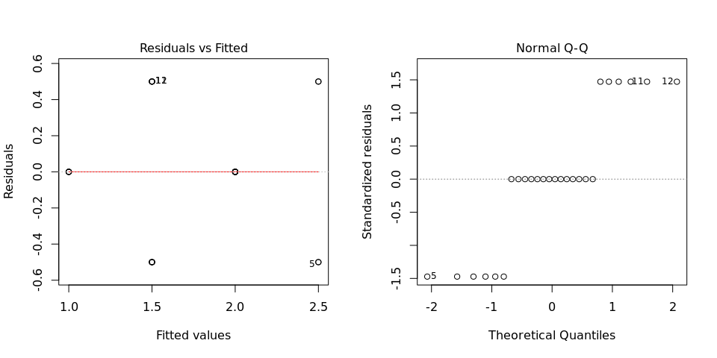

Any trend in the residuals in the left plot would violate the assumption of independence while a trend in the variability of the residuals –for instance a funnel shape– suggests heterogeneity of variances. Departures from the theoretical normal line on the right plot are symptoms of lack of normality.

## 2.3. Genotype means

The means of your genotypes are:

## Apomuden Beauregard Blesbok Cemsa74-228 Huambanchero   
## 2.5 2.5 1.5 1.5 1.0   
## Jonathan Kemb37 Mohc Ningshu-1 Resisto   
## 1.5 2.0 2.0 2.0 1.5   
## SPK004 Tanzania Wagabolige   
## 2.0 2.0 1.0

## 2.4. Variance components

Below are the variance components for this model, under the assumption that genotypes are random. Here the model is fitted using REML.

## Variance Std.Dev.  
## germplasmName 0.1185897 0.3443686  
## Residual 0.2307692 0.4803845