Automatic report for a Completely Randomized Design (CRD)

International Potato Center

July 24, 2018

Table of Contents

# 1. Model specification and data description

There are data from 13 genotypes, evaluated using a completely randomized design. The statistical model is

$$y_{ij}=μ+τ_{i}+ϵ_{ij}$$

where

* $y_{ij}$ is the observed response with genotype $i$ and replication $j$.
* $μ$ is the mean response over all genotypes and replications.
* $τ_{i}$ is the effect for genotype $i$.
* $ϵ_{ij}$ is the error term.

In this model we assume that the errors are independent and have a normal distribution with common variance, that is, $ϵ_{ij}∼N(0,σ_{ϵ}^{2})$.

# 2. Analysis for trait Weight of vines measuring kg per plot|CO_331:0000227

## 2.1. ANOVA

You have fitted a linear model for a CRD. The ANOVA table for your model is:

## Analysis of Variance Table  
##   
## Response: "Weight of vines measuring kg per plot|CO_331:0000227"  
## Df Sum Sq Mean Sq F value Pr(>F)   
## germplasmName 12 3452.7 287.728 19.607 2.279e-06 ***  
## Residuals 13 190.8 14.675   
## ---  
## Signif. codes: 0 '***' 0.001 '**' 0.01 '*' 0.05 '.' 0.1 ' ' 1

The coefficient of variation for this experiment is 24.2%. The p-value for genotypes is 2.279e-06 which is significant at the 5% level.

## 2.2. Assumptions

Don’t forget the assumptions of the model. It is supposed that the errors are independent with a normal distribution and with the same variance for all the genotypes. The following residuals plots must help you evaluate this:

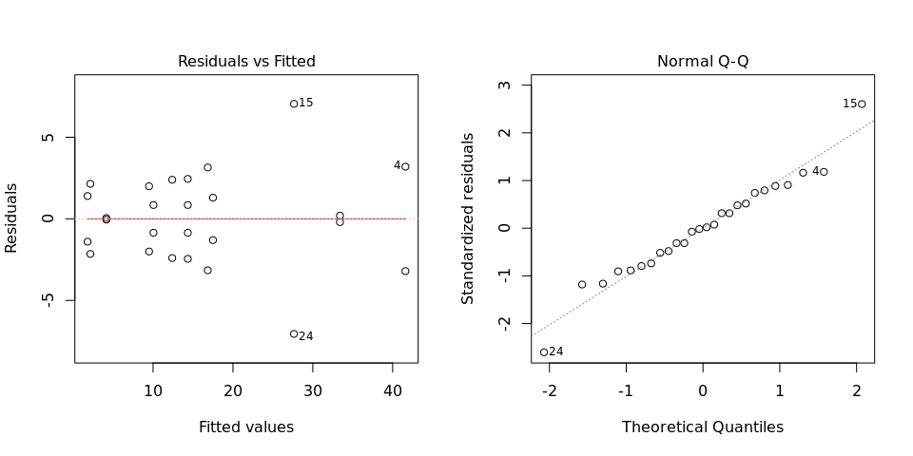

Any trend in the residuals in the left plot would violate the assumption of independence while a trend in the variability of the residuals –for instance a funnel shape– suggests heterogeneity of variances. Departures from the theoretical normal line on the right plot are symptoms of lack of normality.

## 2.3. Genotype means

Below are the sorted means for each genotype with letters indicating if there are significant differences using the multiple comparisons method of Tukey at the 5% level.

## data[, traits[i]] groups  
## SPK004 41.60 a  
## Wagabolige 33.40 a  
## Mohc 27.65 ab  
## Huambanchero 17.50 bc  
## Kemb37 16.85 bcd  
## Tanzania 14.35 bcd  
## Ningshu-1 14.35 bcd  
## Cemsa74-228 12.40 cd  
## Apomuden 10.05 cd  
## Jonathan 9.50 cd  
## Blesbok 4.15 cd  
## Beauregard 2.15 d  
## Resisto 1.80 d

## 2.4. Variance components

Below are the variance components for this model, under the assumption that genotypes are random. Here the model is fitted using REML.

## Variance Std.Dev.  
## germplasmName 136.5265 11.684456  
## Residual 14.6750 3.830796