Automatic report for a Completely Randomized Design (CRD)

International Potato Center

September 12, 2018

Table of Contents

# 1. Model specification and data description

There are data from 13 genotypes, evaluated using a completely randomized design. The statistical model is

$$y_{ij}=μ+τ_{i}+ϵ_{ij}$$

where

* $y_{ij}$ is the observed response with genotype $i$ and replication $j$.
* $μ$ is the mean response over all genotypes and replications.
* $τ_{i}$ is the effect for genotype $i$.
* $ϵ_{ij}$ is the error term.

In this model we assume that the errors are independent and have a normal distribution with common variance, that is, $ϵ_{ij}∼N(0,σ_{ϵ}^{2})$.

# 2. Analysis for trait Weight of commercial storage roots measuring kg per plot|CO_331:0000220

## 2.1. ANOVA

You have fitted a linear model for a CRD. The ANOVA table for your model is:

## Analysis of Variance Table  
##   
## Response: "Weight of commercial storage roots measuring kg per plot|CO_331:0000220"  
## Df Sum Sq Mean Sq F value Pr(>F)   
## germplasmName 12 1429.48 119.124 11.167 9.896e-05 ***  
## Residuals 12 128.01 10.668   
## ---  
## Signif. codes: 0 '***' 0.001 '**' 0.01 '*' 0.05 '.' 0.1 ' ' 1

The coefficient of variation for this experiment is 32.88%. The p-value for genotypes is 9.896e-05 which is significant at the 5% level.

## 2.2. Assumptions

Don’t forget the assumptions of the model. It is supposed that the errors are independent with a normal distribution and with the same variance for all the genotypes. The following residuals plots must help you evaluate this:

## Warning: not plotting observations with leverage one:  
## 25

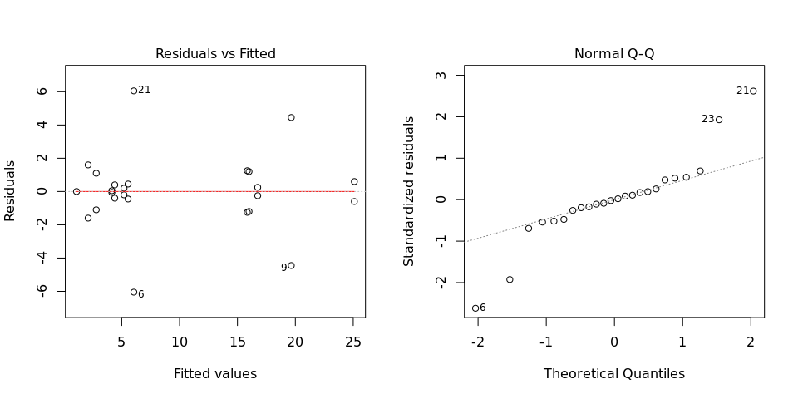

Any trend in the residuals in the left plot would violate the assumption of independence while a trend in the variability of the residuals –for instance a funnel shape– suggests heterogeneity of variances. Departures from the theoretical normal line on the right plot are symptoms of lack of normality.

## 2.3. Genotype means

Below are the sorted means for each genotype with letters indicating if there are significant differences using the multiple comparisons method of Tukey at the 5% level.

## dfr[, traits[i]] groups  
## Mohc 25.10 a  
## Ningshu-1 19.65 a  
## Cemsa74-228 16.75 ab  
## Kemb37 16.00 ab  
## Apomuden 15.85 abc  
## Beauregard 6.05 bcd  
## Jonathan 5.55 bcd  
## Blesbok 5.20 bcd  
## SPK004 4.40 bcd  
## Huambanchero 4.15 bcd  
## Tanzania 2.80 cd  
## Resisto 2.10 d  
## Wagabolige 1.10 d

## 2.4. Variance components

Below are the variance components for this model, under the assumption that genotypes are random. Here the model is fitted using REML.

## Variance Std.Dev.  
## germplasmName 56.80677 7.537027  
## Residual 10.67828 3.267763

# 3. Analysis for trait Virus symptoms 2 estimating 1-9|CO_331:2000004

## 3.1. ANOVA

You have fitted a linear model for a CRD. The ANOVA table for your model is:

## Analysis of Variance Table  
##   
## Response: "Virus symptoms 2 estimating 1-9|CO_331:2000004"  
## Df Sum Sq Mean Sq F value Pr(>F)   
## germplasmName 12 87.76 7.3133 8.776 0.0003352 ***  
## Residuals 12 10.00 0.8333   
## ---  
## Signif. codes: 0 '***' 0.001 '**' 0.01 '*' 0.05 '.' 0.1 ' ' 1

The coefficient of variation for this experiment is 16.19%. The p-value for genotypes is 0.0003352 which is significant at the 5% level.

## 3.2. Assumptions

Don’t forget the assumptions of the model. It is supposed that the errors are independent with a normal distribution and with the same variance for all the genotypes. The following residuals plots must help you evaluate this:

## Warning: not plotting observations with leverage one:  
## 20

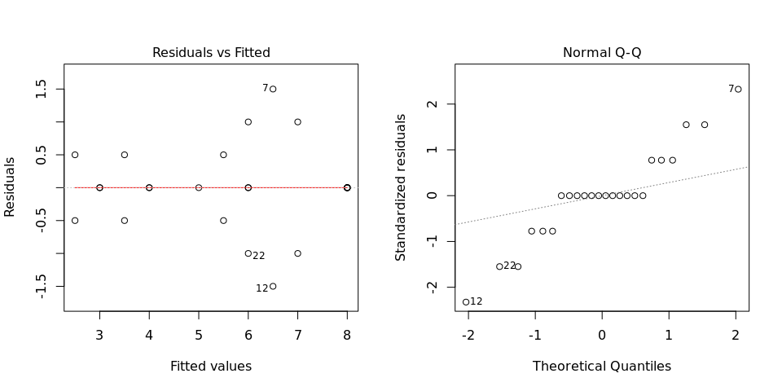

Any trend in the residuals in the left plot would violate the assumption of independence while a trend in the variability of the residuals –for instance a funnel shape– suggests heterogeneity of variances. Departures from the theoretical normal line on the right plot are symptoms of lack of normality.

## 3.3. Genotype means

Below are the sorted means for each genotype with letters indicating if there are significant differences using the multiple comparisons method of Tukey at the 5% level.

## dfr[, traits[i]] groups  
## Blesbok 8.0 a  
## Jonathan 8.0 a  
## Ningshu-1 8.0 a  
## Kemb37 7.0 ab  
## Cemsa74-228 6.5 abc  
## Huambanchero 6.0 abcd  
## Tanzania 6.0 abcd  
## Apomuden 5.5 abcd  
## Beauregard 5.0 abcd  
## Mohc 4.0 bcd  
## Wagabolige 3.5 bcd  
## Resisto 3.0 cd  
## SPK004 2.5 d

## 3.4. Variance components

Below are the variance components for this model, under the assumption that genotypes are random. Here the model is fitted using REML.

## Variance Std.Dev.  
## germplasmName 3.2820572 1.8116449  
## Residual 0.8275241 0.9096835

# 4. Analysis for trait Weight of non-commercial storage roots measuring kg per plot|CO_331:0000223

## 4.1. ANOVA

You have fitted a linear model for a CRD. The ANOVA table for your model is:

## Analysis of Variance Table  
##   
## Response: "Weight of non-commercial storage roots measuring kg per plot|CO_331:0000223"  
## Df Sum Sq Mean Sq F value Pr(>F)   
## germplasmName 12 19.065 1.5888 3.8284 0.01153 *  
## Residuals 13 5.395 0.4150   
## ---  
## Signif. codes: 0 '***' 0.001 '**' 0.01 '*' 0.05 '.' 0.1 ' ' 1

The coefficient of variation for this experiment is 36.18%. The p-value for genotypes is 0.01153 which is significant at the 5% level.

## 4.2. Assumptions

Don’t forget the assumptions of the model. It is supposed that the errors are independent with a normal distribution and with the same variance for all the genotypes. The following residuals plots must help you evaluate this:

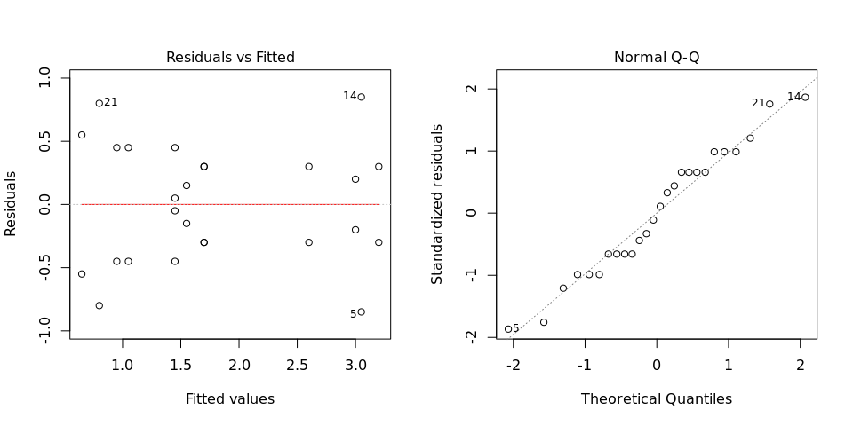

Any trend in the residuals in the left plot would violate the assumption of independence while a trend in the variability of the residuals –for instance a funnel shape– suggests heterogeneity of variances. Departures from the theoretical normal line on the right plot are symptoms of lack of normality.

## 4.3. Genotype means

Below are the sorted means for each genotype with letters indicating if there are significant differences using the multiple comparisons method of Tukey at the 5% level.

## dfr[, traits[i]] groups  
## Kemb37 3.20 a  
## Apomuden 3.05 a  
## Huambanchero 3.00 a  
## Mohc 2.60 a  
## Jonathan 1.70 a  
## Ningshu-1 1.70 a  
## SPK004 1.55 a  
## Blesbok 1.45 a  
## Cemsa74-228 1.45 a  
## Resisto 1.05 a  
## Tanzania 0.95 a  
## Beauregard 0.80 a  
## Wagabolige 0.65 a

## 4.4. Variance components

Below are the variance components for this model, under the assumption that genotypes are random. Here the model is fitted using REML.

## Variance Std.Dev.  
## germplasmName 0.586891 0.7660881  
## Residual 0.415000 0.6442049