Automatic report for a Completely Randomized Design (CRD)

International Potato Center

October 18, 2019

Table of Contents

# 1. Model specification and data description

There are data from 10 treatments evaluated using a completely randomized design. The statistical model is

$$y_{ij}=μ+τ_{i}+ϵ_{ij}$$

where

* $y_{ij}$ is the observed response with treatment $i$ and replication $j$.
* $μ$ is the mean response over all treatments and replications.
* $τ_{i}$ is the effect for treatment $i$.
* $ϵ_{ij}$ is the error term.

In this model we assume that the errors are independent and have a normal distribution with common variance, that is, $ϵ_{ij}∼N(0,σ_{ϵ}^{2})$.

# 2. Analysis for trait Dry weight of storage root samples measuring g of sample|CO_331:0000247

## 2.1. ANOVA

You have fitted a linear model for a CRD. The ANOVA table for your model is:

## Analysis of Variance Table  
##   
## Response: "Dry weight of storage root samples measuring g of sample|CO_331:0000247"  
## Df Sum Sq Mean Sq F value Pr(>F)   
## germplasmName 9 3698.1 410.90 24.917 1.067e-05 ***  
## Residuals 10 164.9 16.49   
## ---  
## Signif. codes: 0 '***' 0.001 '**' 0.01 '*' 0.05 '.' 0.1 ' ' 1

The coefficient of variation for this experiment is 6.104%. The p-value for treatments is 1.067e-05 which is significant at the 5% level.

## 2.2. Assumptions

Don’t forget the assumptions of the model. It is supposed that the errors are independent with a normal distribution and with the same variance for all the treatments. The following residuals plots must help you evaluate this:

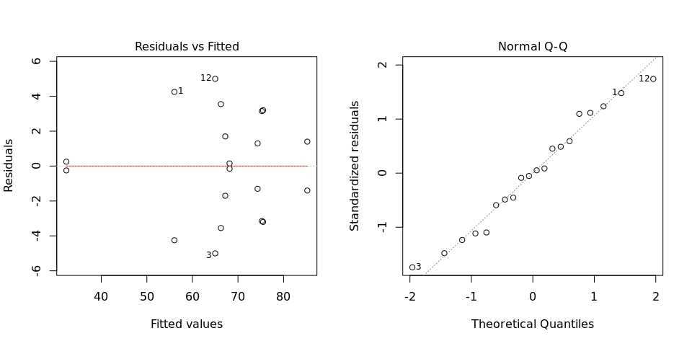

Any trend in the residuals in the left plot would violate the assumption of independence while a trend in the variability of the residuals –for instance a funnel shape– suggests heterogeneity of variances. Departures from the theoretical normal line on the right plot are symptoms of lack of normality.

## 2.3. Treatment means

Below are the sorted means for each treatment with letters indicating if there are significant differences using the least significance difference method and the multiple comparisons method of Tukey, both at the 5% level.

### 2.3.1. LSD test

## means groups  
## Ukerewe 85.20 a  
## NASPOT1 75.50 b  
## CarrotC 75.25 bc  
## Gweri 74.30 bc  
## Cemsa74-228 68.15 bcd  
## Mohc 67.20 bcd  
## Jukwa-orange 66.25 cd  
## Tanzania 65.00 de  
## CIP199062.1 56.05 e  
## Apomuden 32.35 f

### 2.3.2. Tukey test

## means groups  
## Ukerewe 85.20 a  
## NASPOT1 75.50 ab  
## CarrotC 75.25 ab  
## Gweri 74.30 ab  
## Cemsa74-228 68.15 bc  
## Mohc 67.20 bc  
## Jukwa-orange 66.25 bc  
## Tanzania 65.00 bc  
## CIP199062.1 56.05 c  
## Apomuden 32.35 d

## 2.4. Variance components

Below are the variance components for this model, under the assumption that treatments are random. Here the model is fitted using REML.

## Variance Std.Dev.  
## germplasmName 197.2033 14.042909  
## Residual 16.4905 4.060849