Automatic report for a Completely Randomized Design (CRD)

International Potato Center

June 04, 2018

Table of Contents

# 1. Model specification and data description

There are data from 14 genotypes, evaluated using a completely randomized design. The statistical model is

$$y_{ij}=μ+τ_{i}+ϵ_{ij}$$

where

* $y_{ij}$ is the observed response with genotype $i$ and replication $j$.
* $μ$ is the mean response over all genotypes and replications.
* $τ_{i}$ is the effect for genotype $i$.
* $ϵ_{ij}$ is the error term.

In this model we assume that the errors are independent and have a normal distribution with common variance, that is, $ϵ_{ij}∼N(0,σ_{ϵ}^{2})$.

# 2. Analysis for trait weight of cull storage roots measuring kg per plot|CO_331:0000612

## 2.1. ANOVA

You have fitted a linear model for a CRD. The ANOVA table for your model is:

## Analysis of Variance Table  
##   
## Response: "weight of cull storage roots measuring kg per plot|CO_331:0000612"  
## Df Sum Sq Mean Sq F value Pr(>F)  
## germplasmName 13 87.938 6.7645 1.0741 0.4166  
## Residuals 29 182.638 6.2978

The coefficient of variation for this experiment is 87.4%. The p-value for genotypes is 0.4166 which is not significant at the 5% level.

## 2.2. Assumptions

Don’t forget the assumptions of the model. It is supposed that the errors are independent with a normal distribution and with the same variance for all the genotypes. The following residuals plots must help you evaluate this:

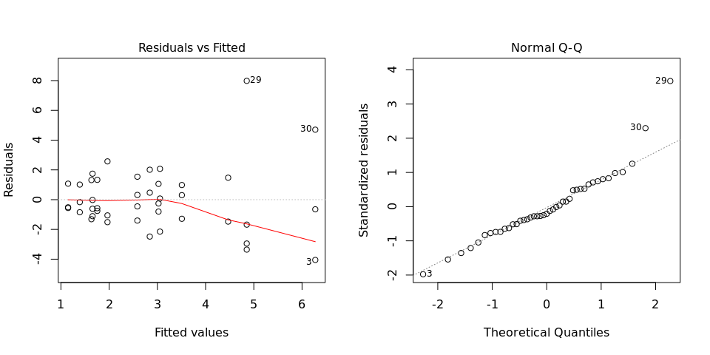

Any trend in the residuals in the left plot would violate the assumption of independence while a trend in the variability of the residuals –for instance a funnel shape– suggests heterogeneity of variances. Departures from the theoretical normal line on the right plot are symptoms of lack of normality.

## 2.3. Genotype means

The means of your genotypes are:

## Beauregard_G2 Covington_G2 Hatteras_G2 NC05-0198_G2 NC10-0433   
## 3.50784 4.46796 1.65564 4.85352 3.02400   
## NC12-0746 NC12-0910 NC13-0151 NC13-0383 NC13-1001   
## 1.96560 3.05424 1.14912 1.63296 1.39104   
## NC13-1027 NC13-1142 NC13-1259 NC14-0118   
## 1.75392 2.58552 6.27480 2.84256

## 2.4. Variance components

Below are the variance components for this model, under the assumption that genotypes are random. Here the model is fitted using REML.

## Variance Std.Dev.  
## germplasmName 0.2231643 0.4724027  
## Residual 6.2301919 2.4960352