Dataset iris (nrow=150)

Not compacted
Table 1 is an example. However, automatic testing is bad and I should feel bad.
label | variable | Species |  |  | test
 |  | setosa | versicolor | virginica
Sepal.Length | Min / Max | 4.3 / 5.8 | 4.9 / 7.0 | 4.9 / 7.9 |  | p value: <0.0001  (One-way analysis of means (not assuming equal variances))
 | Med [IQR] | 5.0 [4.8;5.2] | 5.9 [5.6;6.3] | 6.5 [6.2;6.9]
 | Mean (std) | 5.0 (0.4) | 5.9 (0.5) | 6.6 (0.6)
 | N (NA) | 50 (0) | 50 (0) | 50 (0)
Sepal.Width | Min / Max | 2.3 / 4.4 | 2.0 / 3.4 | 2.2 / 3.8 |  | p value: <0.0001  (One-way analysis of means)
 | Med [IQR] | 3.4 [3.2;3.7] | 2.8 [2.5;3.0] | 3.0 [2.8;3.2]
 | Mean (std) | 3.4 (0.4) | 2.8 (0.3) | 3.0 (0.3)
 | N (NA) | 50 (0) | 50 (0) | 50 (0)
Petal.Length | Min / Max | 1.0 / 1.9 | 3.0 / 5.1 | 4.5 / 6.9 |  | p value: <0.0001  (Kruskal-Wallis rank sum test)
 | Med [IQR] | 1.5 [1.4;1.6] | 4.3 [4.0;4.6] | 5.5 [5.1;5.9]
 | Mean (std) | 1.5 (0.2) | 4.3 (0.5) | 5.6 (0.6)
 | N (NA) | 50 (0) | 50 (0) | 50 (0)
Petal.Width | Min / Max | 0.1 / 0.6 | 1.0 / 1.8 | 1.4 / 2.5 |  | p value: <0.0001  (Kruskal-Wallis rank sum test)
 | Med [IQR] | 0.2 [0.2;0.3] | 1.3 [1.2;1.5] | 2.0 [1.8;2.3]
 | Mean (std) | 0.2 (0.1) | 1.3 (0.2) | 2.0 (0.3)
 | N (NA) | 50 (0) | 50 (0) | 50 (0)
Table 1: Automatic testing is bad
Let's add a figure as well. You can see in Figure 1 that sepal length is somehow correlated with petal length.
Figure 1: Relation between Petal length and Sepal length
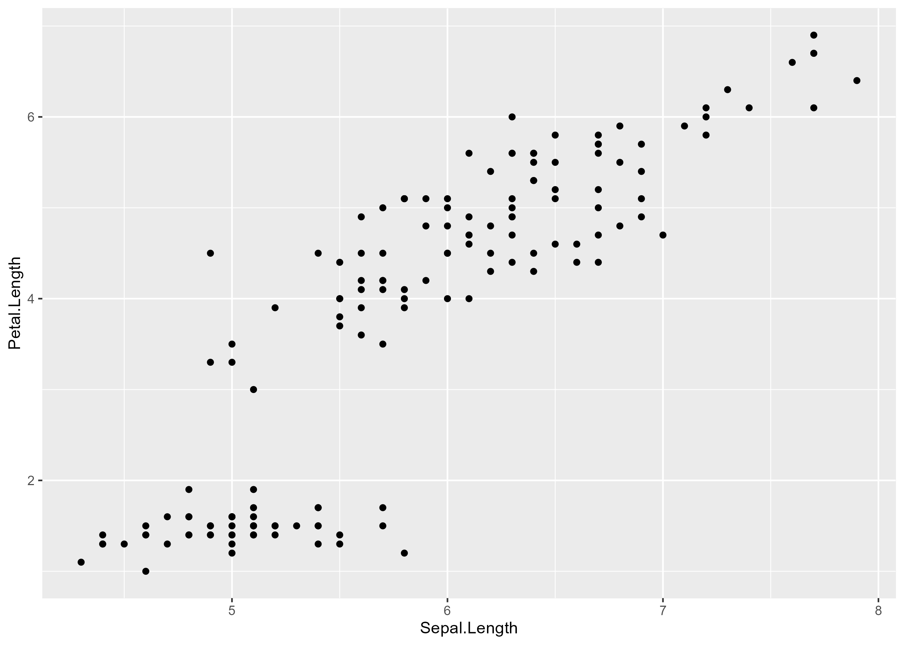

Compacted
When compacting, you might want to remove the test names.
 | Species |  |  | test
 | setosa | versicolor | virginica
Sepal.Length |  |  |  | p value: <0.0001
Min / Max | 4.3 / 5.8 | 4.9 / 7.0 | 4.9 / 7.9
Med [IQR] | 5.0 [4.8;5.2] | 5.9 [5.6;6.3] | 6.5 [6.2;6.9]
Mean (std) | 5.0 (0.4) | 5.9 (0.5) | 6.6 (0.6)
N (NA) | 50 (0) | 50 (0) | 50 (0)
Sepal.Width |  |  |  | p value: <0.0001
Min / Max | 2.3 / 4.4 | 2.0 / 3.4 | 2.2 / 3.8
Med [IQR] | 3.4 [3.2;3.7] | 2.8 [2.5;3.0] | 3.0 [2.8;3.2]
Mean (std) | 3.4 (0.4) | 2.8 (0.3) | 3.0 (0.3)
N (NA) | 50 (0) | 50 (0) | 50 (0)
Petal.Length |  |  |  | p value: <0.0001
Min / Max | 1.0 / 1.9 | 3.0 / 5.1 | 4.5 / 6.9
Med [IQR] | 1.5 [1.4;1.6] | 4.3 [4.0;4.6] | 5.5 [5.1;5.9]
Mean (std) | 1.5 (0.2) | 4.3 (0.5) | 5.6 (0.6)
N (NA) | 50 (0) | 50 (0) | 50 (0)
Petal.Width |  |  |  | p value: <0.0001
Min / Max | 0.1 / 0.6 | 1.0 / 1.8 | 1.4 / 2.5
Med [IQR] | 0.2 [0.2;0.3] | 1.3 [1.2;1.5] | 2.0 [1.8;2.3]
Mean (std) | 0.2 (0.1) | 1.3 (0.2) | 2.0 (0.3)
N (NA) | 50 (0) | 50 (0) | 50 (0)

Dataset mtcars2
This dataset has 22 rows and 4 columns.
Look, there are labels!
 | Transmission |  |  | Total | effect
 | auto | manual | NA
Miles/(US) gallon |  |  |  |  | Difference in means (t-test CI), ref='auto'  manual minus auto: 7.24 [3.64 to 10.85]
Min / Max | 10.4 / 24.4 | 15.0 / 33.9 | no NA | 10.4 / 33.9
Med [IQR] | 17.3 [14.9;19.2] | 22.8 [21.0;30.4] | no NA | 19.2 [15.4;22.8]
Mean (std) | 17.1 (3.8) | 24.4 (6.2) | no NA | 20.1 (6.0)
N (NA) | 19 (0) | 13 (0) | no NA | 32 (0)
Number of cylinders |  |  |  |  | Odds ratio [95% Wald CI], ref='manual vs auto'  6 vs 4: 0.28 [0.03 to 1.99]  8 vs 4: 0.06 [0.01 to 0.39]
4 | 3 (27.27%) | 8 (72.73%) | 0 | 11 (34.38%)
6 | 4 (57.14%) | 3 (42.86%) | 0 | 7 (21.88%)
8 | 12 (85.71%) | 2 (14.29%) | 0 | 14 (43.75%)
NA | 0 | 0 | 0 | 0
Total | 19 (59.38%) | 13 (40.62%) | 0 | 32 (100.00%)
Displacement (cu.in.) |  |  |  |  | Difference in means (bootstrap CI), ref='auto'  manual minus auto: -146.85 [-216.68 to -77.02]
Min / Max | 120.1 / 472.0 | 71.1 / 351.0 | no NA | 71.1 / 472.0
Med [IQR] | 275.8 [196.3;360.0] | 120.3 [79.0;160.0] | no NA | 196.3 [120.8;326.0]
Mean (std) | 290.4 (110.2) | 143.5 (87.2) | no NA | 230.7 (123.9)
N (NA) | 19 (0) | 13 (0) | no NA | 32 (0)

