**Welfare impacts of floods in cities with formal and informal housing**

**Highlights:**

* We develop an urban economics land use model where formal and informal housing markets coexist and household locations respond to flood risks. The model accounts for how the poorest households might trade-off protection from flood risks for cheaper housing and better accessibility. It predicts how these trade-offs might be affected by future demographic, climate and policy scenarios
* We run simulations to estimate fluvial and pluvial flood damages and welfare impacts under different future land availability scenarios that reflect alternative policy approaches to informal land settlement and flood damage mitigation
* We find that in the business as usual scenario the number of informal settlements in flood-prone areas is likely to increase, that flood damages will weigh heavily in the budget of low-income households living in informal settlements.
* We explore the trade-off [FOR WHOM? SOCIETY? PRIVATE AGENTS?] between costs associated with land use restrictions (in the form of restricted land supply, higher prices and greater informality) and exposure to floods (which is particularly harmful to vulnerable populations). [WHAT ABOUT PERSONAL PROTECTION MEASURES VS COLLECTIVE PROTECTION MEASURES?]

# **1.** **Introduction (1 PAGE OR 1 ½ PAGE)**

Global stakes:

· high vulnerability of cities to extreme events (likely to increase with climate change and urbanization).

· especially in the South where urbanization is faster and where people have less way to cope with extreme events

Cape Town context:

· exposition to extreme events: fluvial and pluvial floods [MAYBE SEA-LEVEL RISE- ALTHOUGH IF WE INTRODUCE SEA LEVEL RISE, THE INTRO MIGHT BE DIFFERENT. WE COULD SAY THAT DIFFERENT TYPES OF FLOOD RISKS AFFECT DIFFERENT POPULATION A PRIORI, THE RICH ON THE COAST FACING SEA-LEVEL RISE, AND THE POOR MORE AT RISKS FROM FLUVIAL, AND EVERYONE EXPOSED TO PLUVIAL. AND THEN SAY THAT IN FACT, EVERYONE IS AFFECTED BY THESE RISKS THROUGH GENERAL EQUILIBRIUM EFFECTS] Cape Town is among the cities most affected by pluvial risk in sub-Saharan Africa in terms of population, built-up and infrastructure, with average annual damage from rain estimated at almost $16million (World Bank, 2021). [IS THIS FLUVIAL + PLUVIAL? CAN THE DAMAGES BE BROKEN DOWN?] In comparison, average annual damage from coastal floods are evaluated at less than $400,000 (World Bank, 2021).

The impact of exposure to risk is not just the direct exposure of population, structures and infrastructure in flood zones but affects the whole city through general equilibrium effects (in particular on housing prices throughout the city). [CAN WE COMPARE WELFARE WITHOUT AND WITHOUT FLOOD RISKS FOR EVERYONE AND EVEN LOCATIONS WITHOUT FLOODS?]

· high inequalities -> people living in informal settlements more vulnerable to floods [HAVE SOME FIGURES] In Cape Town, about 160,000 people are directly exposed to pluvial risk (World Bank, 2021). [IS THIS PLUVIAL AND FLUVIAL?]

· rapidly growing cities -> more people likely to live in IS [FIGURES - CHECK THE GREAT WORK PRESENTED BY MARK NAPIER ON THE LAND PORTA - ALL THE FIGURES ARE THERE. [Urban land reform: rethinking informal settlements in pre-apartheid, apartheid and post-apartheid South Africa | Land Portal](https://landportal.org/blog-post/2020/01/urban-land-reform-rethinking-informal-settlements-pre-apartheid-apartheid-and-post)]

· floods impact house structures and contents but also health, schooling,...

Research questions:

· How vulnerable are the poor, especially those located in informal settlements in terms of flood risks and impact from flood risks?

. How will urban expansion scenarios and policies affect exposure to floods and the distribution of flood impacts? [WHAT DO WE WANT TO TELL POLICY MAKERS: EVICT ON THE RIVER BANKS TO PROTECT THE POOR FROM RISKS THEY ARE WILLING TO TAKE?] Benefits from improved accessibility outweigh private flood damages.

Short review of the literature

. What we know about impact of floods in cities

Cite what we know from case studies (WB, etc.). Existing studies show that urbanization can lead to higher vulnerability because of urbanization in flood-prone areas.

Recent economic paper - Kocornick “Flooded cities”, Desmet et al, etc.)

City-scale land use papers (Avner etc.)

Modeling of urbanization with NEDUM - Cape Town

· based on urban economics theories

. adjusted to model the Cape Town case (informal housing in particular) in Pfeiffer et al. (2019)

. NEDUM allows a more realistic assessment where location choices (and competition for land between households i) takes into account flood risks, density is endogenous (including in flood prone areas). Sufficiently granular to account for zoning and physical characteristics of cities. Allows for estimation of damages. [CHECK PREVIOUS PAPER “SELLING MESSAGES” ON NEDUM]

Announce rest of the paper

# **2.** **The Cape Town context and the city’s exposure to floods [SEE PREVIOUS PAPER ALSO] (1 PAGE)**

SUBSECTION: TOPOGRAPHY, DEMOGRAPHY, SPATIAL FRAGMENTATION AND HOUSING TYPES, URBAN EXPANSION (IN-MIGRATION COMBINED WITH POVERTY AND LACK OF SERVICES, INCREASINGLY: SMALLER HOUSEHOLD SIZES). 1 PARAGRAPH [DO WE REALLY NEED THIS SUBSECTION CAN IT BE WEAVED IN WITH THE SUBSECTION ON FLOODS IN CAPE TOWN?]

SUBSECTION: EXPOSURE TO FLOODS / VULNERABILITY. 1 OR 2 PARAGRAPHS, WITH NICE FIGURES AND PICTURES

Socioeconomic and sociodemographic:

· ethnically diverse

· economic inequalities

· formal and informal housing

· high population growth rate

Vulnerability:

· flood vulnerability due to i) climate ii) landscape iii) urbanization and housing (Claus' Research Note)

· impact on houses, households' assets, health, schooling/working,... (Claus' Research Note)

**INTRO [DISTRIBUTE BETWEEN SECTION 1 AND SECTION 2]**

The model described [above] is applied to Cape Town, a sprawling city of four million inhabitants located on a broad, sandy plain connecting a mountainous Cape peninsula to the mainland.

**DEMOGRAPHY** Cape Town’s population has grown dramatically since the dismantling of the Apartheid-era urban influx control laws in the early 1980s, which precipitated large-scale in-migration of poor, predominantly rural households from other parts of South and Southern Africa. Amplified by declining household size, the magnitude and persistence of growth in demand for housing and basic services by poor households exceeds the capacity of formal housing supply processes which have historically governed urban development processes in South African cities.

**HOUSING MARKET / URBAN ISSUES.** Cape Town’s housing market is best understood as four discrete but interacting sub-markets: formal market-led housing, formal subsidy housing, informal dwellings located in backyards of subsidy housing, and informal dwellings located in informal settlements. The vast majority of households in informal settlements live in a low-lying plain called the Cape Flats.

Figure X: TOPOGRAPHY

Note: In the Landsat image, Cape Town and its environs is viewed towards the east, with the peninsula in the foreground. The oval (long axis about 25km) roughly encompasses the Cape Flats, a predominantly low-lying area where approximately 200 000 poor households (15-20% of total) live in informal settlements.

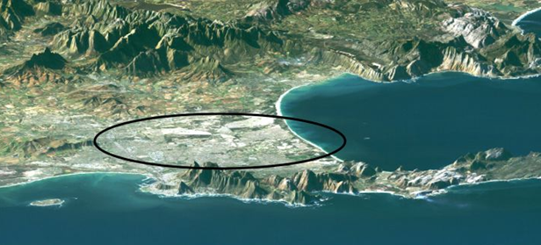

Source: Claus to add

**HYDROLOGY**

The hydrology of the Cape Flats renders poor households living in informal settlements vulnerable to both fluvial and pluvial flooding. Fluvial flooding is episodic and localized along Cape Town’s four perennial rivers and stormwater channels. [NAME THE FOUR RIVERS AND STORMWATER CHANNELS. EXPLAIN WHERE THEY ARE LOCATED. DESCRIBE ON MAP. WOULD BE NICE TO HAVE A PICTURE FOR PRESENTATIONS - NOT NECESSARILY FOR THE PAPER] Pluvial flooding, on the other hand, is persistent and widespread across the Cape Flats area: the vast network of seasonal rivers, streams and wetlands transecting the area is inundated for a few weeks annually during the rainy winter season. From there, drainage is encumbered by flat terrain and a water table which lies between 1-3 meters from the surface in the dry summer months, but rises by between 1- and 2-meters during winter, causing ‘rising water’ or ‘seepage’ in topographic depressions. The impact of hydrology on households is aggravated by inadequate drainage infrastructure, which leads to localized ponding.

Figure x: Informal dwellings in informal settlements vulnerable to flooding

Note: based on desktop analysis of aerial imagery.[NEED FOR APPENDIX ON THE UNDERLYING METHODOLOGY] [REDO THIS WITH FATHOM MAPS TO BE CONSISTENT WITH OUR OWN DATA, OR CONTEXTUALIZE IN A REVIEW OF PREVIOUS WORK]

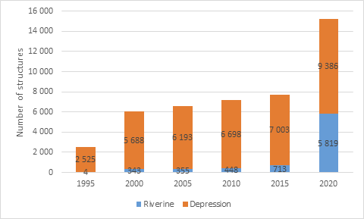

[CHECK IF WE CAN HAVE A GRAPH: HOW IMPORTANT, HOW FREQUENT? IF NOT, ADD SOME FIGURES IN ONE OR TWO SENTENCES TO GIVE AN IDEA OF THE EXTENT OF THE PHENOMENON. FOR EXAMPLE THE NUMBER OF HOUSEHOLDS AFFECTED PER YEAR OVER THE LAST XXX YEARS. MAYBE A FIGURE ON THE DAMAGES?]

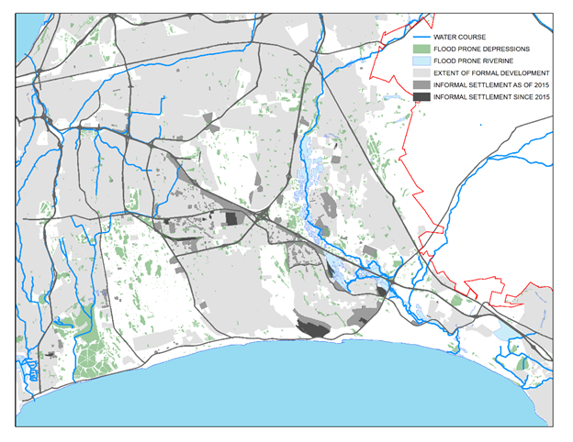

Source: Author

**EXPOSURE TO FLOODS**

The magnitude of the impact of flooding on poor households is determined by nature and by human behaviour. The main *human* cause of impact is the mass, informal occupation of large areas of flood-prone wetlands and detention ponds by poor households who build structures from corrugated iron sheets. The extent of informal settlements in flood prone areas has increased from 17 hectares in 1995 to 147 hectares in 2020. [REDO THIS OURSELVES]

The propensity for households to locate on flood-prone areas is not incidental but attributable to the fact that formal development is prohibited in flood prone areas, leaving vacant remnants of land throughout the Cape Flats area. Furthermore, South African courts have pronounced that local authorities are not allowed to evict illegal land occupants from erected structures unless alternative accommodation is provided. Land occupation events typically occur in the run-up to winter since local authorities are reluctant to evict during winter on humanitarian grounds. Following a successful land occupation event, the local community demands services from the local authorities. However, the provision of basic services is necessarily complicated by topographical and other engineering difficulties associated with flood-prone or geographically isolated areas.

Figure 3. Land occupation event in Makhaza, Khayelitsha

Note: Two Google Earth images before and after land occupation event, indicating extent of 200-year stormwater lines and floodplains and isolated depressions based on data received from the City of Cape town. [HAVE BETTER QUALITY PICTURE. ADD SOURCE. ADD LEGEND. REMOVE YELLOW LINES]

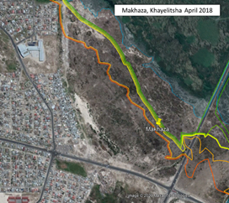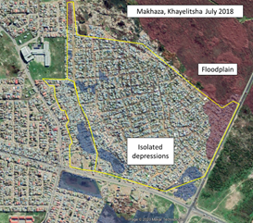

# **3.** **The model (5 PAGES)**

We extend the Pfeiffer et al. (2019) model by introducing flood risks in the supply and demand for housing. The overall structure of the model is unchanged from Pfeiffer et al. (2019) and is presented in Appendix A. We detail below how flood risks modify the demand and supply for housing in our extension. All dwellers bear content damages from floods. Damages to structures, however, are borne in different ways depending on housing type. Developers face an increased cost of capital as (partial) reconstruction of structures are needed following floods (which will tend to reduce production). [CHECK WHETHER THIS IS CORRECT]

WE NEED TO REFER TO PFEIFFER ET AL. AND EXPLICITLY SAY WHICH EQUATIONS REMAIN AND WHICH EQUATIONS HAVE CHANGED. HAVE THE REMAINING EQUATIONS IN THE APPENDIX AND SHOW HERE HOW SOME EQUATIONS ARE MODIFIED WITH FLOODS

**Qualitative overview**. The model is based on the approach developed in Pfeiffer et al. (2019). Pfeiffer et al. (2019) used a LUTI model, the Non-Equilibrium Dynamic Urban Model (NEDUM), that relies on standard urban economics land-use theory (see Fujita 1989) and allows to study the interactions among transport infrastructures, planning policies and housing demand at the metropolitan scale. This model can simulate population and dwellings distribution and evolution. The key assumption of this type of model is that job accessibility plays a key role in the residential choices of households: households choose their accommodation location and size by making a trade-off between the time and money they spend in transport to commute to their jobs and the real estate price level; and private developers choose to build more or less housing at a specific location, depending on the local level of real estate prices. Pfeiffer et al. (2019) applied this framework to the city of Cape Town, enriching the model to account for the four housing types that coexist in Cape Town: formal housing endogenously provided by private developers, informal dwellings in backyards endogenously provided by the beneficiaries of subsidized housing, informal settlements endogenously provided by illegitimate absentee “landowners”, and subsidized housing exogenously provided by the government. This paper builds on Pfeiffer et al. (2019) but additionally considers that households and developers are at flood risks and take them into account in their construction and locations choices. We consider two types of flood impacts : on housing structures and on housing contents. Repair for flood damages on housing contents are paid by households and affect their budget constraints. Repair for flood damages on housing structures are paid by the households for informal settlements or subsidized housing and by the private developers owning the houses for formal housing.

**Land availability and amenities**. We consider a grid that encompasses the whole metropolitan area. Each grid cell is considered as a discrete location and denoted x. In each location, there is an exogenous quantity of land available for residential development L(x), accounting for natural and regulatory constraints, infrastructures, and other non-residential uses, and an exogenous quantity A(x) of natural and historical amenities.

**Job centers, commuting and net income**. The city has a population of N households divided into 4 skill/income groups, indexed by i. Each group has an exogenous number of households Ni and each household has one worker and other family members. There are C employment locations in the city, indexed by c = 1,...,C. A worker of group i employed in c earns a wage wic and has an expected income yic = χiwic, where χi is the exogenous employment rate in group i. There are M possible modes of transportation in the city, denoted by m. For each residential location x, job center c, income group i, worker j and mode m, the expected commuting cost is:

tmj(x, c, wic) = χi(𝜏m(x, c) + δm(x, c)wic) +εmxcij

where χi𝜏m is the expected monetary cost of using transport mode m to travel from c to x, χiδmwic is the expected cost associated with the time spent commuting, assumed to be proportional to the wage wic, and εmxcij is a random term that follows a Gumbel minimum distribution of mean 0 and scale parameter 1/λ. Commuters choose the mode that minimizes their transport cost. By property of the Gumbel distribution, we can thus write the commuting cost between x and c as:

minm tmj(x, c, wic) = − (1/λ) log(exp[−λχi(𝜏m(x, c) + δm(x, c)wic)]) + ηxcij

where ηxcij also follows a Gumbel minimum distribution of mean 0 and scale parameter 1/λ. Given their residential location x, workers choose the workplace location c that maximizes their income net of commuting costs and solve the program: maxc [yic − minm tmj(x, c, wic)]

The probability to choose to work in location c given residential location x and income group i is therefore given by the following equation:

##### πc|ix =

We denote the expected income (over all possible employment centers) net of commuting costs for residents of group i living in location x, that is: ≡ E[yic − minm(tmj(x, c, wic)) | x]. We can calculate :

##### = [πc|ix (yic + (1/λ) log(exp[−λχi(𝜏m(x, c) + δm(x, c)wic)]))]

We can derive the expected number of residents of income group i choosing to work in c, denoted Wic, providing that we know the number of residents of income group i with their residence in x, denoted Ni(x), in all x. We have:

##### Wic = χi Ni(x)]

**Housing types**. There are four types of housing, denoted h: formal housing (h = FP), formal subsidized housing (h = FS), informal settlements (h = IS) and informal dwellings in backyards (h = IB). Only the poorest households (income group 1) are eligible for subsidized housing, and only poor households (income group 1 and 2) consider living in informal settlements and informal dwellings backyards.

**Utility**. Households’ utilities depend on their consumption of composite good z, on the size of their dwellings q, on amenities A, and on location-dependent housing type externality Bhx:

U(z,q,A,h) = zα (q−q0)βABhx

where q0 > 0 is the minimum need in terms of dwelling and α+β=1. We assume that BFP = BFS = 1 in all locations, meaning that there are no disamenities associated with formal housing, and that BIS and BIB <1.

**Housing supply**. At each location, the total quantity of available land for residential purposes L(x) is broken down into land available for each housing type, denoted Lh(x) for h = FP , FS, IS. LFS(x) and LIS(x) are exogenously given. The quantity of land available for private formal development is also exogenous and given by the residual: LFP(x) = L(x)−LFS(x)−LIS(x). We assume that dwellings in backyards can be built in subsidized houses’ backyards only ; the fraction of subsidized-housing land allocated to backyarding is endogenously determined. The number of individuals residing in each housing type Nh(x) and the overall number of individuals residing in each cell, N(x) are also endogenous quantities.

*Formal private housing*. Formal housing is provided endogenously by private developers. In a location x, a developer purchases land at a price P(x) from absentee landlords and combines land with capital to produce housing, before renting out housing to individuals at a price RFP(x). As standard in the developer model (see Fujita, 1989), the housing surface built, SFP, is given by a production function with constant returns to scale:

SFP(K,L) = κLaK1−a

where 0 < a < 1 is the land elasticity of housing production, L is the land surface occupied by the building, K is the capital used for development, and κ is a scale parameter. We express the quantity of housing produced per unit of land as:

sFP(k) = κk1−a

where k = K/L is the capital per unit of land. For a developer, the profit per land unit in location x is thus:

Ⲡ(x, k) = RFP(x)sFP(k) − k(ρ ++ δ) − (ρ+δ)P(x)

where ρ is capital depreciation, is the location-specific annualized value of the fraction of the formal dwellings structure destroyed by floods and δ is the cost of capital. Profit maximization with respect to capital per unit of land yields the solution:

k = ()

sFP(x) = ()

In location x, the total quantity of supplied formal private housing will be SFP(x) = sFP(x)LFP(x).

*Formal subsidized housing*. We assume that subsidized housing is exogenously supplied for free by the state to a limited number of individuals among income group 1 (the low-income group). Each plot in the single-family subsidized housing scheme is of fixed size qFS, including a backyard of fixed size Y. Occupants of subsidized housing may decide to rent out a fraction µ(x) < 1 of their backyard, so that the remaining quantity of housing that they end up consuming is qFS −µ(x)Y.

*Informal housing in backyards*. We adopt here a simplified version of the “backyarding model” recently proposed by Brueckner et al. (2018). In our setting, some individuals from income group 1 will be granted subsidized housing for free. The other individuals from income groups 1 and 2 may decide to reside informally in backyard structures, paying a rent RIB(x) per unit of housing (to be determined in equilibrium) to beneficiaries of subsidized housing. In each location x, the fraction of backyard space rented out µ(x) is chosen to maximize the utility of subsidized housing beneficiaries:

U(z, qFS −µ(x)Y, A, FS) = zα (qFS − µ(x)Y − q0)β A

under the budget constraint + µ(x)YRIB(x) = (1 + 𝛾 )z + hFS with hFS the value of subsidized houses, 𝛾 the fraction of composite good that is kept inside the house and that can possibly be destroyed by floods (food, furnitures,...), the location-specific annualized value of the fraction of the subsidized dwellings structure destroyed by floods and the location-specific annualized value of the fraction of subsidized dwellings contents destroyed by floods. The first-order condition leads to:

µ(x) = α −β.

The quantity of backyard housing in location x will thus be SIB(x) = µ(x)YNFS(x), where NFS(x) is the exogenous number of subsidized plots in location x.

*Informal settlements*. Zones where informal settlements occur are exogenously determined in the model so that the maximum supply of informal settlement land in a location x is LIS(x). Individuals residing in informal settlements pay a rent RIS(x) to illegitimate absentee landowners (see Brueckner and Selod, 2009, for a description of squatting arrangements and associated payments). The rent extracts informal settlers’ willingness to pay for living in an informal settlement given the negative externality and the fixed size of informal structures qI. We assume that hI is the value of the construction cost of the constant-size structure. Informal structures only have one floor: in location x, there can be at most LIS(x)/qI informal settlement structures.

**Housing demand**. We derive the demand for housing conditional on location x and on each housing type h, starting with formal private housing.

*Formal private housing*. For a given location x, an urban resident of income group i will demand a quantity of housing that maximizes utility U(z,q,A,h) = zα (q−q0)βABhx under constraint = (1 + 𝛾 )z + qFP and the minimum dwelling size condition qFP ≥ qmin. This yields the following first-order conditions:

qFP  = β +αq0RFP

z =

qFP ≥ qmin

We denote Q*(x,A(x),i) and Z*(x,A(x),i) the optimal quantity of formal housing and composite good that households would want to consume in the absence of a minimum dwelling size requirement. We can express utility as:

u = ( )A(x)BFPx

This implicitly defines Q*(x,A(x),i | u) as a function of u. Note that, because α < 1, u increases with Q*(x,A(x),i), which implies that Q*(x,A(x),i | u) is an increasing function of u. Because the SOC is verified (given that α and β < 1), it is then easy to see that the constrained housing demand (i.e., the housing demand that is potentially constrained by the minimum dwelling-size condition) is QFP(x,A(x),i,u) = max (qmin,Q*(x, A(x), i | u)). Plugging back QFP(x,A(x),i,u) into the first condition in system and inverting the resulting equation in the rent gives the bid rent:

=

*Formal subsidized housing*. Formal subsidized housing is offered in overall quantity NFS = NFS(x) to a fraction of income group 1 households. The “demand” for subsidized housing will thus involve rationing as long as NFS < N1. Note that the utility of a subsidized-housing recipient residing in x is:

U(z,qFS − µ(x)Y, A, 1) = ()α(qFS −µ(x)Y − q0)βA(x)

*Informal housing in backyards*. Backyard structures have a fixed size qI and a cost hI. Household residing at location x obtains utility:

u = ()α(qI − q0)β A(x)

Inverting this equation gives the following bid rent:

##### = (1/qI)[− ( +

*Informal settlements*. Finally, the same reasoning applies to the demand for informal settlement housing, leading to the following bid rent:

##### = (1/qI)[− ( +

**Equilibrium**. We can now define an equilibrium as follows:

*Definition*. An equilibrium is the set ui ; (x) ; Rh(x) ; Sh(x) ; Wic, for all i, h and x, where:

* ui is the utility of income group i
* (x) is the distribution of households of income group i, housed in housing type h, and residing in cell x
* Rh(x) is the market rent of housing type h in cell x
* Sh(x) is the quantity of each housing type h in cell x
* Wic is the number of workers from group i choosing to work in c.

and satisfying the following constraints:

* Ni = ∑h ∑x  (x)
* RFP(x) ≥ Ra with Ra the agricultural rent
* (x) = ui for all h ≠ FS and (x) > 0
* (x) = 0 if i ≠ Argmax

(x) = Sh(x)Lh(x)/Qh(x,i,u) if i = Argmax

* Wic = ∑x χiNi(x)

###### **Static equilibrium resolution**. We apply an iterative algorithm to converge towards a solution. Because we have a closed city, the total population for each income group is fixed. Our algorithm then solves for all other variables. We start with an arbitrary set of initial utilities, from which we determine: (i) Housing demand for each housing type (ii) Rents (iii) Housing supply (iv) Population in all locations for all housing types. By summing populations across locations and housing types, we obtain the total population for each income group. Utilities are then incrementally adjusted and steps 1-4 iterated until the target population allocation is simulated.

###### **Dynamics**. The system is affected by exogenous variations in inputs over time (for example under a scenario of exogenous demographic changes) and the system responds with adjustments to these exogenous shocks that do not occur instantaneously. More specifically, we assume that the formal housing stock depreciates with time and that formal developers respond to price incentives with delay as in Viguié and Hallegatte (2012). Mathematically, this implies that the stock of housing at time t, SFP(x | t) may not equate the theoretical equilibrium quantity, Denoting Φ the time lag for construction (i.e., the time needed to complete a housing project) and θ the time lag for depreciation (i.e., the time needed for total depreciation of a building), the change in the housing stock between times t and t +1 is:

###### SFP(x | t + 1) − SFP(x | t) = − if SFP(x | t) ≥

###### SFP(x | t + 1) − SFP(x | t) = −SFP(x | t) / θ if SFP(x | t) ≥ .

**Dynamics implementation**. We consider the state of the city in year t. One year later, at t + 1, we solve the equilibrium for a new set of input parameters (which may have exogenously changed, for instance if the population has increased). This determines housing supply without private construction inertia. We then apply the dynamics to determine the actual formal private housing supply at year t + 1, accounting for inertia. Dwelling size and prices are then determined by deriving the new equilibrium given the period’s housing supply. This determines the new state of the city.

**We consider two urban development scenarios**. In a first scenario (“laissez-faire” scenario), the large influx of low-income population in the city drives the development of new informal settlements in areas not suitable for formal housing development and adjacent to other informal settlements. In this scenario, we assume that the authorities let those now informal settlements expand freely. In a second scenario, we assume that the authorities are strictly forbidding new informal settlement developments starting in 2020, evicting low-income populations trying to settle on new lands. [PROBLEM: LATER, FIRST BECOMES SECOND AND SECOND BECOMES FIRST]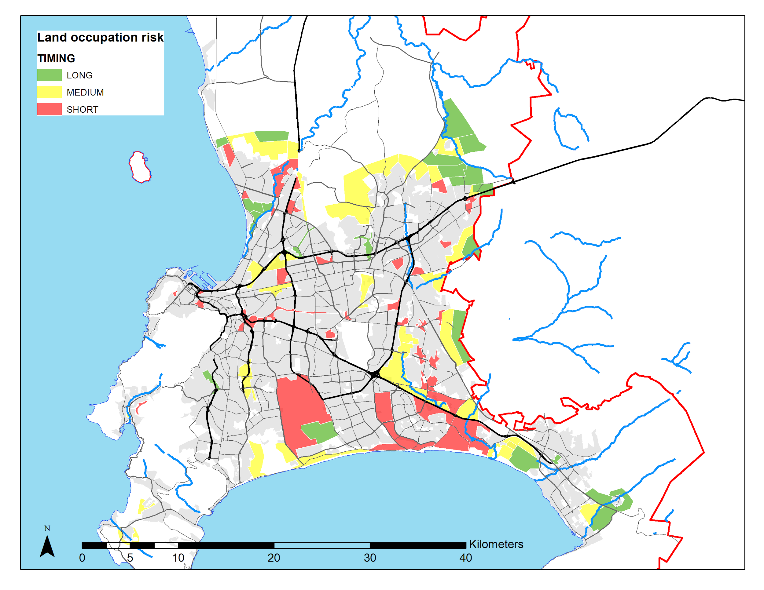

*Land occupation risks. This map represents the areas that are inappropriate for formal housing and where we consider that the government will let informal settlements expand.*

# **4.** **Data sources and calibration**

**4.1 Data sources**

We apply our theoretical model to the city of Cape Town. We use a grid of 500m * 500m resolution, that encompasses the whole urban area and which is aligned with the grid that the City of Cape Town uses for planning purposes. All datasets are either spatially aggregated or disaggregated to fit the grid.

**Floods data**. We use the FATHOM data (Sampson et al., 2015), a global gridded dataset of flood hazard. It provides flood water extent and depth for a range of pluvial and fluvial hazard scenarios, expressed as “return periods”, which indicate the likely frequency of occurrence (i.e., once in 5, 10, 20, 50, 75, 100, 200, 250, 500, 750 and 1000 years) for different flood locations and intensities. The data are at a 3 arc-second (approximately 90m) resolution. See as an example Map A.1 in the Appendix for a representation of flood hazards for a 100-year return period.

For each return period, we convert fluvial and pluvial flood depths into damages to structure, expressed as fractions of capital destroyed for each housing type. We borrow “structure damage functions” by housing type from Englhardt et al (2019).[1] We also consider damages in terms of “contents”, expressed as the fraction of the composite good destroyed by a flood. For damage to contents, we use the flood depth-damage function proposed by de Villiers et al. (2007). [EXPLAIN GAMMA CHOICE IN THE MODELING PART].

Observe that the FATHOM data on floods account for topography and XXX [CHARLOTTE TO CHECK IF THERE ARE OTHER THINGS TO MENTIONS HERE] but not for localized factors (for example permeability, see section XXX). To address this, we modify the damage functions in the pluvial case to account for the presence or the absence of drainage systems, which we assume depends on housing types: We consider that 20-year return period flood events (respectively 10-year return period flood events) do not impact formal housing (respectively for subsidized housing and housing in backyard).[2] [THERE IS NO MODELLING OF PROTECTIVE INVESTMENTS BY THE MUNICIPALITY]

**Socioeconomic data**. The spatial distribution of the population is taken from the 2011 National Census. We define the four income groups by choosing income-group thresholds such that only the lowest income group is eligible for subsidized housing programs, and so that the two highest income groups are not observed to reside informally (appendix). We use the transport model used by the City of Cape Town to retrieve transport times between pairs of transport zones for each transport mode and job locations. We also use aggregated statistics on modal shares and residence-workplace distances in Cape Town, derived from Cape Town’s 2013 Transport Survey. Land availability is defined for each housing type. Areas of subsidized housing are identified from the cadastre of the City of Cape Town. The area available for backyard housing is estimated as the yard size of these units. Informal settlement areas are obtained from the Enumerator Area definition of the 2011 Census. Land available for formal private development corresponds to all land that is not constrained for construction. The amenities that we consider include natural amenities (such as slope and proximity to the ocean) as well as historical amenities (such as the proximity to the historical center). We also use property price data extracted from the City of Cape Town’s geocoded data set on property transactions for 2011, as well as data on dwelling sizes made available to us by the City of Cape Town.

**4.2. Estimation of parameters and calibration of the model**

**Estimates**

Most of the parameters are taken from Pfeiffer et al., 2019 (see values in the Appendix).[LIST WHICH ESTIMATED PARAMETERS ARE THE SAME AND PRESENT THE ESTIMATION OF NEW PARAMETERS]

The average fraction of non-housing and non-transport consumption that is vulnerable to floods is derived from SSA (2015).

The values of the model parameters are given in Appendix Table X.

muu=25 (see Pfeiffer et al)

lambda=34 (estimaed from xx)

**Calibration and benchmark model fit**

The main change is in the disamenity from living in informal settlements and backyards, which is now varying with grid cells to reflect the probabilities of eviction [NOT REALLY MODELED] and level of services in each location. [EXPLAIN THE LINK WITH CALIBRATION] See table XX and explanations in the appendix.

We also validate the model (see Appendix XXX). [DESCRIBE A LITTLE BIT HOW WE VALIDATE, INCLUDING FLOOD PATTERNS/EXPOSURE]

[SHOW FIT OF THE MODEL BY DISTANCE TO THE CITY CENTER IN THE APPENDIX - AS IN PFEIFFER ET AL]

# 

# **5.** **Benchmark equilibrium [MAYBE THIS CAN ]**

**5.1. Maps of population, land prices, informal settlements**

Say that this is very similar to Pfeiffer et al.

**5.2. Exposure to floods**

Say that this is new compared to Pfeiffer et al.

**DAMAGES IN 2011 FOR THE BENCHMARK SIMULATION (THERE IS NO CONSTRAINED OR UNCONSTRAINED SCENARIO YET) [IT IS LOGICALLY WEIRD TO SHOW SCENARIOS AND THEN GO BACK TO A SITUATION WITHOUT SCENARIOS]**

* There is **significant exposure to flood risks for the whole population** (for the **100 return period for both pluvial and fluvial)**. Show graph for 100 return period and show the other periods in the Appendix.
* For return periods greater than 20 years, **formal and informal dwellers are both exposed to floods** (and formal dwellers disproportionately more than informal dwellers for **pluvial** floods but not for **fluvial** floods). Same as figure 8, 8 and 10 but only for 2011.
* The **severity of floods** however (in millimeters, for 100 period return), **for those who are exposed**, **varies by income groups and housing types** (see what we get with the graphs - maybe it does not vary). Comment on differences between backyarders and informal settlers
* The **fraction of income loss varies by income income group and housing type**s (to do that, show, on the same graph the cumulative density functions of the 4 groups regarding the fraction of income loss). Comment on differences between backyarders and informal settlers

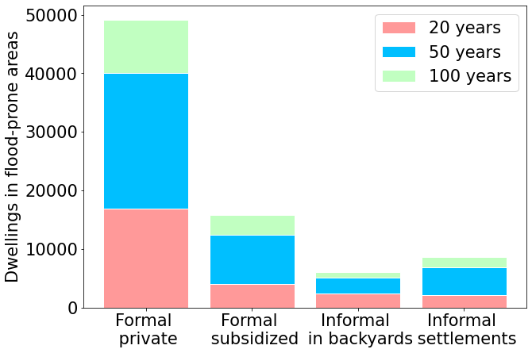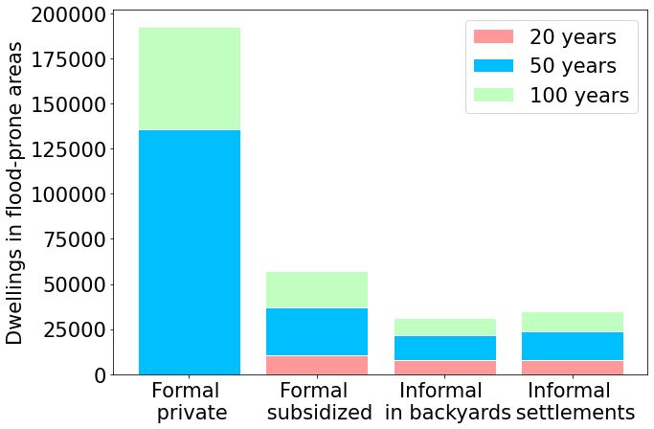

*Flood exposure in 2011. Left: fluvial floods. Right: Pluvial floods. With income classes.* [IT WOULD BE NICE TO GIVE SHARES TOO, NOT JUST ABSOLUTE NUMBERS]

| *Income class 1* | *Income class 2* |
| --- | --- |
| *Income class 3* | *Income class 4* |

*Severity of floods by income class. 100-year return period, fluvial floods. 2011. [SHALL WE DO THE SAME GRAPHS IN TERMS OF FREQUENCY, NOT ABSOLUTE NUMBERS?] Do it by housing types.* [THE POOR (INCOME CLASS 1, RIGHT?) FACE MORE FLOODS, USUALLY NOT AS SEVERE AS THE RICH. I.]

| FLUVIAL (100 yr) | Nb of persons | Average flood depth |
| --- | --- | --- |
| Income class 1 | 30469 | 21.5 cm |
| Income class 2 | 17034 | 56.0 cm |
| Income class 3 | 29569 | 35.0 cm |
| Income class 4 | 2515 | 75.4 cm |

5.3. Counterfactual equilibrium without flood risks?

# **6.** **Dynamics of land use and exposure to floods in Cape Town**

**6.1. Two polar scenarios regarding the tolerance of informal settlements**

Policy introduction: **The history of informal settlement dynamics and its “management**”. Laissez-faire vs prevent land invasion (talk about what authorities did in the past, with figures). Talk about rate of emergence of new informal settlement locations in the past. Predictions of demographic pressure in the low income segment likely to populate informal settlements.

As explained in the Methods section, we consider two urban developments scenarios:

* *eviction* scenario (Scenario 1 - Sc1): authorities are strictly forbidding new informal settlements developments starting in 2020 [WHAT ABOUT THIRD SCENARIO: EVICTION IN FLOOD PRONE AREAS ONLY?]
* *no eviction* scenario (“Challenger scenario” - Scenario 2 - Sc2): new informal settlements expand freely in the areas that are not prone to formal housing development

**6.2. Future spatial equilibria according to the two scenarios**

**Maps of population density (2040)**

**Maps of land prices (2040)**

| Formal housing. | Backyards. |
| --- | --- |
| Informal housing. |  |

*Rent variation in SC1 compared to SC2 (%) in 2040. Why the blue vs the red in almost the same locations? Is it related to floods? [NO THE COMPARISON (SC1 COMPARED TO SC2) GOES IN THE OTHER DIRECTION COMPARED TO FIGURE 1 (SC2 COMPARED TO SC1)]*

Maps of informal settlement locations

Make reference to dynamics of housing over time which is now in the Appendix (although the graph has to be redone)

**6.3. Exposure to flood and flood damages in the two scenarios**

**Map overlaying floods and income group locations**

**Exposure and damages**

**CHANGES OVER TIME**: [WITH ABSOLUTE NUMBERS, WE CANNOT SAY IF THE INCREASE IS DUE TO INCREASE IN POPULATION (ABSOLUTE) OR INCREASE IN EXPOSURE (RELATIVE) - SHALL WE SHOW SOME TYPE OF SHARE TOO?]

* **Exposure to flood increases FOR EVERYONE AND dramatically for informal dwellers** between 2040 and 2011 (REVERSE), and even more so in the **unconstrained scenario** (Figures 8 and 9 in the text, and Figure 10 in the appendix). Comment on role of location choices
* The distribution of **damages is shifted towards high damages for fluvial floods** but not so much for pluvial floods (same as Figures 12 and 13 but with pdfs or cdfs)
* The **poorest and poo**r (living in informal dwellings) see a shift of the damages towards greater costs in the unconstrained scenario due to relocation to places that are even more exposed to floods.

| SC1 | SC2 |
| --- | --- |
| Pluvial floods | |
| SC1 | SC2 |
| Fluvial floods | |

*Exposure to floods.*

| FLUVIAL | 2011 | 2040 (SC1) | 2040 (SC2) |
| --- | --- | --- | --- |
| Formal private | 7.57% | 7.84% | 7.49% |
| Formal subsidized | 8.12% | 7.27% | 7.27% |
| Informal in backyards | 6.12% | 5.83% | 4.67% |
| Informal settlements | 7.44% | 4.22% | 11.04% |

Risks of living in a 100-year-return-period flood-prone area (with a flood depth > 1 cm) - Fluvial floods [WHY ARE IS LESS AT RISK THAN FORMAL PRIVATE IN SC1?]

| PLUVIAL | 2011 | 2040 (SC1) | 2040 (SC2) |
| --- | --- | --- | --- |
| Formal private | 29.69% | 30.36% | 30.27% |
| Formal subsidized | 29.40% | 28.05% | 28.65% |
| Informal in backyards | 31.70% | 26.01% | 25.31% |
| Informal settlements | 29.78% | 27.31% | 28.67% |

Risks of living in a 100-year-return-period flood-prone area (with a flood depth > 1 cm) - Pluvial floods

| SC1 | SC2 |
| --- | --- |
| Pluvial floods | |
| SC1 | SC2 |
| Fluvial floods | |

*Flood damages as a fraction of [ANNUAL?] income (%). X-axis : number of households. (annualized)* [ARE WE SAYING THAT A GREATER SHARE OF INCOME IS DESTROYED UNDER EVICTION FOR FLUVIAL? SHOULDN’T IT BE THE OPPOSITE? ]

##### 

[WE NEED THE SAME TABLE AS BELOW BY INCOME GROUP]

| 100yr | Fluvial | | | Pluvial | | |
| --- | --- | --- | --- | --- | --- | --- |
|  | 2011 | 2040 (SC1) | 2040 (SC2) | 2011 | 2040 (SC1) | 2040 (SC2) |
| Average share of income destroyed | 32.4% | 30.2% | 38.7% | 17.7% | 17.7% | 18.7% |
| Nb pers | 78877 | 126427 | 147890 | 312881 | 543400 | 550137 |

##### (average on the affected people only) (annualized)

## 

| Income class 1 | Income class 2 |
| --- | --- |
| Income class 3 | Income class 4 |

*Flood damages as a fraction of income (%). Focus on fluvial floods in SC2. X-axis: number of households. (annualized) (SC1 also) [NEED TO COMPARE SC1 AND SC2 INDEED]*

##### 

BELOW ARE KEY FIGURES FOR THE ABSTRACT AND CONCLUSION. HOW MUCH CAN SC1 REDUCE THE 61.5% FIGURE COMPARED TO SC2

| 100yr/F/SC2 | Income class 1 | | Income class 2 | | Income class 3 | | Income class 4 | |
| --- | --- | --- | --- | --- | --- | --- | --- | --- |
|  | 2011 | 2040 | 2011 | 2040 | 2011 | 2040 | 2011 | 2040 |
| Average share of income destroyed | 48.6% | 61.5% | 25.9% | 18.9% | 19.5% | 21.3% | 30.1% | 16.6% |
| Nb pers | 30469 | 66013 | 16747 | 21930 | 29339 | 53777 | 2123 | 6170 |

##### *(average on affected households only)*

Comparison [OF WHAT?] with a scenario with no floods:

* SC1: -0.08% for income class 1, -0.03% for income class 2, -0.19% for income class 3, -0.18% for income class 4
* SC2; -0.16% for income class 1, -0.19% for income class 2, - 0.18% for income class 3, - 0.16% for income class 4

Key messages: nothing changes for the formal between the two scenarios. Changes for the informal. [LET’S TALK ABOUT “SUBSTITUTION FROM INFORMAL SETTLEMENTS TO BACKYARDING” REMARK: IN THE MODEL, BACKYARDING ONLY OCCURS ON SUBSIDIZED HOUSING. THIS MIGHT NOT BE THE CASE IN THE FUTURE. WHAT ABOUT VERTICAL GROWTH OF INFORMAL SETTLEMENTS? ]

**6.4. Welfare analysis [THIS SECTION IS A BIT OBVIOUS AND DOES NOT NEED TO BE LONG. MAYBE IT CAN BE INCORPORATED IN THE CONCLUSION?]**

There are winners and losers. The rich gain by restricting the locations of the poor through restriction on informal settlement locations as it decreases competition for land. The poor gain when given the liberty to make their own trade-off regarding accessibility and exposure to floods. This is consistent with the view that poverty leads the poor to make such choices. QUESTION: WHAT IS TOTAL WELFARE? ARE THE EXTERNALITIES IN THE MODEL SUCH THAT THE LAISSEZ-FAIRE IS NOT NECESSARILY BETTER?

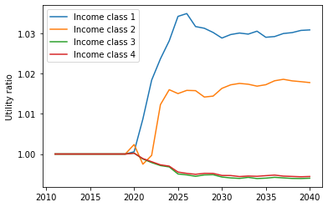

*Fig 2.Utility ratio between SC1 and SC2. Lecture: if the utility ratio is greater than 1, SC2 is preferred to SC1. To understand what happens here, maybe we need a “dynamic” graph of other factors that affect utility: prices, transport costs, externalities? (Add total welfare in appendix) (No dynamics except for land use) [HAVE BETTER TITLE: EVICTIONS DEPRESS RENTS IN FORMAL AREAS AND INCREASES RENTS IN BACKYARDING] [THIS GRAPH COULD EITHER INDICATE THAT SOMETHING IS WRONG WITH THE SIMULATIONS OR THAT WE DO NOT COMPLETELY UNDERSTAND WHAT AFFECTS UTILITIES]*

# **7.** **Discussion**

Results for Cape Town:

· urban expansion leads to an increased vulnerability to floods

· floods will mainly affect the poorer households living in informal settlements.

· two scenarios: if informal settlements are allowed in new areas, it will increase households' utility but also households' exposure to floods

Strength of the model:

· allows forecasting densities

· incorporate floods to the households' program

· forecast damages

Limitations:

* First stab at the issue

· we model damages as annualized damages but extreme events can be terrible for people

· lack of data on health damages

. NO MODELING OF PROTECTIVE INVESTMENTS (20 YEAR THING IS AD HOC)

. NO SEA-LEVEL RISE….

*Over this time, however, neither the city’s economy nor the fiscal capacity of its government has grown at a rate commensurate with mounting demand for housing and services (which, according to South Africa’s inter-governmental fiscal framework, is provided free-of-charge to indigent households).*

*The ability of the city government to respond innovatively and dynamically to the needs of the recently urbanized poor is further encumbered by a sclerotic land use and building regulatory regime better suited to a medium-sized city in the English Midlands than the rapidly evolving urban conurbation of Cape Town, characterized by profound level of material inequality, cultural heterogeneity, and socio-spatial dysfunction.*

**Reference list [PLEASE USE THE “APA” STYLE COPIED FROM GOOGLE SCHOLAR CITATIONS]**

Allaire, M. (2018). Socio-economic impacts of flooding: A review of the empirical literature. *Water Security*, *3*, 18-26.

Bakkensen, L. A., & Ma, L. (2020). Sorting over flood risk and implications for policy reform. *Journal of Environmental Economics and Management*, *104*, 102362.

Balboni, C. (2021). In Harm’s Way: Infrastructure Investments and the Persistence of Coastal Cities. Mimeo.

Bernhofen, M. V., Whyman, C., Trigg, M. A., Sleigh, P. A., Smith, A. M., Sampson, C. C., ... & Winsemius, H. C. (2018). A first collective validation of global fluvial flood models for major floods in Nigeria and Mozambique. *Environmental Research Letters*, *13*(10), 104007.

Brueckner, J., K. Rabe and H. Selod (2018). Backyarding: Theory and Evidence for South Africa, *World Bank Policy Research Working Paper 8636*, 44 pages.

Brueckner, J. and H. Selod (2009) A Theory of Urban Squatting and Land-Tenure Formalization in Developing Countries, *American Economic Journal: Economic Policy*, 1(1), 28-51.

Castells-Quintana, D., Krause, M., & McDermott, T. K. (2021). The urbanising force of global warming: the role of climate change in the spatial distribution of population. *Journal of Economic Geography*, *21*(4), 531-556.

Cruz, J. L., & Rossi-Hansberg, E. (2021). *The economic geography of global warming* (No. 15803). CEPR Discussion Papers.

de Villiers, G., Viljoen, G., & Booysen, H. (2007). Standard residential flood damage functions for South African conditions. *Suid-Afrikaans Tydskrif vir Natuurwetenskap en Tegnologie/South African Journal of Science and Technology*, *26*(1), 26-36.

Denchak, M. (2019). Flooding and climate change: Everything you need to know. *Natural Resources Defense Council*.

Desmet, K., Nagy, D. K., & Rossi-Hansberg, E. (2015). *The geography of development: Evaluating migration restrictions and coastal flooding* (No. w21087). National Bureau of Economic Research.

Diffenbaugh, N. S., & Burke, M. (2019). Global warming has increased global economic inequality. *Proceedings of the National Academy of Sciences*, *116*(20), 9808-9813.

Englhardt, J., De Moel, H., Huyck, C. K., De Ruiter, M. C., and Aerts, J. C. J. H. (2019). Enhancement of large-scale flood risk assessments using building-material-based vulnerability curves for an object-based approach in urban and rural areas, *Nat. Hazards Earth Syst. Sci.*, 19, 1703–1722.

Ford, A., Barr, S., Dawson, R., Virgo, J., Batty, M., & Hall, J. (2019). A multi-scale urban integrated assessment framework for climate change studies: A flooding application. *Computers, Environment and Urban Systems*, *75*, 229-243.

Fujita, M. (1989). *Urban economic theory: Land use and city size*. Cambridge University Press, Cambridge.

Hallegatte, S., Green, C., Nicholls, R. J., & Corfee-Morlot, J. (2013). Future flood losses in major coastal cities. *Nature climate change*, *3*(9), 802-806.

Hammond, M. J., Chen, A. S., Djordjević, S., Butler, D., & Mark, O. (2015). Urban flood impact assessment: A state-of-the-art review. *Urban Water Journal*, *12*(1), 14-29.

Huizinga, J., De Moel, H., & Szewczyk, W. (2017). *Global flood depth-damage functions: Methodology and the database with guidelines* (No. JRC105688). Joint Research Centre (Seville site).

Jean-Baptiste, N., Olivotto, V., Porio, E. E., Kombe, W., Yulo-Loyzaga, A., Gencer, E., ... & Natty, M. (2018). Housing and Informal Settlements.

Joubert, L., & Martindale, L. (2013). Rising waters: working together to solve Cape Town's flooding.

Kahn, M. E. (2017). Will climate change cause enormous social costs for poor Asian cities?. *Asian Development Review*, *34*(2), 229-248.

Kocornik-Mina, A., McDermott, T. K., Michaels, G., & Rauch, F. (2020). Flooded cities. *American Economic Journal: Applied Economics*, *12*(2), 35-66.

Kousky, C., Kunreuther, H., LaCour-Little, M., & Wachter, S. (2020). Flood Risk and the US Housing Market. *Journal of Housing Research*, *29*(sup1), S3-S24.

Kreienkamp, F. (2021). Rapid attribution of heavy rainfall events leading to the severe flooding in Western Europe during July 2021.

Martin, I. W., & Pindyck, R. S. (2015). Averting catastrophes: The strange economics of Scylla and Charybdis. *American Economic Review*, *105*(10), 2947-85.

Martínez-Gomariz, E., Forero-Ortiz, E., Guerrero-Hidalga, M., Castán, S., & Gómez, M. (2020). Flood Depth‒Damage Curves for Spanish Urban Areas. *Sustainability*, *12*(7), 2666.

Merz, B., Kreibich, H., Schwarze, R., & Thieken, A. (2010). Review article" Assessment of economic flood damage". *Natural Hazards and Earth System Sciences*, *10*(8), 1697-1724.

Mosimann, M., Frossard, L., Keiler, M., Weingartner, R., & Zischg, A. P. (2018). A robust and transferable model for the prediction of flood losses on household contents. *Water*, *10*(11), 1596.

Paterson, D. L., Wright, H., & Harris, P. N. (2018). Health risks of flood disasters. *Clinical Infectious Diseases*, *67*(9), 1450-1454.

Pfeiffer, B. F., Rabe, C., Selod, H., & Viguié, V. (2019). Assessing Urban Policies Using a Simulation Model with Formal and Informal Housing: Application to Cape Town, South Africa. *World Bank Policy Research Working Paper*, (8921).

Picarelli, N., Jaupart, P., & Chen, Y. (2017). Cholera in times of floods. The IGC.

Sampson, C. C., A. M. Smith, P. D. Bates, J. C. Neal, L. Alfieri, and J. E. Freer (2015), A high‐resolution global flood hazard model, *Water Resour. Res.*, 51, 7358– 7381

Sekovski, I., Armaroli, C., Calabrese, L., Mancini, F., Stecchi, F., & Perini, L. (2015). Coupling scenarios of urban growth and flood hazards along the Emilia-Romagna coast (Italy). *Natural Hazards and Earth System Sciences*, *15*(10), 2331-2346.

Shabnam, N. (2014). Natural disasters and economic growth: A review. *International Journal of Disaster Risk Science*, *5*(2), 157-163.

***Statistics South Africa’s Income and Expenditure data of 2015 for Western Cape households.***

Subramanyam, N. (2016). Coping with flooding in informal settlements in rapidly urbanizing peripheries in the Mumbai region.

Viguié, V. and S. Hallegatte (2012). Trade-Offs and synergies in urban climate policies, *Nature Climate Change*, 2, 334–337.

Votsis, A. (2017). Utilizing a cellular automaton model to explore the influence of coastal flood adaptation strategies on Helsinki's urbanization patterns. *Computers, Environment and Urban Systems*, *64*, 344-355.

Votsis, A., & Perrels, A. (2016). Housing prices and the public disclosure of flood risk: a difference-in-differences analysis in Finland. *The Journal of Real Estate Finance and Economics*, *53*(4), 450-471.

Wood, R., & Bekker, L. G. (2017). An epidemic uncurbed: tuberculosis in Cape Town, South Africa, 1910–2010. *Transactions of the Royal Society of South Africa*, *72*(3), 234-241.

World Bank, & United Nations. (2010). *Natural hazards, unnatural disasters: the economics of effective prevention*. The World Bank.

Zaveri, Esha, Jason Russ, Amjad Khan, Richard Damania, Edoardo Borgomeo, and Anders Jägerskog. 2021. Ebb and Flow: Volume 1. Water, Migration, and Development. Washington, DC: World Bank. doi:10.1596/978-1-4648-1745-8. License: Creative Commons Attribution CC BY 3.0 IGO.

**APPENDIX**

1. **MODEL APPENDIX**
2. **DATA APPENDIX**

**Fathom dataset. Map A.1. Flood hazard maps (Panel A: Fluvial, Panel B: Pluvial)**. Source: Fathom. Note: These maps represent the location and depth of floods for a 50-year return period.

**Damage curves** (Englhardt et al., 2019, Huizinga, 2017).

1. **CALIBRATION OF THE MODEL**

**Table C1**. Parameters (Panel A: Chosen parameters, Panel B: Estimated parameters, Panel: Calibrated parameters)

**APPENDIX**

**A1. Calibration**

: households utility function parameter β, basic need in housing in the utility function q0, coefficients of development function for formal private housing a and κ, agricultural land price in 2011.

ADD TABLE (MODIFIED FROM PFEIFFER ET AL 2019)

**A2. Validation**. We compare the distribution of households between the four housing types, the simulated densities for all housing types, and the housing prices for formal housing with data to check that the fit is reasonably good. In addition, we checked that we are able to reproduce the distribution of each housing type in flood-prone areas. See appendix.

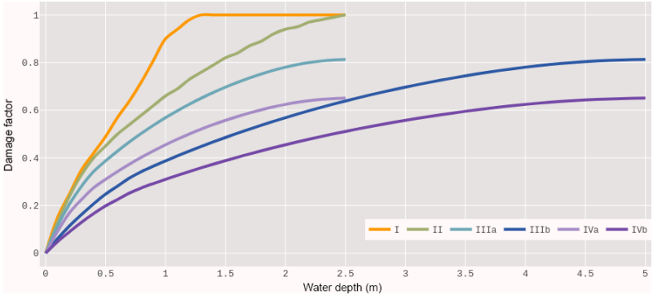

*Flood depth-damage functions for four building-material-based vulnerability classes. For class III and IV, the one- and two-floor curves are denoted by (a) and (b). From Englhardt et al. (2019).*

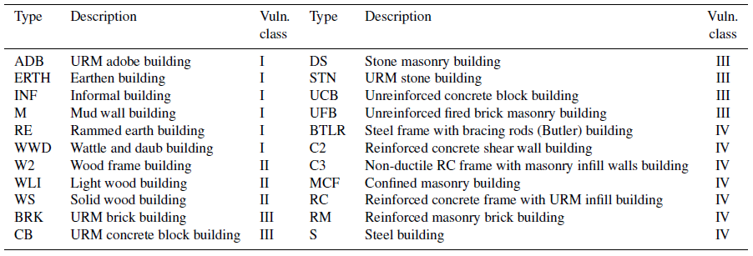

*Construction types and their respective flood vulnerability class. From Englhardt et al. (2019).*

**A3.. Dynamics of housing over time (transfer over time between backyards and informal settlements)**

Constraints on informal settlement locations lead to more backyarding

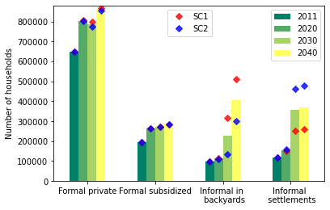

*Fig 1. Number of households living in each type of housing. Add dots legend.* [SHOWING THE AVERAGE DOES NOT MAKE MUCH SENSE] [HAVE BETTER TITLE LIKE : GAINS FROM NO-EVICTION.] [THESE ARE RELATIVE GAINS, WHAT ABOUT ABSOLUTE GAINS? HOW DOES TOTAL WELFARE CHANGE OVER TIME?]

1. We assume that formal private housing and formal subsidized housing correspond to type IVa or IVb, that informal settlements correspond to type II, and that backyards correspond to type II (80% of the time) or to type IIIa (20% of the time). [DESCRIBE A BIT MORE WHAT TYPES IVa IVb AND II ARE].
2. In Cape Town, formally established neighborhoods must comply with the City’s minimum design standards *(Minimum Standards for Roads and Stormwater Design*, TCT, 2014), which requires local drainage infrastructure to cope with floods of 20 year return periods. We assume that subsidized housing and informal dwellings in backyards (which share common infrastructure) can cope with floods with a 10-year return period. We assume that there is no drainage infrastructure in informal settlements.