id = 1



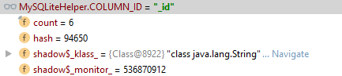

Part 3 – Everything appears to work. We didn’t load the version with errors.