|  |
| --- |
| Temporary File Hosting System |
| Project Statement |

|  |
| --- |
| Project Manager: Connor Oliver  System Analyst: Jordan Campbell  System Analyst: David Campbell  System Analyst: Anson Carmody  January 18, 2016 |

# Table of Contents

Table of Contents 1

Document Changes 3

Project Summary 4

Project Design Team 4

Project Design Team 4

Project Details 4

Project Objective 5

Project Deliverables 6

Assumptions 7

Constraints 8

Project Plan 9

Project Organizational Chart 10

Final Project Group 10

Steering Committee 11

Budget 12

Cost Overview as of January 18, 2016 12

Cost Status for all top-level tasks 13

Cost Status breakdown for all top-level tasks 13

Change Management 14

Status Reporting 15

Decision Making 16

Standards and Conventions 17

Storage Units 17

Executable and Source Code File Naming 17

Source Code Header Documentation 18

Source Code Version Control 18

Database and Table Naming 18

Variable, Function and Class Naming 19

Document Naming 19

Appendix A – Change Request Form 20

Appendix B – Status Report Form 21

Appendix C – Team Contract 22

Code of Conduct 22

Participation 22

Communication 22

Problem Solving 22

Technical Guidelines 22

Meeting Guidelines 22

# Document Changes

|  |  |  |
| --- | --- | --- |
| Date | Changed By | Change Description |
| 17-07-15 | Connor Oliver | Created Document, added my sections and Jordan’s. |
| 18-07-15 | Connor Oliver | Added Anson’s sections of the document. |
| 18-07-15 | Connor Oliver | Added Dave’s sections of the document. |

# Project Summary

## Project Design Team

**Client Name:** Mr. Gerald Caissy

**Client Organization:** Holland College

## Project Design Team

**Project Manager:** Connor Oliver

**System Analyst:** Jordan Campbell

**System Analyst:** Anson Carmody

**System Analyst:** David Campbell

## Project Details

**System Name:** Temporary File Hosting System

**System Acronym:** TFHS

**Start Date:** January 11th 2016

**End Date:** February 19th 2016

**Budget Estimate:** $25,360

# Project Objective

The objective of the proposed project is to provide a temporary file upload service. By allowing users to upload files temporarily through a desktop client this service would make it easy for users to share files which don’t need to be stored permanently on the internet, such as work-in-progress documents or media. This would save resources on the server and in theory provide users with a simple way of sharing files without having to manage a shared document directory or cloud service.

# Project Deliverables

Listed below are the deliverables for the project, including analysis and design documentation for use in implementing and operating the system, as well as the individual system components which will be developed.

* Management Summary
* System Overview
  + Deliverables
  + Assumptions
  + Constraints
  + Non-Deliverables
* System Key Requirements
  + Outputs
  + Inputs
  + Data
  + Process
  + Security
* System Modeling
  + System Use Case Diagram
  + System Class Diagram
  + System Event Table
  + Primary Use Case Diagrams
  + Primary Use Case Detailed Descriptions
  + Primary Use Case Activity Diagrams
  + Primary Use Case Sequence Diagrams
* System Component Details
  + Program Design
  + Output Design
  + Input Design
  + Database Design
  + Support Processing Design
* Environmental Requirements
* Implementation Requirements
* System Components
  + Database
  + File Upload and Retrieval Server
  + Web Portal
  + Client File Upload Application
* Appendices

# Assumptions

During development we are making the following assumptions about the resources available and the use of the finished system:

1. Unlimited storage capacity on server
2. Appropriate hardware running appropriate operating systems for all components will be available
3. Server will run on an optimal internet connection for file distribution
4. Client and server applications will always have an internet connection available
5. Users will not upload corrupt or malicious files

# Constraints

The system will enforce the following constraints to ensure safety of client data and the system itself:

1. All user inputs such as login information and file information will be sanitized and validated
2. User login names and passwords will be encrypted before being sent to the server and retrieved
3. Fixed limit on file sizes
4. User must be authenticated to upload files

# Project Plan

A Gantt chart has been created in order to create a timeline and budget for the project. Tasks have been identified and resources have been assigned accordingly. The following figure is a representation of the Gantt chart project timeline. A copy of the Microsoft Project file used to create this chart and the budget has been embedded at the bottom of this page.

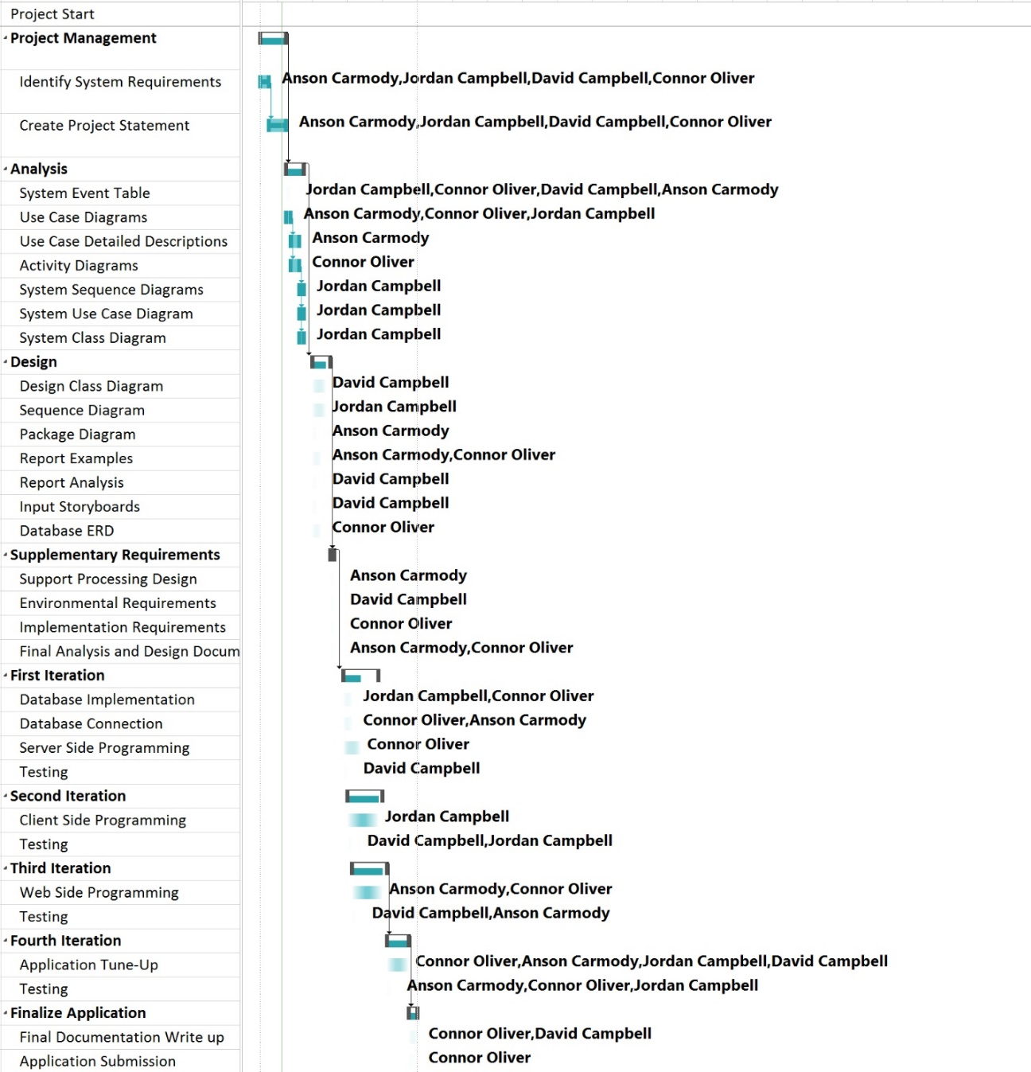



# Project Organizational Chart

## Final Project Group

Connor Oliver is the Project Manager for our final project group. Being the Project Manager, Connor is responsible for delegating all project related tasks to the project analysts.

Analysts for our final project group are Anson Carmody, Dave Campbell and Jordan Campbell. All project members will be working together to complete the analysis, design and implementation of the application.

## Steering Committee

The Steering Committee is comprised of Connor Oliver, Anson Carmody, Dave Campbell and Jordan Campbell as well as Holland College Instructor Gerald Caissy. The Committee will meet on a weekly basis to review project progress as well as review any change requests or additional concerns or considerations that have been addressed since the previous meeting.

# Budget

The following figures represent the project cost overview, the current costs status and forecasted cost expenditures for the project. These budget estimates have been created based on the information available in the Gantt chart. Any additional budgeting information can be found in the Microsoft Project file located in the Project Plan section of the document.

## Cost Overview as of January 18, 2016

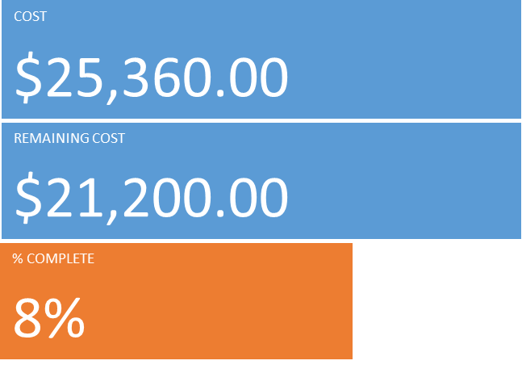

## Cost Status for all top-level tasks

## Cost Status breakdown for all top-level tasks

|  |  |  |  |  |  |
| --- | --- | --- | --- | --- | --- |
| **Name** | **Actual Cost** | **Remaining Cost** | **Baseline Cost** | **Cost** | **Cost Variance** |
| Project Start | $0.00 | $0.00 | $0.00 | $0.00 | $0.00 |
| Project Management | $4,160.00 | $0.00 | $0.00 | $4,160.00 | $4,160.00 |
| Analysis | $0.00 | $3,680.00 | $0.00 | $3,680.00 | $3,680.00 |
| Design | $0.00 | $2,080.00 | $0.00 | $2,080.00 | $2,080.00 |
| Supplementary Requirements | $0.00 | $1,360.00 | $0.00 | $1,360.00 | $1,360.00 |
| First Iteration | $0.00 | $3,760.00 | $0.00 | $3,760.00 | $3,760.00 |
| Second Iteration | $0.00 | $1,680.00 | $0.00 | $1,680.00 | $1,680.00 |
| Third Iteration | $0.00 | $3,280.00 | $0.00 | $3,280.00 | $3,280.00 |
| Fourth Iteration | $0.00 | $3,920.00 | $0.00 | $3,920.00 | $3,920.00 |
| Finalize Application | $0.00 | $1,440.00 | $0.00 | $1,440.00 | $1,440.00 |

# Change Management

Requesting any changes to the requirements of this system must be submitted using the following procedure. Any Change Request must be properly submitted for consideration.

1. Change request form must be submitted to the Project Manager.
2. The Project Manager will present all the newly received Change Requests to the Steering Committee during their weekly meeting.
3. The Steering Committee will have final decision on each Change Request.
4. A decision to either approve or reject the Change Request will be decided by majority vote. The Committee Chair will break a tied vote.
5. Approved changes will be communicated to the Project Team by the Project Manager and integrated into the system design.

A copy of the Change Request form is included as Appendix A of this document.

# Status Reporting

The Project Manager will present an official Status Report to all Steering Committee members during their weekly meeting. This document will outline the following items from the previous week of the project:

* Deliverables that have been completed since the previous Status Report
* Current overview of the Project’s budget
* Any issues that require the intervention of the Steering Committee
* List of Change Requests received since the previous Status Report
* A list of deliverables expected to be completed before the next Status Report

A blank copy of the Status Report is included as Appendix B of this document.

# Decision Making

Project decisions will be made according to the following procedures:

* Proposed changes regarding project business requirements will be discussed between the Project Manager and the Client, with the Client having final say.
* Proposed changes which may impact the budget will first be discussed between the members of the design team to see if any alternatives may be available.
* If a proposed change will have a budgetary impact it will be brought to the Client for final decision.
* Proposed changes without an impact on the budget will be discussed between team members, with the Project Manager having final say.

# Standards and Conventions

## Storage Units

During development the project will be stored on Git, with local copies of the repository on each team member’s development computers.

When running in production the server side code will being running on some form of server and the client level programs will be downloaded from the server and run on client’s personal machines.

## Executable and Source Code File Naming

Source code file names should be relevant to the files purpose and should follow the naming format guidelines of the language being used. If no naming guideline exists for the selected language files will be named using Pascal Case.

Executable files should be named something relevant to what they do using Pascal Case. If the executable is for a compiled version of a program it should be given that program’s name and contain a space between any words in it.

## Source Code Header Documentation

All source code files should have a header that contains the name of the file, the creator’s name, date created, date last edited and brief description of the file and its purpose.

The following is an example of a source code header:

/*

* date.c

* Author: Yuri Gagarin

* Created: Dec 21, 1991

* Last Edited: Jan 29, 1993

* This file is used to process and format dates within the program.

*/

## Source Code Version Control

Source code will be controlled through the Git version control system. Each commit message will be a brief description of the changes made to the source.

The master branch should always contain a working copy of the program(s), while code being actively edited should be in separate branches until completed.

## Database and Table Naming

Naming for databases should following the following naming conventions:

* Database Names: Pascal Case
* Table Names: Camel Case
* Column Names: Snake Case

## Variable, Function and Class Naming

Variable, function and class names should follow the general style guidelines set forth by the language being used. For example when using Python one should use PEP8, or when using C# one should use Microsoft’s style guidelines.

If no common guideline exists for a language, the team will meet before doing any work in that language and document their own guidelines to follow.

## Document Naming

Documents should be named the same as the document title, or in cases without a title something relevant to the contents of the document. Names should be written using capital letters on words with spaces between each word in their name *(ex. “A Long File.txt”)*.

# Appendix A – Change Request Form

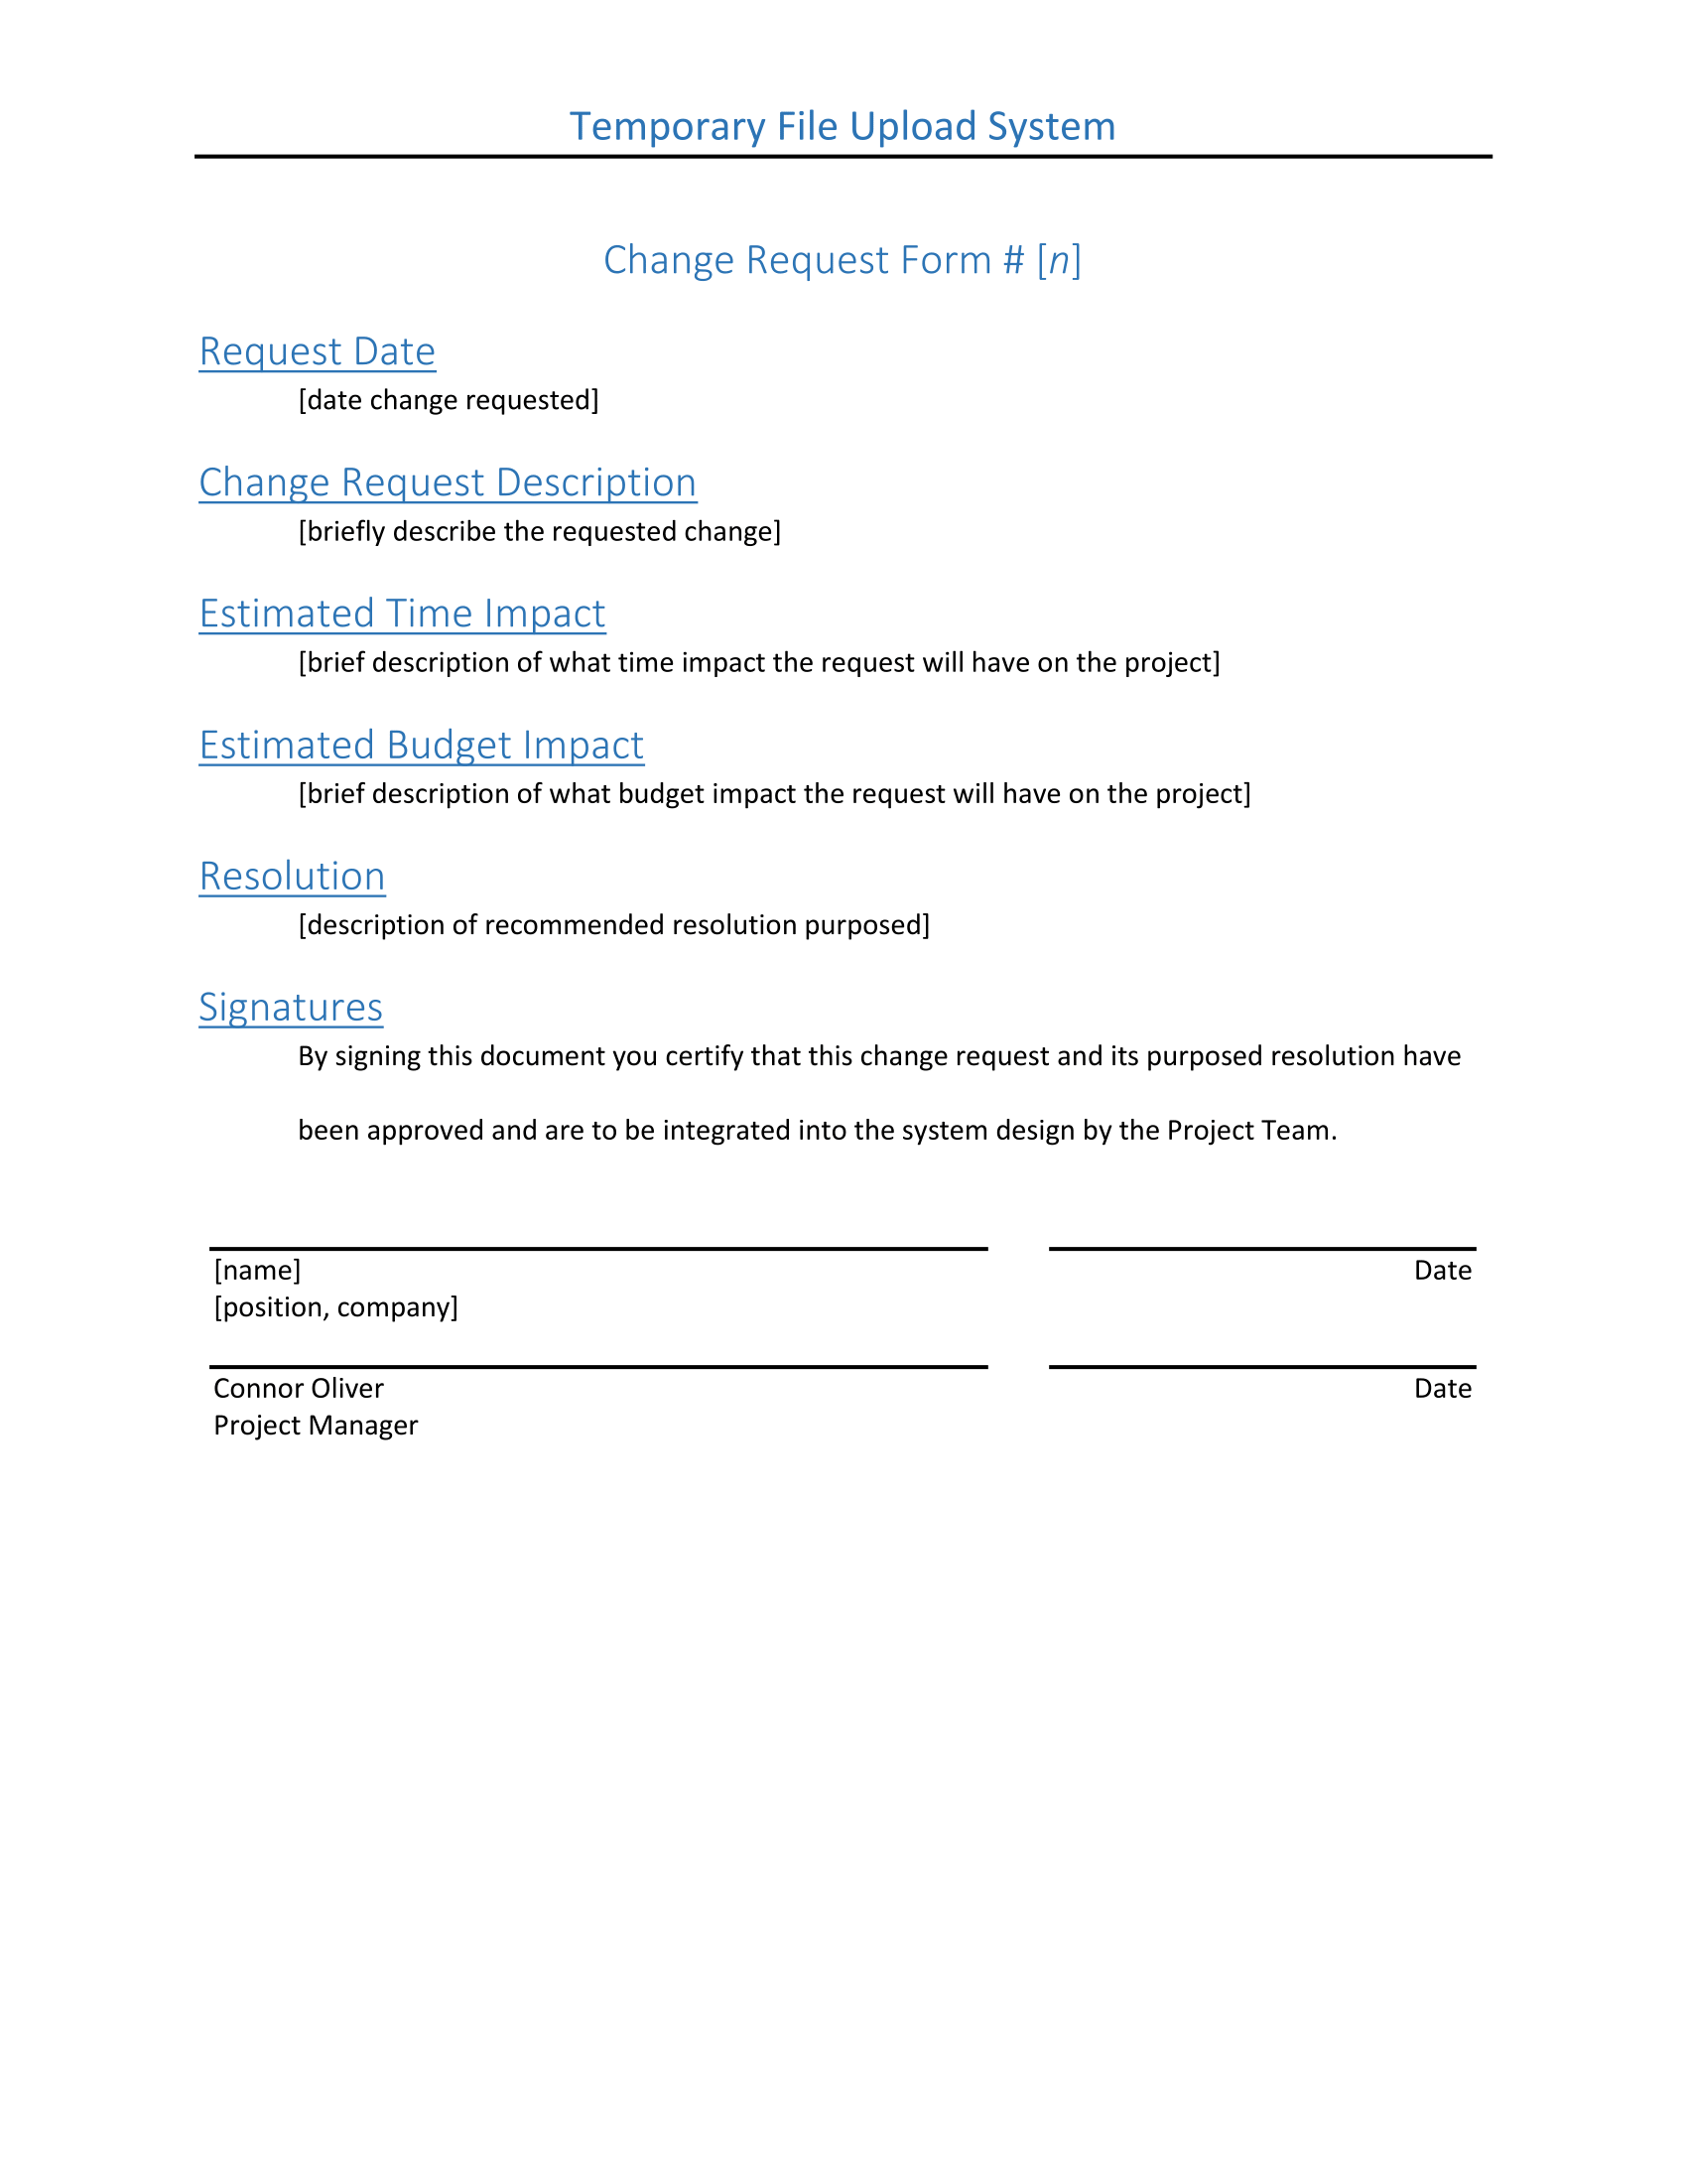



# Appendix B – Status Report Form

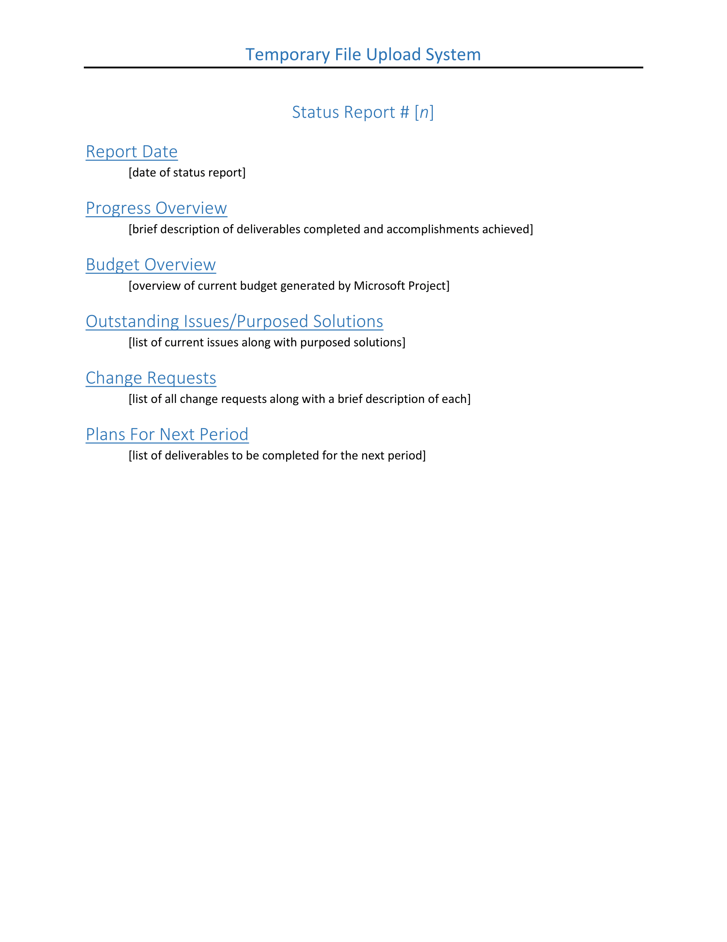



# Appendix C – Team Contract

## Code of Conduct

All members of the team are expected to follow the following code of conduct throughout the course of the project.

## Participation

* We will complete our work to the best of our ability.
* We will not procrastinate in completing our assigned tasks.
* We will make our best effort to cooperate with other team members.

## Communication

* We will use Slack for team communication.
* We will frequently communicate our progress to other team members.
* We will store our work in a Git repository so it’s easily available to all team members and backed up on all members computers.

## Problem Solving

* We will work with each other to find solutions to our problems.
* We will seek outside help and advice if we cannot find a solution to a problem.
* We will ask for the opinions of other group members if we are unsure of something.

## Technical Guidelines

* We will use Microsoft Visio for creating all UML diagrams.
* We will used Microsoft Word for all analysis and design documents.
* We will use Git for version control.
* We will use Github for hosting our code repositories.
* We will meet and decide what IDEs to use as we chose what programming languages to use.
* We will chose stable, well supported code libraries over new, experimental or poorly supported ones.

## Meeting Guidelines

* We will hold one casual meeting daily.
* We will meet in Room 70 or 78, depending upon which is available.
* We will provide at least one day notice for any formal meetings.
* We will we schedule times to meet with Gerald as needed.
* We will alert others if we are not going to be present.

Signing this document signifies that you have read and agree with the above code of conduct and will follow it during the duration of this project.

|  |  |  |
| --- | --- | --- |
| Connor Oliver  Project Manager |  | Date |
| Jordon Campbell  System Analyst |  | Date |
| Anson Carmody  System Analyst |  | Date |
| David Campbell  System Analyst |  | Date |