Concurrent Socket Server
Mujtabaa Muhammad, Kenneth Leung
CNT4505 – Computer Networks & Distributed Processing
Professor Scott Kelly

Introduction
The objective of this project was to design a concurrent, socket-based client-server system. Unlike the iterative server model from our previous assignment, this server introduces a new thread to handle each incoming request, allowing multiple clients to be processed simultaneously. By evaluating the system under various loads and comparing its performance against the iterative approach, we aimed to explore the impact of concurrency on response efficiency, especially in terms of average turn-around time.
This report details the design of both the client and server programs, explains our testing procedures, and presents our data-driven conclusions on how concurrency influences performance in a multi-client environment.

Client-Server Setup and Configuration
The server program, “UnixMultiThreadServer.java”, follows a concurrent design. It listens for client requests on a user-specified port using ServerSocket. Upon accepting a connection, it delegates the request to a new thread from a fixed-size thread pool managed by ExecutorService. This thread is responsible for processing the client's command and returning the output. The supported operations include:
- Date and Time
- Uptime
- Memory Use
- Netstat
- Listening Ports
- Current Users
- User Activity
- Running Processes
Each operation maps to a corresponding Linux command executed using ProcessBuilder. To signal the end of a response, the server appends the string “END_OF_OUTPUT” to its output stream.
The client program (UnixClientTest.java) is multi-threaded and designed to simulate concurrent user requests. The user is prompted to enter the hostname, port number, desired operation, and the number of concurrent client threads to launch. Each client thread:
- Connects to the server
- Sends the selected command
- Records turn-around time using System.nanoTime()
- Appends results to a thread-safe list
Once all threads complete, the client calculates and displays:
- Wall-clock total turn-around time
- Total turn-around time
- Average turn-around time
We reused several practices from the iterative client, including representing commands with integers and marking the end of a response with a designated string.

Testing and Data Collection
The system was tested across multiple thread counts (1, 5, 10, 15, 20, 25) for each of the supported commands. Each test captured:
- Wall-clock Turn-around Time
- Total Turn-around Time for all threads
- Average Turn-around Time per configuration
Data collection was performed on the Course Servers, and we reused testing scenarios from the Iterative Socket Server assignment for consistency.
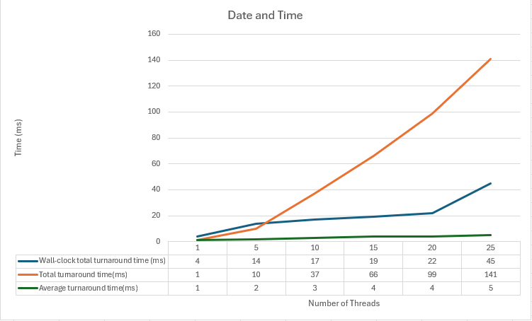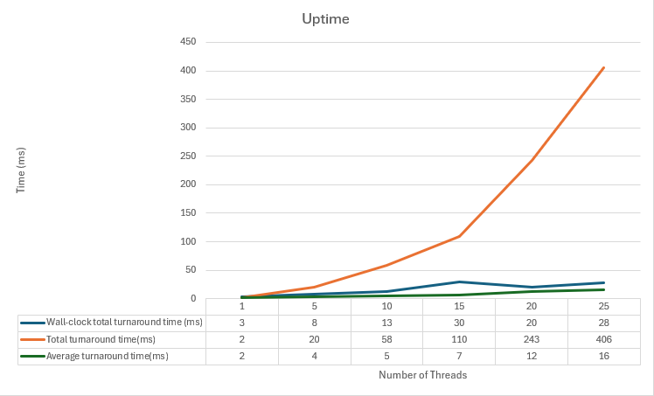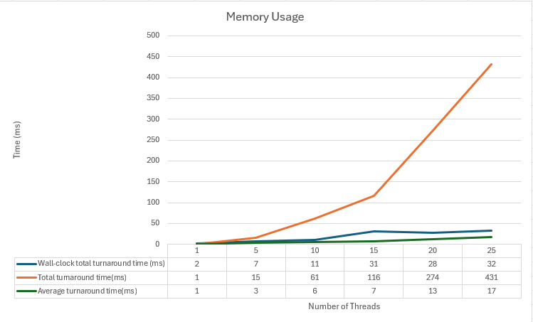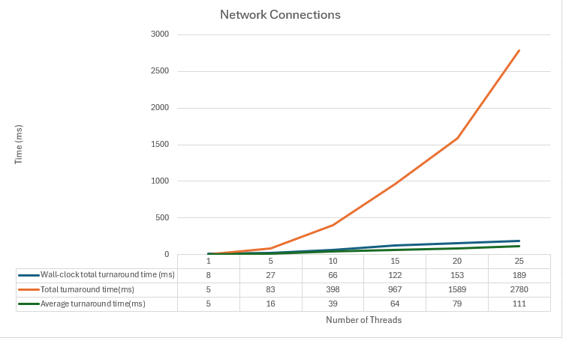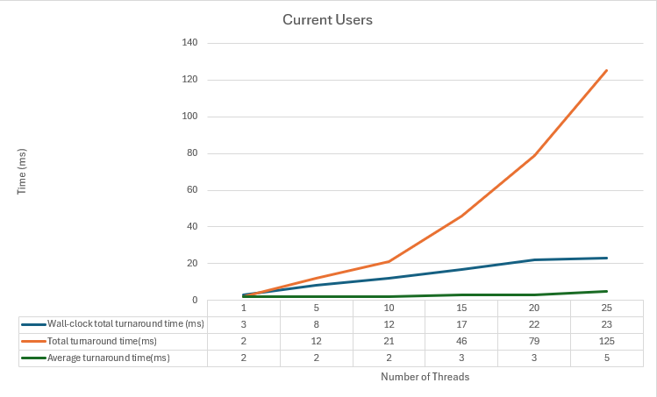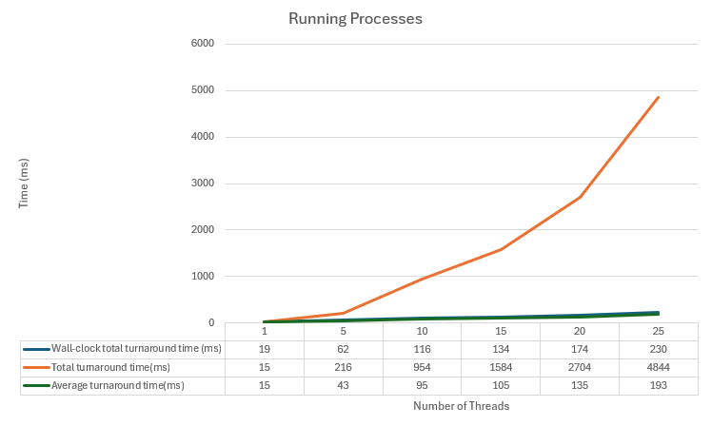
These visualizations confirm that the server’s multi-threaded design helped prevent command latency from affecting the responsiveness of other client threads. While our primary focus was on total and average turn-around time metrics, it’s worth noting that the wall-clock time is another important indicator especially from a user’s perspective. In our concurrent server setup, wall-clock time remained low because all client threads ran in parallel. For example, if five threads each took around 500ms to process, the wall-clock time would be roughly 500ms the time it takes for the slowest thread to finish.
In contrast, in the iterative server, where we did not measure wall-clock time explicitly, the same set of five clients would be executed one after another, resulting in a total delay of approximately 2500ms. Even though the total and average turn-around times might appear similar in both architectures (since the total processing time across all clients remains the same), the concurrent server’s parallel execution compresses the wait into a much smaller real-world duration, greatly improving the system’s responsiveness from a user’s perspective.

Data Analysis
One of the first observations we made was regarding the effect of client load on system performance. As expected, when the number of concurrent clients increased, the overall system workload also increased. However, thanks to the parallelism provided by the concurrent design, the individual turn-around times for client requests remained mostly stable. This was in stark contrast to the iterative server, where clients had to wait for preceding requests to complete, often resulting in long delays under heavy load.
Additionally, the average turn-around time did increase slightly with each increment in thread count. Nonetheless, even during high-load operations such as those involving the ps aux command, the increase in average time was not nearly as steep as it was in the iterative model. This highlights the efficiency of concurrent handling, where delays are distributed more evenly across threads.
When comparing the two architectures directly, the distinction became even more apparent. The iterative server, being sequential by nature, suffered from bottlenecks as more clients were added. Each client had to wait its turn, leading to compounded wait times. In contrast, the concurrent server's multithreaded design allowed it to initiate new client handlers without waiting, dramatically reducing cumulative delays and improving responsiveness.
Another important factor in performance variability was the type of command being executed. Lightweight commands such as date and who produced minimal output and required little processing time. These operations completed quickly regardless of how many threads were active. On the other hand, heavier commands like netstat and ps aux were more resource-intensive and showed greater differences between the iterative and concurrent implementations. Even so, the concurrent server managed to handle these commands more gracefully.
In terms of application, an iterative server may still be appropriate in scenarios where the expected number of simultaneous users is very low, or where hardware resources are limited and thread overhead must be avoided. However, in most modern use cases such as web services, chat platforms, or real-time data processing environments, a concurrent server is the superior choice. Its ability to maintain low response times under pressure makes it ideal for systems requiring high availability and responsiveness.

Conclusion
The concurrent server model effectively addressed the shortcomings of the single-threaded design by enabling parallel processing of requests. Our tests demonstrated that concurrency reduces average wait times and is more scalable under heavier loads. This improvement was particularly noticeable when handling large output or resource-intensive commands.
These findings reinforce concurrency as a best practice for server-side implementations in multi-user systems, where maintaining responsiveness is critical.
Lessons Learned
- Thread Pool Management: We gained hands-on experience managing Java thread pools using ExecutorService, which provided a clean structure for handling parallel tasks.
- System Command Handling: We reused and refined our method of handling Linux commands from the previous assignment, ensuring both standard and error streams were captured safely.
- Synchronized Data Collection: Managing shared turn-around time data across threads helped us better understand synchronization.
- Improved Timing Precision: We again used System.nanoTime() for high-resolution timing, applying conversion logic to display results in milliseconds.
- Client UI Flow: We refined the user interaction flow to prevent UI issues encountered in the iterative client, ensuring clean termination after requests.
- Debugging Race Conditions: Debugging thread-related issues required attention to isolation of variables and robust exception handling.
- Comparison Awareness: Seeing the real-time benefits of concurrency, side-by-side with our prior work, gave us practical insights into scalability and performance tuning.
Overall, this assignment built directly on the foundation of our earlier iterative server, offering both technical and conceptual growth in our understanding of multi-threaded networking applications.

