# Perspectives on Mobile Graphics, OpenGL, and the Future of Graphics Programming

Dave Shreiner, ARM

SIGGRAPH 2014 Conference Chair

Guest Lecture in Computer Graphics

Monday, November 12th, 6-8pm

David Rittenhouse Lab A6

(Across 33rd Street from the SIG lab)

## Computer graphics as a discipline has been around for a long time, but with the rise of mobile platforms capable of workstation-level graphics, the comfortable world of programming graphics is rapidly changing once again. This talk covers a lot of territory in this rapidly changing landscape: from discussions of the design and implementation of mobile graphics platforms, the most prolific systems being deployed today; to how to program those devices to maximize the new performance metrics: power, battery life, and energy dissipation; and perspectives on how graphics programming (particularly emphasizing OpenGL) has evolved, and will be different in the future in light of these changes.

## Dave Shreiner

Dave (BS, Mathematics) is an engineer, author, educator, and API politician who has worked in the

OpenGL community almost since its inception over 20 years ago. He’s contributed to its evolution

through code and specifications, documented its adoption in courses and books, and helped design

numerous systems that relied on OpenGL as a major graphics component. He’s currently labeled as

*Director of Graphics and GPU Computing* at ARM, and is the 2014 SIGGRAPH Conference chair.

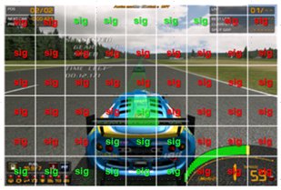

Penn contact:

Patrick Cozzi

CIS 565

pcozzi@seas.upenn.edu