# OpenGL: The Implementer’s Perspective

Graham Sellers, AMD

Guest Lecture in Computer Graphics

Monday, November 19th, 6-8pm

David Rittenhouse Lab A6

(Across 33rd Street from the SIG lab)

In this talk, we will approach the subject of computer graphics and OpenGL in particular from the implementer and hardware vendor’s point of view. We will discuss modern graphics hardware architectures, and the architecture of graphics drivers. We’ll take a look at how performance is achieved in graphics hardware through parallelism, and explore recent features of OpenGL and how they can be used to take advantage of the computing power of the GPU. Some techniques for maintaining throughput in a graphics application will be discussed. We’ll also describe the process at Khronos, the standards body responsible for OpenGL, OpenGL-ES, OpenCL and a number of other key technologies, how extensions come to be and how they make it into the OpenGL specification.

## Graham Sellers

Graham (M.Eng, Engineering) is a Senior Manager at AMD and leads AMD’s OpenGL driver team. He is responsible for the production of OpenGL drivers for AMD’s Radeon HD and FirePro graphics processors. His team’s duties include performance tuning, porting the drivers to new GPU architectures, and the implementation of new features such as extensions and new versions of OpenGL. Graham is also the author of the OpenGL SuperBible, the OpenGL Programming Guide, many OpenGL extensions, and the core OpenGL specification.

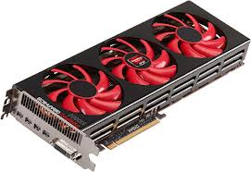  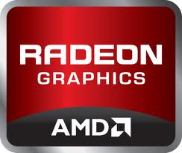

Penn contact:

Patrick Cozzi

CIS 565

pcozzi@seas.upenn.edu