**Computer Graphics in a MOOC: Beyond the Hype and Hysteria**

Eric Haines, Autodesk, Inc.

Guest Lecture in Computer Graphics

Monday, November 4th, 4-5:30pm

Towne Room 225 – Raisler Lounge

## MOOCs, massive open online courses, have been in the news. The MOOC concept has been called everything from the great equalizer to a form of colonialism. The Editor-in-Chief of the ACM wonders if they will destroy academia and wishes he could "wave a wand and make MOOCs disappear". This talk will go beyond the hype and hysteria. I spent half a year developing the MOOC "Interactive 3D Graphics" with Udacity, and the past half-year on the forum helping students progress through the material. Well over 30,000 people have signed up for this self-paced course so far. Beyond such bragging-rights numbers and the pros and cons of MOOCs, I'll focus on the course itself: how it was produced and how it works, the web technologies three.js and WebGL used to drive it, and things that went right and went wrong. There *will*be a quiz, if not two or three.

## Eric Haines

Eric Haines is a Senior Principal Engineer at Autodesk, Inc., working on a next-generation interactive rendering system for computer-aided design applications. He is a coauthor of the book "Real-Time Rendering", a founder and editor of the *Journal of Computer Graphics Techniques*, and maintainer of the *Graphics Gems* code repository, among other activities. He received an MS from the Program of Computer Graphics at Cornell in 1985 and a BS in Computer Science from RPI in 1980.

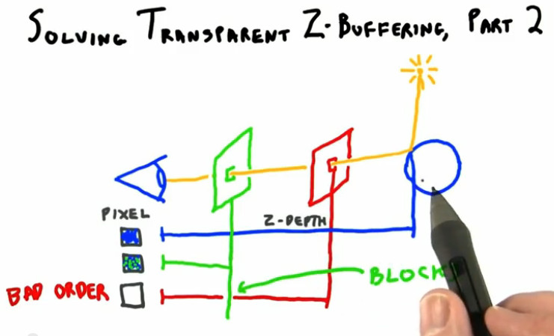 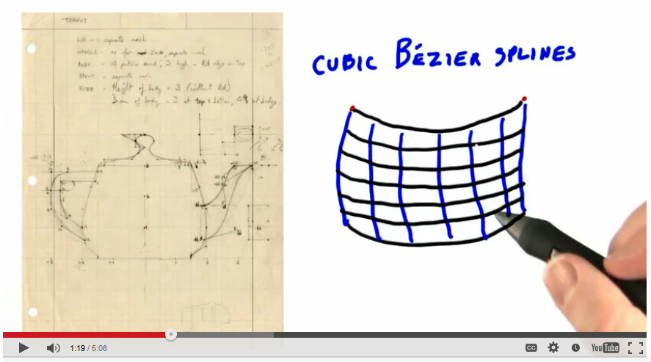 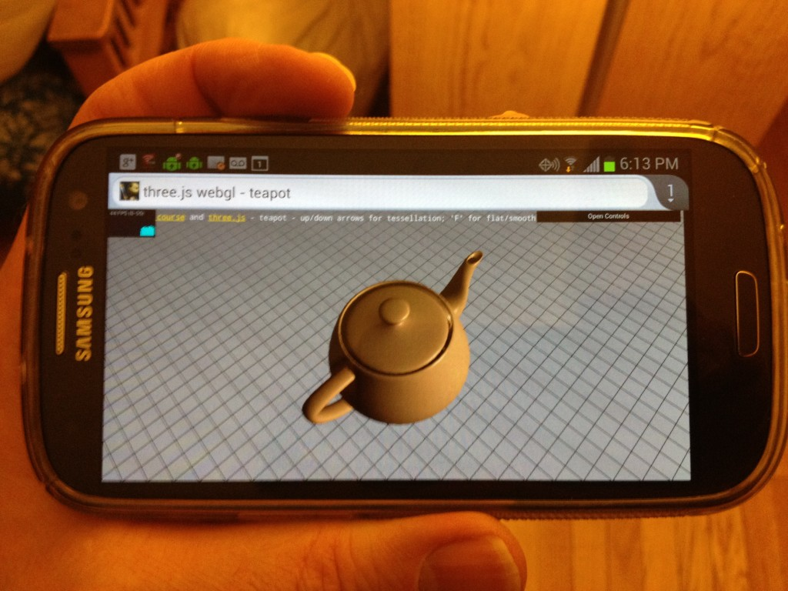

Penn contact:

Patrick Cozzi

CIS 565

pcozzi@seas.upenn.edu