# The C4 Engine Architecture

Guest Lecture in Computer Graphics

Wednesday, November 20th, 6-8pm

Location TBA

The C4 Engine is a popular cross-platform PC game engine known for its clean and elegant software architecture. This talk will discuss the overall design of the C4 Engine and examine the details of how many of its features are actually implemented. We’ll cover a large number of technical topics ranging from low-level rendering methods to high-level aspects of a first-person shooter game currently in development. Time permitting, this talk will include discussions of lighting, shadows, shaders, model animation, cloth and fluid simulation, particle systems, physics, terrain, scene organization, visibility, scripting, and more.

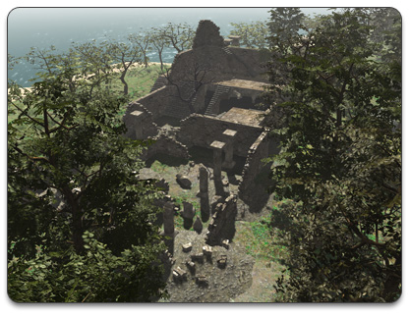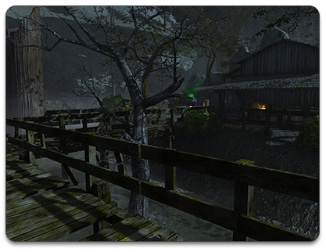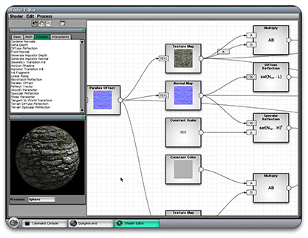

## Eric Lengyel

Eric (Ph.D., Computer Science) is the creator of the C4 Engine, the author of *Mathematics for 3D Game Programming and Computer Graphics*, and the editor of the *Game Engine Gems* series. He has worked in the computer games industry for 17 years and currently heads up a small company in northern California called Terathon Software.

Penn contact:

Patrick Cozzi

CIS 565

pcozzi@seas.upenn.edu