**Rendering the Whole Wide World on the World Wide Web**

Kevin Ring, Analytical Graphics, Inc.

Guest Lecture in Computer Graphics

Monday, December 2nd, 2013, 6pm, Moore 212

Applications like Google Earth have brought massive terrain rendering to the masses, allowing us to interactively explore hundreds of terabytes of terrain and imagery data. But how do such applications actually work? This talk describes the design and implementation of the terrain and imagery engine in Cesium, an open-source virtual globe that uses WebGL to run inside a web browser without the need for a plugin. This talk includes lots of demos, an extensive breakdown of what Patrick Cozzi actually does at work, and technical details, including:

* Terrain level-of-detail using Chunked LOD and a quad-tree of tiles.
* Using off-the-shelf data, since you probably can’t afford your own satellite.
* Limiting what gets rendered, without cheating: horizon culling.
* Rendering even less by cheating.
* The tile load pipeline and out-of-core rendering.
* Making it all work on mobile devices, too.
* Simplifying massive terrain for efficient rendering.

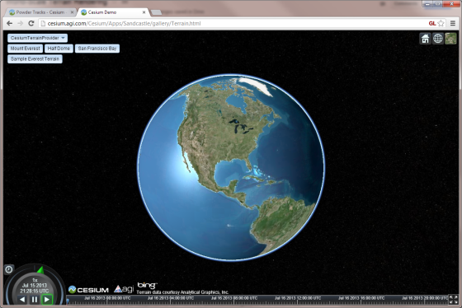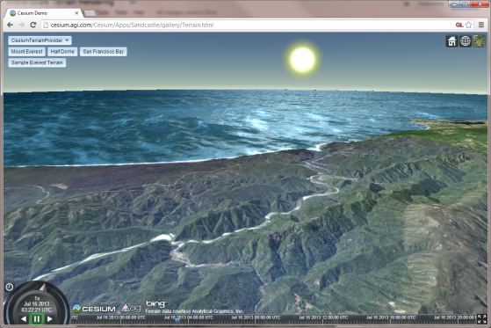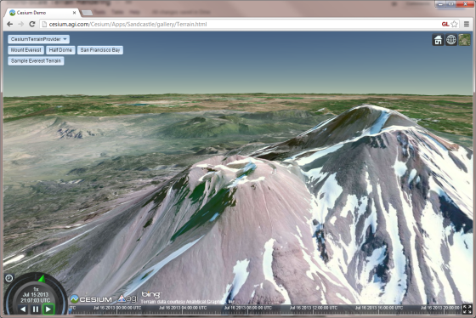

# Kevin Ring

Kevin is coauthor of *3D Engine Design for Virtual Globes*, a presenter in the *Rendering Massive Worlds* course at SIGGRAPH 2013, and the lead architect of STK Components at Analytical Graphics, Inc. When he’s not busy complaining about JavaScript, he works on the terrain and imagery rendering engine in Cesium, on a soon-to-be-released product for processing and serving terrain, and on a frustratingly large number of other things.